POLICY BULLETIN 1, 2014





CENTRE FOR
DISABILITY
RESEARCH
AND POLICY

LEFT BEHIND: 2014
MONITORING THE SOCIAL INCLUSION OF YOUNG AUSTRALIANS WITH DISABILITIES 2001 - 2012

LEFT BEHIND: 2014
MONITORING THE SOCIAL INCLUSION OF YOUNG AUSTRALIANS WITH DISABILITIES, 2001-2012
POLICY BULLETIN 1, 2014
June 2014

ISSN: 2201-7488

Professor Eric Emerson, Professor of Disability Population Health
Professor Gwynnyth Llewellyn, Professor of Family and Disability Studies

The full Technical Report is available at
http://sydney.edu.au/health-sciences/cdrp/publications/policy-bulletins.shtml

Contact details:

Eric Emerson
Centre for Disability Research and Policy
Faculty of Health Sciences, University of Sydney PO Box 170, Lidcombe NSW 1825, Australia
eric.emerson@sydney.edu.au

Cover Artwork: Robbie S. is an artist supported by Sunshine's Community Access Program Art Studio

SUMMARY
This Policy Bulletin is the second in an annual series reporting on the social inclusion/ exclusion of young Australians (aged between 15 and 29) with self-reported long term health conditions, impairments or disabilities. In the first Policy Bulletin – Left Behind: 2013 reporting on the time period 2001-2011, we reported that disabled Australian adolescents and young adults were more likely to experience social exclusion than their non-disabled peers, and that the gap between the two actually widened between 2001 and 2011.
This Policy Bulletin updates Left Behind: 2013 by extending the mapping to the year 2012, the latest year for which data are available. Our findings address two key questions:
- How did the social inclusion of young Australians with disabilities compare with that of their peers in 2012?
- Did the gap between the social inclusion of young Australians with and without disabilities narrow or widen over the 12 year period from 2001 to 2012?
How Did the Social Inclusion of Young Australians with Disabilities Compare with That of Their Peers in 2012?

In 2012 young disabled Australians were fourteen times more likely than their non-disabled peers to experience entrenched multiple disadvantage (defined as experiencing disadvantage in at least three areas - income, work, education, safety and support - for two years or more).
Compared to their non-disabled peers, young disabled Australians in 2012 were significantly less likely to:
- Be employed
- Be fully engaged in education or work
- Attain Year 12 or equivalent educational qualification
- Obtain non-school qualifications
- Feel they have someone to turn to in time of crisis
- Report that they had a voice in the community
- Have contact with family/friends
- Get together socially with family or friends

Compared to their non-disabled peers, young disabled Australians in 2012 were significantly more likely to:
- Live in a jobless household
- Experience long-term unemployment
- Have low economic resources combined with financial stress and material deprivation
- Experience financial stress and material deprivation
- Have low subjective quality of life
- Have poorer self-assessed health
- Have mental illness
- Report feeling unsafe in their local area
- Be a victim of violent crime
- Experience multiple disadvantage and entrenched multiple disadvantage

Did the Gap between the Social Inclusion of Young Australians with and without Disabilities Narrow or Widen Over the 12 Year Period from 2001 to 2012?

Between 2001 and 2012 the gap between the social exclusion of disabled and non-disabled young Australians has widened markedly over time in 11 critical areas:
- Not being employed
- Living in a jobless household
- Being long-term unemployed
- Not being fully engaged in work or education
- Not acting as a volunteer
- Having low economic resources and financial stress
- Having low subjective well-being
- Not having someone to turn to in times of crisis
- Not having a voice in the community
- Experiencing multiple disadvantage
- Experiencing entrenched multiple disadvantage.

In not a single area has the gap narrowed over time.

Despite social policy interventions, such as employment schemes for those in long-term unemployment and policies to include people with disabilities in community activities and organisations, the aspiration for young disabled Australians to become more socially included appears even further out of reach. Australia is a prosperous nation, committed to redressing the profound social disadvantages people with disability experience and to promoting their participation in society. But it has yet to redress the significant and pervasive social exclusion faced by Australian adolescents and young adults with a disability.
Figure 1 Widening gap between social exclusion of disabled (blue line) and non-disabled (red line) young Australians 2002-2012
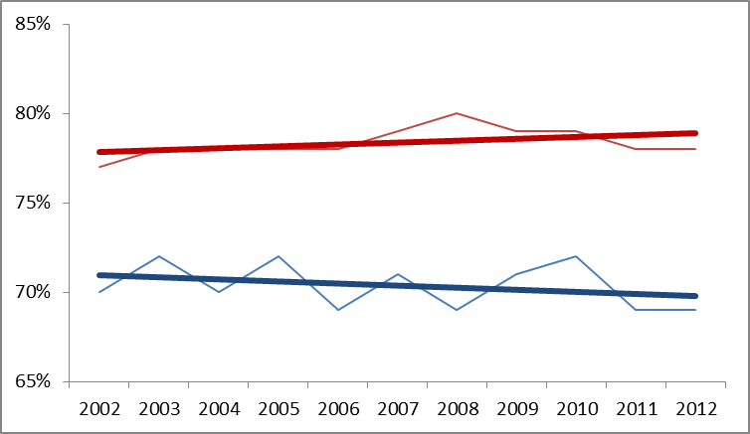
Note: X axis shows average percent on 10 of the 11 indicators on which change was evident between 2002-2012. Data on the 11th indicator – financial stress was not collected in 2010.

POLICY IMPLICATIONS

In 2012, young disabled Australians were five times more likely than their non-disabled peers to experience entrenched multiple disadvantage. In 2012, young disabled Australians are fourteen times more likely than their non-disabled peers to experience entrenched multiple disadvantage. The gap between young disabled Australians and their non-disabled peers has widened markedly between 2001-2012.

This means that not only are young disabled Australians significantly disadvantaged compared to their non-disabled peers – this disadvantage is increasing over time.
Monitoring the effectiveness of policy and service initiatives is central to Australia’s National Disability Strategy 2010-2020. Policy developments through 2013-2014, including the roll out of the National Disability Insurance Scheme, aim to maximise the social and economic participation of all Australians with disabilities.
It is hoped that the implementation of the National Disability Insurance Scheme will address the inequalities evident in the analyses presented here between young disabled Australians and their non-disabled peers. Continued monitoring is critically important to determining whether changes in the right direction occur in the future.

