Interdisciplinary Tools to Enable Middle Suburb Regeneration

Stephen Glackin¹, Roman Trubka², Rita Dionisio³, Peter Newman², Peter Newton¹, Simon Kingham³

¹ Swinburne Institute for Social research, Swinburne University, Melbourne Victoria
² Curtin University Sustainability and Policy, Curtin University, Perth Western Australia
³ The University of Canterbury, Christchurch, New Zealand

Contact:
Stephen Glackin
Swinburne Institute for Social Research
Swinburne University of Technology
EW (Engineering West) Building
PO Box 218 Hawthorn 3122
Melbourne , Australia
Ph: +61-3-9214 8218
Email sglackin@swin.edu.au

Abstract
Due to the unsustainable nature of urban sprawl, Australian metropolitan strategies have increasing been pushing for increased levels of infill: the redevelopment of existing urban (typically residential) land. However, the current infill models of Brownfield and lot-by-lot redevelopment are largely incapable of generating the volume or range of future housing needs. This issue has led to increased attention being placed on greyfield redevelopment, and in particular regeneration precincts, as a way to encourage more efficient reuse of land. However, due to a number of issues, namely the complexity of amalgamating individually owned land, statutory limitations and community concern regarding the redevelopment of existing residential land, this has to date been seen as too difficult to strategically engage with. This paper presents a worked example that aimed to address these issues. Covering the development of 2D spatial tools, 3D visualisation and assessment tools, new statutory responses and community/stakeholder engagement techniques, the paper illustrates how a range of approaches have been used to show the viability of this model to all relevant stakeholders, and how the interdisciplinary approach is beginning to have effect in the policy arena.

1. Introduction
With urban sprawl no longer being a viable option for increasing urban populations (Trubka et al., 2010a; Trubka et al., 2010b; Trubka et al., 2010c) it has become the role of brownfield (ex-industrial land) and greyfield (tracts of obsolete suburban dwellings(Newton, 2010)) to provide significant amounts of additional housing. While an established regeneration model exists for brownfield redevelopment, this form of infill accounts for a very small proportion of dwelling increase, with the vast majority of additional dwellings from urban infill coming from ad-hoc greyfield redevelopment (Newton and Glackin, 2014). However, as this form of redevelopment is largely occurring in a piecemeal fashion, it is not being done in the scale required to retrofit new dwellings with sustainable infrastructure and, due to the lot-by-lot nature of redevelopments, not taking full advantage of the redevelopment opportunities to regenerate entire precincts. It also does not necessitate providing any additional amenities or services for local residents, which, given that conventional greyfield redevelopment at least doubles population densities, is problematic.

The key issue is that of land amalgamation. While brownfield regeneration typically has a significant amount of land under single ownership, and can therefore make use of its scale to provide greater densities, greyfield regeneration is done on small lots that have specific boundary conditions and must adhere to established zoning regulations. The result of this is wasteful, in terms of both redundant replication (driveways, turning circles, setbacks) and opportunity cost (higher yields, boundary conditions, central massing, additional utility and storm water catchment), as illustrated in Murray et al. (2015).

While systematic land amalgamation and redevelopment provides multiple benefits, it has not been taken up as a viable redevelopment model, due mainly to its complexity and a risk-averse development industry. In terms of stakeholders, land owners have the right to dispose of their land when and how they wish, but should they choose to amalgamate their lots, the statutory mechanisms for obtaining better yields, or adapting existing zonings, are not available to them. Similarly, local governments are restrained by existing legislation and must act in the interest of their constituency, guiding them towards meeting metropolitan strategic targets whilst remaining politically secure. Municipal governments are also not currently ‘in the business’ of brokering for redevelopment: which would be a requirement of precinct scale regeneration. Developers are likewise constrained by the existing statutory tools, while state government are largely reluctant to enter into an arena where there are so many difficulties and unanswered questions. As such, this issue represents a problem where the positive outcomes are evident, but the ability to get to a win-win-win outcome among the community, government and development industry is considered intractable.

Despite the complexity of this issue, the research on which this paper is based on has begun to affect positive change, evidenced by inclusion in state (Department of Environment Land Water and Planning, 2015) and local planning policies (the Municipality has asked for this to remain confidential until publication and formal consulting has been finalised). This has been done through actively engaging all stakeholders in an interdisciplinary fashion and developing tools and approaches for all facets of the issue. This paper illustrates the approach and outcomes of this project to date and how it has successfully negotiated the complexities of the problem to achieve successful, but not yet finalised, outcomes.

2. Greening the Greyfields: A worked example of promoting urban regeneration precincts.
Beginning in 2011, and funded for six years through the CRCSI, the ‘Greening the Greyfields’ project set out to generate a viable and extensible model for greyfield regeneration. The project was based on Newton’s (2010) initial paper on the subject which highlighted the opportunities for strategic greyfield regeneration; noting that the middle-ring suburbs of Australian cities contained ample opportunity to provide for housing needs into the future. The inherent difficulties were the focus of an AHURI investigatory panel on greyfield regeneration, which identified the bottlenecks, key stakeholders, issues and the most effective way to achieve industry and government acceptance of a greyfield regeneration model (Newton et al., 2011). The outputs of these projects, which can largely be seen as the requirements for Greening the Greyfields, started the process of project planning and set the key areas of investigation for the project.

2.1 Defining the project scope
Figure 1 illustrates an adapted version of Newton’s original ‘Areas of Innovation’, with some additions to the schema coming from project advancement. This diagram highlights the specific arenas that need addressing and the specific functions that need to be resolved in each arena. Labelled as ‘Where’, ‘Who’, ‘What’ and ‘How’, these categorisations provide a simple breakdown of the complexity of the issue and thus made the issue potentially manageable. These categorisations defined the four modules of the ‘Greening the Greyfields‘ research: Module 1 examined ‘why’ this project was necessary (Trubka et al., 2010a; Trubka et al., 2010b; Trubka et al., 2010c), Module 2 addressed the ‘where’ question by creating software tools to identify precincts (Glackin, 2013), Module 3 developed 3D visualisation software to answer the ‘what’ question (Trubka et al., 2016; Trubka and Glackin, 2016), and Module 4 implemented the entire system, answering the ‘who’ and ‘how’ questions. Each module broke the problem into manageable pieces that were tackled independently and with separate, yet aligned, outputs (Newton et al., 2012).

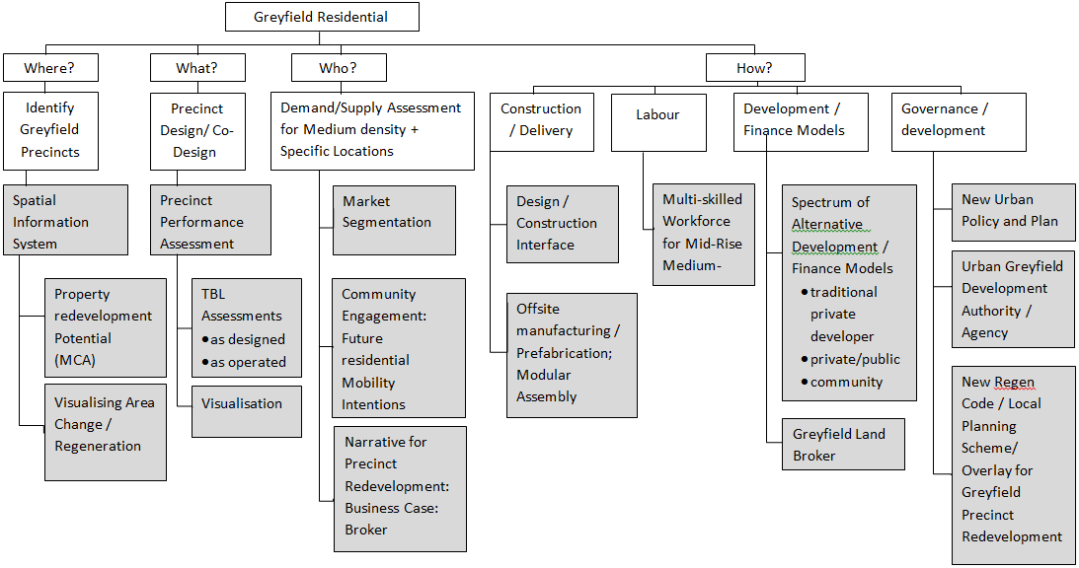
Figure 1: Innovation areas required for greyfield regeneration (adapted from Newton et al. 2011)
Linked to this is the scheme of stakeholders and their relationships, which can be seen in Figure 2. This diagram represents not only the stakeholders but the relationships between them and therefore the officers, policies and statutory obligations that needed to be explored throughout the project. Together these diagrams represent the full scope of the project and an overview of the stakeholder engagement required for successful completion.

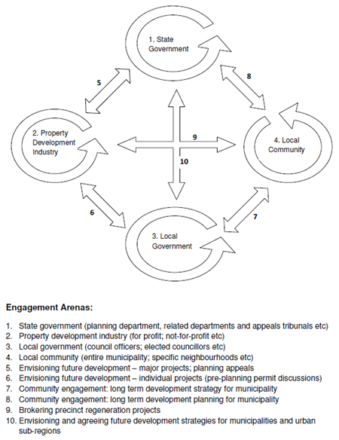
Figure 2: Stakeholder engagement arenas (Newton et al. 2012)
2.2 Partnerships and personnel
The core research team consisted of three researchers with backgrounds in economics, computer programming, GIS, architecture and community engagement. No housing experts were part of the research groups and the skillset was not sufficient to ensure the project’s success. Additional expertise was required in the areas of statutory planning and legal mechanisms, large-scale software systems development and administration, property development, construction engineering, carbon mitigation and so forth.

On the basis of the project plan, partnerships were required with state government and local government, particularly in the capacity of planning, Similarly the interface between these relationships needed to be understood, with relevant agencies providing an understanding of how the relevant stakeholders groups communicate with each other. A full list of partners, the particular office, the module they were involved in and their roles are represented in Table 1 below. Due to the project running in three cities, across three different constituencies, there is some designed replication of function across states.

Table 1: Research partnerships
Partner | Office | Modules | Role
Victorian Department of Environment, Land Water and Planning | Strategic planning | 2, 3 & 4 | Advising on project and providing introductions
Victorian Department of Environment, Land Water and Planning | GIS and data | 2 | Data provision
Victorian Department of Environment, Land Water and Planning | Statutory planning | 4 | Assistance drafting statutory changes
Western Australian Department of Planning | Statutory planning | 4 | Assistance drafting statutory changes
Western Australian Department of Housing | Land and Housing Development | 2 & 3 | Software testing
New Zealand Ministry of Business, Innovation and Enterprise | Planning | 2, 3 & 4 | Data supply, specifications and testing
Landgate (WA) | Innovation | 2 | Data provision
Australian Urban and Research Infrastructure Network (AURIN) | Software development | 2 | Programming of ENVISION (module 2 output)
Melbourne University / MUtopia | Software development | 3 | Programming of ESP (module 3 output)
The City of Manningham (VIC) | GIS | 2 | Data provision
The City of Maroondah (VIC) | Strategic planning | 2, 3 & 4 | Data provision, specification development, software tasting precinct identification
The City of Maroondah (VIC) | Statutory planning | 4 | Assistance drafting statutory changes
The City of Maroondah (VIC) | Community engagement | 4 | Design of engagement for precinct trails
The City of Dandenong (VIC) | Strategic planning | 2 & 3 | Data provision and precinct identification
The City of Yarra (VIC) | Strategic planning | 2 & 3 | Data provision and precinct identification
The City of Brimbank (VIC) | Strategic planning | 2 & 3 | Data provision and precinct identification
The City of Stirling (WA) | Strategic planning | 2 & 3 | Data provision and precinct identification
The City of Stirling (WA) | Statutory planning | 4 | Assistance drafting statutory changes
The City of Canning (WA) | Strategic planning | 2 & 3 | Data provision and precinct identification
The City of Christchurch (NZ) | Strategic planning | 2 & 3 | Data provision and precinct identification

This combined skillset provided the qualitative, quantitative, design and analysis skills necessary for this project. The broad coverage that the research group had, combined with the in-kind resources of partners, was sufficient to imaginatively address most issues. As such, in such a complex environment, it was beneficial to utilise in-kind contributions to broaden research skills, as opposed to focusing on singular domain knowledge typical of academic exercises.

As can be seen, each stakeholder was utilised in a number of dimensions and asked to provide input across a number of modules. Practically, stakeholder engagement was used to address the issues in Figure 1. Co-investment and involvement from state government assisted with the initial process of data sourcing and the design and distribution of the 2D and 3D tools. Interactions with local governments led to the research team being involved in the preparation of housing strategies and discussions regarding the future of housing in municipalities broadly. They then led to discussions with municipal statutory planners about a new greyfield redevelopment model, which in turn required state government statutory planners to become involved in developing new statutory tools for greyfield regeneration. Likewise, local government discussions also resulted in obtaining information from key policy makers as to how best to design precincts (in the context of that municipality). These design briefs ultimately became mechanisms for precinct regeneration, which were fed back to state government for inclusion in statutory tools. Given that local governments also have the responsibility to engage the community with policy changes, local government communications officers were utilised to aid in educating and advising the constituency as to how to utilise these new mechanisms. This has resulted in greyfield regeneration precincts becoming part of a partner municipality’s housing strategy. The success of this process has now seen the outcomes from the project being included in the refresh of the Melbourne metropolitan strategy “Plan Melbourne” (Department of Environment Land Water and Planning, 2015).

2.3. Prototypes, software and tools
Codesign (Howard and Somerville, 2014; Sanders and Stappers, 2014) illustrates the power of prototypes, and generative artefacts more broadly, to drive inquiry by design; their power being to both promote and focus discussion, as well as innovate through iterative redesign. The complexity of this project required that different prototypes be developed for each module and subsection of that module. Though quite distinct, all prototypes were developed iteratively and with the assistance of stakeholders. Similarly, all were used to initiate debate and to provide new stakeholders with well-developed concepts to illustrate the aims of the project and drive the project forward. It is important to note that the prototypes presented below were used to enlist research partners; illustrating the potential of the project to affect significant change and not remain purely academic. It was these outputs, and how they illustrated the willingness to practically overcome issues which was their real strength.

2.3.1 Module 2 Prototype: ENVISION
ENVISION is a planning support system (PSS) designed to allow local governments to identify potential regeneration precincts. It was initially developed as a ‘plug-in’ for QuantumGIS and then as a standalone web-enabled system (Glackin, 2013). The system evolved through multiple iterations with stakeholders, including local government, state government and the housing development industry. The first iteration produced the Precinct Identification tool (Figure 3). This tool allows users to identify precincts based on valuations data and planning overlays, including indicators related to property condition, local redevelopment activity, proximity to strategic infrastructure assets and amenities, and more.

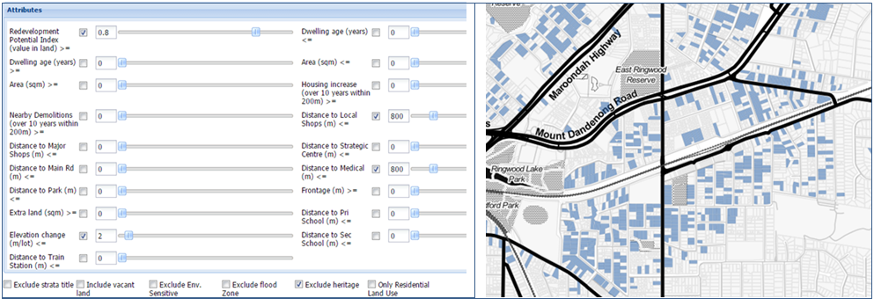
Figure 3: Interface and output of the Precinct Identification tool
System users suggested that a complimentary tool be developed that directed them towards policy imperatives, and particularly a tool that could negotiate diverse and often polemic policies. This resulted in the addition of two multi-criteria evaluation (MCE) tools (Figures 4) that allowed users to select criteria and weight them according to their significance. This proved particularly useful in facilitating discussions with local government officers from different departments, where, for example, sustainability, economic development and transport officers were discussing options for regeneration scenarios. Typically this would result in cyclical debate with little net result; however, when using the MCE tools, the maps generated were able to facilitate intelligent and informed consensus and provided an output signifying the result of negotiations.

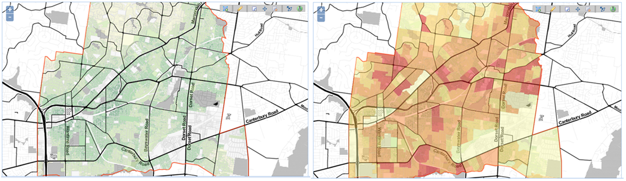
Figure 4: Example outputs of the two MCE tools (property-level analysis on the left and SA1-level analysis on the right)
After presenting the precinct identification and MCE tools to stakeholders, it became apparent that redevelopment site identification needed to be supplemented by capacity analysis as the next step in a greyfield regeneration analysis workflow. This gave rise to the Rezoning tool, which performs a scenario modelling function, allowing users to rezone land and get feedback on the change in housing capacity (see Figure 5). This proved to be a highly valued tool by the local governments that were in the process of preparing new local housing strategies and revising their local planning schemes.

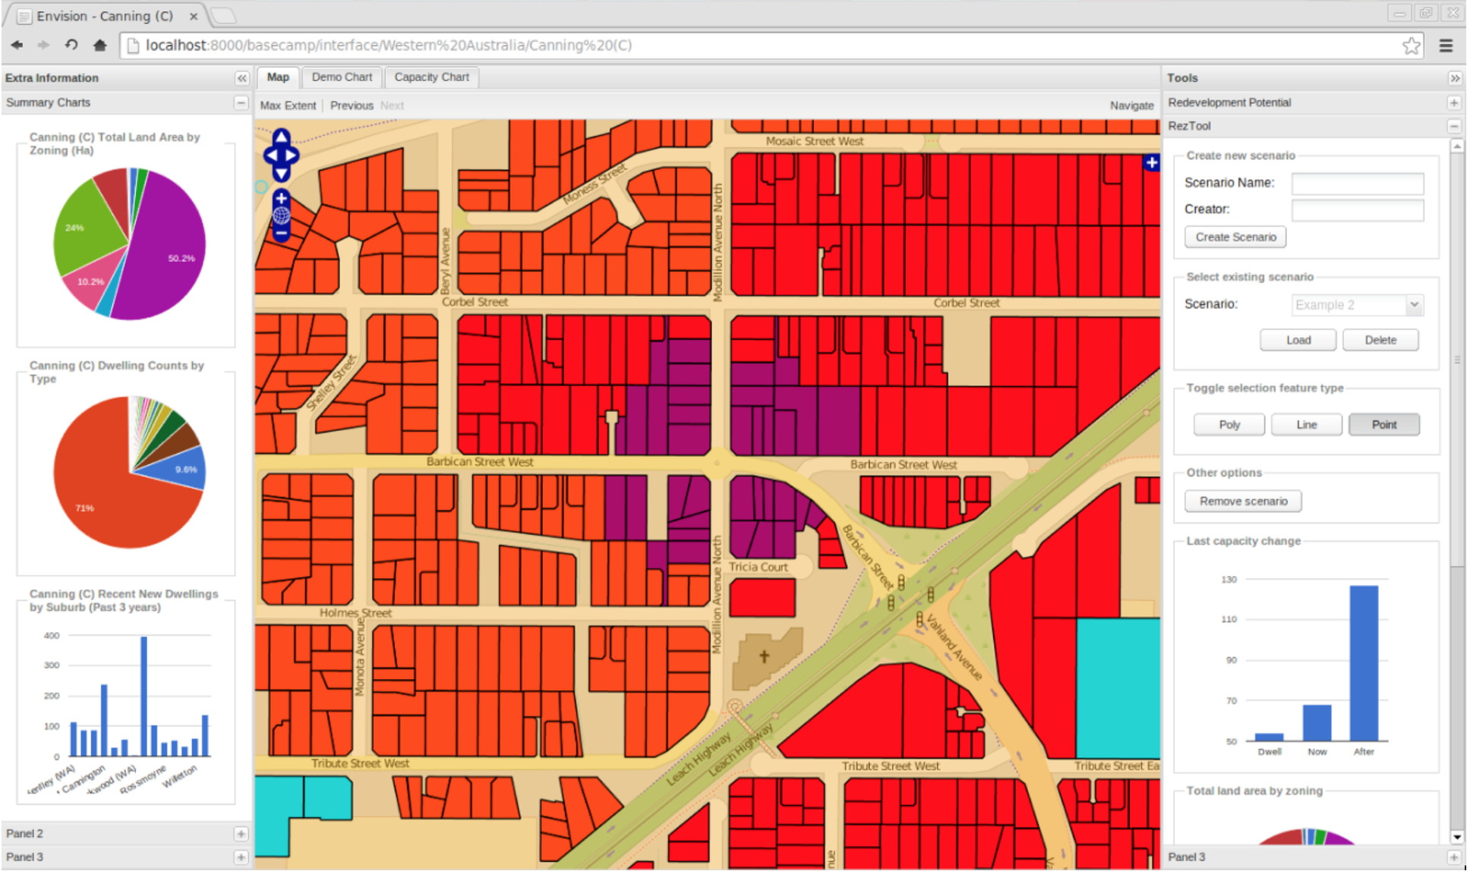
Figure 5: Rezoning tool interface
After a workshop with property developers, it was further evident that without financial analysis of precinct economic viability the toolset would not achieve industry acceptance. This resulted in the Viability tool, which allows users to virtually construct a precinct, assess the costs and compare them with the median sales prices and volumes locally (see Figure 6).

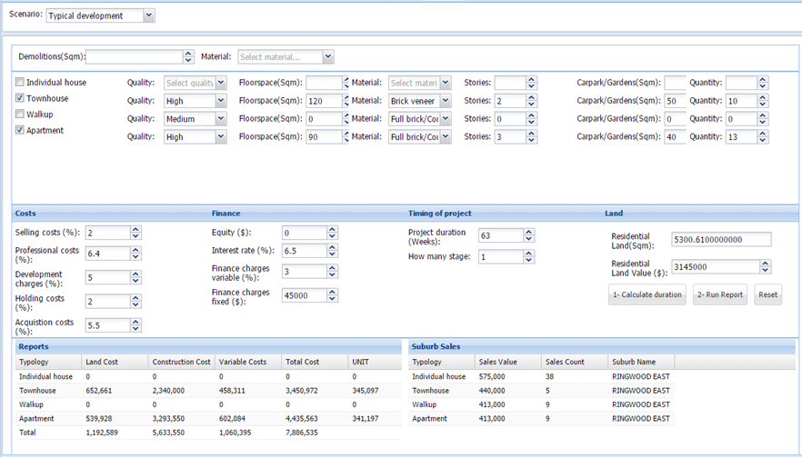
Figure 6: Viability tool interface
On advice from state planning authorities, the Envision system was presented to an organisation capable of rolling it out nationally, resulting in it being hosted on the AURIN workbench (http://aurin.org.au/projects/lens-sub-projects/envision/). This concluded the prototype for Module 2 of the project, which, at the time of writing, was being utilised by seven test municipalities in Australia and New Zealand.

2.3.2. Module 3 Prototype: Envision Scenario Planner (ESP)
The aim of Module 3 was to answer the ‘what’ question. This required developing software that allowed potential precincts to be visualised and assessed so planners, developers and local communities could see and evaluate different redevelopment possibilities and outcomes. The initial concept for this was largely theoretical, with first prototype iterations coming from workshops with industry on specifications. Broadly, the specifications were for a scenario planning tool that was easy to use, provided output on key metrics and had unrealistic visualisation (to avoid community confrontation regarding the finality of scenarios). Other features were added as development advanced, such as functions for lot amalgamation and subdivision, reporting at the precinct and building level, the inclusion of non-residential building typologies, roads, trees and other assets, and modelling of renewable energy and stormwater management. Figure 5 shows the Version 1 release of the system, which like Envision is an online tool published through the AURIN workbench (see http://aurin.org.au/projects/lens-sub-projects/esp/). Although this marks the end of development for Module 3’s prototype, further iterations are possible, including the potential addition of heat island analysis and shading impacts.

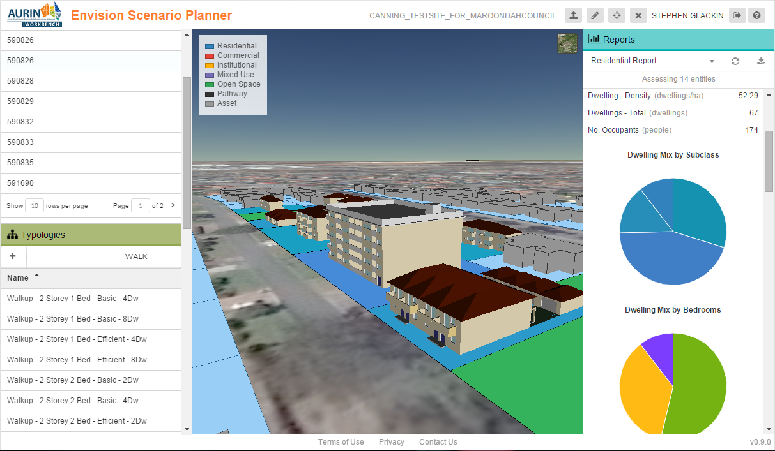
Figure 7: ESP visualisation and a limited view of typology list and reporting functions
2.3.3 Module 4 Prototype: Statutory tools
The complexity of Module 4 (community and statutory tools) necessitated a number of prototypes. The first was a draft schedule amendment for a test municipality. The need for this prototype became evident after initial discussion with state and local government regarding the statutory mechanisms required for precinct regeneration. Both organisations stated that change was necessary but without prior research and evidence of being able to advance this phase of the project, statutory planners were unlikely to supply resources to advance the project. Similarly, without a significant amount of the statutory work completed, it was indicated that researchers would be unable to effectively guide the required statutory outcomes. To begin the process, statutory planners were employed to devise a draft amendment, at both the local and the state level, which would facilitate lot amalgamation and regeneration precincts. This draft served as a prototype; prompting state and local planners to review and comment on the document. At the time of writing, Greening the Greyfields methodologies were being drafted onto municipal housing strategies in Victoria, with plans to implement similar, but locally contextual responses, in Western Australia and New Zealand. This process is being observed and guided by state planning authorities with an aim to implement these methodologies metropolitan-wide.

2.3.4 Module 4 Prototype: Economic and legal scenarios for landowners.
Similar to the above, but relating to the rights of the landowners, as well as the opportunities for their involvement in regeneration schemes, prototypes (in the form of legal templates) were required. These were needed to capture the variety in development scenarios, generate templates for legal arrangements amongst landowners and illustrate the variety of contextual responses to regeneration.

Given the range of possible regeneration scenarios, variable costs were established for each. The costing tool in ENVISION provided an introduction to these issues by presenting a range of variation in land costs, holding costs, selling costs and land transfer fees, among others. These represent the variability that comes from typical scenarios (where land is sold to developers), joint ventures (where land is held by land owners and developed jointly), non-for profit scenarios (with social or affordable housing, as covered in Murray et al. (2015)). This allowed users, regardless of venture, to assess the economic range of outcomes across different redevelopment models

Research into the form of landowner coordination was also required, so as to offer a range of opportunities so as to both protect the rights of individual landowners but also to remove risk from the project to ensure its implementation into the future. Investigation into this field has produced the following options, which will appear in forthcoming publications:
- Partnerships
- Land trusts
- Joint ventures
- Local government and landowner agreements
- Bespoke development contribution schemes
- Collective land readjustment

2.3.5 Module 4: Community engagement methods
The importance of engagement to advertise new land uses, statutory responses and potential opportunities is the final, and potentially the most significant, aspect of this project, as without it communities are likely to be fearful or resistant to change. Given the significant cost involved, as well as the political dimensions of negative responses, it was essential to utilise the resources and local knowledge of municipal governments. This not only provides resources, but also complies with local and state engagement policy, as well as positively negotiating a pathway through locally problematic political arenas.

In this instance the development of a new housing strategy was utilised as a vehicle for delivering the greyfield regeneration message to locals. This occurred in three phases. The first was advertising the potential opportunities to local landowners, which was largely broadcasting the concept of greyfield precincts, along with other pertinent local housing issues. The second was series of workshops with relevant stakeholder groups (developers, business people, community services and resident organisations), aimed at understanding the key concerns of each group as well as the housing and redevelopment opportunities locally. The third was a series of community engagement events, where the community were informed of the specifics of precinct amalgamations, how to utilise them and its benefits. The upcoming final phase is to seek expressions of interest from residents in respective zones where the statutory mechanisms are instantiated.

Ultimately this methodology aimed to reutilise the engagement practices of earlier engagements with residents as to the opportunity for regenerating areas (Glackin and Dionisio, 2016), but to advance it by actually beginning the regeneration process, as opposed to purely illustrating its benefit. A critical component of this engagement, and future greyfield regeneration precincts, will be the inclusion of the counsel officers as brokers for redevelopment. Where rather than developers approaching landowners, local governments would take the lead in identifying redevelopable areas and inform landowners as to the opportunities that were available to them; effectively driving sustainable development in strategic areas.

3. Project outcomes (to date) and lessons learnt
As it stands the project is nearing completion, with six months of its six years remaining. ENVISION, the prototype 2D precinct identification system, is currently being trialled in seven municipalities in three Australian and New Zealand cities. This tool is a largely being used to illustrate the potential for precinct scale regeneration and to inform housing policies in these municipalities. ESP, the 3D precinct design tool, is also running in these municipalities and has been used in stakeholder workshops and community engagement programs. Statutory mechanisms to allow implementation of lot amalgamation and create a risk mitigated greyfield regeneration model are currently being debated by municipalities and their representative state governments. State governments are assisting and advising on the best approaches to these developments, positioning themselves to take control of the process should it prove successful. Community engagement programs have been run and are approaching their final stages of landowner acquisition which will be completed by early 2016, allowing state governments time to assess the results prior to the end of the project. Through the most difficult aspect (land acquisition) is yet to come, the project has seen “greyfield regeneration precincts” turn from a novel academic concept into a model that is changing urban policy and gaining acceptance in wider community.

In hindsight, while the number and variety of stakeholders, including partners from across Australia and New Zealand, made the impact of the project far-reaching, the overall scale of engagement played to the project’s detriment in some regards. Having so many stakeholders in different jurisdictions with different priorities and planning issues at times limited progress by necessitating the negotiation of different aims and requirements in the preparation of prototypes to make them more universally applicable. For instance, if prototypes were allowed to be prepared and refined for one planning region or context before translating them to another, the project could have delivered on some outputs much more quickly and effectively. This would have also made stakeholder involvement stronger and more manageable as more time and focus could be given to fewer partners. However, without the range of stakeholders and the multiple jurisdictions, abstract rules that work across states could not have been implemented. As such stakeholder management and risk management are directly correlated, but so are stakeholder breadth and positive outcomes. What this equates to is, once again, the necessity of planning and mapping at the early stages of the project, so that an effective multi-threaded program can be successfully implemented.

4. Conclusion
The above has shown the practical outputs to-date of a long-term applied research project. It has been written as much to show the inter-disciplinary methodology as well as the developments in the field and the potential of greyfield regeneration as a potential source for infill housing in Australia. Methodologically it represents an intersection of econometrics, computer science, sociology, urban planning, law, community engagement and environmental science, among other fields, and is emblematic of the types of coverage necessary to deeply engage with issues pertaining to intersecting urban systems.

Beginning with the project planning, and in particular drafting the “Areas of Innovation” and “Stakeholder Engagement Arenas”, the project developed clearly defined outputs, each of which was encapsulated in a research module with specific deadlines, accompanied by a set of relationships and interfaces for the researchers to navigate. This led to the involvement of research partners, who not only part-funded the program, but who were also instrumental in its delivery. The development of prototypes as intermediate outputs for each module ensured that the project was delivering on expectations and, by applying the tools in real world situations, addressing issues in-situ as opposed to academically. The iterations of prototypes and the new processes identified through their use were then tackled mainly by the research team, who had greater knowledge of the existing workflows, software technologies, policies and statutory limitations of the field, as well as the expertise and oversight tie everything together.

This methodology, when applied to strategic residential infill precincts, resulted in the iterative development of 2D mapping software to identify areas of strategic focus for new housing, 3D precinct scenario planning software to visualise and assess future housing, new statutory mechanisms for infill precincts, a variety of regeneration models and a range of legal tools for landowners to utilise. As such the project has delivered many of the necessary tools required by stakeholders to begin resolving the issue of greyfield regeneration. However, and regardless of stakeholder engagement, these systems, and the whole greyfield methodology, were conceived and implemented in a largely academic setting. The result of which was that while end-users, policy writers and others assisted with the development iterations, they had no actual reason to use these systems, as there was no policy mandate, and therefore no rationale, outside of assisting with research, for provisioning staff to the issue of greyfield regeneration.

What this amounts to is that the existing business processes within local and state governments were not properly mapped, resulting in low staffing, implementation resistance and less than optimum level of uptake. This, unfortunately, is the nature of disruptive innovation; where the primacy of existing systems is challenged and uptake occurs slowly as the concept becomes more mainstream. The lack of official mandate has been the key challenge for this project, which inclusion in Plan Melbourne Refresh (Department of Environment Land Water and Planning, 2015) will resolve, but it has, by far, been the hardest problem to address. It is indicative of the fact that, while academics can inform and innovate urban processes, without utilising existing business models and integrating novel concepts into these systems, the political/institutional will will not develop to carry these projects through to implementation.

Acknowledgements.
This paper is based on the Greening the Greyfields project which was funded by the Cooperative Research Centre for Spatial Information (CRCSI), in collaboration with the Victorian Department of Environment, Land, Water and Planning (DEWLP), the New Zealand Ministry of Business and Innovation (MBIE), Landgate (WA), the City of Maroondah (VIC), the City of Stirling (WA), the City of Canning (WA) and the City of Christchurch (NZ)

References
Department of Environment Land Water and Planning. (2015) Plan Melbourne Refresh Discussion Paper. Melbourne: Victorian Government.
Glackin S. (2013) Redeveloping the Greyfields with ENVISION: Using Participatory Support Systems to Reduce Urban Sprawl in Australia. European Journal of Geography 3: 6-22.
Glackin S and Dionisio MR. (2016) ‘Deep engagement’ and urban regeneration: tea, trust, and the quest for co-design at precinct scale. Land Use Policy in print.
Howard Z and Somerville MM. (2014) A comparative study of two design charrettes: implications for codesign and participatory action research. Codesign Intenational Journal of CoCreation in Design and the Arts 10: 46-62.
Murray S, Bertram N, Khor L-A, et al. (2015) Processes for developing affordable and sustainable medium-density housing models for greyfield precincts. Melbourne: AHURI.
Newton P. (2010) Beyond Greenfield and Brownfield: The Challenge of Regenerating Australia's Greyfield Suburbs. Built Environment 36: 81-103.
Newton P and Glackin S. (2014) Understanding Infill: Towards New Policy and Practice for Urban Regeneration in the Established Suburbs of Australia's Cities. Urban Policy and Research In Press.
Newton P, Murray S, Wakefield R, et al. (2011) Towards a New Development Model for Housing Regeneration in Greyfield Residential Precincts, Melbourne: Australian Housing and Urban Research Institute (AHURI).
Newton P, Newman P, Glackin S, et al. (2012) Greening the Greyfields: Unlocking the Redevelopment Potential of the Middle Suburbs in Australian Cities. International Conference on Urban Planning and Regional Development. Venice.
Sanders EB-N and Stappers PJ. (2014) Probes, Toolkits and Prototypes: Three Approaches to Making in Codesigning. CoDesign: International Journal of CoCreation in Design and the Arts 10: 5-14.
Trubka R and Glackin S. (2016) Modeling Housing Typologies for Urban Redevelopment Scenario Planning. Computers, Environment and Urban Systems In Print.
Trubka R, Glackin S, Lade O, et al. (2016) A Webbased 3D Precinct Visualisation and Assessment System for Urban Precinct Scenario Modelling. ISPRS Journal of Photogrammetry and Remote Sensing In print.
Trubka R, Newman P and Bilsborough D. (2010a) The Costs of Urban Sprawl - Infrastructure and Transportation. Environmental Design Guide April: 1-6.
Trubka R, Newman P and Bilsborough D. (2010b) The Costs of Urban Sprawl - Physical Productivity Links to Health Care Costs and Productivity. Environmental Design Guide April: 1-13.
Trubka R, Newman P and Bilsborough D. (2010c) The Costs of Urban Sprawl - Predicting Transport Green hosue Gases from Urban Form Parameters. Environmental Design Guide April: 1-16.

