Arrested (re)development? Will multi-owned properties effect urban redevelopment in Auckland?

Craig Fredrickson¹
¹Research and Evaluation Unit, Auckland Council

Abstract:
Auckland has 47% of New Zealand’s multi-owned properties, and they account for 31% of all properties in Auckland. These multi-owned properties are either unit titles (strata titles), or cross leases. Cross leases are a unique form of property ownership developed by a lawyer in the late 1950s to allow the ownership of units within a building. From the 1960s to 1990s cross leases found a second life when they become a popular way to circumvent planning and subdivision rules allowing for the infill development of houses in existing suburbs with large lots.

It is expected that Auckland will need an additional 400,000 dwellings by 2041, with Auckland’s new planning framework providing the zoning for many of these through the intensification of existing suburbs and urban redevelopment in and around town centres. However property boundaries as well as ownership structures, including unit titles and cross leases, may play a considerable role in how intensification or urban redevelopment is realised in many locations.

Quantitative analysis of property data undertaken for this study provides the number, characteristics, and location of unit title and cross lease properties in the Auckland region. In order to better understand the issues and potential solutions concerning multi-owned property, qualitative in-depth interviews were conducted with industry professionals who have had first-hand experience with cross lease and unit title properties in Auckland. The combined results from this quantitative and qualitative research underscore the widespread effect that multi-owned properties are likely to have on the future planned residential redevelopment and intensification of Auckland.

Keywords: multi-owned property; redevelopment; intensification; urban development

Introduction
Auckland is a growing city; its population increased 2.8% between 2015 and 2016 (Statistics New Zealand, 2016) and the region’s projected population growth is expected to account for more than half of New Zealand’s between 2013 and 2043, increasing by 833,000 (Statistics New Zealand, 2017). To accommodate this growth Auckland’s spatial plan sets out a normative future land use that features the compact city model to accommodate 400,000 additional dwellings. The plan includes a target to accommodate 60-70% of dwelling growth within the 2010 urban growth boundaries (Auckland Council, 2012). To achieve this target a new planning rulebook, the Auckland Unitary Plan (AUP), was adopted in November 2016. The AUP includes a number of new planning rules and zones that enable increased dwelling densities around urban centres as well as across most existing residential neighbourhoods (Auckland Council, 2016). In established suburbs, existing property boundaries and ownership structures have an effect on how suburbs can be redeveloped and intensified. In particular, multi-owned properties present a distinct set of constraints to redevelopment and can be difficult to overcome (Adams et al., 2001). To date there has been little research undertaken to understand multi-owned properties in Auckland, or comprehend how they may impact the plans for intensification. This research attempts to understand the number and nature of multi-owned properties in Auckland through quantitative analysis. This was complemented with semi-structured interviews with professionals who may have been involved with multi-owned properties.

Multi-owned property in New Zealand
Multi-owned property is where the ownership is shared using some sort of formal mechanism; multi-owned property is sometimes also referred to as ‘commonly owned property’ or ‘common interest property’. In many western societies contemporary types of shared residential property ownership mostly fall in one of three categories; co-operatives, strata titles/condominiums/units, and homeowner associations/planned communities.

The two most numerous examples of multi-owned property in New Zealand are cross lease titles and unit titles. While unit titles in New Zealand are very similar to strata titles, condominiums or units found in other countries, cross lease titles are unique to New Zealand. Cross lease titles are created through a lease arrangement between two or more parties, and create separate ownership for two or more dwellings on a single parcel of land without the need for a subdivision or a unit title (Pidgeon, 2014). Legally, a cross lease creates two layers of rights on a property; the rights of ownership, and the rights of use (HomeLegal, 2015). McMorland and Gibbons (2013) describe cross leases as built on a structure of an underlying estate (usually a freehold title), owned by ‘flat’ owners as tenants in common, with each leasing to each other their respective flats. Simply put, a cross lease is where property owners cross lease part of a property from one another, essentially creating units, common areas, and in some cases areas of exclusive use. Cross leases were not created by statute but are a legal device created by lawyer Bryan Mahon in the late 1950s to allow the individual ownership of units or flats in a single building (Pidgeon, 2014). However, after legislative changes they were used as a way circumvent subdivision rules in order to enable construction of more than one dwelling on a site that would otherwise be too small for subdivision (Espie, 1995, Pidgeon, 2014). The use of cross leases to facilitate infill development become popular in the 1970s, but peaked in the early 1990s, after which legislation treating them the same as subdivisions under planning rules came into force (Figure 1). Despite the decrease in popularity of new cross lease developments, they still occur. McMorland and Gibbons (2013) express that the ‘one size fits all’ nature of the unit titles, and the complexity and costs involved, means that some smaller urban housing developers still choose a cross lease arrangement rather than a unit title scheme.

It was the shortcoming of cross leases for multi-dwelling properties (especially multi-storey buildings) that eventually resulted in the in the Unit Titles Act 1972 (Alston et al., 2000). The act was based on Australian strata title legislation from Victoria and New South Wales (NSW) (Dupuis et al., 2003), and created a mechanism to own individual ‘units’, own shared property in common within a development, and a system to manage and maintain buildings through a body corporate. The number of unit titles being created in Auckland has increased as the number of cross lease titles has reduced and apartment living has become more popular (Figure 1). New Zealand’s unit title legislation was updated in 2010 with the aim of better accommodating more sophisticated unit title developments and to ensure bodies corporate are run more effectively (Lundon et al., 2011). Further changes to the Unit Titles Act are currently being considered, with a proposed bill seeking to make it easier to amend default body corporate rules and extend the timeframes for cancelling unit plans (Office of the Minister of Housing, 2016).

Both cross lease and unit titles are common throughout Auckland, with 100,145 cross lease titles and 73,376 unit titles existing as at March 2016. Auckland has a large concentration of both of these title types compared to most other cities in New Zealand, and has 47% of the national total of cross leases and 53% of unit titles. Combined cross lease titles and unit titles account for 31% of all titles in Auckland.

Figure 1: Cross lease titles and unit titles in Auckland by issue date, annotated with milestones (titles that existed at March 2016, data sourced from Land Information New Zealand)

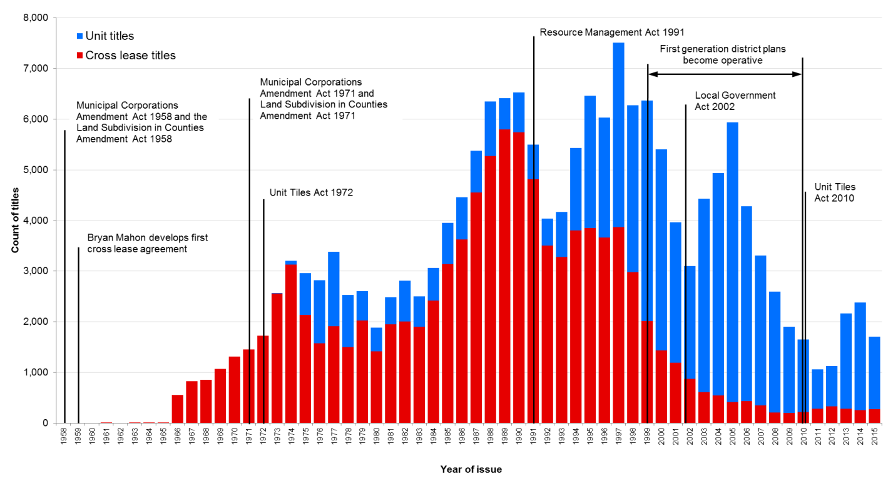

Multi-owned properties and redevelopment
Like Auckland other cities are seeking to enable urban renewal and redevelopment to accommodate additional dwellings as their population grows. As urban redevelopment moves from disused or industrial areas to existing residential suburbs, the replacement of existing multi-unit housing with their complex ownership structures present a number of challenges (Troy et al., 2015a, Easthope et al., 2013). In addition, issues such as high land values, the legislation governing multi-owned properties, compliance with building codes, and developer profitability have also been noted as potential barriers to redevelopment (New South Wales Department of Planning, 2005).

The highly urbanised city-countries of Hong Kong and Singapore have identified the need to streamline the redevelopment of multi-owned properties to deliver new housing. Both have put in place mechanisms for dissolving multi-owned schemes to allow redevelopment, including removing the need for unanimous consent from unit owners (Legislative Council of the Hong Kong Special Administrative Region, 2012, Reid and Pocock, 2016). In Sydney, Australia, 27% of the dwelling stock is a flat, unit or apartment, and one quarter of strata schemes are older than 35 years (Troy et al., 2015a). The popularity of strata housing schemes over the past half-century has created potential barriers to the renewal of strategic centres, where the majority of new dwellings are expected to be constructed (2005 Metropolitan Plan for Sydney as cited in Troy et al., 2015b). In response to these barriers, the NSW Government has enacted changes to the legislation governing the strata management, also removing the need for unanimous consent to terminate a strata scheme, lowering the threshold to 75% (Troy et al., 2015a).

New Zealand’s original unit title legislation, the Unit Titles Act 1972, required unanimous resolution of the owners of all units for redevelopment to take place (Unit Titles Act 1972). The Unit Titles Act 2010 lowered the threshold to 75%, although all owners materially affected by any potential changes need to give their consent and a special resolution must be passed (Unit Titles Act 2010). To date there have bene no significant examples of this being used to facilitate redevelopment.

The redevelopment of unit title properties in New Zealand does not appear to be an area which has garnered much research interest, and there is no information on the numbers of cross lease and unit title schemes that have been terminated or redeveloped. Until now there has been no research to either quantify the number of multi-owned properties in Auckland, or understand their potential to impact future development or redevelopment. The redevelopment of cross lease properties is even less well understood than unit titles, and has no legislation to guide it, with the problems to redevelopment presented by cross lease titles being different to unit titles. Cross lease properties often have dwellings on them that are of different ages – meaning dwellings on the same property end their economic or physical life at different times. Further complications also arise as cross leases require a co-lessees permission to undertake everything from minor building work through to a complete rebuild. Given their number, location, and issues, can the presence of multi-owned properties in Auckland be overcome to increase the number of dwellings through intensification? Or will multi-owned properties arrest (re)development?

Quantitative analysis
Basic overlay queries in ArcGIS and FME software using property title, parcel, and planning related datasets were used to quantify and characterise the location and nature of cross lease and unit titles in Auckland. Analysis was based on parcel and land title information as at March 2016, and sourced from Land Information New Zealand. For the purposes of this paper the results for cross lease titles and unit titles were viewed and analysed separately. While these two property types are both forms of multi-owned property, they are unique and each presents a different set of barriers to redevelopment.

Analysis revealed that cross lease titles in Auckland totalled 100,148 – 18% of all titles in the city. These titles were in 39,636 ‘schemes’, with an average of 2.5 titles per scheme. Cross lease titles are distributed widely across the city (Figure 2), with strong concentrations in older residential areas; suburbs originally developed with large lots, which later made them suitable for accommodating additional dwellings through infill development. This coupled with restrictive subdivision rules, and their location, made these areas suitable for cross leases. Almost all cross lease titles (98%) are in residential zones under the new planning rules (November 2016). These rules allow for greater dwelling densities in residential zones than was permitted previously; these zones contain over four fifths of cross leases titles. The age of dwellings on cross lease titles was also analysed, finding that 25% of dwellings were built in the 1950s or 1960s; a further 23% built in 1970s, meaning that close to half of these properties have one or more dwelling that is at least 37 years old.

Unit titles in Auckland numbered 75,376 – 13% of all titles in Auckland. Unlike cross lease titles, only 58% are in residential zones. This is a function of large numbers of apartment buildings in commercial and business zones, particularly around the city centre (CBD), and that that unit titles are also used as an ownership mechanism for commercial and light industrial buildings. Assessment of unit title’s actual use from council’s land rating records showed that 74% were residential. The location of unit titles across the city was not as widespread as cross lease titles, with the highest concentration in and around the CBD, with lower intensities seen in other urban centres, as well as in light industrial areas (Figure 2). Unit titles schemes ranged in size from two to 827 units, with the 6318 schemes having an average of 12 units. One third of schemes have only two units in them, and 57% have four or less units. Over half (51%) of dwellings on unit titles were built in the 2000s or later and a further 26% built in the 1980s and 1990s. The high number of dwellings built in the 2000s corresponds with the building boom experienced at that time (Ministry of Business Innovation and Employment, 2014), which included a large number of apartment developments being constructed near the CBD (Friesen, 2009).
Qualitative analysis
The second part of this study undertook semi-structured interviews with professionals who have experience with cross lease title and unit title properties. Participants were recruited using the snowballing method. Participants interviewed included: two lawyers, a legal consultant, a surveyor, a property owner and body corporate committee member, two valuers, and an academic. The interviews were used to explore their experiences and to gather understanding of the effects of multiple owners, specific issues related to cross lease and unit titles, potential solutions for issues, and other comments. In addition to the interviews a number of informal comments were received from property developers during the recruitment process.

A large number of issues with both cross lease titles and unit titles were raised in the interviews, but many of these did not relate redevelopment, as such I have not outlined these in this paper. More detail is available in the report on this research.

Redevelopment of cross lease properties
None of our study participants had any experience with the redevelopment of cross lease titled properties, with one noting that redevelopment would be rare as there were plenty of other easier development opportunities available. Another noted that as cross lease properties involved multiple owners, redevelopment was difficult. There was comment that even if one owner thought there was enough space on the property for infill development, it was not possible for them to do so without all lessees agreeing, with the participant observing redevelopment required “a lot of meeting of the minds of people”. A number of participants commented on future redevelopment, with several stating that as land values increase and houses get older, there will be more incentive to redevelop. Reference was made to older buildings coming to the end of their physical life, coupled with zoning changes in many areas, may be an impetus to redevelop. Location was also cited as a driver for future redevelopment, with observation that cross lease properties around urban centres that would be ideal for intensification.

Co-lessees
While no participants were able to comment on the full redevelopment of cross lease properties, most commented on partial redevelopments – particularly additions to existing dwellings and the redevelopment of single dwellings. Clauses in all cross lease documents require a co-lessee’s permission before any structural alterations are made to a dwelling. This requirement means that cross lease property owners need working/flexible/tolerable relationships with other co-lessees (Burgess and Dravitzki, 2008), If disagreement occurs, a further lease clause requires arbitration or court action to resolve issues (Pidgeon, 2013, Gibson, 2013). One participant spoke at length about a case where one owner wanted to completely redevelop their house but the co-lessee viewed the redevelopment as being large and imposing; as such, they withheld their consent. This lead to arbitration at which determined that consent was not unreasonably withheld, and costs were awarded against the owner who wanted to redevelop. This meant that they had to cover the co-lessees legal fees as well as their own – in addition to the time and money they had spent on architects and engineering fees for plans that they could not use. While this case is perhaps not the usual, it illustrates the problems associated with cross lease properties and issues that can arise when partial redevelopment is attempted.

Figure 2: Location of cross lease titles and unit titles in Auckland’s urban area, as at March 2016

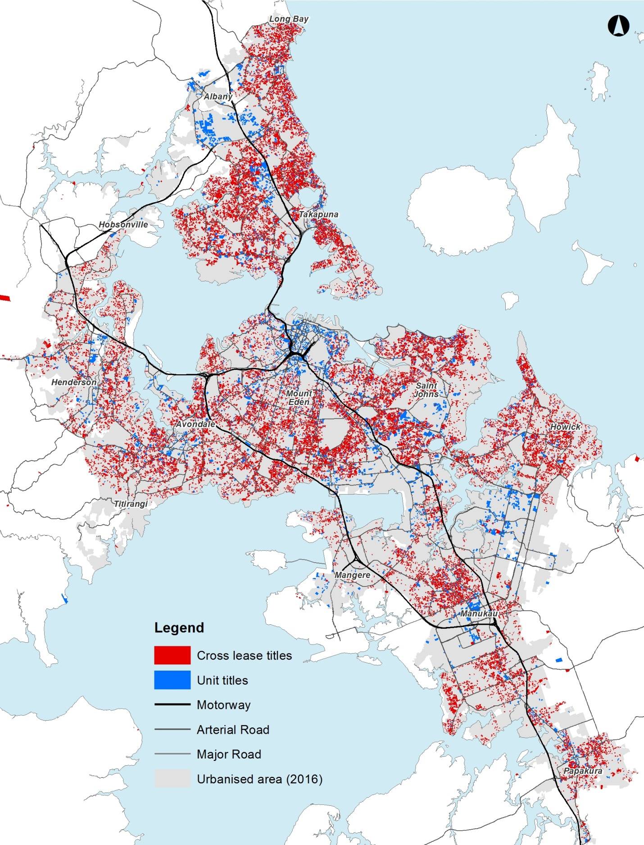

“Just too hard!”
In trying to recruit participants, I spoke to a three developers who stated that while they were willing to participate in the project, but felt they could not offer any in-depth information. All three stated they purposefully avoided redevelopment of cross lease and unit title properties, due to the difficulties associated with them. One developer stated:

[I]t’s an area I would typically avoid as it is usually just too hard! I don’t know anyone in particular who has had direct experience in this area, I’d guess many developers would just put it in the too hard basket unless there were exceptional circumstances.

A number of our participants also commented on the difficulty of redeveloping cross lease properties, with one noting that the easiest way to redevelop is to buy all the cross lease titles on a site first. One lawyer commented that they had had at least two clients get into serious financial strife trying to redevelop cross lease properties. Another participant remarked that redevelopment of cross lease properties are currently in the “too hard basket”, but added that this will need to be addressed in time as the dwellings on the properties come to the end of their physical life.

Redevelopment of unit title properties
Few comments were made about the redevelopment of unit title properties, and there was indication from one participant that developers also avoided them. Some suggested that the best way to facilitate redevelopment was to acquire all the units in a scheme. One noted that there were other mechanisms that could be used, suggesting developers seek an agreement with an owner to sell their existing unit in exchange for a unit in the redevelopment. They also commented that they were aware of this being done in Auckland in the past. The case of Lake Hayes Property Holdings Ltd v Petherbridge and the use of the Property Law Act 2007 were cited as an examples of the cancellation unit title scheme for redevelopment.

Unit titles act – more work still needed
One participant mentioned that regular reviews of the Unit Title Act might be an ideal way for the laws around unit titles to evolve, citing the NSW strata legislation as an example. A second participant commented that the Australian legislation was far ahead of New Zealand’s, adding further that the mechanisms NSW and Victoria had added to their legislation, to deal with buildings or buildings that are coming to the end of their useable life, were considerably ahead of New Zealand’s.

Discussion
Spatial analysis and interviews indicate that residential intensification through redevelopment will be inhibited in areas zoned for higher-densities, due to the large number of existing multi-owned properties. Complications associated with cross lease and unit titles means that developers currently avoid redevelopment projects on land with these two title types. This view is reflected in Webb and Webber (2017) who note that redevelopment of this nature requires engagement with multiple owners, which adds further complexity to land assembly and imposes a risk to long term revitalisation.

If intensification and redevelopment are unable to occur in areas zoned for higher-densities, new dwellings will need to be located in other areas. If this is the case in Auckland, this will have implications for delivery of the targets in the Auckland Plan, which will have flow-on effects to council’s long-term planning, including the provisioning of infrastructure. Modelling undertaken to inform the development of the AUP estimates that cross lease and unit title properties, if redeveloped, have capacity for an additional 180,000 dwellings, or 18% of the capacity for 998,000 additional dwellings potentially enabled on residential zoned parcels. With 86% of cross lease title properties being in ‘higher’ density zones, in addition to a large number of unit title properties, these properties account of a not insignificant amount of development potential.

Obstacles to redevelopment of multi-owned properties are not confined to Auckland or New Zealand. In Toronto, Canada, the effects of multi-owned properties on urban redevelopment have been studied by Webb and Webber (2017) and in Sydney, Australia by Troy et al. (2015a). Both pieces of research highlight the physical, financial and social difficulties that can arise, and the issue of government intervention and legislative change to enable and moderate the effects of urban renewal and intensification.

Despite changes to the Unit Titles Act in 2010 which saw the lowering of the threshold to redevelop a unit title scheme to 75%, to date there has been no examples of this being used. It is likely that in the future this method will be used as schemes come to the end of their physical and economic life. NSW has also lowered the threshold to 75% in order to better facilitate redevelopment. It may be a good idea for New Zealand to monitor how this method is employed in NSW to better understand the effects and the extent of its use. Under the provisions of the AUP, the city is likely to see the creation of many more unit titles in coming years; especially as low- and high-rise apartment living becomes more common. Will further changes to unit title legislation enable better management, maintenance, and redevelopment of unit title schemes? Other jurisdictions, such as NSW have recently reformed the legislation that governs their equivalent of unit titles, and their experiences are likely to assist in the evolution of our own legislation. Queensland is also currently reviewing their legislation and the outcome of this review and its implementation will also provide guidance for future changes in New Zealand.

Strategic land use planning, especially for existing urban areas, can view land and space as a blank slate, either ignoring or not fully taking into account property boundaries or ownership structures. In order to overcome these constraints and realise a different urban form, processes like land assembly must first take place. The concept of assembly not only applies to land, but also to the ownership of units or shares of properties. Much of the literature on the topic of land assembly focuses on overcoming a limited number of individual property ownership constraints in order to redevelop land, rather than the multiple property ownership constraints that can occur in a single building or on a single parcel of land. In their research Webb and Webber (2017) note that ageing suburbs that will eventually require revitalisation will be faced with difficulties related to assembly because individual units will need to be acquired before any redevelopment takes place. While Webb and Webber’s research focuses on condominium apartment buildings, I propose that the same principles and difficulties apply to single storey and low-rise cross lease and unit title properties. Rather than ‘land assembly’ this concept is known as ‘ownership assembly’ (Adams et al., 2001), something Adams and Watkins (2002) describe as the “most destructive kind or constraint”. They add that “multiple ownership of land, in particular, proved hard to resolve without the prospect of lucrative commercial development and/or state acquisition or intervention”. Likewise, research by Fredrickson et al. (2016) showed that between 2004 and 2014 there was only a small amount of land assembly for residential redevelopment in Auckland’s urban area. This research also showed the difficulties of the land assembly process, including what Webb and Webber refer to as the ‘individual property ownership constraints’, but did not address the ‘multiple property ownership constraints’ which both cross lease and unit titles present. However, in the interviews undertaken for this study, the difficulty of dealing with multiple-owners of properties was identified as a major constraint to the redevelopment process. This was seen as a key reason why developers avoided such properties for redevelopment. Given the barriers, it is evident that multi-owned property in Auckland will arrest (re)development.

Is there a way to overcome the barriers associated with multi-owned property to realise redevelopment?
Currently the only practical way to overcome the ownership constraints of multi-owned property is to remove the ‘multi’ element. For cross lease properties this means acquiring all titles on a property, and for unit title schemes acquiring at least 75% of units. For both title types the acquisition process could be expensive and is likely to be exacerbated by the ‘hold out problem’ which could increase costs and also be time consuming, especially if legal action is sought by any parties.

In New Zealand there is currently no formal mechanism for either local or central government to overcome the barriers presented by multi-owned properties to facilitate redevelopment, apart from the market purchase of properties. Overseas, urban development agencies (UDA) have been used as an effective way to agglomerate land and ownership for redevelopment, although utilising government powers to expropriate land for private sector investments is recognised as controversial and potentially infringing private property rights (Carpenter & Ross, 2009). In 2015 the New Zealand Productivity Commission (NZPC) recommended the use of UDAs as a mechanism to facilitate redevelopment, particularly in Auckland, noting that agglomerating land was a particular challenge (New Zealand Productivity Commission, 2015). In response to the NZPC, the Government announced in February 2017 that they were seeking feedback on the establishment of UDAs in order to fast track redevelopment in urban areas (Smith, 2017). UDAs would be able to undertake land (and ownership) assembly through a normal purchase processes or through compulsory acquisition under the Public Works Act 1981, which allows acquisition for urban renewal or development (New Zealand Government, 2017). Despite currently the ability to acquire land for this purpose, no council or government body has ever used this clause because it is not understood or tested, with case law indicating that if a project involves a public element, but includes land that is privately owned, it cannot be considered a public work under the Act (Sustainable Urban Development Unit, 2008). This may need to be clarified in any enabling legislation for UDAs.

Conclusion
Multi-owned properties present a number of challenges to achieving dwelling intensification through redevelopment (Troy et al., 2015a), and their ownership structures and have been described as the “most destructive kind or constraint” (Adams and Watkins, 2002). In Auckland multi-owned property, cross lease and unit titles, are numerous and widespread, totalling 173,521, and together accounting for 31% of all titles in Auckland. In addition, a large proportion of multi-owned properties are in areas that have been zoned for higher-density residential under the city’s new planning framework. As part of this research interviews and feedback with a range of professionals including developers showed that there is currently little interest in redeveloping multi-owned properties in Auckland. Developers and others noted that developers purposely stay away from multi-owned property, with one commenting that their redevelopment is “just too hard”. Given that many dwellings on multi-owned properties in Auckland are likely to be at or nearing the end of either their physical or economic life, and will be prime for redevelopment in the very near future, their presence is likely to effect the amount of intensification through redevelopment that can be achieved. Multi-owned properties will arrest (re)development and affect the ability for the city reach the goals set out in the spatial plan. Changes in 2010 to the Unit Titles Act to enable easier redevelopment of unit title schemes may help, but there are currently no mechanisms available to encourage or simplify the redevelopment of cross lease properties. As cross leases are more numerous and more complex they may prove to be strong impediment to redevelopment efforts. As such, legislative changes, inducements, or new mechanisms, such as UDAs, may be required to aggregate land and its ownership in key locations before intensification through redevelopment can occur.

References
1972. Unit Titles Act 1972. New Zealand.
2010. Unit Titles Act 2010. New Zealand.
Adams, D., Disberry, A., Hutchison, N. & Munjoma, T. 2001. Ownership Constraints to Brownfield Redevelopment. Environment and Planning A, 33, 453-477.
Adams, D. & Watkins, C. 2002. Greenfields, Brownfields and Housing Development, Osney Mead, United Kingdom, Wiley-Blackwell.
Alston, A., Bennion, T., Slatter, M., Thomas, R. & Toomey, E. 2000. Guide to New Zealand Land Law, Wellington, New Zealand, Thompson Reuters.
Auckland Council 2012. The Auckland Plan, Auckland, New Zealand, Auckland Council.
Auckland Council 2016. Auckland Unitary Plan (operative in part), Auckland, New Zealand, Auckland Council.
Burgess, H. & Dravitzki, V. 2008. Living with our Neighbours. International Cities Town Centres & Communities Society Conference. Sydney Olympic Park, Sydney, Australia: International Cities Town Centres & Communities Society.
Dupuis, A., Dixon, J., Lysnar, P. & Mouat, C. 2003. Bodies corporate and housing intensification in Auckland: a preliminary assessment. Auckland, New Zealand: Auckland Regional Growth Forum.
Easthope, H., Hudson, S. & Randolph, B. 2013. Urban Renewal and Strata Scheme Termination: Balancing Communal Management and Individual Property Rights. Environment and Planning A, 45, 1421-1435.
Espie, S. 1995. The Cross Leasing Blues. New Zealand Valuers' Journal, 39-40.
Fredrickson, C., Fergusson, E. & Wildish, B. 2016. Residential Property Amalgamation and Aggregation Study. Auckland, New Zealand: Auckland Council.
Friesen, W. 2009. The Demographic Transformation of Inner City Auckland. New Zealand Population Review, 33, 55-74.
Gibson, A. 2013. Cross lease titles a ticking time bomb, warns lawyer. New Zealand Herald, 6 July.
Homelegal. 2015. Purchasing a Cross-Lease Property in NZ - Things to Look Out For [Online]. Lower Hutt, New Zealand: HomeLegal. Available: http://www.homelegal.co.nz/purchasing-a-cross-lease-property-nz-things-to-look-out-for/ [Accessed 24 March 2016].
Legislative Council of the Hong Kong Special Administrative Region 2012. Implementation of the Land (Compulsory Sale for Redevelopment) Ordinance. Hong Kong SAR, China: Legislative Council Commission of Hong Kong.
Lundon, D., Kelleher, D., Von Dadelszen, C., Whittington, S. & Buchan, J. 2011. A guide to the Unit Titles Act 2010 [Online]. Auckland, New Zealand. Available: https://www.buddlefindlay.com/insights/a-guide-to-the-unit-titles-act-2010 [Accessed 06 June 2017].
Marvini, F. 2014. Sale of lakeside retreat ordered [Online]. Dunedin, New Zealand. Available: https://www.odt.co.nz/regions/queenstown-lakes/sale-lakeside-retreat-ordered [Accessed 3 November 2016].
Mcmorland, D. & Gibbons, T. 2013. McMorland and Gibbons on Unit Titles and Cross-Leases, Wellington, New Zealand, LexisNexis NZ Ltd.
Ministry of Business Innovation and Employment 2014. Building and Housing Portfolio Briefing for the Incoming Minister. Wellington, New Zealand: Ministry of Business Innovation and Employment.
New South Wales Department of Planning 2005. City of cities: a plan for Sydney's future. Sydney, Australia: New South Wales Department of Planning.
New Zealand Government 2017. Urban Development Authorities: Discussion Document. Wellington, New Zealand.
New Zealand Productivity Commission 2015. Using land for housing. Wellington, New Zealand: New Zealand Productivity Commission.
Office of the Minister of Housing 2016. Regulatory Systems Bill: Housing Portfolio Matters (Cabinet paper). Wellington, New Zealand: New Zealand Government.
Pidgeon, J. 2013. The Deficiencies of Cross Leases. LawNews, 5.
Pidgeon, J. 2014. Property - converting cross leases to freehold and unit title. Auckland, New Zealand: NZLS CLE Limited.
Reid, S. & Pocock, M. 2016. Strata Title Scheme Termination. Nathan, Australia: Griffith University.
Smith, N. 2017. Enabling faster and better urban development [Online]. Wellington, New Zealand: New Zealand Government. Available: https://www.beehive.govt.nz/release/enabling-faster-and-better-urban-development [Accessed 15 June 2017].
Statistics New Zealand. 2016. Subnational Population Estimates: At 30 June 2016 (provisional) [Online]. Wellington, New Zealand: Statistics New Zealand,. Available: http://www.stats.govt.nz/browse_for_stats/population/estimates_and_projections/SubnationalPopulationEstimates_HOTPAtJun16.aspx [Accessed 13 June 2017].
Statistics New Zealand. 2017. Subnational Population Projections: 2013(base)–2043 update [Online]. Wellington, New Zealand: Statistics New Zealand,. Available: http://www.stats.govt.nz/browse_for_stats/population/estimates_and_projections/SubnationalPopulationProjections_HOTP2013base-2043.aspx [Accessed 13 June 2017].
Sustainable Urban Development Unit 2008. Building Sustainable Urban Communities. Wellington, New Zealand: Department of Internal Affairs.
Troy, L., Randolph, B., Crommelin, L., Easthope, H. & Pinnegar, S. 2015a. Renewing the Compact City: Economically viable and socially sustainable approaches to urban redevelopment. Sydney, Australia: City Futures Research Centre,.
Troy, L., Randolph, B., Pinnegar, S. & Easthope, H. 2015b. Planning the end of the compact city. In: BURTON, P. & SHEARER, H. (eds.) State of Australian Cities Conference. Gold Coast, Australia: Australian Cities Research Network.
Webb, B. & Webber, S. 2017. The implications of condominium neighbourhoods for long-term urban revitalisation. Cities, 61, 48-57.

75% of eligible voters voting for a resolution at a meeting of owners with a quorum of 25% of eligible voting owners.
Modelling was undertaken for the AUP Independent Hearings Panel, on a set of rules that they recommended to council for adoption, these rules differ to the rules that are now operative (in part), and as such only provide an indication of the dwelling capacity enabled under Auckland’s current planning rules.

