Why strategic planning matters: a case study approach to examining industrial land use planning and development in Melbourne.

Peter Elliott*
Department of Environment, Land, Water and Planning, State Government of Victoria.
*The views expressed in this paper are those of the author and should not be regarded as representing the views of the Victorian Government or the Department of Environment, Land, Water and Planning.

Abstract: The Victorian economy is transitioning from an industrial economy to one based on knowledge and services. This might suggest that there is no need to plan for industrial uses. However using the measure of land consumption, industrial users across metropolitan Melbourne consume nearly 300 hectares of land per year (which is equivalent to one and a half times the urban area of North Adelaide).

This growth has been enabled and supported over time by consistent and long term strategic planning. By its very nature, the outcomes of strategic planning often lie far in the future. Using time series data from the Victorian Urban Development Program’s geospatial industrial land database, this paper explores the land use outcomes of strategic plans. The paper will start with a broad economic and land use analysis of metropolitan Melbourne. It will then focus on development over the last quarter of a century in Australia’s most active industrial land market, Laverton North in Melbourne’s west, to draw the linkages between strategic planning, economic structure and on the ground development.

Key words: Industrial Land Planning; Strategic Planning; Consumption of Industrial Land; Metropolitan Melbourne; Laverton North.

Introduction

The Victorian economy is transitioning from one based on manufacturing to one based on the production and delivery of services. Figure 1 shows the value added by selected industries for Victoria and shows that the Victorian economy has been undergoing change for some time. The output of business services, such as Financial and Insurance Services and Professional and Technical Services, as well as population services, such Health Care and Social Assistance, has been increasing over time. On the other hand, Manufacturing’s output has been relatively flat and is currently at a level similar to that of 25 years ago.

While manufacturing has delivered a relatively stable level of output over the last 25 years, the rest of the economy has grown resulting in manufacturing’s share of the Victorian economy declining from around 14% in the early 1990s to around 7% in 2015/16. The level of manufacturing employment has also been decreasing. In the early 1970s one in every 3 workers in metropolitan Melbourne were employed in manufacturing (DELWP analysis of ABS Census of Population and Housing, 1971). In more recent times this ratio sits at one in every 12 (ABS Census of Population and Housing, 2011).

The decline in manufacturing’s contribution to Victoria’s economy and labour force raises important questions for policy makers around the requirement to maintain an appropriate supply of industrial land for a sector that appears to be in decline. This may lead to a situation where planners may think there is no longer a need to provide a substantial supply of industrial land.

However the use of industrial land in the post-industrial city is transforming from the location of manufacturing plants to one that houses a range of services that support the city, particularly large scale logistics and distribution services. Dicken observes, “…distribution rarely makes an appearance on the stage. It remains hidden, mainly confined to the specialist fields of supply chain management and transportation. The distribution processes get taken for granted.” (2007, p. 410). While the operation of the logistics and distribution industries may appear hidden, they have a significant impact on land use in the city as they require access to international gateways, such as seaports and airports, high capacity transport infrastructure as well as buildings and land or “organisational space” (Hesse, 2008, p.4) to store, repackage and distribute goods. This type of activity does not occur evenly across the city. In metropolitan Melbourne, this activity is quite concentrated; one of these concentrations is Laverton North.

Figure 1: Victorian Gross State Product, selected industries, 1989-90 to 2015-16.
(Source: ABS catalogue number 5220.0)

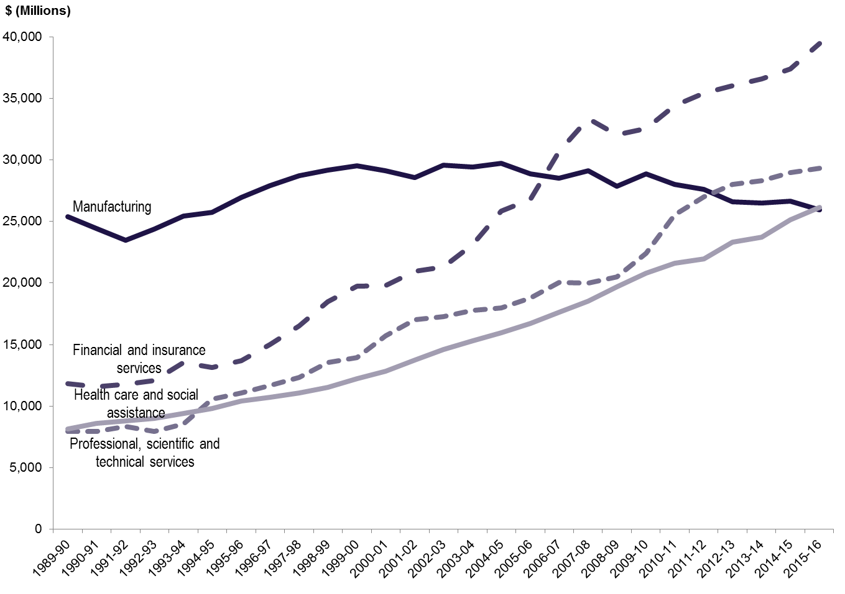

This paper uses Laverton North, located in the western suburbs of Melbourne, as a case study to explore the land use impacts of the changing economy and the way that long term planning has enabled this development to occur. Laverton North is a very appropriate location to carry out this research as it is one of the most active industrial land markets in Australia and has a long history of planning for industrial development. Earlier work assessing the impact of the Western Ring Road on this area (Mees, 2001 and Dodson and Berry, 2004) suggest that Laverton North, and the Western suburbs in general, did not experience a significant increase in industrial or employment activity as a result of the construction of the road. However, these pieces of work were undertaken relatively soon after the completion of the Western Ring Road. Given the length of time since these pieces of work were undertaken, it is now appropriate to undertake a reassessment of development this area and the factors that contributed to it.

By its very nature, the outcomes of strategic planning often lie far in the future. Using time series data from the Urban Development Program’s geospatial industrial land database, this paper explores the land use outcomes of strategic plans. The paper will provide a broad analysis of industrial land development in metropolitan Melbourne. It will then focus on development over the last quarter of a century in Australia’s most active industrial land market, Laverton North in Melbourne’s west, to draw the linkages between strategic planning, economic structure and development occurring on the ground.

Method
There are a range of data, such as the Building Approvals or Place of Work data from the Census of Population and Housing published by the Australian Bureau of Statistics (ABS), that can provide an indication of land use change over time. However these data do not directly measure land use change. To assist it in its strategic and regulatory land use planning responsibilities, the Department of Environment, Land, Water and Planning (DELWP), and its predecessors, has collected an industrial land database to inform it about the supply and take-up of industrial land. It is collected annually and is published as the Urban Development Program Report (DELWP, 2016a and 2017).

The industrial land database is a binary assessment of industrial land where individual pieces of land are assessed as either occupied by some use, which ranges from large warehouses to informal storage areas, or vacant based on a visual assessment of aerial photography. There are three steps to produce this data.

- Identify areas that are zoned for industrial purposes from the planning scheme. This provides the areas in metropolitan Melbourne that are or can be used for industrial purposes.
- Use the industrial planning scheme zones to identify the cadastral base parcels that are zoned industrial. This provides the individual properties that are zoned for industrial purposes.
- Make an assessment from geo-rectified digital aerial photography of the status of the land as either occupied or vacant.

This data has been collected for 1989/90, 1994/95, 2000/01 and then annually between 2004/05 and 20015/16 to produce a time series that extends over 25 years. The data has been published each year as both a summary report and Geographical Information System data of individual land parcels since 2003. This paper uses the most recently published data (DELWP, 2016b) as well as a long time series data of previously published data that has been adjusted to reflect changes in industrial land zoning and is identified throughout the paper as “UDP – Time Series Database”. Using time series data from 1989/90 to 2015/16 enables the amount of land taken-up or consumed over time to be determined by identifying land that changes from vacant to being occupied.

As the database is built up from individual parcels of land, it provides a high degree of flexibility for creating special geographies for analysis or policy development rather than being restricted to using ABS geographies such as Statistical Area Level 2, Local Government Areas, etc. The flexibility of the UDP data enables the analysis of the supply and consumption of industrial land at both the broad metropolitan level as well as focusing on Laverton North.

Consumption of industrial land across Metropolitan Melbourne and in Laverton North
From the limited data available, as only Sydney and Adelaide have comparable land supply data, metropolitan Melbourne is the most active industrial land market in Australia with 298 hectares of industrial land consumed between 2014-15 and 2015-16 (DELWP, 2016a). This compares to 105 hectares in 2015 across Sydney (Department of Planning and Environment, 2017) and an estimated 100 to 110 hectares per year across Greater Adelaide between 2002 and 2008 (Department of Planning, Transport and Infrastructure, 2013).

While Melbourne is the most active market, there has been some variation in consumption rates over the last ten years (see Figure 2). There are two clear periods of development. The first period between 2005-06 and 2007-08 is characterised by consistently high levels of development averaging around 300 hectares per year (DELWP, 2016a). This development occurred prior the Global Financial Crisis (GFC). The second period is after the GFC where the level of industrial development declined significantly with industrial land consumption in 2010-11 declining to almost half of that seen prior to the GFC (DELWP, 2016a). This decline in activity reflected, at the time,

“...a number of factors including the general deterioration in the economic outlook, a significant increase in uncertainty and risk aversion, and tighter financial conditions. These tighter conditions are most evident for the property development industry, where construction activity is expected to fall further over the period ahead.” (RBA, 2009).
Figure 2: Consumption of industrial land, metropolitan Melbourne, 2005-06 to 2015-16.
(Source: DELWP, 2016a)
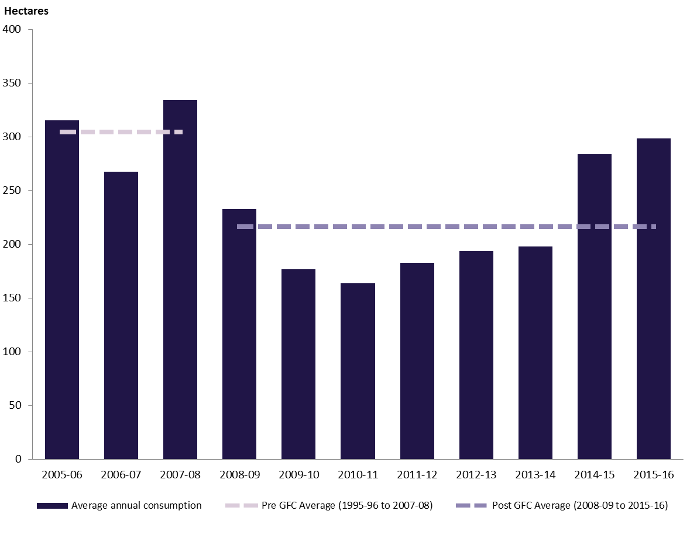

However recent activity since 2014-15 has seen consumption levels considerably higher than those since the GFC with consumption for 2014-15 to 2015-16 approaching levels similar to those prior to the GFC.

The amount of industrial land consumed is not an insignificant physical area. From Figure 2 it can be seen that an average of 215 hectares of industrial land across metropolitan has been consumed per year since the GFC. This is equivalent to over one and a half times the size of the Hoddle grid that makes up the core of Melbourne’s central business district. This activity is not evenly distributed across the metropolitan area; it is concentrated within the State Significant Industrial Precincts (SSIP) identified in Plan Melbourne (Department of Transport, Planning and Local Infrastructure, 2014). The SSIPs are located on the edge of the established metropolitan area (see Figure 3) where there are large tracts of vacant land in large blocks that are well serviced by high capacity road infrastructure. As stated in Plan Melbourne, the purpose of the SSIPs is “To provide strategically located land for major industrial development linked to the Principal Freight Network and transport gateways. They will be protected from incompatible land uses to allow continual growth in freight, logistics and manufacturing investment.” (State Government of Victoria, 2017, p.14).

Figure 3: State Significant Industrial Precincts, Metropolitan Melbourne. (Source: DELWP, 2017)

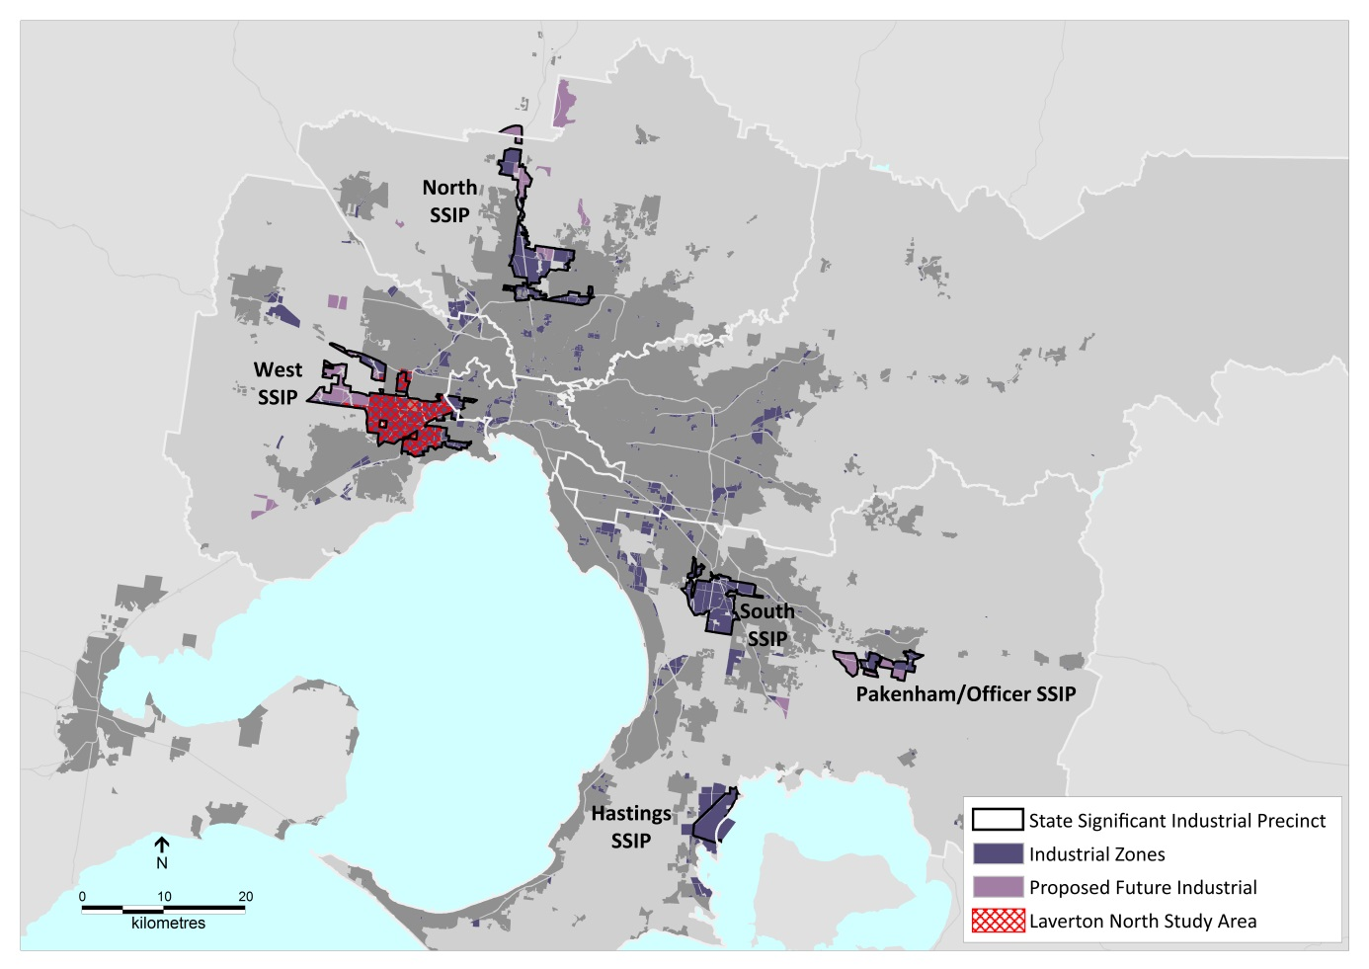

Of the SSIPs, the most active one over the last 12 years has been the West Precinct which has seen an average of 78 hectares consumed annually (DELWP, 2017). During the same period the South SSIP averaged 47 hectares per year and the North SSIP 34 hectares per year.

The West Precinct is also physically the largest of the SSIPs stretching from Williamstown North and West Footscray within the inner western suburbs to Laverton North on the fringe of Melbourne. So the West SSIP contains industrial areas that are both long established, such as those areas in the inner and middle western suburbs as well as other areas on the fringe that have been undergoing rapid development. Laverton North is a subset of the West SSIP (see Figure 3 for the context of Laverton North in the West SSIP) as a result the consumption figures used later in the paper differ from those of the SSIP. In fact the level of consumption is higher in Laverton North than that across the entire SSIP as there is very little recycling of land (i.e. occupied land being converted to vacant land, such as when building is demolished and the land is classified as vacant which subtracts from total consumption) occurring in Laverton North compared to the established parts of the West SSIP.

Industrial Development in Laverton North: 1954 to 2016
Using the data from the Urban Development Program’s Time Series Database, the following section looks in detail at planning for industrial uses and the on-ground development of Laverton North from 1954 to the present day and outlines the factors that enabled this development to occur. The analysis is broken into two time periods; before and after the construction of the Western Ring Road. At a superficial level, this division would suggest that the construction of the Western Ring Road was the key event that propelled the development of industrial land in Laverton North. However, a more nuanced approach is required that examines the historical and structural conditions that came together to enable development to occur. To this end, this paper argues that the development of Laverton North is based on a number of interrelated factors generated by both the public and private sectors.

Government’s primary roles in Laverton North were specific to the area, such as:

- Preconditions for development. Strategic planning provided the preconditions for development by zoning suitable land (i.e. relatively flat land) and the identification of appropriate transport infrastructure to service this area.
- Long term market certainty. The consistency of planning for this area over a long period provided long term market certainty about the future use of this area.
- Investing in transport infrastructure. Government unlocked the value of this area by providing funding to construct the Western Ring Road.

The private sector’s factors in the development of Laverton North are more diffuse and are related to changing market conditions, such as:

- Demand for large pieces of land. Increased demand for large pieces of land to support large premises required by contemporary logistics uses. Large blocks of land for these uses could not be sourced in the established parts of Melbourne.
- Access to gateways. Access to gateways and markets has become increasingly important. Laverton North has good access to the Port of Melbourne (which has the highest level of container throughput in Australia (BITRE, 2016, p. 19)) as well as an interstate road network which has enabled a number of firms to develop national distribution systems in Melbourne’s west.
- Flexibility in providing premises. The use of the Real Estate Investment Trusts (REIT’s) provided industrial land users with the option of accessing purpose built facilities without the need to purchase property adding a greater degree of flexibility into the industrial property market.

The next sections describe these factors in more detail and relates them to the development of Laverton North.

Prior to the development of the Western Ring Road - 1954 to 1997
Most of the industrial land in Laverton North was identified for industrial uses, particularly offensive and dangerous industries, in the first planning scheme by the Melbourne and Metropolitan Board of Works (MMBW) in 1954 (1954a and 1954b). The 1954 plan was largely trend based (Logan: 1981). In its survey and analysis to support the plan, the MMBW characterised industrial uses in the western part of Melbourne as “... those industries requiring large areas of land, such as meat killing and processing, and those producing basic chemical products, such as oil, explosives and fertiliser manufacture.” (MMBW, 1954a, p.75).

Subsequent strategic plans and statutory planning schemes maintained the industrial zoning of this land, which was broadly consistent with the MMBW’s 1954 plan. The role of strategic and statutory planning was to provide the preconditions for future industrial development; first, by identifying large tracts of relatively flat land and; second, maintaining the intended use of the land over many years which provided the market with a high degree of certainty about the future use of the land.

In addition to identifying the future land uses in Laverton North, the MMBW plan also identified new transport infrastructure. The 1954 plan identified the development of a road connecting the Princes Highway in the south to the Hume Highway in the north. The original purpose of this road was to “... join the proposed stock saleyards at Derrimut and associated industries and the north-western, northern and north-eastern country districts. This will facilitate the transport of stock and largely divert this traffic from built-up areas.” (MMBW, 1954b, p. 99).

Later transport plans confirmed the future development of what was to become known as the Western Ring Road. The 1968 Melbourne Transport Plan confirmed the general alignment of the Western Ring Road (Infrastructure Victoria: 2016, p. 15), while the 1987 Metropolitan Arterial Access Study recommended its construction to commence within 10 years (Victoria Transport, 1987). Construction of the Western Ring Road was undertaken in stages with the first stage between the Tullamarine Freeway to Pascoe Vale Road completed in 1992 (VicRoads, 1993) and the section completed in 1997 linking Laverton North with the Princes Freeway to it south and the Hume Highway to its north (VicRoads, 1997).

Figure 4 shows Laverton North at the earliest period for which the Urban Development Program data is available. Most of this land was designated for industrial uses since 1954 and much of it remained vacant from that time. Prior to the completion of the Western Ring Road in 1997, industrial land consumption (i.e. changing from vacant to occupied) in Laverton North was relatively low, compared to the levels seen in the mid-2000s, averaging 30 hectares per year (analysis of UDP – Time Series Database). A number of large users had been long established in this area, particularly land extensive manufacturers such as the ICI explosives factory, organic chemical manufacturers Qenos and Dow Chemicals and Toyota’s car manufacturing plant (see Figure 4).

Figure 4: Laverton North, 1989-90. (Source: DELWP, UDP – Time Series Database)

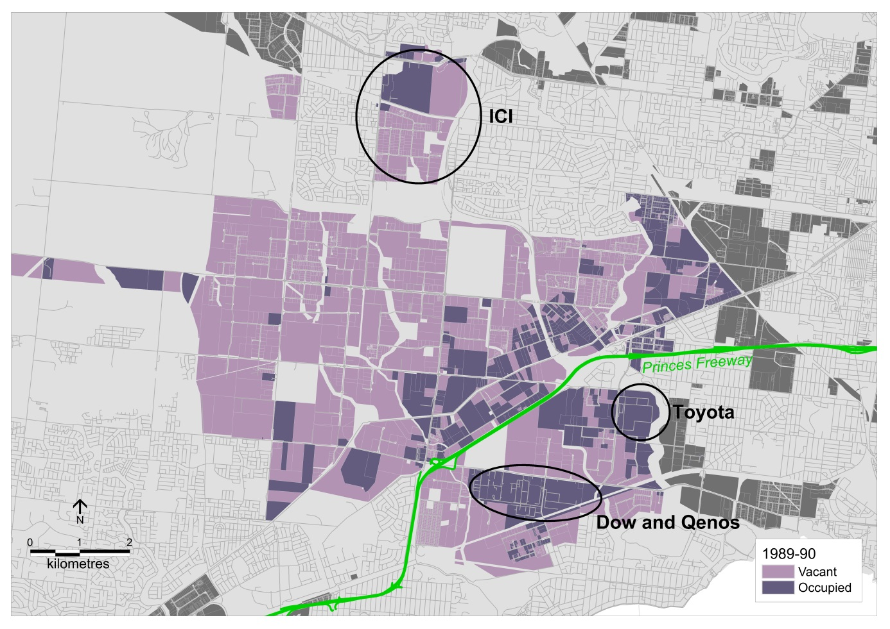

After the construction of the Western Ring Road 1997 - 2016
After the opening of the Western Ring Road, there was a significant increase in the consumption of industrial land in Laverton North. At the same time a number of changes were occurring in the logistics and land development industries that took advantage of the earlier strategic planning and government investment in the Western Ring Road.

Laverton North is a key location for logistics firms in Melbourne and Australia. Using WorkSafe data, approximately 17% of the workplaces in Laverton North are in the Transport, Postal and Warehousing industry (DELWP, 2017). While this may appear to be a relatively small share, in the other two large SSIPs, the North and South, firms in this industry make up about 4% to 5% of total workplaces (DELWP, 2017). Laverton North appears to be a significant location for logistics users.

According to McKinnon (2009), contemporary logistics users have two key land and building requirements. First is access to high capacity transport infrastructure (McKinnon, 2009). The development of the Western Ring Road provides firms in Laverton North access the key international gateways of the Port of Melbourne and Melbourne Airport. Furthermore it also provides access to the Princes Highway to service Adelaide and Perth to the west and to the Hume Highway to the north for access to Sydney and Brisbane (Melway, 2012). From Laverton North firms can access international gateways, transport goods to a distribution centre (organisational space) and then forward goods to retailers and end users in Melbourne, across Victoria and interstate.

The second key requirement is the use of large buildings and, as a consequence, large pieces of land (McKinnon, 2009). The need for the use of large buildings is driven by increasing efficiencies by consolidating activities into one or two large distribution centres rather than a larger number of smaller, scattered warehouses (ProLogis and Capgemini Consulting Services, 2006). An example of this is the dairy products manufacturer Murray Goulburn, which in 2004 closed a number of warehouses across Melbourne and consolidated onto one large site in Laverton North. The consolidation “not only delivered a reduction of logistics costs but an improvement in delivery of customer service.” (Murray Goulburn Co-operative Co. Ltd, 2004, p.9.). There are few pieces of land in the inner and middle suburbs of Melbourne that have the capacity to house a large logistics building, which can be in excess of 25,000 m² (analysis of UDP – Time Series Database and DELWP, 2016b). As a result logistics users are drawn to locations on the fringe of Melbourne where large blocks of land are available for use. This is evidenced further by the fact that of the 95 buildings in excess of 25,000 m² in the State Significant Industrial Precincts, 51 of them are located in the West SSIP (DELWP, 2017). A small number of these buildings are related to manufacturing, such as the former Toyota plant in Altona, while a number of them are used for freight and logistics purposes such as the Aldi, Coles and Woolworths distribution centre (Melway, 2012).

While the logistics industry was experiencing structural change, the way developers delivered premises to users also changed. Traditionally industrial land developers would purchase a piece of land, provide services, subdivide the land and then sell blocks to individual users. Users would be restricted to the blocks that were offered in the market at a particular time which may be sub-optimal to their requirements. In the early 2000s, large industrial developers started using Real Estate Investment Trusts (REIT) to provide flexible methods for users to access premises. REITs are a financial instrument where a company purchases a property with the intention of leasing it to one or number of users and using the rent as a source of income as well as capital growth from the appreciation of the asset (ASX, Undated). This business model enables users to access purpose design and built premises while paying the lower cost of renting premises rather than the more expensive option of purchasing premises with capital that could be utilised in other ways (Lasfer, 2007). The flexibility provided by industrial REITs enabled users to access purpose built premises at a lower cost compared to previous models of development.

Once the Western Ring Road was opened (see Figure 5), industrial land consumption increased markedly from 37 hectares before the Ring Road to around 100 hectares a few years after its completion (analysis of UDP – Time Series Database). The first industrial estates such as the Angliss and Gilbertsons industrial estates started to attract large industrial uses (See Figure 5).

Figure 5: Laverton North, 2000-01. (Source: DELWP, UDP – Time Series Database)

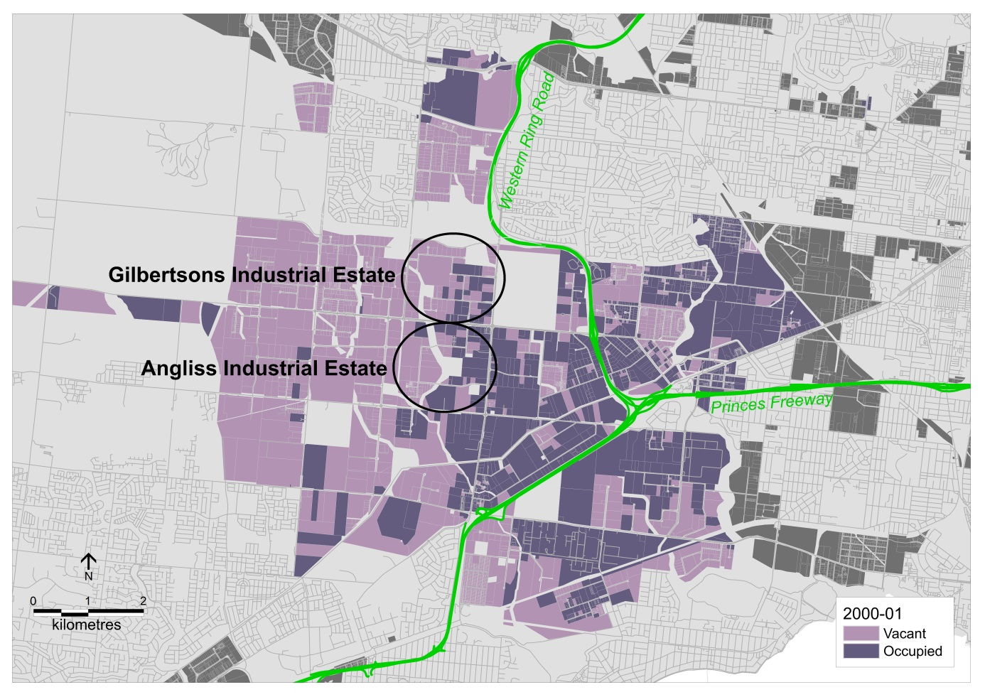

The ten year period between 2000-01 (Figure 5) and 2010-11 (Figure 6) takes in the time before the GFC and just after it. Prior to the GFC, consumption averaged 107 hectares per year and peaked at 140 hectares in 2007-08 (analysis of UDP – Time Series Database). In the early 2000s the first very large warehousing uses (in excess of 25,000) were developed, such as the Aldi distribution centre with an area of 53,000 m² and the Murray Goulburn Integrated Logistics Centre with a total built space of 76,000 m² (DELWP, 2017).

From Figure 6, it can be seen that during this time, land in the first large industrial estates, Angliss and Gilbertsons industrial estates, started to become exhausted and developers opened up new estates once there was an established market for this type of development. In addition to new large estates being developed, land that had been previously subdivided adjacent to the Western Ring Road and to the south of the Princes Freeway became attractive for smaller users as vacant land supply diminished in the established suburbs (analysis of UDP – Time Series Database).

The accessibility of this area was further enhanced by the completion of the Deer Park Bypass in April 2009. This road provided a freeway connection from Laverton North to the Western Freeway/Highway at Caroline Springs, beyond the built up part of Melbourne (see Figure 6), and avoiding 20 traffic lights on the previous route along the Western Highway (State Government of Victoria, 2008, p. 91).

However land development activity declined significantly in the period just after the GFC, with consumption dropping to 61 hectares by 2009-10 (analysis of UDP – Time Series Database) due to the market conditions in the real estate development sector (RBA, 2009).

Figure 6: Laverton North, 2010-11. (Source: DELWP, UDP – Time Series Database)

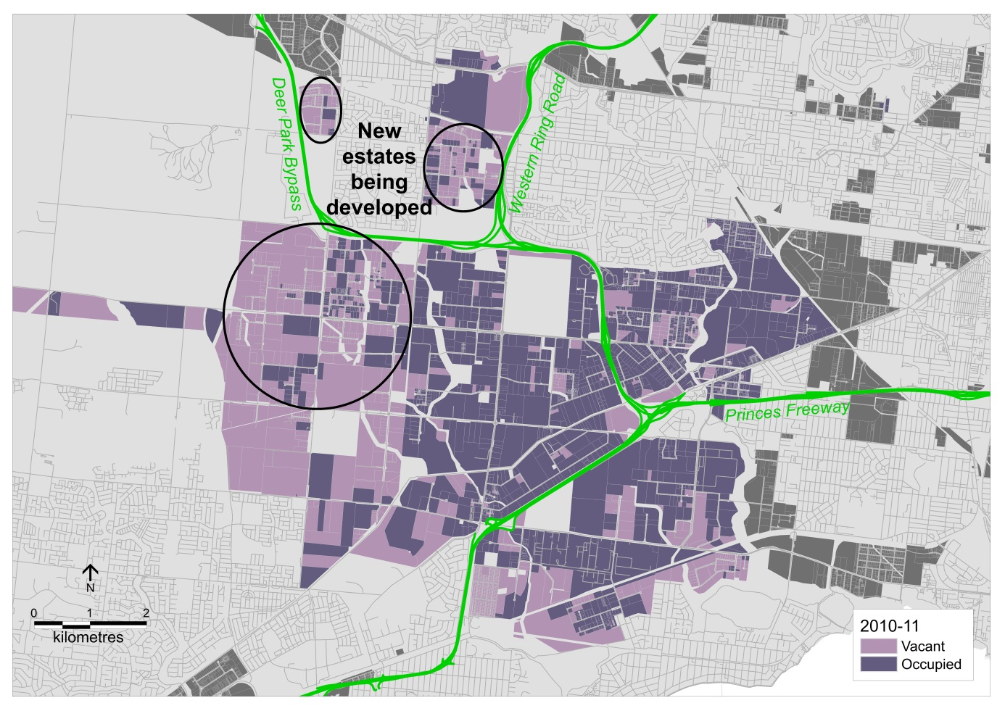

Figure 7: Laverton North, 2015-16. (Source: DELWP, 2016b)

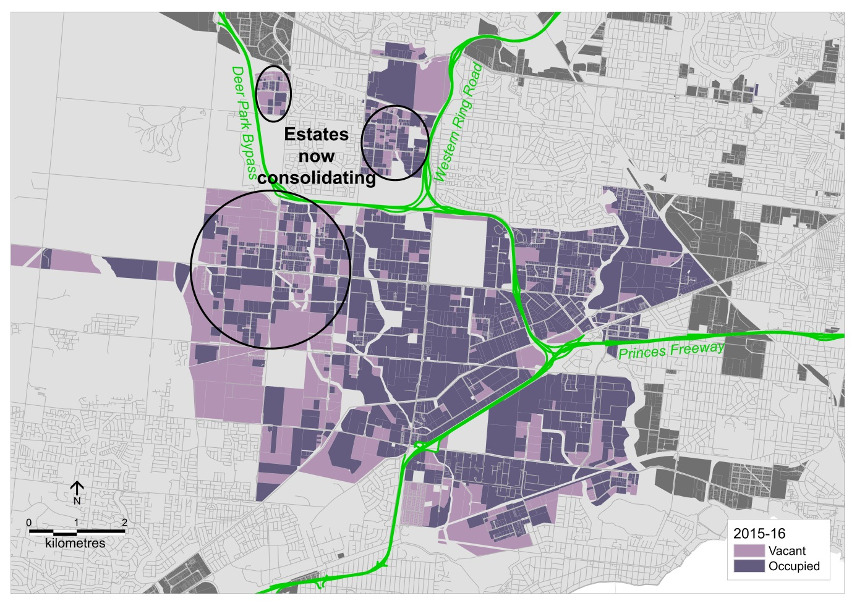

After the GFC, consumption of industrial land across Melbourne (see Figure 2) and in the North and South SSIPs declined significantly. Laverton North also experienced a decline in the consumption of industrial land directly after the GFC (DELWP, 2016a, p. 21). However unlike the North and South SSIPs, industrial land consumption in Laverton North recovered to an average of 87 hectares per year (analysis of DELWP, UDP – Time Series Database and DELWP, 2016b). While this is an average of 20 hectares less compared to the average level of consumption before the GFC, consumption levels across Melbourne have started to increase in the last 2 years (Figure 2 and DELWP, 2016a). In the latest data for 2015/16 (see figure 7), the new estates identified in figure 6 are continuing to develop. This suggests that industrial development in Melbourne is starting to enter a new period of high levels of consumption.

Concluding Comments
Laverton North is the most active industrial area in Australia. The development of this area is due to a combination of interrelated factors. Some of which, such as strategic planning, government is responsible for while others, such as how the development industry delivers land and premises, are outside its control.

Prior to the construction of the Western Ring Road, development in Laverton North was relatively low. The construction of the Western Ring Road increased the accessibility of the area which attracted land extensive users, such as logistics firms, as well as a range of smaller industrial users.While the construction of the western ring road unlocked the potential of the area, without long term land use and transport planning, the opportunity for the development of this area would not have occurred and may have impacted on the ability of Melbourne to adapt to the broader economic changes that have occurred.

The results of strategic planning often lie in the future, in Laverton North’s case, the legacy of the original planning started to be realised nearly half a century after the development of the initial plans and this legacy continues to support its development today.

References
ASX. (Undated) A-REITs, retrieved on 24/6/2017 from http://www.asx.com.au/products/managed-funds/areits.htm

Bureau of Infrastructure, Transport and Regional Economics. (2016) Australian Infrastructure Statistics Yearbook 2016, Department of Infrastructure and Regional Development, Commonwealth of Australia, Canberra, retrieved 1/10/2017 from https://bitre.gov.au/publications/2016/files/BITRE_yearbook_2016_statistics_full_report.pdf

Dicken, P. (2007) Global Shift: mapping the changing contours of the world economy – fifth edition. SAGE Publications Ltd, London.

Department of Environment, Land, Water and Planning. (2016a) Urban Development Program – Metropolitan Melbourne 2016. Department of Environment, Land, Water and Planning, State Government of Victoria, Melbourne, retrieved 24/6/2017 from https://www.planning.vic.gov.au/__data/assets/pdf_file/0017/27440/Urban-Development-Program-2016.pdf

Department of Environment, Land, Water and Planning. (2016b) Urban Development Program – MapInfo Data. Department of Environment, Land, Water and Planning, State Government of Victoria, Melbourne, retrieved 24/6/2017 from https://www.planning.vic.gov.au/__data/assets/file/0021/27426/UDP2016.zip

Department of Environment, Land, Water and Planning. (2017) Urban Development Program – State Significant Industrial Precincts 2016. Department of Environment, Land, Water and Planning, State Government of Victoria, Melbourne, retrieved 24/6/2017 from https://www.planning.vic.gov.au/__data/assets/pdf_file/0025/27439/Urban-Development-Program-SSIP-2016.pdf

Department of Planning and Environment. (2017), Employment Lands Development Monitor – Highlights. Department of Planning and Environment, New South Wales Government, Sydney, retrieved 24/6/2017 from http://www.planning.nsw.gov.au/Research-and-Demography/Employment-Lands-Development-Monitor/Highlights

Department of Planning, Transport and Infrastructure. (2013), Greater Adelaide Housing and Employment Land Supply Program: 2012 Monitoring Report, Department of Planning, Transport and Infrastructure, Government of South Australia, retrieved 24/6/2017 from https://www.sa.gov.au/__data/assets/pdf_file/0004/18193/Housing_and_employment_land_supply_program_report_2012.pdf

Department of Transport, Planning and Local Infrastructure. (2014) Urban Development Program - Metropolitan Melbourne 2014, Department of Planning, Transport and Local Infrastructure, State Government of Victoria, retrieved 24/6/2017 from https://www.planning.vic.gov.au/__data/assets/pdf_file/0020/14186/Urban-Development-Program-Report-2014.pdf

Dodson, J and Berry, M. (2004) The Economic ‘Revolution’ in Melbourne’s West, Urban Policy and Research, 22 (2), pp 137-155.

Hesse, M. (2008), The City as Terminal: The Urban Context of Logistics and Freight Transport, Ashgate, Aldershot.

Infrastructure Victoria. (2016) Learning from the past: a history of infrastructure planning in Victoria, Infrastructure Victoria, Melbourne.

Lasfer, M. (2007) On the financial drivers and implications of leasing real estate assets: The Donaldsons-Lasfer’s Curve, in Journal of Corporate Real Estate, Vol. 9 No. 2, pp. 72-96

Logan, T. (1981) Urban and Regional Planning in Victoria, Shillington House, Melbourne.

McKinnon, A. (2009) The present and future land requirements of logistical activities, in Land Use Policy, 26: S293-S301.

Mees, P. (2001) The short term effects of Melbourne’s Western Ring Road, paper presented to the 24th Australasian Transport Research Forum conference, Hobart, Tasmania, 2001, retrieved on 18/6/2017 from http://atrf.info/papers/2001/2001_Mees.pdf.

Melbourne and Metropolitan Board of Works. (1954a) Melbourne Metropolitan Planning Scheme 1954: Survey and Analysis. McLaren & Co Pty Ltd, Melbourne.

Melbourne and Metropolitan Board of Works. (1954b) Melbourne Metropolitan Planning Scheme 1954: Report. McLaren & Co Pty Ltd, Melbourne.

Melway. (2012) Greater Melbourne Street Directory, Melway Publishing Pty.Ltd., Mount Waverley.

Murray Goulburn Co-operative Co. Ltd. (2004) 54th Annual Report, Murray Goulburn Co-operative Co. Ltd, Brunswick.

ProLogis and Capgemini Consulting Services. (2006) Warehousing space in Europe: meeting tomorrow’s demand, ProLogis and Capgemini Consulting Services, Utrecht.

Reserve Bank of Australia. (2009) Statement on Monetary Policy – May 2009, Reserve Bank of Australia, Sydney, retrieved on 24/6/2017 from http://www.rba.gov.au/publications/smp/2009/may/intro.html

State Government of Victoria. (2008) The Victorian Transport Plan, State Government of Victoria, East Melbourne.

State Government of Victoria. (2017) Plan Melbourne 2017-2050: Metropolitan Planning Strategy. DELWP, Melbourne.

Vicroads. (1993) Vicroads Annual Report 1992-93, VicRoads, Kew.

Vicroads. (1997) Vicroads Annual Report 1996-97, VicRoads, Kew.

Victoria Transport. (1987) Metropolitan Arterial Road Access Study: Melbourne’s arterial road strategy the next 10 years, Victoria Transport, Melbourne.

