Skilled Workers in Ballarat and Bendigo:
Why did they choose a regional location and are they likely to stay?

Fiona McKenzie
Victorian Government - DELWP, Melbourne, Australia

Abstract: Capital cities like Melbourne continue to attract the majority of State population growth. This can create challenges for attracting skilled workers to, and retaining them in, regional locations. This paper reports on a survey of more than 1200 professional workers in the Victorian regional cities of Bendigo and Ballarat. The survey aimed to better understand the migration pathways and locational choices of these workers, focusing on their location at four key life stages: birth; childhood; secondary schooling; and higher education. Key motivations for choosing to live in the current location were explored along with respondents’ views on the advantages and disadvantages of that regional location. While most respondents had no intention to move away from their regional city, others were finding that career and salary progression were limited in the smaller regional economies, particularly when compared to Melbourne. Respondent age influenced the relative importance given to economic versus lifestyle considerations. Overall though, it was family factors, more than economic or amenity considerations, which were the main driver of relocation to regional cities. These findings are of relevance to policy makers concerned with attraction and retention strategies for regional areas as well as businesses seeking to recruit or retain key workers.

Keywords: Regional development; Regional policy; Human capital; Attraction and retention.

Introduction
Retention and/or attraction of young adults is central to the aspirations of many regional areas as well as policy makers seeking to support regional development. However, there is a long-standing trend of net loss of young adults from regional areas. Many school leavers seek educational and employment opportunities in capital cities (McKenzie 2010). Some of these people will return to regional areas after attaining higher education while others will make a regional move later in life. The fact that many regional areas experience skills shortages, or difficulty in recruiting skilled workers, suggests that the net loss of young adults creates ongoing difficulties maintaining adequate stocks of human capital. In turn this can have a dampening effect on regional development (Faggian et al. 2017; Stockdale 2016).

From the beginnings of European settlement in Australia, urban development was concentrated in a few coastal port settlements. Melbourne was established in 1835 and, while the 1850s gold rush enabled inland centres like Bendigo and Ballarat to flourish, Melbourne gained much of the economic benefit through being a centre of banking, commerce and trade. As gold mining declined, internal migration to Melbourne from the goldfields established Melbourne’s pre-eminence even further. From this point onwards, the share of Victoria’s population living outside the metropolitan area began to fall, a trend that has continued to the present day (figure 1). As at 30 June 2016, the population of Melbourne was 4.6 million. The Local Government Areas of Ballarat and Greater Bendigo had populations of 104,000 and 111,000 respectively (ABS cat. no. 3218.0).

Figure 1: Population of Melbourne and the rest of Victoria, 1841 to 2011
Sources: ABS Victorian Yearbook cat 1301.2; ABS Australian Demographic Statistics cat no 3101.0

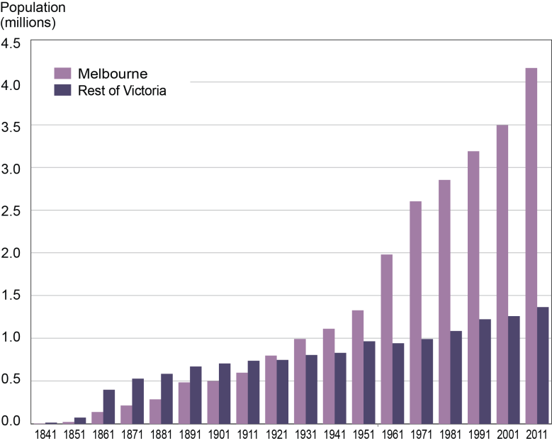

The Research Project
Although many professionals are attracted to metropolitan Melbourne, others remain in, or return to, non-metropolitan locations, particularly regional cities like Bendigo and Ballarat. Understanding the migration histories and motivations of these skilled workers provides insights which can inform attraction and retention strategies for government or private enterprise. In 2015, a survey was conducted within the municipality of Greater Bendigo (figure 2). This formed part of a larger study, an Australian Research Council (ARC) Linkage Project, which examined the spatial dimensions of educational and post-educational pathways. A comparative survey was conducted in 2016 in the City of Ballarat.

Figure 2: Location of Bendigo and Ballarat

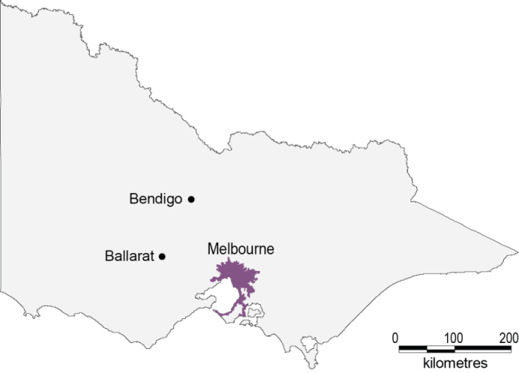

In each location, three workforces were selected on the basis of them having a high proportion of professional workers. The focus on professionals was due to the oft reported difficulty in attracting and retaining such skilled workers in non-metropolitan areas (McKenzie 2004; Miles et al. 2006). The workforce samples included the local Council and major health service in each location along with a private business: Bendigo Bank and IBM Ballarat. The survey aimed to collect information about locational histories of these regional workers. Key questions included:
- Did workers originate from the local area?
- Did they train in the local area or did they train elsewhere and return?
- What have been the motivations for various migration decisions?
- What are the future intentions of these workers – are they likely to stay or leave?

The surveys were undertaken via a web-based survey tool. Collected data were de-identified and analysed using Excel software. In total, the combined sample contains 1,271 respondents from six organisations (table 5). Both the Ballarat and Bendigo sample have a higher proportion of female than male respondents, however, there is a great deal of variation between organisations ranging from only 30 percent at the male-dominated IBM technology company to 87 percent for the female-dominated Ballarat Health Services. IBM is also notable for having a much younger age profile, with more than half of the respondents being less than 35 years of age. This profile has influenced the overall age profile of Ballarat which is younger on average than the Bendigo sample.

Table 1: Profile of survey samples, Ballarat 2016 and Bendigo 2015
Sources: Ballarat Survey Data 2016 and Bendigo Survey Data 2015

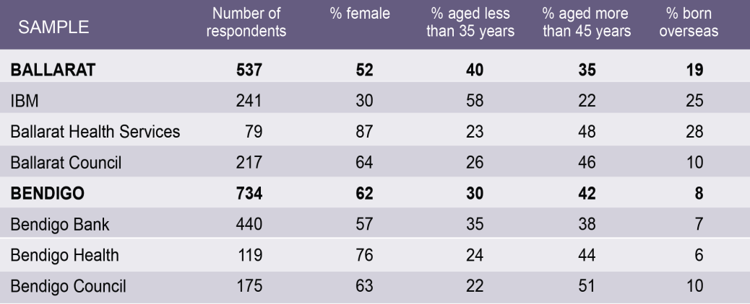

Perhaps the most significant difference between the Ballarat and Bendigo samples is the proportions born overseas. None of the Bendigo samples has more than 10 percent born overseas whereas Ballarat has two organisations with more than a quarter of respondents in this category: IBM (25%) and Ballarat Health Services (28%).

Locational backgrounds of the respondents
The survey gathered information about respondents’ location at four key life stages: birth, childhood, The current location (Ballarat or Bendigo) accounts for a higher proportion of the sample at each subsequent life stage: birthplace, childhood, schooling and higher education (figure 3). Nevertheless, it remains more prominent in Bendigo than Ballarat by between 5 and 9 percentage points at each stage. By the time of highest education qualification, Ballarat was home for 48 percent of the Ballarat sample while Bendigo was home for 54 percent of the Bendigo sample. The overseas category is more prominent at each life stage in Ballarat.

Figure 3: Location of respondents at key life stages, combined Ballarat and Bendigo samples
Sources: Ballarat Survey Data 2016 and Bendigo Survey Data 2015

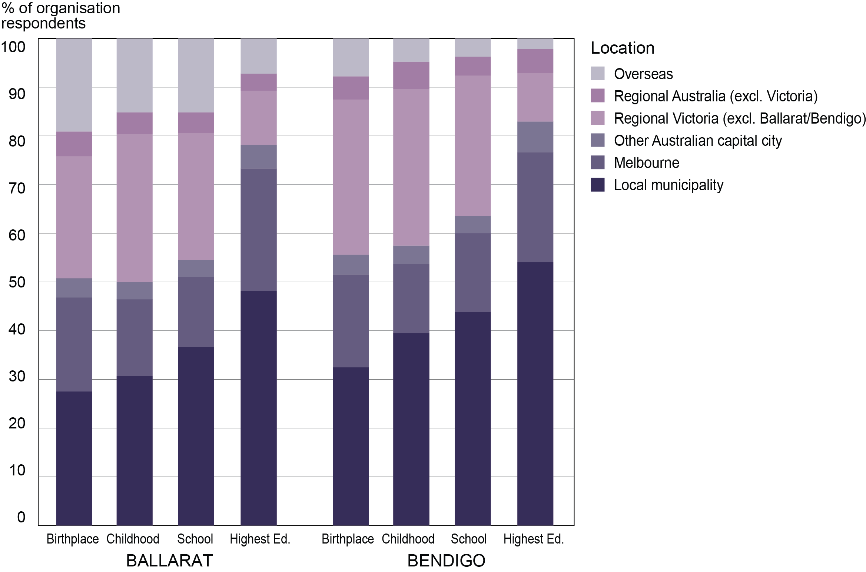

In terms of individual workplace samples, Bendigo Bank has the most local profile with nearly 40 percent born in that regional city. Ballarat Council has a high level of local-born respondents (>30%) and Bendigo Council has 25 percent in this category. Both councils have a similar proportion of overseas-born (10%). However, there are very large differences between other organisations. IBM and Ballarat Health Services have 25-30 percent of respondents born overseas while Bendigo Bank and Bendigo Health have only 5-7 percent of respondents in this category. This is a much lower figure than the Victorian average of 34 percent of working age persons (15-64 years) being born overseas (ABS Census 2011). Bendigo Health had the highest proportion of Melbourne-born (nearly 30%). All other organisations had between 15 percent and 20 percent of respondents born in Melbourne. The organisation with the highest proportion born in regional Victoria was Bendigo Health with more than 35 percent of respondents in this category.

Migration pathways
In presenting this data longitudinally, there were 16 migration history patterns in which more than 20 respondents from the combined samples were represented. The total number of combinations was 129, but the 16 patterns shown in figure 4 represent 80 percent of the total sample of 1,152 useable responses.

Figure 4: Migration histories for Ballarat and Bendigo samples
Sources: Ballarat Survey Data 2016 and Bendigo Survey Data 2015

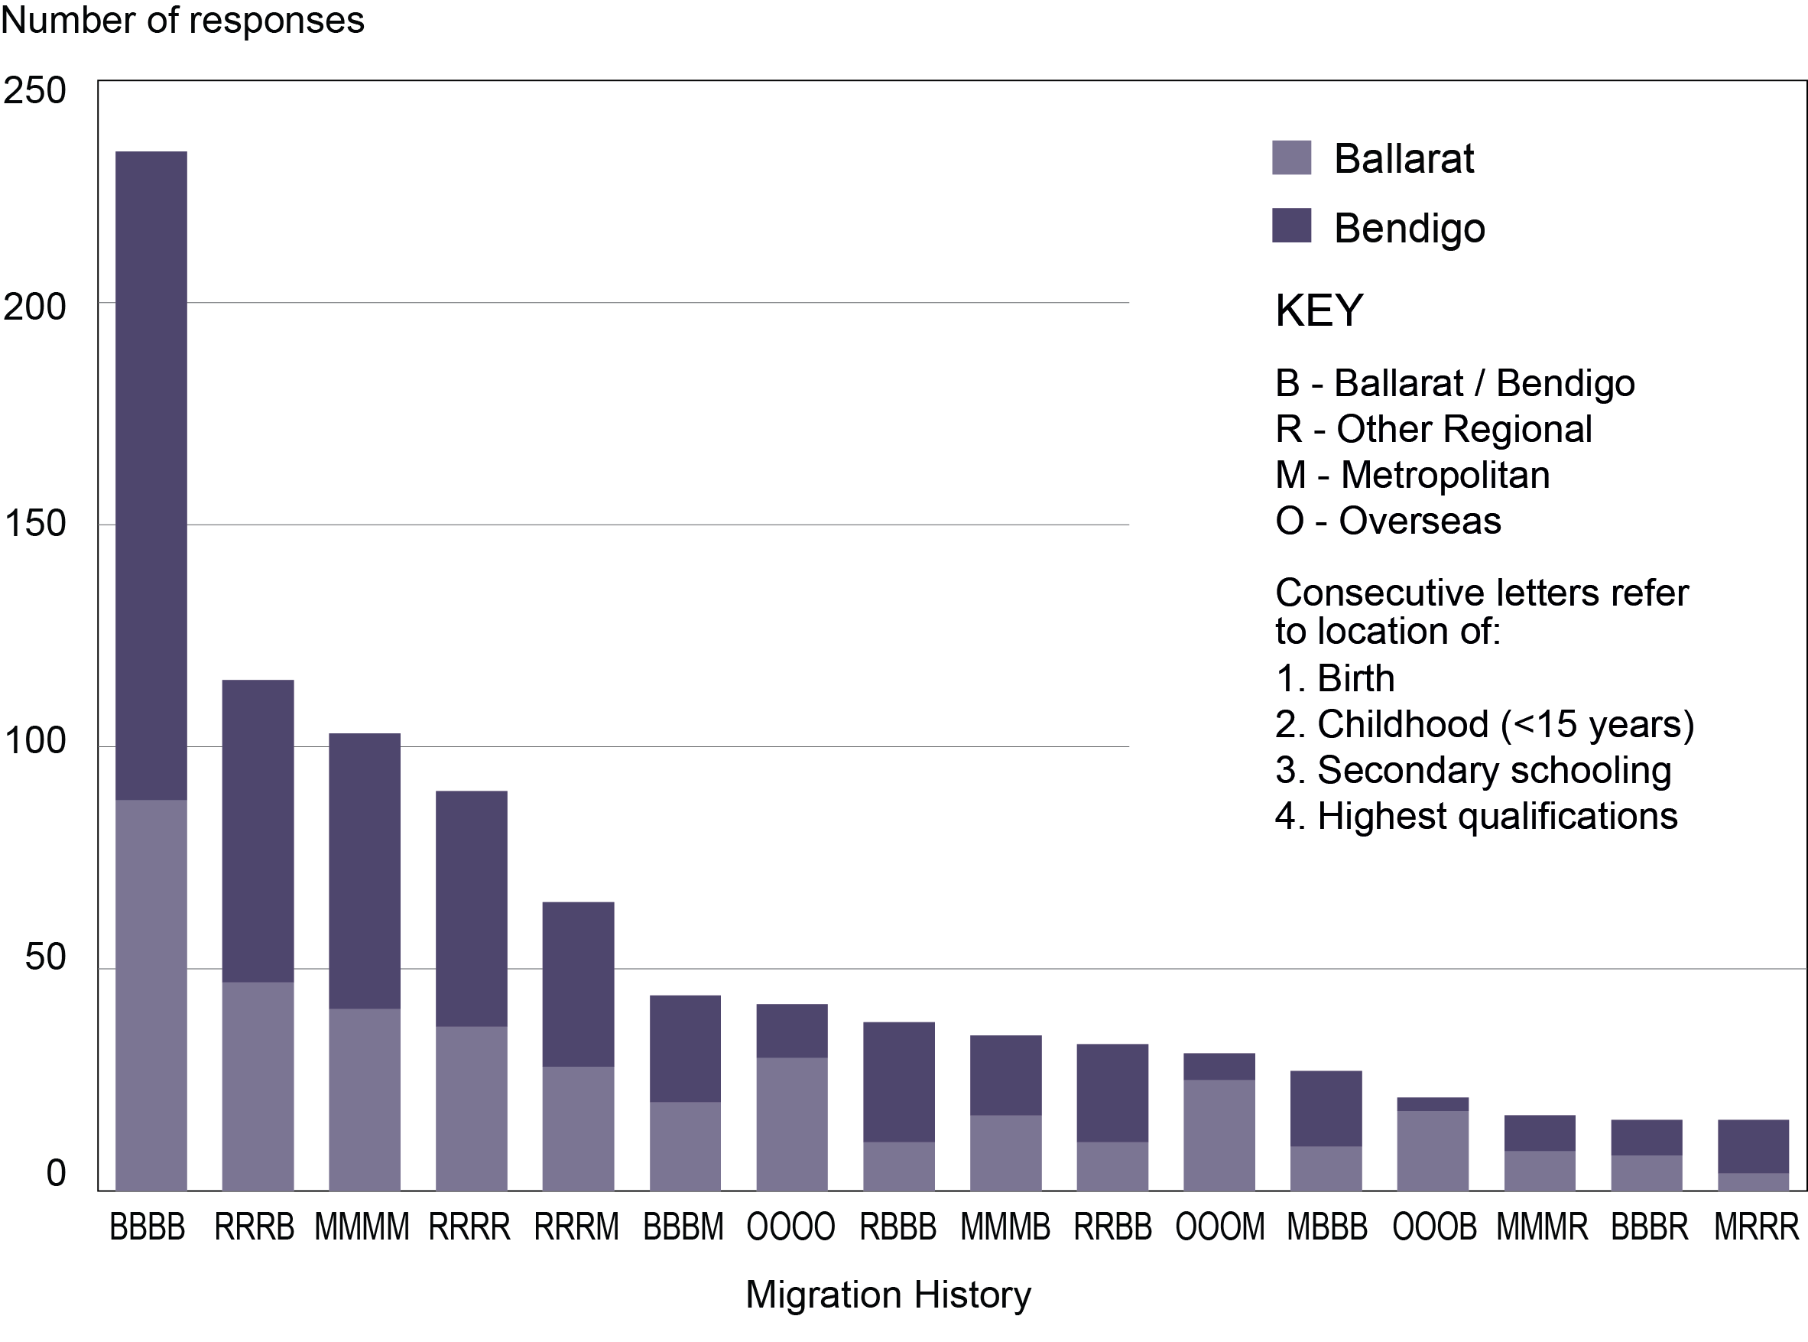

Bendigo’s profile is generally more local or regional in character, while Ballarat shows more categories containing an overseas element. In fact, taking into account all pathway combinations, 21 percent of Ballarat pathways contained at least one “O”, compared to 7 percent for all Bendigo combinations. One exception to this pattern was Ballarat Health Services for which metropolitan locations accounted for 43 percent of respondents compared to a Ballarat location of only 28 percent.

Gaining human capital
The research project was concerned with issues of human capital. One assumption was that Melbourne would play an important role in offering a wide range of higher educational opportunities and therefore it would feature in the migration histories of regional professionals. However, this assumption was challenged by the findings which showed that regional areas were a significant source of higher education qualifications among the professionals surveyed. As shown earlier in figure 3, at the time of gaining higher education qualifications, more than half the respondents were located in a regional location, the majority in their respective regional city (Ballarat or Bendigo).

Further analysis of higher education is provided in Figure 5 which looks specifically at those who had attained bachelor or postgraduate degrees. The chart shows that more than half of respondents holding bachelor degrees had obtained them locally. While similar numbers of respondents had obtained their highest degrees in Melbourne, in proportional terms, most postgraduate degree holders had obtained their qualification in a metropolitan area (mostly Melbourne).
Figure 5: Location where selected higher degrees
were obtained, Ballarat and Bendigo samples
Sources: Ballarat Survey Data 2016 and Bendigo Survey Data 2015

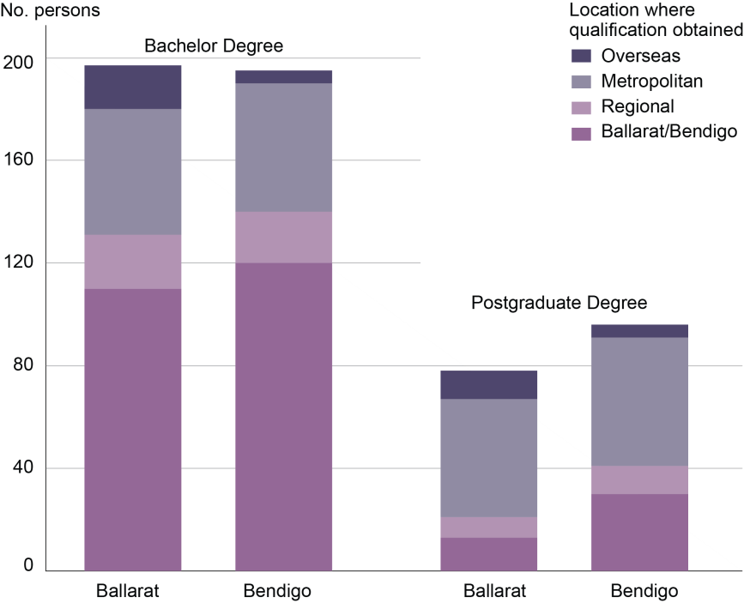

Reasons for moving to a non-metropolitan location
In terms of reasons for moving to Ballarat or Bendigo, the greatest difference was seen in relation to ‘family reasons’ with this being more important for Bendigo respondents, as was returning to region of birth (figure 6). The Ballarat sample showed a greater proportion moving to join the current organisation or for education and training. It is useful, however, to consider the organisation-level data as the differences are often explained by specific workplace groups (table 2).

Figure 6: Reasons for moving to Ballarat and Bendigo
Sources: Ballarat Survey Data 2016 and Bendigo Survey Data 2015

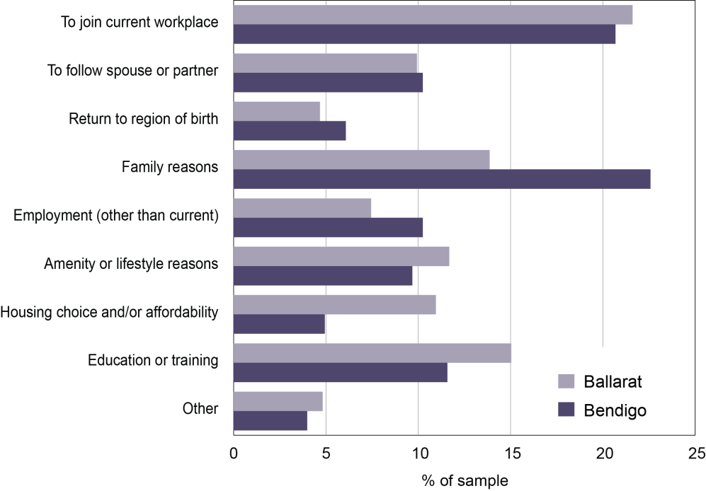

Table 2: Reasons for moving to Ballarat and Bendigo by organisation
Sources: Ballarat Survey Data 2016 and Bendigo Survey Data 2015

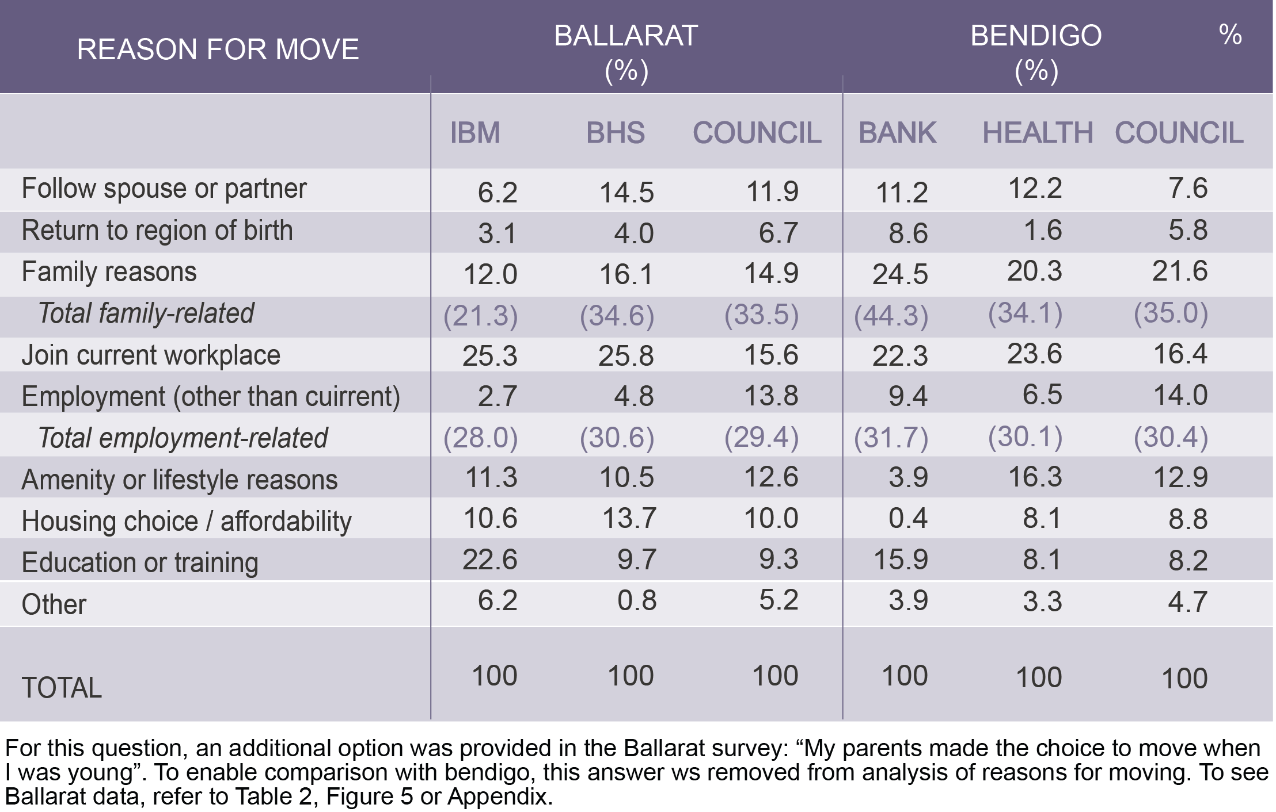
An additional option was provided in the Ballarat survey: “My parents made the choice to move when I was young”. To enable comparison with Bendigo, this answer was removed from analysis of reasons for moving. A total of 37 Ballarat survey responses selected this option (5% of the total sample of responses).

Both councils have nearly identical profiles with rank order and magnitudes being almost the same. Health services are similar although rank order and magnitude differences are seen in relation to amenity and housing affordability reasons. Like the councils, family and employment reasons rank number one and two at both health organisations. The largest differences are seen between the two private businesses with the home-grown Bendigo Bank showing much higher proportions of people having moved for family reasons. Employment reasons were of a similar magnitude to the other organisations already discussed, but amenity and housing affordability were much lower than for any other organisation. The multinational firm, IBM, has a distinctive profile with employment reasons out-ranking family as a reason for moving to Ballarat. Of note also is the high proportion who moved for education or training (ranked number two). The co-location of IBM with Federation University and the use of graduates by the company (for both internships and casual staff in their call centre) may account for some of this difference.

Advantages of being in a non-metropolitan region
The survey offered open‐ended questions about the advantages and disadvantages of living in a regional city. Up to three items could be recorded and these were then grouped into broad categories for ease of analysis. Following analysis of the Ballarat sample, responses from the Bendigo sample were re-analysed to ensure alignment of thematic categorisation. The subsequent results are presented in Figure 7.

Figure 7: Reported advantages of living in Ballarat and Bendigo
Sources: Ballarat Survey Data 2016 and Bendigo Survey Data 2015

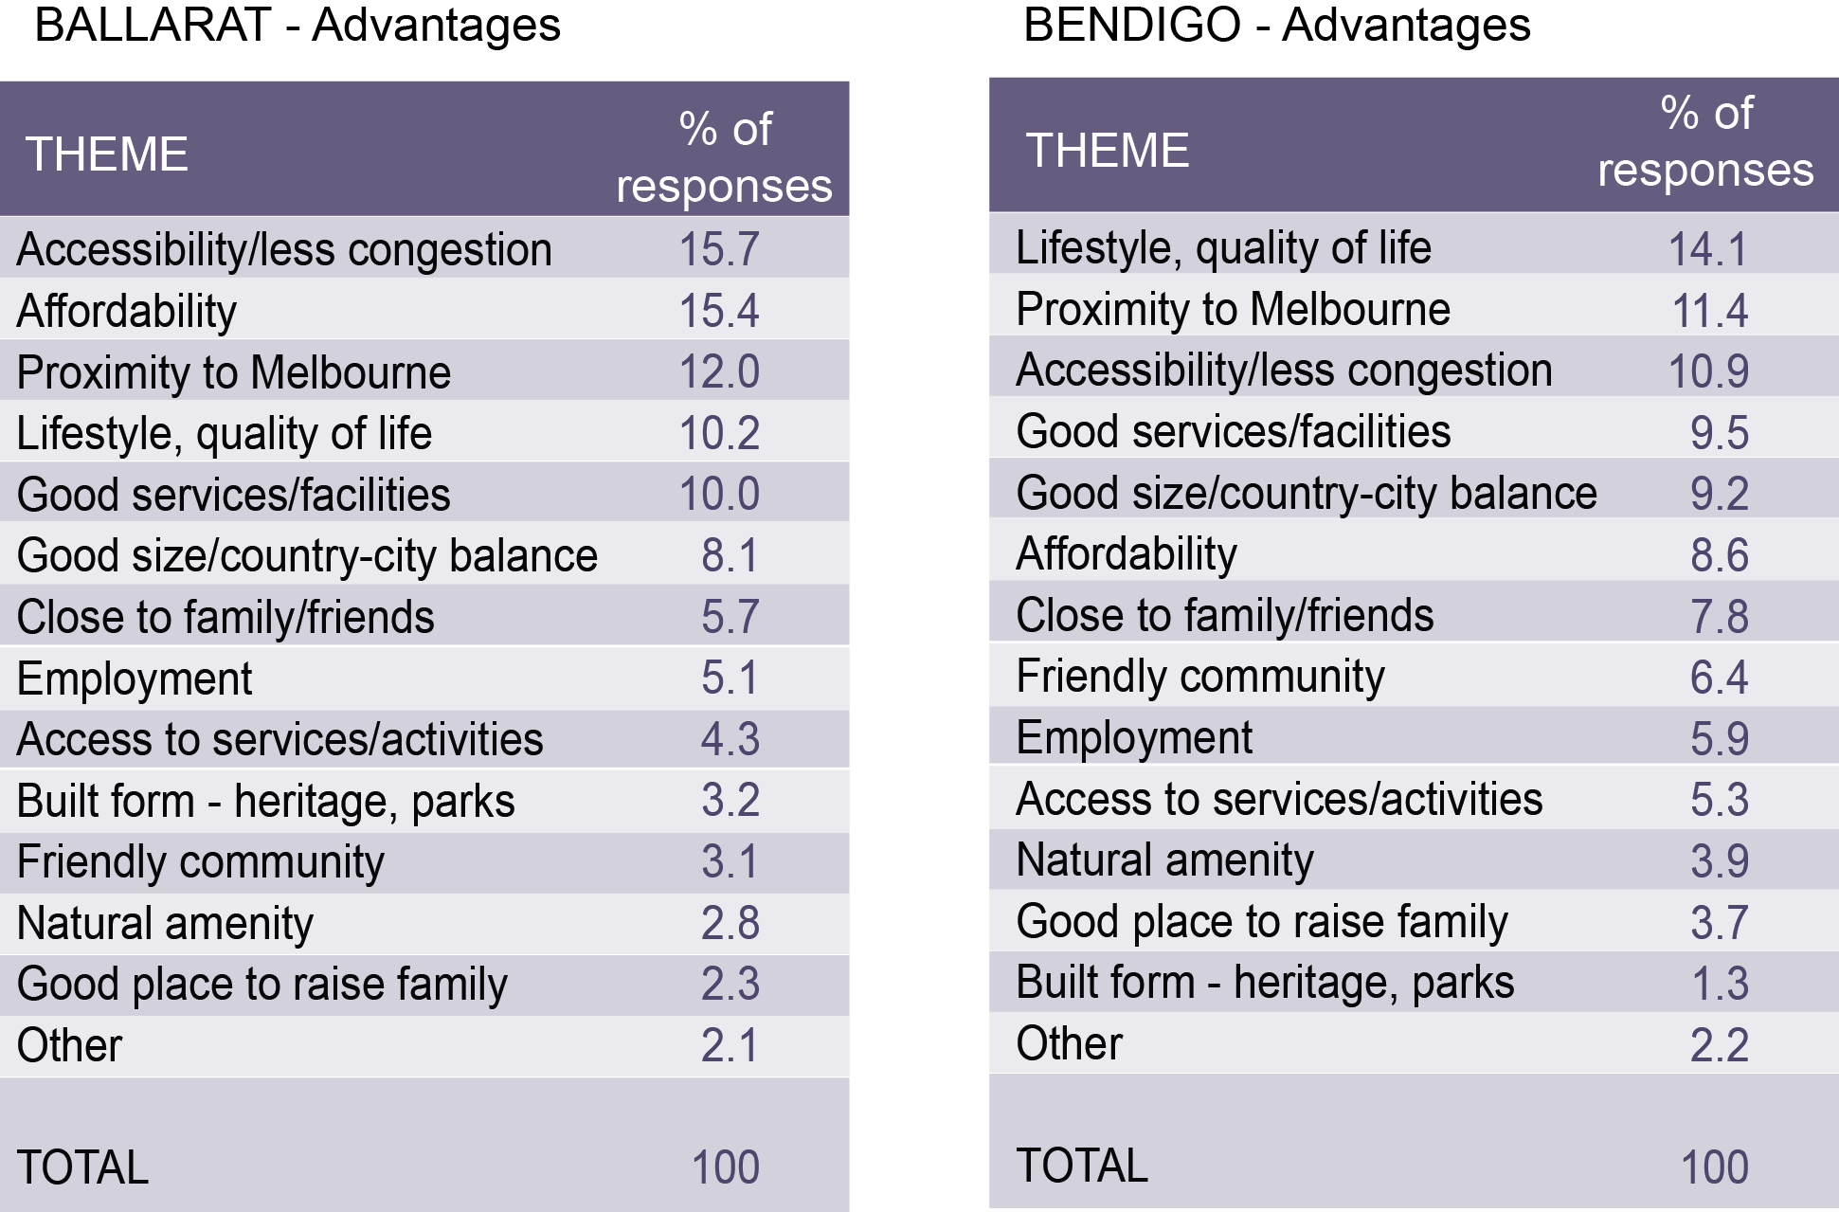

In Ballarat, the ease of getting around town and lack of congestion ranked as the greatest advantage of being in the city. This theme ranked third in the Bendigo sample. Ballarat respondents placed greater emphasis on housing affordability than their Bendigo counterparts which may reflect the younger age profile of the Ballarat sample, many of whom may be seeking their first home. Bendigo respondents were more likely to list lifestyle and quality of life factors than their Ballarat counterparts. Proximity to Melbourne ranked third for both samples, yet this theme also appeared in the list of disadvantages, showing how perceptions of closeness or distance can vary between individuals. It is perhaps interesting that natural amenity ranks low in each of the samples. Although many non-metropolitan areas consider their natural amenity to be a strong selling point, non-natural amenities (services, and the more generic ‘lifestyle’ factors) seem to be a more significant measure of individual welfare.

Disadvantages of being in a non-metro region
Access to services and the (cold) weather provided the greatest dissatisfaction for Ballarat survey participants, followed by employment issues related to limited career opportunities (figure 8). For Bendigo, infrastructure issues such as parking and congestion ranked highly, followed by limited career opportunities in the region and also the (hot) weather and associated issues around lack of recreational water.

Figure 8: Reported disadvantages of living in Ballarat and Bendigo
Sources: Ballarat Survey Data 2016 and Bendigo Survey Data 2015

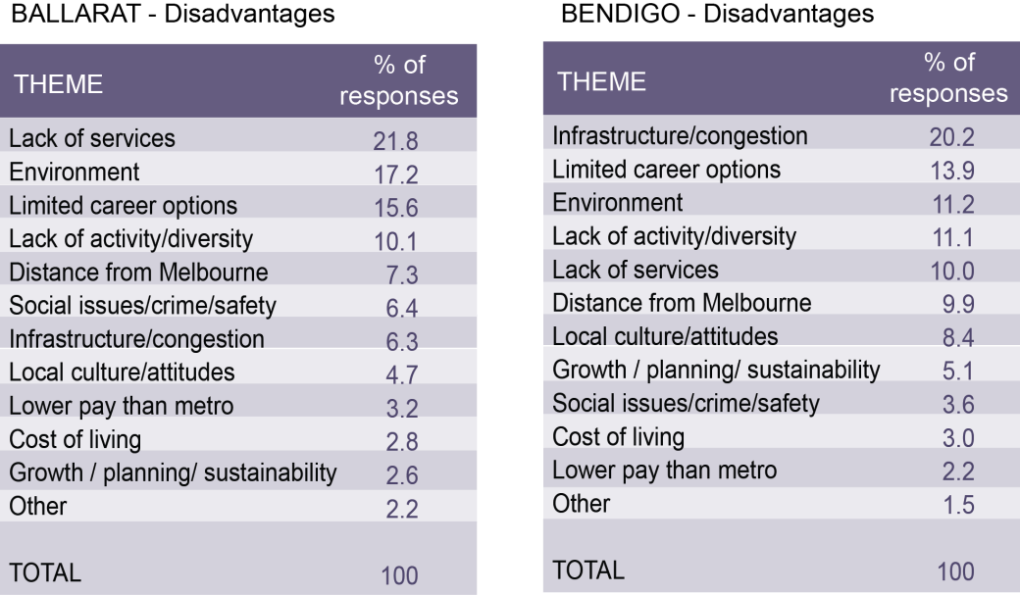

In both cases, the issue of limited career opportunities is related to city size. Many respondents compare their city to Melbourne, yet Melbourne is vastly larger in size and can therefore offer a range of career choices which are inevitably more limited in smaller cities like Bendigo and Ballarat.

It is interesting that many expressed dissatisfaction with immutable factors like climate. High proportions reported cold weather as a disadvantage of Ballarat and hot weather conditions and lack of water as a disadvantage of Bendigo. Although the existence of such climatic conditions cannot be changed, it may be that in both centres there are measures which can be taken to make life more comfortable. This may take the form of improvements in building insulation and heating systems in Ballarat, or developing opportunities for water-based recreation in Bendigo.

Intentions to stay or leave
In both samples, most respondents intended to stay in their regional city and were generally happy with the lifestyle that their location afforded (figure 9). A relatively high proportion of Bendigo respondents (86%) indicated that they did not intend to leave the area in the near future compared to Ballarat (62%). The proportion indicating they intended to move showed very little difference between the two samples: 12 percent in Ballarat; and 14 percent in Bendigo. However, there was a large proportion (27%) of Ballarat respondents who were unsure about their future intentions.

Figure 9: Intention to stay or leave by organisation
Sources: Ballarat Survey Data 2016 and Bendigo Survey Data 2015

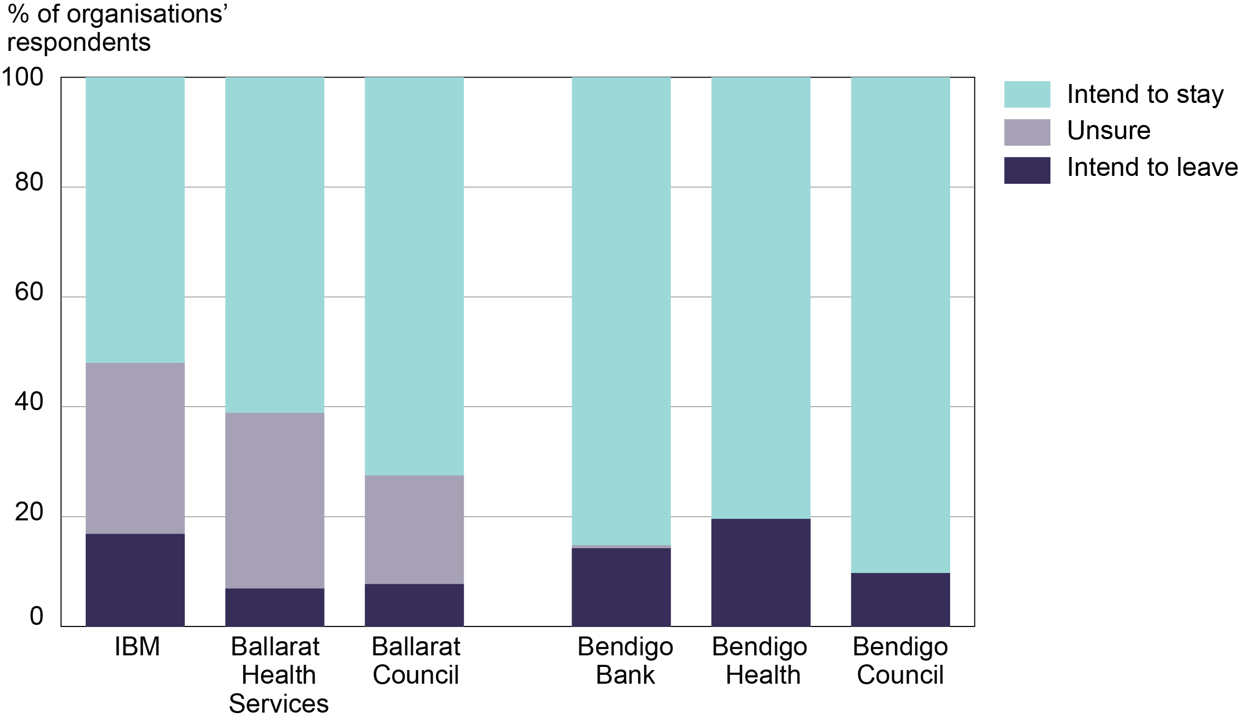

With a younger age profile than the Bendigo sample, it might be expected to see a higher level of potential mobility for the Ballarat sample, as young adults are more likely to move than older adults. In fact, cross-tabulation of the combined data samples highlights the correspondence of both “intend to leave” and “unsure”, with younger age groups (figure 10). Higher proportions “unsure” can be seen as a risk or an opportunity – while some will choose to leave, there are opportunities to encourage them to stay if they are yet to make up their mind.

Figure 10: Intention to stay or leave by age (combined sample)
Sources: Ballarat Survey Data 2016 and Bendigo Survey Data 2015

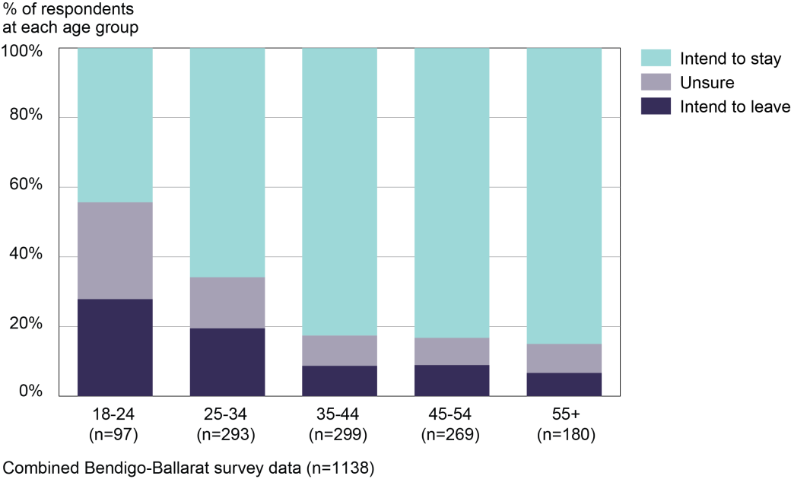

Because of the relatively small numbers of respondents indicating an intention to leave, and the even smaller number with a clear view about potential destination, an analysis of destinations was not possible at the level of individual organisations. However, the combined Ballarat and Bendigo sample provides a total of 126 people who indicated an intended destination: a large enough sample to analyse (figure 11). Metropolitan areas were the most common intended destination, accounting for 65 respondents (43%), of which 55 indicated Melbourne as their intended destination. This was followed by regional destinations which accounted for 47 respondents (31%), 36 in Victoria and 11 interstate. Overseas destinations accounted for 14 responses (9%) and the remaining 27 (18%) were unsure of their potential destination.

Figure 11: Intended destination (combined sample)
Sources: Ballarat Survey Data 2016 and Bendigo Survey Data 2015

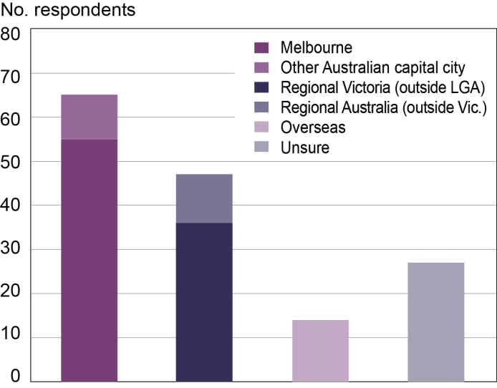

Retention, attraction, or re-attraction?
Given that many regional locations experience skills shortages, knowing the most effective ways to attract skilled workers to, and retain them in, a regional location is important. The findings of the Ballarat and Bendigo surveys contribute to our understanding of the pathways and motivations of professional workers in regional Victoria which, in turn, can inform attraction and retention strategies.

This paper has revealed that many of those currently working in non-metropolitan locations have regional backgrounds. For those who had moved to Bendigo or Ballarat, it was most commonly for reasons of family: following a spouse or partner; wishing to raise children in a non-metropolitan location; or a desire to return to their region of birth. These motivations highlight the importance of having connections with a location through friends, family or past experience. This is likely to mean that attraction strategies will be more effective if targeted to those who already have experience of country life.

Economic factors are also important drivers of migration, particularly employment. However, a challenge for those working in professional roles is that the smaller job markets of regional cities (compared to metropolitan areas) makes it less likely that a wide selection of alternative jobs are available. This is a particular issue for workers at the start of their career. This is likely to explain why respondents from IBM (with its younger age profile) tended to have higher levels of uncertainty about whether they would stay in Ballarat, and a greater likelihood to report the lack of employment opportunities in Ballarat as a problem.

There are limits to the range and depth of services that a city of 100,000 can provide compared to a city the size of Melbourne (4.4 million population). This will always be a challenge for Australia’s regional cities given the primacy of Australian state capitals. Nevertheless, the finding that regional cities like Ballarat and Bendigo are now large enough to provide the basis for skilled career development is a positive one. It is worth noting that in both locations, private companies like IBM and Bendigo Bank had proactively sought and helped develop training courses through partnerships with local universities. This provides a useful model for planners seeking to address specific skills shortages in regional areas.

In response to the dual challenge of smaller labour markets and skills shortages, local business can play an important role in ‘growing their own’ employees. Developing and maintaining close partnerships with local training providers and universities is one way of ensuring skills training is available to locals. This is a strategy used by IBM Ballarat and the Bendigo Bank. In addition, both organisations use internships and scholarships, both of which can provide career pathways for local youth. Communicating these pathways to those still at secondary school may assist in retaining young adults in the local labour force. While they may still spend some time away to gain wider work experience in their chosen career, having a regional start to their working life may be important in showing that a regional career is possible – either to develop or to return to at a later date.

The Ballarat and Bendigo surveys provide a unique insight into the pathways and motivations of professional workers who end up living in a regional location. Based on a combined sample of more than 1000 respondents, the results clearly indicate that regional cities can provide successful career pathways across a range of professional occupations. In addition, the advantages of a regional location, such as a more relaxed lifestyle and lower levels of congestion than metropolitan areas, leads to a high level of satisfaction as seen by the majority of respondents who do not intend to leave their regional city in the near future.

References
ABS (Australian Bureau of Statistics) Australian Demographic Statistics, cat. no. 1301.0 (Canberra, ABS).
ABS (Australian Bureau of Statistics) Regional Population Growth, cat. no. 3218.0 (Canberra, ABS).
ABS (Australian Bureau of Statistics) Victorian Yearbook, cat. no. 1301.2 (Canberra, ABS).
DELWP (Department of Environment, Land, Water and Planning) (2016) A Regional Career: Migration Histories of Professionals Working in Bendigo, Victoria, report prepared by Fiona McKenzie (Melbourne, Victorian Government).
DELWP (Department of Environment, Land, Water and Planning) (2017) A Regional Career: Migration Histories of Professionals Working in Ballarat, Victoria, report prepared by Fiona McKenzie and Fiona Koutsivos (Melbourne, Victorian Government).
Faggian, A., Rajbhandari, I. and Dotzel, K. (2017) The interregional migration of human capital and its regional consequences: a review, Regional Studies, DOI: 10.1080/00343404.2016.1263388.
McKenzie, F. (2004) Understanding regional skills shortages: a review of recent Australian Government policy, Australasian Journal of Regional Studies, 10(3), pp. 331-353.
McKenzie, F. (2010) The influence of tertiary institutions on regional youth migration in Victoria, in Dalziel, P. (ed.), Innovation and Regions: Theory, Practice and Policy. Refereed Proceedings of the 34th Annual Conference of the Australia and New Zealand Regional Science Association International, 7-10 December 2010, Melbourne, AERU Research Unit, Lincoln University, New Zealand: pp. 144-160.
Miles, R., Marshall, C., Rolfe, J. and Noonan, S. (2006) The attraction and retention of professionals to regional areas, Australasian Journal of Regional Studies, 12(2), pp. 129-152.
Stockdale, A. (2006) Migration: pre-requisite for rural economic regeneration? Journal of Rural Studies, 22(3), pp. 354-366.

ARC Linkage Project LP LP120100212 ‘Attraction and Retention: The role of mobility in educational pathways and human capital development’, involving a partnership between the Victorian Government, University of Queensland, Graduate Careers Australia and Latrobe University Bendigo.

