Harness the ‘love’ – using social connections to re-frame
how we manage urban nature reserves

Kathryn Eyles
Australian National University

Abstract: Australian cities are increasingly important for the conservation of threatened species and their habitat, supporting more species per unit area than non-urban regions. Canberra is a case in point with its existing suburbs and greenfield developments occurring alongside nationally threatened ecological communities and species in the urban reserve network, Canberra Nature Park.

At the same time, evidence is growing about the importance of access to nature for human health and well-being particularly in urban environments. Access to open space was part of the rationale for protection of the Capital’s landscape with most suburbs within walking distance of a nature reserve. Despite their multiple values, Canberra’s nature reserves are managed as bounded conservation units with limited reference to their other social values. Neighbours and recreational users are often framed as the source of conflict and disturbance.
This qualitative research uses a case study of Mt Taylor Nature Reserve in Canberra Nature Park to explore how local people value and experience the reserve. It uses observational data to quantify users and their practices, and semi-structured interviews to distill meanings about the place and perspectives about management.
The results reveal Mt Taylor is valued for amenity, recreation and nature-therapy. It is a ‘social’ egalitarian place fostering human connection and networks. Local users treasure the mountain and share legitimate concerns about its management. Given these strong social bonds, there is an opportunity to re-frame the way reserves are managed, to harness these attachments and align programs to benefit urban users and nature conservation.

Key words: urban nature, conservation, recreation, amenity, management

Introduction
Canberra’s natural landscape frames the city, a sympathetic design response first articulated in Griffin’s 1912 plan and expressed in successive phases of city planning and development (NCDC 1970, 1984, ACTG 2004a). The inner hills were originally set aside to protect the natural landscape setting and for the recreational benefit of the residents (Seddon 1977) and not designed as conservation reserves (Rayner et al. 2014). The national loss of lowland grassy woodland ecosystems and the threatened species dependent on these systems (Ives et al. 2015) means these landscapes have assumed greater conservation importance (ACTG 2004b). Biodiversity conservation has become the formal policy setting for these urban reserves, despite their historical protection for amenity values (Philips and Gay 2001).

Canberra’s nature reserves are within a short walk for most residents with this accessible green space regularly touted as the most loved element of Canberra (Jose 2010). Research about the values of Canberra’s reserves however, draws on the views of established recreation and conservation user groups. This means the values and experience of most everyday users and neighbours are under-represented in existing studies (ACTG 2010, Chevalier and Norman 2010, Cooper 2011, NCA 2014).

This situation is not unique to Canberra, with only a small body of Australian research about urban residents living near nature. These studies find that people value living near the bush and with urban wildlife (Barnett et al. 2005, Fitzgibbon et.al, 2006, Gill et al. 2009) and have positive levels of connection and engagement with nature (Head & Muir 2007). Residents are also to appreciate the significance of nature without knowing much about the local biodiversity. Whether nearby residents have the skills to live sympathetically with nature is less certain. US studies reveal that edge residents while desiring to protect adjoining reserves had limited knowledge about how household practices might impact or assist conservation (George and Crooks 2006, Yougentob and Hostetler 2005).

- Canberra’s abundant and accessible nature presents an ideal setting to expand on this body of research particularly with growing evidence about the benefits of nature for human well-being (Chiesura 2004). Direct experience of nature builds attachment to local places (Luck et al. 2011, Ryan 2005, 2000) as well as providing many health benefits (Maller 2006, Maas et al. 2006, WHO 2016). Restorative benefits have been demonstrated from exercising in nature (Carrus et al. 2015, Bratman et al. 2015, Barton et al. 2012) and from environmental volunteering (Townsend 2006).

With more people now living in cities, there is also concern about the loss of everyday contact with nature, both for health reasons and with developing an affinity for nature (Soga and Gaston 2016). The disconnection of children is seen as particularly harmful (Louv 2007, Monbiot 2012, Broom 2017). A UK literature review suggests children’s health outcomes and acquiring positive feelings about nature is best achieved through hands-on free play and less structured engagements (Gill 2011).

Health data appears to support concerns about disconnection, with beneficial access to nature not taken up by many Canberra residents, especially kids (The Canberra Times 2017). This is borne out in both the weight and physical activity data for children. 25% of 5 to 17 year olds are overweight with little change over five years (ACTG 2016) and consistent with national figures for this age group (ABS 2013). The number of overweight children nationally has also doubled in one generation from 1985 (NHMRC 2003, Margarey et al. 2001). For physical activity, 80% of 5-17 year olds did not meet daily minimum recommendations (ABS 2013). An innovative longitudinal study of Canberra primary school children confirms this activity deficit. Only 42% of boys and 37% of girls in Grade 2 meet daily recommendations. By grade 6, this falls to 30% for both sexes (Telford et al. 2012, 2013, Telford 2017).

Planning and management of urban nature reserves
At global, national and regional scales, park agencies are recognising the social and health benefits of nature connection (ParksVic 2015, IUCN 2014a) and the importance of engaging urban communities in conservation (IUCN 2016, Phillips and Gay 2001).

Planning for protected areas has been slow to adapt with most reserves still managed as ‘bounded’ conservation units without reference to their local communities and their experiential values (Gill et al. 2009, Gurran 2005). Park planners and managers while skilled in the physical sciences are often uncertain how to apply social values information in management (Miller and McKee 2001). This focus on natural values excludes local people and their experience, even though they are the most connected with the place (Hirschnitz-Garbers and Stoll-Kleeman 2011). This is a lost opportunity as the support of local people is integral to the success of reserves (Nastran 2015) and human well-being is an important motivation for conservation of urban biodiversity (Dearborn and Kark 2010).

Re-framing urban conservation practice outwards would necessitate a richer and more regular form of engagement with local communities. This would provide managers with a better understanding of how people use these spaces and which features encourage more active engagements (Dallimer et al. 2012) so landscapes are managed in a way that builds connection (Standish et al. 2011). There are other practical benefits. Bounded management makes threat mitigation more problematic. Weed control, bushfire risks and native wildlife all require management across the urban matrix, land tenure and uses (Buxton et al. 2006, Fallding 2004) as well as active engagement and co-operation with adjoining landowners (Hansen and DeFries 2007, Tryzna 2005, Crofts 2004).

This research explores the relationship of users and neighbours with a popular urban nature reserve to see how local attachments might be built into the ongoing care and management of the reserve. It will explore whether the ecological management of the reserve might more effective when coupled with richer social engagement (WHO 2016).

Research Setting and Context
Canberra’s has a unique urban structure with Canberra Nature Park woven through the suburbs. This means the Nature Park has a high perimeter to area ratio of managed reserves (TAMS 2011) and many neighbours, an ideal setting for this research. Canberra is also a rapidly growing city (McIfroy and O’Mallon 2017) facing challenges in common with other cities around land supply, water scarcity, bushfire risk and biodiversity conservation (ACTG 2016a).

This study is about the Mt Taylor Nature Reserve, located in the geographic centre of urban Canberra. Encompassing an area of 297 hectares, the reserve is surrounded by six suburbs and a major transport corridor, Tuggeranong Parkway on its western boundary and east-west connector road, Sulwood Drive to the south and south-west (See Figure 1).

Figure 1.Mt Taylor Nature Reserve

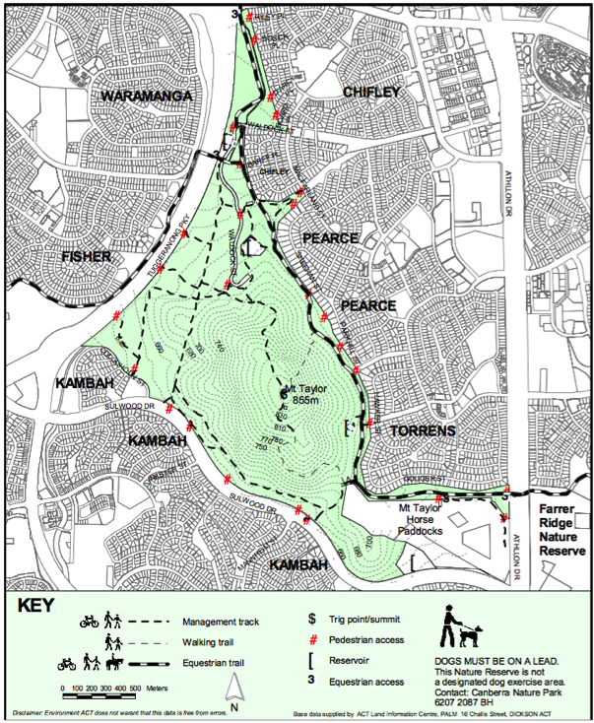

Ahead of urban development, the mountain and surrounding land was used for grazing. It was declared a nature reserve in 1993, is part of the National Capital Open Space System (NCOSS) and a ‘Designated Area’ under the National Capital Plan (ACTG 2016b).

Mt Taylor is a hybrid landscape, a legacy of former grazing land uses and urban development around its perimeter. Weed infestations and Eastern Grey Kangaroos impact on the regeneration of native vegetation (Ryan 2011). Amenity tree planting has been carried out on the northern slopes and the summit (DCT 1982) and the mountain has experienced many fires (DoT 1984) and was burnt out in the 2003 fires. Mt Taylor has had an active ParkCare group since 1989 removing weeds, undertaking erosion control and restoration works (Rainbird et al. 2013).

Mt Taylor is the second highest mountain in urban Canberra and one of the mostly heavily-used, its challenging ascent to the summit (857m) attracting walkers, mountain runners and people training for trekking adventures. Trail trackers have recorded over 14,000 passes on the main southern walking trail and 6000 passes on the eastern face ‘zigzag’ trail in the month of February 2017 (ACTG 2017). Riding horses and bikes is allowed on fire trails and dog walking on a lead is permitted. Group events like orienteering are permitted subject to agency approval (ACTG 2016).

At the 2016 Census, there were 7,250 people living in the three Woden suburbs directly abutting the reserve (ABS 2016) along with 3 pre-schools, 2 primary schools and 2 high schools and many near neighbours in the northeast of Kambah, and eastern part of Fisher and Waramanga in Weston Creek.

Research Approach and Methods
The research uses a case study of Mt Taylor Nature Reserve to explore how people use and experience the reserve. Case studies are well-suited to this sort of in-depth investigation of social phenomena in context (Yin, 2009). This study uses multiple sources and methods including: direct observation; semi-structured interviews; participant observation; and document analysis of reports and media. Each method provides different insights and allows for triangulation of the data (Creswell 2013) and cross-checking (Layder 2013).

Direct observation is used to understand the relationship between people and place. On-the-ground impressions of users and daily activity reveal the ‘authentic local context’ and provide a rich description of the socio-temporal context (Wolfe 2017, Hay 2010). Observation involved walking on different days, times and routes and across the seasons from 2011 to 2014. A total of 110 observations on weekdays and 100 on the weekend were recorded in a diary, including the type of users, activities, dog-walking as well as park maintenance and physical evidence of other behaviours. The researcher also participated in monthly work parties held by the Mt Taylor Parkcare Group, observing their activities as well as the school community service events with the Group.

Observations are a prime source of data in the study along with semi-structured interviews. Interviews were used to ‘discover’ information about individual views and experience with the reserve (Layder, 2013). 12 residents and users, including ParkCare and urban fire volunteers participated in interviews lasting 60 minutes. Interviews explored how people experience and use the reserve and their perceptions about impacts, care and management. Interviews were capped once no new perspectives were forthcoming (Ritchie and Lewis 2009), and audio recorded and transcribed.

Results
Direct Observation
Direct observation yielded a rich picture about the people using Mt Taylor and interesting patterns of activity both diurnally and seasonally (see Appendix 1). Walking is the most popular activity in the reserve accounting for more than 95% of user observations. A distinct seasonal pattern was observed with the warmer seasons attracting 5 times more users. The most popular day for walking is Sunday, both morning and afternoon across the seasons (See Figure 2). Other observed peaks were the early evening during daylight saving months with a younger cohort observed. Public holidays and early in the New Year saw a threefold increase in users.

Figure 2 Sunday morning at the Summit

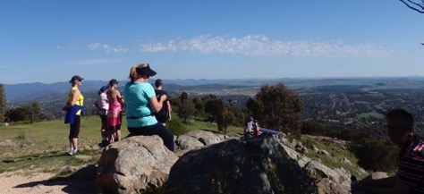

There is a strong social component to walking practice with groups of walkers, particularly women in pairs and groups training for mountain hikes and overland treks in Australia and overseas. A group of regular early morning walkers, an older cohort, have formed close friendships and get together for an annual Christmas drinks event at the summit (see Figure 3 and Warden 2014).

Figure 3 Mt Taylor Early Morning Walkers (Ian Warden)

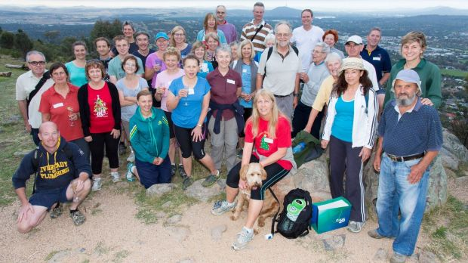

Almost one in ten people were observed walking with a dog, with two-thirds on a lead and one third off. There was no significant difference in lead compliance between weekdays and weekends. No compliance and very little park management activity were observed. Rangers were sighted on only 3 occasions (Figure 4) and a ranger was present at community service events with Marist High School.

Figure 4 Rangers on the beat

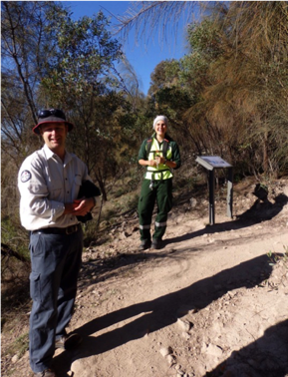

The most surprising observation is how few children use the reserve either in the company of walking adults (4.2%) see Figure 5, or on their own, 1.7% of observed users. One local high school uses the lower trails for physical education on a weekly basis, and another undertakes community service activities twice a year and more irregularly, uses the reserve for science study.

Figure 5 Grandparents with grandkids at the summit

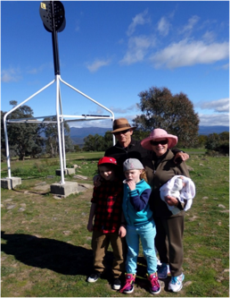

Incidents of anti-social behavior and vandalism on the reserve were observed by evidence left after the event. There was a pattern to hooning behaviours (skid marks and oil along access roads) occurring in school holidays perhaps initiated by older teens. Incidents of trade, garden and household dumping occurred along the access road and reserve edge (see Figure 6).

Figure 6 Household dumping Mt Taylor Nature Reserve

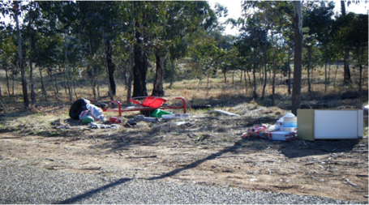

Semi-structured interviews
Results have been grouped under the inquiry themes of the interview, drawing out the common threads and presenting some individual perspectives about the reserve using quotes.

Feelings and experience about living near Mt Taylor
Common to all responses was the importance of the nature reserve in people’s lives, for the utility of physical access, new discoveries as a volunteer, nature-therapy through regular exercise and amenity for walkers and neighbours, seeing wildlife, and views to the reserve and beyond (Table 1).

Table 1. Informant perspectives about living near Mt Taylor

Perspectives
About proximity, access and safety | “That’s always something that’s been a positive with me, that you can just walk out your door and into the reserve.”  “I love Mount Taylor being behind me, having somewhere we can easily get out into the bus, to me it is all about access.”
About favourite walks, places  and activities | “Mount Taylor for me is a place of quiet calmness. There’s a little outcrop I stand there and breathe in deeply. It’s very important to me, the mountain, that walk every morning and seeing friends up there.”  “I have 2 nice walks that get me away from the main track to where the foreground feels natural and undisturbed and with fantastic views of the Brindabellas.”  “There’s plenty of hidden areas, 90% of people walk the main trails and nobody knows those beautiful things - I never cease to find things when I’m observing what’s around”.  “I particularly like the 4WD path along the east side of Mt Taylor. There's some nice trees, it has e dappled light, and the north side has a beautiful view, but really the whole thing is pretty special.”  “We love it –the kids say can we go to top of Mt Taylor and make half day of it with a picnic. They really enjoy climbing rocky outcrops and seeing lizards but once they have a break they then want see what’s around the next little knoll.“
About the views, amenity and breathing space | “I like that there’s greenery outside my house. I see bush and mountains, its very distinctive about Canberra, green that meets the eye. That has a major psychological impact on me.”  “I bought here because it was right next to Mt Taylor, its got a beautiful view, that whole concept of having a city in a national park appeals to me enormously.”  “It might sound passive, but just sitting on the veranda and watching what transpires in front of you, you see a whole mob of roos go up the hill. Or, you’d get a roo in your yard, just being able to see it is important.”  “We get the greatest pleasure out of the bird life that comes in and also the kangaroos. So for us, to have no houses there, is the nicest thing and we feel very blessed to have bush around our house.”

Perspectives about what might harm the reserve
Informants identified the recreational use of the nature reserve and lack of maintenance as harmful, with poor design and condition of tracks also contributing to this harm. One user, also a volunteer, identified weeds and kangaroo mobs as harmful (see Table 2).

Table 2. Informant perspectives about what might harm the reserve

Perspectives
Recreational use of the reserve | “I mean it’s good seeing everybody using it, but it makes it deteriorate much faster.”
Recreational use of the reserve | “Look from what I’ve seen up there - people wander off heading into the gullies, not just on the main tracks, tracks everywhere and getting more eroded.”
Recreational use of the reserve | “Overuse that’s number 1, it’s being, literally loved to death and the lack of track maintenance.”
Recreational use of the reserve | “I think allowing people unfettered access, like, the tracks up there are a mess and the new track on this side was poorly designed and encourages people to cut corners.”
Weeds and kangaroos | “I think weed and kangaroo management. It concerns me that kangaroos breed up, because I haven't seen a lot that species of orchid up on Mt Taylor and wonder whether the kangaroos are eating them out.”

What concerns you for the reserve
Informants identified the lack of maintenance and compliance and the absence of rangers as their major concern. This agency shortfall was seen as undermining the existing ParkCare partnership. Both volunteers and other reserve users expressed the view that too much is being expected of the care volunteers (Table 3).

Table 3. Informant perspectives concerns for the reserve

Concerns
Dumping | “I see lots of rubbish and left over materials - a big clean up would improve the look, hopefully dissuade others from dropping rubbish and maybe take an interest in the reserve.”
Agency neglect | “To me until Parks have a presence I can’t see anyway of ending vandalism. You can’t leave it up to the volunteers. I have only once seen a ranger Yeah, a long, long time ago.’
Agency neglect | “The thing that worries me is the benign neglect by Parks. They don't have the money, but then some things they do are not very useful, they put signs up which people ignore, and you end up with all this stuff that’s never taken down.”
Agency neglect | “I’ve probably been on Mt Taylor more than 150 times and I’ve never seen a ranger.”
Agency neglect | It’s poorly managed and not enough rangers, lack of money– the one that drives me mad, it’s the lack of maintenance for Taylor.”
Support for  Parkcare | “I think a lot is being imposed on ParkCare. The government’s not bad at writing plans. It’s implementing them that’s an issue. Nothing’s ever happens!”
Support for  Parkcare | “It appears that ParkCare gets very little support, that’s a pity because these things feed off each other, if you’ve got support and money, that builds the group up, our contact person changes frequently and we haven’t seen a ranger for years.”
Support for  Parkcare | “(track) maintenance is bigger than we can cope with. Those things we really shouldn’t need to worry about.”

What are your thoughts about management responsibility?
Informants were asked who they felt should be responsible for management of the mountain. The concept of sharing responsibility and closer partnerships between community and government was expressed by nearly all informants. Most felt that government should be responsible for the big jobs, compliance and overall security (Table 4).

Table 4. Informant perspectives about management of the reserve

Perspectives
“Look, I think there’s roles for different groups. The major roles, to take away dumped car bodies, obviously lies with ACT government and maintaining safety and security of the infrastructure, I don’t think it’s right to expect the community to maintain paths. Weeding and re-vegetation there’s a role for community as long as the material is provided for them.”
“It comes back to the Parks and Conservation group. They have to have overall control of it.”
“The government should have an overall managerial (role) but I hope that people who live near the edges would volunteer and be willing to help. But if the government doesn’t care why should the people fight hard, you know, it has to be both ways.”
“It does need to be under a structure that is going to protect it, and government is the way to do that. But with Mount Taylor, they’re never going to have enough money. So they do rely on volunteers, and it’s really a perfect mesh, The care and eyes on the landscape, done by volunteers, and agency people when specific things need to be done and tap into resources.”

Intersections between interview and observational data
As well as generating insights about personal experience and user perspectives about management, the interview data also complemented many of the researcher’s observations (See Appendix 1) about walking and trek training, seasonal variation in use and some of the demographics (Table 5).

Table 5. Informants views that align with direct observation

Informant observations with direct observation data
“You’ve got the more elderly lot in the morning.”
“I’ve come across quite a few people and they’re carrying packs and you say “Where are you training for?” and it’s nearly always the two Ks- Kilimanjaro or Kokoda.”
“I don’t think parents these days let their kids go up there on their own. I think those days are gone.”
“A lot of people use it, and especially go up there for the view…and you see a lot more in the summer months, definitely.”
“Most people– they haven’t got much time- they go up the top and come straight back and if you see them they’ll say “Hi” but they continue walking. I think it’s just a good exercise place quite frankly.”
“It has been co-opted for fitness and is used a lot by people training for Kokoda. M'mm, I love that and I always stop and they love telling you what they're training for. Cradle Mountain's the other big one.”
“You know, I would think 99 per cent of the people walking up there are return visits.”
“The older kids don’t want to go on walks up the mountain, they are too interested in computer games. I encourage our youngest, who is 7, to walk with me to points of interest.”

Discussion
- Park managers who understand how local people relate to nearby nature are better equipped to manage the multiple values of urban conservation reserves (Hull and Robertson 2000) and to find the ‘best fit’ for community outreach and infrastructure.

- Study findings reveal that Mt Taylor is a ‘social’ egalitarian space supporting a diverse range of activities spanning the spectrum from individuals with regular exercise regimes to those who walk to experience the naturalness of the place. It has multiple values and meanings among its users and neighbours with social and physical dimensions covering its:
  - Utility - an outdoor recreation venue,
  - Amenity - a beautiful view, and place to view
  - Specialness - a place to refresh and commune with nature.

Close proximity has created intimate relationships with the reserve, expressed in both emotional and protective feelings about the reserve and falling within concepts of place attachment (Altman and Low 1992, Scannell and Gifford 2010). Accessible nature-based recreation builds place attachment in urban reserves (Beery and Jonsson 2017) with attachment to nature growing the more frequently people experience the place, whether through recreation or volunteering (Ryan 2000). A sense of social stewardship evolves which is evident on Mt Taylor with both formal (ParkCare) and informal (early morning walkers) social networks and bonds among local people (Stedman 2003).

The most surprising finding is the absence of children using the reserve, with those observed mostly in the company of adults. This is likely part of a wider phenomenon with changing social norms around child safety, risk and play (Gill 2007). Parental fear of strangers and injury means few children enjoy the same neighbourhood freedoms their parents enjoyed (O’Brien 2013). This change is happening as the evidence grows about the benefits of outdoor play for children’s cognitive development and increasing rates of childhood obesity and declining physical activity (Telford 2017).

Importantly, outdoor experiences involving repeated visits to the same site (like a local reserve) give children the exploratory, play-oriented contact with nature that builds affinity with their environment (Gill 2011). At the most recent World Parks Congress, there was unanimous recognition of the need to connect young people with nature and the role for protected areas to offer these meaningful experiences (IUCN 2014).

Bounded management however is excluding rather than facilitating youth engagement with little tolerance for exploratory activities like cubby building (Ryan 2016). It also makes it more difficult to align with other policy initiatives. The ACT’s Healthy Weight Action Plan a ‘whole of government’ policy makes no mention of Canberra’s nature reserve network nor are funds being directed to this outdoor infrastructure (ACTG 2013). Funds are being spent on retrofitting ‘nature’ playgrounds (Gupta 2016) that while meritorious, ignores the natural free-play areas that already exist at the backdoor.

Bounded management is also failing to protect conservation values with ParkCare volunteers holding it together for a resource stretched agency (Beeby 2011). Informants in this study and others identify ‘overuse’ as the biggest impacts on reserves (CoA 1992, Chevalier and Norman 2010, ACTG 2010). This has become such a dominant narrative that it deflects from the failure of current management to deliver basic urban park infrastructure and outreach to allow social and ecological values to co-exist.

What if the positive local attachments evident on Mt Taylor were recognised as important for community engagement (Head and Muir 2007) and building blocks for management success. Users and neighbours could then be positioned as advocates, partners and carers and programs developed to ‘harness the love’ and encourage care behaviours. This is just one example of the opportunities to re-frame management of urban nature reserves like Mt Taylor.

Conclusion
This research reveals strong attachments between residential neighbours and recreational users with the Mt Taylor Nature Reserve. The reserve is both physically and socially embedded in its urban setting, appreciated for its views, naturalness and physical accessibility for exercise.

These social connections are likely to be replicated across Canberra Nature Park but are only loosely treated under the ‘bounded’ conservation model. While neighbours and users are framed through an impact lens, there is little room to acknowledge this social co-existence and how local protection of nature engenders valuable social practices and relationships (Bieling et al. 2014).

Expanding our concepts of how nature conservation is managed in these human-dominated landscapes also requires better alignment with other public policy initiatives in preventative health and education, particularly how natural spaces are situated in policy responses in these policy domains. The disconnection of children for example requires an integrated policy response.

Additional perspectives will be forthcoming in the next phase of this case study to build the case for re-framing the way we manage urban nature reserves. This will include reserve managers, community organisations and local care volunteers. This will develop a richer picture of the challenges and opportunities to move beyond the bounded model and how this might be done.

Appendix 1. Summary: Direct Observation

Users | Statistics | Description | 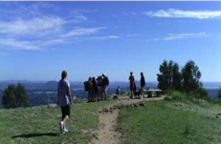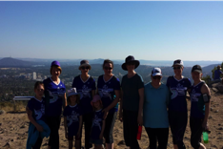
Walkers | 95+% of all observations (obs)  - Most popular activity  - Strong seasonal patterns with 5 times as many walkers on weekends in summer versus winter  - Peaks on public holidays and Sundays (am & pm)  - Older cohort in the morning  - Younger cohort evenings | Strong social component  Regulars walking, talking together  Women in pairs and groups  Some formal groups like Walking for Pleasure  People with backpacks training for mountain treks  Early morning walkers gather for Annual Xmas drinks
Runners | 3.5% of all obs | More men than females | 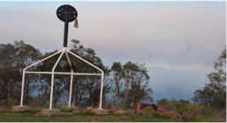
Mountain bikers | 1.2% of all obs | Only males observed  A few kids (6 in total)
Dog walking | 9% walkers out with a dog  - Two thirds on the lead  - One third off – constant for weekdays and weekends  - Few with poo bags | Both sexes and all ages involved  Water bowl at the top with water carried up male walker | 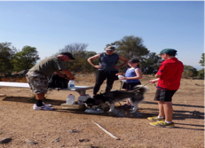
Kids in the reserve | 4.2% all walking obs with adults  - 20% of these grandparents  1.7% all obs kids on their own  - mostly older kids | With adults: walking, picnics, rock climbing, exploring  On their own: on bikes (=30% of bike obs), at a cubby and walking a small dog | 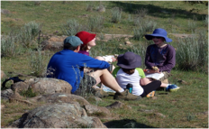
Hobbyists | 3 obs radio transmitting gear and yoga practice  3 walkers with binoculars | Evidence of Geo-casing sites on the mountain | 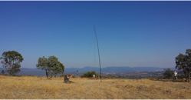
School groups | Melrose High  Weekly walk for physical education Years 7-9.  Marist College  2 Community service activities x 60+  Science class x 20  Torrens Primary  1 walkathon event | Community service -assisting ParkCare with weeding and trail maintenance.  Science class vegetation study  Some periodical events e.g. walkathon | 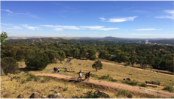
Volunteers  ParkCare | 217 participants over 28 events | Included 2 citizen science projects: Reptile survey in 2011  Vegwatch monitoring 2012 to 2014 | 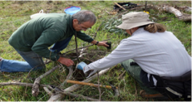
Park management | 3 rangers  4 maintenance activities | Management activities: prescribed burn; fire trail repairs; weed contractor; track inspection. | 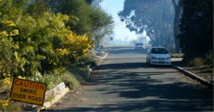
Other:  Youth activity | 13 obs youth activity: burn-outs drinking; drugs; sex, trail bikes; BMX tracks, cubbies, campfires | Evidence: bottles, bongs condom wrappers, foil, envelopes, discarded clothes, lubricants, oil bottles, skid marks, dirt mounds and tracks  Car-based activity in school holidays  along access roads | 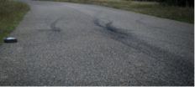  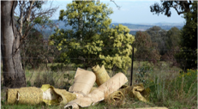  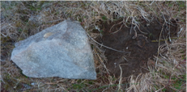
Other:  Dumping | 10 obs household and garden rubbish dumping | Trade and household dumping observed along access roads at fringes of reserve
Other:  Theft | 3 obs rock-turning | Likely scorpion and reptile theft  Different locations around the reserve, all in school holidays

References

ABS (2016) Census QuickStats – State Suburbs (SSC) Chifley, Pearce, Torrens, Viewed on line:
http://abs.gov.au/websitedbs/D3310114.nsf/Home/2016%20QuickStats

ABS (2013) Australian Health Survey: physical activity, 2011–12. Cat. no. 4364.0.55.004, Australian Bureau of Statistics, Canberra.

ACTG (2017) ParkCare and Landcare Coordinators’ Meeting Minutes, 28 February 2017, prepared by Community and Visitor Programs, Parks and Conservation Service, Environment, Planning and Sustainable Development Directorate, ACT Government Canberra.

ACTG (2016a) Annual Report 2015-2016, ACT Commissioner for Sustainability and the Environment, ACT Government, Canberra.

ACTG (2016b) Canberra Nature Park, Draft Reserve Management Plan, Unpublished for internal consultation only, Planning and Sustainable Development Directorate, ACT Government Canberra May 2016.

ACTG (2016c) A Picture of ACT’s Children and Young People 2016, Community Services Directorate, ACT Government, December 2016.

ACTG (2014) The ACT Strategic Bushfire Management Plan 2014-2019, Emergency Services Agency Australian Capital Territory, Canberra.

ACTG (2013) Towards Zero Growth Healthy Weight Action Plan, ACT Government, October 2013.

ACTG (2010) Community Consultation Forums, Investigation into the Canberra Nature Park (nature reserves), Molonglo River Corridor (nature reserves) and Googong Foreshores, ACT Commissioner for Sustainability and the Environment, Canberra May 2010.

ACTG (2004a) The Canberra Spatial Plan, Australian Capital Territory, Canberra

ACT Government (2004b) Woodlands for Wildlife: ACT Lowland Woodland Conservation Strategy. Action Plan No. 27, Environment ACT, Canberra.

Altman, I. and Low, S. (1992) Place Attachment: A conceptual Inquiry, in Altman. I and Low, S (Eds.) Place Attachment, (Plenum New York).

Barnett, G., Doherty, M. and Beaty, M. (2005) Urban Greenspace: Connecting People and Nature. Paper to 2nd State of Australian Cities Conference, Brisbane.

Barton, P. Griffin, M. and Pretty, J. (2012) Exercise, nature and socially interactive-based initiatives improve mood and self-esteem in the clinical population, Perspectives in Public Health, 132 (2) pp. 89-96.

Barton, H. and Grant, M., (2006) A health map for the local human habitat, Journal of the Royal Society for the Promotion of Public Health, 126 (6) pp. 252-261.

Beeby, R. (2011) Capital nature parks go to seed, The Canberra Times, 8 January 2011.

Beery, T. and Jonsson, K.I. (2017) Outdoor recreation and place attachment; Exploring the potential of outdoor recreation within a UNESCO Biosphere Reserve, Journal of Outdoor Recreation and Tourism, 17, pp. 54-63.

Bieling, C., Plieninger, T., Pirker, H., Vogl, C.R. (2014) Linkages between landscapes and human well-being: An empirical exploration with short interviews, Ecological Economics, 105, pp.19-30.

Bratman, G.N., Daily, G.C., Levy, B.J. and Gross, J. (2015) The benefits of nature experience: Improved affect and cognition, Landscape and Urban Planning, 138, pp. 41-50.

Broom, C. (2017). Exploring the Relations Between Childhood Experiences in Nature and Young Adults’ Environmental Attitudes and Behaviours. Australian Journal of Environmental Education, 33 (1), 34-47.

Buxton, M., Tieman, G., Bekessy. S., Budge, T., Mercer, D., Coote, M., Morcombe, J., (2006) Change and Continuity in Peri-urban Australia, State of the Peri-urban Regions: A Review of the Literature, RMIT University, Melbourne.

Carris, G. Scopelliti, M.,Lafortezza, R., Colangelo, G., Ferrini, F., Salbitano, F., Agrimi, M., Portoghesi,L., Semenzato, P. and Sanesi, G. (2015) Go greener, feel better? The positive effects of biodiversity on the well-being of individuals visiting urban and peri-urban green areas, Landscape and Urban Planning, 134, pp. 221-28.

Chiesura, A. (2004) The role of urban parks for the sustainable city, Landscape and Urban Planning 68(1), pp.129-138.

Commonwealth of Australia (1992) Our Bush Capital, Protecting and Managing the National Capitals’ Open Spaces, A Report of the Joint Committee on the National Capital, October 1992, AGPS Canberra.

Cooper, M (2011) Facing the challenges – positioning our nature reserves for the 21st century Report on Canberra Nature Park (nature reserves); Molonglo River Corridor (nature reserves) and Googong Foreshores Investigation, Part 3. Submissions, July 2011, ACT Commissioner for Sustainability and the Environment, ACT Government, Canberra.

Chevalier, B. and Hoffmann, S. (2010) Values and Uses of Canberra Nature Park, A survey of Canberra Nature Park user groups, Report prepared for the Investigation into the Canberra Nature Park (nature reserves), Molonglo River Corridor (nature reserves) and Googong Foreshores by the ACT Commissioner for Sustainability and the Environment, September 2010, Canberra.

Commonwealth of Australia (1992) Our Bush Capital Protecting and Managing the National Capital‘s Open Spaces, Report of the Joint Committee on the National Capital, October 1992, AGPS Canberra.

Creswell, J.W. (2013) Qualitative Inquiry and research Design: Choosing among Five Traditions, 3rd edition, (Sage Publications, California)

Crofts, R. (2004) Linking Protected Areas to the Wider World: A Review of Approaches, Journal of Environmental Policy & Planning, 6(2), pp.143-156.

Dallimer, M., Irvine, K.N., Skinner, A.M. J., Davies, Z.G., Rouquette, J.R., Maltby, L.L., Warren, P.H., Armsworth, P.R. and Gaston, K.J. (2012) Biodiversity and the Feel-Good Factor: Understanding Associations between Self-Reported Human Well-being and Species Richness, Bioscience, 62 (1), pp. 47-55.

Dearborn, D. and Kark, S. (2010) Motivations for Conserving Urban Biodiversity, Conservation Biology, 24(2), 432-440.

DCT (1982) Department of the Capital Territory Annual Report 1981-82, DCT Canberra.

DCT (1984) Department of the Capital Territory Annual Report 1983-84, DCT Canberra.

Fallding, M. (2004) Planning for biodiversity-Can we do it better? Australian Planner, 41(4), pp.45-50.

FitzGibbon, S. I. and Jones D. N. (2006) A community-based wildlife survey: the knowledge and attitudes of residents of suburban Brisbane, with a focus on bandicoots, Wildlife Research, 33(3), pp. 233-241.

George, S.L. and Crooks, K.R. (2006) Education and Conservation on the Urban-Wildland interface: Testing the Efficacy of Informational Brochures, The South-Western Naturalist, 51(2), pp. 240-250.

Gill, N., Waitt, G., Head, L. (2009) Local engagements with urban bushland: Moving beyond bounded practice for urban biodiversity management. Landscape and Urban Planning 93(3-4), pp.184-193.

Gill, T. (2011) Children and Nature, A quasi systematic review of the empirical evidence, Report prepared for the London Sustainable Development Commission, Greater London Authority, November 2011.

Gill, T (2007) No Fear Growing up in a Risk Averse Society, Calouste Gulbenkian Foundation, London.

Griffin, W.B. (1913) The Federal Capital. Report Explanatory of the Preliminary General Plan. Commonwealth of Australia

Gupta, E, (2016) Back to nature: Playgrounds in Canberra to take play out of the box and into the world, Foreground, 6 December 2016. Viewed on-line:
https://www.foreground.com.au/public-domain/nature-play-canberra-playgrounds/

Gurran, N. (2005) Planning at the Conservation Frontier, Australian Planner, 42 (1), pp.31-38.

Hansen, A. J. and DeFries, R. (2007) Ecological mechanisms linking protected areas to surrounding lands, Ecological Applications, 17(4), pp 974-988.

Hay, I (2010) Qualitative Research Methods in Human Geography, Third Edition, (Oxford University Press. Canada).

Head, L. and Muir, P. (2007) Backyard: Nature and Culture in the Suburban Australia, (University of Wollongong Press, Wollongong)

Hirschnitz-Garbers, M., Stoll-Kleemann, S. (2011) Opportunities and barriers in the implementation of protected area management: a qualitative meta-analysis of case studies from European protected areas. Geography Journal, 177, pp. 321–334,

Hitchings, R. (2013) Studying the preoccupations that prevent people from going into green space, Landscape and Urban Planning, 118, pp. 98-102.

Hull and Robertson (2000) The language of nature matters: we need a more public ecology In: Gobster, P.H. and Bruce,R. (Eds.) Restoring nature: perspectives from the social sciences and humanities, (Island Press Washington, DC)

Ikin, K., Le Roux, D.S., Rayner, L., Villaseñor, N.R., Eyles, K., Gibbons, P., Manning, A.D. & Lindenmayer, D.B. (2015) Key lessons for achieving biodiversity‐sensitive cities and towns, Ecological Management & Restoration, 16, pp. 206‐214.

IUCN (2014a) The Promise of Sydney Innovative approaches for Change: Stream 3 Improving Health and well-being. Viewed online: http://www.worldparkscongress.org/downloads/approaches/Stream3.pdf

IUCN (2014b) The Promise of Sydney Innovative approaches for Change: Stream 8, Inspiring a New Generation. Viewed online http://www.worldparkscongress.org/downloads/approaches/Stream8.pdf

Ives, C. and Kelly, A. (2016) The co-existence of amenity and biodiversity in urban landscapes, Landscape Research, 41 (5), pp. 495-509.

Ives, C.D., Lentini, P.E., Threlfall, C., Ikin, K., Shanahan, D.F., Garrard, G., Bekessy, S.A., Fuller, R.F., Mumaw, L., Rayner, L., Rowe, R., Valentine, L. & Kendal, D., (2015). Spatial patterning of threatened species distributions and the pivotal role of cities for conservation. Global Ecology and Biogeography, 25, pp. 117-126.

Jose, J. (2010) Time to talk Canberra 2030: Outcomes report, Prepared for the ACT Government

by Elton Consulting.

Layder, D. (2013) Doing Excellent Small-Scale Research, (Sage, London).

- Luck, G.W., Davidson, P., Boxall, D. and Smallbone, L. (2011) Relations between Urban Bird and Plant Communities and Human Well-Being and Connection to Nature, Conservation Biology, 25 (4), pp. 816-826.

- Maas, J., Verheij, R.A., Groenewegen, P.P., de Vries, S. and Spreeuwenberg, P. (2006) Green space, urbanity, and health: how strong is the relation? Journal of Epidemiology and Community Health, 60, pp.587–592.

- Magarey, A.M, Daniels, L.A., TJC Boulton, T.J.C. (2001), ‘Prevalence of overweight and obesity in Australian children and adolescents: reassessment of 1985 and 1995 data against new standard international definitions’, Medical Journal of Australia, 194, pp. 561–64.

- Maller, C., Townsend, M., Pryor, A., Brown, P., & St Leger, L. (2006) Healthy nature healthy people: contact with nature as an upstream health promotion intervention for populations, Health Promotion International, 21(1), pp.45-54.

McIlfroy, T. and O’Mallon, F. (2017) Census 2016: ACT records largest population growth, on track for new MP, The Canberra Times, 27 June 2017.

Monbiot, G. (2012) Children must experience nature in order to learn it’s worth saving, The Sydney Morning Herald, 22 November 2012.

Nastran, M. (2015) Why does nobody ask us? Impacts on local perception of a protected area in designation, Slovenia Land Use Policy, 46, pp.38-49.

NCA (2014) NCOSS National Capital Open Space System Review Report, National Capital Authority February 2014, Canberra.

NCDC (1984) Metropolitan Canberra Policy Development Plan, National Capital Development Commission, Canberra, July 1984.

NCDC (1970) Tomorrow’s Canberra, National Capital Development Commission, Canberra.

- NHMRC (2003) Clinical Practice Guidelines for the Management of Overweight and Obesity in Children and Adolescents, National Health and Medical Research Council, Commonwealth of Australia.

- NPWS (2002) Urban Wildlife Renewal: Growing Conservation in Urban Communities, NSW National Parks and Wildlife Service, November 2002.

O’Brien, S. (2013) Protective parents deny children the outdoor activities they enjoyed, The Herald Sunday Sun, 18 May 2013.

Parks Victoria (2015) Healthy Parks Healthy People, the State of the Evidence 2015, Prepared by Townsend, M., Henderson-Wilson, E., Warner, E. and Weiss,L., School of Health and Social Development, Deakin University.

Phillips, A (2003) Turning Ideas on their Head The New Paradigm for Protected Areas, The George Wright Forum, 20 (2), pp 8-32.

Phillips, A. and Gay, H. (2001) Nature in cities - biodiversity and protected areas in London, PARKS 11 (3), pp. 35-43.

Rainbird, W., Eyles, K., Widdowson, J., Welch, S. (eds) (2013) A Labour of Love – Celebrating Landcare in the ACT, Southern ACT Catchment Group, Canberra.

Rayner, L., Lindenmayer, D., Wood, J., Gibbons, P., Manning, A. (2014) Are protected areas maintaining bird diversity?, Ecography, 37, pp. 43-53.

Ritchie, J. and Lewis, J. (2009) Qualitative Research Practice, A Guide for Social Science Research Students, (Sage, London).

Ryan, M. (2016) Cubby House Fun, Letter to the Editor, Canberra Times, 30 June 2016.

Ryan, S. (2011) History of Canberra Nature Park, report prepared for the ACT Commissioner for Sustainability and the Environment, Canberra.

Ryan, R. (2005) Exploring the effects of environmental experience on attachment to urban natural areas, Environment and Behaviour, 37 (1), pp. 3-42.

Ryan, R.L (2000) A people-centred approach to designing and managing restoration projects: Insights from understanding attachment to urban natural areas. In Gobster, P.H. and Hull, R.B (Eds.) Restoring Nature, Perspectives from the Social Sciences and Humanities, (Island Press, Washington)

Scannell, L and Gifford, R. (2010) Defining Place Attachment, A tripartite organising framework, Journal of Environmental Pyschology, 30, pp. 1-10.

Seddon, G. (1977) An Open Space System for Canberra. Technical Paper No. 23. National Capital Development Commission, Canberra.

Soga, M. and Gaston, K.J. (2016) Extinction of experience: the loss of human–nature interactions, Frontiers of Ecology and the Environment, 14(2), pp. 94-101.

Standish, R.J., Hobbs, R.J. and Miller, J.R. (2013) Improving city life: options for ecological restoration in urban landscapes and how these might influence interactions between people and nature, Landscape Ecology, 28(6), pp.1213-1221.

Stedman, R.C. (2003) Is it really just social construction? The contribution of the physical environment to sense of place, Society and Natural Resources, 16 (8), pp. 671-685.

Sushinsky, J.R., Rhodes, J.R., Possingham, H.P., Possingham, H.P., Gill, T.K. and Fuller, R.A. (2012) How should we grow cities to minimize their biodiversity impacts? Global Change Biology, 19, pp. 401-410.

Telford, R.D. (2017) Physical education: clear and present benefits and responsibilities. The Fritz Duras memorial lecture 2017, Asia-Pacific Journal of Health, Sport and Physical Education, 8(2), pp. 133-145.

Telford, R.M, Telford R.D, Cunningham R.B, Cochrane, T., Davey, R. and Waddington, G. (2013) Longitudinal patterns of physical activity in children aged 8 to 12 years: the LOOK study, International Journal of Behavioral Nutrition and Physical Activity, 10, pp. 81-92.

Telford, R. D., Cunningham, R. B., Fitzgerald, R., Olive, L. S., Prosser, L., Jiang, X., & Telford, R. M. (2012). Physical education, obesity, and academic achievement: A 2-year longitudinal investigation of Australian elementary school children. American Journal of Public Health, 102(2), pp. 368–374.

The Canberra Times (2017) If we're so smart and rich then why aren't we healthy? Editorial, The Canberra Times, 3 May 2017.

Townsend, M. (2006) Feel blue? Touch green! Participation in forest/woodland management as a treatment for depression, Urban Forestry & Urban Greening, 5(3), pp.111-120.

Tryzna, T. (2005) Urban dwellers and protected areas: natural allies. In McNeely J. A (Ed.) Friends for Life: New partners in support of protected areas, IUCN, Gland, Switzerland and Cambridge, UK.

Turnhout, E., Waterton, C., Neves, K. and Buizer, M. (2013), Rethinking biodiversity: from goods and services to “living with”, Conservation Letters, 6, pp. 154–161.

Warden, I. (2014) Moodlifting Mount Taylor, The Canberra Times, 17 December 2014.

WHO (2016) Urban green spaces and health. Copenhagen, WHO Regional Office for Europe.

Wolf, I.G and Wohlfart, T. (2014) Walking, hiking and running in parks: A multidisciplinary assessment of health and well-being benefits, Landscape and Urban Planning, 30, pp. 89-103.

Wolfe, C.R. (2017) Seeing the better city, How to Explore, Observe, and Improve Urban Space (Island Press Washington DC).

Yin, R.K. (2009) Case Study research Design and Methods, Fourth Edition, (Sage, California).

Youngentob, K. and Hostetler, M. (2005) Is a New Urban Development Model Building Greener Communities, Environment and Behaviour, 37(6), pp. 731-759.

