Undermining the Tunnel: the Problem-Solution Nexus of Melbourne’s East-West Tunnel

Nathan Pittman, Sophie Sturup, Jennifer Day
University of Melbourne¹, Xi’an Jiaotong-Liverpool University, Suzhou, Jiangsu Province, China²

Abstract: this paper explores the development of the ‘problem-solution nexus’ of a cancelled mega urban transport project in Melbourne, Australia. The East-West Link (Eastern Section) was the most recent iteration of a cross-town motorway connection that has been proposed numerous times since the 1960s, most recently in early 2013. After a State parliamentary election in November 2014, in which the opposition party defeated the incumbent, the project contracts were cancelled, amid widespread community discontent. This research employs the concept of ‘problem-solution nexus’ (Sturup, 2010) – in which problem and solution are recursively generated and arise in tandem – to explore the historical framing of the problems the project was intended to solve. We perform a discourse analysis of historical planning documents, newspaper articles, and government reports. Our work reveals a shifting and unstable nexus, in which processes of technical rendition change the definition of the problem and correspondingly the form of the solution. The findings suggest that the instability in the EWT’s problem-solution nexus may have created the space for the political dissent and resistance against the project.
Key words: megaproject; transportation; problem-solution nexus; governmentality; technology.

Introduction
In 2014, the Minister for Planning in the Australian state of Victoria, controversially approved expenditure of AU$6.8 billion for twin 4.4km road tunnels. The Minister’s justification, however, appears to be based on circular sets of logic, with the project justified as concordant with the metropolitan spatial plan, Plan Melbourne - but the chapter containing the tunnel as part of the vision had been placed in Plan Melbourne against the recommendations of the Ministerial Advisory Committee, and presumably under the direct instruction of the Minister (Sturup et al., 2015). This project, the East-West Link (Eastern Section) (see Figure 1), was seemingly a ‘solution’ in search of a problem – and a solution that has, in some form or another, existed since the 1960s.
In this paper, we explore how the proposed solution, and the problems it was to solve, recursively generate each other through practices of technical rendition. We refer to this process of problem and solution alignment as the problem-solution nexus (PSN): a core feature of the mentality of mega urban transport projects (MUTP), generating an inescapable, circular logic through which the construction of the project becomes the only solution to a problem (Sturup, 2015). As a structure, it sits alongside the other features of the art of government of MUTPs, namely: they are strongly sovereign in the structuring of power, and that they are difficult to observe critically from within because of the personal attachment people within the project acquire (Sturup, 2010). Mentalities of MUTPs indicate the world view of those that operate within them. Elucidating the mentalities of MUTPs allows us to understand the way that projects are driven forward, the actions that will be taken, and the context within which protest will be heard. By more specifically engaging in the changing modes of technical rendition, we seek to demonstrate the historical development of the problem-solution nexus in this MUTP. These changes, at times, appear to align the problem and solution, which may lend understanding as to why the project was propelled forward, despite its limited public appeal.
We first present an overview of the problem-solution nexus as it exists in the governmentality and anthropology literatures. Following this, we outline the steps taken to complete this research, which involved the construction of an historical narrative from relevant planning documents and periodical reports. Finally, we present the results and discussion of this project: that the definition of solution and the calculation of problem have varied across the history of the project, and that these changes may be traced through an understanding of practices of technical rendition. These gradual changes demonstrate an increased appearance of project viability alongside the refinement of techniques of travel demand forecasting and benefit cost analysis.
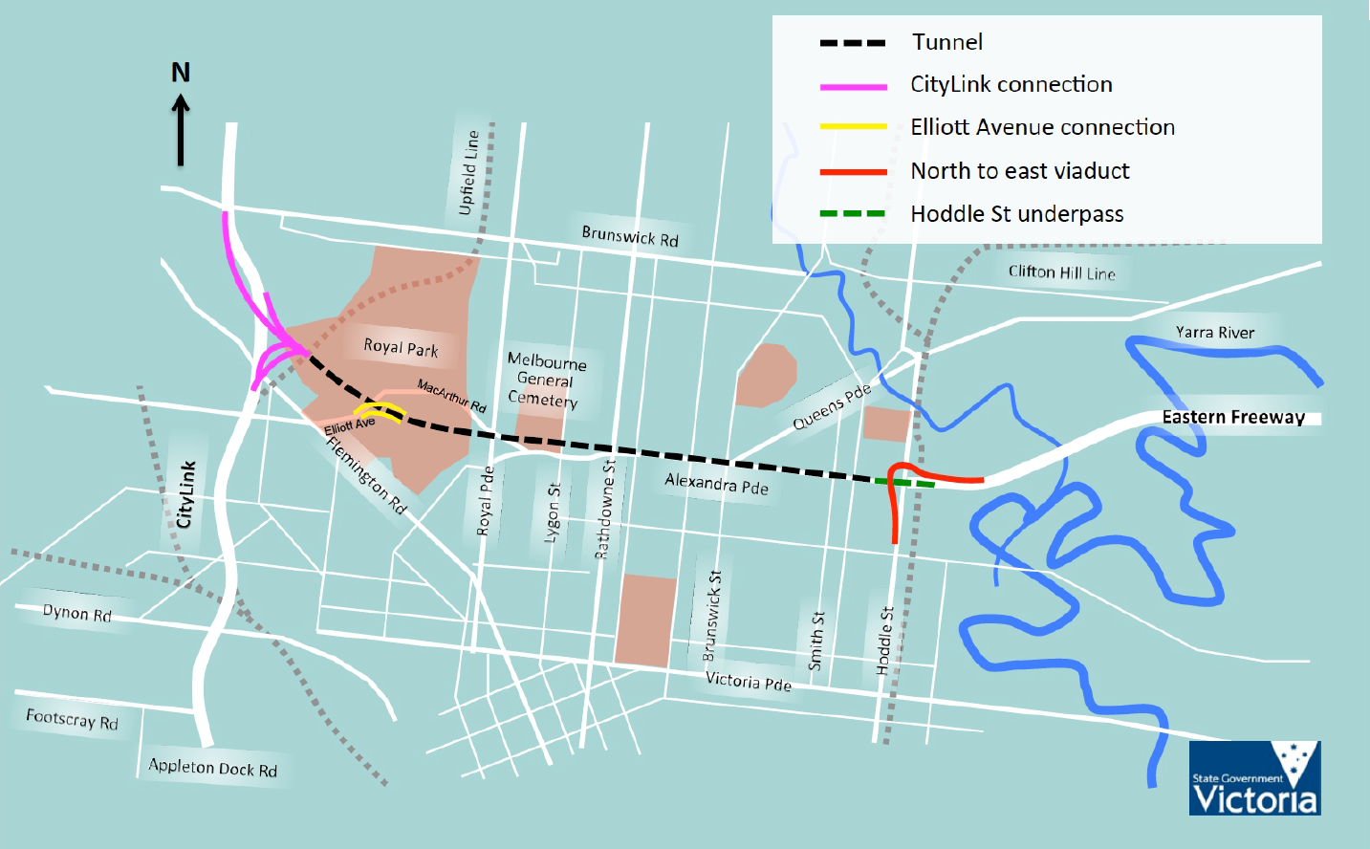
Figure 1: Base case designs solution of the East-West Link (Eastern Section), not including ancillary upgrades or the extension to the port (Victorian Government, 2013, p. 89)

Mega Projects and the Problem-Solution Nexus
The madness of mega projects has been extensively explored in the literature. MUTPs are attractive because they promise rapid and vast transformation of the city or the region, by promising social, economic, or environmental transfiguration. They are colossal in size and scope, and provoke a sense of awe and sublime (Trapenberg Frick, 2008). They are vastly expensive, and often under-costed (Siemiatycki, 2009). In addition to cost over-runs, the forecast benefits are often not met after project completion, an issue expanding as the scope of projects expands (Flyvbjerg, 2007). Further, MUTPs problematise strategic spatial and transportation planning, by substituting effective planning practices with infrastructure projects (Dodson, 2009). An important assumption of much of the prior work on MUTPs (for example, Kumaraswamy and Morris, 2002, Altshuler and Luberoff, 2003, Rothengatter, 2008, Samset, 2008) is that the planning process is rational and linear and that an objective analysis of problems comes before a decision on the solution, as outlined by Banister (2002). Our approach differs as it embraces an observable circularity in the infrastructure planning.
This paper is the product of a larger research project examining the arts of government of Melbourne’s EWT. Our approach in this research, and our understanding of PSN, is based in the governmentality texts. This research understands governmentality in the ‘arts of government’ sense, relating to the mentalities and operation of power in an organised society (Dean, 2010). Governmental power, per Foucault (1991), is polyvalent and productive, and is exercised by regulating biological, social, and personal conducts (Huxley, 2008, Dean, 2010). Arts of government are illustrated through an examination of the forms of knowledge, technology, and rationality (Dean, 2010), expressed through the texts, speech, and actions of government (Rose et al., 2006). Of particular interest in this paper are the sets of calculative technologies (Miller and Rose, 1990) used in the EWT project.
PSN is the phenomenon through which a perceived problem and a proposed solution arise recursively and iteratively over the lifespan of a project, and is observed by documenting changing practices of technical rendition. As the programmatic translation of the will to improve (Li, 2007), the problem-solution nexus relates to the technical rendition of fields of intelligibility (Dean, 2010) through practices of calculation and the setting of boundaries around the knowable (see Miller and Rose, 1990). The result of technical rendition is that “the identification of a problem is intimately linked to the availability of a solution. [Problem and solution] coemerge within a governmental assemblage in which certain sorts of diagnoses, prescriptions, and techniques are available to the expert who is properly trained” (Li, 2007, p. 7). Technical rendition also translates the political-economic into terms knowable within the field of intelligibility, which “limits and shapes what improvement becomes” (Li, 2007, p.8). Through these processes, problems are rendered solvable, which provides political impetus for action, because the governmentalised State is supposed to solve problems (Sturup, 2015).
Although Li (2007) concentrated on development projects in the highlands of Sulawesi, the concept of problem-solution nexus also illuminates the aforementioned quirks of MUTPs. Sturup (2010) demonstrates that the Cross-City Tunnel in Sydney, NSW, was initially to provide streamlined car parking access under major retail centres, creating additional surface capacity for cross-city trips. Its next iteration was a shorter version than that eventually built, and was purported to solve the problem of cross-city traffic causing congestion on surface streets – the opposite of its first iteration! The final version, almost twice the length of the second version, was extended once more to facilitate a new pedestrian boulevard on reclaimed surface streets (Sturup, 2010). The rationalities used to justify the project slowly shifted – from removing conflicts between different road users, to providing improved amenity and streetscapes to local residents. Problem and solution, in the case of the CCT, were iteratively defined through processes of technical rendition.

Methods
The EWT was chosen as a case study as it presented a timely opportunity to explore mentalities in an MUTP that was unsuccessful. Sturup’s (2010, 2015) previous inquiries focused on projects that were successfully completed. We saw this framing as useful because we wanted to demonstrate that the presence of mentalities of mega projects were not related to the success, or lack thereof, of mega projects. The mentalities of government specific to MUTPs include the problem-solution nexus, explored in this paper in more detail, sovereign power structures in decision-making processes, and the sublime of project (Sturup, 2010, 2015). Existing work in a mentalities framework on the EWT has demonstrated that the problem-solution nexus appears to be the least stable of these mentalities in the EWT (Sturup et al., 2015), and as such, warrants further exploration.
The main sources of data for this research are official planning and project documents outlining the various iterations of the EWT, supplemented with periodical articles. These documents are outlined in the following sections. The timeframe in question is from 2003-2014, which is the lifespan of the most current iteration of the project. Our analysis identifies throughout the planning documents discussion of transportation problems, and the form of the solution attached to those problems. Problems are categorised thematically per their core technologies: travel demand forecasting as a technology of engineering, and benefit-cost analysis as a technology of accounting.

Findings
This section describes the evidence for the presence of a PSN occurring within the project. Firstly, we present a brief historical overview of the forms of the project, from its first appearance in the 1960s, to its current iteration in the 2010s. We then move to the problematisations in the planning documents, demonstrating the eventual return of project proponents to the tunnel – each time using differentiated justification techniques. This is not an exhaustive list of mentions of a tunnel solution; such a task is beyond the scope of this paper. It is a representative sample that we use to demonstrate how problematisations changed over time in the EWT. We identify two central aspects of the technical rendition of the EWT: travel demand forecasting and technologies of engineering; and benefit-cost analysis and technologies of accounting. Together, these technologies suggest that both solution and problem exist as evolving narratives, in which project proponents use each of the technologies to produce agreement.

Key Documents and Moments of the Life of the East West Tunnel
Solutions like the EWT have been proposed numerous times over the past half-century. The EWT first appeared during the 1960s during the first wave of comprehensive transportation plans. The 1969 Melbourne Transportation Plan proposed an extensive grid of motorways across metropolitan Melbourne, which included a route corresponding to the EWT project (Metropolitan Transportation Committee, 1969). The route would cut through the established urban areas of Carlton, Fitzroy, Collingwood, and other inner suburbs – but on the surface, rather than as a tunnel. Slated for construction in the 1971 Planning Policies for Metropolitan Melbourne, as part of a larger Eastern Freeway route (Gleeson et al., 2003), the segment that looked like the EWT was scrapped in March 1973 in the face of fiercely organised and active residents’ groups (Rundell, 1985). Construction continued on the segment now known as the Eastern Fwy. In the early 1990s, a proposal like the EWT, but terminating at Nicholson Street in Carlton, was similarly scrapped: this time more fiercely organised community groups constructed ramparts of household junk in the median of the corresponding cross-town route (Farrant, 1994).
In 2003, the Northern Central City Corridor Strategy Draft (NCCCSD) (Department of Infrastructure, 2003) presented two optional road tunnel solutions – a direct, east-west tunnel under Alexandra Parade, Princes Street, and Royal Park (like EWT), and a tunnel towards the Melbourne CBD. Its concern was mainly around increasing public and active transportation mode share, while improving local amenity, within the context of the Melbourne 2030 metropolitan strategic plan. The NCCCSD analysed passenger and freight movements in the inner-north area of Melbourne, bounded by the CityLink to the west and the Eastern Fwy terminus to the east (see Figure 2) – specifically chosen because “it is the primary area of influence of a possible road tunnel link” (Department of Infrastructure, 2003). Given the high cost of constructing either tunnel solution, the NCCCSD recommended that “due to their high cost in comparison to their benefits no further investigation should take place on road tunnel options in the inner north” (Department of Infrastructure, 2003). For the EWT-like tunnel, the analysis was uncertain about the project’s ability to reduce traffic on surface streets due to induced traffic (Department of Infrastructure, 2003). The solution instead was to improve relevant railway lines, tram routes, and cross-town bus services, alongside a suite of land-use, parking, and active transportation measures.
Problematisation of cross-town travel also occurs in the 2006 transportation strategy, Meeting Our Transport Challenges (MOTC), however this is done without reference to a solution like the EWT (Department of Infrastructure, 2006). Primarily the problematisation occurs around congestion and efficacy of the M1 Corridor within a broader context of the metropolitan region – much broader than the NCCCSD. The M1 is characterised as having multiple roles – as a commuter route to the CBD, and as a freight route around the Port of Melbourne – and that it is close to capacity and that this will only worsen. It presents as a solution the implementation of several high-quality (for Melbourne, at least) orbital bus routes and improved bus services along the Eastern Fwy. It also suggests further problematisation of east-west travel in the form of a technical assessment.
The East West Link Needs Assessment (Eddington Report), conducted in 2008 by Rod Eddington (Eddington, 2008), undertook the problematisation suggested by MOTC. It is in the Eddington Report that the EWT project in its most recent form begins to take shape. The Eddington Report considers a wider study area than NCCCSD (see Figure 3), but more constrained than MOTC, which nonetheless leads to specific ways of problematising. In this frame, there is an overreliance on the M1 Corridor, because Melbourne only has two cross-town motorways (the other being the Metropolitan Ring Road, much further to the north). Other cross-town routes are constrained because of the Maribyrnong and Yarra Rivers, and nonetheless are not suited to regional traffic. These cross-town routes are important because of surplus population in the western suburbs that travels towards the east for employment, education, and recreation. Freight movement from the Port of Melbourne further complicates this picture.

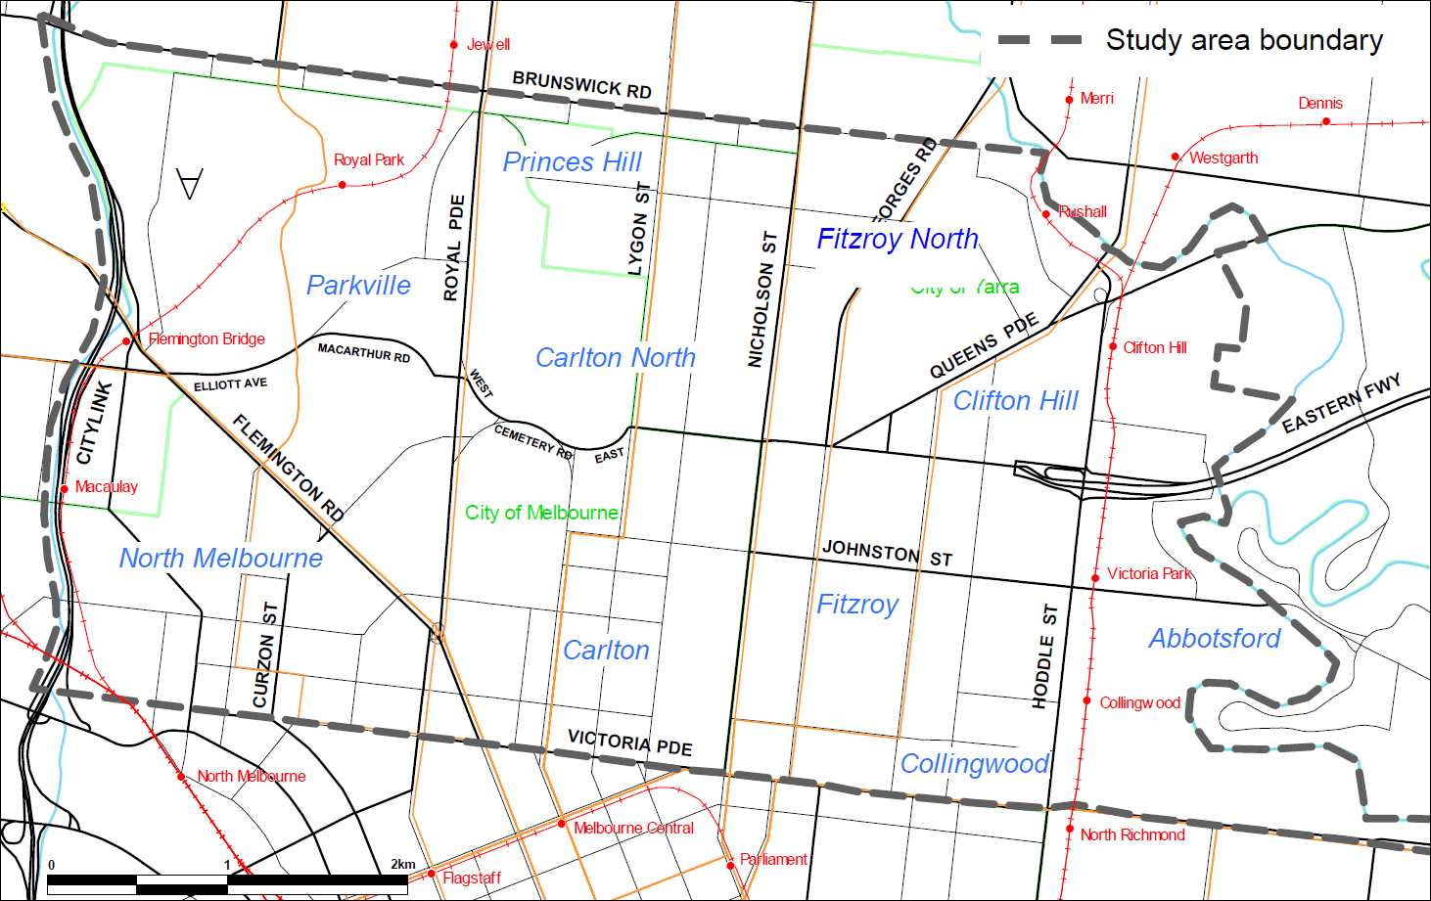
Figure 2: Study area of the Northern Central City Corridor Strategy Draft (Department of Infrastructure, 2003, p. 2).
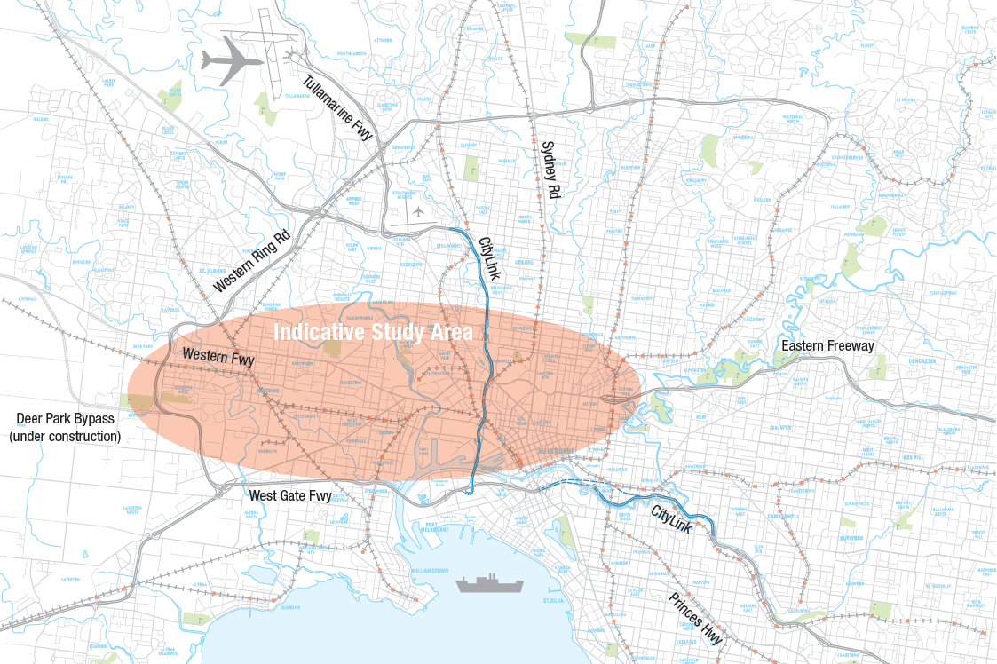
Figure 3: Study area of the East West Link Needs Assessment (Eddington, 2008, p. 13)
The Eddington Report presented a large package of MUTP solutions, and a staging mechanism: its intent was to begin a pipeline of infrastructure construction, including a three-stage East-West Link, from the Western Ring Road in Sunshine to the Eastern Fwy terminus in Abbotsford. The first stage was a short tunnel, running underneath Footscray, to connect the Port of Melbourne with Geelong and Sunshine Roads. The second stage was the eastern half of the East-West Link (the EWT of this paper), and the third stage is the remaining western section of the road link. The full East-West Link and the other projects presented in the Eddington Report were to improve the economic and social disadvantage of the western suburbs, while providing more resilient transportation connections.
Later in 2008, the Government of Victoria released an updated metropolitan transportation strategy: the Victorian Transport Plan (VTP) (DTPLI, 2008). This plan incorporated Stage 1 of the Eddington Report, because it responded most effectively to the greatest perceived need – an additional crossing of the Maribyrnong River to act as an alternative to the West Gate Bridge. A combined first and third stage from the Eddington Report, known as ‘Westlink’, eventually appear in the Commonwealth Government’s Infrastructure Australia priority lists (Infrastructure Australia, 2010), which is eventually expanded to the entire East-West Link (i.e. all three stages) (Infrastructure Australia, 2012).
Planning concerns for the project were outlined in an updated metropolitan land-use and transportation strategy, Plan Melbourne (PM14) (DTPLI, 2014). In this 2014 proposal, the eastern section (the EWT) was to be constructed first, and the western section (with an additional crossing of the Maribyrnong) coming later. At this point, the Commonwealth priority lists included only the eastern section of the full EWL (Infrastructure Australia, 2013). This solution is presented in more detail in the East-West Link Business Case (EWTBC) from March 2013 (Victorian Government, 2013).
There is a familiar set of justifications for the PM14/EWTBC version of the EWT. It is similar to the earlier documents. The full EWL would “transform the way people move around Melbourne, help alleviate our reliance on the M1 corridor for cross-city road connections, and provide greater resilience in the transport network” (Victorian Government, 2013). Unlike previous iterations, though, the eastern section would be constructed before the western section – this, per the EWTBC, would fix congestion at the Eastern Fwy terminus by connecting disconnected freeways, allow for a new cross-city link, and improve north-south public transport routes. The issue of a lack of river crossings, as stressed in the Eddington Report and VTP, is less prominent in the PM14/EWTBC problematisation – a useful discursive shift, as the EWT does not cross the Maribyrnong or the Yarra.
The main problems identified in these analyses of east-west traffic and the solutions of various iterations, in some form or another, relate to travel and economic value. Firstly, there is a strong, ongoing discourse relating to freeway termination being problematic. This links in to a generalised discourse about the ‘mixing’ of local and regional traffic and the predictions of future congestion. Secondly, tunnelling is expensive, and the problematisations in these documents seek to engage with the costs relative to benefits of such a project. It is around these two main discussions that there were attempts to forge a PSN, so in the next sections, we examine in more detail the specific attempts to render the problem technical using travel demand forecasting and benefit cost analysis.

The Problem of Freeways that Just End
Each of the source documents each make reference to a forecast or a model of some sort. In the following sections, we consider how the EWT was problematised and rendered technical using techniques of travel demand forecasting. These take form throughout the discursive formations of network completion, congestion, traffic hierarchies, etc. Each source document recognises the Eastern Fwy terminus, cross-city traffic, and rising congestion as major ‘problems’, however, there is some variation in the available solutions. We contend that changes in project form may be traced against the changes in outputs of the technology used to frame the problem. Further, studies in which modelling is structured around road network bottlenecks will unsurprisingly produce solutions that are roads. The solution is defining the problem, and vice versa.
The ‘disconnected freeway’ is a stable discursive formation in the source documents. As demonstrated in Figure 4, there are major ‘gaps’ in Melbourne’s road network. The horror of the freeway that ends takes place within logics of road hierarchies and technologies of civil engineering. These discourses hold that different roads have different purposes, local traffic should not mix with regional traffic, and traffic should be, where possible, as free-flowing, and fast as possible (Low et al., 2003). Freeways that end abruptly violate these laws, and act to further congestion in the road network. The NCCCSD, in part, was set up to consider whether an extension of the Eastern Fwy was justifiable. The Eddington Report was set up to assess the need for additional east-west links (Department of Infrastructure, 2006, Eddington, 2008). The study areas of these reports were geographically bounded at the east by the Eastern Fwy terminus. The NCCCSD, the Eddington Report, and PM14/EWTBC all agree that creating a motorway link along the project corridor would be solve the Eastern Fwy ending abruptly, allowing cross-town traffic to bypass local and arterial streets.

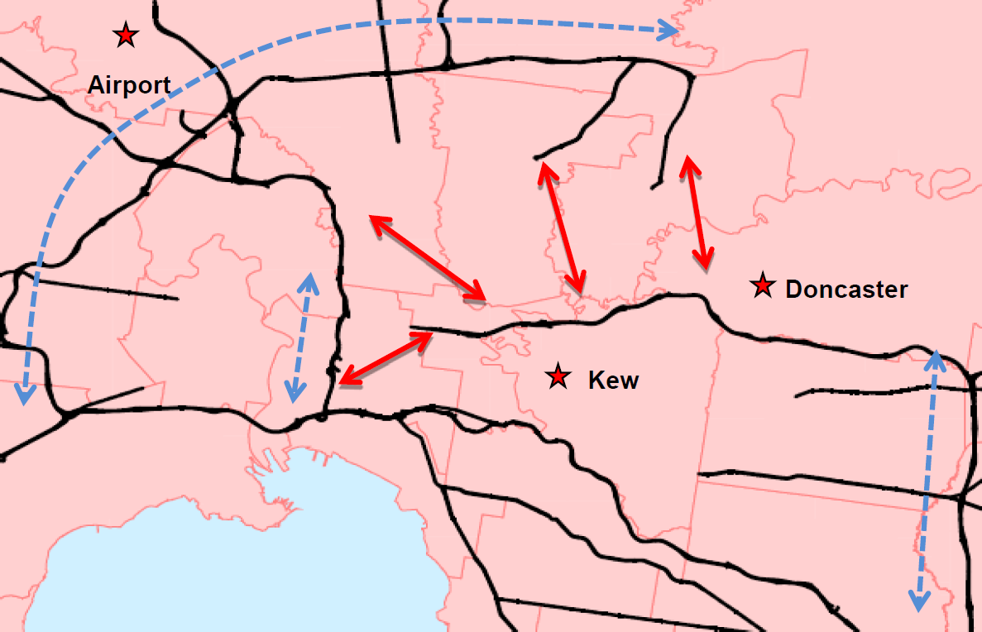
Figure 4: Selective representation of the major roads of Melbourne. Arterials/freeways are black, circumferential roads blue, and network ‘gaps’ red (Victorian Government, p. 35).
Cross-city traffic, and resultant congestion, however, are framed somewhat differently in each of the documents. This is reflected in the outputs of the travel demand forecasts produced for each of the reports (see Figures 5, 6, 7, & 8). The NCCCSD frames traffic congestion as being primarily a problem local to the (relatively small) study area – only 10% of vehicles completed the entire cross-town trip to the CityLink corridor. In the more regionally-focussed Eddington Report, the way in which ‘city’ and ‘cross-city’ are defined is different to the NCCCSD (compare Figs 2 & 3, for example). Using the Yarra and Maribyrnong as a screen line, the Eddington Report predicts 40% more traffic by 2031 – and recommends a new road link. Because NCCCSD did not extend as far as the Eddington Report geographically, its understanding of the problem of cross-town traffic was substantially different. The inclusion of the greater western suburbs in the Eddington Report traffic modelling renders the solution more viable.
An additional justification for the EWT emerges in the Eddington Report – network resilience. This is discussed primarily in terms of ‘what would happen if the Westgate Bridge were out of action for an extended period’, or similar lines. The traffic models predict chaos – so both the Eddington Report and the EWTBC argue that a full east-west link is needed to provide additional river crossings and capacity in the motorway network. Interestingly, the EWT under consideration in this paper did not actually cross either the Yarra or Maribyrnong Rivers, so it is not clear how the tunnel was to solve the river crossing problem. Network resilience discourse is not readily observed in NCCCSD, which may be due to its more constrained geographical scope. NCCCSD did not extend to either river and could therefore its field of intelligibility did not include river crossing issues.
The definition of east and west plays an important role in the technical rendition of travel in the EWT project. When the geographical scope of the respective transport studies is changed – or, when the mode of technical rendition is altered – the available solutions change. A tunnel-solution is presented in NCCCSD because of perceived traffic problems. The tunnel-solution is rejected, because the traffic problems are not big enough. Traffic is measured differently in subsequent documents, making a tunnel an increasingly viable solution. It is here, through technologies of travel demand forecasting, that we see attempts to construct a problem-solution nexus based around east-west travel.

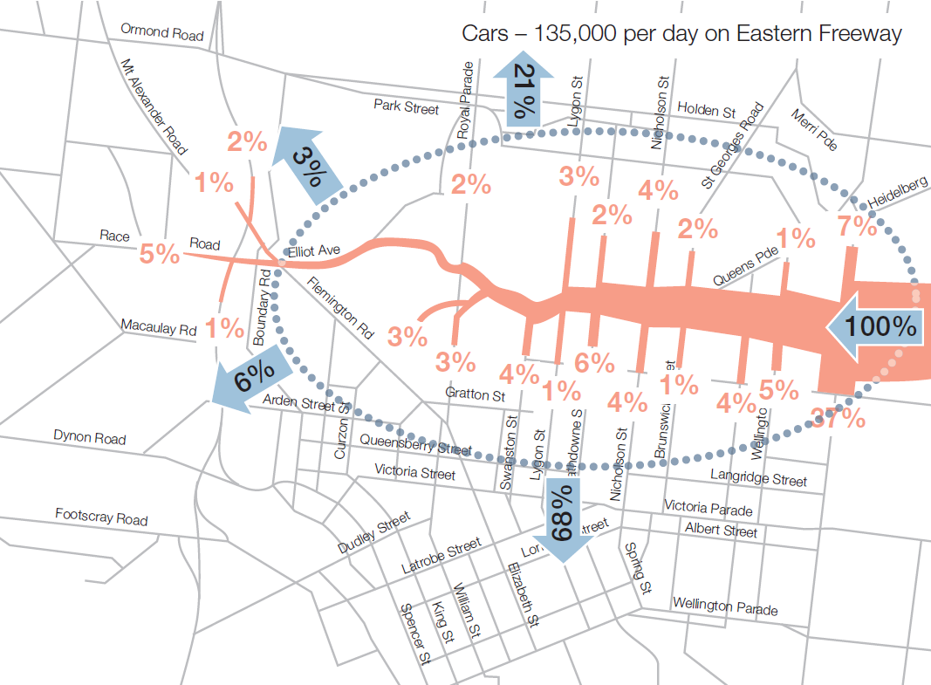
Figure 5: Traffic distribution from the Eastern Fwy into inner metropolitan Melbourne, as modelled by NCCCSD, but re-mapped for the Eddington Report (Eddington, 2008, p. 130)
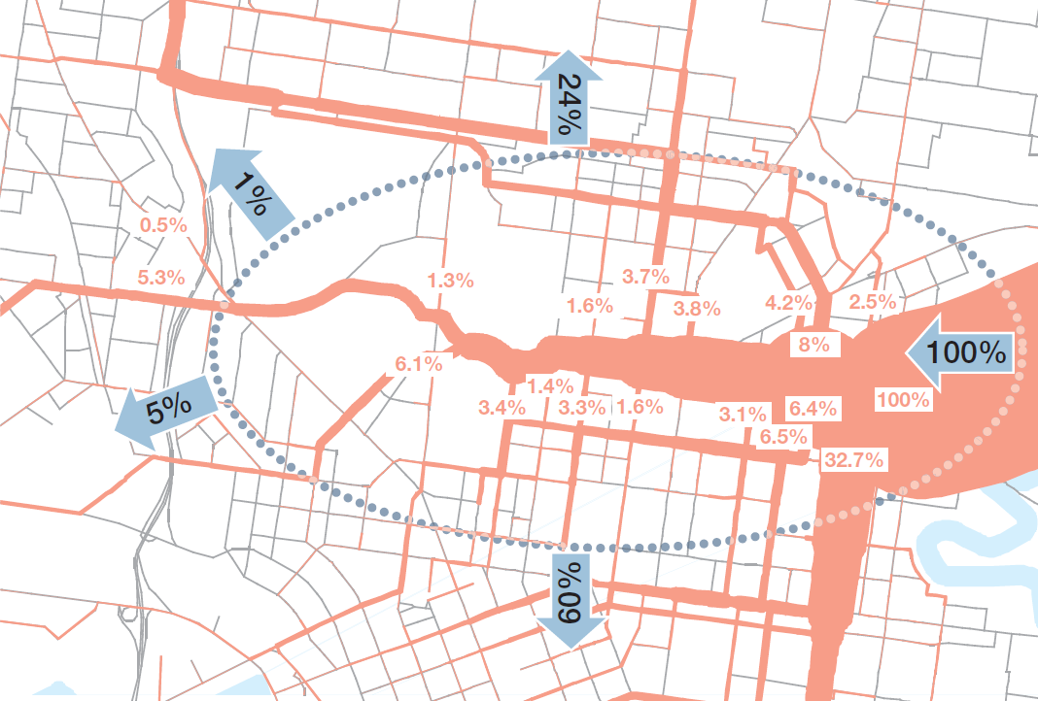
Figure 6: Traffic distribution from the Eastern Fwy into inner metropolitan Melbourne, using the same inputs as NCCCSD, but re-modelled for the Eddington Report (Eddington, 2008, p. 130).

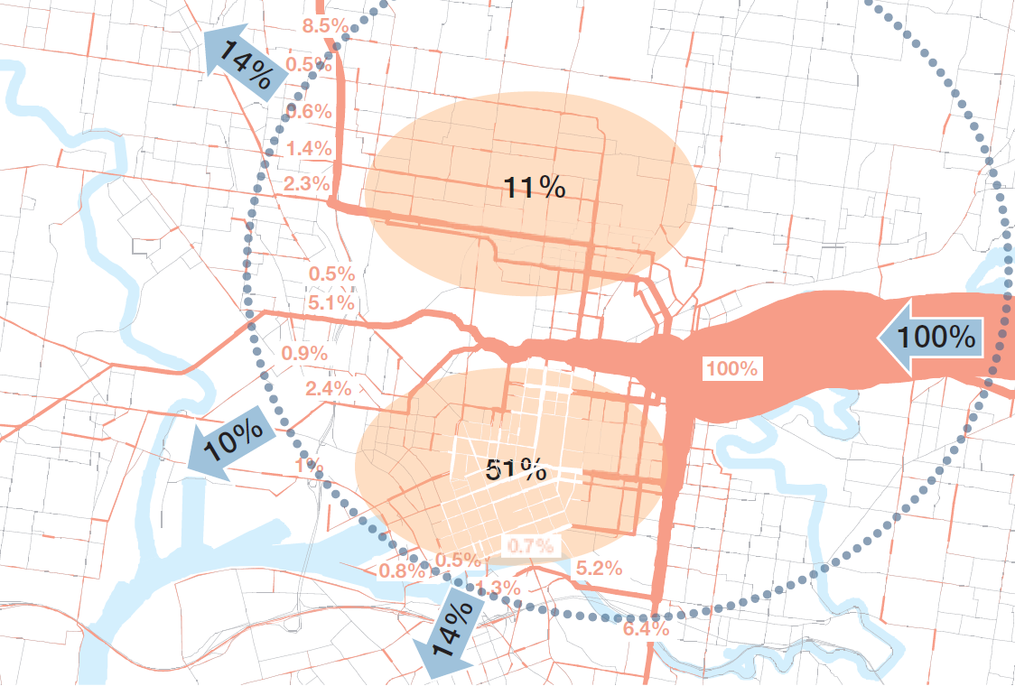
Figure 7: Traffic distribution from the Eastern Fwy into inner metropolitan Melbourne, as modelled for the Eddington Report (Eddington, 2008, p. 131)
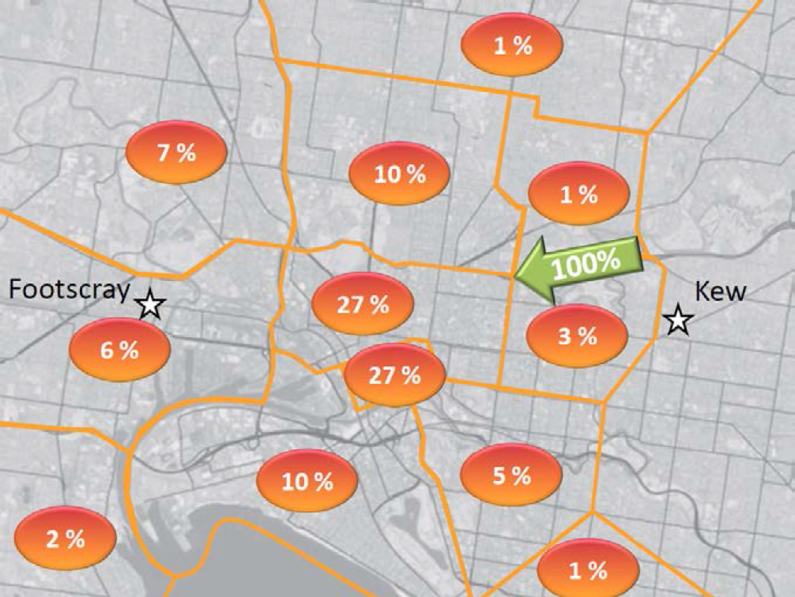
Figure 8: Traffic distribution from the Eastern Fwy into inner metropolitan Melbourne, as modelled for the EWTBC (Victorian Government, 2013, p. 13)

The Problem of Value for Money
Road construction and tunnelling is a costly endeavour. As part of the development of a problem-solution nexus, the financial costs of construction and operation are compared to the potential economic benefits of the project. The specific technology used in the technical rendition of costs and benefits is benefit-cost analysis (BCA), which considers the welfare effects of project implementation and non-implementation against a base case (Rouwendal, 2012). The economic benefit of a project should be higher than its financial costs. BCA appears to be an important technology used in PSN formation, because it speaks of the viability of the solution in an economic sense. This section tracks the evolving use of forms of BCA technologies in the construction of the EWT’s PSN.
Each of the iterations of the EWT family of projects recognises the potentially large direct benefits of an EWT solution. Infrastructure projects are understood to have wide-ranging economic benefits, including, for the EWT, “travel time savings, reduced vehicle operating costs, fuel savings, accident reductions, reduced carbon dioxide emissions, increased agglomeration, and attraction of greater labour supply” (Victorian Government, 2013). While the NCCCSD recognised the potential benefit of an EWT project in removing traffic from Royal Park, a tunnel, and any further discussion of a tunnel, was not recommended because of the predicted high cost compared to benefits. A project like the EWT would be “unlikely to give economic returns in proportion to the investment required, [and] the high level of investment required will divert resources from investment in other transport needs” (Department of Infrastructure, 2003). This was not, however, conducted as a formal BCA.
This story begins to change with the Eddington Report and the 2013 Business Case, in which benefit-cost analysis is used formally and specifically. The Eddington Report presented a benefit-cost analysis of the megaproject pipeline proposed therein. The total package of projects would cost an estimated AU$15 billion, with the EWT being approximately AU$5.5 billion (Eddington, 2008). The benefits in the Eddington Report, however, are only presented in aggregate across all projects. The 2013 Business Case included numerous BCRs of various solution configurations, with a financial cost of AU$6.8 billion. A summary of the BCRs is presented in Table 1.
Table 1: Comparison of the different modes of benefit-cost analysis on some of the EWT iterations (Eddington, 2008, Victorian Government, 2013).
 | Traditional BCR | BCR including WEBs
Eddington (all projects) | 0.74 | 0.94-1.36+
EWTBC | 0.45 | 0.84
EWTBC + Extensions | 0.73 | 1.19
EWTBC (Surface option) | 2.35 | 4.62

In both the Eddington Report and the EWTBC, project proponents incorporated wider economic benefits (WEBs) into the BCA, which makes the BCR marginally positive. That is, traditional measurement of direct project costs (i.e. construction and operation) versus direct project benefits (travel time savings, decreased fuel costs, decreased accident costs) was not able to justify any of the solution iterations, with the major exception of the EWTBC’s surface option (which would place a surface freeway through a densely developed urban area – the disbenefits of which are recognised to be not fully costed). The inclusion of WEBs renders the project/s worthwhile because these (mostly) push the BCR above one – where the traditional, direct approach for the EWT indicated that the project was not worth it. A visible and documented change in the method of technical rendition of a project has resulted in the viability of the solution. While the BCA presented in the NCCCSD was rudimentary, at best, this nonetheless demonstrates how the technology used in PSN formation was changed and altered for the solution to appear viable. When rendered technical through traditional modes of BCA, the EWT was not a viable solution. For the EWT to become a viable solution, the boundaries of the “intelligible field” (Ferguson, in Li, 2007, p. 7) of the project had to be broadened.

Conclusions
The problem-solution nexus limits available solutions in terms of specified problems, while also working to limit available problems in terms of specified solutions, meaning that the solution that eventually arises should not be understood as selected based solely on its capacity to solve some pre-existing problem. The merits of the solution are based on the definition of the problem that the solution exists to solve, which creates a higher probability that it will solve the problem thus defined. We demonstrated this in the case of the EWT by exploring how the technologies of travel demand forecasting and benefit-cost analysis were shifted. Changing the mode of technical rendition – such as the addition of WEBs in BCA – can act to make solutions appear more viable. We do not argue for or against the relative merits of an idealised, rational approach to infrastructure planning, which could likely be considered a technology itself. Nor do we expect to stamp out the practice of problems and solutions co-generating each other. We ask questions of reflection, to try to identify where PSNs occur in practice, and to allow for possibility that other competing modes of technical rendition might be incorporated into transportation decision-making – such as technologies of participatory governance. Given the instability and ineptitude of travel demand forecasting (Nicolaisen and Driscoll, 2014) and benefit cost analysis (Rouwendal, 2012), different ways of knowing transportation problems and solutions can only serve to improve decision-making.
The East West Link (Eastern Section) remains a contentious issue in the hearts of many in Melbourne – there is a sense of victory in the segments of the community that resisted the project, and there remains anger at the millions of dollars paid to not build a road. Exploring the problem-solution nexus in further detail, though, has revealed that the EWT has never been a stable project. Given the recent controversies around MUTPs in Australia, further research along these lines could be fruitful: including the recently-cancelled Roe 8 in Perth, which was to damage wetlands to improve freight transit, the currently contentious WestConnex in Sydney, which daily appears to grow larger in scope and cost and purpose, and the West Gate Tunnel, effectively a shortened version of the Western Section of the greater East-West Link, which was proposed not by the State but by a private infrastructure firm. The latter, however, potentially demonstrates that despite the cancellation of the EWT, nothing much has changed in transportation planning in Melbourne.
References

Altshuler, A. & Luberoff, D., 2003. Mega-Projects: the Changing Politics of Urban Public Investment Washington, USA: Brookings Institution Press.
Banister, D., 2002. Transport Planning, 2nd ed. London: Spon Press.
Dean, M., 2010. Governmentality: Power and Rule in Modern Society, 2nd ed. London, UK: Sage.
Department of Infrastructure, 2003. Northern Central City Corridor Strategy Draft. Melbourne, Australia: State of Victoria.
Department of Infrastructure, 2006. Meeting Our Transport Challenges: Connecting Victorian Communities. Melbourne, Australia: State of Victoria.
Dodson, J., 2009. The ‘Infrastructure Turn’ in Australian Metropolitan Spatial Planning. International Planning Studies, 14, 109-123.
DTPLI, 2008. The Victorian Transport Plan. Melbourne, Australia: State of Victoria.
DTPLI, 2014. Plan Melbourne: Metropolitan Planning Strategy. Melbourne, Australia: State of Victoria.
Eddington, R., 2008. Investing in Transport - East West Link Needs Assessment. In Dtpli (ed.) Melbourne, Australia: State of Victoria.
Farrant, D., 1994. Freeway Protesters Keep Watch on Junk [online]. Fairfax Media. Available from: http://newsstore.fairfax.com.au/apps/viewDocument.ac;jsessionid=9EE37FFEF1C40487E280DD21399B61DF?page=1&sy=age&kw=Freeway+protesters+keep+watch+on+junk&pb=all_ffx&dt=selectRange&dr=entire&so=relevance&sf=text&sf=headline&rc=10&rm=200&sp=0&clsPage=1&docID=news941016_0247_8813 [Accessed Access Date 2015].
Flyvbjerg, B., 2007. Policy and Planning for Large-Infrastructure Projects: Problems, Causes, Cures. Environment and Planning B: Planning and Design, 34, 578-597.
Foucault, M., 1991. Governmentality. In G. Burchell, C. Gordon & P. Miller (eds.) The Foucault Effect: Studies in Governmentality with Two Lectures by and an Interview with Michel Foucault. Hertfordshire: Harvester Wheatsheaf.
Gleeson, B., Curtis, C. & Low, N., 2003. Barriers to Sustainable Transport in Australia. In N. Low & B. Gleeson (eds.) Making Urban Transport Sustainable. Hampshire, UK: Palgrave Macmillan.
Huxley, M., 2008. Space and Government: Governmentality and Geography. Geography Compass, 2, 1635-1658.
Infrastructure Australia, 2010. Getting the Fundamentals Right for Australia's Infrastructure Priorities: an Infrastructure Australia Report to the Council of Australian Governments. Canberra, ACT: Commonwealth of Australia.
Infrastructure Australia, 2012. Australian Infrastructure Progress and Action: a Report to the Council of Australian Governments, June 2012. Canberra, ACT: Commonwealth of Australia.
Infrastructure Australia, 2013. Infrastructure Priority List Update - December 2013. Canberra, ACT: Commonwealth of Australia.
Kumaraswamy, M.M. & Morris, D.A., 2002. Build-Operate-Transfer-Type Procurement in Asian Megaprojects. Journal of Construction Engineering and Management, 128, 93-102.
Li, T.M., 2007. The Will to Improve: Governmentality, Development and the Practice of Politics Durham, London: Duke University Press.
Low, N., Gleeson, B. & Rush, E., 2003. Making Believe: Institutional and Discursive Barriers to Sustainable Transport in Two Australian Cities. International Planning Studies, 8, 93-114.
Metropolitan Transportation Committee, 1969. Melbourne Transportation Study / Prepared for Metropolitan Transportation Committee by Wilbur Smith and Associates and Len T. Frazer and Associates. Carlton, VIC: Metropolitan Transportation Committee.
Miller, P. & Rose, N., 1990. Governing economic life. Economy and Society, 19, 1-31.
Nicolaisen, M.S. & Driscoll, P.A., 2014. Ex-Post Evaluations of Demand Forecast Accuracy: A Literature Review. Transport Reviews, 34, 540-557.
Rose, N., O'malley, P. & Valverde, M., 2006. Governmentality. Annual Review of Law and Social Science, 2, 83-104.
Rothengatter, W., 2008. Innovations in the Planning of Mega-Projects. In H. Priemus, B. Flyvbjerg & B. Van Wee (eds.) Decision Making on Mega-Projects: Cost-Benefit Analysis, Planning and Innovation. 1st ed. Cheltenham, UK: Edward Elgar, 66-84.
Rouwendal, J., 2012. Indirect Effects in Cost-Benefit Analysis. Journal of Benefit-Cost Analysis, 3, 1-27.
Rundell, G., 1985. Melbourne Anti-Freeway Protests. Urban Policy and Research, 3, 11-21.
Samset, K., 2008. How to Overcome Major Weaknesses in Mega-Projects: the Norwegian Approach. In H. Priemus, B. Flyvbjerg & B. Van Wee (eds.) Decision Making on Mega-Projects: Cost-Benefit Analysis, Planning and Innovation. 1st ed. Cheltenham, UK: Edward Elgar.
Siemiatycki, M., 2009. Delivering Transportation Infrastructure Through Public-Private Partnerships: Planning Concerns. Journal of the American Planning Association, 76, 43-58.
Victorian Government, 2013. East West Link Business Case - 22 March 2013. Melbourne, Australia: State of Victoria.
Sturup, S., 2010. Managing Mentalities of Mega Projects: the Art of Government of Mega Urban Transport Projects. University of Melbourne.
Sturup, S., 2015. The Problem/Solution Nexus and its Effect on Public Consultation. In R. Leshinsky & C. Legacy (eds.) Instruments of Planning: Tensions and Challenges for More Equitable and Sustainable Cities. New York: Taylor and Francis.
Sturup, S., Pittman, N. & Day, J., 2015. Compelling and Perpetuating: How and Unpopular Infrastructure Project Stayed Alive in an Era of Public Consultation. Association of European Schools of Planning Annual Congress. Prague, Czech Republic.
Trapenberg Frick, K., 2008. The Cost of the Technological Sublime: Daring Ingenuity and the New San Francisco-Oakland Bay Bridge. In H. Priemus, B. Flyvbjerg & B. Van Wee (eds.) Decision-Making on Mega-Projects: Cost-Benefit Analysis, Planning and Innovation. Cheltenham, UK: Edward Elgar Publishing Ltd, 239-262.

For brevity, we refer to the Project henceforth as EWT, or East-West Tunnel.
First on the list was the Melbourne Metro Rail Tunnel, a modified version of which is in the initial stages of construction, and second was the Regional Rail Link, completed in 2015.
PM14 is used for clarity, as Plan Melbourne has subsequently been refreshed in 2017.
Controversially, the EWTBC was not actually made public until after the EWT was cancelled by the newly-elected State Government.
Travel demand forecasting is generally considered problematic, inaccurate, and unstable. See Nicolaisen & Driscoll (2014) for a thorough review of the accuracy problems in modelling.
This is the “estimated total risk adjusted capital cost” for the EWT per the 2013 Business Case. The figure does not include the additional extensions to the Port of Melbourne. The risk adjusted capital cost for all three sections is estimated at AU$16.1 billion.
The measurement of WEBs is considered problematic and unstable. In any given project, they are potentially negative, potentially positive, potentially non-existent, and ultimately heavily dependent on econometric model specification: proper consideration of WEBs is “practically impossible” (Rouwendal, 2012).

