Where is the compact city?: A method to monitor the implementation of compact activity centre policy

Mark Limb, Carl Grodach, Severine Mayere
Civil Engineering and Built Environment, Queensland University of Technology

Abstract: Metropolitan planning policy in Australia has focussed on creating more compact cities for the past twenty years. Yet the multi-nodal expression of Australian compact city policies has, to date, proven difficult to implement (Newton and Glackin 2014; Chhetri et al. 2013; Woodcock et al. 2011; Bunker 2014). Much of the existing research examining progress towards the compact city is based on data that is now 10 years old, thereby omitting the significant growth in infill residential development that has occurred more recently in Australian cities. In this presentation, we outline a new method to investigate longitudinal changes in population, land use, and built form in activity centres. We firstly describe the challenges involved in using common data sources and methods, before showing how the use of Google Street View, aerial imagery, and census data can be combined to overcome these challenges and provide a simple and accessible method to track changes indicative of the compact city. Preliminary findings from the application of this method to nominated activity centres in the Greater Brisbane area reveal signs of significant progress in some centres, however overall progress remains mixed. Future research that examines these results in combination with land use policy, transit accessibility, property valuations, and employment changes may highlight important implications for the planning of future compact city development.

Key Words: Compact city; Google Street View; Areal Interpolation; Urban Consolidation; Land Use Planning

Background and introduction
For the past 20 years, most Australian capital cities have been pursuing policies to reshape their urban form into a network of compact activity centres. These policies typically propose changes to the existing built form to create a polycentric network of more densely populated compact activity centres that concentrate mixes of higher density residential, employment generating services, and commercial uses. Policy makers argue that doing so will result in a range of environmental, economic, and social benefits. For more than a decade, these policies have been expressed in regional level planning documents that cover most Australian capital cities (Bunker 2014). Regional level centre planning has occurred since the 1950s and 60s, but often with disappointing results (Forster 2004; McLoughlin 1992). From the 1990s however, policy makers began to transfer concepts like “compact city” and “smart growth” to Australia under the label of “urban consolidation” (Dodson 2012). It was the purported sustainability benefits of urban consolidation that became a key driver for the adoption of policies that aimed to create regional and metropolitan land use patterns that concentrated housing, employment and services in a poly-nodal network of compact centres (Dodson 2012; Forster 2006). However like the previous attempts at metropolitan scale centres planning in Australia, progress towards refitting existing urban forms to this poly-nodal settlement pattern, particularly in the middle and outer rings of Australia’s largest cities, has been mixed (Newton and Glackin 2014; Chhetri et al. 2013; Woodcock et al. 2011; Bunker 2014). Moreover, existing research examining progress towards the compact city is often based on older data thereby omitting the substantial infill residential development that has occurred more recently in Australian cities.
The aim of this paper is to outline new methods to investigate longitudinal change toward urban consolidation. We first discuss the limitations of existing approaches to measure progress towards compact activity centre policy using conventional methods and data. We then outline how using Google Street View data and aerial imagery can overcome these issues, before describing a method that makes use of these sources. The preliminary results of this analysis informs further discussion on the potential of these data sources in methods to analyse changes to land use and the built form. We conclude with a discussion on the possibilities for the method’s future use.

Context and justification
Current approaches used to investigate compact activity centres typically rely on census data and/or other data such as building approvals and changes to cadastral boundaries. However there are challenges associated with using these approaches more broadly. The poly-nodal settlement pattern at the core of Australian attempts to establish more compact cities calls for the longitudinal analysis of discrete parts of a city or region; a task that is perhaps not as straightforward as it initially seems. Longitudinal analysis of this nature presents difficulties disentangling the changes associated with the identified activity centres in planning policies from broader measures of urban development. Land use data is often not freely or publically available at a detail that is sufficient for centre analysis, and data sources can differ in methodology and availability across state and local jurisdictions.
Using census data
Perhaps the most methodologically consistent analysis of the performance of Australian compact city policies comes from the Australian Government’s Bureau of Infrastructure, Transport and Regional Economics’ (BITRE) series of reports on “Population Growth, Jobs Growth, and Commuting Flows” (Bunker 2014). The BITRE reports specifically investigate the performance of activity centre policy and tends to give an optimistic tone of progress towards the compact city. In their report on South East Queensland for example, BITRE reports that “significant density gains occurred in SEQ’s regional activity…” , and that residential growth in activity centres has been greater than in other locations across the region (BITRE 2013, pp.102, 107). However 57% of activity centre population growth occurred in the Brisbane CBD, and 3 other centres that were formed as ‘masterplanned’ greenfield developments rather than the desired infill development in existing centres that is more typical of the requirements of South East Queensland’s activity centre policies. These typical centres exhibit far more modest levels of growth, in line with the regional average (BITRE 2013). The BITRE reports use 2001 and 2006 census data for their centres analysis.
Census data provides longitudinal data with detailed information on population and housing that is essential in developing an understanding of urban consolidation. This data is methodologically consistent in a census year, however, some geographic boundaries may not be precise in estimating population change over time. This creates problems for accurately studying consolidation in activity centres. For example, the South East Queensland Regional Plan (SEQRP) identifies centres using large “blobs” that are not spatially precise. In their study, BITRE therefore inferred a boundary for each activity centre based on local government plans (BITRE 2013). Boundaries of this nature will rarely align with census geographical boundaries, so BITRE selected the ABS “destination zones” that intersected with the local plan boundaries. It is not explicitly stated how population and dwelling data was assembled however the report does describe this process as being consistent with the approach used in their analysis of employment, where BITRE (2013, p.121) states that “population figures were not directly available at the destination zone level, and so were constructed from Census Collection District (CCD) data using an area-weighted concordance”. BITRE (2013, p.100) acknowledge that when using this approach “…the destination zone containing the centre is significantly larger than the activity centre itself. This means that population estimates for some activity centres may be higher than actual population within the centre.”
These boundary issues are further complicated by ongoing changes to the boundaries of Australia’s statistical geographic standards, including the substantial changes that occurred when the ABS switched from the Australian Standard Geographical Classification (ASGC) to the Australian Statistical Geography Standard (ASGS) with the 2011 census. This creates significant difficulties for researchers examining small geographical scale longitudinal urban change, as comparisons over time on exactly the same geographic area are not immediately possible. Other more consistent geographic boundaries used by the ABS (such as suburb and postal code boundaries) often bare little relation to the on the ground realities of a phenomenon to be studied, or are simply too coarse (Coffee, Lange and Baker 2016). The method used by Coffee, Lange and Baker (2016) provides a simple method to address this problem at lower scales, however their validation criteria could not be satisfied for the very small geographic scales required to understand changes in an activity centre.
Areal interpolation
One potential solution is the use of a technique commonly known as areal interpolation. Areal interpolation uses the data from source zones (such as census geographic boundaries) to develop an estimate of how that data is distributed in overlapping target zones with different geographic boundaries (Schroeder 2017). One of the simplest methods of areal interpolation is area weighting, where data is assigned to a target zone on the basis of the proportion of the area that it shares with the source zone/s. The problem with using this approach with population and dwelling count data is that it assumes that population and dwellings are evenly distributed in both the source and target zones (Reibel and Agrawal 2007). This was the method used by BITRE and it is clearly problematic in urban areas, such as within activity centres, where there can be very abrupt changes to population and dwelling densities. Such abrupt changes with this type of data also reduces the accuracy of the more complex “smoothing” techniques such as those sometimes available in geostatistical tools in GiS software (Reibel 2007).
To overcome these limitations, the area weighted method can be supplemented with additional data such as in the “target density weighting” method (Schroeder 2007) or the more commonly used method of “dasymetric” interpolation. Dasymetric methods introduce additional auxiliary data sets that assist in more accurately distributing source data in the target zone. The most commonly used form of auxiliary data sources are land cover and land use data, however other sources such as road networks have also been used (Schroeder 2017; Mennis 2015; Reibel and Agrawal 2007). Hawley and Moellering (2005) undertook a comparison of a variety of areal interpolation methods and found that the use of one dimensional road network data proved to be the most accurate. However, this measure is likely to be less accurate in existing areas (such as activity centres) as the pre-established road networks in existing urban areas tend to remain relatively consistent as an area develops. The second most accurate method was dasymetric interpolation using simple land cover data. Hawley and Moellering (2005) detail how the primary shortcoming of this method is related to the auxiliary data not having enough precision to distinguish between high and low density residential areas. The use of more precise auxiliary data in dasymetric methods such as zoning data (Mennis 2015) or more detailed land cover data identifies categories of residential density (Reibel and Agrawal 2007), therefore increases accuracy.
Finding appropriate auxiliary datasets can be difficult in the Australian context. Zoning data in Queensland for example is aspirational; it describes the land use intent for an area and therefore does not necessarily reflect existing uses. As the development assessment system is “performance based”, zoning also does not offer certainty of restriction of particular uses. Freely available land use data from the Queensland Government provides only a single residential category and we have been unable to obtain current and historical land cover data with pre-existing classifications that distinguish between different residential intensities. It is possible to classify and validate land cover using aerial imagery, however this process can be highly complex (Reibel and Agrawal 2007; Hussain and Shan 2016).
Using approval and cadastral data
Other sources of data can also be useful in directly monitoring compact activity centre development, particularly data recorded at the address level. In their study of Melbourne, Newton and Glackin (2014, p.126) make use of the Victorian Government’s yearly published Housing Development Data which provides for “lot-by-lot” data on “dwelling densities, residential yields of development projects, number and location of demolished dwellings, [and] the location of vacant lots”. They found that infill housing development is occurring in suburban Melbourne, however only a relatively small number of infill dwellings (14% of the total number of infill dwellings) can be attributed to policies to cluster development in and near nominated activity centres (Newton and Glackin 2014, p.133). The HDD dataset is an excellent source of dwelling information for urban researchers. Unfortunately not all states freely release similar data at the address level, nor historical versions of the data. For example, combining freely acquirable Queensland Government land use data with property address data could give address level dwelling counts, however the historical property address data was not available at the time we enquired.
Chhetri et al. (2013) made use of comparisons between property cadastral data from 2001 and 2006 in their analysis of designated activity centres under the Melbourne 2030 plan. Their analysis found a statistically insignificant correlation between population densities and the plan’s designated activity centres (Chhetri et al. 2013). As the authors acknowledge however, the use of cadastral data will not detect all new dwellings, particularly certain forms of multiple dwelling structures. This is a severe limitation and unfortunately even the necessary cadastral data is also not always available. Using Queensland as an example once more, although the current cadastral database is freely available, historical cadastral data is only released for a significant fee.
Other potential data sources include ABS Building Approval data such as used by Buxton and Tieman (2005). Although a good source of data on dwelling changes over time, this data is also based on standard ABS geographic classifications and is therefore subject to the issues previously discussed in relation to interpolating this data to different geographic areas. At the time of writing, this data was available from the SA2 level, with SA1 level data only available for a significant fee. Planning approvals are another potential source of address level data however, as Woodcock et al. (2011) highlight, they are often speculative in nature. They therefore do not necessarily identify actual changes to the built form, and the timing of the commencement of construction needs to be correlated with building approvals or direct site observations.

The above examples have shown some of the difficulties inherent in using a range of common data sources to monitor progress towards compact activity centres policy intents. Such research requires data that can be isolated to small areas with customised extents, be consistent and available across jurisdictional boundaries, and be periodically captured so that changes can be observed over time. There is a need for freely available data sources of land use, population and dwellings that meet these criteria.

Methods and preliminary findings
Given the extant problems with conventional approaches to measuring compact activity centres, we show how observations taken from Google Street View and aerial imagery can be of use in direct analysis, as well as indirectly as auxiliary data used with areal interpolation of census results, and apply this method to the Greater Brisbane area. Figure 1 provides an overview of the key steps involve in this method and further detail on each step is provided below.
Figure 1 - Overview of key steps of the method

Using Google Street View to Analyse Compact Activity Centre Progress
As activity centres are generally small geographic areas, it is possible to manually investigate changes in land use and built form by comparing Google Street View (GSV) images taken at different times. GSV allows for the direct comparison of images from approximately 2007 to more recent images (typically dated from 2015 to 2017). This direct observation of the built environment enables the recording of changes to the built form and land uses. The validity of the use of GSV to undertake built form observations has been demonstrated by a number of previous studies in other areas (Griew et al. 2013; Hwang and Sampson 2014; Kelly et al. 2013; Rundle et al. 2011; Vanwolleghem et al. 2014). Directly observing changes in the built form between two differently dated images obviously gives clear evidence of change, however in most instances the difference in time between available images is only five to ten years. One of the key benefits of direct observation is that the approximate age of each structure can also be estimated thereby providing historical estimates of the built form that extend beyond the oldest available GSV image. Initial estimates can be further verified through a comparison of historical to current aerial imagery, as well as data on building age available on real estate websites. Geographic Information Systems (GIS) assist greatly in recording and analysing this spatial data.
Our research is focused on the implementation of compact activity centre policy in the greater Brisbane conurbation. For the purposes of this research, the definition of “activity centre” has been drawn from metropolitan policy itself and is defined as an existing or proposed location that metropolitan level planning has identified to “support a concentration of activity including higher density living, business, employment, research, education and services” (The State of Queensland 2005, p.133). In the Brisbane conurbation, these centres are spatially identified in metropolitan policy and classified as either “principal” or “major” regional activity centres. This results in a total of 23 centres within a 35km radius of the Brisbane CBD. The 35km range roughly corresponds to the distance the greater suburban conurbation spreads North, South and Westwards from the CBD before changing into distinctly different cities, such as the Gold Coast. The greenfield centre of Ripley is still in its incipient stages of development, and was therefore excluded from further analysis.
The various iterations of the South East Queensland Regional Plan identify centres using large points that are not spatially precise. Extents shown in local government plans for centres were considered to be unsuitable to identify the spatial extent of the centres as they have not been developed with a consistent methodology, and often include large areas of low density residential uses that can be significant distances from the centre’s centre. As the regional planning intent for activity centres (as is also common with compact city principles) is based around transport orientated development principles, the primary public transport interchange of each activity centre was designated as a central point. The centre extent was then determined using a walkable catchment of 800m from these central points. The 800m distance is based on provisions from the latest draft regional plan, within which higher residential densities are sought (The State of Queensland 2016, p.36). Similar to the research undertaken by Newton and Glackin (2014, pp.131-132), a further 400m buffer area is added to the core centre extent to account for a “ripple effect exerting extra market pressures beyond the boundary onto surrounding properties”. The centre transit points were imported into a freely available “neighbourhood generator” tool that calculates walkable distances from points using street network data (AURIN 2016), and polygons of 800m and 1200m walkable catachments for each centre were generated. Using the street network to determine a walkable centre extent has the advantage of excluding areas that are segregated from the centre by physical barriers such as rivers and creeks, motorways, rail lines, and large holdings of private property.
The most current version of the Queensland Digital Cadastre Database was downloaded from the Queensland Spatial Catalogue and imported to ArcMap. Polygons representing transport infrastructure and water bodies were removed. The 800m and 1200m walkable catchment polygons were used to identify the intersecting lots from the cadastre. The selected lots formed the extent of each activity centre. New fields were added to an extract of the activity centre lots to record the observed GSV and aerial imagery data. Aspects captured included dates of the oldest and newest available GSV images, estimated building age, whether the land use had changed, current and previous use, current and previous number of storeys, current and previous frontage types, shopping centre names, and whether new development was visible on aerial imagery that was not visible on the latest GSV image.
Of these fields, the estimated building age is crucial in determining estimated land use at different time periods. Figure 2 below shows a sample image from GSV. The panel in the top left provides the date of the latest and past imagery, and allows the selection of other imagery that was captured between these dates.
Figure 2 - Example GSV image
Source: Google Street View
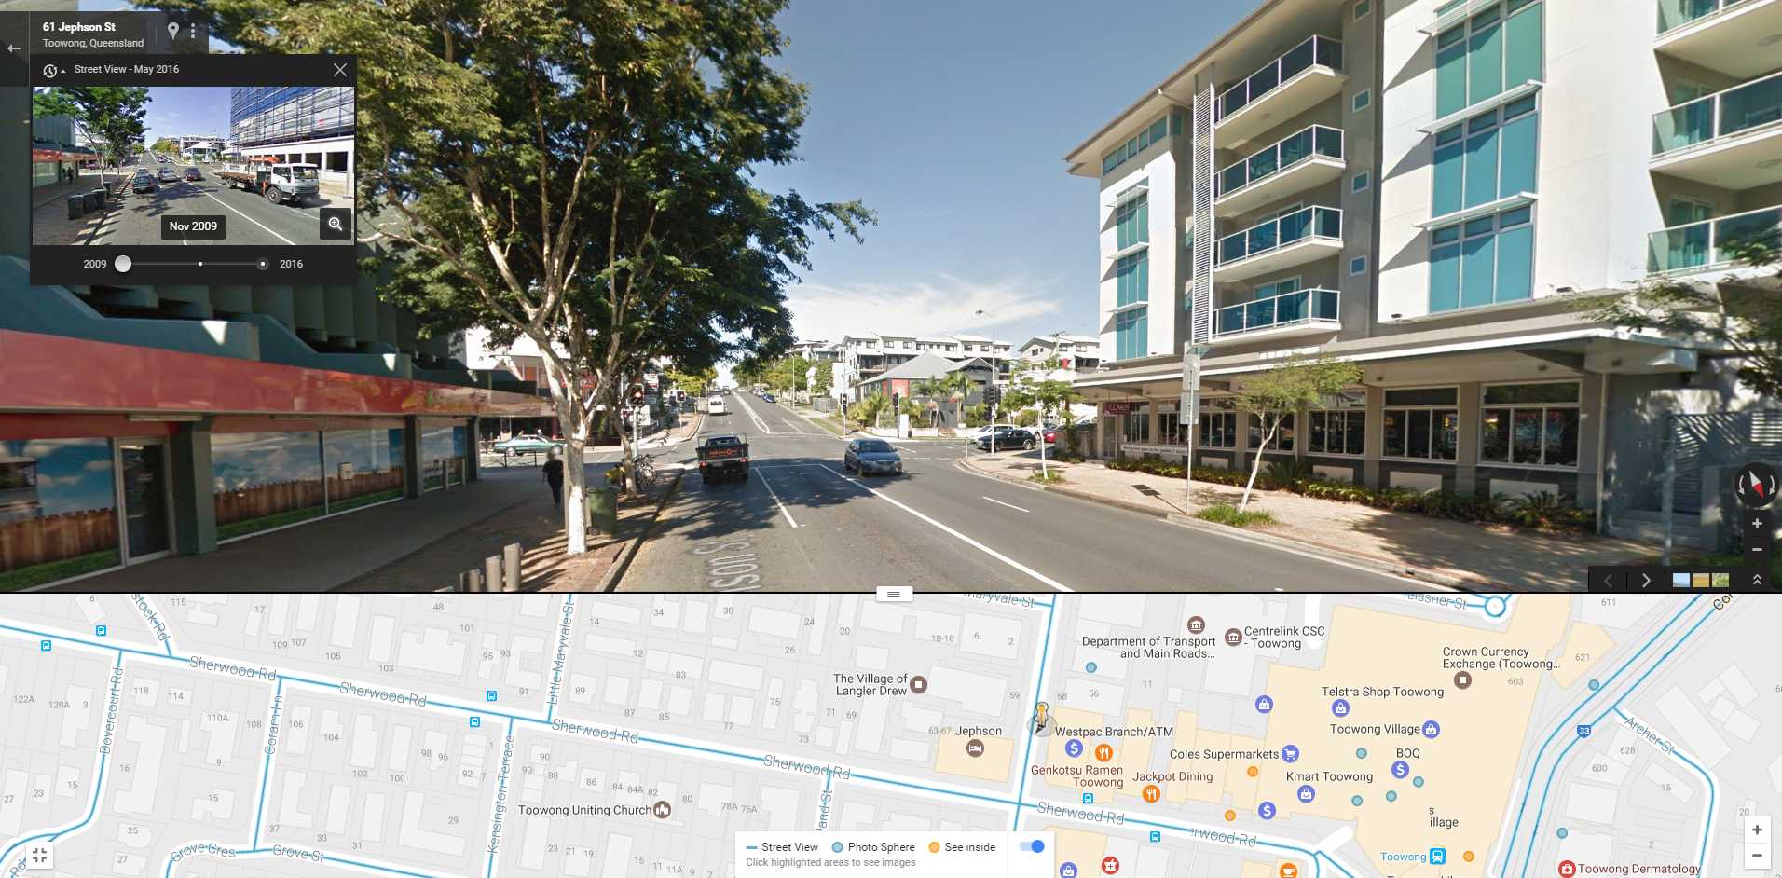
If the researchers observed a change to a building or use between the oldest and latest GSV images, a range of years was entered that corresponded to the oldest observed date where the old building/use was visible, and the first date in which the new building/use was visible. In the example shown above, the building on the right is under construction in November 2009, but in the image available for November 2013, the building is complete. The estimated building age was therefore recorded as 2009 to 2013. Where changes were not visible between GSV image date ranges, historical aerial imagery on Google Earth was compared with GSV and the latest aerial imagery (we used a paid service from NearMap, but other sources of free imagery can also be used). Buildings that were not visible on the Google Earth historical imagery, but which were visible on the oldest GSV image were dated between the year of the Google Earth imagery, and the oldest GSV date. This approach detects building changes, but cannot detect whether uses within the buildings have changed between the completion of construction and the first available GSV image. The approach therefore assumes that a building used for a certain category of use is likely to have maintained that use since its construction. Occasionally, GSV imagery would be several years (sometimes up to four years) old. NearMap aerial imagery allowed for changes between the latest GSV image date and the NearMap image to be detected (i.e. buildings that are newer than what is shown in GSV). In these instances the use was estimated on the basis of the buildings’ appearance from the aerial, as well as from the oblique angle aerial imagery available on NearMap which can provide a view of a building’s elevation (the 3D building layer on Google Earth offers a free alternative to the subscription based NearMap for this function). Where the building was visible in the oldest GSV image and the oldest Google Earth aerial image, an estimation was made for the date of the building on the basis of its architectural style, materials, and general condition. It is relatively simple to identify key periods of style in residential buildings, however it can be more difficult with industrial and commercial buildings. Buildings that were clearly of an age and style prior to the 1990s, were recorded as “Pre 96”. Where there was doubt as to the age, the age listed in the property sales history website (onthehouse.com.au) was used. If the building age was between the latest Google Earth image and 1996, the building age was recorded as 96 to the date of oldest Google Earth image.
Once all lots have been observed, the end result is a database that identifies land use change over time for the selected areas. Analysis of this data alone can provide details on a range of factors relevant to progress towards compact activity centres, such as ratios of residential to non-residential land, and changes in areas of different types of residential and non-residential uses. The addition of building footprint areas combined with land use data can contribute towards estimates of centre-based employment figures. Key indicators for compact activity centres obviously also need to include changes to dwelling and population numbers and densities. To estimate this data, the database can also be used as auxiliary data in dasymetric interpolation of census data.
To interpolate population and dwelling estimates from census data, we firstly needed to develop estimates for land use changes in a broader area. The CD or SA1 areas for each census year were selected where lots within the activity centre extent were located within these areas. The maximum extent of the combination of the CD and SA1 areas for each census year was then used to select lots from the QLD cadastre layer. NearMap and Google Earth aerial imagery were then used to assign an estimated land use to each of these lots, and also record a date range of when obvious changes to the built form occurred on these lots. We then combined these estimates with the activity centre database and used the building age fields and imagery dates to create snapshots of the estimated land use at the time of the 1996, 2001, 2006, 2011 and 2016 censuses. As these dates were typically recorded as a range of years, the median year of the range was used to assign the change of use to one of five, five yearly cohorts that align with census years. The combined table was then spatially joined to the applicable census boundaries for each census year, and the area of land for the various types of residential uses were summed for each census boundary. The proportion of area of low (detached dwellings and duplexes), medium (townhouses, multiple dwellings, etc. up to three stories), and high (apartments of four or more stories) density residential land within the activity centre extent vs. outside the activity centre was then calculated for each census boundary and year. Census dwelling structure data for counts of private occupied dwellings and population that coincided with these types of residential uses were then multiplied by the relevant proportional figure to determine an estimate of the number of dwellings and population within the activity centre extent in each census boundary area. Census counts of unoccupied dwellings are only provided as a total figure therefore unoccupied dwellings in activity centres were estimated using the proportion of overall residential land in/out of the activity centre. The results were then summed within each centre to develop an estimate of the number of dwellings and population within the activity centre extent at each census year.
Limitations
The method described here has a number limitations that ought to be considered. Lot by lot manual observation is tedious and time consuming, thereby limiting the extent of areas that can be observed. As already mentioned, where uses cannot be directly observed, the approach requires more subjective estimations of use that rely on assumptions based on surrounding uses, and that a building has maintained a similar type of use category since its construction. Fewer estimations will be necessary as more GSV data becomes available with time, provided GSV data continues to be made available on the same terms. Bader et al. (2017) discusses this matter of proprietary data further, as well as other matters related to ethical concerns and “rater fatigue”. As a manual process, there is of course the possibility of missing changes, misinterpreting land use and/or building age, and introducing errors through the data entry process. Checking the data for logical consistency allows for the identification and correction of many of such errors, however some are inevitable.
The areal interpolation method of incorporating census results also has its limitations. The results of interpolation are estimates only, and although accuracy ought to be significantly increased through the dasymetric approach of aligning auxiliary land use data with census dwelling structure data, there will be errors introduced through this process. As the method relies of weightings of areas, this is most likely to occur when significantly larger or smaller lots (compared to the typical lots within a given source area) are unequally located within or without the extent of the target area. The use of census data itself also has some potential issues. The ABS uses “introduced random error” which may result in some errors when working with small values, and the dwelling structure data only counts “private occupied dwellings”, therefore excluding counts of residents in short term accommodation, hospices and other “non-private” dwellings (ABS 2016b). We have also identified issues where observed dwelling types do not align with the census counts for that type of dwelling; a situation that has been explained by discrepancies in how ABS field officers interpret dwelling structure types (ABS 2017).

Preliminary Results
The following charts highlight some preliminary results of basic analysis of the dataset. These results suggest that progress towards compact activity centres has been mixed in the Greater Brisbane area, with the most significant land use changes typically occurring in residential uses. In most instances however, population and dwellings are failing to increase in centres at rates greater than their surrounding areas.
Figure 3 shows key differences in the land use mix between the different centre types across the region, from the residential based centres of Wynnum and Logan Central, to the outer ring centres featuring high proportions of industry and commerce. Further analysis of these differences is proposed in order to develop a typology of centre types. In most instances, the proportions of the various types of land use have changed only subtly over the past 20 years (Table 1). The notable exception of course can be seen in the increased proportions of higher density residential uses (townhouses and apartments), particularly in the middle centres. The proportion of the area of each land use category within each centre was determined by dividing the sum of the area of the lots in each land use category by the total area of all lots (excluding vacant and rural land, and land under development). The greenfield areas of North Lakes and Springfield were excluded as these centres are still in various stages of development and their proportional land uses therefore tend to give misleading results. The inner, middle and outer categories refer to a series of ranges from the Brisbane CBD (inner = 0-5km, middle = 5km to 15km, and outer = 15 to 35km).
Figure 3 - Proportions of areas of estimated land use by activity centre - 2016 and 1996
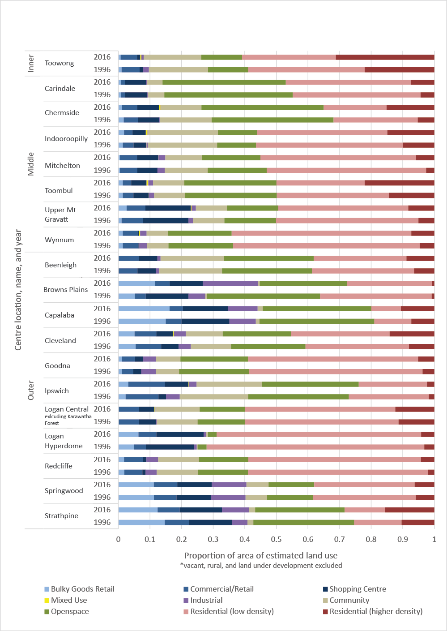

Table 1 - Difference in proportions of area of estimated land use from 1996 to 2016
 |  | Land Use Category
Location | Centre Name | Bulky Goods Retail | Commercial/Retail | Shopping Centre | Community | Industrial | Mixed Use | Open space | Residential (higher density) | Residential (low density)
Inner | Toowong | -0.3% | -0.6% | 0.0% | -0.5% | -1.1% | 0.4% | 0.1% | 9.1% | -7.1%
Middle | Wynnum Central | 0.0% | -0.2% | 0.1% | -0.1% | -0.3% | 0.3% | -0.3% | 2.6% | -2.2%
Middle | Carindale | 0.0% | 0.0% | -0.3% | -0.2% | 0.0% | 0.0% | -1.7% | 3.1% | -0.9%
Middle | Mitchelton | 0.0% | -0.1% | 0.4% | -2.2% | -0.1% | 0.1% | 0.0% | 3.2% | -1.3%
Middle | Upper Mt Gravatt | 1.6% | -0.8% | -0.1% | -0.1% | 0.0% | 0.2% | -0.1% | 3.3% | -4.0%
Middle | Indooroopilly | 0.4% | -0.6% | 0.1% | 0.0% | -0.1% | 0.5% | 0.1% | 5.0% | -5.3%
Middle | Toombul | 0.0% | -0.7% | 0.0% | 0.1% | -0.2% | 0.5% | 0.1% | 7.7% | -7.5%
Middle | Chermside | -0.5% | 0.2% | 0.2% | -3.6% | -0.1% | 0.5% | 0.1% | 9.9% | -6.8%
Outer | Browns Plains | 6.3% | 1.3% | -3.1% | 0.2% | 12.2% | 0.0% | -8.4% | -0.2% | -8.3%
Outer | Springwood | 0.0% | 0.3% | 0.1% | 0.1% | -0.1% | 0.0% | 0.0% | 0.4% | -0.8%
Outer | Ipswich | 0.8% | 1.1% | 5.2% | -0.9% | -1.9% | 0.1% | -1.3% | 0.5% | -3.7%
Outer | Logan Hyperdome | 1.4% | 1.9% | -0.3% | 0.2% | 0.0% | 0.0% | -0.1% | 1.0% | -4.1%
Outer | Logan Central  Excluding Karawatha Forest | 0.0% | 0.1% | -0.6% | 1.0% | 0.0% | 0.1% | -0.6% | 1.0% | -1.0%
Outer | Goodna | 0.0% | 0.6% | 0.0% | 0.4% | -0.6% | 0.0% | -0.7% | 1.5% | -1.2%
Outer | Redcliffe | -0.1% | 0.2% | 0.1% | -0.1% | 0.2% | 0.0% | -0.3% | 2.3% | -2.4%
Outer | Beenleigh | 0.0% | 0.5% | 0.0% | 0.3% | 0.0% | 0.0% | -0.1% | 2.4% | -3.0%
Outer | Capalaba | 1.2% | -0.8% | -0.8% | 0.5% | 1.0% | 0.0% | -2.0% | 3.3% | -2.3%
Outer | Strathpine | -2.3% | -0.7% | -0.1% | 0.1% | 3.6% | 0.0% | -3.6% | 5.2% | -2.2%
Outer | Cleveland | -0.4% | -1.1% | -0.3% | -1.1% | -0.1% | 0.3% | -2.0% | 6.1% | -1.5%

Figure 4 shows middle ring activity centres growing more rapidly than other middle ring locations, whereas outer ring activity centres are growing significantly more slowly than outer areas more generally. However this picture becomes considerably more nuanced when examining the relative change in individual centres as seen in Figure 5, where changes in residential growth vary dramatically between different centres. These results seemingly support the position of Bunker (2014); that progress toward more compact activity centres has been “patchy”. The majority of outer centres do not show significant residential growth, and all show less growth than the non-centre baseline growth. The picture for middle centres shows significant growth in Chermside and Toowong, however other centres are growing less rapidly than out of centre middle ring areas.
These figures represent the interpolated results of census data from 2016 to 2001, showing the estimated relative changes to population and dwellings within activity centres compared to baseline population and dwelling growth outside the activity centres. Baseline changes were determined using a method similar to that described by Coffee, Lange and Baker (2016). The inner, middle and outer distance rings (previously described) were used to select the census areas that had a centroid within the rings, and counts for population and dwellings were summed. Only census areas that had a centroid within the SEQRP’s urban footprint were included. The estimated activity centre population and dwelling counts were subtracted from the baseline counts. The relative change was calculated by subtracting the 2001 counts from the 2016 counts and dividing by the 2001 counts.
Figure 4 – Estimated relative change in dwellings and population from 2001 to 2016, for activity centre vs. non-activity centres areas
Source: interpolation and aggregation of census data (ABS 2001, 2016a)
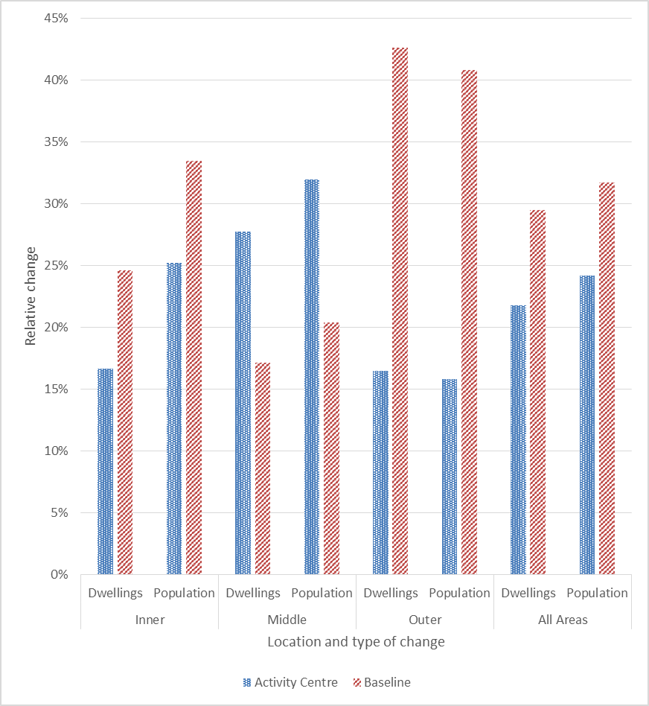

Figure 5 – Estimated relative change in dwellings and population from 2001 to 2016, for activity centres (North Lakes and Springfield excluded)
Source: interpolation of census data (ABS 2001, 2016a)
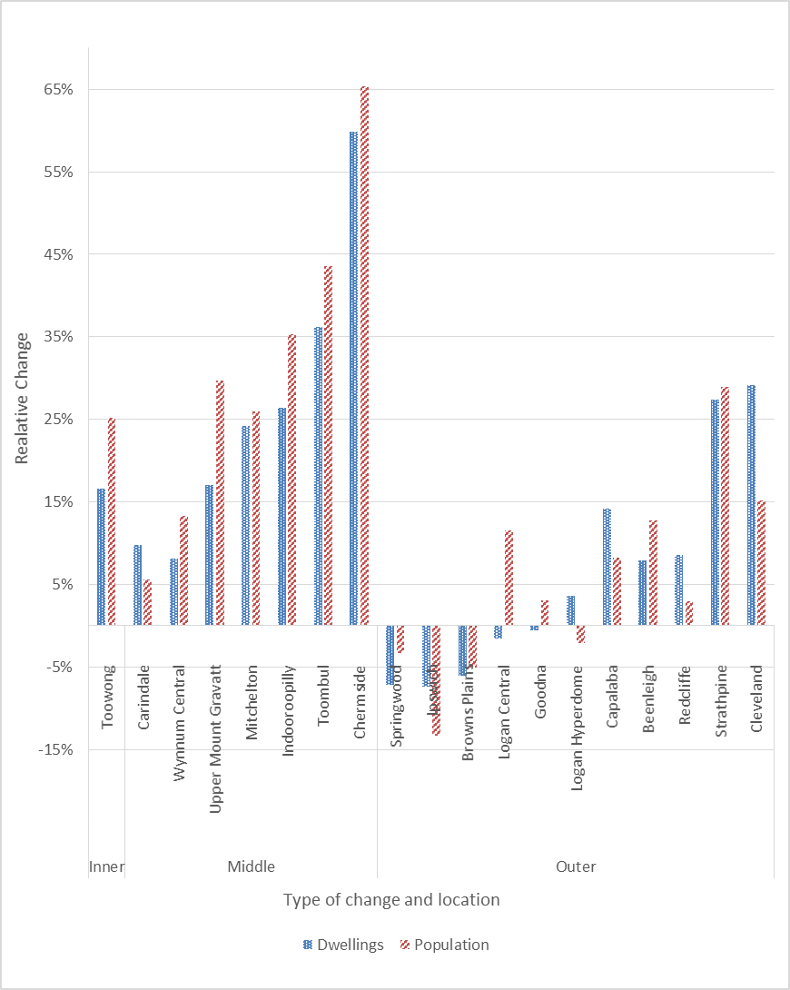
These preliminary findings give an up to date estimation of some of the key population and land use changes that have been occurring in the identified activity centres of Greater Brisbane. The data gathered to date enables further comparison between a range of urban compaction indicators such as changes in residential densities, and more specific analysis of changes in commercial and other employment uses. We intend to further analyse this data by considering a range of other factors such local government land use policies, transit times and accessibility, and property valuations and structure, with the aim of providing a current view of progress towards the implementation of compact activity centre policy as identified by the SEQRP.

Future application
Using observations of GSV and aerial imagery as described here enables the detailed longitudinal analysis of discrete areas, such as activity centres, and also assists with the areal interpolation of other data sources such as census data. The required data is freely available in most Australian localities, as well as in many other places globally. Recording and analysing the data is not complicated, and the required knowledge of GIS systems is relatively simple and can be learned quickly. Although making and recording observations is initially time consuming, once complete, they form a detailed database of land use that can be periodically updated to maintain currency. The approach can also be used to record and analyse a wide range of other built form factors; from street tree coverage to informal artwork.
New computer processing methods hold promise for overcoming some of the limitations associated with manual observation and data entry. Naik et al. (2017) have utilised automated processing of GSV historical images to reliably record changes in urban appearance overtime. Though technically complex, the use of such automated methods to determine changes in land use and built form would enable the comparison and analysis of very large geographies. Initial attempts at the automated classification of detailed land uses by Li, Zhang and Li (2017) show some progress, however testing revealed issues with accuracy when distinguishing between different types of residential structures. Until such issues are resolved, the simplicity and accessibility of our described method makes it a useful option for those looking to further understand changes to distinct urban geographies.

References
ABS. (2001) 2019.0.30.001 - Census of Population and Housing: CDATA 2001 - Full GIS, Australia, 2001. http://www.abs.gov.au/ausstats/abs@.nsf/productsbytitle/0BA23A4A2D33FF1DCA2570A3007C0DFA?OpenDocument.
ABS. (2016a) 2016 Census of Population and Housing - Basic Community Profile Datapack, SA1. https://datapacks.censusdata.abs.gov.au/datapacks/.
ABS. (2016b) 2901.0 - Census of Population and Housing: Census Dictionary, 2016. http://www.abs.gov.au/ausstats/abs@.nsf/Lookup/2901.0Chapter38202016.
ABS. (2017) Personal communication with authors, June.
AURIN. (2016) Neighbourhood Generator. https://docs.aurin.org.au/portal-help/analysing-your-data/walkability-tools/walkability001-points-to-regions/.
Bader, M.D.M., Mooney, S.J., Bennett, B. and Rundle, A.G. (2017) The Promise, Practicalities, and Perils of Virtually Auditing Neighborhoods Using Google Street View, The ANNALS of the American Academy of Political and Social Science, 669 (1), pp. 18-40. doi: 10.1177/0002716216681488.
BITRE. (2013) Population growth, jobs growth and commuting flows in South East Queensland, Report 134. Edited by (Bureau of Infrastructure Transport and Regional Economics). Canberra, ACT. http://bitre.gov.au/publications/2013/report_134.aspx.
Bunker, R. (2014) How Is the Compact City Faring in Australia?, Planning Practice & Research, 29 (5), pp. 449-460. doi: 10.1080/02697459.2014.945376.
Buxton, M. and Tieman, G. (2005) Patterns of Urban Consolidation in Melbourne: Planning Policy and the Growth of Medium Density Housing, Urban Policy and Research, 23 (2), pp. 137-157. http://www.tandfonline.com/doi/pdf/10.1080/08111470500135086. doi: 10.1080/08111470500135086.
Chhetri, P., Han, J.H., Chandra, S. and Corcoran, J. (2013) Mapping urban residential density patterns: Compact city model in Melbourne, Australia, City, Culture and Society, 4 (2), pp. 77-85. http://www.scopus.com/inward/record.url?eid=2-s2.0-84878114331&partnerID=40&md5=5e4dcde8ff87012990a6742faee23cf8. doi: 10.1016/j.ccs.2013.03.001.
Coffee, N.T., Lange, J. and Baker, E. (2016) Visualising 30 Years of Population Density Change in Australia’s Major Capital Cities, Australian Geographer, 47 (4), pp. 511-525. doi: 10.1080/00049182.2016.1220901.
Curtis, J.W., Curtis, A., Mapes, J., Szell, A.B. and Cinderich, A. (2013) Using Google Street View for systematic observation of the built environment: analysis of spatio-temporal instability of imagery dates, International Journal of Health Geographics, 12, pp. 53. https://www.ncbi.nlm.nih.gov/pubmed/24298903. doi: 10.1186/1476-072X-12-53.
Dodson, J. (2012) Transforming Australia's 'housing solution': How We Can Better Plan Suburbia to Meet Our Future Challenges, in R. Tomlinson (Ed) Australia's Unintended Cities: The Impact of Housing on Urban Development (Victoria, Australia, CSIRO Publishing)
Forster, C. (2004) Australian Cities: Continuity and Change (Melbourne, Australia, Oxford University Press).
Forster, C. (2006) The challenge of change: Australian cities and urban planning in the new millennium, Geographical Research, 44 (2), pp. 173-182. http://www.scopus.com/inward/record.url?eid=2-s2.0-33646421446&partnerID=40&md5=497c2dd24673bf6e47f02f163f4b8bb1. doi: 10.1111/j.1745-5871.2006.00374.x.
Griew, P., Hillsdon, M., Foster, C., Coombes, E., Jones, A. and Wilkinson, P. (2013) Developing and testing a street audit tool using Google Street View to measure environmental supportiveness for physical activity, International Journal of Behavioral Nutrition and Physical Activity, 10, pp. 103. https://www.ncbi.nlm.nih.gov/pubmed/23972205. doi: 10.1186/1479-5868-10-103.
Hawley, K. and Moellering, H. (2005) A Comparative Analysis of Areal Interpolation Methods, Cartography and Geographic Information Science, 32 (4), pp. 411-423. doi: 10.1559/152304005775194818.
Hussain, E. and Shan, J. (2016) Urban building extraction through object-based image classification assisted by digital surface model and zoning map, International Journal of Image and Data Fusion, 7 (1), pp. 63-82. doi: 10.1080/19479832.2015.1119206.
Hwang, J. and Sampson, R.J. (2014) Divergent Pathways of Gentrification: Racial Inequality and the Social Order of Renewal in Chicago Neighborhoods, American Sociological Review, 79 (4), pp. 726-751. doi: 10.1177/0003122414535774.
Kelly, C.M., Wilson, J.S., Baker, E.A., Miller, D.K. and Schootman, M. (2013) Using Google Street View to audit the built environment: inter-rater reliability results, Annals of Behavioral Medicine, 45 (1), pp. 108-12. https://www.ncbi.nlm.nih.gov/pubmed/23054943. doi: 10.1007/s12160-012-9419-9.
Li, X., Zhang, C. and Li, W. (2017) Building block level urban land-use information retrieval based on Google Street View images, GIScience & Remote Sensing, pp. 1-17. doi: 10.1080/15481603.2017.1338389.
McLoughlin, J.B. (1992) Shaping Melbourne's Future? Town Planning, the State and Civil Society (Cambridge, Cambridge University Press).
Mennis, J. (2015) Increasing the Accuracy of Urban Population Analysis With Dasymetric Mapping, Cityscape: A Journal of Policy Development and Research, 17 (1), pp. 115-126.
Naik, N., Kominers, S.D., Raskar, R., Glaeser, E.L. and Hidalgo, C.A. (2017) Computer vision uncovers predictors of physical urban change. In Proceedings of the National Academy of Sciences, Jul 06, edited. https://www.ncbi.nlm.nih.gov/pubmed/28684401. doi: 10.1073/pnas.1619003114.
Newton, P. and Glackin, S. (2014) Understanding Infill: Towards New Policy and Practice for Urban Regeneration in the Established Suburbs of Australia's Cities, Urban Policy and Research, 32 (2), pp. 121-143. http://www.tandfonline.com/doi/pdf/10.1080/08111146.2013.877389. doi: 10.1080/08111146.2013.877389.
Reibel, M. (2007) Geographic Information Systems and Spatial Data Processing in Demography: a Review, Population Research and Policy Review, 26 (5-6), pp. 601-618. doi: 10.1007/s11113-007-9046-5.
Reibel, M. and Agrawal, A. (2007) Areal Interpolation of Population Counts Using Pre-classified Land Cover Data, Population Research and Policy Review, 26 (5-6), pp. 619-633. doi: 10.1007/s11113-007-9050-9.
Rundle, A.G., Bader, M.D., Richards, C.A., Neckerman, K.M. and Teitler, J.O. (2011) Using Google Street View to audit neighborhood environments, American Journal of Preventive Medicine, 40 (1), pp. 94-100. https://www.ncbi.nlm.nih.gov/pubmed/21146773. doi: 10.1016/j.amepre.2010.09.034.
Schroeder, J.P. (2007) Target-Density Weighting Interpolation and Uncertainty Evaluation for Temporal Analysis of Census Data, Geographical Analysis, 39 (3), pp. 311-335. doi: 10.1111/j.1538-4632.2007.00706.x.
Schroeder, J.P. (2017) Hybrid Areal Interpolation of Census Counts from 2000 Blocks to 2010 Geographies, Computers, Environment and Urban Systems, 62, pp. 53-63. https://www.ncbi.nlm.nih.gov/pubmed/28260826. doi: 10.1016/j.compenvurbsys.2016.10.001.
The State of Queensland. (2005) South East Queensland Regional Plan 2005-2026. Edited by Office of Urban Management.
The State of Queensland. (2016) ShapingSEQ: Draft South East Queensland Regional Plan. Edited by Department of Infrastructure Local Government and Planning.
Vanwolleghem, G., Van Dyck, D., Ducheyne, F., De Bourdeaudhuij, I. and Cardon, G. (2014) Assessing the environmental characteristics of cycling routes to school: a study on the reliability and validity of a Google Street View-based audit, International Journal of Health Geographics, 13, pp. 19. https://www.ncbi.nlm.nih.gov/pubmed/24913256. doi: 10.1186/1476-072X-13-19.
Woodcock, I., Dovey, K., Wollan, S. and Robertson, I. (2011) Speculation and Resistance: Constraints on Compact City Policy Implementation in Melbourne, Urban Policy and Research, 29 (4), pp. 343-362. http://www.tandfonline.com/doi/pdf/10.1080/08111146.2011.581335. doi: 10.1080/08111146.2011.581335.

The SEQRP also includes Specialised Centres and Rural Centres. These centres have more specialised functions and are not necessarily intended to adhere to “compact city” principles. They were therefore excluded from analysis.
This is necessary to account for possible “spatio-temporal instability of imagery dates” (Curtis et al. 2013)
This research is focussed on a 20 year period however this method could also be used to estimate older building dates on the basis of style and/or through the use of older aerial imagery to provide increased dating accuracy

