Using Photovoice to research the experiences of parents raising children in new, inner-city, higher density housing developments
Fiona Andrews¹, Elyse Warner¹, Belinda Robson²
Deakin University¹, City of Yarra, VIC²

Abstract: Traditionally, parents have moved to low density, middle and outer suburbs of Australian cities to raise their children. However census data shows that between 2001 and 2011, the number of families raising children in inner-city, higher density, suburbs has increased. Many of these suburbs are undergoing rapid transformation through in-fill development of apartments, often not designed for families with children. Little is known about how parents experience raising children in these new settings.
Previously, the participatory research method, Photovoice, has been shown to be particularly useful for researching marginalised or emerging communities. It was thus selected as a means of identifying the needs of parents raising children in new, higher density developments, as well as providing a platform for this emerging group to engage with each other and advocate for change.
This paper reports on the use of Photovoice to explore parents’ experiences of raising children in higher density developments in one inner Melbourne municipality. The project involved a three-step process of 1) individual interviews based on participants’ photographs, 2) a participant group discussion of collective understandings of the issues and development of a presentation for the local council, and 3) delivery of the presentation to elicit council feedback. Using examples, this paper describes the challenges of implementing the Photovoice methodology amongst this group of parents, along with the benefits to participants, council and researchers of using this methodology to explore the experiences of parents raising children in new higher density developments.
Keywords: Parent; apartment; high-density; inner-city; Photovoice.
Introduction
Background
Australian cities are in the midst of an apartment boom. While there are many advantages to increasing housing density in Australian cities, including reducing urban sprawl, improving access to services and increasing walkability (Giles-Corti, Ryan & Foster, 2012), there are also challenges to liveability. In-fill, higher density, developments in the inner suburbs of Australian capital cities have been developed predominantly to suit the housing needs of young professionals and empty-nesters (Fincher, 2004, 2007). Despite this, increasingly parents are choosing to raise their children in these settings. While there has been research on disadvantaged families raising children in public, high density, housing in Australia (Taylor, 2014) and in private, high density, housing internationally (Appold & Yuen, 2007; Karsten 2015), very little is known about the experiences of families raising children in new, higher density, private housing developments in Australia. What research that is available reveals predominantly the difficulties of raising children in these new developments, including children’s limited independent mobility (Whitzman & Mizrachi, 2012) and spatial constraints on families (Nethercote & Horne, 2016).
The City of Yarra is an example of an inner-city municipality in Australia that has experienced a significant growth in the development of higher density private dwellings. The past ten years has seen high density development now accounting for almost half of all Yarra’s dwellings (City of Yarra, n.d.[a]). Furthermore, the number of new, privately owned, dwellings is predicted to rise from 41,921 in 2016 to 57,166 in 2036. This represents an increase of 15,245 privately owned dwellings in the next 20 years, or approximately 762 new dwellings a year (City of Yarra, n.d.[a]). At the same time, couples with children are projected to increase by 17% in Yarra between 2011 and 2036 (City of Yarra, n.d.[b]). Many of these households will choose to live in apartments and townhouses as an affordable way of living in an increasingly unaffordable part of Melbourne.
Overall however, parents in higher density areas of the municipality report less satisfaction with their neighbourhoods as a place to raise a family. A randomised survey of Yarra residents conducted in 2015 indicated that perceptions of whether Yarra is a good place to raise children varied according to of location of the respondent (City of Yarra, 2015). A greater percentage of those who lived in areas with more detached housing on larger blocks felt Yarra was a good place to raise children, compared to higher density areas. The current study arose out of the need to understand some of the reasons why families in higher density housing in the City of Yarra, were less satisfied with their experiences of raising children in their dwellings and immediate neighbourhood.
While these high density areas contain public housing, older terrace housing and new private apartment/townhouse complexes, the City of Yarra identified that parents raising children in new, private, high density developments represent a group they know the least about in terms of service and support needs. Thus the aim of the overall of our research was to explore the lived experiences of parents raising children in new, higher density housing developments in the City of Yarra. This paper focusses specifically on the methods developed and used to address this project aim.
Rationale for the choice of methods
In order to understand the lived experiences of parents raising children in new higher density housing in the City of Yarra, qualitative research methods were employed. Our approach used a combination of interpretive phenomenology and the participatory method Photovoice.

Interpretive phenomenology seeks to interpret experiences of a phenomenon using word-based communication, usually through an interview (van Manen, 1997). On the other hand, Photovoice is a participatory method that aims to enable people to record and reflect on their community’s strengths and weaknesses; to promote critical dialogue and knowledge about community issues through group discussion of photographs; and to reach policy makers and service providers (Wang & Burris, 1997). We based our methods on those of Plunkett, Leipert & Ray (2013) who argue that the combination of interpretive phenomenology with its emphasis on individual experience, and Photovoice which focuses on social and contextual issues, can provide a richer, deeper understanding of the lived experience than interviews alone.

Furthermore, Photovoice is particularly useful for working with marginalised, excluded or newly emerging communities about which little is known (Wang, 1999) and hence fitted well with trying to understand the experiences of this group of parents. The use of a participatory method (as opposed to individual interviews alone) also aligns with the City of Yarra’s new community engagement approach ‘Liveable Yarra; better planning for people and places’, that fosters collective, community participation in planning (City of Yarra, n.d.[c], Stone & Andrews, 2016). It was anticipated that building in an aim to reach policy makers and service providers into our research would provide a platform for this marginalised group of parents to engage with local government.

Methods
Sampling
A purposive sampling approach was utilised to recruit participants from a range of organisations in the City of Yarra, known to be frequented by parents. These included; Maternal and Child Health services, preschools, child care centres, libraries and recreation centres. Posters advertising the project were displayed on community noticeboards in these settings, as well as on notice boards in apartment complexes where permitted by the Body Corporate organisation. Invitations were also distributed via resident’s mailboxes where these were accessible. New, higher density developments were targeted across the municipality and included apartments and townhouses however, if the latter, the townhouses had to be part of a large housing complex. The study aimed to recruit between six and 10 participants as this is a reasonable sample size for this type of study (Morse, 2000), with the final sample size being determined by saturation of new concepts in individual interviews.
After obtaining consent from the 10 participants who took part in this project, researchers collected demographic information (see Table 1) and provided information about the use of photography in the project with regard to issues of power, ethics, safety and privacy. Participants were then given a maximum of two weeks to photograph 10 aspects of their development and neighbourhood that they perceived to have positive or negative impacts on them raising their children. Photographs were emailed to the researchers in preparation for the participant’s individual interview.

Table 1. Participant details
Dimension | Details
Sex | Male – 2  Female - 8
Age | 20-29 years - 1  30-39 years - 5  40-49 years - 4
Place of birth | Australia – 6  Asia – 3  Oceania - 1
Employment status | Full time - 2  Part time - 1  Self-employed – 1  Casual – 2  Parental leave - 3  Stay at home parent - 1
Occupations | Professional 5, manager 2, small business owner 1, full time parent 1, student 1.
Education | Postgraduate – 5  University Bachelor Degree - 4  Graduate Certificate or Diploma – 1
Household composition | Couple + children – 10
Relationship status | De Facto – 1  Married – 9
Weekly household income | $400 – 799 - 1  $800 - 1249 – 1  $1250 – 1999 – 1  $2000 – 2999 – 4  More than $3000 – 3
Proportion of income spent on housing per week | Less than ¼ - 2  ¼ - 3  1/3 – 4  ½ - 1
Length of time at current address | 1 - 9 years

Individual interviews
Interviews took place in a neutral setting. Participants were first asked to describe what each image represented and their reason for its inclusion. Further questions were asked in response to the themes emerging from each photograph, in order to gain a deeper understanding of participants’ lived experiences. For example, where participants had photographed negative aspects, they were asked for suggestions about what could be undertaken to improve the situation. To further understand how social, cultural or contextual factors that affected the phenomenon of raising children in their developments and neighbourhoods, the SHOWeD acronym was used (Wang, et al. 1998). SHOWeD consists of the following questions: What do you See here? What’s really Happening here? How does his relate to Our lives? Why does this problem or this strength exist? What can we Do about this? (Wang et al. 1998). Finally, participants were asked about their experience of participating in the project. Discussion about each photograph concluded with participants providing a caption for the image.

Interviews were digitally recorded, transcribed verbatim and returned to participants for member-checking. Two members of the research team reviewed the transcripts and the photographs and identified the key concepts. These were then discussed to arrive at overarching themes reflective of participants’ experiences. Participants were assigned a number to maintain confidentiality.
Group interview
Following the individual interviews, participants were invited to attend a group session to compare their experiences and to discuss their collective meanings. Plunkett, Leipert & Ray (2013) argue this collective approach to the phenomenon in question, deepens understanding of the data obtained in the individual interviews. To prepare for this, participants were asked to choose up to four of their photographs that best reflected their experience of raising children in the City of Yarra, with up to two reflecting experiences of their development and up to two reflecting experiences of their neighbourhood.
The group discussion took place at a local library. Five participants were involved. Each participant was given the opportunity to present their chosen photographs, before others were invited to comment on similar or different experiences of the phenomenon under discussion. Participants were then asked to identify overall areas of consensus for taking forward to present to the City of Yarra. The group discussion session was recorded and transcribed. Discussion material was analysed to determine key collective themes.
Council Presentation
The researchers then developed a one hour PowerPoint presentation of the findings and presented this to Council staff and Councillors at the Yarra City Council. Eighteen council staff and one Councillor attended the session. This session brought together officers from Strategic Planning, Social Policy and Research, Advocacy and Engagement, Urban Design, Sustainability, Maternal and Child Health and Children and Family Services to discuss the issues faced by these parents and the ways Yarra Council can better respond to the very practical difficulties faced by these parents. Specifically, in terms of the issues raised by the presentation attendees were invited to reflect as follows:
- Not a Council area
- Already dealing with this
- This raises something to think about
- This raises something to act on
- This raises the need for further research
Notes were taken by one of the researchers during the session to record participants’ reactions to the presentation. Another researcher followed up with staff after the presentation to obtain further feedback on the usefulness of both the data presented and the methods in relation to Council’s work.

Findings

This section of the paper outlines the challenges and benefits of researching the experiences of raising children in new high density housing developments using interpretative phenomenology and Photovoice. It draws on individual interview material, group discussion material as well as feedback from the presentation of the data to Yarra Council.

Challenges
The main challenge experienced in this project related to recruitment of participants. While we employed a range of recruitment strategies, we were unsure what services and facilities these parents frequented because they are a newly emerging group. Furthermore, many of the new high density developments where potential participants lived were closed to the public with letterboxes being located behind security doors. Only one Body Corporate organisation of the 10 we contacted allowed us into their complex to letterbox residents. Despite this, each of our participants did reside in a different development.
A second challenge was the time-consuming nature of the project for participants. The Photovoice method requires participants to undertake three main activities, take their photographs, have an individual interview and participate in a group interview. Given that parents of young children are reported to be one of most time-poor in Australian society (Strazdins & Loughrey, 2007), this was potentially a barrier to participation in the project and was reflected in the drop off of participants contributing to the group discussion.
A final challenge related specifically to one aspect of the photography component of the project. Seven participants discussed the issue of drug taking in the City of Yarra and the impact this had on them as parents of young children however, only three participants photographed anything to represent this because of fears for their personal safety. For example, one participant explained how overall she loved living in her high density neighbourhood and entitled her photograph ‘Hell in heaven’ (Figure 1), but had to photograph a different area of her neighbourhood to represent her experiences. She said:
‘This is a picture of Burnley Street... as a parent I’d like to bring up the drug use and drug dealings happening on Victoria Street, it’s quite dangerous and sometimes you don’t feel safe… I really wanted to get a picture of Victoria Street but I wasn’t, I didn’t want to do that because I didn’t want people confronting me ‘Oh you took a photo of me’ so I didn’t do that but I really wanted to, so this should actually represent Victoria Street.’ (P10)
Figure 1. Hell in heaven
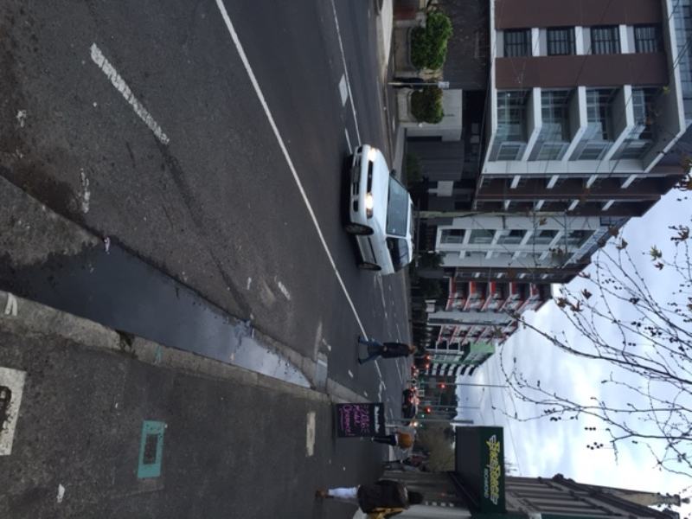

Benefits
Despite the above challenges, the benefits of using this method outweighed the challenges. These benefits are discussed in relation to participants, researchers and Council.
Participants
While, this group were time poor, those parents who did participate became highly engaged with the activities and contributed 120 images and over 15 hours of interview material. There were four main benefits of the Photovoice method discussed by participants. In the first instance, participants described the benefits of the photographic exercise in helping them to reflect in a focussed way on their developments and community’s strengths and weaknesses. For example, one participant explained:
‘Oh, I think the photos was a really good way of doing it, cos otherwise I think I’d be really stuck to know, you know ‘Oh what do I think’? It gave me really good access points and it helped me pinpoint and really reflect on ‘Okay so I know I like living here but why? What is good about it?’ So the local area, it just made me realise I really, I feel so grateful for that, I really appreciate it and I love living here and so there’s that side of it. And then also I guess just reflecting on what is it about where we live, in terms of our actual townhouse, that’s really more difficult. It just helped me narrow down and really pinpoint, I think otherwise, I have the ability to waffle and maybe just be a little bit vague, but it helped me put things in categories and think about what was good, what I’d change and what I wish was different.’(P7)
While two participants in our study spoke of some contact with local government about one-off issues, the rest had no engagement with the local council. Despite this, their interviews and photographs raised a number of issues of concern to them in raising children in their developments and local neighbourhoods. Thus the second benefit to participants of the Photovoice method was that it provided an opportunity for participants to have a say, particularly for those who had not had this opportunity previously. One participant explained:
‘I think it’s such a great tool to use, photos, as a way of participating, and especially people who might not be very verbal, or feel comfortable being very verbal, it’s such a good way to kind of get people to find a way to voice about what they’re thinking about, when they’re maybe not very good at talking about it.’ (P9)
A further benefit of being involved in Photovoice related to the way in which it helped to build social capital amongst the participants. During the individual interviews, a number of participants spoke of experiencing social isolation. However, at the group discussion one participant explained:
‘Well I think since catching up with you during my interview we’ve started talking to our neighbours. Amazing how it transforms your life! We had an emergency, I called the neighbour and she came and looked after the children while I took my husband to hospital. Quite interesting that it was really easy. It’s like how have I not done this before, like cultivate the friendship previously?’ (P6)
Furthermore, the group discussion component of Photovoice, provided an opportunity for building social capital through mutual support. This ranged from sharing ideas on where to access childcare in the municipality, to how to prevent apartments in their complexes being rented out through Airbnb.
Finally, participants commented on the benefits of Photovoice in terms of making a contribution to their community and advocating for change.
‘It made me think a little bit about you know how other people might perceive things but it was a creative way to do it and yeah I quite enjoyed getting out and thinking and just the space to reflect and we don’t always have the chance to stop and think about things like this, so the opportunity to think about what’s good and what’s not so good and what has been good over the years as well, so if there is anything that can come of it, can help future families in the same situation.’ (P2)
Researchers
There were a number of benefits of the combined interpretative phenomenology and Photovoice methods from a researcher perspective. Photographs acted as a conversation starter where participants were more hesitant about being interviewed. They also helped us to visualise the issues that were difficult to explain with words alone. For example one participant’s photograph captioned ‘Goldfish bowl’ (Figure 2) helped us to visualise the physical relationship between apartments in her development:
‘So that’s from the front of our house, one of the things I absolutely hate, this one’s a big negative for me, is the fact that our house just totally looks into two other people’s apartments so there’s someone on the top floor, someone on the bottom floor and then on, so there’s those two and there’s two, like we just look exactly opposite, so you could look out your window and see someone brushing their hair in the mirror or whatever and it feels very invasive, you don’t want to feel like you’re staring at someone, and then also that someone could be staring at you when you’re just doing your mundane things and it makes me feel, I’m quite a private person, and so living like that it makes me feel like I’m in a bit of a goldfish bowl’ (P5)
Figure 2. Goldfish bowl
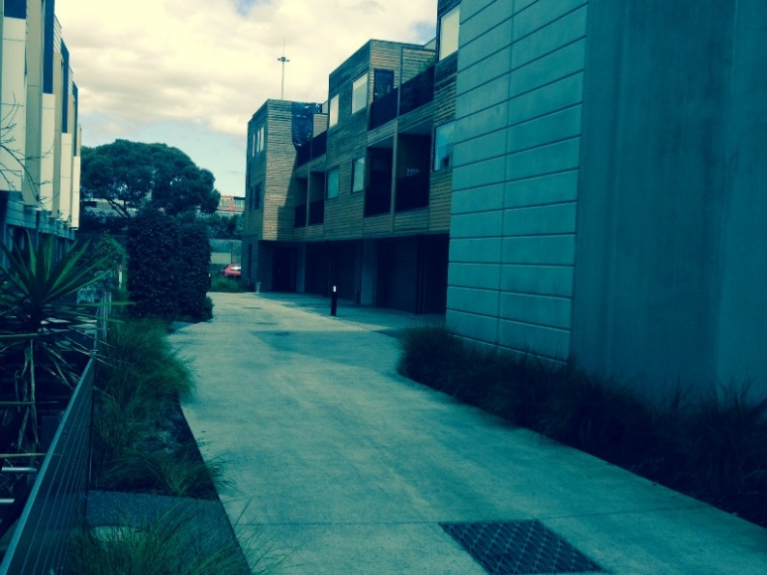

Photographs also allowed participants to capture the atmosphere of their lived experiences. One participant captured the insecure atmosphere in an underground walkway near her home in her photograph captioned ‘Tunnel’ (Figure 3), saying:
‘You know lurgies are hiding there and shadows are there and I don’t like it, I feel very unsafe when I have to walk through there at night and this photo was actually taken at 7.30pm so you know I should feel safe at 7.30… if I needed to take one of the girls for a walk, when they’re unsettled and you want to take the pram out I would only walk along Hoddle Street or have my husband join me.’ (P2)
Figure 3. Tunnel
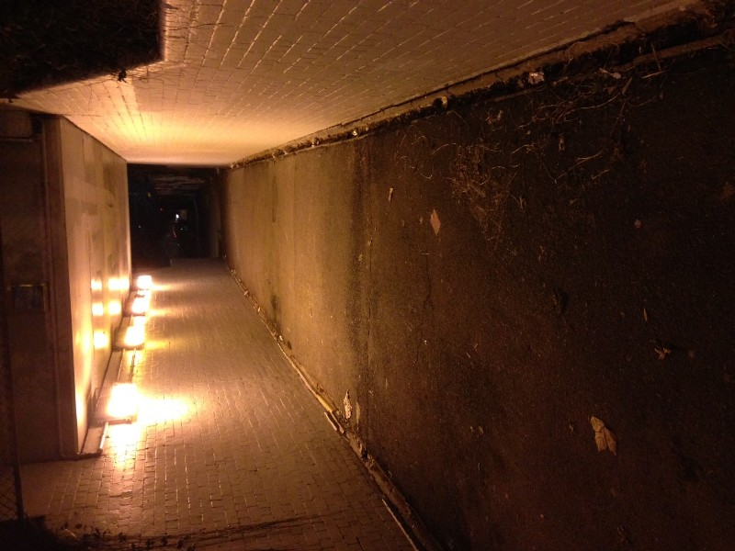

Furthermore, photographs allowed participants to describe the fine-grained detail of their lived experiences to researchers. For example one participant took a photograph captioned ‘140 steps’ (Figure 4) saying:
‘So this our car space… I really didn’t know how to communicate it so this is why I just took a photo of my feet at our car space, and basically to get, from our apartment door to where we have to park our car is 140 steps… like everything is secure, which is great but it’s kind of also a pain when you’ve got the baby and the groceries and your coat and maybe the pram and you’ve got to get your keys out to kind of scan yourself in at all the different points, which is like one point to get up the elevator, one point to get into the door and then one point to get, no one point to get into the gate, then one point to get into the door, then one point to get into the elevator, before you get to your floor where you use your actual key so that’s three times you need to use your scanner and the doors are all really heavy and they open outwards… I don’t know we just feel like, my partner and I just feel like everything’s just an obstacle to get in and out… When I went into labour, the lift broke, and we’d just moved in…. and I had to walk down the fire escape in labour, which was like this horrible like, I just remember thinking ‘I can’t believe I’m in labour and I have to spend time in this, like, stairwell’ and then walk through the underground car park to get to the car (laughs) because the lift was broken and because it was so far to get to our car, yeah, so it was a pretty horrific time.’ (P9)

Figure 4. 140 steps
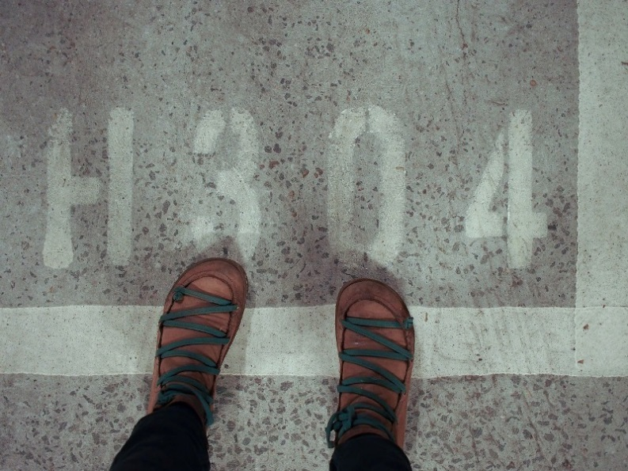

Finally, the use of individual photographs to guide interviews, followed by the group discussion where participants cross-checked our interpretation of their individual data, ensured we had a clear understanding of the issues from the perspective of participants.
Council
From Yarra Council’s perspective, the methods used by the project provided an important insight into the experiences of a group of residents that they do not often hear from. Being time-poor, these parents may not have the time to engage with Council issues and are too busy managing their day-to-day lives to attend Council consultations. However, by using parents’ current life experience as a starting point, the project offered Council officers access to deep insights into the challenges faced by people raising children in new, high density developments.
Parents’ experiences cross into many different functions of Council, including urban design, social and community planning and children’s services. The cross-Council feedback session enabled important thematic connections to be made and solutions to be considered from the perspective of many different areas. As Council staff work across different sites, it was invaluable to bring officers together to hear from researchers who structured the presentation across themes that were relevant to Council’s work. The method was open-ended enough for a range of Council officers to feel that it was relevant to their work and also the discussion was able to spring board directly from the photographs and quotes discussed at the session. This approach was very stimulating for officers who valued the opportunity to share reflections and interpretations. Finally, the project fostered a motivated group of parents, representing residents from whom Council had previously had little contact, raising the possibility of involving these parents in further Council engagement opportunities.

Discussion
This paper describes the use of Photovoice and interpretative phenomenology to explore the lived experiences of parents raising preschool aged children in new, high density, housing in one Australian inner-city municipality, the City of Yarra. Photovoice has been used extensively as a tool to understand the lived experiences of residents’ homes and neighbourhoods, from studies of physical activity (Hennessey et al. 2010) and healthy eating (Mareno, 2014), to climate change (Baldwin & Chandler, 2010), homelessness (Bukowski & Buetow, 2011), refugee housing (Fozdar & Hartley, 2014), and aged care facilities (Lewinson, Robinson-Dooley & Grant, 2012). However, to our knowledge the method has not been used with parents in high density housing developments, or in partnership with local government to provide input on the housing needs of local residents. Our study has thus not only taken a novel approach to exploring the phenomenon of parenting in new, high density housing, but also describes an approach with the potential for use in urban research more generally.
There were a number of benefits of the methods used in our study in understanding the lived experiences of this newly emerging group of parents. These are discussed in relation to the three aims of Photovoice namely; to enable people to record and reflect on their community’s strengths and weaknesses; to promote critical dialogue and knowledge about community issues through group discussion of photographs; and to reach policy makers and service providers (Wang & Burris, 1997). Aligning with the work of Plunkett, Leipert & Ray (2013), we found that a combination of interpretive phenomenology and Photovoice allowed participants to provide deep and rich reflections on the strengths and weaknesses of their community. In particular, we observed that the use of photographs to guide interviews helped participants to prioritise their experiences, and gave them some agency in both the data collection and presentation. In line with previous work using Photovoice, it also gave voice to those who did not usually speak up (Wang & Burris, 1997; Hennessey et al. 2010; Bukowski & Buetow, 2011). From a researcher and Council perspective, the latter is of particular significance in trying to understand a newly emerging group’s perspectives on their community. Previous research has shown that even where outsiders are familiar with a community, their perspectives on key issues can differ considerably from those of residents (Kilmartin, 1996, Permentier et al., 2008, Andrews et al. 2013).
In terms of promoting critical dialogue of parents’ experiences, the use of multiple data sources (photographs, individual and group interviews), afforded by a combined Photovoice and interpretive phenomenological approach, proved invaluable in allowing us to cross-check our interpretations of participants’ experiences, to ensure rigour in the research (Plunkett, Leipert & Ray, 2013). More specifically, the opportunity provided by the group discussion for a collective approach to critical dialogue, was also found to cultivate relationships between participants and invited advocacy, aligning with previous studies (Wang & Burris, 1997; Bukowski & Buetow, 2011).
Perhaps the most significant benefit however, came from the way in which our methodology provided a tangible link between research and practice. Local government has been described as a ‘place shaper’ (Dorling, 2010) and is the level of government closest to the community, best able to respond to community needs in terms of policy development and service provision (Victorian Government, 2001). In contrast to the usual route for dissemination of research from academics to government via reports, the use of a participatory research method encouraged Council to actively engage with the research findings. Both long and short term practical responses to the research were discussed, including possible future engagement with this newly emerging group of parents through our study participants.
As with all research methods there are limitations. The challenges we encountered using the combined method of interpretative phenomenology and Photovoice with this newly emerging group of parents, point to some limitations in our research. The difficulties we encountered in recruiting and retaining participants, as well as barriers to photographing certain experiences, may have meant that we did not fully capture the phenomena of raising children in new high density housing.
Conclusion
In conclusion, the combined use of Photovoice and interpretative phenomenology provided a useful method for exploring the lived experiences of parents raising children in new, high density developments. In particular, it provided benefits to participants, researchers and to the local Council in which the study was located. These included participant-driven dialogue and knowledge of the experiences of raising children in new higher density developments designed predominantly for residents without children. This information will enhance currently available survey data by providing explanations that Council can consider, and where appropriate address, to improve the situation for this emerging group of parents. Furthermore this method may have wider applications both to Yarra Council and to other local governments seeking to better understand the experiences of new groups of residents in the evolving Australian urban landscape.

Acknowledgements
This study was funded by a grant from the University in which this research took place. The authors are grateful to all the parents and Council staff who participated in this study.

References
Andrews, F., Barter-Godfrey, S., Rich, S., Klein, R. & Shelley, J. (2013) A good place to raise a family? Comparing parents', service-providers', and media perspectives of the inner and outer suburban areas of Melbourne. State of Australian Cities conference proceedings.
http://www.soacconference.com.au/soac-conference-proceedings-and-powerpoint-presentations/
Appold, S. & Yuen, B. (2007) Families in ﬂats, revisited. Urban Studies 44(3), 569–589.
Baldwin, C. (2010) “At the water’s edge”: community voices on climate change. Local Environment 15(7), 637–649.
Bukowski, K & Buetow, S. (2011) Making the invisible visible: A Photovoice exploration of homeless women’s health and lives in central Auckland. Social Science & Medicine 72, 739-746.
City of Yarra (2015) Planning for the Future: Results of a Randomised Household Survey.
City of Yarra, (n.d. [a]) Community profile. http://profile.id.com.au/yarra
City of Yarra, (n.d. [b]) Residential development http://forecast.id.com.au/yarra/residential-development
City of Yarra (n.d. [c]) Liveable Yarra. http://yarraconversation.com.au/liveableyarra
Dorling, D. (2010) Using the concept of place to understand and reduce health inequalities. In: The Social Determinants of Health and the role of Local Government. Improvement and Development Agency. http://www.local.gov.uk/health/-/journal_content/56/10180/3510830/ARTICLE
Fincher R (2004). Gender and life course in the narratives of Melbourne’s high-rise housing developers.
Australian Geographical Studies 42(3), 325–338.
Fincher, R. (2007) Is high-rise housing innovative? Developers’ contradictory narratives of high-rise
housing in Melbourne. Urban Studies 44(3), 631–649.
Fozdar, F. & Hartley, L. (2014) Housing and the creation of home for refugees in Western Australia. Housing, Theory and Society 31(2), 148–173.
Giles-Corti, B., Ryan, K. & Foster, S. (2012) Evidence review. Increasing density in Australia: maximising the health benefits and minimising harm. Commissioned by the National Heart Foundation of AustraliaHennessy, E., Kraak, V.I., Hyatt, R.R, Bloom, J., Fenton, M., Wagoner, C. & Economos, C.D. (2010) Active living for rural children. Community perspectives using PhotoVOICE. American Journal Preventive Medicine 39(6), 537–545.
Karsten, L. (2015) Middle-class households with children on vertical family living in Hong Kong.
Habitat International 47, 241–247.
Kilmartin, C. (1996) Local differences in problems for families: Views of providers and parents. Family Matters 43, 38-41.
Lewinson, T., Robinson-Dooley, V. & Grant, K.W. (2012) Exploring “Home” through residents’ lenses: Assisted living facility residents identify homelike characteristics using Photovoice. Journal of Gerontological Social Work 55 (8), 745-756.
van Manen M. (1997) Researching lived experience: Human science for an action sensitive pedagogy, 2nd edn. (London, ON, Althouse Press).
Mareno, N. (2014) Parental perception of healthy eating and physical activity: results from a preliminary Photovoice study. Journal of Clinical Nursing, 24, 1440–1443.
Morse, J (2000). Editorial: Determining sample size. Qualitative Health Research, 10, 3-5.
Nethercote, M, & Horne, R. (2016) Ordinary vertical urbanisms: City apartments and the everyday geographies of high-rise families', Environment and Planning A 48 (8), 1581-1598.
Permentier, M., van Ham, M. and Bolt, G. (2008) Same neighbourhood … Different views? A confrontation of internal and external neighbourhood reputations. Housing Studies, 23, 833-855.
Plunkett, R., Leipert, B.D. & Ray, S. (2012) Unspoken phenomena: using the Photovoice method to enrich phenomenological inquiry. Nursing Inquiry 20, 156-164. Taylor, J. (2014) Life chances: stories of growing up in Australia (Annandale, NSW, Federation Press).
Stone, A & Andrews F.J. (2016) Liveable Yarra – planning for the city’s future using a deliberative process. in 9th Healthy Cities Conference Proceedings: Working Together to Achieve Liveable Cities, AST Management Pty Ltd, Nerang, Qld.
Strazdins, L., Loughrey, B. (2007) Too busy: why time is a health and environmental problem. NSW Public Health Bulletin 18, 219-221.
Victorian Government. (2001) Environments for Health. Promoting Health and Wellbeing through Built, Social, Economic and Natural Environments. Municipal Public Health Planning Framework, September 2001.
Wang, C.C. & Burris, M.A. (1997) Photovoice: Concept, methodology and use for participatory needs assessment. Health Education Behavior 24, 369-387.
Wang, C.C. (1999) Photovoice: A participatory research strategy applied to women’s health. Journal of Women’s Health 8, 185-192.
Wang C.C., Yi, W.K., Tao, Z.W. & Carovano, K. (1998) Photovoice as a participatory health promotion strategy. Health Promotion International 13, 75–86.
Whitzman C. & Mizrachi, D. (2012) Creating child-friendly high-rise environments: Beyond wastelands and glasshouses. Urban Policy and Research 30, 233-249.

