Trees, Townhouses and Apartments: The effect of development density on private property tree distribution in Melbourne

Abstract:
Urban trees provide substantial ecosystem services, and trees on private land are a sizeable segment of overall urban tree cover. Trees provide shade, cooling and habitat, and contribute to aesthetic values, sense of place, and urban dwellers’ mental and physical wellbeing. With increasing size and density of cities, tree cover decreases, as buildings replace private open spaces. As a result, there is intensifying focus on establishment and maintenance of trees in public spaces, through street tree establishment, and in public open spaces. There has been less research on tree cover in private open space in areas of increasing residential density. This research focuses on the influence of development density on urban trees on private residential land. Specifically, we analysed the relationship between dwelling density and the proportion of available land that is used for trees. Available land within residential properties may be used for a number of different purposes, including tree cover, garden beds, paved surfaces and so on. Our analysis utilised data on recent multi-unit residential development and GIS-based analysis of aerial photos of inner city areas in Melbourne, Australia. We found that with an increase in development density, tree cover increases proportionally compared with other private open space uses. Changes to soft landscaping cover had greater impact than development density on the proportion of tree cover in private open space. Our research can be utilised by policy-makers seeking to maximise urban tree cover. Further research could examine the social and policy influences on hard and soft landscaping practices.

Keywords: Canopy; Forest; Private; Density; Urban.

Introduction
Urban trees provide significant environmental benefit to urban residents through stormwater management (Walsh et al. 2005), air pollution reduction (Nowak et al. 2006; Jim & Chen 2008), and climate change mitigation and adaptation (Davies et al. 2011; Akbari 2002; Santamouris & Asakopoulos 2001; Loughner et al. 2012). Green spaces of trees and other vegetation provide substantial physical and mental health benefits for urban populations (Norton et al. 2015; Gabriel & Endlicher 2011; Sugiyama et al. 2008; Grind & Patil 2009).
Associated with increased research on the roles, benefits and functions of urban vegetation, including trees, is an increasing focus on the factors influencing urban tree distribution. However, much of this focus has been on a narrow selection of influencing factors, including the impact of social and temporal factors such as race, income, education, and historic socio-economic characteristics and land-use (Landry & Chakroborty 2009; Kabisch & Haase 2014; Santamouris & Asakopoulos 2001; Heynen et al. 2006; Luck et al. 2009; Heynen & Lindsey 2003; Shanahan et al. 2014; Kirkpatrick et al. 2007; Kendal et al. 2012; Kirkpatrick et al. 2011; Krafft & Fryd 2016). Most studies have focused on trees within the public domain (Landry & Chakraborty 2009; Kirkpatrick et al. 2009; Kirkpatrick et al. 2011). Where the relationship between urban density and canopy cover has been studied, the relationship is usually observed at a neighbourhood or city scale, concluding that an increase in density results in decreased canopy cover due to the decreased area available for trees (Kabisch & Hasse 2014; Kendal et al. 2012; Troy et al. 2007; Rodriguez et al. 2004; Kirkpatrick et al. 2007; Cook et al. 2015). Fewer studies have addressed the provision of trees on an individual property scale (Landry & Chakraborty 2009).
This paper aims to extend the research on urban tree distribution by focusing on the influence of development density on tree distribution within the private domain. In doing so, the paper situates itself within a growing body of research focusing on the driving factors of urban tree distribution within the Australian context.
In response to growing urban populations, many cities are planning for significant increases in densities. While there are several negative sustainability outcomes associated with increases in urban density, such as increase stormwater runoff and decreased private open space for urban residents (Hatt et al. 2004; Haaland, C & van den Bosch, C 2015), this study focuses on the decrease in available urban space to establish vegetation (State of Victoria 2014), especially within the private realm (Troy et al. 2007). However, this is an area of contention within research, with some findings suggesting that increases in density will result in decreased tree density (Troy et al. 2007), and others suggesting that development density is positively associated with larger vegetation such as trees (Conway & Bourne 2013).
This study’s focus on urban trees in the private realm is important as private land contributes significantly to urban tree canopies (Kirkpatrick et al. 2009; Kirkpatrick et al. 2011; Cook et al. 2015). Furthermore, current Australian planning regulations have limited influence on private gardens (Kirkpatrick et al. 2009; Kirkpatrick et al. 2011), with owners’ personal preferences, and social variables the dominant influences on gardening practices (Kendal et al. 2012; Shanahan et al. 2014). Research on tree distribution in the private realm has the potential to inform policy development in this important area.
This paper investigates the relationship between residential development density and the proportion of private land used to plant trees. The research asks: is there a positive relationship between residential development density and the proportion of available private land used for canopy trees in inner-city Melbourne, Australia? The research focuses on tree distribution in relation to development density in 10 inner suburban areas in Melbourne, Australia. The paper provides results of the research which extend understandings of the relationship between urban tree distribution and development density.

Background
Trees are of substantial environmental and social importance within cities. Environmental benefits associated with urban trees include air pollution reduction, Urban Heat Island (UHI) mitigation, climate change mitigation, stormwater management, and biodiversity conservation, in-turn contributing social, health and wellbeing outcomes. Air pollutant reduction by trees principally results in the removal of finer particulate matter pollutants (Akbari 2002; Nowak et al. 2006). Though there are intricacies regarding pollutant removal by vegetation types, trees provide pollution reductions through large canopy biomass (Abhijith et al 2017). This is significant for human health as air pollutants, especially finer particulates, are of greater concentration in cities and are linked to respiratory and cardiovascular disease, and increased mortality (Rodriguez et al. 2004; Kampa & Castanas 2008).
The UHI effect, a phenomenon where urban environments exhibit higher than average temperatures (Kleerekoper et al. 2012), is mitigated through the evaporative cooling and shading produced by trees (Akbari 2002; Santamouris & Asimakopoulos 2001; Loughner et al. 2012). As a result, urban trees contribute to decreased mortality rates during extreme heat events (Norton et al. 2015; Gabriel & Endlicher 2011) which is of growing importance given increasing temperatures and heatwaves associated with climate change (Christensen et al. 2007). Trees assist climate change mitigation efforts through carbon sequestration and by reducing energy consumption associated with artificial cooling demand in cities (Akbari 2002; Davies et al 2011; Nowak & Crane 2002; McPherson 1994).
Trees contribute to mitigating both quality and quantity of stormwater runoff. Canopy interception of rainwater results in a reduction in stormwater runoff (Xiao et al. 2000) and therefore ameliorates the Urban Stream Syndrome, “the ecological degradation of streams draining urban land” (Walsh et al. 2005 P. 1), leading to improvements in biodiversity (Paul & Meyer 2001). These biodiversity improvements are further supported through provision of habitat and improved ecological connectivity (Forman 1995; Luck & Wu 2002).
Economic benefits associated with urban trees generally involve changes to housing prices, in addition to improved economic activity in certain urban areas. Improved economic activity has been associated with public space landscaping in commercial areas (Rogers et al. 2012). Additionally, urban trees are found to positively impact the sale price of properties (Pandit et al. 2013; Donovan & Butry 2010; Morales 1980). However, this impact is influenced by species type and location, with private property trees showing a less significant impact on property value due to their potential ‘dis-amenities’, the perceived disadvantages associated with large trees (Donovan & Butry 2010).
Mental health benefits, including improved attention capacity and stress reduction, are associated with an increased access to plants and neighbourhood greenness (Sugiyama et al. 2008; Velarde et al 2007), though the causes of such benefits are still debated (Grinde & Patil 2009). Overall, trees provide many ecosystem services to urban populations and an understanding of the mechanisms that impact urban tree distribution is therefore beneficial for urban populations (Gómez-Baggethun & Barton 2013).

What Influences Tree Distribution? Socio-economic and Temporal Variables
Socio-economic variables including income, home ownership, immigration status, and education have been shown to influence urban tree distribution (Landry & Chakraborty 2009; Kabisch & Haase 2014; Schwarz et al. 2015; Heynan et al. 2006), though causal relationships are in many cases unclear (Des Rosiers et al. 2002). Income is related to urban tree canopies on both public and private land; with increasing median income associated with greater number of trees. Studies in Hobart demonstrate a relationship between income and the number of trees in private gardens (Kirkpatrick et al. 2007), as higher income increases the quantity of land available for tree planting (Troy et al. 2007). Income is also associated with increased street trees on public land in wealthier neighbourhoods (Pham et al. 2012); possibly due to residents’ greater access to public funding and political influence (Heynen 2006; Escobedo et al. 2006). Home ownership is associated with tree distribution on both private and public land. Neighbourhoods containing more renters exhibit lower public and private tree quantities (Landry & Chakraborty 2009; Perkins et al. 2004); possibly in response to a reduced sense of ownership and less perceived long-term benefits (Perkins et al. 2004).
Education exhibits a positive relationship with vegetation quantity on both private and public land (Kendal et al. 2012; Kirkpatrick 2011). On public land, this may be associated with increased power-relations and political influence (Heynen 2006). On private land, an increased understanding of the benefits of vegetation improves the perceived value of trees (Luck et al. 2009; Lohr et al. 2004). Accordingly, where income impacts the amount of land available to plant trees (Troy et al. 2006), higher levels of education are associated with increased number of trees actually planted (Luck et al. 2009).
Temporal variables also influence the prevalence of urban trees. As trees take time to grow, there is often a lag in canopy size and canopy cover, causing development and neighbourhood age (Kendal et al. 2012; Kirkpatrick 2011), past tree plantings (Boone et al. 2009; Pham et al. 2012), and socio-economic factors to impact significantly on present tree distribution (Luck et al. 2009; Krafft & Fryd 2016).

What Influences Tree Distribution? Built Form Variables
Compared to socio-economic variables, the relationship between built form characteristics and tree distribution is an understudied area. Some studies state that an increase in population and housing density decreases tree distribution (Kendal et al. 2012; Coutts Et al. 2007) due to a reduction in space available to plant large trees (Shanahan et al. 2014) and a preference to use the limited space for smaller vegetation (Sugiyama et al. 2008). Other studies suggest more nuanced findings. For example, an Australian study found a peak in canopy cover at moderate densities of 6 houses per hectare, possibly due to an increase in preference for trees compared to other smaller vegetation (Luck et al. 2009: Cook et al. 2015). This is a factor that may be significant when evaluating canopy cover within higher-density developments.
Canadian researchers studying the relationship between parcel density and tree distribution found a positive relationship between moderate scale apartment developments (five or more storeys) and the quantity and diversity of trees within those properties (Coneway & Bourke 2013). This may suggest that management companies and owners corporations controlling land around apartments influence the types of vegetation being planted (Cook et al. 2015).
In summary, there is growing research on the socio-economic and temporal variables influencing the distribution of trees privately and publicly within the urban matrix, but causal factors are often still unclear. The influence of development density is comparatively less studies and therefore forms the focus of this research. The following section outlines the research methods.

Methods
The study compared tree canopy cover on private land across a range of development densities in selected areas of inner Melbourne, Australia. Inner-urban areas were selected as they were expected to have the greatest proportion of multi-dwelling development and the greatest development density range from which to sample. Melbourne’s strategic planning currently focusses on encouraging inner-city development (DTPLI 2016). Ten inner-city areas were selected, that are a similar distance from Melbourne’s CBD: Maribyrnong, Yarraville, Niddrie, Brunswick East, Fitzroy North, Abbotsford, South Yarra, Prahran-Windsor, St Kilda, and St Kilda East (Figure 1). These areas are spread evenly across Melbourne’s inner-city, providing a representative selection of inner-city Melbourne generally. The selected areas are also characterised by relatively similar socio-economic demographics (Table 1), as indicated by the Index of Relative Socio-economic Disadvantage (IRSD) (ABS 2016).

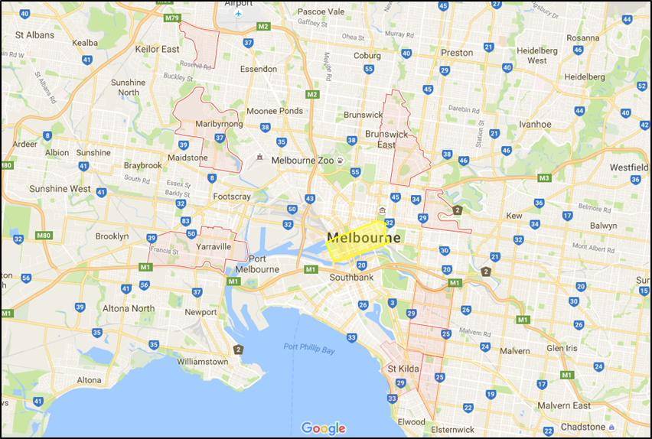
Figure 1. Location of SA2 areas (highlighted in red) in relation to the Melbourne CBD (highlighted in yellow) (Adapted from Google Maps 2016)

Table 1: IRSD values and percentiles of each SA2 selected

Area | IRSD value | IRSD percentile
St Kilda | 1057 | 78
St Kilda East | 1050 | 75
Prahran-Windsor | 1058 | 78
South Yarra | 1056 | 77
Maribyrnong | 1052 | 75
Yarraville | 1047 | 73
Niddrie | 1054 | 76
Brunswick East | 1052 | 75
Fitzroy North | 1052 | 76
Abbotsford | 1054 | 76

Canopy cover, land covered by a tree canopy, is a widely-used indicator for assessing urban tree distribution (Krafft & Fryd 2016; Shakeel & Conway 2014; Escobedo et al. 2006; Heynen 2006; Heynen, Perkins & Roy 2006). Canopy cover is assessed through aerial/satellite photography, allowing for the evaluation of private and public land (Perkins, Heynen & Wilson 2004; Heynen 2006; Escobedo et al. 2006; Heynen, Perkins & Roy 2006; Kirkpatrick Daniels & Davidson 2011; Kendal, Williams & Williams 2012). Because older trees have larger canopy cover compared with younger trees, this study focused on dwellings constructed 2006-2014, assuming that trees were predominantly planted in association with new development, to reduce the impact of varying tree age on results.
Using aerial photography, the level of canopy-cover within individual properties was assessed, in addition to assessing the land that was underutilised to plant trees. Individual properties were classified as: single dwelling on a lot, 2-5 dwellings, 6-19 dwellings, and 20+ dwellings, providing a diversity of property types and dwelling densities. The chosen sample sizes ensured a 7% precision and 95% confidence interval (Israel 1992) (Table 2). The development age of dwellings was established using the Department of Environment, Land, Water, and Planning’s Housing Development Dataset.

Table 2: Total population and sample sizes

Development Category | Total Population | Sample Size
1 Dwelling | 1156 | 173
2-5 Dwellings | 547 | 149
6-19 Dwellings | 148 | 86
20+ Dwellings | 122 | 76

This research assessed land-cover using i-Tree Canopy software and satellite imagery obtained through Google Earth. i-Tree Canopy generates multiple random sample points within a defined area on a satellite image. The land-cover at each point generated was classified, producing a proportional figure for each property (Figure 2).
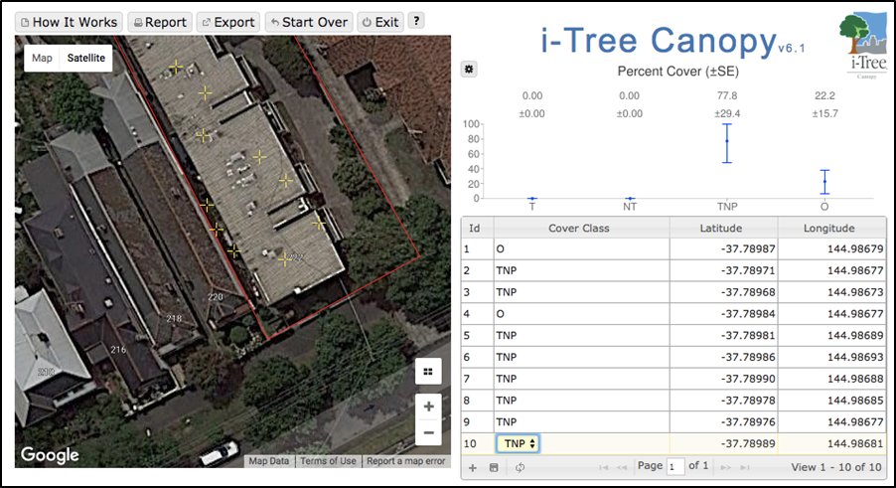
Figure 2. Image of i-tree canopy demonstrating the randomly selected points (left) and classification of the points (right) (i-Tree Canopy 2016)
Four classification categories were used: Tree Realized, Tree Not Realized, Tree Not Possible, and Other (Table 3). These categories provided insights into both the tree distribution of each site and the land within each property that could host a tree. The data was analysed to determine the ratio of Tree Realized to Tree Not Realized land-cover (TR:TNR), and Tree Realized to Tree Not Realized and Other land-cover (TR:TNR+O) per property. These ratios were compared between the different categories of development density to ascertain the relationships between development density and canopy cover. The inclusion of the ‘Other’ land-cover category allowed for greater depth regarding how different densities utilise their land, in particular the paving of private open space (POS) instead of vegetated land-cover.

Table 3. Land-cover types, descriptions, and examples
Land-cover | Description | Example
Tree Realized | A tree canopy exists and a tree has been planted | Tree canopy
Tree Not Realized | A tree could be planted but has not been | Garden bed, grass lawn
Tree Not Possible | Building prevents the planting of a tree | Building, wall
Other | Land-cover choices other than a building prevents the planting of a tree | Paved surface, swimming pool, tennis court, driveway

As the focus of the research is to compare land-cover distribution at different development densities, results from different suburbs were amalgamated and divided by development density category. For each land-cover category, and TR:TNR and TR:TNR+O ratios, the mean value was calculated and compared. The following section presents the findings.

Results

Tree Realized
The ‘Tree Realized’ (TR) category indicates an area of the site that was covered by tree canopy. This demonstrates that the land owner/occupier has made a decision to plant/retain a tree over other landscaping options. As the number of dwellings on a lot increased, overall TR decreased (Figure 3). There is a strong negative correlation between development density and TR land-cover percentage (trend-line gradient of -1.44 and correlation coefficient (r) of -0.98). This indicates that as the density of a development increases, the proportion of trees on a lot decreases, with a high statistical confidence that development density is the influencing factor in this relationship.

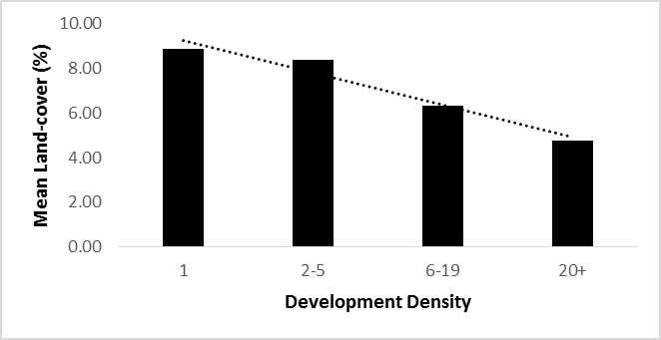
Figure 3 Relationship between mean TR land-cover percentage and development density

Tree Not Realized
The ‘Tree Not Realized’ (TNR) category includes land where a tree could currently exist but doesn’t; including garden beds, grassed lawns, or exposed soil. A strong negative correlation (r value of -0.97) between development density and TNR percentage was observed (Figure 4). There is a significantly greater negative relationship with development density than was found with TR (TNR trend-line gradient of -4.5 compared with TR trend-line gradient of -1.44). Findings indicate that as development density increases, soft landscaping of POS decreases. This decrease is significantly greater than that found for TR. There is a high statistical confidence that development density is the contributing factor for this decrease in soft landscaping.

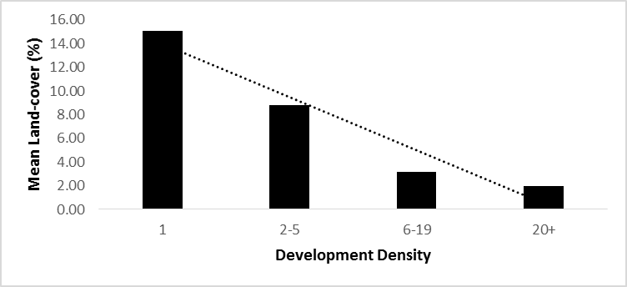
Figure 4 Relationship between mean TNR land-cover percentage and development density

Other
The ‘Other’ (O) category applies to land within the open space of a property that is neither occupied by trees, nor where a tree could be planted. This land-cover consists of hardscaping elements such as paving and driveways. A strong negative correlation between development density and O land-cover percentage was found (Figure 5). This negative relationship has a trend-line gradient of -2.96 and r value of -0.87. There is a reduced confidence in the correlation between development density and O land-cover 9as indicated by the r value) compared to other land-cover categories (TR=-0.98, TNR = -0.97, TNP = 0.96). This reduced confidence indicates that the O categorisation is a less optimal classification of land-cover compared to TR, TNR, and TNP, and that variations in O are likely to be caused by other un-controlled (and unidentified) variables apart from development density.
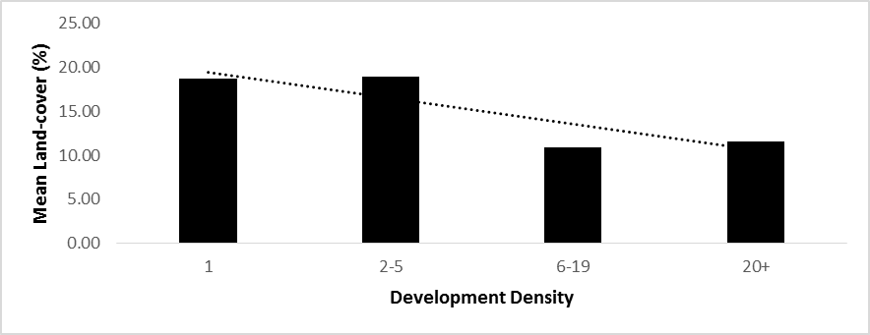
Figure 5 Relationship between mean Other land-cover percentage and development density

As development density increases, the proportion of land used for hardscaping land-cover decreases. Though the reduction in hardscaping is less than the reduction in soft landscaping land-cover, the planting of trees was found to be the least influenced by an increase in development density (Figure 6).

Figure 6 Relationship between TR, TNR, and Other, and development density

TR:TNR Ratio
The ratio of Tree Realized to Tree Not Realized (TR:TNR) demonstrates the proportion of land where a tree occurs (TR) compared to the land covered by soft landscaping (TNR) and indicates the proportion of land available to plant trees where trees planting has been realised. The results found strong positive correlation between TR:TNR and development density (trend-line gradient of +0.66, and r value of 0.98) (Figure 7). As development density increases, the ratio of trees compared to land available to plant trees increases. There is a high confidence that the development density is the contributing factor to this trend.

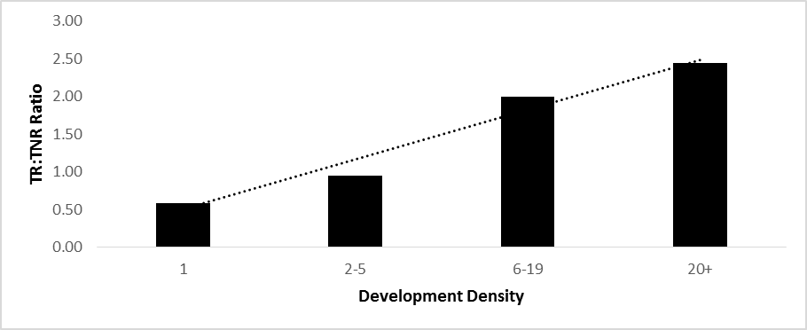
Figure 7 Relationship between TR:TNR and development density

TR:TNR+O
The categories defined in this study considers private open space to have three possible uses: supporting a tree (TR), supporting soft landscaping (TNR), or supporting hard landscaping options (O). While TR:TNR demonstrates the proportion of available land used to plant trees in a given site, it does not incorporate alternative landscaping arrangements such as hardscaping. There is a possibility for land to be increasingly used for hardscaping compared to soft landscaping and tree planting as development density increases. Accordingly, a ratio of TR to TNR and O (TR:TNR+O) is required to ascertain whether an increase in development density results in the preference of trees over alternative landscaping, or whether hardscaping is the primary preference compared to the planting of trees.
A moderate positive relationship exists between development density and TR:TNR+O (trend-line gradient of 0.04 and r value of 0.67) (Figure 8). As the relationship demonstrates a weak correlation between the independent and dependant variables, it is difficult to conclude that an increase in development density will result in an increase in the proportion of trees compared to soft and hard landscaping options.
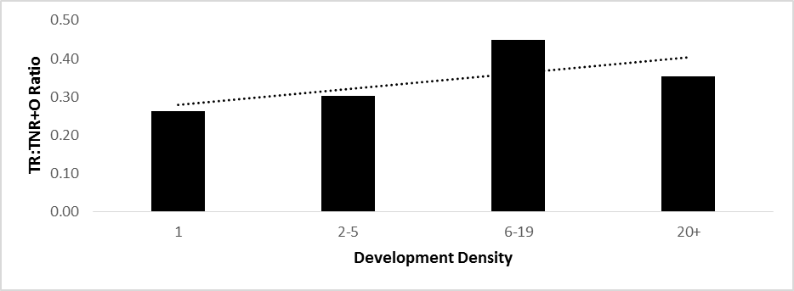
Figure 8 Relationship between TR:TNR+O and development density

In summary, the findings showed decreases in the proportion of all land-cover categories except TNR in association with an increase in development density. The rate of decline was greatest for TNR, followed by O and TR indicating that the planting of trees is the least influenced by an increase in development density. The TR:TNR ratio had a strong positive relationship with development density, indicating that that the ratio of trees compared to land available to plant trees increased with an increase in development density. However as the TR:TNR+O ratio was less statistically significant than TR:TNR, questions are raised regarding the nature of the O land-cover category. The following section discusses the results, highlighting areas of support or conflict with other studies’ findings, and provides some reflections on implications for land use planning approaches.

Discussion
This study has found that the reduction in both TR and TNR in association with an increase in development density is consistent with other research findings that have shown a reduction in available space results in a decrease in the total canopy-cover and landscaped surfaces on site (Kendal, Williams & Williams 2012; Coutts et al. 2007; Smith et al. 2005). Though both TR and TNR demonstrated strong negative relationships with development density, the reduction in TR was significantly less than TNR, resulting in a positive TR:TNR ratio associated with an increase in development density (Figure 6). This indicates that as development density increases, the proportion of trees compared with area available to plant trees increases. These findings are consistent with the expected results and indicate a preference for trees compared to smaller vegetation when available space is limited (Cook et al. 2015). Whilst other studies have found that when provided with limited space, vegetation tends towards smaller varieties (Troy et al 2007), these different results may be due to contextual differences, with Troy et al (2007) conducting their research in the U.S.A compared to Cook et al. (2015) focusing specifically on Melbourne, Australia.
Though a positive relationship was found between residential development density and the proportion of available private land used for canopy trees, many questions remain unanswered. Firstly, the mechanisms behind the relationship were not examined. Though it has been suggested that the existence of management companies or owners corporations result in larger, lower-maintenance vegetation being selected (Conway & Bourne 2013; Shakeel & Conway 2014), an analysis of such factors has been outside the scope of this research.
Additionally, it is possible that the positive TR:TNR ratio is the result of an increase in paved surfaces rather than an increase in tree distribution. This is supported by the relatively stable TR:TNR+O ratio (trend line gradient = 0.04) compared to the sizeable TR:TNR ratio (trend line gradient = 0.66), indicating that when paved surfaces are considered, the proportional increase in trees is negligible (Figure 10). This is consistent with research undertaken in Perth arguing that recent landscaping trends have favoured paved surfaces over soft landscaping (Brunner & Cozens 2013).

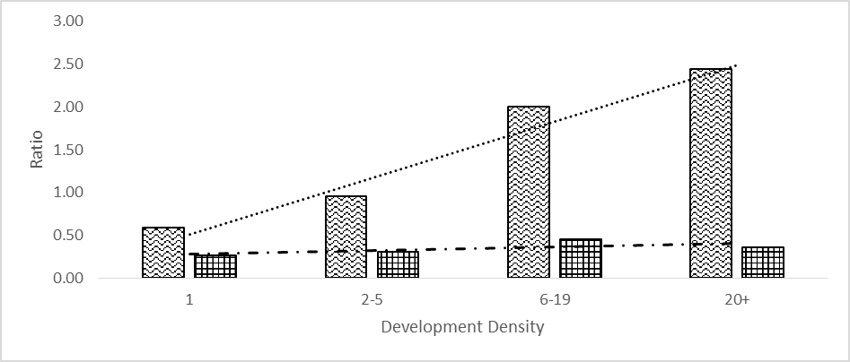
Figure 10 Relationship between TR:TNR (waved shape, dotted line) and TR:TNR+O (grid shape, dashed line), and development density.

There are a number of research limitations related to the analysis method. These include uncertainty whether trees were planted in conjunction with development and whether trees were planted at similar ages. Also, different species exhibit different canopy size and growth rates, possibly impacting result accuracy (Pedlowski, Adell & Heynen, 2002; Schwarz et al. 2015). The sample sizes of each category achieved a precision of 7%; to further reduce the occurrence of sampling error, a more significant precision (either 5% or lower) would preferably be selected (Israel 1992). By decreasing the prevalence of sample error, greater confidence in the results would be achieved. This is likely to be significant for future research that assesses the relationship between density and realized canopy-cover. In addition, inclusion of other relevant factors such as housing ownership, which has been shown to influence private property tree distribution (Perkins, Heynen & Wilson 2004), would be beneficial to ensure greater control of influential variables, ensuring greater reliability and validity of results.
Due to the procedural limitations of the assessment, the land-cover categories were required to be divided into four general groups of development density. Though the progression between the categories was generally linear, allowing for the analysis of a trend line and correlation coefficient, the accuracy of the results would benefit from a greater specificity of development density. For example, an analysis of dwellings at every stage along the development density continuum (1 dwelling, 2 dwellings, 3 dwellings and so on) would allow a more accurate correlation coefficient as well as providing additional information regarding determination of the peak for density of trees compared to space available to plant trees.
Though the assessment identified a relationship between development density and the proportion of available land used to plant canopy trees, the mechanisms behind this relationship remain uncertain. It is considered that, as both the O land-use category and the TR:TNR+O ratio demonstrated the weakest correlation coefficients, -0.87 and 0.66 respectively, this indicates a level of uncertainty relating to the O land-cover category. To gain a greater understand of the true nature of the O land-cover category and TR:TNR+O ratio, a more detailed division of the Other land-use category would be beneficial. Dividing O into ‘Driveways’ and ‘Other paved private open space’, would be a simple modification to the method that would provide insight into the mechanisms at play. In this way, it could be ascertained whether the increase in TR:TNR ratio was due to an increase of the use of land for canopy trees, or if the paving of private open space generated a false positive, making the change in proportion of trees to land available to plant trees seem more significant than is actually the case.
Notwithstanding these research limitations, the study supports the application of prevailing methodologies in the field of canopy-cover assessments. Methods used to assess urban canopy-cover often involve the analysis of aerial imagery across large urban areas containing both private and public land (Escobedo et al. 2006; Krafft & Fryd 2016; Heynen 2006). This study supports less common methodologies where aerial imagery is analysed at a finer grain, to assess land-cover within individual, privately owned lots (Landry & Chakraborty; Troy et al 2007; Kirkpatrick, Daniels & Davison 2011), providing a basis from which to develop further research on single-lot canopy-cover.

Finally, the study found that compared with soft landscaping such as grassed lawns, tree cover decreased proportionally less with increasing density and was therefore more resistant to landscape changes. This reinforces a focus on planning regulations that include requirement for planting of at least one tree as seen in the Melbourne council areas of Brimbank, Moreland, and Monash (Brimbank City Council 2016; Monash City Council 2016), as once a tree is established, it is more likely to be retained in the face of future development than other vegetative landscaping treatments.

Future Research Opportunities
The results of the assessment, while indicating a relationship between residential development density and the proportion of available private land used for canopy trees, provide a number of additional research questions for further studies in the field.
The specific nature of the relationship between development density and the proportion of available land used to plant trees remains uncertain. To study the specifics relating to the threshold of development density at which the TR:TNR ratio increases, necessitates an assessment of canopy-cover for each development density. Whereas this assessment divided development density into four categories, future assessments should focus on the land-cover of developments along a density continuum. To enable this assessment, while controlling for the necessary variables, a significantly greater sample size would be required than is possible to be provided in Melbourne. Accordingly, to accommodate the increased sample size, a larger population of developments would be required. It is suggested that data be gathered from either a national or international database to accommodate the significant increases in sample size required. However, caution should be given to the possible contextual variance between cities and countries (for example, Troy et al. 2007).
To strengthen the understanding of the relationship between development density and the proportion of available land used to plant trees, a better appreciation of the characteristics of paved surfaces on each individual property is required. Accordingly, additional research should address the relationship between development density and paved surfaces. This will assist in determining whether the increase in TR:TNR ratio is due to the preference of tree plantings over landscaped areas, or whether the preference for paved open space over landscaped land-cover is artificially enhancing the TR:TNR ratio.
This assessment focused specifically on suburbs within inner-city Melbourne. By replicating this research across a number of different cities in Australia and internationally, insight may be gained into the range of factors that influence both tree canopy-cover and other landscaping decisions.
Finally, future research should be targeted to ascertain the human preference factors that influence the distribution of trees on private property. For example, research could focus on the influence that body corporates and owners corporations may have on landscaping decisions and on urban tree distribution (Conway & Bourne 2013; Shakeel & Conway 2014). An understanding of the preferences and practices of these bodies may better allow policy to be targeted towards increasing urban tree distribution.
It is considered that as the urban populations rises and urban areas develop in Melbourne, Australia and globally, ways to maximise urban green infrastructure, in particular trees, is becoming increasingly important. This research responds to this need by investigating the impact changing urban densities has on urban forests, in-turn helping pave the way for future research in the field of environmental urban planning.

Conclusion
Trees have many benefits for urban environments and urban dwellers. Though trees planted within private property contribute significantly to the urban canopy, private property tree distribution is often underserviced by Australian planning policy. Accordingly, to better design planning policy and in turn enhance human and environmental outcomes within cities, it is important to better understand the mechanisms behind private property urban tree distribution.
Much research regarding urban tree distribution focuses on social-economic and temporal variables influencing canopy-cover; often overlooking the potential influence of the built form. Where research does focus on the influence of urban form, this is often associated with assessment of overall canopy, foregoing a more nuanced investigation into the efficiency of various urban densities to house canopy trees. Accordingly, this study analysed the relationship between residential development density and the proportion of available private land used for canopy trees in inner-city Melbourne, Australia.
The study assessed aerial imagery to build an understanding of land-cover distribution within recently constructed private properties of varying densities. The results of the assessment found decreases in the number of trees, and the quantity of soft and hard landscaping areas associated with an increase in development density; however, trees were found to be the least influenced by changes in development density. The ratio of trees to land available to plant trees demonstrated a strong positive correlation with development density. However, this was less significant when paved land-cover was considered; raising questions regarding the influencing factors in the relationship between development density and the ratio of trees to landscaped areas.
As urban populations continue to grow, cities need to find ways to maximise the use of available space to ensure positive outcomes for their inhabitants. This is especially true for urban forests, where trees ensure positive mental and physical health outcomes for urban residents, yet are provided with continuously less space for establishment. The assessment found that for privately owned land in Melbourne, an increase in development density resulted in an increase in the number of trees compared to land available to plant trees. These results are significant as they provide insight into the impact urban densification has on the urban environment, specifically the distribution of urban canopies. The results support emerging trends in Melbourne’s urban forestry planning and have the potential to inform planning policy and other urban forest programs by ensuring a better understanding of this relationship.

References
ABS 2016, '2033.0.55.001 - Census of Population and Housing: Socio-Economic Indexes for Areas (SEIFA), Australia, 2011', Australian Bureau of Statistics, accessed October 18, 2016, from <http://www.abs.gov.au/ausstats/abs@.nsf/Lookup/2033.0.55.001main+features100052011 >.
Abhijith, K, Kumar, P, Gallagher, J, McNabola, A, Baldauf, R, Pilla, F, Broderick, B, Di Sabtino, S & Pulvirenti, B 2017, 'Air pollution abatement performances of green infrastructure in open road and built-up street canyon environments - A review', Atmospheric Environment, vol. 162, pp. 71-86.
Akbari, H 2002, 'Shade trees reduce building energy use and CO2 emissions from power plants', Environmental Pollution, vol. 116, pp. S119-S126.
Boone, C, Buckley, G, Grove, J & Sister, C 2009, 'Parks and People: An Environmental Justice Inquiry in Baltimore, Maryland', Annals of the Association of American Geographers, vol. 99, no. 4, pp. 767-787.
Brimbank City Council 2016, Urban Forest Strategy 2016-2056, Brimbank City Council, City of Brimbank.
Brunner, J & Cozens, P 2013, '‘Where Have All the Trees Gone?’ Urban Consolidation and the Demise of Urban Vegetation: A Case Study from Western Australia', Planning Practice and Research, vol. 28, no. 2, pp. 231-255.
Bryman, A 2012, Social research methods, 4th edn, Oxford University Press, Oxford.
Christensen, J, Hewitson, B, Busuioc, A, Chen, A, Gao, X, Held, I, Jones, R, Kolli, R, Kwon, W, Laprise, R, Rueda, V, Mearns, L, Menendez, C, Ralsanen, J, Rinke, A, Sarr, A & Whetton, P 2007, 'Regional Climate Projections', in S Solomon, D Qin, M Manning, M Marquis, K Averyt, M Tignor, H LeRoy Miller & Z Chen (ed), Climate Change 2007: The Physical Science Basis, Cambridge University Press, Cambridge, pp. 847-940.
Conway, T & Bourne, K 2013, 'A comparison of neighborhood characteristics related to canopy cover, stem density and species richness in an urban forest', Landscape and Urban Planning, vol. 113, pp. 10-18.
Cook, N, Hughes, R, Taylor, E, Livesley, S & Davern, M 2015, Shading Liveable Cities: exploring the ecological, financial and regulatory dimensions of the urban tree canopy, The University of Melbourne.
Coutts, A, Beringer, J & Tapper, N 2007, 'Impact of Increasing Urban Density on Local Climate: Spatial and Temporal Variations in the Surface Energy Balance in Melbourne, Australia', J. Appl. Meteor. Climatol., vol. 46, no. 4, pp. 477-493.
Davies, Z, Edmondson, J, Heinemeyer, A, Leake, J & Gaston, K 2011, 'Mapping an urban ecosystem service: quantifying above-ground carbon storage at a city-wide scale', Journal of Applied Ecology, vol. 48, no. 5, pp. 1125-1134.
Des Rosiers, F, Thériault, M, Kestens, Y & Villeneuve, P 2002, 'Landscaping and House Values: An Empirical Investigation', Journal of Real Estate Research, vol. 1, no. 2, pp. 139-161.
Donovan, G & Butry, D 2010, 'Trees in the city: Valuing street trees in Portland, Oregon', Landscape and Urban Planning, vol. 94, no. 2, pp. 77-83.
DTPLI 2016, Planning Permit Activity Annual Report: 2014-2015, Department of Transport, Planning and Local Infrastructure, Melbourne, accessed May 13, 2016, from <http://www.dtpli.vic.gov.au/planning/planning-applications/planning-permit-activity-in-victoria/annual-report-2014-15>.
Escobedo, F, Nowak, D, Wagner, J, De la Maza, C, Rodríguez, M, Crane, D & Hernández, J 2006, 'The socioeconomics and management of Santiago de Chile's public urban forests', Urban Forestry & Urban Greening, vol. 4, no. 3-4, pp. 105-114.
Forman, R 1995, 'Some general principles of landscape and regional ecology', Landscape Ecology, vol. 10, no. 3, pp. 133-142.
Gabriel, K & Endlicher, W 2011, 'Urban and rural mortality rates during heat waves in Berlin and Brandenburg, Germany', Environmental Pollution, vol. 159, no. 8-9, pp. 2044-2050.
Gómez-Baggethun, E & Barton, D 2013, 'Classifying and valuing ecosystem services for urban planning', Ecological Economics, vol. 86, pp. 235-245.
Google Maps, 2016, 'Melbourne', Melbourne, accessed October 13, 2016, from <https://www.google.com.au/maps/place/Melbourne+VIC/@-37.9712369,144.492671,9z/data=!3m1!4b1!4m5!3m4!1s0x6ad646b5d2ba4df7:0x4045675218ccd90!8m2!3d-37.8136276!4d144.9630576>.
Grinde, B & Patil, G 2009, 'Biophilia: Does Visual Contact with Nature Impact on Health and Well-Being?', International Journal of Environmental Research and Public Health, vol. 6, no. 9, pp. 2332-2343.
Haaland, C & van den Bosch, C 2015, 'Challenges and strategies for urban green-space planning in cities undergoing densification: A review', Urban Forestry & Urban Greening, vol. 14, no. 4, pp. 760-771.
Hatt, B, Fletcher, T, Walsh, C & Taylor, S 2004, 'The Influence of Urban Density and Drainage Infrastructure on the Concentrations and Loads of Pollutants in Small Streams', Environmental Management, vol. 34, no. 1.
Heynen, N 2006, 'Green Urban Political Ecologies: Toward a Better Understanding of Inner-City Environmental Change', Environment and Planning A, vol. 38, no. 3, pp. 499-516.
Heynen, N & Lindsey, G 2003, 'Correlates of Urban Forest Canopy Cover: Implications for Local Public Works', Public Works Management & Policy, vol. 8, no. 1, pp. 33-47.
Heynen, N, Perkins, H & Roy, P 2006, 'The Political Ecology of Uneven Urban Green Space: The Impact of Political Economy on Race and Ethnicity in Producing Environmental Inequality in Milwaukee', Urban Affairs Review, vol. 42, no. 1, pp. 3-25.
Israel, G 1992, Determining Sample Size, University of Florida, Florida.
i-Tree Canopy, 2016, 'i-Tree Canopy', Canopy.itreetools.org, accessed October 30, 2016, from <https://canopy.itreetools.org/>.
Jim, C & Chen, W 2008, 'Assessing the ecosystem service of air pollutant removal by urban trees in Guangzhou (China)', Journal of Environmental Management, vol. 88, no. 4, pp. 665-676.
Kabisch, N & Haase, D 2014, 'Green justice or just green? Provision of urban green spaces in Berlin, Germany', Landscape and Urban Planning, vol. 122, pp. 129-139.
Kampa, M & Castanas, E 2008, 'Human health effects of air pollution', Environmental Pollution, vol. 151, no. 2, pp. 362-367.
Kendal, D, Williams, N & Williams, K 2012, 'Drivers of diversity and tree cover in gardens, parks and streetscapes in an Australian city', Urban Forestry & Urban Greening, vol. 11, no. 3, pp. 257-265.
Kirkpatrick, J, Daniels, G & Davison, A 2009, 'An antipodean test of spatial contagion in front garden character', Landscape and Urban Planning, vol. 93, no. 2, pp. 103-110.
Kirkpatrick, J, Daniels, G & Davison, A 2011, 'Temporal and spatial variation in garden and street trees in six eastern Australian cities', Landscape and Urban Planning, vol. 101, no. 3, pp. 244-252.
Kirkpatrick, J, Daniels, G & Zagorski, T 2007, 'Explaining variation in front gardens between suburbs of Hobart, Tasmania, Australia', Landscape and Urban Planning, vol. 79, no. 3-4, pp. 314-322.
Kleerekoper, L, van Esch, M & Salcedo, T 2012, 'How to make a city climate-proof, addressing the urban heat island effect', Resources, Conservation and Recycling, vol. 64, pp. 30-38.
Krafft, J & Fryd, O 2016, 'Spatiotemporal patterns of tree canopy cover and socioeconomics in Melbourne', Urban Forestry & Urban Greening, vol. 15, pp. 45-52.
Landry, S & Chakraborty, J 2009, 'Street Trees and Equity: Evaluating the Spatial Distribution of an Urban Amenity', Environment and Planning A, vol. 41, no. 11, pp. 2651-2670.
Lohr, V, Pearson-Mims, C, Tarnal, J & Dillman, D 2004, 'How urban residents rate and rank the benefits and problems associated with trees in cities', Journal of Arboriculture, vol. 30, no. 1, pp. 28-35.
Loughner, C, Allen, D, Zhang, D, Pickering, K, Dickerson, R & Landry, L 2012, 'Roles of Urban Tree Canopy and Buildings in Urban Heat Island Effects: Parameterization and Preliminary Results', J. Appl. Meteor. Climatol., vol. 51, no. 10, pp. 1775-1793.
Luck, G, Smallbone, L & O’Brien, R 2009, 'Socio-Economics and Vegetation Change in Urban Ecosystems: Patterns in Space and Time', Ecosystems, vol. 12, no. 4, pp. 604-620.
Luck, M & Wu, J 2002, 'A Gradient analysis of urban landscape pattern: a case study from Phoenix metropolitan region, Arizona, USA', Landscape Ecology, vol. 17, pp. 327-339.
McPherson, E 1994, 'Chapter 8: Benefits and Costs of Tree Planting and Care in Chicago', in E McPherson, D Nowak & R Rowntree (ed), Chicago's Urban Forest Ecosystem: Results of the Chicago Urban Forest Climate Project. USDA Forest Service General Technical Report NE-186, United States Department of Agriculture, Radnor, PA, pp. 115-132.
Monash City Council 2016, Monash Planning Scheme, Clause 22.05 - Tree Conservation Policy, Monash City Council, City of Monash.
Moreland City Council 2017, Draft Urban Forest Strategy 2017-2027, Moreland City Council, City of Moreland.
Morales, D 1980, 'The Contribution of trees to residential property value', Journal of Arboriculutre, vol. 6, no. 11, pp. 305-308.
Norton, B, Coutts, A, Livesley, S, Harris, R, Hunter, A & Williams, N 2015, 'Planning for cooler cities: A framework to prioritise green infrastructure to mitigate high temperatures in urban landscapes', Landscape and Urban Planning, vol. 134, pp. 127-138.
Nowak, D & Crane, D 2002, 'Carbon storage and sequestration by urban trees in the USA', Environmental Pollution, vol. 116, no. 3, pp. 381-389.
Nowak, D, Crane, D & Stevens, J 2006, 'Air pollution removal by urban trees and shrubs in the United States', Urban Forestry & Urban Greening, vol. 4, no. 3-4, pp. 115-123.
Pandit, R, Polyakov, M, Tapsuwan, S & Moran, T 2013, 'The effect of street trees on property value in Perth, Western Australia', Landscape and Urban Planning, vol. 110, pp. 134-142.
Paul, M & Meyer, J 2001, 'Streams in the Urban Landscape', Annu. Rev. Ecol. Syst., vol. 32, no. 1, pp. 333-365.
Pedlowski, M, Adell, J & Heynen, N 2002, 'Urban forest and environmental inequality in Campos dos Goytacazes, Rio de /Janeiro, Brazil', Urban Ecosystems, vol. 6, pp. 9-20.
Perkins, H, Heynen, N & Wilson, J 2004, 'Inequitable access to urban reforestation: the impact of urban political economy on housing tenure and urban forests', Cities, vol. 21, no. 4, pp. 291-299.
Pham, T, Apparicio, P, Séguin, A, Landry, S & Gagnon, M 2012, 'Spatial distribution of vegetation in Montreal: An uneven distribution or environmental inequity?', Landscape and Urban Planning, vol. 107, no. 3, pp. 214-224.
Rodriguez, S, Querol, X, Alastuey, A, Viana, M, Alarcon, M, Mantilla, E & Ruiz, C 2004, 'Comparative PM10–PM2.5 source contribution study at rural, urban and industrial sites during PM episodes in Eastern Spain', Science of The Total Environment, vol. 328, no. 1-3, pp. 95-113.
Rogers, K, Jaluzot, A & Neilan, C 2012, Green Benefits in Victoria Business Improvement District, Victoria Business Improvement District, London.
Santamouris, M & Asimakopoulos, D 2001, Energy and climate in the urban built environment, James X James, London.
Schwarz, K, Fragkias, M, Boone, C, Zhou, W, McHale, M, Grove, J, O’Neil-Dunne, J, McFadden, J, Buckley, G, Childers, D, Ogden, L, Pincetl, S, Pataki, D, Whitmer, A & Cadenasso, M 2015, 'Trees Grow on Money: Urban Tree Canopy Cover and Environmental Justice', PLOS ONE, vol. 10, no. 4, p. e0122051.
Shakeel, T & Conway, T 2014, 'Individual households and their trees: Fine-scale characteristics shaping urban forests', Urban Forestry & Urban Greening, vol. 13, no. 1, pp. 136-144.
Shanahan, D, Lin, B, Gaston, K, Bush, R & Fuller, R 2014, 'Socio-economic inequalities in access to nature on public and private lands: A case study from Brisbane, Australia', Landscape and Urban Planning, vol. 130, pp. 14-23.
Smith, R, Gaston, K, Warren, P & Thompson, K 2005, 'Urban domestic gardens (V): relationships between landcover composition, housing and landscape', Landscape Ecology, vol. 20, no. 2, pp. 235-253.
State Government of Victoria, 1988, Subdivision Act 1988 - Section 27A, State Government of Victoria, Melbourne.
State of Victoria, 2014, Plan Melbourne, State Government of Victoria, Melbourne.
Sugiyama, T, Leslie, E, Giles-Corti, B & Owen, N 2008, 'Associations of neighbourhood greenness with physical and mental health: do walking, social coherence and local social interaction explain the relationships?', Journal of Epidemiology & Community Health, vol. 62, no. 5, pp. e9-e9.
Troy, A, Grove, J, O’Neil-Dunne, J, Pickett, S & Cadenasso, M 2007, 'Predicting Opportunities for Greening and Patterns of Vegetation on Private Urban Lands', Environmental Management, vol. 40, no. 3, pp. 394-412.
Velarde, M, Fry, G & Tveit, M 2007, 'Health effects of viewing landscapes – Landscape types in environmental psychology', Urban Forestry & Urban Greening, vol. 6, no. 4, pp. 199-212.
Walsh, C, Roy, A, Feminella, J, Cottingham, P, Groffman, P & Morgan, R 2005, 'The urban stream syndrome: current knowledge and the search for a cure', Journal of the North American Benthological Society, vol. 24, no. 3, p. 706.
Xiao, Q, McPherson, E, Ustin, S, Grismer, M & Simpson, J 2000, 'Winter rainfall interception by two mature open-grown trees in Davis, California', Hydrol. Process., vol. 14, no. 4, pp. 763-784.

