Airbnb in Melbourne: How does the existing urban spatial structure shape the location of short-term accommodation sharing economy activity?
Vanessa O'Shea, Sun Sheng Han
The University of Melbourne, Melbourne, Victoria, Australia

Abstract
Airbnb is a short-term accommodation in the sharing economy platform that has become increasingly prevalent since its inception in 2008. Despite the growth of Airbnb, limited research has been focussed on understanding how this facet of the sharing economy interacts with the existing urban spatial structure. Within this paper metropolitan Melbourne is used as a case study to further an understanding of how Airbnb occupies space in cities. Spatial analysis of the distribution of the entire home, private room and shared room listing types in January 2016 was undertaken to gain an insight into the temporal and spatial characteristics of Airbnb listings in metropolitan Melbourne. The findings suggest that each listing type demonstrated a distinctive spatial pattern. The entire home listings were highly concentrated in central Melbourne and the private room and shared room listings were more evenly but less intensively distributed throughout the central, middle and outer ring suburbs. Results from the regression analyses revealed variances in the contribution of economic, household and locational characteristics in explaining the number of Airbnb listing specific to the types over space. The findings provide a context specific understanding of the distribution of Airbnb listings in Melbourne as well as some of the factors that contribute to this distribution.

Keywords:
Airbnb; sharing economy; Melbourne; spatial distribution

Introduction
Airbnb is an online short-term rental (STR) platform that was established in 2008 in San Francisco (Zervas, Prosperio & Byers et al, 2016). As a peer-to-peer sharing economy platform, Airbnb allows people to rent out entire dwellings or rooms temporarily (Martin, 2016, p. 149). Airbnb differs from traditional ownership-based businesses because of its dependence on the Internet and its patterns of consumption that involve short-term access and non-ownership (Nica & Potocovaru, 2015; Demary, 2015). The utilisation of idle goods and services provides Airbnb with a competitive advantage over traditional business models (Hansen Heten & Windekilde et al, 2015). With it’s prolific growth and ease of access, Airbnb has the potential to disrupt established supply chains (Barnes & Mattsson, 2016).Within an international context the predominant research directions undertaken regarding Airbnb are largely focussed on the impact the platform has on the tourism sector and housing markets within cities. Nevertheless, the limited analyses of Airbnb within the tourism sector suggest that tourism has benefitted from the emergence of Airbnb as it provides a source of supplementary income for unemployed residents (Fang, Ye & Law, 2016). Despite the economic benefits, Airbnb can negatively impact the tourism sector as it competes with traditional forms of accommodation such as hotels (Guttentag, 2013; Cusumano, 2015). While Airbnb is commonly associated with tourism there has been speculation regarding the impact Airbnb has on the affordability and supply of housing markets in global cities that attract a large number of tourists (Hill, 2015; Lee, 2016).

Studies that connect Airbnb to various aspects of housing have been conducted (Windener, 2015; Davidson & Infranca, 2016; Lee, 2016). According to Hill (2015) Airbnb can have more of an impact on housing markets in cities that attract a large number of tourists and are particularly prone to housing shortages. Lee (2016) examined the relationship between short- term rental (STR) and the affordable housing crisis in Los Angeles. The findings suggest that the transference of traditional rental dwellings into STR apartments (Airbnb) have reduced the availability of rental housing for Los Angeles residents. Moreover, Lee (2016) asserts that markets with low rental vacancy rates are particularly susceptible to a natural increase of rental prices because the public sector and the market cannot contribute to the existing housing stock at a rate that meets the demand. Some researchers suggest that Airbnb has become a major competitor to traditional accommodation services such as hotels (Guttentag, 2015; Ert, Fleischer & Magen, 2016; Hansen Heten & WindekildeHansen et al, 2016; Zervas, Prosperio & Byers; 2015). The minimal time and cost associated with making Airbnb rooms and apartments market ready is advantageous when compared to establishing and maintaining hotel chains. Further, hosts are able to post listings online almost immediately, there are no building costs and there are no zoning requirements to abide by (Zervas, Propserio and Buyers, 2015). The competitive pricing of Airbnb has encouraged a shift in the demand for tourist accommodation that is particularly threatening to low-cost accommodation providers (Guttentag 2013; Cusumano, 2015; Fang et al, Ye & Law, 2015).

Despite the rapid growth of the sharing economy there has been little inquiry into its spatial distribution characteristics. The same is true in researching Airbnb, except anecdotal evidence showing that Airbnb listings are more highly concentrated in central tourist areas (Aznar et al. 2016). This paper is probably the first attempt to explore the spatial distribution characteristics of Airbnb listings and the association between the number of Airbnb listings and selected socioeconomic and built environment features, using metropolitan Melbourne as a case study. Specific spatial distribution theories (SDT) specific to Airbnb listings have not yet been developed. Nevertheless, Zervas, Prosperio & Byers (2016) identified Airbnb is an alternative service that operates on the principle of supply and demand, therefore it is conceivable that Airbnb listings are distributed in a similar way as traditional businesses. Further, in reference to spatial competition and agglomeration effects, Ho and Hensher (2016) theorise that clustered businesses are more competitive with one another than with businesses that are located further away. It is suggested that the benefits associated with time and convenience make clustered businesses more attractive to consumers, and thus more competitive (Ho and Hensher, 2016). Similarly, research undertaken by Aznar et al. (2016) suggests that Airbnb listings are more highly concentrated in central tourist areas within Barcelona. This finding is consistent with findings that relate to the distribution of sharing economy platforms. Davidson and Infranca (2016) suggest that sharing economy platforms are more prevalent in dense, highly amenable and centrally located urban environments. Further, Cohen and Munoz (2015) identified population density as a locational factor that is associated with sharing economy activity.

Studies relating to Airbnb have not been undertaken in Melbourne, however the literature has established the need for a better understanding of the contributory economic, household and spatial characteristics associated with Airbnb listings. According to Coffee, Lange and Baker (2016) Melbourne has experienced a notable increase in population density within a 10km radius of the Melbourne CBD reported that between 1981 and 2011. Additionally, Coffee, Lange and Baker state that population density deteriorates as the distance from the CBD increases. Ellen (2015) highlights the importance of exploring how different households can potentially benefit financially from sharing economy companies such as Airbnb. Research undertaken by Healy (2016) suggests that Melbourne is an unaffordable city. The financial incentives associated with housing have been explored in Airbnb literature. Hill (2015) identifies that Airbnb can provide a financial incentive for landlords to convert their long-term rental property into a short-term rental property. Additionally, Jefferson-Jones (2015) identifies short-term rentals such as Airbnb as a means of reducing the costs associated with homeownership. Considering the relative unaffordability and the incentives for both landlords and reductions in costs associated with homeownership it is conceivable that aspects of housing can be inherently linked to Airbnb.

Research questions, methods and data
This research seeks to address this gap by way of spatial analyses and multiple linear regressions. Two research questions are explored.

RQ1: Are Airbnb listings concentrated in the Melbourne CBD and inner suburbs?
RQ2: How much of the spatial variations in Airbnb listings can be explained by economic, household and locational characteristics in Melbourne.

Methodology
Exploratory Spatial Data Analysis (ESDA) was selected to address the first research question, which was to understand how entire home, private room and shared room Airbnb listing types are distributed throughout Melbourne. Quantum GIS was used to analyse and interpret the distribution of entire home, private room and shared room Airbnb listings across metropolitan Melbourne. According to Stevenson (2011) GIS has the capacity to combine social and scientific processes through generating a visualization of information that can be analysed and interpreted. Graphical representation of Airbnb provides a means to analyse and interpret the distribution of Airbnb listing data. The findings in addressing RQ1, which are the number of Airbnb listings of each type in each suburb, will be used as input to answering RQ2.

The second research question is to explore if and the extent to which economic, household and locational characteristics contribute to explaining the spatial pattern of Airbnb listings at the suburb level. Multiple regression analyses were selected as the most appropriate method to understand the direction and strength of the relationship between economic, household and locational characteristics and the distribution of Airbnb listings. The multiple regression analysis enabled the cumulative impact of variables that contribute to the spatial distribution of Airbnb listings to be identified. Minitab 17 was used to produce separate multiple linear regression models for all listings within the distribution as well as each of the three listing types.

Data
Geolocated Airbnb listing data from Inside Airbnb was used to analyse the spatial distribution of Airbnb listings in the Greater Melbourne Area. Inside Airbnb is an independent and non-commercial project that is run by Murray Cox. The project provides publically accessible Airbnb data for a number of cities around the world (Inside Airbnb, 2016). The data comprised of listing data that was collected in January 2016 and April 2017. Statistical Area 2 (SA2) Polygons for all suburbs in metropolitan Melbourne were downloaded from the ABS (2016a). The polygons were reflective of the 2016 statistical divisions.
Dependent variable
The findings from the spatial distribution of each Airbnb listing type were used in a range of linear regression analyses. The number of listings in each suburb with respect to all listings, entire home, private room and shared room is the dependent variable that is used to represent the spatial distribution.

Independent variables
The independent variables (IV) were comprised of economic, household and locational characteristics were collected from the Australian Urban Research Infrastructure Network (AURIN). Refer to table 1. These datasets contain data that was collected as part of the 2011 census. Within existing literature, household, demographic and locational characteristics were identified as factors that can potentially impact Airbnb listings. SEIFA IER was chosen as the economic variable that will be used to provide insight into the relationship between access to economic resources and Airbnb listing distributions. Population density was selected as the locational variable used to determine if the number of listings in a suburb is associated with population density of suburbs. A variety of housing variables were selected to determine whether differences in household characteristic between different listing types. Refer to Dataset 1 of Table 2. Each of these housing variables was considered for each regression and comprised a pool of variables that the computer used to select from.

Table 1: Independent variable data sets and source

Table 2: Coded independent variable subtypes

Methodological limitations
A limitation of using multiple regressions is that a computer was used to determine the variables that were entered into each model that was produced. According to Wand (2011) multiple regression analyses can fail to select the model that best fits the data. This could lead to result in a situation where the combination of variables that were selected for a model are not the most appropriate variables to explain the regression. Further, a particular IV may be excluded from the regression model if only a small difference exists between it and another IV (Cramer and Howitt, 2011). This exclusion of variables can potentially result in a situation where a variable that contributes to a regression model is not recognised. Additionally, as the literature pertaining to the field is relatively limited, the methodology could have been hindered by an inability to ascertain the most influential variables that contribute to the listing distribution of Airbnb listings in Melbourne.

Results
The results from table 3 demonstrate that entire home listings are the dominant listing type in the greater Melbourne area as this category has the highest number of listings. Private rooms are the second most common listing type, followed by shared rooms. In comparison to entire homes and private rooms, shared rooms account for an almost negligible proportion of the total listings. The results also demonstrated that there was variation in the proportion of each listing type within suburbs.

Table 4 and table 5 demonstrate each distribution was impacted by outlier values that substantially impacted the mean number of listings in each suburb by way of comparing the mean and median measures of central tendency. In each listing type the means were substantially larger than the median, which suggests that mean value of listings for each suburb would not be an accurate representation of Airbnb listings across Melbourne.

Table 3: Comparison of Melbourne Airbnb listings by type

Table 4: Mean measure of central tendency for Melbourne Airbnb listings by type

Table 5: Median measure of central tendency for Melbourne Airbnb listings by type

Spatial analysis of all Airbnb listings by region
Table 6 demonstrate that at the regional level the majority of Airbnb listings are located within inner Melbourne. The regions with the second, third and fourth highest proportion of Airbnb listings were the inner south (7.2%), west (5.1%) and inner east (4.8%), respectively. Similar results occur at the suburb level as the Airbnb listing distribution in Figure x demonstrates that listings are concentrated within the CBD and inner suburbs.

Table 6: Spatial analysis of Melbourne Airbnb listings

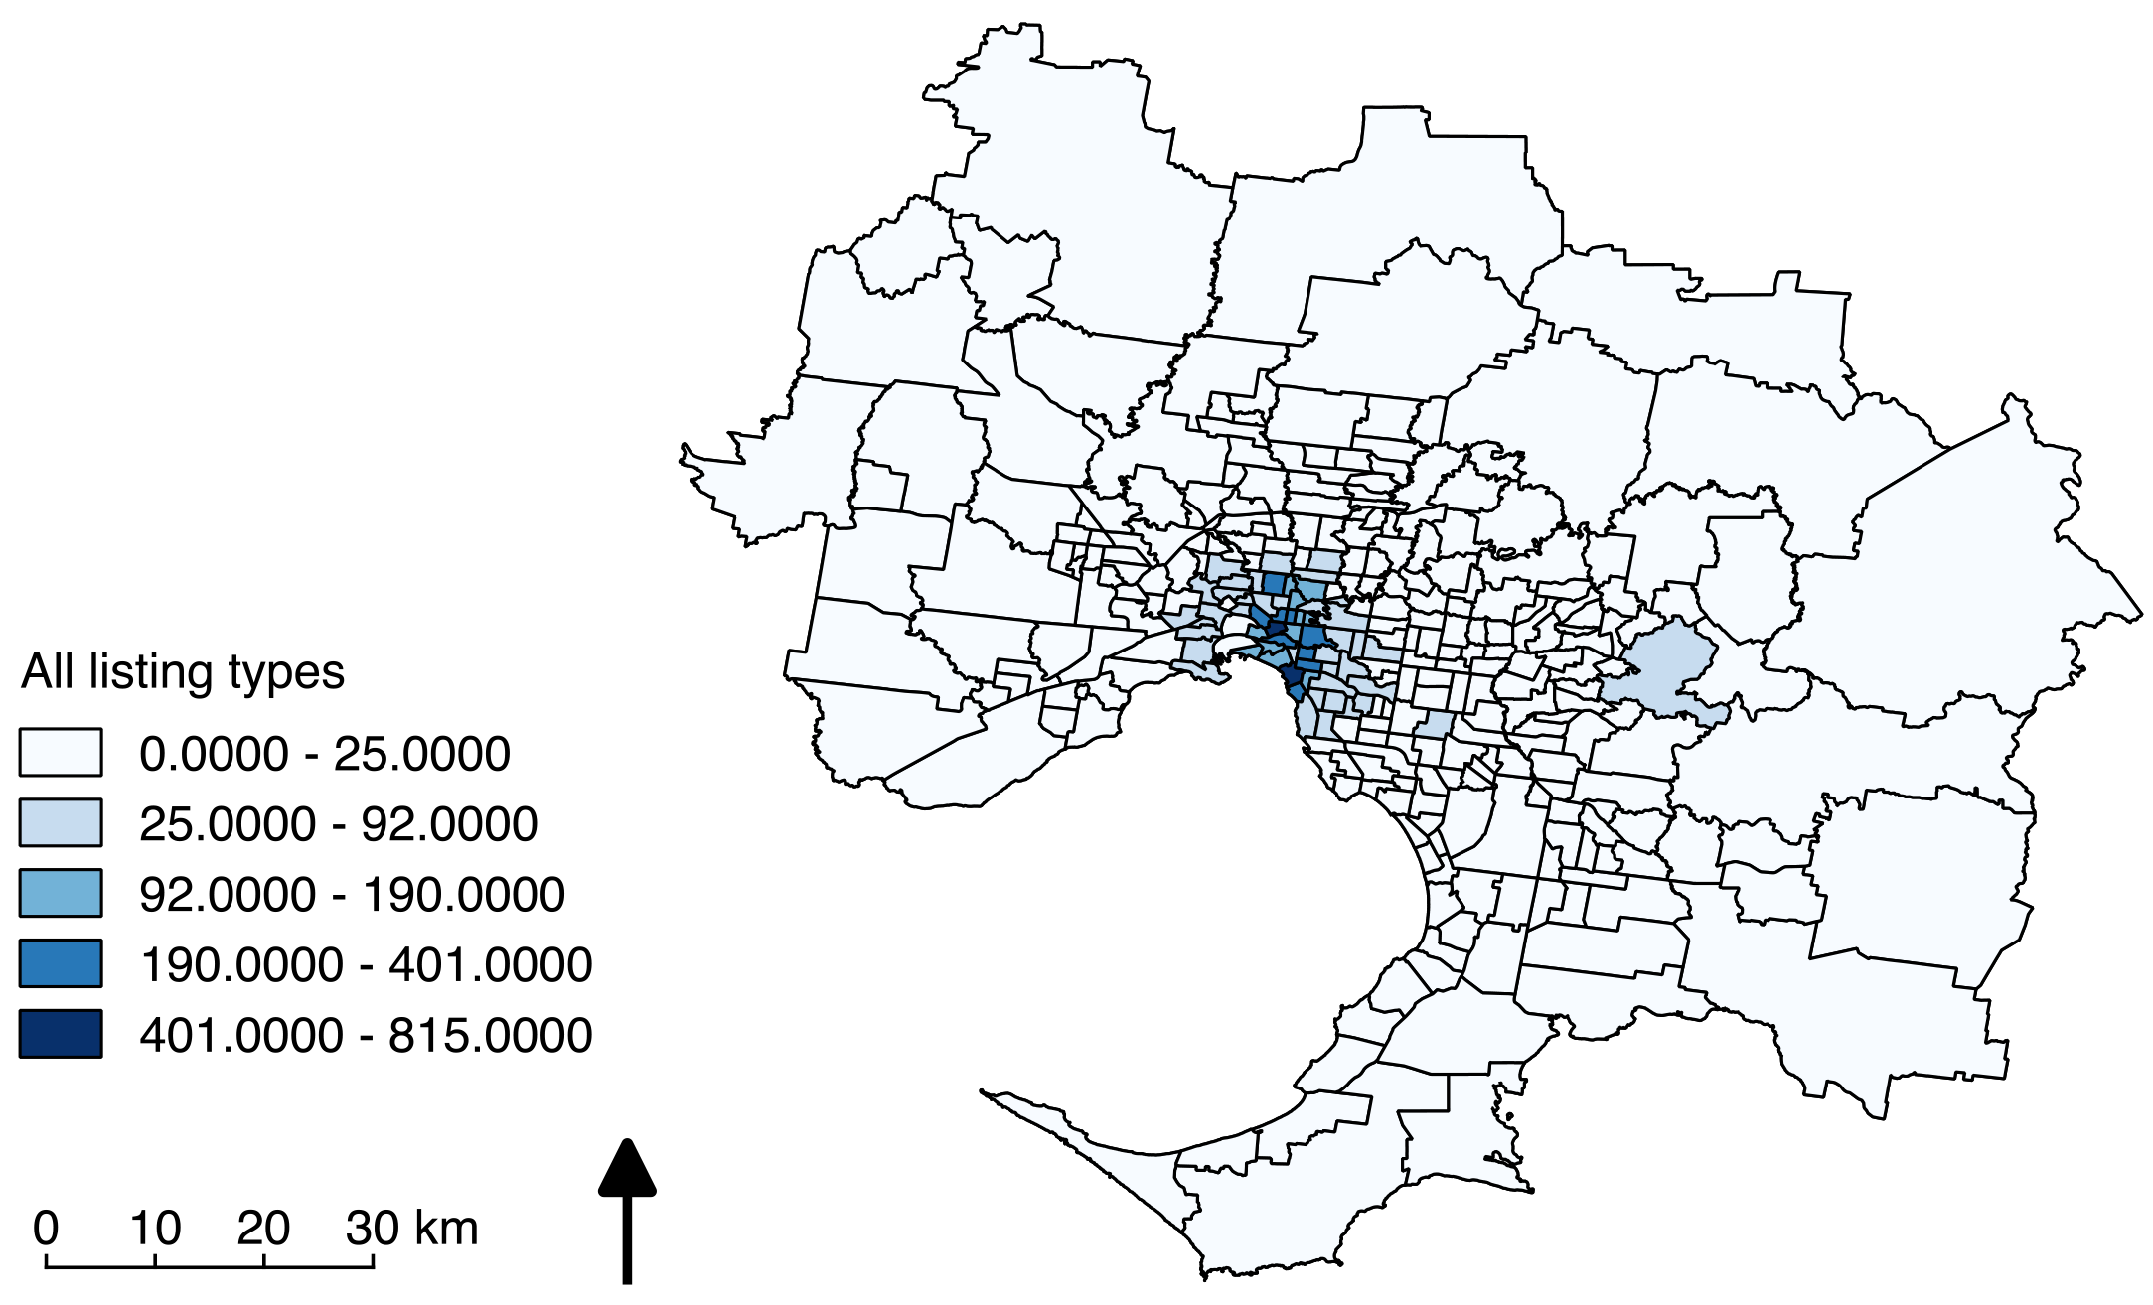

Figure 1: Distribution of all Airbnb listings across metropolitan Melbourne

Entire home listings
Table 7 demonstrates that over 82% of Entire home Airbnb listings are located within inner Melbourne. The regions with the second, third and fourth highest proportion of Airbnb listings were the inner south (6.3%), west (3.3%) and inner east (2.9%), respectively. Similar results occur at the suburb level as the Airbnb listing distribution in Figure 2 demonstrates that listings are concentrated within the CBD and inner suburbs. The entire home listings are more highly centralised and concentrated in comparison to the private and shared room listing distributions.

Table 7: Spatial analysis of Melbourne Entire home Airbnb listings

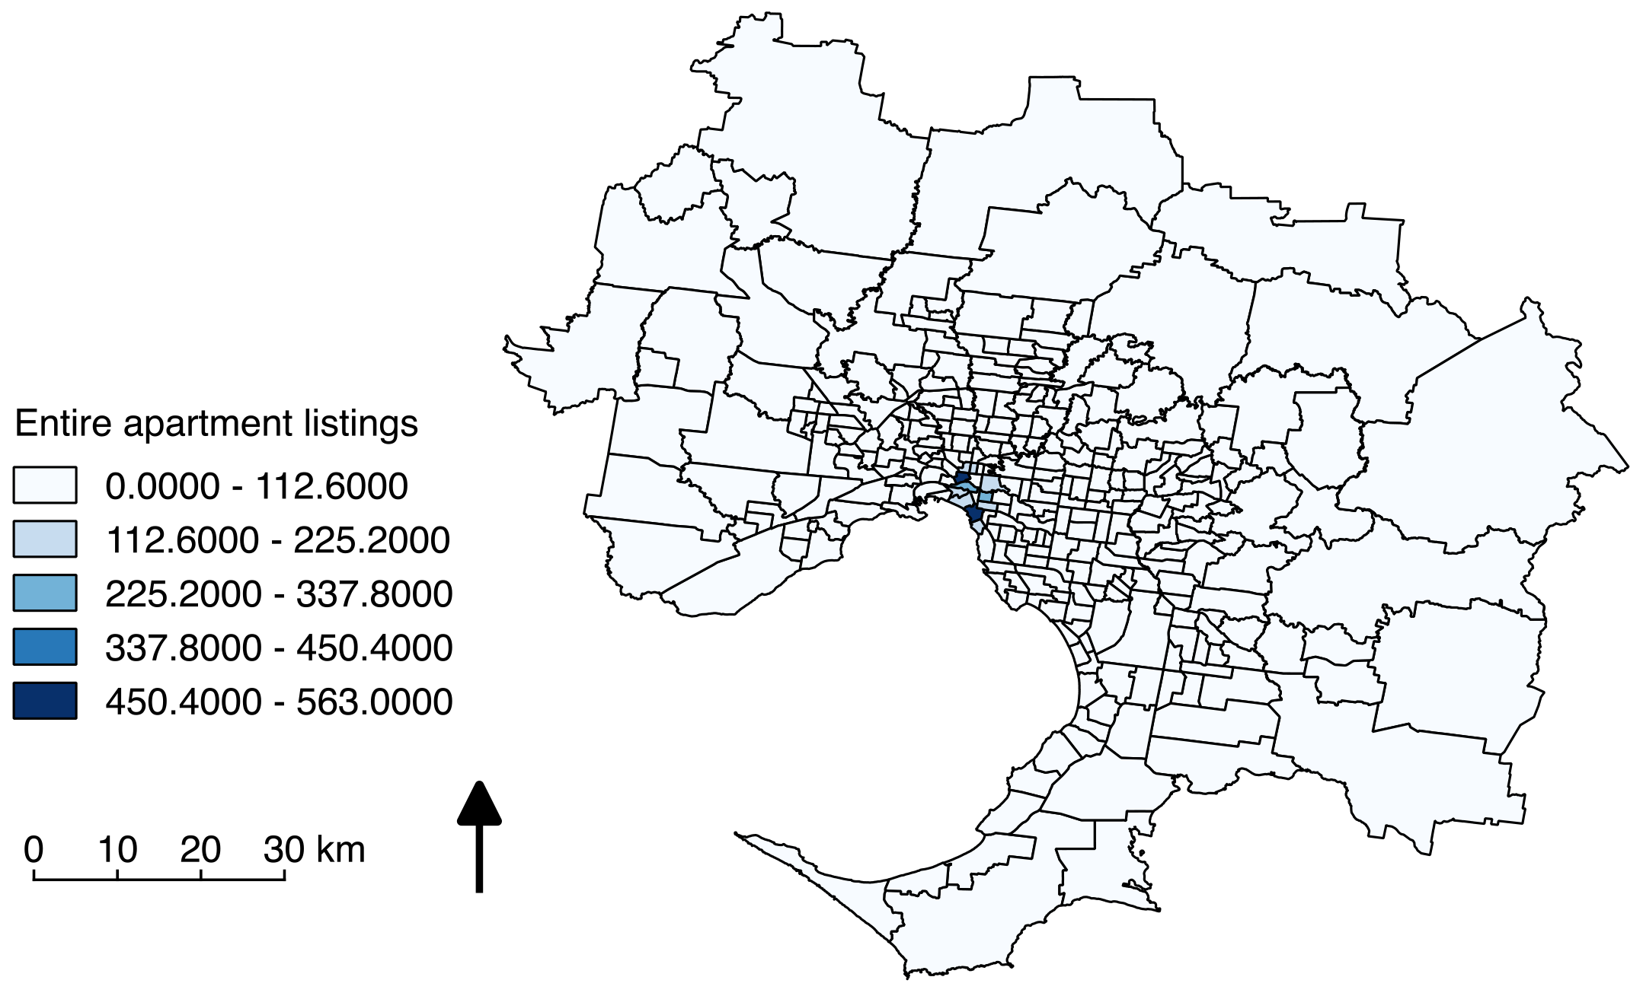

Figure 2: Distribution of entire homes across metropolitan Melbourne
Private room listings
Table 8 demonstrate that in 2016 private room listings were concentrated in inner Melbourne. Over 64% of private room Airbnb listings were located within inner Melbourne. The regions with the second, third and fourth highest proportion of Airbnb listings were the inner south (8.6%), west (7.1%) and inner east (7%), respectively. Furthermore, Figure 3 demonstrates that at the suburb level the private room listings are the most evenly distributed and dispersed throughout the inner suburbs of Melbourne. The majority of the suburbs within the top two listing type classes are located within a 20km radius of the CBD.

Table 8: Spatial analysis of Melbourne private room Airbnb listings

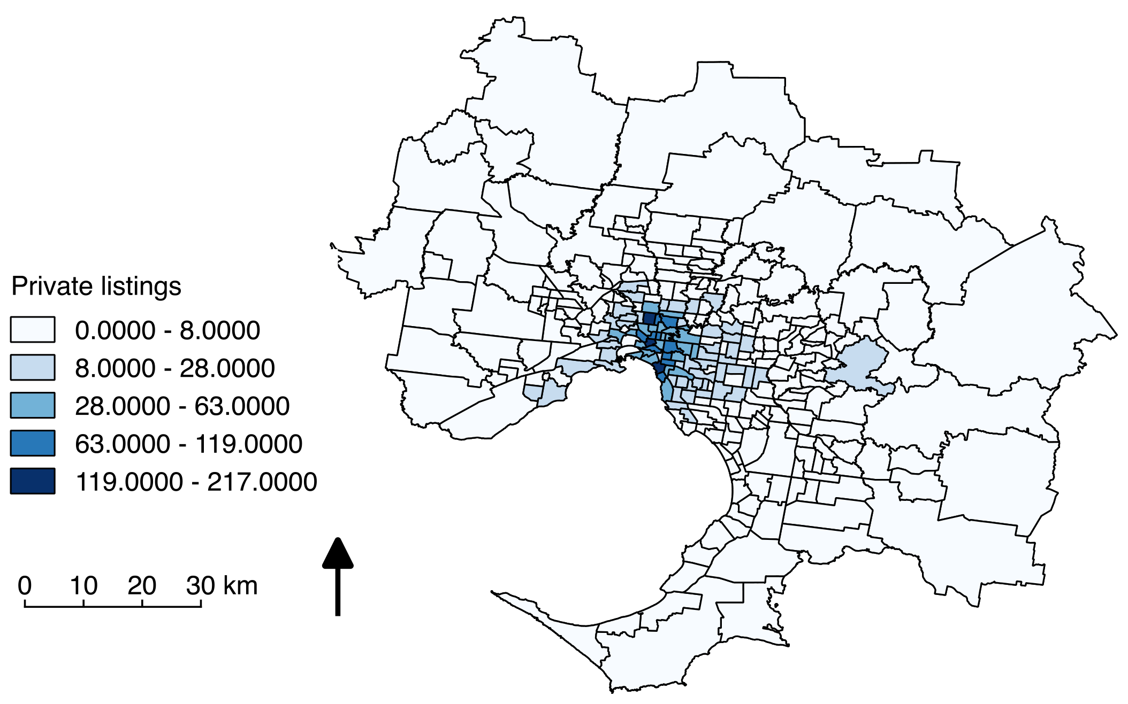

Figure 3: Distribution of private rooms across metropolitan Melbourne
Shared room listings
Table 89demonstrate that in 2016 shared room listings were concentrated in inner Melbourne. Over 67% of private room Airbnb listings were located within inner Melbourne. The west region had the second highest proportion of shared room listings in metropolitan Melbourne with 11%. Figure 4 demonstrated that the distribution of shared room listings is sporadic relative to the entire home and private room listing distributions. The suburbs within the top two listing type classes are located within a 20km radius of the CBD as well as a number of outer suburbs.

Table 9: Spatial analysis of Melbourne shared room Airbnb listings

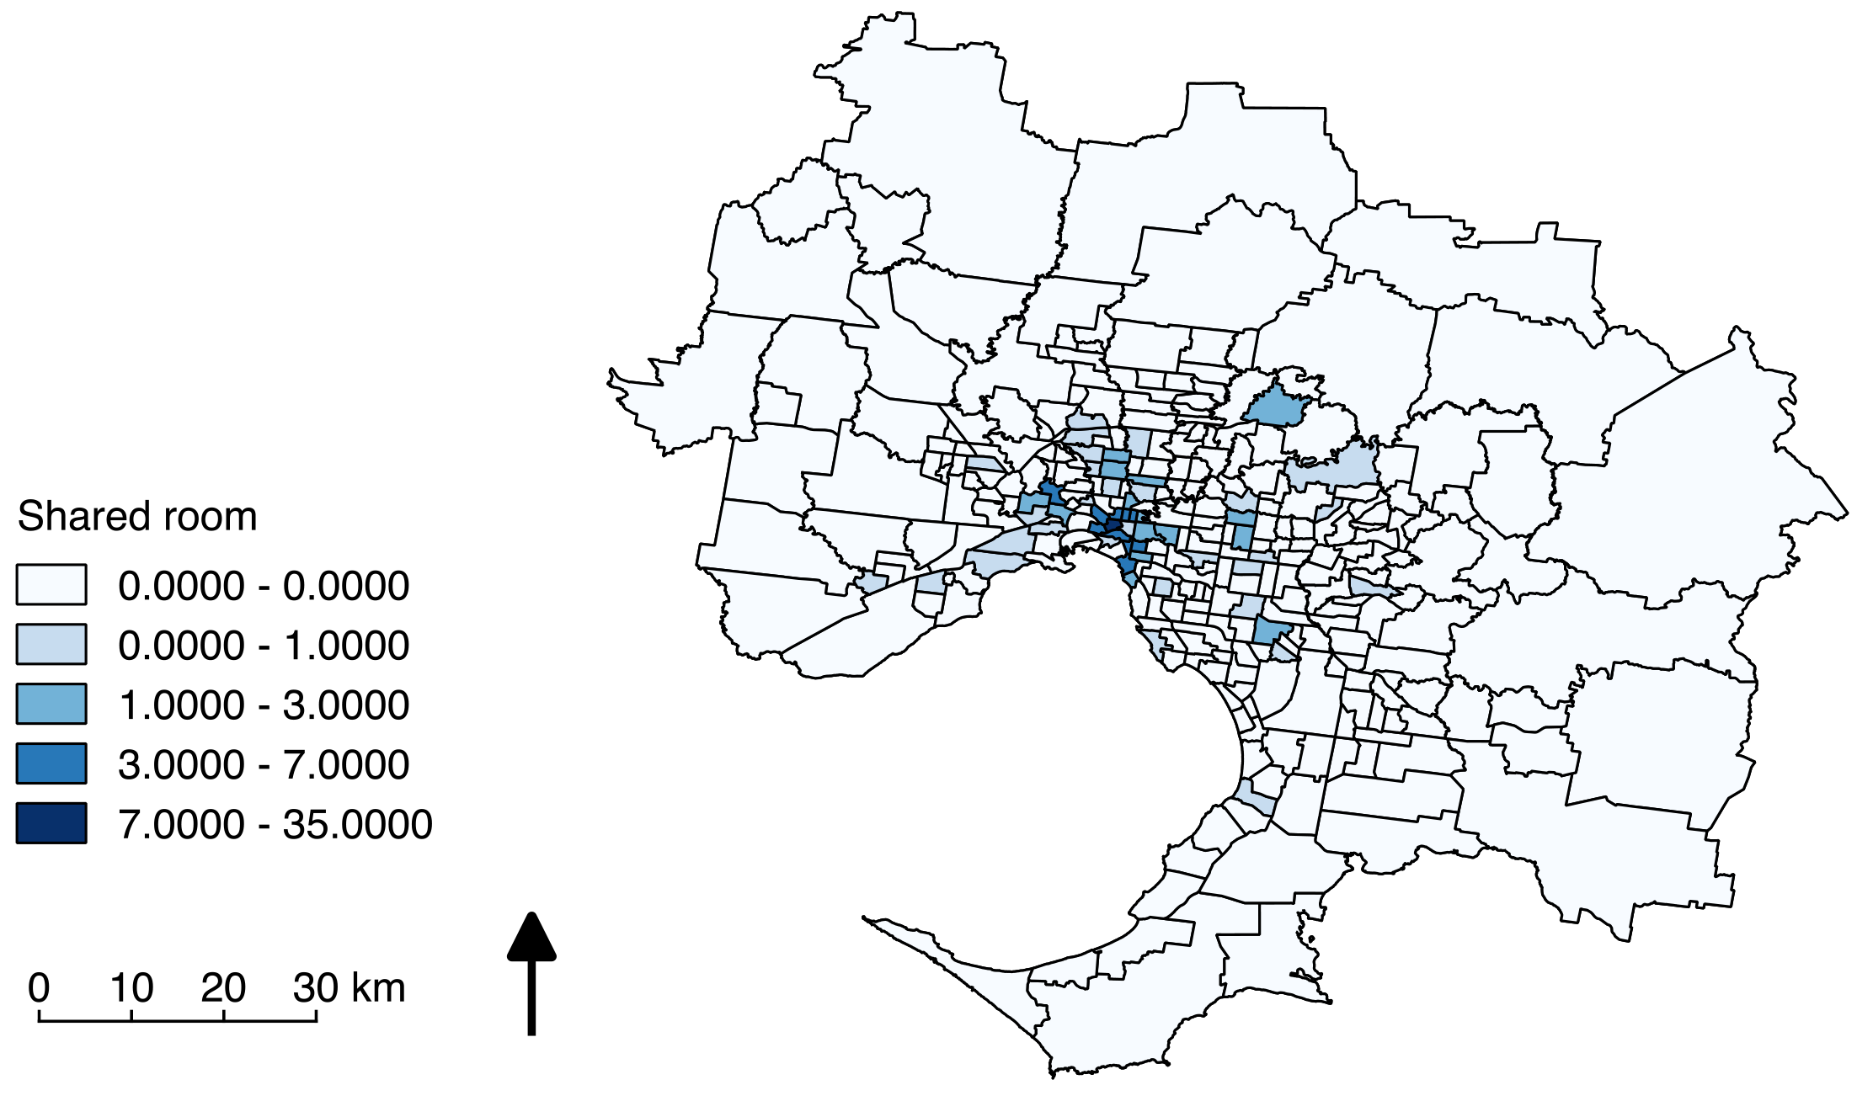

Figure 4: Distribution of shared rooms across metropolitan Melbourne
All listings regression
Population density, non-family two member households, semi-detached owned with a mortgage and couple with no children was entered into the overall distribution regression. The adjusted R² value found in table 8 demonstrates these aforementioned variables explain 66.33% of the variation in listing density. Table 9 demonstrates that all four variables selected were statistically significant, however the only two variables that contributed to an increase in listing density were population density and non-family two member households.

Table 9: Model summary table for all listing types regression equation

Table 10: Multiple linear regression summary statistics for all listing types

Entire home listings regression
Population density, semi-detached, flat/ apartment owned outright and one-person household were entered into the entire home distribution regression. The adjusted R² value found in table 10 demonstrates these aforementioned variables explain 70.58% of the variation in entire home listing density. Table 11 demonstrates that out of the three independent variables were statistically significant however population density was the only the variables contributed to an increase in entire home listing density.

Table 11: Model summary table for entire home listing types regression equation

Table 12: Entire home listing type multiple linear regression summary statistics

Private room listings regression
Population density, semi-detached owned outright, access to economic resources and non-family three-person household were entered into the private room distribution regression. The adjusted R² value found in table 11 demonstrates that these variables explain 75.93% of the variation in private room listing density. Table 12 demonstrates that out of the four independent variables, SEIFA IER was the only variable that contributed to an increase in private room listing density, however this contribution is not statistically significant.

Table 13: Model summary table for private room listing types regression equation

Table 14: Private room listing type multiple linear regression summary statistics

Shared room listings regression
Population density, semi-detached owned with mortgage and access to economic resources was entered into the shared room distribution regression. The adjusted R² value found in table 14 demonstrates these aforementioned variables explain 64.31% of the variation in shared room listing density. Table 15 demonstrates all of the independent variables that were entered into the shared room listing regression equation were statistically significant. The table also demonstrates that out of the population density and access to economic resources were the only variables that contributed to an increase in shared room listing density.

Table 15: Model summary table for shared room listing types regression equation

Table 16: Shared room listing type multiple linear regression summary statistics

Discussion
The general distribution of Airbnb listings suggests that there is a greater number of listings in the central and inner suburb areas, however when each Airbnb listing type was analysed individually, varying distribution patterns were evident. Evidently the results from the spatial distribution analysis demonstrated that there are differences in the spatial patterns of different Airbnb listing types. Further, the regression analyses revealed that different spatial characteristics contribute to these differences in listing distribution. The theory of convergent and divergent spatial trends within the Australian context, postulated by O’Connor, Stimson and Taylor (1998) was used to analyse and compare the spatial patterns of the different Airbnb listing types. A notable difference between the distribution of entire home listings and private room listings are apparent. The entire home listings distribution conforms to what has been described by O’Connor, Stimson and Taylor as convergent, as entire home listings are highly centralised. The private room listings distribution demonstrates a divergent spatial pattern, as the listings are less concentrated, but more wide spread than the entire home listing distribution. In comparison to the other two listing types, the shared room distribution exhibited an incongruent and random pattern. It is arguable that this inconsistency may have arisen due to the relatively small sample size of the shared room listings. The results of the regression analyses demonstrated the differences in the interaction between the independent variables and the listing distribution. Further, it is evident that the computer selected different household variables to enter into the regression equations used to explain the distribution of each Airbnb listing type.

Economic variable
SEIFA IER the variable that was used to represent the influence economic access to economic resources has on Airbnb listing distributions. SEIFA IER was entered into the regression model for all listings equation and each of the regressions for all three listing types, however it only contributed an increase in listing density to the private room and shared room regression equations. This finding suggests that access to economic resources contributes to private and shared room listing distribution, but it does not contribute to the entire home listing distribution. Nevertheless, the relevant r² value for each revealed that the contribution SEIFA IER had on these listing types was minimal.

Locational variable
The distribution of Airbnb listings in Melbourne, is consistent spatial trends associated broader sharing economy activity as the listings the majority of listings were centrally located. More specifically, the results demonstrate that population density contributed to an increase in the number of each Airbnb listings within each type. Further, the results suggest that Airbnb listings of all types are more likely to be found in suburbs with a high population density. The suburbs with a high population density are typically located within the CBD and inner suburbs of Melbourne, therefore the findings of this study demonstrate that the centrality of listings is a locational variable that should be considered in addition to population density. The presence of Airbnb listings, particular entire home listings in metropolitan Melbourne supports the Ho and Hensher (2016) theory of spatial competition and agglomeration effects. It is conceivable that the listings located in highly central and populated environments are more attractive to guests, which can potentially influence the supply of Airbnb listings in Melbourne.

Household variables
The variation in the household variables that contributed to Airbnb listings support the notion presented by Ellen (2015), which suggest that different household receive different financial benefits from Airbnb. Comparison of the listing distribution regressions demonstrate tenure type, number of people and family type contribute to the spatial distribution of each Airbnb listing type differently. Variables associated with entire home listings suggest that entire room Airbnb listings are found suburbs where there are less family households who own homes outright. Conversely, non-family variables showed a significant positive relationship with the private room listing distribution, suggesting that private room listings are more prevalent in suburbs with a higher number of non-families. The only household variable that contributed to the shared listing distribution was “semi-detached, owned outright”. The relationship was negative, which indicates that as the number of semi-detached homes that are owned outright increases the number of Airbnb listings decrease.

Airbnb in the Melbourne housing market
It is arguable that the entire home listings will have the biggest impact on the decreasing the supply of rental housing in the CBD and inner suburbs of Melbourne. Hosts who list entire homes on Airbnb are essentially removing long-term housing from the housing market, which decreases the supply of available housing. In Melbourne, entire home Airbnb listings can potentially increase cost of housing in the CBD and inner cities through contributing to a reduced supply of available housing for owner-occupiers and renters. Conversely the private room and shared room listing types will be less likely to negatively influence specific suburbs within the housing market from a financial perspective. Private room and shared listing distributions are less prevalent; more widely spread and do not detract from existing housing stock. It is arguable that if the private and shared room listing types are made more viable in areas where there is a high concentration of Airbnb listings, then it can reduce the contribution Airbnb has on housing affordability in that area. In sum, all three listing types can provide income for hosts, however entire home listings are more likely to negatively impact housing affordability and availability within the CBD and inner suburbs.

Summary and conclusion
This research examined the spatial distribution of Airbnb listings in Melbourne and provided insight into potential spatial characteristics that can potentially influence listing distribution. In the absence of specific spatial distribution specific to Airbnb, the listing distributions examined in this study were assessed using traditional theories of location and employment. The regional and suburb level analyses demonstrated that Airbnb listings are generally centrally located however variances in the centrality and distribution of the three listing types were apparent. These findings suggest that not all listing types conform to traditional theories relating to the location of employment opportunities. The entire home listings were highly concentrated in the CBD and inner suburbs; conversely the private room listings were more evenly distributed throughout metropolitan Melbourne, as the listings were more centrally distributed outside of the CBD.
A comparison of the four regression models produced suggests that the extent to which the chosen variables contributed to explaining the distribution of each listing type varied at the suburb level. Notwithstanding the locational variable, population density demonstrated a positive relationship with all three Airbnb listing types. Analysis of r-squared values suggest that economic, locational and housing variables are more likely to explain the private room listing distribution than other listing types in the Melbourne context. The entire home listing distribution was explained by the three variables to a lesser extent and the shared room listings distribution was the least likely to be explained by the three variables. Nevertheless, the hypothesis was partially supported, as some economic, locational and household variables were shown to significantly contribute to explaining the spatial distribution of Airbnb listings. The r-squared values for each regression indicate that there are additional or alternative factors than can contribute to each of the entire home, private room and shared room Airbnb listings types. In addition to spatial factors, social factors such as consumer awareness, cultural acceptance of Airbnb, tax incentives and tenancy agreements can contribute to the differing distribution of different Airbnb listing types. As Airbnb becomes better understood and research in the field will be increasingly empirically justified, identification of additional factors that influence Airbnb listing distribution will become evident.
This research provides insight into how a currently unmonitored platform is distributed throughout Melbourne. The findings contribute to existing knowledge about Airbnb by providing analysis of the spatial distribution of the platform. An understanding of where Melbourne Airbnb listings are located, as well as the trends associated with these patterns of distribution was ascertained. Additionally, the findings demonstrate that there is variation in the way Airbnb listing types materialise spatially. Nevertheless, uniformity is evident in the ATO policies that address Airbnb within Australia. The sharing economy guidelines administered by the ATO (2016) provide tax deduction incentives for Airbnb hosts with all types of listings. The “umbrella approach” guideline encourages the growth of all three listing types in a uniform way. The geographic variation in the Airbnb listing distributions establishes the need for specialised approaches to facilitate and mediate all three listing types within the Melbourne context. Additionally, the variation in the prevalence of Airbnb listings across metropolitan Melbourne should be considered. The varying prevalence of Airbnb listings across Melbourne suggests that particular local government areas are more susceptible and likely to be affected by Airbnb. Given the findings of this research it is reasonable to suggest that short-term accommodation sharing economy activity be adopted at the local government level by way of statutory controls relating to land use.

This research builds upon the limited research within the field through providing an understanding of how Airbnb listings occupy space within metropolitan Melbourne. While the findings of this research may not be contextually relevant within international or interstate contexts, the framework developed for the analysis can be applied to other contexts and can be used as a basis for future exploratory and explanatory research.

Reference list

Australian Bureau of Statistics, 2016, 1270.0.55.001 - Australian Statistical Geography Standard (ASGS): Volume 1 - Main Structure and Greater Capital City Statistical Areas, July 2016: Metadata for digital boundary files, Australian Bureau of Statistics, Canberra, viewed 14 September 2016,
<http://www.abs.gov.au/AUSSTATS/abs@.nsf/Lookup/1270.0.55.001Explanatory%20Notes1July%202016?OpenDocument>

ATO 2016, The sharing economy and tax, Australian Government, viewed 25 Sep 2016, < https://www.ato.gov.au/Business/GST/In-detail/Managing-GST-in-your-business/General-guides/The-sharing-economy-and-tax/>
Aurin, 2015d, SA2-based T14 Dwelling Structure by Household Composition and Family Composition as at 2011-08-11, Australian Bureau of Statistics, viewed 15 September 2016, <http://data.aurin.org.au/dataset/au-govt-abs-abs-census2011-t14-sa2>

Aurin, 2015a, SA2-based B30 Household Composition by Number of Persons Usually Resident as at 2011-08-11, Australian Bureau of Statistics, viewed 15 September 2016, < http://data.aurin.org.au/dataset/au-govt-abs-abs-census2011-b30-sa2>

Aurin, 2015b, SA2-based B31 Dwelling Structure as at 2011-08-11, Australian Bureau of Statistics, viewed 15 September 2016,
<http://data.aurin.org.au/dataset/au-govt-abs-abs-census2011-b31-sa2>

Aurin, 2015c, SA2-based B32 Tenure Type and Landlord Type as at 2011-08-11, Australian Bureau of Statistics, viewed 15 September 2016,
<http://data.aurin.org.au/dataset/au-govt-abs-abs-census2011-b32-sa2>

Aurin, 2015d, SA2-based T14 Dwelling Structure by Household Composition and Family Composition as at 2011-08-11, Australian Bureau of Statistics, viewed 15 September 2016, <http://data.aurin.org.au/dataset/au-govt-abs-abs-census2011-t14-sa2>

Aurin, 2015e, SA2 SEIFA 2011 – The Index of Economic Resources (IER), Australian Bureau of Statistics, viewed 15 September 2016, <http://data.aurin.org.au/dataset/au-govt-abs-seifa-ier-aust-sa2-sa2>

Aurin 2016, SA2 Estimated Resident Population 2004 – 2015, Australian Bureau of Statistics, viewed 15 September 2016, <http://data.aurin.org.au/dataset/au-govt-abs-erp-2004-2015-aust-sa2-sa2>
Barnes, SJ, & Mattsson, J 2016, 'Understanding current and future issues in collaborative consumption: A four-stage Delphi study', Technological Forecasting & Social Change, vol. 104, pp. 200-211.

Coffee, NT, Lange, J, & Baker, E 2016, 'Visualising 30 Years of Population Density Change in Australia’s Major Capital Cities', Australian Geographer, vol. 47, no. 4, pp. 511-525.

Cohen, B, & Muñoz, P 2016, ‘Sharing cities and sustainable consumption and production: towards an integrated framework’, Journal of Cleaner Production, vol. 134, no. Part A, pp. 87 – 97.

Cusumano, MA 2015, 'How Traditional Firms Must Compete in the Sharing Economy', Communications of the ACM, vol. 58, no. 1, pp. 32-34.

Cramer, D, Howitt, D 2011‘stepwise entry, in Cramer, D, The SAGE dictionary of statistics, SAGE Publications, London, pp. 162- 163
Demary, V 2015, Competition in the Sharing Economy, viewed 8 May, viewed, <https://www.iwkoeln.de/en/studies/beitrag/vera-demary-competition-in-the-sharing-economy-235445>

Ellen, IG 2015, 'Housing Low-Income Households: Lessons from the Sharing Economy?’, Housing Policy Debate, vol. 25, no. 4, pp. 783-784.

Ert, E, Fleischer, A, & Magen, N 2016, ‘Trust and reputation in the sharing economy: The role of personal photos in Airbnb’, Tourism Management, vol. 55, pp. 62 – 73.
Fang, B, Ye, Q, & Law, R 2016, 'Effect of sharing economy on tourism industry employment', Annals of Tourism Research, pp. 264 – 267.
Guttentag, D 2015, 'Airbnb: disruptive innovation and the rise of an informal tourism accommodation sector', Current Issues in Tourism, vol. 18, no. 12, p. 1192.
Hill, S 2015, 'The unsavory side of Airbnb: how the popular matching company facilitates landlord conversion of entire rental buildings to de facto hotels', The American Prospect, no. 4, p. 80.

Ho, CQ, & Hensher, DA 2016, 'A workplace choice model accounting for spatial competition and agglomeration effects', Journal of Transport Geography, vol. 51, pp. 193-203.
Infranca, J 2016, 'Intermediary Institutions and the Sharing Economy', Tulane Law Review, vol. 90, p. 29.

Inside Airbnb 2016, Get the Data, viewed 4 April 2016,
< http://insideairbnb.com/get-the-data.html>

Jefferson-Jones, J 2015, 'Can Short-Term Rental Arrangements Increase Home Values?: A Case for Airbnb and Other Home Sharing Arrangements', Cornell Real Estate Review, vol. 13, pp. 12-19.
Lee, D 2016, 'How Airbnb Short-Term Rentals Exacerbate Los Angeles's Affordable Housing Crisis: Analysis and Policy Recommendations', Harvard Law & Policy Review, vol. 10, no. 1, pp. 229-253.

Martin, CJ 2016, 'Analysis: The sharing economy: A pathway to sustainability or a nightmarish form of neoliberal capitalism?', Ecological Economics, vol. 121, pp. 149-159.
Nica, E, & Potcovaru, A 2015, 'The Social Sustainability of the Sharing Economy', Economics, Management, and Financial Markets, vol. 10, no. 4, pp. 69-75.
O'Connor, KB, Stimson, RJ, & Taylor, SP 1998, 'Convergence and divergence in the Australian space economy', Australian Geographical Studies, no. 2, p. 205.

Stevenson (2011) describes process of GIS as a process that involves “building data in a series of maps, each representing a specific type or theme of information” (p. 2).

Wand, J 2004, 'Stepwise regression', in Lewis-Beck, MS, Bryman, A & Liao, TF (eds), The sage encyclopaedia of social science research methods, SAGE Publications, Inc., Thousand Oaks, CA, pp. 1083-1084, viewed 17 October 2016, doi: 10.4135/9781412950589.n974.

Zervas, G., Proserpio, D. and Byers, J., 2015. A first look at online reputation on Airbnb, where every stay is above average. Where Every Stay is Above Average, viewed 26 August 2016, <https://pdfs.semanticscholar.org/7e13/088d568cfda45b4b042d44876e03c65ab68e.pdf>

