Urban Campgrounds as Service Hubs for the Marginally-Housed

Robin Kearns¹, Damian Colllins², Laura Bates¹, Elliott Serjeant¹
University of Auckland, NZ¹, University of Alberta, Canada²

Abstract: Although the service hub concept is most commonly associated with deprived areas of the North American inner city, similar clusters of facilities can also be found in other contexts. In this paper, we conceptualise urban campgrounds in Auckland, New Zealand as small-scale service hubs for long-term residents as well as more transient recreational campers, and explore their precarious and resilient qualities. Building on research into caravan park occupancy in Brisbane, we examine the contemporary geography of Auckland’s campgrounds, based on narratives from field research at eight urban campgrounds. First, given pressures for closure and conversion to housing, we document why campgrounds are a precarious form of urbanism. We present them as an ephemeral form of settlement for longer-term residents (by virtue of the informality of their tenure); a tenuous foothold in the city for recreational campers (by virtue of limited spaces and uncertainty of future operations); and a marginal land use as an urban space in their own right (by virtue of pressure for conversion to higher and ‘better’ use). Second, we conceptualise campgrounds as service hubs, and consider how this may provide a basis for their resilience. Specifically, they offer a relatively low-cost way to inhabit the city, combined with both formal and informal social supports. Such a combination is especially critical for residents, who may otherwise be at risk of homelessness. Urban campgrounds take on added importance for those marginalised by the diminishing provisions of the welfare state and the over-inflated housing market of Australasian Pacific Rim cities.

Key words: Campgrounds; service hubs; homelessness; housing; precarious geographies.

Introduction
The idea of ‘service hubs’ was developed in reference to the clustering of small-scale facilities which are sufficiently proximate that interaction between staff and clients occurs and they become an integrated entity (Dear, Wolch and Wilton, 1994).​ While service hubs are most commonly associated with deprived inner-city areas in the North American context, similar clustering of support services and facilities can be seen elsewhere. In this paper, we conceptualise Auckland’s urban campgrounds as small-scale service hubs for both recreational campers and less-mobile long-term residents. Developing the service hub idea formulated by Dear et al.(1994), we consider how a focus on accommodating the housing-needy may provide at least a provisional basis for the resilience of both individual campers and campgrounds themselves. Specifically, we argue that campgrounds offer a tenuous foothold in the city, with formal and informal social supports being particularly significant for resident campers, who may otherwise be at high risk of street homelessness. Indeed, research into residential caravan park occupancy in Brisbane has identified the tensions when privately-owned campgrounds serve as an alternative to social housing (Nelson and Minnery, 2008). In light of pressure for closure and conversion to housing in the challenging housing market of contemporary Auckland, campgrounds are a precarious form of urbanism. There is a key ambivalence at play within campground service hubs: while the state uses them as encampments for the poorly housed, the entrepreneurialism of owners/managers suggests the transformation of some into spaces of at least provisional hope for many residents.

Urban campgrounds as last resorts
Given that they are located outside the scope of established tenancy arrangements, caravan parks and campgrounds increasingly provide housing options of last resort for very-low-income or welfare-dependent families. However, as Reed and Greenhalgh (2004) have shown, longer-term residents are prone to displacement by not only higher paying tourists, but also by campground sales. Nelson and Minnery (2008) also explored the place of privately-owned caravan parks as providers of low-cost housing. In Brisbane they observed that these facilities are particularly suited to, and increasingly under pressure for, conversion to residential development. These qualities stem from their proximity to transport routes, being large solely-owned land parcels, and existing connections to infrastructure. This pressure is particularly acute in Auckland, given unprecedented escalation of property prices over the last decade.

While coastal campgrounds are an archetypal element of the New Zealand recreational landscape (Collins and Kearns, 2010), those located in/near metropolitan landscapes are increasingly precarious. To recreational campers, urban campgrounds can still be a budget-priced place from which to explore the city, but the challenge of viability through the winter months has led many campground managers to accept longer-term occupants. We argue that tipping points can be reached as campgrounds transition away from recreational/tourist accommodation and into encampments of the poorly housed. We contend that residence in such places is itself a precarious form of settlement, given informality of tenure. Further the campgrounds themselves are an increasingly marginal land use by virtue of pressure for conversion to higher and (arguably) better use.

We propose that as housing crises intensify in tandem with the imperative towards more intensive residential development, one response on the part of campground owners/managers is to seek greater resilience by more self-consciously serving the needs of those in housing need. To conceptualise this transition, we adapt the idea of the ‘service hub’ (Dear et al, 1994, and its associated recognition that agglomeration has advantageous effects and many users “prize the maximised accessibility that a central location affords” (DeVerteuil, 2016, p10).

The service hub idea can be applied at two scales. First, a single campground can potentially provide a set of co-located services for the marginalised, thus being a hub unto itself. Hence within a bounded ‘campus’, residents can access services ranging from shared kitchen, laundry and washroom facilities, to TV lounges, wifi/computers and green space. Second, in their plural form, campgrounds can serve as a networked hub through which the marginally housed may cycle, often guided or instructed by agents of the state (in the New Zealand context, the Ministry of Social Development, which provides welfare supports through Work and Income New Zealand (WINZ)). This network of housing of last resort (ironically, in places hitherto regarded as the resorts of recreational campers) meets what Dear et al (1994, p188) describe as a "fundamental planning objective" which is "to create decentralized service and housing opportunities throughout an urban area". Such decentralisation can mitigate against the inequitable concentration of low-cost housing and associated services in low-status neighbourhoods.

​Our argument is that campgrounds themselves can be fundamentally understood to function as service hubs – sites where, for a modest fee, travellers and residents alike are accommodated and, in return, can access a cluster of services. Moreover, some facilities now function primarily as fortuitous service hub for those with limited socio-economic as well as residential mobility, and who lack of material means and/or inclination to rent formal housing in the private market or residual social sector.

Campgrounds and Auckland’s housing ‘crisis’
Despite persistent government denials that there is a housing crisis in Auckland (2016 population approximately 1.6 M), housing concerns are rarely far from media and scholarly attention in New Zealand. Affordability is a prominent concern with average house prices in Auckland increasing from NZ$562,000 to NZ$956,000 between 2012 and 2016 (QV, 2016). In tandem, there is a growing population of severely housing-deprived people (Amore et al, 2016). One outcome has been escalating evidence of ‘makeshift’ housing arrangements – in the same city that makes much of its high rankings in Mercer’s Quality of Living Survey (McArthur, 2017). It has been estimated, for instance, that a small but growing percentage of “private dwellings” are “other occupied private dwellings” – a Census category which includes motorhomes, sheds and ‘temporary’ structures (Statistics NZ, 2015).

Like mobile home occupants in Florida (Kusenbach, 2009), Auckland’s longer-term campground residents live with the ongoing spectre of displacement through the sale of campgrounds and their subsequent redevelopment for housing. These trends are linked to population growth and the residential intensification promoted by Auckland Council through its Unitary Plan, which is advancing a more compact city with housing developments adjacent to transport routes (McArthur, 2017). Under this planning imperative campgrounds, along with other greenspaces within the existing built-up area, are prone to being deemed candidates for intensified housing.

More immediately, two pieces of legislation are relevant to the security and welfare of long-term campers: the Camping-Grounds Regulations Act 1985 (CGRA), and the Residential Tenancies Act 1986 (RTA). The CGRA requires campground owners to be registered, licensed providers of “temporary living spaces” (GGRA s2; s3(1)). However, it does not account for long-term campers. Instead, it prohibits residence in “temporary” accommodation for more than 50 consecutive days – a regulation which remains largely unenforced (Severinsen and Howden-Chapman, 2014). The CGRA also requires campground managers to comply with Health Act 1956 standards. This means campgrounds must provide sanitation, amenities and living conditions that are deemed acceptable for temporary use, and approved by local authorities. Again, this gives no consideration for long-term campers who often reside in inadequate housing conditions. The RTA outlines the obligations and rights of both landlords and tenants with respect to residential premises. However, similar to the CGRA, the RTA specifically excludes from these regulations any “caravan, vehicle, tent or other building … intended for human habitation for periods not exceeding 50 days” (s5(1)(ta)). As such, this Act also offers no protection for the rights of long-term campers.

In the sense that this form of long-term housing exists outside the bounds of legislation, it is unsanctioned. However, residential use of campgrounds is increasingly accepted in national and regional contexts of a housing affordability crisis (Severinsen and Howden-Chapman, 2014). This is evident in the state’s increasing reliance on these somewhat ‘below-the-radar’ service providers to meet emergency housing needs. Urban campgrounds can ostensibly address the public good of relatively low-barrier, if not low-cost, housing. In addition, they tend to be located in suburban areas (see next section), including near areas where poverty has long been concentrated in Auckland (Kearns et al, 1991). In this context, we can envision campgrounds as not entirely private entities, but rather increasingly part of the shadow state (Wolch, 1990): that is, part of a network of non-governmental actors who provide frontline welfare and support services, usually underpinned by governmental contracts and grants.

Method
Initial online scoping searches identified a total of 86 campgrounds (excluding freedom camping sites) in the greater Auckland region. We categorised 11 as being urban (see Table 1), by virtue of location within the built up area of the city, as designated by the Auckland Metropolitan Urban Limits (Auckland Council, 2013) (see Figure 1).

Table 1: Categorisation of Organised Camping Opportunities in the Greater Auckland Area.

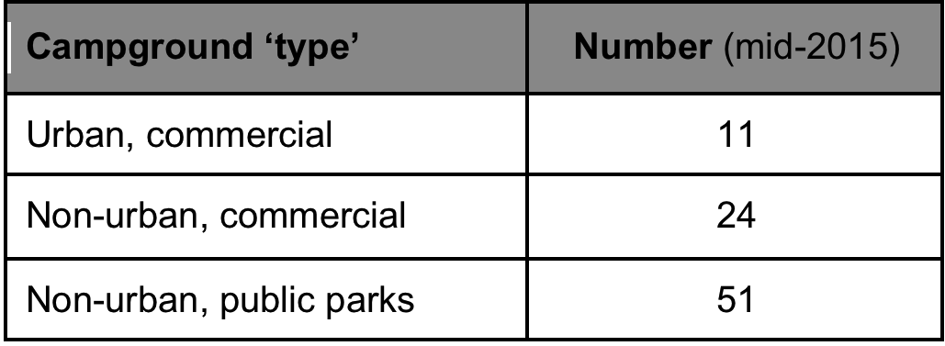

Figure 1: Distribution of Urban Camping Opportunities Across the Greater Auckland Area Immediately Prior to Fieldwork (mid-2015).
(source: Google Earth, Field data)

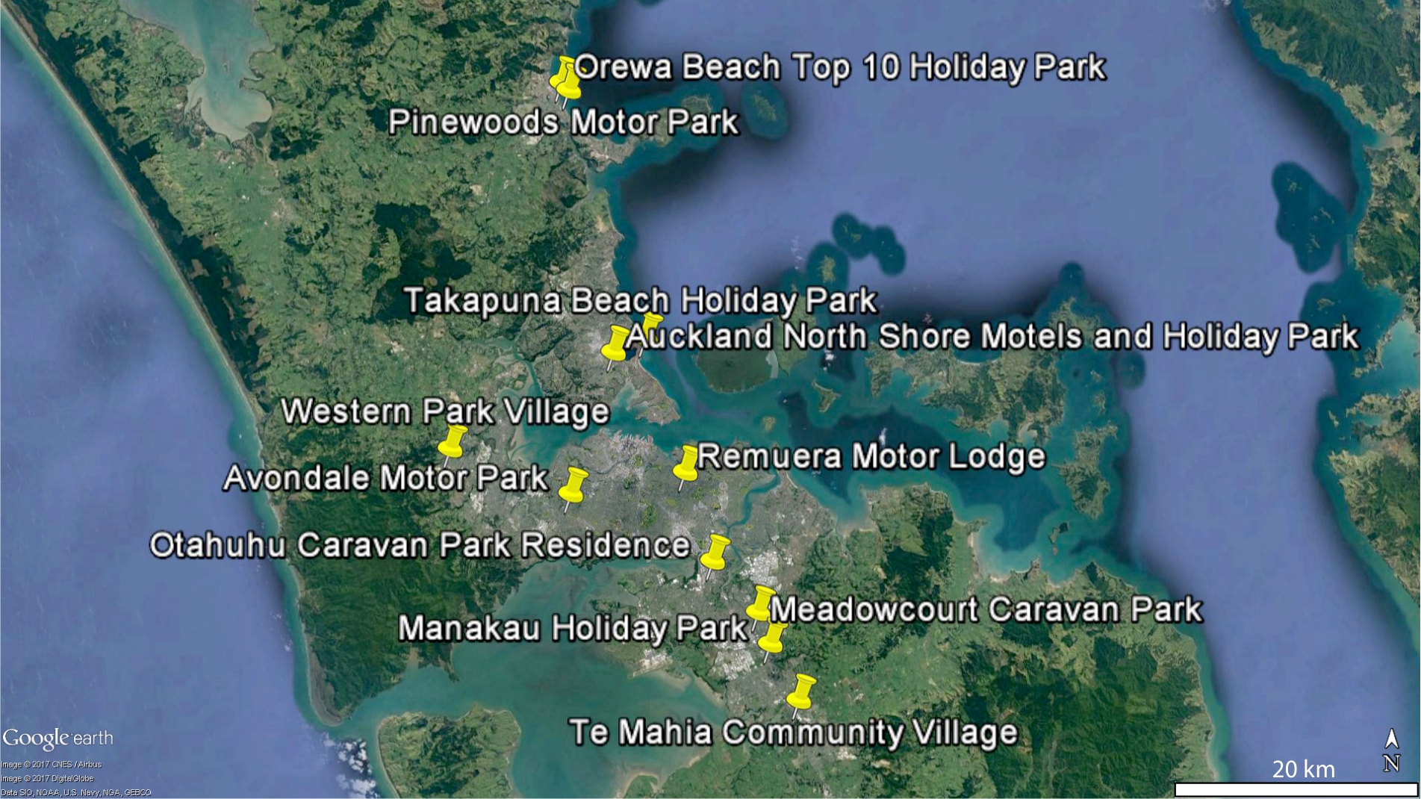

Indicative of the pressures and precariousness faced by Auckland’s urban campgrounds, one of the 11 closed prior to the commencement of data collection. Two of the authors approached all remaining 10 campgrounds during peak summer months (mid-December 2015 to late-January 2016). Eight owner/managers were willing to be interviewed and seven of these agreed to on-site interviews with campers. Approximately six campers were interviewed at each of these seven campgrounds, with a range of recreational and residential campers sought where both were present at the same facility. In total, 46 of 52 campers approached agreed to be interviewed.

Interview questions for both owner/managers and campers were informed by recurrent issues identified in academic and grey literature as well as local media reports. They addressed a range of issues relating to campers’ locational preferences and experiences, and issues of campground regulation/management. Owner/managers were also asked for their views on recent trends of campground closures/conversions.

Owner/manager interviews were usually 30-60 minutes in length, while camper interviews were typically shorter. Owner/managers’ interviews were audio-recorded, after gaining consent, while campers’ responses were documented in handwritten notes as audio-recording was anticipated to disrupt typically relaxed/informal camping experiences. Notes were entered into a database to assist with analysis.

We categorised campers as either ‘long-term’, ‘temporary’ or ‘recreational’. For the purposes of this research, we defined a long-term (LT) camper as one who:

- identified the campground as their "permanent home", and/or
- lived in a campground (not necessarily, but often, the same campground) for one year or more, and/or
- had no plans to move to another form of housing/accommodation (except those anticipating camp-to-camp mobility as a result of closure).
Essentially, these criteria recognise long-term campers by virtue of their intent and/or their camping biography. We distinguish them from ‘temporary’ (Temp) campers, who reside in a campground for less than one year and have plans/intentions to move elsewhere. By contrast, ‘recreational’ campers were holidaying at the time of our interview, and nominated their home to be somewhere other than the campground. In total, 22 recreational campers, 17 long-term campers and seven temporary campers were interviewed. Given this paper’s focus on campgrounds as potential service hubs and sites of marginal housing, this paper focuses on the narratives of long-term and temporary campers.

Data analysis involved all authors identifying key themes across owner/managers’ and campers’ responses. Themes included: campers’ motivations and experiences; surveillance and spatial control of/within campgrounds; tensions within/between camper ‘types’; and campground precariousness, resilience and socio-economic importance. Responses were enumerated into frequency tables where appropriate. Owner/manager and camper interviewees’ narratives were drawn together to illuminate the precariousness faced by both urban campgrounds and campers, as well as to shed light on the service hub functions served by urban campgrounds in the Auckland context.

Findings

Characteristics of campgrounds and campers
The number of years that the eight surveyed campgrounds had been in operation ranged from 30 to 86. The two coastal campgrounds were the longest-established (86 and 76 years respectively), and both are commercially-run and privately-managed on publicly-owned sites. Two of the campgrounds accommodated only recreational camping, four accommodated a mixture of recreational and residential campers, and two accommodated only residential campers. Five campgrounds were within 15 km of the Auckland CBD, with the furthest being 28 km away. Maximum capacities ranged from 100 persons (Residential-1) to 1400 persons (Recreational-1).

Significantly, inland campgrounds were sites where we noted the greatest investment in facilities specifically targeting temporary residents and long-term campers. At Residential-1, for instance, recent expenditure in the campground of around $2.5 million has gone towards purchasing and furnishing new caravans for residential campers (see figure 2). For both Residential-1 and Residential-2’s managers, it was clear that the provision of accommodation and facilities for residential campers is not only a business venture but also a “community style approach” (Residential-2 manager). This full embrace of catering for the marginally-housed contributes to these campgrounds’ economic resilience.

Table 2: Socio-demographic Overview of Camper Interviewees.

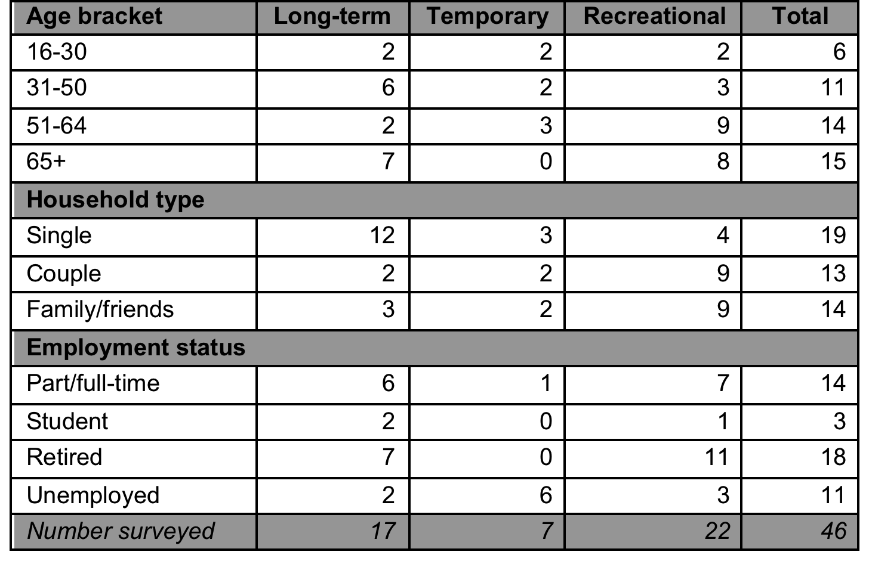

As shown in Table 2, campers ranged across all age groups, with a large proportion over 50 years (63%). Long-term campers were predominantly single, and their ages were relatively evenly distributed (aside from a larger proportion in the 65+ group). Recreational campers tended to be older, with fully half of this group retired.

Figure 2: Recently Purchased Caravan Accommodation for Campers at Residential-1.

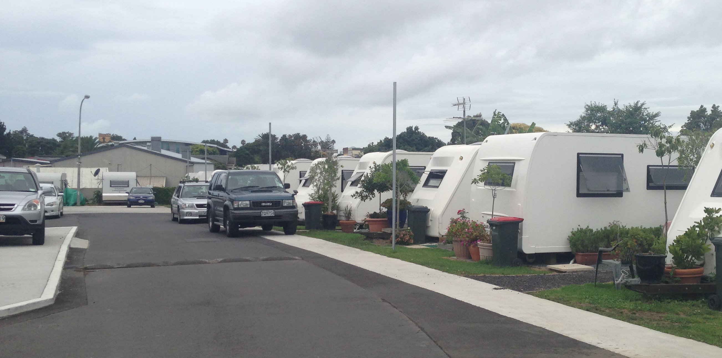

Across all three categories, a number of positive aspects of the camping experience were repeatedly highlighted. Frequently mentioned positive aspects of staying in Auckland’s urban campgrounds included proximity to local facilities/attractions, social interactions and affordability. Part of the campgrounds’ place appeal therefore seems to be not only the amenities within, but also those located nearby. For example:

[Being in this location] helps us, shopping is close and most of us have no car so it's better than being stuck out in the country somewhere. (Residential-2, temp-a)

Long-term campers frequently mentioned the security of the campground, the social environment, independence and the cost of living. These (perceived) advantages are evident in the following narratives:

Living here, it's like the old days, I don't even lock up when I leave - it's the kiwi lifestyle. ... It's central, convenient, not expensive, close to public transport to the airport and city, Pak'n'Save is close. I can be alone here, be safe, relax. I love it all here, we all get on well, we're happy campers! It's peaceful. Some of us don't want to live with others - maybe because of mental illness, or other issues, or just preference, for some people it's just better alone. I tried living with women and stuff but it's just too much drama. (Mixed-3, LT-f)

[I enjoy] the flexibility and independence compared to a flat or boarding house. I like the natural surrounds ... [and] meeting different people. The caravan is less hassle than flats or renting with bad landlords. (Mixed-3, LT-a)

For long-term campers especially, problems with other campers’ behaviour were the most commonly reported challenges. These included violence, substance abuse, thefts and arson, as well as less-extreme issues related to noisy children, loud music/parties and personality clashes. As one long-term camper put it:

Some [campers] have drugs and binge drinking, but not all. One person here in the blue caravan was caught drink driving eight times. He's not here anymore…. Once we had some violent people and they tried to burn down the office block, but they aren't here now. No disadvantages really. (Mixed-3, LT-a)

It is evident that, despite a number of problematic camper behaviours where this interviewee was staying, they were determined to emphasise that there were no ‘real’ disadvantages associated with the long-term campground lifestyle, and that not all campers could or should be framed as ‘trouble makers’.

Despite a lack of permanence, long-term campers consistently commented on their sense of being ‘at home’ in their campground-of-residence. This sense of home was experienced strongly by some:

It's home, it's local. It is a private place, a little community, affordable, safe and good for single people. The government should buy it to keep it going. (Mixed-3, LT-a)

Since I own my caravan, I am my own boss, I can put up a picture without getting in trouble with the landlord. I'm a homeowner! I didn't want to live in a normal house, I wanted something different. Then I saw a caravan and now I'm here. (Mixed-1, LT-a)

Long-term campers clearly appreciate both their sense of independence and the sense of community some campgrounds offer. Managers of these campgrounds spoke of accommodating long-term campers in order to enhance their business viability:

It was initially set up as a tourist park set up for travelling public going from the airport. My parents who established the park quickly figured out that we weren't going to remain afloat doing that ... the only way to keep our head above the water was to bring in a lot of permanents. ... The sort of people we would usually only bring in over the winter months, we have been bringing more of those people in. (Mixed-4 manager)

No [length-of-stay rules]. As long as they behave, we keep them. We have long-term campers, they keep us going for the basic power, water, rates, because they’re not going anywhere. We have 47 permanent residents at the back. These people have been staying here for 12-13 years. ... That helps us for the two quiet winter months. (Mixed-1, manager).

As the foregoing narrative indicates when in a minority, long-term campers can be discretely segregated into certain parts of the campground (‘at the back’) to minimise disruption to the sanctuary-within-the-city atmosphere often promoted for recreational campers.

Precariousness/insecurity of long-term campers
There is a precariousness experienced by temporary and longer-term residential campers given highly variable approaches to length-of-stay management and eviction processes. Campground residents are legally ‘homeless’, and by virtue of their insecure and informal tenure, they are typically vulnerable to sudden eviction and the attendant risk of street homelessness. Indeed, 19 of the 24 long-term campers expressed a sense of insecurity regarding their living arrangements, with three having been affected by previous campground closures and six experiencing uncertainty due to imminent campground closure. Several managers commented on this precariousness, especially those at campgrounds which were themselves vulnerable to (or in the process of) being closed/redeveloped. As one manager explained:

We are closing down. The new owners purchased the campground two years back, with no intentions of continuing running the holiday park. ... Apparently it's due to close at the end of January, which is stressful for us and our 48 residents. The pensioners especially are finding it really tough finding houses; in January there are going to be a lot more homeless people. We are not meant to be here for the homeless, but we are. ... Everyone is hoping something magical will happen to keep it open. We are providing for people from [Mixed-4], and there are rumours of [Mixed-2] closing too. (Mixed-3, manager)

Similarly, Residential-2’s manager commented on the lack of any sense of security for long-term campers during renovations:

Some have been quite worried. ... It's like a little world in here, this is safe and the outside world is scary. With all its faults, this place is their sanctuary. And because of closures of [another residential campground] they might have to go far to find a new place. (Residential-2, manager)

These insecurities and uncertainties highlighted by the managers we interviewed were, perhaps unsurprisingly, also voiced by campers. Several campers’ narratives powerfully illustrated a sense of precariousness:

I've been everywhere looking for a place, I was in [another residential campground]but it closed. I'm lucky to have this. (Residential-1, LT-f)

The hardest thing is the uncertainty – will it close? We want to know what we can be doing, not wondering, being in limbo. We don't know if we will be booted out – that's what sucks. (Mixed-3, LT-d)

Managers commonly mentioned the importance of campgrounds as facilitators of social inclusion and housing for vulnerable residents in an increasingly unaffordable Auckland housing market. The appeal of these places appears to be rents of typically up to $350 NZD per week for a small cabin or trailer with modest bathroom facilities (as advertised at one West Auckland campground). While this sum is similar to the current (2017) average rent for a one bedroom flat in Auckland, this more permanent form of housing also requires upfront costs (e.g, a bond), furnishings and ongoing utility costs. Indeed, several interviewees explained that the unaffordability and limited availability of rental housing in Auckland contributes to resident campers’ pathways into temporary or long-term camping arrangements. As one camper explained, campgrounds fulfil an important role because:

If the 30+ campers weren't there, there would be 30+ more homeless people in Auckland. We need more of these for less homelessness. It's great as it offers affordable, portable living. Some of these people have no family support or money. ... It's like a community [pointing to the back of the campground]. For people without means, that's their home. (Mixed-3, temp-e)

As this temporary camper has explained, financial hardship and challenges finding affordable housing can be what initially prompts a person/family to consider a campground as last-resort housing or a place of ‘refuge’ in a high-pressure housing market. Indeed, Residential-2’s manager detailed the difficult circumstances faced by the most of the campground’s residents:

We are on the emergency accommodation list of WINZ, have been for years. Occupancy is always high, 95-96% all year round. It's not an attraction, it's a need, the basic need for shelter. Beggars can't be choosers if you know what I mean. ... We now have a recreation hall, and a social coordinator who does stuff for the kids, but people don't know that when they move in. They don't ask "What facilities do you have?" when they arrive, because they are desperate, they are sleeping in their car and have nowhere else to go. They don't really care about facilities. (Residential-2, manager)

In identifying a government agency (WINZ) as actively involved in referring people to this campground, we see vivid evidence of the state’s reliance on such facilities as housing sites of last resort. Elsewhere this ad hoc use of campgrounds as emergency housing is seen in $472,000 being reportedly spent on grants for residential campers at one West Auckland campground (RNZ, 2016).Moreover, in some camp situations managers described their work as similar to that of a social worker, for example:

We choose to have some understanding, we could evict anyone. It could be instant eviction. But we try and work with them ... we try and direct them to counselling or rehab and bring proof that you are doing it. (Residential-2, manager)

Camp ‘management’, in this sense, involves dealing with behaviours and personal situations of residential campers at a greater – and closer – scale than might be expected in recreationally-focused campgrounds. These managers seem to express a sense of responsibility for ‘looking after’ vulnerable campers on a personal level, even when the issues at hand (e.g. substance abuse, violence, mental health concerns) may extend well beyond the boundaries of the campground itself.

Movements between campgrounds within a service hub
We discussed the service hub construct as observable both within individual campgrounds (given their cluster of on-site facilities), but also at a larger scale as evidenced in a network of urban campgrounds. The movement of long-term campers between sites (and social housing) was evident in manager interviews:

When [[another residential campground] closed I was approached by four social workers and I managed to get three people in here, and they have proved to be ideal tenants. I was approached numerous times when 90 days’ notice was given for [closed residential campground], and some we have just had to refuse. … Many of their long-termers wouldn't be able to live anywhere other than a caravan park, they were instinctively 'caravan people'. (Residential-1, manager)

They just love it here ... they feel at home probably. I even have a customer who moved out to a Housing NZ house from a campervan, then she came back in two weeks. She said she would rather pay out of her pocket here rather than live anywhere else. She was so used to living here. (Mixed-1, manager)

The salutary observation in the foregoing narratives is that some longer-term residents are so habituated to camping (institutionalised, even) that in the manager’s view they would not easily adapt to different and more orthodox circumstances. Campers themselves also spoke to the experience of moving between nodes within a network of campgrounds:

It's my second time in a place like this. I was in one in Australia for a while, but it was more expensive. ... I lived here for a bit with my family a few years ago. (Residential-2, temp-a)

Before this I was in a car for two months. [My friend here] was in [another] Campground [to the north-west of Auckland]. (Mixed-3, LT-c)

[I’ve been here] since 1998. I was in a caravan before this in Mangere, but that place was developed. (Residential-1, LT-d)

Auckland’s network of urban campgrounds offers housing opportunities through which precariously placed long-term campers may cycle depending on changes in personal circumstance and also the changing availability of campgrounds themselves. This network, combined with the more localised and concentrated services and amenities available on-site, enables urban campgrounds to fulfill a safety net or service hub function for often-vulnerable long-term campers who may otherwise experience literal homelessness.

Discussion
Assuaging some of the hardships of more literal forms of homelessness (e.g. living on the street and/or in emergency shelters), some contemporary urban campgrounds are enabling residents to survive in the city with a measure of support and dignity. In Auckland, these potentially supportive but precarious spaces are located on the more socio-economically marginal suburban fringes rather than in the downtown core of the typical service hub (DeVerteuil, 2016). These locations speak to the origins of campgrounds as tourist sites. Their offer of the co-location of related facilities on a small scale (Dear et al, 1994) initially extended to tourists, but has been increasingly taken up by populations with more acute needs.

These needs are for a form of inhabiting the city enacted in the absence of either formal tenure or the costs of owning or renting. Residents also seek a break (whether short-term or long-term) from forced mobility: literally, the campground offers a place to dwell on the threshold of homelessness. As described by Severinsen and Howden-Chapman (2014, p127) “temporary housing becomes ‘permanent’ … [due to] situations of poor housing and high housing insecurity”. In other words, and as also observed in US trailer parks (McTavish et al, 2006), an initial voluntary stay can become permanent as campers experience increased marginalisation from the mainstream rental market. Hence residing in a campground can, in itself, contribute to social exclusion and establish barriers to opportunity. Nevertheless, because of widespread (and increasing) housing insecurity, the state relies on campgrounds to meet housing need (see also Nelson and Minnery, 2008; Newton, 2006). In this double dependency (i.e., both longer-term residents and the state dependent on campgrounds), we witness a contemporary, suburbanised expression of the service hub.

The place of campgrounds on the precarious outer edges of the housing system is evidenced in social service providers relying on them for emergency accommodation and their receipt of payments of rents and government subsidies (Severinsen and Howden-Chapman, 2014). For some campground owners, establishing the financial resilience of their enterprises in the face of development pressures, has extended to offering some provisional resilience to those they accommodate. Long-term campers can be a significant revenue stream However, these campground residents are also a group otherwise at the mercy of an unforgiving and unaffordable rental sector. In this situation we observe a convergence between owners’ business interests and the needs of service-dependent residents. Hence, a residentially- rather than recreationally-oriented campground may seek to formalise its hub-type services to both protect its revenue stream and resolve the tension in trying to accommodate both types of campground user (evident in the segregation of tourists and ‘long-termers’).

Campgrounds need to be resilient and adaptable if they are to remain as land uses within an intensifying city. Just as the classic urban service hub has to change to remain viable in the context of inner city gentrification (DeVerteuil, 2016), so too a suburban campground must develop strategies to remain viable and to move from precariousness to resilience. Within our sample of Auckland campgrounds, we observed three forms of rejuvenation occurring:

- Purification of space at more ‘up-market’ tourist sites
At the two beach-front, recreational-only facilities there is intolerance of long-term residents and a clear goal to return to the roots of being holiday based campgrounds for short-term recreational campers. As one manager said “As soon as they bring out a pot plant it’s time for them move on”, with the implication being that long-termers disrupt the recreational ‘feel’ and tourist experience. This, we argue, amounts to purification of camping space and is a luxury that these recreational-only campgrounds can afford by virtue of their valorised coastal locations.
- Careful management of mixed recreational/residential campgrounds
Here we see a move to include facilities such as self-contained cabins and motel units on site, which appeal to residents as well as tourists who no longer want to camp in the traditional sense (Brooker and Joppe, 2013). However, some socio-spatial control is required to accommodate both types of campers. Recreational campers potentially rub up against residents and have different expectations, and one way to manage this juxtaposition is through physical design components and rules that encourage segregation. In the classical service hub, there is some inter-dependence between service providers and service users. This inter-dependence is mirrored in the increasing “mutual dependency between owners of camping grounds and long-term residents” (Severinsen and Howden-Chapman, 2015, p144). In mixed camps, this mutual dependency is complicated by the desire to retain an orientation towards recreational tourism. There may also be financial incentives to evict long-term campers in favour of higher-paying tourists, especially in summer ‘high season’.

- Service hubs for residents outside of the formal housing market
In response to the inflated Auckland housing market we see the redevelopment of campgrounds as de facto residential communities for those in severe housing need. These facilities have so completely reinvented themselves that, as seen at Residential-2, while tourists might remain provisionally welcome they seldom stay when they realise it no longer resembles a recreational campground. On first sight, this model might seem a long distance from a tent-and-caravan type tourist campground. However, several lines of continuity are evident when we take the broader view that a camp is a bounded area in which a unique spatial ordering and a proximity of strangers prevail. For housing-poor residents, some of the appeal at a residential campground facility is how many services are provided (i.e. property maintenance, water, electricity, fully-furnished cabins and communal facilities, as well as support groups/services run on-site by external community groups and charities).

Conclusion
Campgrounds are something of an anomaly in New Zealand cities, especially in Auckland where land values are so high. In the Auckland context they are increasingly polarised; becoming either recreation-only or being reinvented as providers of low-barrier housing. Drawing on the experience of managers and users of eight Auckland campgrounds, we have shown that both the facilities themselves and their residents are subject to increasing precariousness. We interpreted these developments as a new expression of the idea of the service hub. Despite its initial formulation with reference to the inner city and its mutually-dependent service providers and marginalised clienteles (Dear et al, 1994), we have illustrated its applicability to the network of campgrounds within Auckland’s suburbanised landscape of poverty.

In reconsidering the service hub concept, DeVerteuil (2016, p10) sees them as not only “spaces of social innovation, sanctuary and refuge, but also incubators for voluntarism and care/support”. Our study has shown campgrounds in transition away from the conventional recreational mandate. Through self-consciously housing and offering amenities to the urban poor, residential-only campgrounds are offering spaces where, although there is no security of tenure, there is a sense of fragile refuge from the ‘open market’ - places where basic utilities are provided and a provisional sense of community can be found.

At one level, any campground with agglomerated amenities might be seen as a service hub. But in a more nuanced manner, we have shown that the spatially disparate but loosely connected network of campgrounds self-consciously accommodating the housing-needy have a symbiotic relationship with the state. Campgrounds to which state representatives refer clients are part of a broader fabric of places of last resort, including motels and backpacker hostels. From the state’s perspective, camps-as-service-hubs contribute to a broader regime of poverty management and helpfully sequester the poor within a bounded environment, minimising their visibility and potential for disruption. Thus, as in DeVerteuil’s (2016) description, these contemporary service hubs are indeed a ‘sanctuary’ for the poorly housed. Further, through the provision of on-site social services, they are also spaces of innovation and support. Yet, as Nelson and Minnery (2008) point out, there are limits to the support that can be offered for campground managers are not trained to act as social workers for high-needs residents.

Urban campgrounds take on added importance for those marginalised by the diminishing provisions of the welfare state and the over-inflated housing markets of Australasian Pacific Rim cities such as Auckland. We conclude that campground service hubs can, at best, be spaces of ambivalence. On the one hand, their use by the state as a repository for those locked out of housing opportunities amounts to an endorsement of the status quo and tacit admission of defeat. Campground residence is not a substitute for formal housing with security of tenure. On the other, a progressive entrepreneurialism at some campgrounds appears to suggest that service hubs can be “generative of social innovation” and part of “a geography of potential transformation” (DeVerteuil, 2016, pp243-244).

References
Amore, K., Viggers, H., Baker, M.G. and Howden-Chapman, P. (2006). Severe housing deprivation: The problem and its measurement. Department of Public Health, University of Otago Wellington, New Zealand.
Auckland Council (2013). Rural Urban Boundary: Proposed Auckland Unitary Plan Fact Sheet.
Brooker, E. and Joppe, M. (2013). Trends in camping and outdoor hospitality – an international review. Journal of Outdoor Recreation and Tourism, 3(4): 1-6.
Camping-Ground Regulations (1985). Statutes of New Zealand. No. 216.
Collins, D.C.A. and Kearns, R.A. (2010). ‘Pulling up the tent pegs?’ The significance and changing status of coastal campgrounds in New Zealand. Tourism Geographies 12, 53-76.
Dear, M. Wolch, J. and Wilton, R. (1994). The Service Hub Concept in Human Services Planning. Progress in Planning, 42, 173-271.
DeVerteuil, G. (2016). Resilience in the Post-Welfare Inner City: Voluntary Sector Geographies in London, Los Angeles and Sydney (Policy Press, Bristol).
Howden-Chapman, P. (2015). Home Truths Confronting New Zealand’s Housing Crisis (Bridget Williams Books, Wellington).
Kearns, R.A., Smith, C.J. and Abbott, M.W. (1991). Another day in paradise? Life on the margins in urban New Zealand. Social Science and Medicine, 33, 369-79.
Kusenbach, M. (2009). Salvaging decency: Mobile home residents’ strategies of managing the stigma of “trailer” living. Qualitative Sociology, 32, 399-428.
McArthur, J. (2017). Auckland: Rescaled governance and post-suburban politics. Cities, 64, 79–87.
McTavish, K. Eley, M. and Salmon, S. (2006). Housing vulnerability among rural trailer park households. Georgetown Journal of Poverty Law and Policy, 13, 95-118.
Murphy, L. (2011). The global financial crisis and the Australian and New Zealand housing markets. Journal of Housing and the Built Environment, 26, 335.
Nelson, K. and Minnery, J.R. (2008). Caravan parks as social housing: The tensions between public goals and private interests in Brisbane, Australia. Planning, Practice and Research, 23(4), 479-494.
Newton, J. (2006). Permanent residents in caravan parks, managers and the persistence of the social. Health Sociology Review, 15(2), 221-233.
Reed, R and Greenhalgh, E. (2004). Caravan parks as a provider in the affordable housing market. Property Management, 22 (5), pp.396-409.
Residential Tenancies Act (1986). Statutes of New Zealand. No. 120.
RNZ (Radio New Zealand) (2016). Caravan park receives half a million dollars from Work and Income, http://www.stuff.co.nz/national/87585673/caravan-park-receives-half-a-million-dollars-from-work-and-income (accessed 17 /10/17)
Severinsen, C. and Howden-Chapman, P. (2014). The Problem and Politics of Temporary Housing. Housing Theory & Society, 31, 125-147.
Statistics New Zealand (2015). Occupied dwelling type, for occupied private dwellings, 2001, 2006 and 2013 Censuses. http://dotstats.govt.nz, website accessed 15/8/2015.
Wolch, J. (1990). The Shadow State: Government and Voluntary Sector in Transition (Foundation Center, New York).

To protect interviewees’ anonymity, we refer to campgrounds by number (Recreational-1/2; Mixed-1/2/3/4; Residential-1/2). “LT” and “Temp” are used to signal the ‘type’ of camper interviewee, with lettering to distinguish between individual interviewees at the same campground.

