Urban structure, commuting burdens, and productivity of urban labor markets in Australian city

Li Tiebei
RMIT University, Melbourne

Abstract

Improving urban productivity is central to the Australian Government’s Smart Cities agenda. Urban productivity is fundamentally related to the capacity of firms to access high quality labour pools and in turn for workers to access optimal employment without high costs. Yet Australia lacks systematic analysis of how current urban structure and the cost of commuting would enhance or inhibit urban productivity. In this paper, a spatial model was used to understand the relationships between jobs, labor mobility, and commuting costs for workers of a range of industry and occupational groups in Melbourne. Based on the analysis of workers’ commuting costs and the value of the work (wages), we identified that workers are able to earn their wages for low commuting cost is likely to be more productive in terms of the use of time, energy and infrastructure. In contrast, other groups which incur a high cost for work travel but generate low wages are considered to detract from urban productivity. The understanding the productivity of commuting is essential to appraise urban planning and investment strategies to improve urban productivity. This includes alternative approaches to invest transport infrastructure and new employment centers that can alter commuting patterns.

Keyword: urban productivity, commuting, transport costs

Introduction

Improving urban productivity is central to the many government’s ‘Smart Cities’ agenda. Urban productivity is fundamentally related to businesses’ ability to match worker capabilities to job specifications. The better matched the worker is to their job skill requirements the more productive they are likely to be in their role because they can produce more outputs per hour worked than less well-matched workers. Thus at the metropolitan scale urban productivity is dependent on the capacity of firms to access high quality labour pools and in turn for workers to access the optimal employment type for their skills (Lobo and Smole, 2002). Urban spatial structures typically separate the housing locations of workers from employment sites, creating spatial labour market frictions via daily commuting flows. How the cost of commuting enhances or inhibits urban productivity is a fundamental concern for governments seeking to improve economic performance at metropolitan scale, while optimising infrastructure provision and limiting costs.

Productivity is typically measured as a relationship between the outputs and inputs to achieve an economic outcome. At the metropolitan scale we may consider the transport system as a contributor to productivity. In relation to transport system productivity the relationship is between the volume of transport task necessary to generate a given wage (Crafts, 2009). Commuting costs are an input that enables workers to produce an economic output, measured in wage share of DGP. A city whose workers are able to earn their wages for low commuting cost is likely to be more productive in terms of the use of time, energy and infrastructure than a city which incurs a high cost for work travel. Typically commuting costs have been measured primarily in travel time such that travel time reductions increased efficiency of travel. The productivity of commuting flows can be measured by identifying the value of the work (wages) undertaken relative to the cost of commuting for both workers (fuel use, travel time, car costs, public transport fares) and society (such as vehicle emissions, road congestion, and infrastructure investment). Commuting patterns that generate high wages at low commuting cost can be seen to enhance urban productivity. In contrast, high cost commuting flows that result in low wages can be understood as detracting from urban productivity.

Conventional urban transport models focus on travel times as a measure of commuting cost. But this is an inadequate representation that fails to measure the full costs of commuting and the differential effects on workers of varying occupation and skill groups. A new approach that can better identify the productivity costs of urban structure can support better planning and investment decisions for Australia’s cities. Yet Australian cities lack systematic analysis of the way that urban housing, employment and transport relationships support or detract from improved metropolitan productivity. In particular there is dearth of research investigating commuting patterns as the industry sector or occupational status level. To resolve this deficit this paper constructs a spatial model that can be used to investigate the relationships between jobs, housing, and commuting costs and their impact on urban productivity in Australian cities. The model draws together journey-to-work analysis, transport cost modelling, and detailed demographic and economic data bases to 1) explore the commuting and transport costs (by mode) incurred by workers across different economic sectors and occupational categories; 2) assesses the productivity of commuting by comparing workers’ commuting burdens, income and skill levels. The commuting cost is analysed separately for workers by industry sectors and by occupational profiles to identify important industry and skill variations. This allows useful questions to be posed, such as which categories of workers have the least costly commutes but earn the highest wages? Conversely which workers experience costly commutes but low wages? By appraising the productivity of commuting this paper then considers potential urban planning and transport investment strategies to mitigate workers commuting burdens and improve urban productivity.

Literature review

The early economic literature appraised worker productivity in terms of an efficiency wage and often assumed that a worker’s productivity is independent of their commute. This is primarily because the earlier spatial structure of cities in which jobs and houses were close together, and the value of commuting cost or travel time was marginal compared with total wage (Zenou and Smith, 1995). The expansion of cities, changing urban structures, housing costs, and transport technology have enabled greater spatial dispersion of population and production sites. In this context, movement of labour (via commuting) takes on an increasing significance relative to the production process. As cities continue to grow, commuting between home and work tends to become an activity that costs time, income, and energy (Wender and Evans, 2011; Turcotte, 2011). The cost of commuting can affect the quality of labour inputs involved in the production. Growing literature has found that commuting can cause numerous social stresses that relate to workplace outcomes. Control, predictability, impedance, and length of commute are commonly associated with commuter stress that cause commuting related problems in workplace (Holland, 2016). Emre and Gebze (2015) summarized that commuting can affect worker productivity in several ways. It usually distorts the rational use of time (Costa et al 1988) that causes temporary absenteeism via lateness, withdrawal from work, physical or mental related issues and level of job satisfaction (Brooke, 1986; Koslowsky, 2000; Van Ommeren, 2011; Van Hooff, 2013). Some literature found commute time affects work duration (Schwanen and Dijst, 2002), and high commuting cost may also results in higher levels of worker turnover which also generate high operational cost for employers (Brooke, 1986). The effect of commuting costs on worker labour supply patterns has been examined in recent literature. Commuting costs can strongly affect worker engagement with the labour market. As commuting costs increase, job seekers become reluctant to accept jobs in remote locations, or prefer taking jobs that are relatively closer, even if those jobs need lower skills or offer lower wages (Wrede, 2011). Gultierrez-i-Puigarnau and Ommeren (2010) found that companies tend to employ workers with short commuting distance block out people living further away with appropriate skills especially for female workers.

The cost of commuting can be evaluated in several dimensions. Many studies assess journey to work based on travel distance or travel time. Commuting time is often associated with workers’ time goes into earning income outside of standard working hours. The economic value of worker commute time has been examined by a number of transport economic studies. Many studies usually estimated the value of workers’ commute time based on their wage rates and the cost per travel time unit (per hour) vary significantly depending on type of trip, characteristics of travelers and travel conditions (Nelson, 1977; Mackie, et al, 2001; Laird, 2006; Litman, 2010). However, whether commute time can be considered as working hour to assess its productivity impacts is in debate. Lyons et al (2007) pointed to the challenge of understanding the productivity of travel time and offers some critical comments concerning the economic appraisal of travel time. Although travel time savings are commonly used to assess the monetary benefits of road transport projects, many researchers suspect the true value of travel time saving. They hold the view that people tend to have fixed travel time budgets and increased travel efficiency would allow worker commute longer distance to work rather than saving commute time (see for example, Lyons, 2003; Metz, 2008). As a result, efforts of travel time saving are often offset by increase in travel demand which in turn would lead to limited economic benefits.

In addition to travel time, financial considerations play a major role in determine commuting costs. With increasing spatial distance between residence and workplaces, rising fuel prices and public transport fares, commuting can impose high costs on workers, with negative impact on productivity, health, and quality of life. For example, the 2011 Australian household expenditure survey reported that transport costs make up the third highest category of household expenditure at 16 percent, after housing at 18 percent and food at 17 percent (Australian Bureau of Statistics, 2011). Work trips are the dominant component of household transport costs and are the category of work least able to be reduced. Many researchers have drawn attention to transport-related economic stress, revealing that rising transport costs are shrinking household spending capacity and increasing rates of poverty (Mattioli, 2013; Day and Walker, 2013; Lovelace and Philips, 2014). Some researchers have found that rising fuel prices and hence transport costs are likely to aggravate the economic burden on households, adding to socio-economic stresses in car-dependent oil-vulnerable suburbs (Dodson and Sipe, 2008). Li et al (2015) attempted to model commuting burdens in Australian city by linking journey to work data and transport cost associated with travel mode (e.g. vehicle fuel prices, public transport fares), and found that residents of outer suburbs with low income and qualification levels are most financially affected by higher commuting costs. Although the commuting cost has attracted attention to questions of affordability and risks for socially disadvantaged groups, they are confined one part of a city. The economic burden it generates for all workers in a city and its potential effects on urban productivity have not been fully examined in the urban economic literature.

It is generally recognized that commuting burdens of workers are shaped by job locations, housing costs, and transport methods. Classical urban economic models assume an equilibrium in which workers optimize their residential locational preferences in relation to their employment location in terms of their spending capacity, as largely determined by income. Critical scholarship has however recognized that employment categories also shape such spatial organization. Although many commuting analyses have examined overall patterns, comparably, very few investigations to date have offered detailed appraisal of how workers’ commuting pattern vary in relation to the industry, type of occupation, and travel method used. In order to account for the heterogeneity in labour commuting and productivity, this paper explores how urban workers in different industry sector are able to produce different amount of outputs (measured by income) with standard commuting costs. Analysis of differences in commuting productivity patterns will enable the understanding of commuting burden and transport infrastructure efficiency for workers in both ‘highly productive’ sectors and ‘low productive’ sectors which constitute overall urban economy. We also consider type of occupation and level of skills within a specific economic sector to better account for worker productivity differences. This is due to the evidence of skill and income variation within an industry sector (e.g. productivity differences between managers and clerks). The estimates of productivity of commuting for separate occupation groups capture the differences in skills and professional experiences of labour capital and their outputs to the overall urban economy.

Modelling commuting cost

The major datasets that support our journey to work analysis is from Australian Bureau of Statistics (ABS) which provides detailed industry of employment using standard ANZSIC classification. We aggregate these industries into four major industry groups: 1) financial, technical, and professional services, 2) retail and hospitality services, 3) health and education, and 4) manufacturing and construction. The purpose of aggregation is to capture major industry and skill level of workers which are significant to the state’s economy. The selection and aggregation of industry sectors are based on several factors: economic functions, contribution to GDP, number of workers, projected growth, and location characteristics (Table 1(a)). ABS also provides the occupations of workers within each industry. We aggregate types of occupation into three major categories: professionals, commercial/service workers, and blue collar workers (Table 1(b)). The major occupation categories in each industry group are shown in Table 1(c).

The transport cost for car commuting is estimated based on three factors: vehicle travel distance, vehicle fuel consumption rate, and fuel prices. The vehicle travel distance was calculated based on road distance between origin and destinations of commuting. The average fuel consumption rate for vehicle fleet within each SA2 was calculated through an analysis of private vehicle registration data combined with Australian Green Vehicle Guide data which provide the standard fuel efficiency (VFE) (litres of fuel per 100km travelled) for great range of vehicle make and models in the registration. Because the original VFE measures provided by the Green Vehicle Guide tend to be higher than the actual on-road fuel consumption, the standard fuel consumption rate was then adjusted by increasing 20% to account for additional fuel consumption in stop-start traffic (BITRE, 2014). The average annual fuel prices in Melbourne in 2015 ($AU1.2 per litre) was used to generate the monetary cost of per unit of fuel consumed by car (in Australian dollars).

The datasets for all JTW trips using public transport (including train, tram, and bus) were used to calculate the average PT trip costs. The PT fare for each trip was calculated based on the transit zones travelled between trip origin and destination and the standard fare charge for the zones travelled. In Melbourne, the PT fares were charged for two transit zones: Zone 1 and Zone 2 (Public Transport Victoria, 2017). Trips start and end within Zone 1 or within Zone 2 are charged at standard price of each zone (AU$4.1, AU$5.6). If one trip starts from Zone 1 and ends in Zone 2 (or on reverse direction), a two-zone price will be charged for that trip. Since January 2015, Transport Department of Victoria has changed fare structure making all PT travels within Zone 1 and between Zone 1 and Zone 2 are charged at one zone price (AU$4.1), with AU$8.2 capped per day.

Table 1: Classification of workers by industry and occupation

(a): Aggregation of industry
Industry group | Industry | Total share of economy (%) | Projected growth 2020 (%) | Location
I | Construction | 26.5 | 8.3 | Suburb
I | Manufacturing | 26.5 | -5.3 | Suburb
II | Health Care and Social Assistance | 25.9 | 16.4 | Precinct
II | Education and Training | 25.9 | 13.0 | Precinct
III | Retail Trade | 22.0 | 8.4 | Sub-centre
III | Accommodation and Food Services | 22.0 | 12.0 | Sub-centre
IV | Professional, Scientific and Technical Services | 23.1 | 14.8 | CBD
IV | Financial and Insurance Services | 23.1 | 8.5 | CBD

Industry Group | Occupations group
I | a) Professional
I | b) Commercial/service worker
I | c) Blue collar worker
II | a) Professional
II | b) commercial/service worker
III | a) Professional
III | b) Commercial/service worker
III | c) Blue collar worker
IV | a) Professional
IV | b) Commercial/service worker
(b): Aggregation of occupation (c): Occupations in industry group
Occupation  group | Occupation
a) Professional worker | Managers
a) Professional worker | Professionals
b) Commercial/service worker | Community and personal service workers
b) Commercial/service worker | Clerical and administrative workers
b) Commercial/service worker | Sales workers
c) Blue collar worker | Technicians and trades workers
c) Blue collar worker | Machinery operators and drivers
c) Blue collar worker | Labourers

Results

In order to understand the residential and workplace characteristics of separate commuting group on urban areas and the resultant commuting costs, we calculated average commuting space for each groups. Figure 1 shows the conceptualized commuting space for separate groups which are defined based on the overall trip origin and destination in relative to distance to the CBD. The higher end and lower end of each bar show the average trip origin and destination of a group.

In general, workers commuting by car tend to start and end their trip between middle and outer suburb in Melbourne. The average commuting space for workers in this category is within 18-26km belt from the CBD (except Fin/Sci sector). Supported by the radial PT network, most workers commuting by PT tend to live and work within the 15km from the city centre, except blue collar workers in the Man/Con industry (19->11km) and service workers in the Fin/Sci industry (18->1km). Across all industry groups, trip by professional workers tend to start and ends at close proximity to the CBD. Commuting trips by service and blue collar workers take place at more distance areas (e.g. 2-5km further than professional workers). Workers who live further away from the city centre are service workers in the Ret/Hos industry commuting by car (28km), followed by blue collar workers (25.5km) and service workers in the Man/Con industry (26km). Figure 1 also shows that trips for Fin/Sci workers who use PT are most dispersed over space. They on average start their journey from 18km location and end at 1km to the CBD, reflecting a tendency that workers trade off more distant commuting (e.g. to the CBD) for higher income.

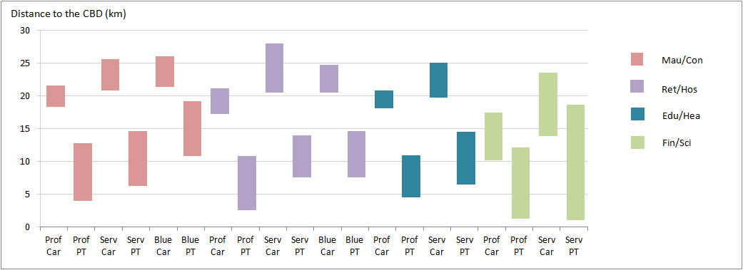

Figure 1: Standardized commuting space in relative to distance to the CBD for separate commuting groups

Commuting productivity outcome

This section analyses the productivity of commuting patterns by comparing workers income against commuting costs. First, a summary of commuting patterns for separate industry/occupation groups is provided in Table 2. These include total trips, commuting distance, monetary costs, and daily income generated as an outcome of commuting. In the last column, the productivity of commuting for specific industry, occupation, and transport group is estimated by comparing workers’ commuting costs and worker’s daily income (measured by calculating workers’ commuting costs of every AU$100 income earned).

Table 2: Summary of commuting costs for separate industry/occupation groups
Industry group | Worker  occupation | Travel mode | Total trips | Average distance (km) | Commuting cost (AU$/day） | Income (AU$/day) | Productivity of commuting*
I  (Man/Con) | Professional | Car | 54,619 | 14.8 | 9.94 | 193 | 4.7
I  (Man/Con) | Professional | PT | 1,788 | 19.7 | 8.01 | 193 | 3.5
I  (Man/Con) | Service worker | Car | 32,984 | 13.2 | 9.55 | 130 | 7.3
I  (Man/Con) | Service worker | PT | 1,215 | 19.9 | 7.87 | 130 | 5.6
I  (Man/Con) | Blue collar worker | Car | 120,191 | 12.3 | 9.34 | 133 | 6.9
I  (Man/Con) | Blue collar worker | PT | 3,335 | 20.1 | 7.44 | 133 | 5.6
II  (Edu/Hea) | Professional | Car | 125,281 | 12.3 | 9.37 | 168 | 5.6
II  (Edu/Hea) | Professional | PT | 11,670 | 11.9 | 8.09 | 168 | 4.6
II  (Edu/Hea) | Service worker | Car | 69,851 | 10.3 | 8.66 | 98 | 8.9
II  (Edu/Hea) | Service worker | PT | 7,351 | 12.2 | 7.86 | 98 | 7.8
III  (Ret/Hos) | Professional | Car | 40,397 | 11.5 | 9.06 | 145 | 6.4
III  (Ret/Hos) | Professional | PT | 3,466 | 11.3 | 8.08 | 145 | 5.5
III  (Ret/Hos) | Service Worker | Car | 71,325 | 9.9 | 8.58 | 90 | 12.5
III  (Ret/Hos) | Service Worker | PT | 14,131 | 9.9 | 7.7 | 90 | 10.7
III  (Ret/Hos) | Blue collar worker | Car | 31,280 | 10.1 | 8.57 | 80 | 9.5
III  (Ret/Hos) | Blue collar worker | PT | 6,547 | 11.1 | 7.7 | 80 | 11.0
IV  (Fin/Sci) | Professional | Car | 61,214 | 13.0 | 9.80 | 218 | 4.6
IV  (Fin/Sci) | Professional | PT | 34,209 | 14.0 | 8.17 | 218 | 3.7
IV  (Fin/Sci) | Service Worker | Car | 28,559 | 13.1 | 9.47 | 141 | 6.9
IV  (Fin/Sci) | Service Worker | PT | 16,961 | 17.3 | 8.19 | 141 | 5.8
* Productivity of commuting is measured by the commuting cost of every AU$100 income earned.

The productivity of commuting for separate commuting groups are compared in Figure 2. It shows noticeable differences in the productivity of commutes based on worker occupation, industry sectors, as well as travel mode. Among all sectors, service workers and blue collar workers in the Ret/Hos industry are the lease productive groups in commuting. The next least productive commuting group is service workers in the Edu/Hea sector. The low commuting productivity of workers in these categories are not exactly caused by the expensive commuting cost but are affected by their lower income. Many low paid workers in these industries typically spend very high proportion of their income on commuting costs, making their work-based travel lease productive. The productivity of commuting for service workers and blue collar workers in the Man/Con industry remain at a moderate level. Although workers in this category commute over a slightly longer distance, they generally earn mid-high income as an outcome of the commuting costs. The lower end of the chart represent the groups whose commute is most productive. They are mainly constituted by professional workers in varying industry who are on low commuting cost but earn high income and therefore make commuting more productive. Of those groups, professionals in the Fin/Sci and Man/Con industries using PT are the most productive groups who only spend 3.5-3.7% of income on commuting. The commuting productivity do not strongly vary between workers in the remaining industry/occupation categories including professionals in the Ret/Hos sector who on average spend 5.8-6.9% of income on commuting.

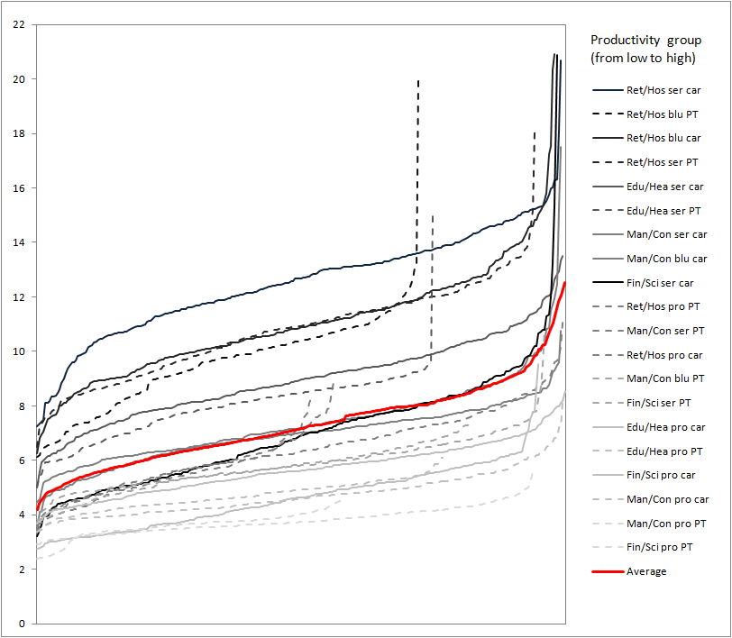

Figure 2: Distribution of commuting productivity for workers

Next, the spatial distribution workers whose commuting is less productive are analyzed. The least productive zones are identified by least productive groups which exhibit high number of travels. Figure 2 shows that service workers and blue collar workers in the Ret/Hos industry commuting by car are most vulnerable to transport costs. Workers in this category are found in a great number of outer suburbs in the north-west, north-east, and far south. Some middle urban areas also show several low productive zones for service and blue collar workers using PT. Workers in those zones are typically affected by high PT fare rate relative to income (AU$8.2/day), although they do not travel long distances (beyond the fare Zone 1). Commuting for some service workers in the Man/Con industry are found low productive. They are mostly located in zones in the far-west (Melton), far-east (Yarra Glen) and far-south (Point Nepean). These areas are also the residence of some service workers in the Edu/Hea sector who spend high level of income on commuting. High level of commuting costs in those areas is mainly caused by their distant locations to the major middle suburban education and health job precincts. Figure 2 also shows that commuting for some service workers in the Fin/Sci industry are less productive, although they earn moderate income. Workers in this group tend to locate at several new residential zones in the Carrum Downs, Cranbourne, and Cranbourne South in the south-east where are 40-50km from the CBD.

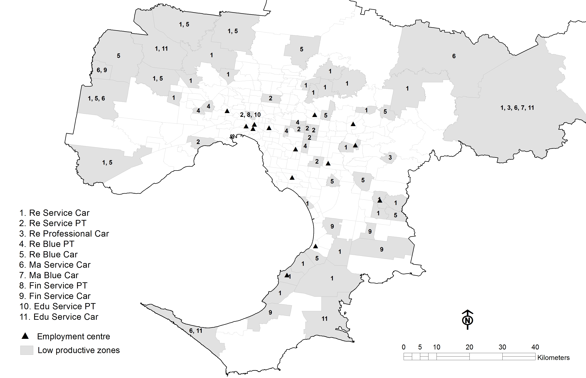

Figure 3: Spatial distribution of less productive commuting groups.

Discussion and Conclusion

This paper has identified categories and spatial characteristics of high/low productive commuting groups in Melbourne. We conclude this paper by discussing a number of urban planning strategies in resolving low productive commuting identified. The policy will be suggested based on key urban policy concerns to identify mitigating strategies that can better achieve improved social economic inclusion, reduce commuting cost and travel time and improve workers productivity.

Our results show that great number of low income workers are located in outer areas where are far away from their jobs. This is partly caused by the high housing cost in the inner and middle suburbs. Workers of mid-low income often trade off job access to achieve affordable housing in the outer-suburban zones causing high expenditure on transport. As there is increasing policy focus on housing accessibility to jobs to influence urban economic productivity, a shift in housing supply strategy is needed. The affordable rental housing development would offer strategies for altering the current limited stock of affordable housing units in the middle suburbs. We suggest that a strategy should be based on supplying affordable rental housing for low productive commuting groups in areas close to employment centres or supported by efficient public transport systems in connecting workers to jobs.

Our results show high transport costs in some industry and skill groups. These, in part, reflect the limitations in current suburban employment mixes which did not provide good catchment of increasing suburban labour markets. As the workforce in the suburban residential areas increases, planning for suburban employment will enhance jobs and worker relationships, promote changes in travel behaviour and reducing transport costs. Effective employment planning in suburban areas has the potential in improving these linkages and increase urban productivity. We have identified a number of sub-economic centres based on commuting patterns and labour markets. Expanding these suburban jobs especially in the service sectors to further out areas would improve economic opportunities to suburban Melbourne by providing sufficient localised economic density and high levels of accessibility to their respective catchments. This research would assist government’s employment planning strategy by providing insight into the location and types of jobs to be located in suburban areas to reduce the low productive commuting identified in this research.

Transport connectivity is crucial to efficient labour market functioning. High commuting costs in low income groups are associated with long distance travel and poor access to alternative transport modes. The under-supplied public transport networks serving jobs in low-density middle and outer suburban areas limit transport choices available to workers. An emphasis on public transport investment is necessary to promote use of alternative transport modes and to accelerate transport transition in the outer suburbs. Based on the results of this work, we suggest that creating improved transport systems would make our cities more economically viable. One extension to this research is to evaluate the future transport infrastructure based on an assessment of the proportion of jobs or types of jobs, it enables people to reach from different locations. Which group of workers are most and least productive in using transport infrastructure to get to work and ensure that space on city roads goes to the most productive use, and could help workers get access to jobs and raise economic outputs.

References

Australian Bureau of Statistics. (2011) ‘Household Expenditure Survey, Australia: Detailed Expenditure Items, 2009-10’; Canberra, Australian Bureau of Statistics

BITRE. (2014) New passenger vehicle fuel consumption trends, 1979 to 2013. Information Sheet 66, BITRE, Canberra.

Brooke, P. P. (1986). Beyond the steers and Rhodes models of employee attendance. Academy of Management Review, 11(2), pp. 345-361.

Costa, G., Pickup, L. and Marino, V. D. (1988) Commuting--a further stress factor for working people: evidence from the European Community. II. An empirical study, International Archives of Occupational and Environmental Health, 60(5), pp, 377-385.

Crafts, N. (2009) Transport infrastructure investment: implications for growth and productivity, Oxford Review of Economic Policy, 25(3), pp. 327-343.

Day, R., and Walker, G. (2013) Household energy vulnerability as assemblage, in Bickerstaff, K., Walker, G., and Bulkeley, H. (ed) Energy Justice in a Changing Climate: Social equity and low-carbon energy, Zed Books, London.

Dodson, J., and Sipe N. (2008) Shocking the Suburbs: Urban location, home ownership and oil vulnerability in the Australian city, Housing Studies, 23(3), pp. 377-401.

Emre, O. and Elci, M. (2015) Commuting related problems in the workplace, Journal of Business Studies Quarterly, 6(4), pp.1-9.

Holland, D. M. (2016) Cost of commuting: A review of determinants, outcomes, and theory of commuting-related stress, University Honors Thesis, Portland State University, Paper 299.

Koslowsky, M. (2000) A New Perspective on Employee Lateness, Applied Psychology, 49(3), pp. 390-407.
Laird, J. (2006) Commuting costs and their impact on wage rates, Working Paper 587. Institute of Transport Studies, University of Leeds, Leeds, UK.

Li, T., Dodson, J., and Sipe, N. (2015) Differentiating metropolitan transport disadvantage by mode: household expenditure on private vehicle fuel and public transport fares in Brisbane, Australia, Journal of Transport Geography, 49, pp. 16-25.

Litman, T. (2010) Transportation Cost and Benefit Analysis II–Travel Time Costs, Victoria. BC: Victoria Transport Policy Institute.

Lobo, J. and Smole, D. (2002) Stratification and spatial segregation of human capital as determinants of metropolitan productivity in the United States, Urban Studies, 39(3), pp529-547.

Lovelace, R., and Philips, I. (2014) The “oil vulnerability” of commuter patterns: A case study from Yorkshire and the Humber, UK, Geoforum, 51, pp. 169-182.

Lyons, G. and Chatterjee, K. (2008) A human perspective on the daily commute: costs, benefits and trade-offs, Transport Reviews, 28(2), pp.181-198.

Mackie, P.J., Jara-Diaz, S. and Fowkes, A. S. (2001) The Value of Travel Time Savings in Evaluation, Transportation Research Part E 37, pp. 91-106.

Mattioli, G. (2013) Where sustainable transport and social exclusion meet: Households without cars and car dependence in Germany and Great Britain. PhD thesis, University of Milan-Bicocca.

Metz, D. (2008) The myth of travel time saving, Transport Reviews, 28(3), pp.321-336.

Nelson, J. P. (1997) Accessibility and the Value of Time in Commuting, Southern Economic Journal, 43(3), pp. 1321-1329.

Ommeren, J. V. and Fosgerau, M. (2009) Worker’s marginal costs of commuting, Journal of Urban Economics, 65, pp.38-47.

Ommeren, J. V. and Gultierrez-i-Puigarnau, E. (2011) Are workers with a long commute less productive? An empirical analysis of absenteeism, Regional Sciences and Urban Economics, 41, pp. 1-8.

Public Transport Victoria, 2017. Metropolitan myki fares, https://www.ptv.vic.gov.au/tickets/fares/metropolitan-fares/

Rosvall, M. Axelsson, D and Bergstom, C. T. (2009) The map equation, The European Physical Journal, 178, pp. 13-23.

Russell, M., Price, R., Singal, L. and Stanley, J. (2011) What do passengers do during travel time? Structured observations on buses and trains. Journal of Public Transportation, 14( 3), pp. 123-146.

Schwanen, T. and Dijst, M. (2002) Travel-time ratio for visits to the workplace: the relationship between commuting time and work duration, Transportation Research Part A, 36, pp. 573-592.

The Grattan Institute. (2010) An analysis of Victoria’s labour productivity performance,
https://grattan.edu.au/wp-content/uploads/2014/04/024_eslake_vic_diird.pdf

Van Hooff, M. L. M. (2013) The daily commute from work to home: examining employees’ experience in relation to their recovery status, Stress and Health, 31(2), pp. 124-137.

Wener, R. E. and Evans, G. W. (2011) Comparing stress of car and train commuters, Transportation Research Part F, 14, pp. 111-116.

Wrede, M. (2011) Unemployment, commuting and search intensity, Discussion Paper 12, University of Erlangen-Nuremberg.

Zenou, Y. and Smith T. E. (1995) Efficiency wages, involuntary unemployment and urban spatial structure, Regional Science and Urban Economies, 25, pp. 547-573.

