State of Australian Cities 2017
Structure / Transport stream

What’s best for the West? Plan Melbourne 2017-2050 and alternative transport futures for Melbourne’s western suburbs

Iain Lawrie¹, John Stone¹, Ian Woodcock²
¹University of Melbourne, Melbourne, Victoria, Australia, ²RMIT University, Melbourne, Victoria, Australia

Abstract

The recently released strategic plan, Plan Melbourne 2017-2050 forecasts a metropolitan population of 8 million. The city’s western suburbs will take a large proportion of this growth, with a further 625,000 projected residents. Despite such projections, no substantial changes to the public transport network are proposed beyond currently committed projects. Many initiatives proposed in PTV’s 2012 Rail Network Development Plan have not yet been implemented, nor are there any targets for increased mode share that might direct investment towards less congestion-prone futures.
This paper reports on a design-research project run by the authors with graduate students at the University of Melbourne, which considered alternative scenarios for the future of transport in Melbourne’s west. A ‘business as usual’ approach was compared against the service levels, capacities and urban form required to support higher public transport mode shares for all journey types. The results indicate startling dis-connects between official plans and even delivering ‘business as usual’ mode shares for public transport. The studio found that alternative integrated, multi-scalar planning and design approaches, combining ‘network effect’ transit theory and assemblage thinking, present significant new city-making opportunities, including in locations not previously considered suitable for urban renewal.
The findings of the studio provide fresh interpretations of transport and land use relationships, reinforcing the need for new thinking about growth areas and dispersed urban environments more broadly. Given the scale of population growth envisaged, the paper argues that such alternatives will be critical to achieve the headline objectives of Plan Melbourne.

Introduction

In November 2013, shortly after Fiorente passed the winning post to claim the Melbourne Cup, over 100,000 people began their journey home from Flemington Racecourse. A substantial proportion boarded the train from the Racecourse station located adjacent to the grandstands, allowing the course to be largely cleared of patrons within an hour or so of the last race. Others queued to leave congested car parks. A month earlier, the Victorian Racing Club and a private property developer announced plans for a high density residential development on surplus land near the track. The developer’s proposals envisaged opening the Flemington Racecourse rail spur (a branch of the Craigieburn suburban line) to regular all day services. High capacity public transport would be used to leverage high density development on the site. However, in evidence presented to the Planning Panel Advisory Committee (tasked with considering the site’s rezoning), Public Transport Victoria indicated reopening the spur would be unviable, citing insufficient capacity in the broader rail network and ample capacity in the site’s nearby bus services (PTV, 2015). Despite reservations about the transport implications, the Committee consented to a scaled back development. No major alterations were demanded of the public transport network (Planning Panels Victoria 2015) with the towers to be built adjacent to the mostly dormant, special event only rail corridor.

Debate over development of high density residential land use at the Flemington Racecourse presents a microcosm of the broader challenge of how to best manage substantial population growth across metropolitan Melbourne. The initial population data released from the Australian Bureau of Statistics (ABS) 2016 Census shows Melbourne’s population has risen to 4.49 million (ABS 2017), up from 3.99 in 2011 (ABS 2012). A substantial proportion of that population growth has occurred in the western suburbs. Median band predictions by the Victorian Department of Environment, Land, Water and Planning (DELWP) predicts the Melbourne metropolitan population will rise to 6.05 million by 2030 and 8.02 million by 2050 (DELWP 2016, p13). ABS predictions range from 6.70 to 8.70 million by 2050 (ABS, 2013). The western suburbs, incorporating the municipalities of Wyndham, Hobsons Bay, Brimbank, Melton, Hume, Maribyrnong and Moonee Valley are predicted to add a further 495,500 residents by 2030 (DELWP 2016).

The state government’s official strategic planning response to the challenges imposed by this population growth is ‘Plan Melbourne 2017-2050’. Plan Melbourne outlines 9 key principles to guide the ‘future and shape of the city and state over the next 35 years’ (DELWP, 2017). Contemplating an 8.0 million metropolitan population by 2050 (DELWP 2017), the document envisages an additional 10.4 million trips per day on the city’s transport network, whilst acknowledging congestion and capacity limitations are already major problems (DELWP, 2017 p62). The plan sets out a range of strategic challenges and approaches to their resolution. Relevant to this paper are the plan’s themes of:
- Creating a city of ‘20 minute neighbourhoods’, where most local services required on a day to day basis can be reached within that timeframe by active or public transport (DELWP, 2017 p 99);
- Re-orienting jobs growth, particularly higher value knowledge based jobs to non CBD locations, including in National Employment and Innovation Clusters (NEICs) in the western suburbs (DELWP, 2017 p25); and
- Ensuring adequate access is provided to education facilities within local regions (DELWP, 2017 p102)

This paper reports on the outcomes of a design-research studio run by the authors with graduate students in the Melbourne School of Design at the University of Melbourne. The studio comprised urban planning and architecture students and was run during Semester 1 2017 between February and June. The studio’s overall objective was to have students interact and respond to the broader population growth challenge in the western suburbs of Melbourne from a transport and land use perspective.

The studio initially presented students with a core set of demographic and transport data, and introductions to relevant transport planning theory (including Mees, Nielson etc). Students were introduced to key databases, including the broad range of transport and demographic statistics available via AURIN, VISTA, the ABS and Public Transport Victoria. Using this data, a collective analysis was undertaken assessing the performance of the existing public transport network in terms of frequency, connectivity and ease of modal transfer.

Early in semester, students were set a fieldwork task to complete solely by public transport, involving a hypothetical day of typical travel between different suburban locations across the western suburbs. The experiences assisted students in better understanding the limitations of the public transport network in providing an effective service for non-CBD oriented trips. It provided an Illuminating taste of the profound difficulties in cross suburban travel without use of a car.

Building on fieldwork experiences, a series of guest presentations were subsequently given by representatives from PTV, Transport for Victoria, Local Government, transport consultants and academics. Students were tasked with preparing an individual response to a specific aspect of the broader transport challenge of the west. To guide the direction of the work, three conceptual structures were set:

- What are the implications of maintaining a ‘business as usual’ approach to transport policy? A ‘business as usual’ assumes a continuation of existing mode share splits between private, public and active transport, and that currently proposed transport infrastructure investments (both public transport and road) publicly announced would proceed;
- What are the challenges associated with attempting to increase mode share on public transport to 20% of motorised trips (as envisioned in initiative 8.2.1 of the Melbourne 2030 plan (DSE 2003)) or more; and
- What are the challenges associated with achieving Plan Melbourne’s ’20 minute’ neighbourhood’ concept?

This paper presents the general themes arising from the studio. We first present a summary of the findings from the collective data analysis undertaken on the performance of the existing public transport system. We next present the key strategic problems identified by the students, followed by an outline of some of the key transport and spatial design responses proposed. We finally provide some general observations and conclusions that identify a range of areas for further research.

Collective Data Analysis

To provide insight into the existing public transport system, and its ability to effectively provide for the diversity of travel across the western suburbs, students undertook an analysis of key data relating to co-ordination of services. Multi-modal coordination of services is a key feature of best practice public transport network planning (as described by Nielsen et al 2005 and 2008; Mees 2010, Dodson et al 2011, and others). Therefore, an analysis was made of the timetable coordination between bus and rail, the physical distances between stops, and rates of transfer observed in PTV’s available patronage data sets. This provided a snapshot of the service offer and performance of the current network. The timetabled and physical relationship between 91 bus routes, serving 35 stations in the metropolitan network were analysed. In summary, the results showed that:

- Generally, there is a very poor level of timetabled connectivity between train and bus. Most train services are not met with a connecting bus within an optimal sub-10 minute wait time;
- A wide variation exists in the physical proximity between rail platforms and bus stops;
- Many transfer routes are hard to navigate and require lengthy detours due to lack of safe places to cross roads
- A very high proportion of transfer points are in extremely poor quality environments, lacking weather protection or complementary land-uses
- Overall, levels of transfer between bus and train at stations in Melbourne’s west are low- with very few bus routes exceeding 500 transfers to rail per weekday (PTV, 2013)

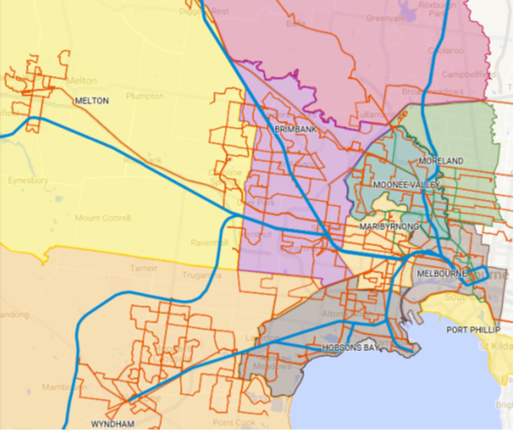
Figure 1: Rail(blue), Tram(green) and Bus(orange) Network, Western Suburbs Melbourne (source: MSD students via Google maps using PTV base data)

The analysis concluded that there is little evidence of systematic bus-rail transferring. The few locations where transferring occurs to any significant degree (Essendon, Footscray, Williams Landing) vary greatly from an urban-design perspective - thus do not provide insight as to the relative influence of elements of station design on transfer numbers (see Woodcock & Stone 2015 for more detailed analysis of this issue).

Problems Identified

Using data introduced in the first phase of the studio, students identified a number of key transport and land use challenges in the west over the medium and longer term. These are that:

- The public transport system, in its current and publicly announced forms of capacity enhancement, will fail to adequately maintain even the ‘business as usual’ mode shares;
- A disconnect exists between population growth and provision of adequate regional scale services such as health and education to ensure the needs for extended travel are minimised. A number of students picked up on the education challenge which is already especially acute for the tertiary sector;
- The Precinct Structure Planning (PSP) approach to growth area development inadequately addresses both local and regional scale public transport challenges;
- The lack of alternatives to the private car for travel to and between major employment centres in the west (especially Werribee, Sunshine, Highpoint, Footscray, Essendon) as well as the designated National Employment and Innovation Cluster (NEIC) at Werribee East;
- There is inadequate consideration of access to Melbourne Airport in terms of its role as a regional jobs node of comparable stature to the declared NEICs at Sunshine and Werribee East. In particular there is a lack of nuanced consideration for public transport access to the airport, within the current debates about a new city-airport rail line.

The evidence and analysis presented by the students on each of these questions is described below.

Public Transport service and capacity limitations

A key finding of the studio emerged from the work carried out by Nick Lane on rail capacity (2017) . Lane investigated the likely increased demand on the rail network as a result of projected population growth, and compared that against the three general scenarios set for the studio. Taking investments in additional capacity outlined in the 2012 PTV Network Development Plan as the ‘business as usual’ scenario, Lane compared the resulting network against the likely demand arising in the west through to 2036 (the timeframe envisaged within PTV’s plan). The results, based on DELWP population growth forecasts (DELWP, 2016), an extrapolation of current trends and data relating to workplace location (ABS 2012), participation rates and train loading capacities, indicate that demand is expected to quite substantially exceed supply. As shown in Figure 2, Lane calculated that throughout the Network Development Plan’s planning horizon, most trains approaching the city from the west in the 2 hour morning peak period would exceed the standardised load capacity of 900 passengers. While the specific assumptions in Lane’s analysis might be debated, the general thrust of the analysis is illuminating. It suggests that even with the substantial investment to be made in the Melbourne Metro rail tunnel (now under construction), it will not be until 2030 before capacity adequately matches demand. Only once initiatives in Stage 4 of the Network Development Plan (system wide high capacity rail signalling and reconfiguration of the City Loop - largely removing its function as a loop) are complete might there be congestion relief, but only at modes splits similar to those seen today – the huge investments in public transport will only match population growth not allow for a shift away from the car.
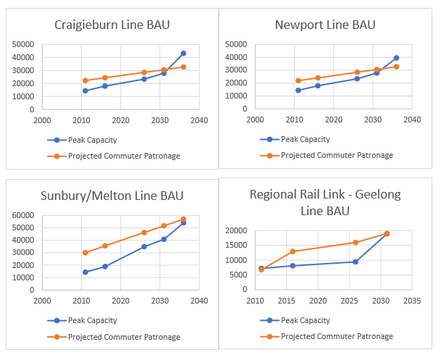
Figure 2: Melbourne Western Suburbs rail demand and supply analysis 2012-2036 (source: Lane 2017)

Provision of regional education services

McNair (2017) and Kurne (2017) undertook separate investigations into the spatial distribution of education facilities across the west.

McNair observed that there appears to be a limitation in the current Precinct Structure Plan (PSP) process for ‘higher order’ health and education facilities (2017, p6). His critique is that whilst the ‘area by area’ PSP process may or may not produce appropriate land-use outcomes on a sub-regional scale, the process overlooks the aggregated demand accruing at a regional scale for health and education facilities. McNair focused on the provision for tertiary education in the west. He contrasted current practice with the far-sighted planning processes in the immediate post war period, exemplified by the Murray Report in 1957 which prefigured the development of Monash and Latrobe Universities (2017 p4). It was noted that the growing population, combined with shifting demographic patterns away from the west’s traditional blue collar employment base was driving a substantial lift in demand for higher education (2017, p10). Increasing CBD and inner north travel demand to access tertiary education campuses from the west will place continual pressure on already congested radial rail services.

Kurne’s work focused on the interrelation of secondary schools with public transport services. His conclusions, based on an analysis of the Wyndham City Council area, were that there was a spatial and temporal inconsistency in their provision (2017 p15). It was found that these trends continued even in new build growth suburbs. Using the example of the proposed Black Forest Road PSP, Kurne observed that whilst the PSP process had the ability to align secondary schools to proposed public transport alignments, in practice this often did not occur (2017 p5).

Public Transport provision and growth area Precinct Structure Plans

Zeng (2017) investigated the planning for public transport within PSPs and the associated relationship between accessibility and affordability. Zeng identified issues with the current approach, in that roads within new suburbs are designated as ‘bus capable’, but not otherwise linked to a broader regional public transport network plan (p9). Likewise, whilst roads have been designed for bus routes, a lack of integrated planning which dictates when bus services will actually be deployed, and to what destinations, means new residents have no choice but to utilise private cars from the outset (p 11). Drawing on the example of the Aurora development in Melbourne’s north, Zeng noted that by the time public transport services were deployed, private vehicle travel patterns have become habituated in place and are difficult to change. Zeng noted previous research by Currie et al (2009) linking this ‘forced car ownership’ to pronounced economic and social disadvantage.

Airport access from the west

Pringle (2017) and Su (2017) considered the broader issue of access to Melbourne Airport. While debate over improved public transport access to Melbourne Airport has been an ongoing theme (see Richards, 2017 just as a recent example), most discussion has centred on direct rail access from central Melbourne. Acknowledging the diversity of geographic trip origins and purposes, the studio encouraged a more holistic approach, investigating options to improve public transport access from both the city and the broader western suburbs.

Pringle noted that while public transport mode share for airport passengers was 14 per cent, share for airport employees (whose residences are dominantly located within the western suburbs) was a mere 5 per cent (2017, p15). With an expanding non-aviation land use at the airport, and a congested arterial road and freeway network on the approaches, Pringle identified the limitations of non-CBD oriented public transport services (2017, p15) including that access to off terminal office/warehouse employment precincts is almost non-existent. Citing a previous US study by Mandle et al (2000), Pringle argued that the diversity of origins, for both airport environs employees and air travellers, may cap potential public transport mode share at around 15 per cent under a ‘business as usual’ approach to service provision (p22). As a result, he concluded that more radical public transport investments are needed to achieve more substantial mode shift (p22). These are described in the next section.

Transport Planning and Design Responses

Building on the problems identified, students were encouraged to conceptualise appropriate responses based on best-practice public transport network planning theory. These concepts, informed by the work of Mees (2010), Nielsen et al (2005, 2008), Walker (2012), Dodson et al (2011) among others, emphasise the importance of a well-connected network of public transport services as a means for public transport to become a genuine competitor to private vehicles for a large range of trip purposes. The studio’s fieldtrip and collective work that highlighted limitations of the current system assisted in the contextual understanding of the problem.

General themes in the students’ responses became apparent. These identified:
- That a trunk, high frequency inter-regional public transport network across the broader western suburbs will be necessary to avoid increasing traffic congestion. Such a network would be a critical policy response to achieve either the higher mode share or ‘20-minute city’ concepts set for the studio.
- The nature of key road and rail corridors in which such a region-wide network would operate brings the strategic importance of several locations into a new focus. In particular, a number of students identified both Airport West (around the existing Westfield Shopping Centre) and the Orica site in Deer Park to be of strategic importance in an enhanced multi-modal public transport network (see figure 3 below).

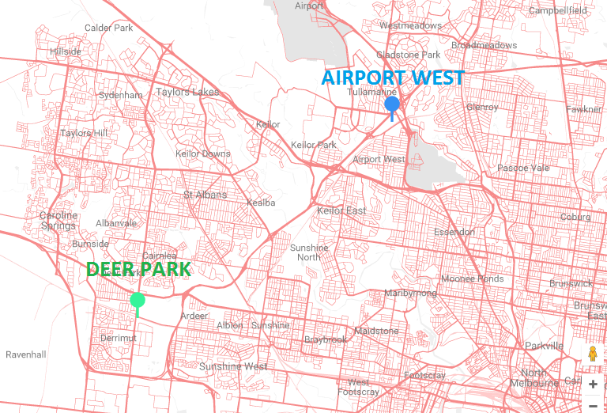
Figure 3: Location of Airport West and Deer Park within context of arterial road network (source: authors)

A non-radial trunk public transport network for western Melbourne

In response to the shortcomings identified in current services and plans at state level relative to projected population growth for the west, three students developed concepts for additional public transport as a driver of denser, more walkable urban precincts.

Gomez (2017) undertook an analysis of conceptual routes for a medium capacity light rail network to better connect the existing, planned and emerging land use patterns in the west. A comprehensive assessment methodology was created to determine possible routes, informed by the light rail assessment process used in the broadly comparable urban form of Mississauga, Ontario (Metrolinx, 2017, in Gomez 2017,p14). Using the spatial structure of activity centres presented within Plan Melbourne, and taking into account land use findings from projects such as McNair’s on tertiary education, Gomez developed a conceptual light rail network for the region (shown below in figure 4). Like the Mississauga precedent, Gomez’ project draws on the city-shaping potential of light rail to change patterns of density, land-use and walkability on a regional as well as local basis. The project provides an alternative to the ‘business as usual’ of the disconnected PSP approach and its shortcomings identified earlier.

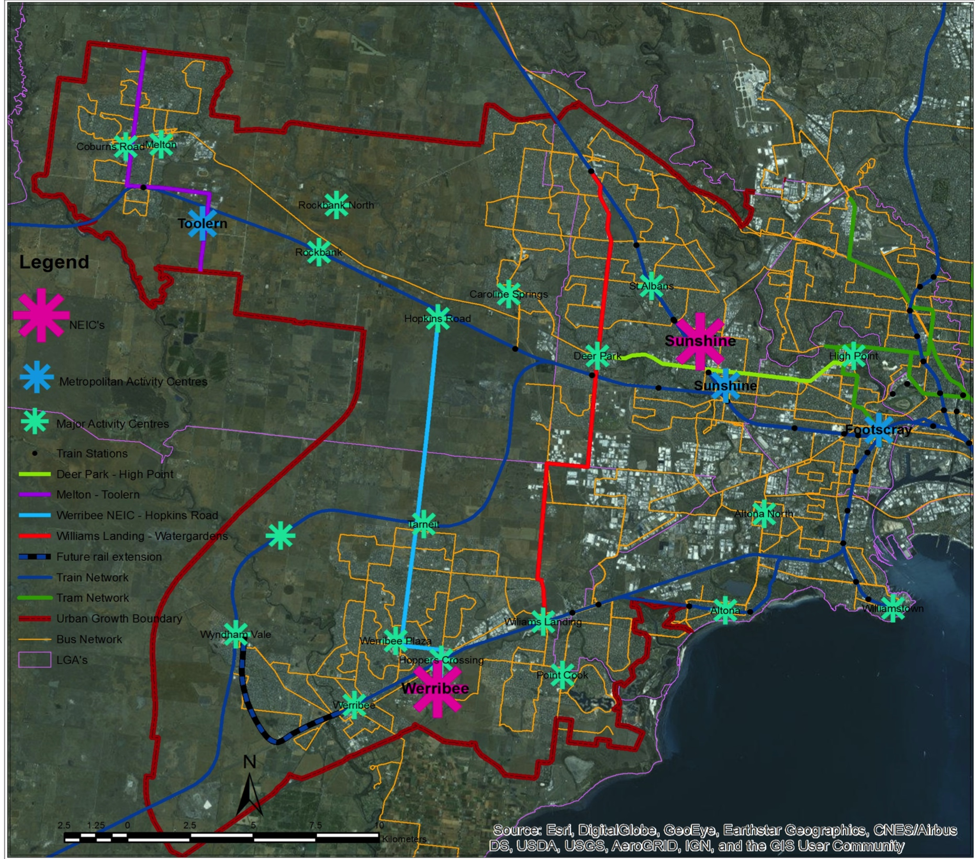
Figure 4: Western Suburbs conceptual light rail network, linking activity centres, NEICs and rail corridors (source: Gomez 2017)

Using similar network planning best practice concepts, Pringle (2017) proposed a staged, multi-modal orbital network to improve access from the west to Melbourne Airport. Pringle identified that Airport West, in the vicinity of the Ring Road, Tullamarine Freeway, Westfield Shopping Centre and Albion rail corridor was a highly strategic location within a staged rollout of this network.

Working on a similar theme, Su (2017) presented a conceptual infrastructure investment plan to address CBD to airport demand. Involving a new metro line from Victoria Gardens in the city’s inner east to the airport via the CBD, Highpoint shopping centre, the former Maribyrnong Defence Site, Essendon Fields and Airport West, Su’s concept seeks to unlock latent potential for substantial urban renewal in brownfield sites through the north western suburbs. A conceptually similar alignment (though with lower value capture and urban uplift potential) has recently been canvassed as an option by the Federal Government (see Harris, and Minear 2017).

A University of Western Melbourne at Deer Park?

Anteet (2017) responded to McNair’s (2017) observations on the lack of provision for a growing tertiary education demand in the west, and the strategic potential of the Orica Chemicals site in Deer Park. He developed a sophisticated proposal for two new stations on an enhanced four track elevated alignment (where several level crossings require removal) catering for long term growth along the Melton, Ballarat, Tarneit and Geelong corridors. Anteet’s proposal involved stations located directly above both the Western Ring Road and Station Road/Mt Derrimut Road, serving the east and west sides of an expansive re-development of the current Orica site (see figure 5 below). Anteet’s work provided a spatial and design response to the strategic identification of Deer Park as a viable location for a tertiary education campus by McNair (figure 6). Anteet’s proposals thus built on the regional public transport concepts for light rail (Gomez) and orbital freeway express bus (Pringle) to convincingly re-imagine Deer Park as a locality highly connected with the entire western region.

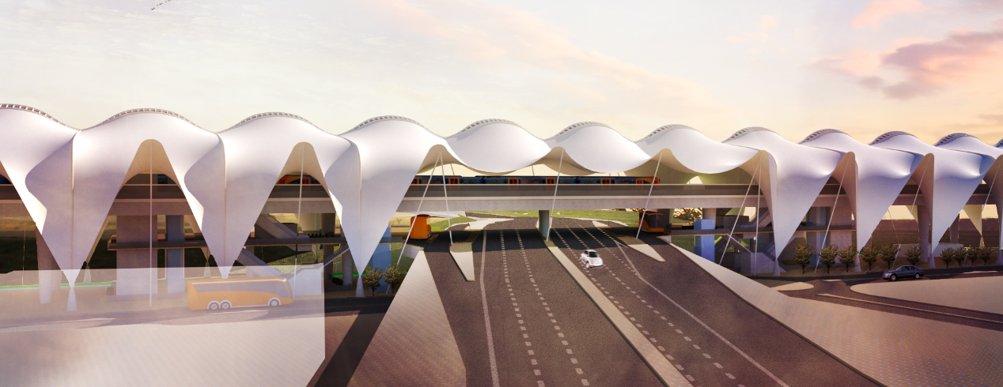
Figure 5: New Ardeer/Deer Park East Station concept straddling the Western Ring Road to provide convenient bus/train interchange and access to a potential university central to the west (Anteet 2017)

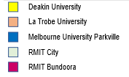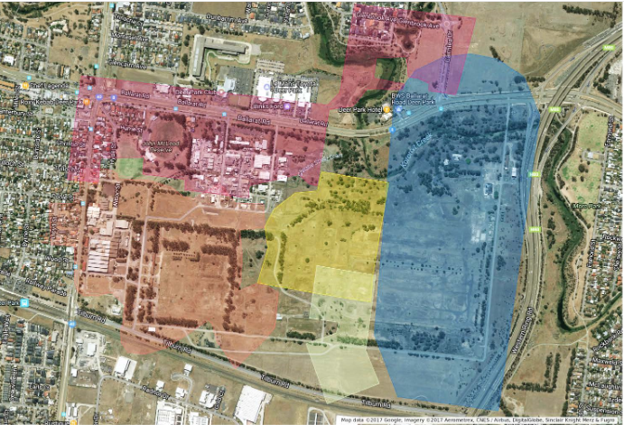
Figure 6: Orica Chemicals site Deer Park, overlayed with existing campus footprints for key Melbourne tertiary education institutions (source: Anteet 2017)
Discussion

Population growth will continue to place immense pressure on the transport network of Melbourne’s western suburbs. Based on analysis undertaken in this studio, a ‘business as usual’ approach, incorporating a build out of transport investments articulated in Plan Melbourne 2017-2050 and PTV’s Passenger Rail Network Development Plan will fail to meet the anticipated demand. Indeed, Plan Melbourne does not commit to most key rail initiatives of the Network Development Plan in the west, including the Wyndham Vale extension of the Werribee line, duplication of the Altona loop and electrification to Geelong and Melton (see figure 7 below). Plan Melbourne’s 2050 transport plan appears no more ambitious than an incorporation of existing publicly announced road (including the controversial and to be approved West Gate Tunnel) and committed rail projects (Melbourne Metro, 50 level crossing removals). This is manifestly inadequate to address the transport challenges of a burgeoning western suburbs, much less a metropolitan wide population of around 8 million. Thus, a ‘business as usual’ approach will conceivably result in deteriorating mode shares for public transport in the west and dramatically worsening traffic congestion. These outcomes conflict with the stated objectives of the Passenger Rail Network Development Plan, Plan Melbourne 2017-2050 and also, with the fundamental principles of Victoria’s Transport Integration Act 2010 (Parliament of Victoria 2010). Objective 11 of the TIA is to:

“provide for the effective integration of transport and land-use and improve access to social, and economic opportunities … to reduce the need for private motor vehicle transport and the extent of travel” (TIA 2010, S.11)

Of course, a fundamental goal of the studio was to explore ways that objectives such as these could be achieved. However, the solutions are not straightforward. Our studio work has identified two specific dilemmas. The first is that capacity constraints on the rail network might preclude the adoption of best practice public transport planning concepts. Efficient, integrated multimodal public transport aims to compete with cars by providing frequent and rigorously coordinated services across a wide area. Yet such a network requires adequate capacity to be provided within each mode. As shown in Lane’s (2017) assessment, even with deployment of the Network Development Plan’s signature investments (Melbourne Metro, high capacity signalling, re-configuration of the city loop) peak period capacity constraints will likely remain. Therefore, providing a region-wide coordinated bus/light rail network feeding a trunk rail backbone is likely to be ineffectual. Best-practice networked public transport cannot be effective if trunk services regularly cannot handle the volume of transferring passengers from feeder services. Nevertheless, the alternative, where the west’s growing travel demand is met through continually rising car volumes, is a recipe for further entrenching car dependency and ongoing and worsening congestion.

Thus, allied with improvements in the public transport network, spatial re-distribution of jobs and services to suburban clusters and centres is necessary to limit peak demand on CBD-oriented trunk rail services. This is conceptually aligned with Plan Melbourne’s ‘20 minute neighbourhood concept’, but would reach beyond that to incorporate substantial employment decentralisation which might otherwise require CBD oriented trips. In this, the benefits of providing a large university site centrally placed within the west, attractive and easily accessible to its changing demographics is also important. In doing so, rail capacity limitations may by eased and efficiencies gained by promoting and absorbing more non-CBD direction demand. In this arrangement, an effective multimodal PT system becomes more achievable.

The second dilemma comes from the likelihood that achieving a meaningful proportional re-distribution of growth will be slow. Further, as identified by a limited network planning analysis in this studio, strategically advantageous sites at Airport West and Deer Park are not identified in Plan Melbourne as nodes, either for substantial intensification of employment-generating land uses or residential development, both of which would be needed to make the most of the opportunities the locations present. Swifter rates of decentralisation might be possible, but only through more powerful planning tools than those contemplated under Plan Melbourne.

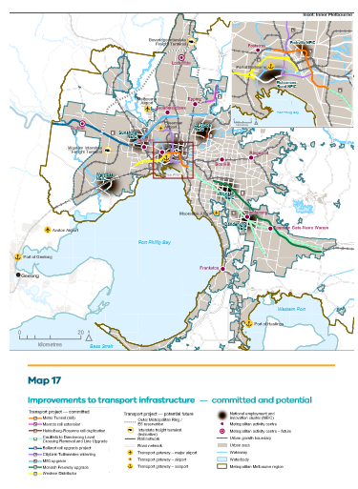
Figure 7: Plan Melbourne 2017-2050 Committed and potential improvements to transport infrastructure 2050 (DELWP 2017)

Conclusions

One of the primary conclusions that we offer here is that graduate studio engagement with planning and design questions is a viable mode of research activity. This studio directly builds on earlier work using the design research method investigating activity centre intensification (Dovey and Woodcock 2011), railway station access and design (Woodcock 2016; Woodcock and Wollan 2013) and the benefits of elevated rail (Woodcock and Stone 2016). This work contributes to the growing evidence of the value of design research as a method (for example, Ramirez-Lovering et al 2015; Moloney et al 2015). In this instance, the method was extended into the notoriously complex, multi-discipline and multiscale problem of transport and land use integration. The teaching team reflected this with planning and design expertise, as did the students enrolled in the course. Furthermore and notably, there was a significant component of industry engagement – across disciplines and across sectors. At one level, a semester long studio proposing to look at the entire western suburbs of Melbourne is an audacious proposition. However, the level of interest and engagement from external stakeholders indicates the potential of this method of working for creating the space in which to debate much-needed questions across institutional boundaries. These debates have few other forums given the constraints of current public and private sector work practices in planning.

Having considered the current strategic planning documentation, from the Network Development Plan, to Plan Melbourne to the various PSPs, we conclude that Melbourne’s west is on a trajectory toward a ‘business worse than usual’ outcome. We argue that to maintain existing public transport mode share rates, and certainly to achieve a material increase in PT mode share, much more dramatic city shaping interventions are required. These are not impossible, but they do require radical thinking along the lines of the proposals Su, Anteet, Pringle and Gomez have presented. When first canvassed in the studio sessions, Su’s proposals appeared overly ambitious. However, when considered alongside the core network constraints shown in Lane’s analysis, the merits of such investments become worthy of detailed consideration.

Results of this studio demonstrate the benefits of this multidisciplinary design-research approach which engages practitioners by providing timely provocations to recognise the deep gap between current proposals for new infrastructure and the stated objectives of planning policy. The results also trigger a range of further research avenues. In particular, we see an urgent need for sophisticated public transport modelling, along the lines of the SNAMUTs assessment model (see Curtis and Scheurer 2016), to inform a region wide multi-modal public transport plan. Such modelling would test the strategic connectivity potential of locations such as Airport West, Deer Park and others. It would also inform a proper region wide plan, allowing a major limitation of the PSP process to be overcome. Further, we see benefit in further exploring the spatial, urban design and architectural opportunities suggested by intensification at brownfield sites identified in the studio.

Overall, the studio highlights pressing transport challenges for Melbourne’s west. With a continued focus of jobs growth in the inner city, dramatic changes to the rail network well beyond the Network Development Plan will be needed to meet rising demand and generate increased mode shares. This must be complemented by a drive to locate most new growth to suburban nodes, which also requires a substantial investment in the public transport network and possibly dramatic interventions to attract meaningful number of businesses to locate to western suburban nodes. Neither approach is easy. However, the alternative is to continue further along the current trajectory of a private-vehicle dominated transport mix. Rising population growth ensures that such an approach will be unworkable for the daily lives of the residents of the west, and unsustainable from an environmental and economic perspective.

References

Anteet, Q. (2017) Deer Park Activity Centre unpublished graduate studio report, Melbourne School of Design

Australian Bureau of Statistics (2012) Census of Population and Housing 2011 ABS, Canberra

Australian Bureau of Statistics (2013) Population Projections, Australia, ABS, Canberra

Australian Bureau of Statistics (2017) Census of Population and Housing 2016 ABS, Canberra

Currie, G, Richardson, T, Smyth, P, Vella-Brodrick, D, Hine, J, Lucas, K, Morris, J, Kinnear,
R & Stanley, J (2009), Investigating links between transport disadvantage, social exclusion and well-
being in Melbourne—Preliminary results, Transport Policy, vol. 16, no. 3, pp. 97-105.

Curtis, C and Scheurer, J. (2016). Planning for Public Transport Accessibility - An International Sourcebook. London and New York: Routledge

Department of Environment, Land, Water and Planning (DELWP) (2016) ‘Victoria in the Future 2016: Population and Household Projections to 2051’ State of Victoria, Melbourne, Victoria

DELWP (2017) ‘Plan Melbourne: 2017-2050’ State of Victoria, Melbourne, Victoria

Dept. of Sustainability and Environment (2003) ‘Melbourne 2030’ Victorian Government: Melbourne

Dodson, J, Mees, P, Stone, J and Burke, M (2011) ‘The Principles of Public Transport Network Planning: A review of the emerging literature with select examples’. Urban Research Program Issues Paper 15, Griffith University, Brisbane

Dovey, K. and Woodcock, I. (2011) The Character of Urban Intensification: A Report in projects funded by the Australian Research Council, 2002-2010, University of Melbourne, Melbourne, http://www.placeresearch.net/pdf/Character_of_Urban_Intensification.pdf

Gomez, G. (2017) Towards Developing a Light Rail Transit (LRT) network: Melbourne's Western Suburbs unpublished graduate studio report, Melbourne School of Design

Harris, R and Minear, T ‘Melbourne airport rail link may be built without Victorian funding’ Herald Sun
http://www.heraldsun.com.au/news/victoria/future-melbourne/melbourne-airport-rail-link-may-be-built-without-victorian-funding/news-story/2ef855853e494fc9fbd6261611a48085 Retrieved 2 July 2017

Kurne, A. (2017) Planning for current and future secondary schools in Wyndham and optimizing the potential for PT use by students, unpublished graduate studio report, Melbourne School of Design

Lane, N. (2017) Rail Capacity in the Western Suburbs, unpublished graduate studio report, Melbourne School of Design

McNair, J (2017) Accessibility of higher education in a Bigger West: A policy analysis of transport and land use planning in the western suburbs toward 2050, unpublished graduate studio report, Melbourne School of Design

Mandle, P. B., Mansel, D. M., & Coogan, M. A. (2000). ‘Use of Public Transportation by Airport
Passengers’ Transportation Research Record’ 83-89.

Mees, P (2010) Transport for Suburbia. Earthscan, London

Metrolinx (2017), Hurontario Light Rail Transit master plan, viewed April 1 2017, <http://www.metrolinx.com/en/docs/pdf/hurontario_epr/HurontarioMain_LRT_Project_EPR.pdf>

Moloney, J., Smitheram, J. and Twose, S. (2015) Perspectives on Architectural Design Research: What Matters – Who Cares – How, Spurbuchverlag, Bamberg

Nielsen, G., Nelson, J., Mulley, C., Tegner, G., Lind, G. and Lange, T. (2005). Hi Trans Best Practice Guide 2: Public Transport - Planning the Networks EU North Sea Region/Rogaland County Council, Oslo

Nielsen, G and Lange, T (2008) Network Design for Public Transport Success –Theory and Examples, Oslo, Norway: Norwegian Ministry of Transport and Communications

Parliament of Victoria (2010) Transport Integration Act (2010), State of Victoria

Planning Panels Victoria (2015) Flemington Hill and Epsom Road Advisory Committee State 1 Report 17 December 2015, State Government of Victoria

Pringle, A. (2017) AirWest: A Strategy for Improving Public Transport Airport Access from Melbourne's West unpublished graduate studio report, Melbourne School of Design
Public Transport Victoria (2013) Estimated Station Entries at Metropolitan Stations 2008/09 to 2011/12 Public Transport Victoria, Melbourne

Public Transport Victoria (2015) Letter to Flemington Hill and Epsom Road Advisory Committee Chair regarding Flemington Racecourse Rail Line 30 November 2015, Public Transport Victoria, Melbourne

Ramirez-Lovering, D., Bates, D. and Mitsogianni, V. (eds)(2015) Future Studio-Future Practice: Changing Trajectories in Architectural Education, Melbourne, URO Media

Richards, M (2017). ‘Melbourne airport and Victoria's transport network’ Planning News, Vol. 43, No. 2, Mar 2017: 12-13

Su, M. (2017) Melbourne Metro North West unpublished graduate studio report, Melbourne School of Design

Walker, J (2011), Human Transit- How Clearer Thinking about Public Transport Can Enrich Our Communities and Our Lives, Island Press, Washington

Woodcock, I. (2016) ‘The Design Speculation and Action Research Assemblage: “Transit for All” and the transformation of Melbourne’s passenger rail system’, AECURN Special Issue, Australian Planner, Online First 29 January, http://dx.doi.org/10.1080/07293682.2015.1135818

Woodcock, I. and Stone, J. (2016) The benefits of elevated rail: lessons from the graduate design studio ‘RailUp!’ case study two-The Frankston Line, RMIT/University of Melbourne, Melbourne, http://cur.org.au/project/benefits-elevated-rail-lessons-graduate-design-studio-rail/

Woodcock, I. and Stone, J. (2015) ‘Grade separations and intermodal transfer at railway stations in Melbourne’, Proceedings of the 27th Australasian Transport Research Forum, Sydney, online publication: http://atrf.info/papers/2015/files/ATRF2015_Resubmission_143.pdf

Woodcock, I. and Wollan, S. (2013) ‘Public Use Zone: A new paradigm for suburban rail station design for Australian cities’, State of Australian Cities National Conference, Sydney

Zeng, E. (2017) Rethinking Precinct Structure Plans (PSPs): Can they be more Public Transport sensitive? unpublished graduate studio report, Melbourne School of Design

List of Studio Participants

Andrew Pringle
Austin Kurne
Emily Zeng
Guilermo Gomez Pedrozo Michel
Jonathan Thong
Jonathan McNair
Tong Wu
Nicholas Lane
Rena Li
Mitchell Su
Yining Ying
Qusai Anteet

Unpublished reports referenced in this paper are available on request.

The authors would also like to acknowledge:

Level Crossing Removal Authority – for funding the study.

The following academic and industry participants

Adrian Webb (PTV/TfV)
Chris Loader (PTVTfV)
Alexandra Almond (PTV/TfV)
Cait Jones (PTV/TfV)
Griff Davis (City of Wyndham)
Professor Allan Rodger (University of Melbourne)
Dr Jan Scheurer (RMIT)
Dr Ilan Wiesel (Independent Consultant)
Kristen Bell (RMIT)
Dr Jack Barton (Aurin)
William McDougall (Independent Consultant)
Matthew Gardiner (Arup)
Manuel Lawrence (Arup)
Paul Hamer (Melbourne Airport)
Mark Bol (OVGA)

