Planning for growth management and environmental change:
Modelling options for the future of the City of Hobsons Bay, Melbourne

¹M Herron, ¹, D Jones²
¹ School of Architecture and Built Environment, Deakin University, Geelong, Australia, Tel +61 3 9398 4308, jmher@deakin.edu.au
²School of Architecture and Built Environment, Deakin University, Geelong, Australia, Tel +61 3 5227 8763 david.jones@deakin.edu.au

Abstract
In an era where increasingly urban planning is required to envisage and model development and growth scenarios, there is a dearth of creative, flexible, timely and three-dimensional electronic tools that allow the planners to both model and visualize their scenarios without wading through extensive computer software. This paper reviews the capacity of contemporary visualization and simulation software and techniques to simulate real-time current and future directions in urban planning to highlight the advances in the applied ability to measure and predict sustainable land use outcomes internationally. The paper applies a municipal-level detailed visualization case study interrogation of the City of Hobson’s Bay, in south-western metropolitan Melbourne, in Australia. The discussion will include a series of projections and simulated forecasts from 2014 to 2050, using two scenarios, to assess if a process or methodology could better aid or guide better informed judgements as to the future growth of the City of Hobsons Bay as well as Australian coastal settlements generally. Two planning scenarios are developed for Hobsons Bay that are evaluated as to their respective environmental sustainability values and attributes using the international sustainability software package developed by the STAR Community Rating SystemTM program in North America. The results from these scenario evaluations, using Hobsons Bay as a case study, highlight the impacts of population expansion and urban development on the urban landscape and the need to provide an innovative digital barometer for the future land use planning for metropolitan areas not only in Australia but around the world.

Overview
In this research, two scenarios were developed for Hobsons Bay. The first, entitled “Continued Growth,” was based on existing socio-economic trends and local planning instruments. This scenario had three growth rates (low, base and high). The second scenario, entitled “Maximizing Rates Base”, was based on maximizing the Council’s rate base.

Introduction to Hobsons Bay
The City of Hobsons Bay municipality, or local government area (Figure 1), was created on 22 June 1994 following the amalgamation of the former municipalities of Williamstown and Altona, and includes annexed parts of the suburbs of Laverton and South Kingsville. Williamstown became a town in 1886 and a city in 1919, while parts of the Altona area originally was contained in the Shire of Wyndham. In 1957 Altona was annexed from Wyndham and became a shire in its own right. In 1968 Altona changed its legal status from a shire to a city and remained with that status until the merger forming the current City of Hobsons Bay.

Figure 1 Aerial of Hobsons Bay
Source:(Google Earth 2014)

The key features of Hobsons Bay include:

- It is located approximately 6 km southwest of Melbourne with low density character typified by parks and waterfront beaches that cover the built form;
- Hobsons Bay contains a large number of nature reserves;
- It is characterized by a fairly flat topography;
- Buildings are generally low profile in height, with the maximum height level of three stories;
- The coastal areas of Hobsons Bay are subject to storm surges and coastal erosion;
- Hobsons Bay has a coverage area of approximately 66 km²;
- Hobsons Bay has over 20 km² of Port Phillip Bay;
- The current population of Hobsons Bay is 83,863;
- Hobsons Bay has 33,963 dwelling and represents 21.73% of the total area;
- Hobsons Bay has 39,442 residents working in 20 nominated industry categories;
- There are 26 planning zones in Hobsons Bay;
- Hobsons Bay has 448 separate overlays contained in 9 classes;
- Hobsons Bay has 83 separate land use categories. The most numerous land use category, with 28,645 entries, is single detached homes;
- 30% the land mass is dedicated to heavy industry including petro-chemicals, oil refining, distribution and ship-building; and,
- In 2015 there is no provision for high density residential development or high rise living.
Three questions needed to be answered to resolve or provide guidance to shape the future urban environment of Hobsons Bay, as follows:

- The expected increase from 25,000 to 50,000 new residents by 2050 (Victorian Government Forecasts) where will they be housed;
- Limited available residential land for development - not enough to cover expected demand; and,
- How to balance future residential demands against the demands of industrial and commercial land requirements.

The planning dilemma facing Hobsons Bay is summarized in Figure 2. There is only 936 parcels available for development to potentially house up to 25,000-50,000 new residents.

Figure 2: Hobsons Bay Planning Problems
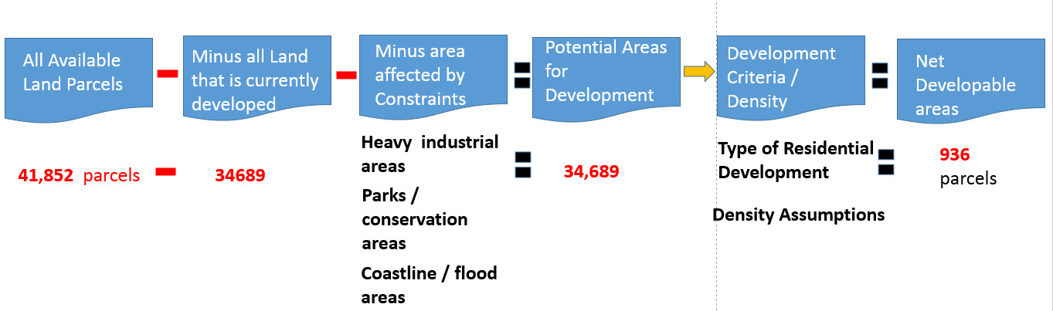

Source: (Herron Murray 2016)
The current Hobsons Bay land use is shown in Figure 3. Hobsons Bay commercial activities and residential housing activity are influenced by the presence of the oil and chemical buffers which surround the heavy industrial facilities which exist in Hobsons Bay.

Figure 3: Hobsons Bay Current Land Use
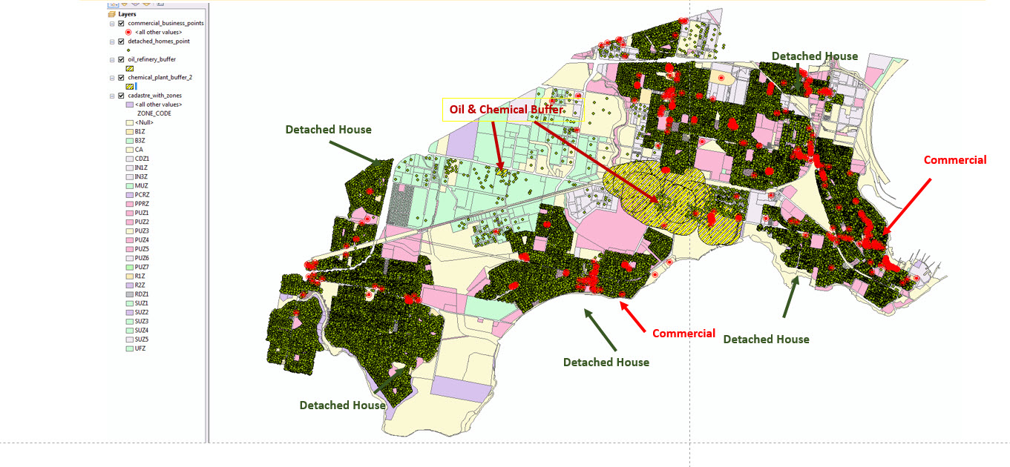

Source: (Herron Murray 2016)

Methodology

Scenario 1
A buildout analysis allows planners to estimate the amount and location of development allowed in an area according to current or proposed zoning regulations was undertaken. The buildout modelled potential urban development for Hobsons Bay in 5 year periods from 2016 through to 2050.

The buildout methodology took into consideration density rules, mixed use designations, mixed land use area, building information, constraints to development, existing buildings, and spatial layout.

The results for 2016 show that a potential 2,064 dwelling units could be constructed that would house up to 5,368 residents. The dwellings would be the result high density residential developments.

Figure 4: Buildout Result for 2016 High Scenario
Source: (Herron Murray 2016)

By 2050 residential development will add an additional 1,000 residential dwelling units and approximately 2,600 additional residents.

Figure 5: High Scenario Buildout Result for 2050
Source: (Herron Murray 2016)

To highlight the impact of urban development 15 environmental indicators we developed. The indicators and results are shown in Table 1.

Table 1: Summary of Urban Development Indicators
Indicator | Measurement | 2016 Result | 2050 Result | Number Increase | Percentage Increase
CO Auto Emissions | Lbs | 915,093 | 1,374,412 | 459,319 | 50.19%
CO² Auto Emissions | Tons | 17,355 | 26,938 | 9,583 | 55.22%
Hydrocarbon Auto Emissions | Lbs | 104,875 | 157,516 | 52,641 | 50.19%
NOx Auto Emissions | Lbs | 67,478 | 101,347 | 33,869 | 50.19%
* Commercial Energy Use | Million BTU / year | 766,289 | 766,289 | 0 | 0.00%
*Commercial Floor Area | m² | 782,314 | 782,314 | 0 | 0.00%
Common Impacts Vehicle Trips per Day | Trips per day | 11,682 | 17,545 | 5,863 | 50.19%
Common Jobs to housing Ratio | Commercial Jobs / Dwelling Units | 0.43 | 0.23 | 0 | -46.51%
Labour force | Number of Workers | 3,186 | 4,708 | 1,522 | 47.77%
Population Increase | Number of Persons | 5,368 | 8,006 | 2,638 | 49.14%
Residential Dwelling Units | Number of Dwelling Units | 2,064 | 3,100 | 1,036 | 50.19%
Residential Energy Use | Million BTU /Year | 196,282 | 294,500 | 98,218 | 50.04%
Residential Water Use | Gallons / Year | 283,366,290.00 | 319,083,000 | 35,716,710 | 12.60%
School Children | Number of School children | 934 | 1,402 | 468 | 50.11%

- * The commercial area = ha

Scenario 2
The objective of Scenario 2 was to maximize Hobsons Bay’s rate base through determining the optimal demand for specific categories of land use. Each future land use scenario for Hobsons Bay used a variety of techniques including linear programming (LP) and incorporates those techniques into GIS land use modelling.

For Hobsons Bay three land uses (residential land use, commercial and industrial) were examined. In Hobsons Bay the optimum result for maximizing the rates base produced the following results:

- Residential taxes increase of AU$25,338,093 based on the construction of 6,768 new dwellings with an average tax rate of AU$1,515 per dwelling; and
- Commercial tax increase of AU $813,957.

The Hobsons Bay analysis started with an overview of the strategic planning studies that had been undertaken by the City of Hobsons Bay. Three studies (Hobsons Bay Activity Centre Strategy, Western Regional Housing Statement and the Hobsons Bay Industrial Land Management Strategy) were selected as the most relevant studies for the modelling study, as they consider in detail the amount of land and implementation strategies needed for residential, commercial and industrial expansion requirements in Hobsons Bay.

Figure 6:
Hobsons Bay Activity Centres
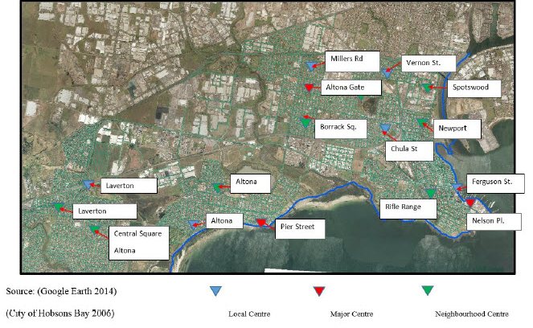
Source: (Herron Murray 2016), (City of Hobsons Bay 2006)
Table 2 highlights the results for four shopping areas (i.e. Hobsons Bay Activity Centre Strategy). The Table highlights the future retail trends and the implications for future retail floor space provisions.

The results show that 7 areas (Pier Street, Rifle Range Shopping Centre, Central Williamstown, Newport, Newport West, Altona Gate and Aviation Road) have the ability for future retail expansion. Each Activity Centre has an increasing in population ranging from 5-30% (i.e. Pier Street 14%; Rifle Range 25%; Central Williamstown 20%; Newport 14%; The Circle 30%; Altona Gate 16%; Borrack Square 30%; Central Square 5% and Aviation Road 8%).

Table 2 Results for Four of Hobsons Bay Activity Centres
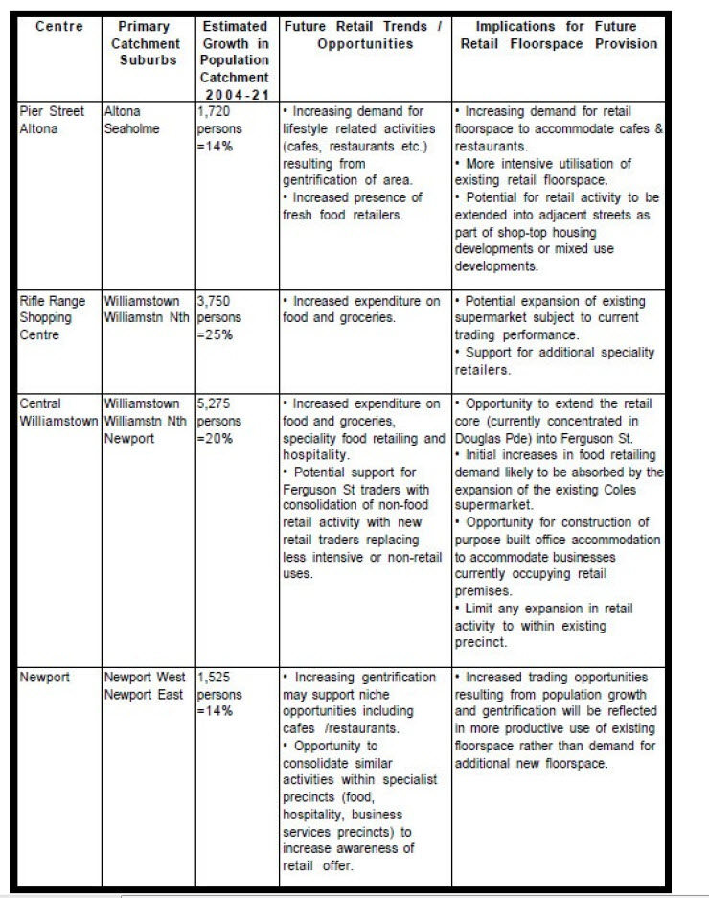
Source:(Herron Murray 2016) , (City of Hobsons Bay 2006)
The Hobsons Bay analysis outlined the number (41,668) and the type (82) of land parcels in Hobsons Bay. The Hobsons Bay analysis detected discrepancies between the spatial information provided by the Victorian Department of Primary Industry (DPI) and other government reports. The number of lots identified by the DPI was correct, but the allocation of land use activity needed to be adjusted to reflect what is actually on the ground. The major anomaly that drew the most attention was a category of land entitled “unclassified private land”. This category contained 5,632 parcels, with a recorded area of 12,026,490m², representing 13.46% of the total area.

The “unclassified private land” category was overlaid on an aerial photograph of the Hobsons Bay area and a re-classification of land use activities in the unclassified private land category was undertaken. The largest 287 parcels out of the total 5,632 parcels in the unclassified land category were re-classified. This re-classification accounted for 84.1% of the total area represented in the unclassified private land category. The remaining 5,345 parcels could not be re-classified.

The re-classification highlighted major faults in the first DPI land use identification process. At least 9 classes of land use activities had been reported incorrectly in the unclassified private land use category. It was discovered the vast majority of the remaining 1,906,297m², or 5,345 units, are single detached housing. This total was added to the single detached house category.
The linear programming results for Hobsons Bay showed a demand for an additional 5,644,061m² of residential zoned land for 2016-2050. The Hobsons Bay analysis indicated there is only a potential 4,496,336m² of land that can be re-zoned residential, implying a shortfall of 1,147,725m² of residential land needed to meet the 2050 forecast. This shortfall means Hobsons Bay will have to introduce the concept of medium and high density residential living to accommodate the expected increase in population.

The 2015 Hobsons Bay average tax rate of AU$1,515 per dwelling was used for all projected low, medium and high density residential dwellings.

New Mobility and Economic Data
The results from Scenario 1 and Scenario 2 were supplemented with a new series of mobility data which can analyse people movement as a function of both where the live and where they travel to. This data has the ability to be aggregated in half hour time segments to provide an understanding of how cities are used by residents and visitors. Areas can now be analysed over half hour periods regarding their respective economic and vibrancy.

Figure 7 is an illustration of movement data classified in residents, workers or visitors. The Figure is showing the number of visitors, residents and workers in a specific locale at a specific time interval.

Figure 7: New Movement Data
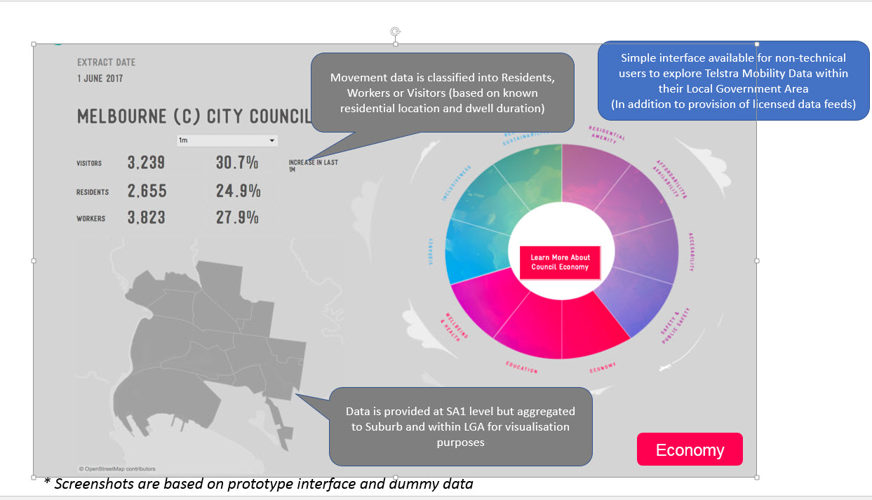
Source:(Sensing Values 2017)

Movement Data is based on known residential location and dwelling duration. The data looks at how various activities varies across specific locations over time. Figure 8 is a representation of workers during the Monday to Friday 9.00am to 5.00pm time frame. It is highlighting how many individuals are shopping at 2:30pm in the afternoon. There are several identified activity types ranging from visiting an art gallery to shopping, sightseeing to attending a sport event.

Figure 8: Identified Movement Patterns
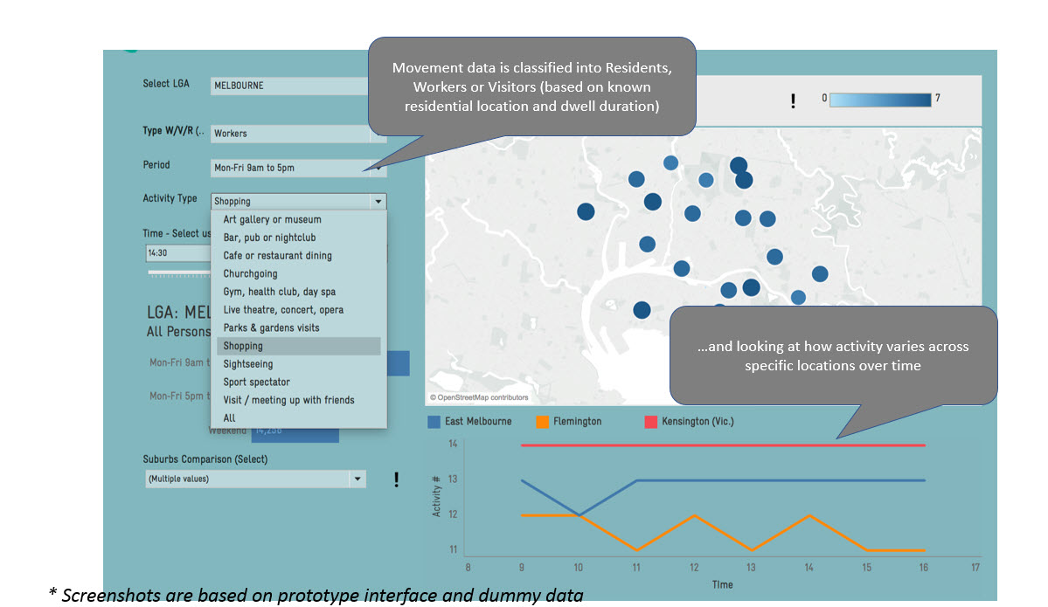
Source:(Sensing Values 2017)
Movement data such as this can aid in the strategic transport, infrastructure and land use planning. The data can directly be used to identify new or potential new commercial precincts by classification of shopper (resident, worker or visitor) as shown in Figure 9.

Figure 9: Shopping Precinct
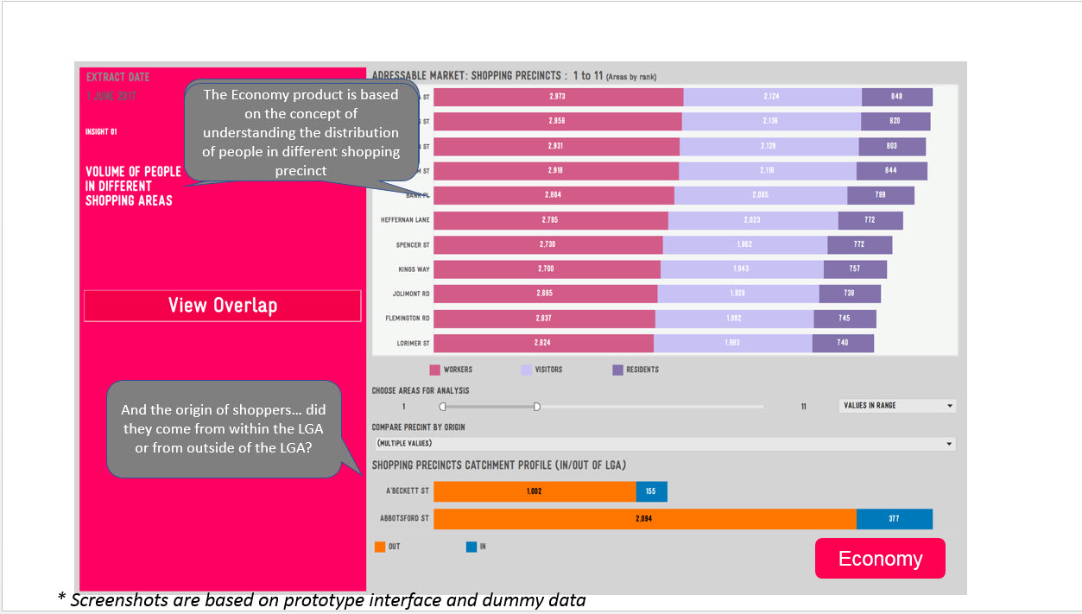
Source:(Sensing Values 2017)

Star Communities
Scenario 1 and 2 of Hobsons Bay with the new mobility data was then subjected to STAR Community Rating SystemTM (Star Communities 2015) (http://www.starcommunities.org/). STAR is the first international certification program to recognize sustainable communities. It’s framework integrates economic, environmental, and social aspects of sustainability and is organized by goals, objectives, and evaluation measures. STARS’s design is intended to align with local government processes and standard practice.

The rating system includes 7 goal areas and 45 sustainability objectives, with over 500 different measurable indicators, including both quantitative and qualitative measures.

The STAR Community Rating SystemTM supports three leadership certifications: 3-STAR Community, 4-STAR Community and 5-STAR Community.

General descriptions and points ranges required for certification are shown below
3-STAR Community  Recognized for sustainability leadership | 250 – 449
4-STAR Community  Recognized for national excellence | 450 – 649
5-STAR Community  Recognized as top tier achiever in national sustainability | 650+

Eleven objectives were developed from the Hobsons Bay Planning Scheme the indicators derived through the buildout process and the results for the STAR Communities scoring system.

The eleven evaluation objectives include:
1. Protecting the coast line;
2. Heritage and measures to protect it;
3. Infrastructure;
4. Schools;
5. Environment and its protection;
6. Land use;
7. Parks;
8. Health;
9. Transport;
10. Economy; and
11. Housing

The Hobsons Bay 2016 result garnered 434 points out of a possible 720 points as follows:
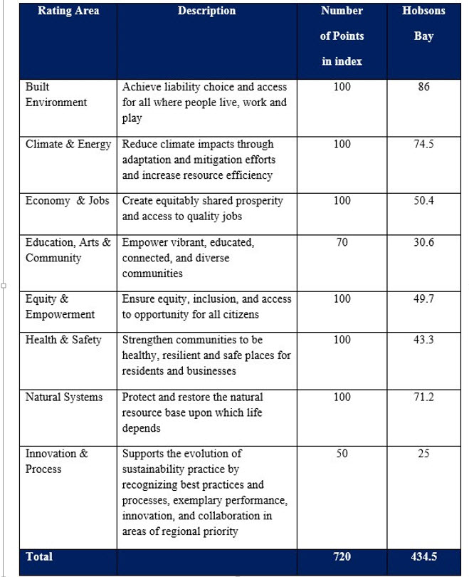
Source: (Herron Murray 2016), (Star Communities 2015)
This score placed Hobsons Bay into the 4 Star community class. As of February 2015 there were only 8 communities in the United States (Austin, TX; Broward County, FL; Davenport, IA; Evanston, IL; Portland OR; Tacoma, WA; Tucson, AZ and Washington DC) that held that rating.

Hobsons Bay would have returned a higher score if data could have been sourced for the Economy & Jobs, Education, Arts & Community, and the Health & Safety Objectives sections.

The Greater Melbourne Area ranks in the top 20 most liveable cities in the world in 2016 and has a higher liveability ranking than any of the 8 listed 4 STAR communities listed above (NEWS.COM.AU 2016)
Conclusion
Since 2000, a number of planning models and modelling techniques in conjunction with on line tools and software packages have been developed to improve the current understanding of the socio-economic, environmental, infrastructure physical factors that influence the growth and decline on regional and rural areas. Several of those techniques were used in this research to highlight comparative and competitive advantages Hobsons Bay has in economic and environmental criteria as well as sustainability.

Local government areas can be measured using a variety of factors such as job growth, projected population growth and new housing statistics in determining whether the local government area is a growth area or an area in decline. Through the use of planning models and tools decision-makers will be better able to identify, examine and understand the drivers of growth and sustainability. The tools and methodology developed and applied n this research provide a practical contribution to identify areas experiencing growth and mechanisms and or strategies which would be needed to address subsequent additional demands for land and supporting infrastructure.

Bibliography

City of Hobsons Bay (2006). Activity Centres Strategy. Altona, Victoria, City of Hobsons Bay.

Google Earth (2014). ""Hobsons Bay, Victoria Australia."." from www.googleearth.com.

Herron Murray (2016). Climate Change Resilience and Development Growth of Two Australian Cities 2016-2050: Scenarios for the future of Portland and Hobsons Bay. Architecture and Built Environment. Geelong, Deakin University. PhD.

NEWS.COM.AU (2016). "Monocle’s 2015 Quality of Life Survey: Melbourne is better than Sydney."from- life/monocles-2015-quality-of-life-survey-melbourne-is-better-than-sydney/news- story/b3c0664eed9cb669763b534e50635bd0. NEWS.COM.AU.

Sensing Values (2017). Economic and Mobility Data. Sensing Values. Melbourne.

Star Communities (2015). Star Communities Technical Guide. Washington, Star Communities.

