Walking for recreation: an innovative method for creating a GIS-based walkability surface on the Gold Coast, Australia

Heather Shearer
Griffith University, Gold Cosat, Queensland, Australia

Abstract: Encouraging greater levels of physical activity is a key policy focus in many urban areas, given the link between this and improved physical and mental health outcomes. The majority of previous studies on walkability however, have focussed on walking for transport; and generally consisted of creating desktop based walkability indices using variables such as residential density, street connectivity, and land use mix. This paper reports on research which investigated a lesser studied aspect of walkability; walking for recreation, in the Gold Coast City Council, Queensland, Australia. A GIS-based recreation walkability layer was created, and used to define the relative walkability of the Gold Coast. Unlike many such indices, this was based on raster rather than vector data and used different variables, distances, and weightings than the majority of walking for transport indices. The distances were based on the minimum recommended distance of 30 minutes exercise per day, and the variables, such as parks, dog parks, proximity to water, and fitness stations, were chosen and weighted according to their appeal for both routes and destinations. Other variables used as cost factors in Network Analysis, included slope, road parameters (traffic volume, speed, footpaths and cycleways). The vector datasets were a small scale (SA1) and rasterized to 5m square cells. Further research aims to groundtruth this index.

Key words: Geographical Information Systems; walkability; raster; Gold Coast; recreational walking.

Background

Increasing research highlights the benefits of physical exercise, not just for physical and mental health but also for environmental, economic and social benefits (Australian Government, 2017; Leslie et al., 2007). One of the most accessible types of physical exercise is walking, which has proven physical and mental health benefits(ABS, 2013). Moreover, in an ageing society, such as Australia, improving health outcomes has major economic and social benefits. Moderate exercise such as walking reduces rates of chronic diseases such as Type 2 diabetes, certain cancers and cardiovascular disease; it reduces obesity and high blood pressure; and it has even been linked to a reduction in rates of Alzheimer’s and dementia. Walking also has multiple mental health benefits such as reducing stress, anxiety and depression. Interrelated with mental health, are the social cohesiveness benefits, as it is often a social activity with people walking in groups, or has a social outcome, such as walking to a destination such as a coffee shop or dog park.

Encouraging more walking can also have environmental benefits, as increased walking for transport can reduce car use, improve traffic congestion and as a result, reduce greenhouse gas emissions. Walking is also flexible, and does not require specific infrastructure; it is possible to walk on both formed and unformed surfaces, such as roads, footpaths or cycleways, grassy laneways or open woodland. Walking for recreation is also extremely popular; nearly 84% of Americans say that they walk for recreation (Cutts, Darby, Boone, & Brewis, 2009), and in Australia; walking is the commonest form of voluntary exercise, with 24% of Australians aged 18-64 reporting walking for exercise in the past year(ABS, 2012).

Despite the proven health benefits of moderate exercise and walking however, a majority (60%) of Australian adults do less than the minimum recommended rates exercise, which is generally considered to be around 30 minutes a day (ABS, 2013; Australian Government, 2017) This is, arguably, reflected in the increasing rates of overweight and obese people, of all ages and genders. For this reason, researchers from a variety of fields, such as health, urban studies and transport, together with policy makers, are seeking to find ways to encourage people to do more exercise.

Encouraging more physical activity by improving the walkability of cities (whether for transport or recreation purposes) therefore has benefits for individual walkers, for the wider society and for the environment. However, many urban areas are not particularly ‘’friendly’’ for walkers, with inadequate and poorly maintained walking infrastructure (such as footpaths), lack of recreation areas like parks, insufficient plantings of trees to provide shade, and residential areas isolated by high traffic roads or other barriers (Leslie et al., 2007). Importantly, both for encouraging more walking, and from a planning perspective, it is a cost effective activity, and does not require much, if any, additional infrastructure. The relationship between the design and planning of the urban built environment and improving rates of physical activity is therefore an important and ongoing global research focus (Christian et al., 2011; Leslie et al., 2007; Sallis et al., 2016).

The majority of studies have investigated walking for transport (to places of employment, public transport stops and retail destinations), from both quantitative and qualitative perspectives (Giles-Corti et al., 2015; Leslie et al., 2007). From a qualitative perspective, researchers have investigated the experiential aspects of walking, psychosocial reasons why people choose (or do not choose) to walk in certain areas, and ethnographic studies observing walking behaviour. From the quantitative perspective, researchers often conduct large scale surveys on rates and type of exercise, and create maps of walkable areas, indices of walkability and weighted checklists of footpath and road attributes (Frank et al., 2010; Giles-Corti et al., 2015; Hooper, Knuiman, Bull, Jones, & Giles-Corti, 2015; Leslie et al., 2007). Walkability is frequently modelled to investigate and thus promote active transport modalities. Walkability is often included as a transport mode in accessibility modelling, for destination based models (how accessible are various types of destination from specified spatial areas) or travel cost, time-space, utility and other models (Scheurer & Curtis, 2007).

Geographical Information Systems (GIS) is increasingly used to calculate walkability indices using various toolsets such as buffers and network analysis. The indices use a range of variables, but the most common are land use mix, street connectivity and residential density (Frank et al., 2010; Giles-Corti et al., 2015). Other studies have disaggregated the land use variable into more categories, such as retail floor space (Leslie et al., 2007); transport density and accessibility to parks (Sallis et al., 2016); access to greenspace, greenness index, road traffic volumes, type of retail/commercial destinations, the inclusion of footpaths and cycleways and the aesthetic quality of the neighbourhood (Christian et al., 2011). The underlying principle is that a denser, more connected urban area, with a wider variety of land uses, within a reasonable walking distance (commonly used distances range from 400m to 1600m or more) to destinations such as public transit stops, retail, parks, post offices, schools, workplaces, is considered more walkable (Frank et al., 2010; Giles-Corti et al., 2013; Leslie et al., 2007).

The majority of these indices have relatively good correlation with walking for transport, but they do have certain limitations. One of the major limitations is that the spatial units for which walkability indices are constructed are frequently quite large, even suburb level. For more accurate results, and to minimise the results being biased by the ecological fallacy and the Modifiable Areal Unit Problem (MAUP), using smaller units, even the property scale, is more desirable. However, many past walkability indices did not have access to spatial data at small enough scale, or (at the time) had insufficient computer processing power.

The majority of these indices are relatively effective in predicting walking for transport, but they are less effective in predicting with walking for recreation or total walking (Christian et al., 2011; Karen Witten, 2009). Moreover, variables used to create transport walkability indices are often not relevant for recreational walking which, rather than accessing workplaces or shopping, is done for exercise, dog walking, connection with nature or other reasons. In addition, because of data limitations, relatively few walkability indices include multiple additional variables that are more important for recreational walking, such as sidewalks, footpaths, shading, traffic volumes, crime etc.

In the context of both walking for recreation, and improving walkability indices, it is suggested, at minimum, including variables such as open space destinations (beach and waterfront, dog parks, other parks, playgrounds), traffic information (traffic volumes, and types of traffic --particularly heavy traffic), improved transport network information (including footpaths, easements used as short cuts, cycleways and the quality thereof), slope categories, and weightings given to attractive and desirable walking destinations (i.e. dog parks and beaches)(Frank et al., 2010).

In summary, from a health and economic perspective, it is desirable to encourage people to be more active, and the cheapest and most accessible type of exercise is walking. This innovative pilot study aimed to construct a GIS based walkability index for recreation, using a range of variables not commonly used in other indices, and also at a very fine scale (individual lot and SA1 scale). Further, the method used to construct this index may be used in any urban area for which sufficient data exists.

Aims and Objectives

The aim of the project were to assess the greater Gold Coast City Council Local Government Authority (LGA) for the degree of walkability for recreation. An important aspect were to identify those areas which are currently difficult to traverse on foot, and the reasons thereof, and to suggest cost effective planning amendments to improve the situation.

The second phase of the study will seek to groundtruth the index; desktop based spatial analysis is a valuable tool, but no amount of desktop work can take the place of on-ground, mixed methods research. For example, ‘’mobile methodologies” investigating the ethnographic lived experience of walkability often has very different metrics than pure GIS based work. In a UK study for example, during an ‘’on the move survey’’ with study participants, researchers were able to observe real life pedestrian interactions with traffic, markedly improve communication by including non-verbal body language, and enrich descriptions of the aesthetic quality of the environment (Kelly, Tight, Hodgson, & Page, 2011).

Study Area

The study area is the Gold Coast City Council (GCCC) LGA. The spatial unit studied were individual properties, Mesh Blocks and Statistical Area (SA) 1, but for certain demographic and health related variables, the results were aggregated to SA2 as these variables are only available at this scale.

Method and Results

This paper reports on the GIS method used to create the Recreation Walkability Surface Index. The method was largely modified from that of Holbrow (2010). Unlike many other walkability indices, a raster based surface was used to create a recreation walkability index. This study also used different and a greater variety of variables than most standard walkability indices (i.e. a combination of connectivity, land use mix and residential density)(Giles-Corti et al., 2013; Leslie et al., 2007). It also used greater distances than those common to walking for transport indices (generally around 400 to 800m); and instead created Service Areas from 500 to 1500m (equating to a one to three kilometre return trip). These distances were based on the minimum recommended distance for walking per day, which is around 30 minutes, or 2km @ 15 minutes per km(Australian Government, 2017).

The method was largely modified from that of Holbrow (2010). The initial phase of the GIS analysis involved creating a base map in ArcGis 10.4.1, and a file geodatabase to store the datasets. File geodatabases make storing and manipulating spatial data much faster and more effective, ensure that all layers share a common coordinate system and are required to use Network Analysis. A geographic coordinate system (GCS_GDA_1994, which was common to the majority of the datasets) was used. Feature datasets were created to store the data and included the following categories, Land Use and Cadastre, Cartographic and Transport. The Transport feature dataset was used to store the transport-related data and for network analysis.

Table 1: Datasets used in GIS analysis

Dataset (Original) | Description | Format
Digital Cadastral Database | Property boundaries, including waterways and roads | Geodatabase. Polygon
Cycleways and Footpaths | Digitized line file of cycleways and footpaths | KML converted
OSM Roads | Roads dataset derived from OSM | Converted OSM
QPWS Roads and Tracks | Parks and Wildlife roads and tracks | Shapefile
Contours | 5m contours of SEQ. Used to derive DEM/slope | Shapefile
Various amenity features | Point and polygon files of amenities in GCCC area (schools, shops, post office, library etc) | Shape, KML, Json
Railway lines and stops | Line file of rail lines (including light rail) | Shapefile
Mesh blocks | Mesh block boundaries with resident population and dwelling | Shapefile
SA1 | SA1 with housing and person variables, including SEIFA | Shapefile
LGA boundary | Boundary of the Gold Coast | Shapefile
GCCC Planning Scheme | Planning scheme, used for land use | Shapefile
Satellite imagery | 10cm imagery of the Gold Coast 2011 | ECW
Dwelling House overlay | Overlay of Gold Coast dwelling house zone | WebGIS
Waterways and beaches | Polygon of waterway features | Shapefile

GIS layers (of various formats, converted to shapefile format if necessary) were imported into the geodatabase, except the raster data, which is standalone in a geodatabase (Table 1). When data was available only in CSV or Excel, the dataset was linked to a shapefile by a unique field, and then exported as a shapefile and then added to the geodatabase. Some layers, such as roads were clipped to the GCCC boundary, to reduce the size of the dataset.

Geoprocessing

Firstly, the OSM roads layer was spatially joined to the QPWS and Cycleway and Footpath layers and some minor groundtruthing was done against the satellite imagery and DCDB (and matched against existing classifications in the OSM layer). Additional fields, Type, Pedestrian and Weighting, were added to the attribute table. Pedestrian was either 0 (prohibited) or 1 (allowed); Type included Pedestrian, Motorway, Residential, Track etc., and Weighting was done in accordance with the potential appeal to pedestrians, ranging from 6 (i.e. pedestrian infrastructure such as walkway or footpath), to 1 (primary road, with high speed traffic, where pedestrians are permitted, but the appeal for walking was subjectively rated as very low).

A transport network dataset was then set up, using the ArcGIS extension, Network Analyst. This used the modified roads layer and did not include connectivity, elevation or one-way metrics (as it was not designed to analyse access to public transport or car based traffic). Various evaluators were added to the network dataset (based on the roads weighting) and including Prohibited (all walking prohibited, i.e. M1), and Avoid High, Medium and Low (high speed road, secondary road and tertiary road) and Prefer Low, Medium and High (residential and service road, cycleway or similar, pedestrian only walkway). In this way, the analysis will preference routes based on the Evaluators (for example, a route coded as Prefer High, will be taken in preference to one coded as Avoid High. The network dataset was then built and sample calculations generated lines to see if the evaluators were working correctly.

Other datasets were derived from the original datasets (see Table 2) and included point shapefiles of the centroids of smaller area polygons (individual cadastre, small parks, Mesh Blocks etc.). Additional processing was conducted on certain attribute tables (i.e. reducing the number of planning zone categories in the Gold Coast Planning dataset for Land Use calculations), adding population and housing density fields to the SA1 Demographics and using Field Calculator to populate them.

Table 2. Derived Datasets
Dataset (Derived) | Description | Format
MB Centroids | Calculated centroids from Mesh Block boundaries | Point shapefile
OSM_Roads | Spatially joined roads file with all different types of transport infrastructure | Line shapefile
DEM and Slope | Derived from contours – reclassified rasters | Raster
Small Parks | Centroids of parks/open space smaller than 1ha, selected from all open space polygons | Point shapefile
Large Parks | Randomly placed points (no closer than 100m) in all parks over 10,000m2 (1ha), created with the data management toolbox ArcGIS | Point shapefile
Amenity | Centroids of polygons, created in ArcGIS (fitness stations, dog parks, etc) | Point Shapefile
Waterway buffers | Service areas around intersections within 100m of waterways | Polygon shapefile
Street intersections | Intersections of all streets, tracks and footpaths. Network Analyst used to create 25m Service Areas around intersections, then a kernel density surface created in Spatial Analyst | Network Analyst, point shapefile
Land use mix | GCCC planning scheme zones (per cadastre, aggregated to SA1). Categories: Commercial, Government, Residential, Industrial, Open space/Rural & Industrial. Shannon Wiener Diversity Index | Excel spreadsheet linked to SA1 code
Residential density dwellings | Ratio of dwellings to area of SA1 (dwellings / area km2), added field, calculated from Field Calculator | Attribute table
Person density | Usually resident population divided by area of SA1 (population/ area km2). Calculated in Field Calculator | Attribute table

Network Analyst was then used to create service areas towards amenity point features, such as centroids of dog parks, and from the centroids of Mesh Blocks. It was initially planned to create service areas from the individual properties, but this was beyond the processing power of the computer used for the analysis. Service areas are more accurate than Euclidean straight line buffers, as they use the actual road network to calculate distance to or from a destination, and Network Analyst can be modified to prioritise certain roads or paths over others, and add different time cost evaluators.

Evaluators were added to the Network Dataset, so that for each service area, the route would prioritise routes from Prefer:High to Avoid:High and with certain roads prohibited. Meters were used rather than walk speed, as this can be highly variable between individuals. For the SA polygons, three categories were created, 500m, 1000m and 1500m, these equate to (approximately) 15, 30 and 45 minutes of walking (under the assumption that each distance can be doubled in an out and back calculation). SAs of ring polygons, separated by break value, were generalized to 25m and merged by break value. Each iteration of a service area calculation created a three row attribute table for each feature at the break distance set up in the analysis.

Each point dataset of destinations, and of the Mesh Block Centroids was used to create a set of polygons which was then saved in a group folder, called Poly for Raster. Each of the 500m polygon features was rated as 3, the 1000m as 2 and the 1500m as 1 (in descending order of walkability, hence ranging from 1km to 3km walking, in the assumption that people will walk for half the distance, and then return either the same path, or by a circular route).

Network analyst was also used to create network nodes (intersections) on the roads file, and these were modified to remove dangling intersections, dead ends and cul-de-sacs, highways and roundabouts. This was used to calculate the connectivity of the road and footpath network. It required some manual editing however, which was a bit time consuming. Having a very good roads and other transport infrastructure dataset was very useful, as this included footpaths, and routes away from the main road network. Initially, the method of Leslie et al. (2007)and Frank et al. (2010)was used to calculate intersections per spatial area (SA1) but this proved insufficiently granular for the analysis. Instead, the points were used as input for the Spatial Analyst extension, kernel density, and created 3 polygons, ranging from 15 to 50m (based on research into intersection choice). This was rasterized at 5m2 cells in keeping with the other datasets.

The Spatial Analyst tool was then used to create a Digital Elevation Model (DEM) raster from the contour data, and then a derived slope map. This was used to add an additional cost weighting to the Service Area calculations, with the values derived from the slope map added to each road segment. This was used in weighting the rasters, in that areas with steeper slope were weighted lower than flatter areas. The slopes raster was reclassified into 6 categories, loosely based on the Australian walking track classification; 0-5degrees =6, 5 – 7.5 degrees = 5; 7.5 to 10 degrees = 4, 10 – 12.5 degrees = 3; 12.5 – 15 degrees = 2, 15 – 20 degrees = 1, >20 degrees = 1.

Once all the vector processing was completed, a new attribute was added to the Gold Coast LGA boundary shapefile, NoData, and was given a value of 0. Then each of the resulting SA shapefiles was joined (using Union, Only FID) to the Gold Coast LGA, so that all parts of the polygon that did not fall within the distance buffers, were given a value of 0. Then, Spatial Analyst was used to create rasters from each polygon (with the exception of the slopes and intersections datasets), with the Gold Coast LGA boundary as the raster analysis mask, and a 5m raster cell size. Each raster now had four attribute values; 0, 1, 2 and 3.

After converting each polygon to raster, Raster Calculator in Spatial Analyst was used to add up the raster layers. Initial weightings were based on the service area polygons (i.e. 500m walking distance was given a rank of 3, 1000m a rank of 2, and 1500m a rank of 3). Further weightings were given to three datasets, based on the literature inter alia Sallis et al. (2016) and from personal experience. These datasets included small urban parks, access to waterways and service areas around mesh block centroids, as these were considered the most appealing for recreational walking, and most relevant to walking from one’s dwelling.

All rasters were summed with raster calculator, and the scores for the more desirable locations (as above) were doubled. Despite their appeal for walking, dog parks were not additionally weighted, as these generally fell within the other park areas. The resulting raster, at 5m square cells, was added to the map. The scale of this raster enabled aggregate scores to be calculated for any desired spatial unit, for analysis against other data, such as SEIFA or health data. For statistical analysis, zonal statistics were calculated on the basis of SA1 areas (summary and mean scores), and exported to Excel.

Figure 1: Walkability Raster (5m cells) Gold Coast
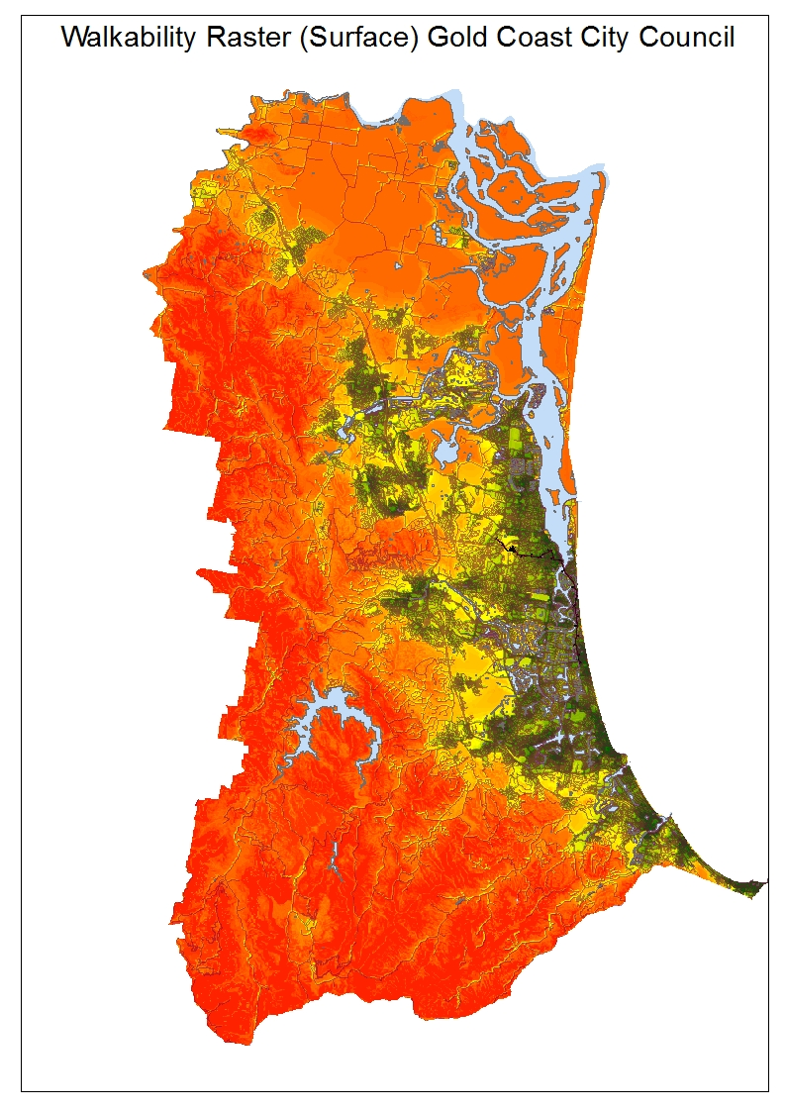

Figure 2: Detail of walkability raster
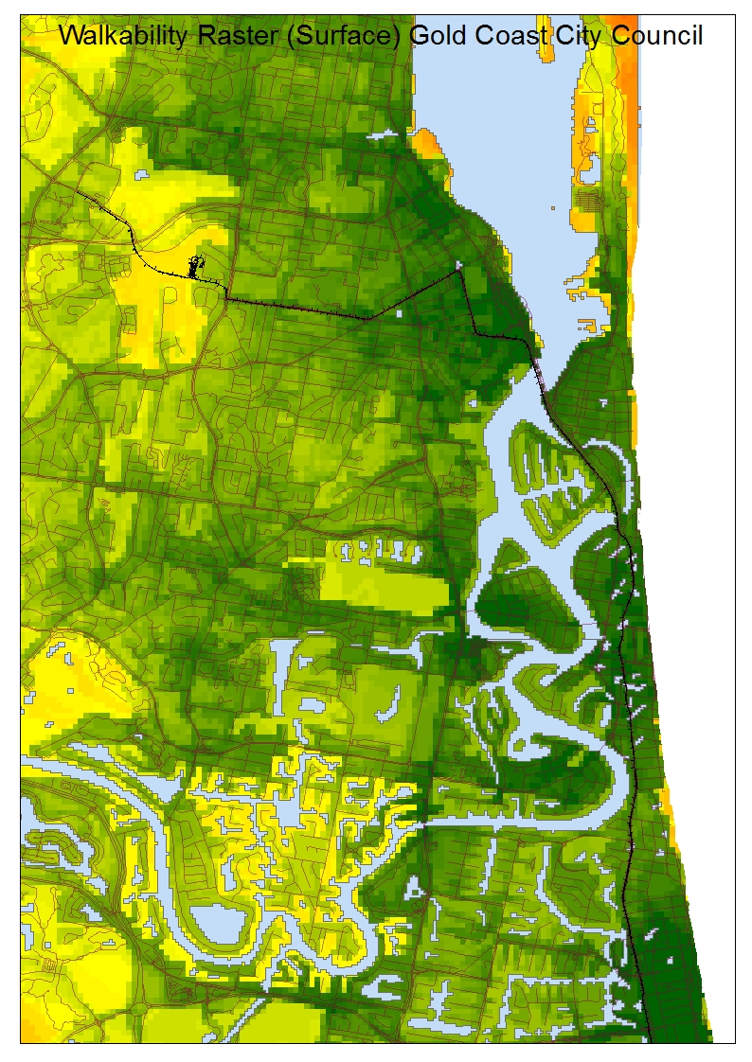

Finally, two additional analyses were conducted; one to create a walkability index based on the most common vector method, as used by Frank et al. (2010). Excel was used for this purpose, and calculated intersection density and a Shannon Wiener entropy score for Land Use Mix (using variables from the GCCC planning scheme, with some modifications made based on satellite imagery of actual land use). Five land use classes were used for this, namely residential, commercial, industrial, government and open space, recreation and rural.
For the other variables, the ArcGis plugin Create Junction Connectivity Features was used to calculate intersections with three or more connecting roads (or walkways). Intersections closer than 25m were merged (the datasets had many divided roads and roundabouts, and the standard 15m was too small). This procedure duplicated some intersections, so a delete identical procedure was used to reduce the number of spatially similar intersections. The final intersection table was then aggregated by SA1.

To this was added dwelling density (number of dwellings divided by SA1 area) and population density (number of residents divided by land area). Z Scores were created for each variable and then summed to create an index per SA1. Finally, all variables were added to an Excel table (using Power Query to merge tables by SA1 number) and Z Scores were calculated for each vector variable, and then summed for the index. This table was then added back to ArcGis, to ensure accuracy, and for mapping purposes.

Figure 3: Vector map of walkability
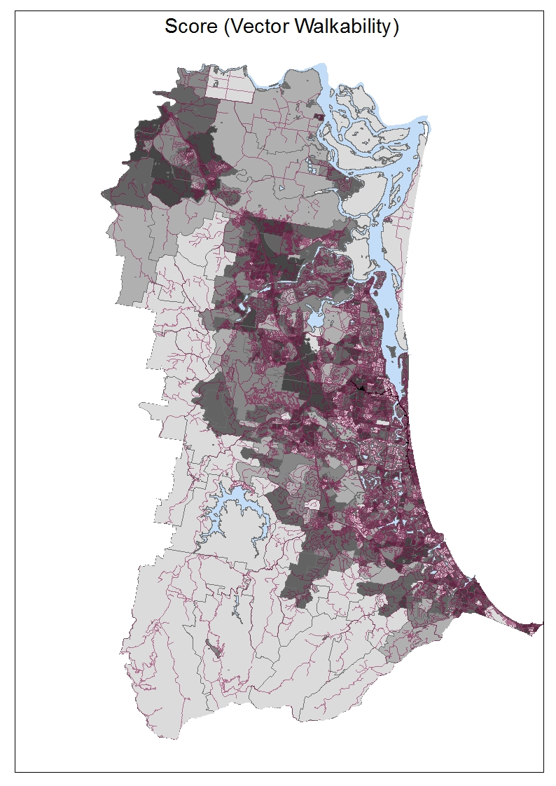
Figure 4: Detail of vector walkability
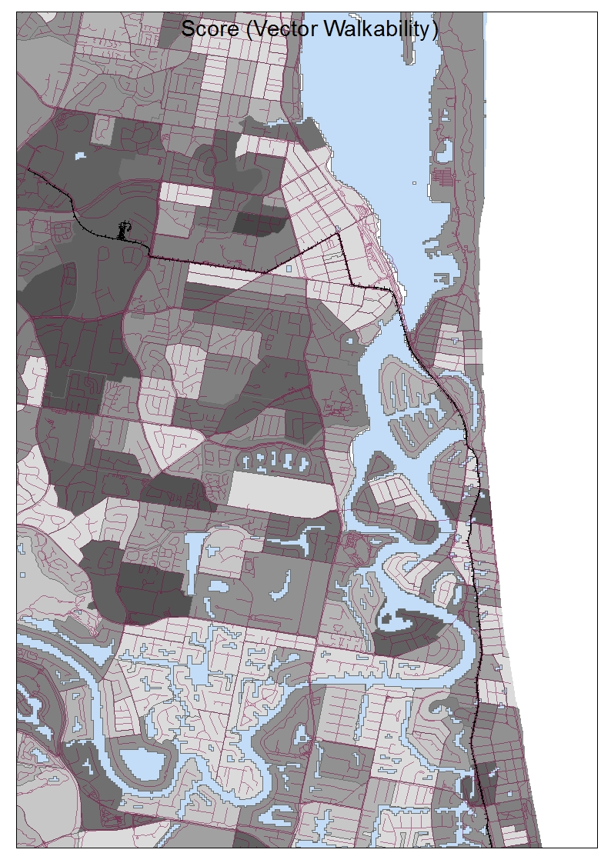

Each index (raster and vector) was correlated, as were the indices with Census Journey to Work (active only) and SEIFA deciles (4 SEIFA factors), to identify any preliminary relationships with the calculated walkability scores and socio-demographic variables. Some broad analyses were also conducted against available health variables, but these are only available at SA2 level, so required too high a degree of spatial aggregation to be anything other than broadly valid.

Table 3. Index correlations with SEIFA Deciles

 | VectorScore | RasterMean
Raster Mean | .110**
IRSAD | .021 | -.035
IRSD | -.015 | -.149**
IER | .035 | -.107**
IEO | .059 | .079*
*. Correlation is significant at the 0.05 level (2-tailed).
**. Correlation is significant at the 0.01 level (2-tailed). N = 1037

Conclusion

The initial results showed that, as expected, the denser coastal areas of the GCCC were more walkable than the steeper, lesser populated hinterland. The raster walkability surface was in every way superior to the vector scores (SA1 level) with a far greater level of detail. In addition, the 5m cell size could be aggregated to any size spatial unit, using whatever spatial statistics were deemed most valid.

Nonetheless, the brief statistical analysis conducted also indicated that the two indices were highly correlated with each other, at p.0.01. The raster index, but not the vector index, was significantly correlated with all the SEIFA deciles, in particular, negatively correlated with the indices that indicate disadvantage, and positively correlated with the IEO index. This is an area of potential future research, given that there is an indication that more walkable areas are those with higher rates of income and education. Of course, the index weights more highly proximity to desirable destinations such as parks and waterways and properties close to such areas are generally higher priced. Further phases of this research will investigate property sale prices and walkability to identify any relationship between income (property prices used as proxy) and more walkable areas. Further research will also investigate Journey to Work at SA1 level, but to date (July 2017) this data has not yet been released by the ABS.

This analysis indicates that walkability indices, when calculated at a small scale and in a raster based format, have the capacity to add a nuanced and detailed overlay that may aid Local Governments and other land managers in planning for walkability at small scales, including property scale. Using Network Analysis together with Spatial Analyst, can enable including cost evaluators and weighting to the calculation of service areas. This method calculates walking areas on the actual road and pedestrian network, and is weighted by factors such as traffic volumes, road type and other factors.

This method also allows the addition of multiple variables, such as connected footpaths and other pedestrian friendly walking areas, which can significantly improve walkability of an area. Once the modelling procedure is established and saved, adding additional variables, such as tree cover and shading, as well as other traffic related variables, including traffic accidents (particularly involving pedestrians) is a simple matter, subject only to data availability.

This project is intended to be a pilot study to inform a future, larger research project. The revised (and groundtruthed) walkability indices will then be used to research the psychological benefits of improved walkability; what variables add to this, can urban areas be cost-effectively retrofitted to improve walkability and will this in turn improve mental health (particularly by reducing rates of depression, stress and anxiety)?

References

ABS. (2012). 4177.0 - Participation in Sport and Physical Recreation, Australia, 2011-12. Retrieved from http://www.abs.gov.au/ausstats/abs@.nsf/Products/4177.0~2011-12~Main+Features~Characteristics+of+participation?OpenDocument.
ABS. (2013). 4364.0.55.004 - Australian Health Survey: Physical Activity, 2011-12 Retrieved from http://www.abs.gov.au/ausstats/abs@.nsf/Lookup/4364.0.55.004Chapter4002011-12.
Australian Government. (2017). Australia's Physical Activity and Sedentary Behaviour Guidelines. Australian Government Department of Health Retrieved from http://www.health.gov.au/internet/main/publishing.nsf/content/health-pubhlth-strateg-phys-act-guidelines.
Christian, H. E., Bull, F. C., Middleton, N. J., Knuiman, M. W., Divitini, M. L., Hooper, P., . . . Giles-Corti, B. (2011). How important is the land use mix measure in understanding walking behaviour? Results from the RESIDE study. International journal of behavioral nutrition and physical activity, 8(1), 1.
Cutts, B. B., Darby, K. J., Boone, C. G., & Brewis, A. (2009). City structure, obesity, and environmental justice: an integrated analysis of physical and social barriers to walkable streets and park access. Soc Sci Med, 69(9), 1314-1322. doi:10.1016/j.socscimed.2009.08.020
Frank, L. D., Sallis, J. F., Saelens, B. E., Leary, L., Cain, K., Conway, T. L., & Hess, P. M. (2010). The development of a walkability index: application to the Neighborhood Quality of Life Study. Br J Sports Med, 44(13), 924-933. doi:10.1136/bjsm.2009.058701
Giles-Corti, B., Macaulay, G., Middleton, N., Boruff, B., Whitzman, C., Bull, F., . . . Roberts, R. (2013). Development and trial of an automated open source walkability index tool through the Australian urban research infrastructure network’s open source portal. Paper presented at the State of Australian Cities National Conference, 2013, Sydney, New South Wales, Australia.
Giles-Corti, B., Mavoa, S., Eagleson, S., Davern, M., Roberts, R., & Badland, H. (2015). How walkable is Melbourne? The development of a transport walkability index for metropolitan Melbourne.
Holbrow, G. (2010). Walking the Network. A Novel Methodolgoy for Measuring Walkability Using Distance to Destinations Along a Network. Retrieved from http://sites.tufts.edu/gis/files/2013/02/Holbrow_Gabriel.pdf
Hooper, P., Knuiman, M., Bull, F., Jones, E., & Giles-Corti, B. (2015). Are we developing walkable suburbs through urban planning policy? Identifying the mix of design requirements to optimise walking outcomes from the ‘Liveable Neighbourhoods’ planning policy in Perth, Western Australia. International journal of behavioral nutrition and physical activity, 12(1), 1.
Karen Witten, S. M., Robin Kearns. (2009). Objective measures of a walkable neighbourhood: how do they fit with residents’ experiences? Paper presented at the State of Australian Cities, Perth, Australia.
Kelly, C., Tight, M., Hodgson, F., & Page, M. (2011). A comparison of three methods for assessing the walkability of the pedestrian environment. Journal of Transport Geography, 19(6), 1500-1508.
Leslie, E., Coffee, N., Frank, L., Owen, N., Bauman, A., & Hugo, G. (2007). Walkability of local communities: using geographic information systems to objectively assess relevant environmental attributes. Health & place, 13(1), 111-122.
Sallis, J. F., Cerin, E., Conway, T. L., Adams, M. A., Frank, L. D., Pratt, M., . . . Owen, N. (2016). Physical activity in relation to urban environments in 14 cities worldwide: a cross-sectional study. Lancet, 387(10034), 2207-2217. doi:10.1016/S0140-6736(15)01284-2
Scheurer, J., & Curtis, C. (2007). Accessibility measures: Overview and practical applications. Department of Urban and Regional Planning, Curtin University, 52.

Data References
Australian Bureau of Statistics 2017, Mesh Blocks and Demographics, TableBuilder. Findings based on use of ABS TableBuilder data

Australian Bureau of Statistics 2017. SA1 person and housing variables, TableBuilder. Findings based on use of ABS TableBuilder data

Australian Bureau of Statistics 2017,Statistical Indices for Areas (SEIFA) for SA1, TableBuilder. Findings based on use of ABS TableBuilder data

Australian Bureau of Statistics, 2016, 1270.0.55.001 - Australian Statistical Geography Standard (ASGS): Volume 1 - Main Structure and Greater Capital City Statistical Areas, July 2016

City of Gold Coast, Open Data Access Project on data.gov.au, 2017, Data from Pathways, electronic dataset http://data.gov.au/dataset/gold-coast-pathways

City of Gold Coast, Open Data Access Project on data.gov.au, 2017, Data from Dog Park facilities, electronic dataset http://data.gov.au/dataset/dog-parks-and-facilities

City of Gold Coast, Open Data Access Project on data.gov.au, 2017, Data from Fitness stations, electronic dataset http://data.gov.au/dataset/fitness-stations

City of Gold Coast, Open Data Access Project on data.gov.au, 2017, Data from Cycleway guide, electronic dataset, http://data.gov.au/dataset/cycleway-guide

City of Gold Coast, Open Data Access Project on data.gov.au, 2017, Data from City Plan Zone, electronic dataset, http://data.gov.au/dataset/city-plan-zone

City of Gold Coast, Open Data Access Project on data.gov.au, 2017, Data from Beach Surveillance towers, electronic dataset, www.goldcoast.qld.gov.au/documents/BeachTowers.kml

OpenStreetMap contributors, 2017, Data from Planet dump Australia, OSM Roads and features, electronic dataset https://planet.openstreetmap.org

Queensland Government, 2011, Gold_Coast_epoch1_10cm_mosaic_mga56_2011, Satellite imagery

Queensland Government, Queensland Spatial Catalogue, 2017, Data from Queensland Parks and Wildlife Service access, electronic data set, http://qldspatial.information.qld.gov.au/catalogue/custom/detail.page?fid={63DDDAE1-CE0C-4BCE-AD5F-29CC3F6FA247}

Queensland Government, Queensland Spatial Catalogue, 2017, Data from Contours - 5 metre - South Queensland, electronic data set, http://qldspatial.information.qld.gov.au/catalogue/custom/detail.page?fid={4E1DD452-AB3A-4B7C-BEDD-9C817F484F31}

Queensland Government, Queensland Spatial Catalogue, 2017, Data from Rail network - Queensland, electronic data set, http://qldspatial.information.qld.gov.au/catalogue/custom/detail.page?fid={8C0F5D96-96C0-4510-8D67-445A0E92893A}

Queensland Government, Queensland Spatial Catalogue; 2017, Data from Cadastral data weekly - whole of State Queensland (DCDB), electronic data set, http://qldspatial.information.qld.gov.au/catalogue/custom/detail.page?fid={4091CAF1-50E6-4BC3-B3D4-229AA318231A}

