Are our Coastal Development Strategies Inspired by Nature-Based Solutions? A review of the Moolap Strategic Framework Plan
Sareh Moosavi and Marcus Lancaster
University of Melbourne

Abstract:
With around 85% of Australia’s population living in coastal areas, rising sea levels and increasing storm surges will continue to have significant impacts on many of the continent’s coastal communities and landscapes. This presents great challenges to urban planners, urban designers and landscape architects responsible for creating safe, functional, and robust built environments for coastal communities. In preparation for sustainable adaptation to sea-level rise, nature-based solutions and soft ecosystem-driven approaches are increasingly considered at the micro scale of design, but less explored at the planning level.
This research investigates the integration of nature-based solutions (NBS) at the planning level for a proposed development project in the coastal city of Geelong, south-west of Melbourne, Victoria. We examine whether the draft strategic plan for the redevelopment of Point Henry-Moolap coastal area in Geelong, incorporates principles of nature-based approaches to address projected impacts of coastal climate change. A brief review of coastal management policies in Victoria is provided. An analysis framework derived from NBS principles is used to identify concepts within the development framework plan that are aligned with NBS and ecosystems-based approaches. From the analysis, areas that provide opportunities for a better integration of NBS in coastal planning and responding to future climate-induced impacts are identified. We conclude that providing clearer directions, including regulatory instruments in high level land use planning, can help local governments and developers make informed decisions that consider human well-being, biodiversity and climate change.
With Australia’s global premises of coastal population growth, and increasing impacts of climate change on coastal areas, this research provides a timely contribution aligned with current social and ecological challenges.
Key Words: Coastal climate change impacts; Nature-based solutions; Coastal development strategies; Moolap Plan.

Introduction
Cities have been historically concentrated along coastlines and waterways. Low-elevation and biodiversity-rich coastal areas are increasingly affected by rapid urban expansions (McDonald et al., 2013). It is projected that by 2030 more than 25% of all endangered or critically endangered species will be affected to varying degrees by urban expansion, with coastal areas and islands identified among the regions to be most affected (Elmqvist et al., 2013). In addition, climate change-induced risks such as sea-level rise, storm surge and land loss affecting low-lying coastal areas, are projected to increase in many regions. These impacts present great challenges to the built environment professionals responsible for the planning, design, and provision of safe, functional, and robust environments for coastal communities while safeguarding the health of natural ecosystems.
Increasingly, ecosystem-based approaches, or in more general terms nature-based solutions (NBS) for climate change adaptation have been recognised by different agencies and scholars for protecting coastal communities and ecosystems from negative impacts of urbanisation and climate change (Convention on Biological Diversity CBD, 2009, IPCC, 2014, Wamsler, 2016). Ecosystem-based adaptation is defined as the ‘use of biodiversity and ecosystem services as part of an overall adaptation strategy’ (Convention on Biological Diversity CBD, 2009). The European Commission defines nature-based solutions as ‘actions which are inspired, supported by or copied from nature’ (European Commission, 2015). Similarly, the International Union for Conservation of Nature (IUCN) defines NBS as ‘actions to protect, sustainably manage, and restore natural or modified ecosystems, that address societal challenges effectively and adaptively, simultaneously providing human well-being and biodiversity benefits’(Cohen-Shacham, 2016). Nature-based solutions are argued to provide a better alternative to hard engineering coastal protection structures by supporting a balanced co-existence between nature and the built infrastructure, while contributing to the health of natural and human ecosystems (Sutton-Grier et al., 2015).
A number of projects have emerged, particularly in Europe and North America that adapt the NBS framework in coastal management practices. For example, the European Commission has invested in a pilot network of 79 cities in 32 countries, to develop a multi-stakeholder communication platform that will support the understanding and the promotion of nature-based solutions in local, regional, EU, and International level. Funded under an EU Research and Innovation program, the Horizon 2020 scheme, the ‘ThinkNature’ project aims to use this platform to improve regulatory instruments, share best commercial practices and demonstrate the long-term value of nature-based solutions (Nikolaidis et al., 2017).
In the US, a series of projects led by the San Francisco Estuary Institute developed a list of alternatives for coastal infrastructure that were intended for application along different segments of the bay shoreline. A workshop led by The San Francisco Bay Commission for Development and Conservation in 2015 provided guidelines for participants, clearly stating that ‘strategies should maximise nature-based adaptation solutions where appropriate’ (Hill, 2015). The San Francisco Bay Living Shorelines project, for example, has focused on the use of a suite of coastal stabilisation and habitat restoration techniques, such as using natural substrates in creating artificial reefs that provide cohabitation opportunities and improve biodiversity (Latta and Boyer, 2015).
Conservation International, a non-government conservation organisation, in 2014 commenced a pilot mangrove restoration project, in Costa Rico. This was developed as a response to overexploitation of mangrove forests for firewood and their conversion into salt evaporation and shrimp ponds in two coastal communities located on the island of Chira in the Gulf of Nicoya. The restoration project followed a NBS approach to address the socio-economic impacts of mangrove degradation. This project included establishing baseline measures and assessments of carbon sequestration for policy making, replanting of mangrove forests by local stakeholders, building local capacity for sustainable use of mangroves and livelihood diversification, and creating a local education programme (Cohen-Shacham, 2016).
In Australia, integrating nature-based solutions in coastal management practices and policies are slowly growing. For example, a number of researchers from the University of Sydney investigated the use of ecological engineering in the enhancement of seawalls, by adding flowerpot rock pools to Sydney Harbour’s foreshore seawall (Morris et al., 2016). The flowerpots were designed to mimic natural rock pools that encourage colonisation by marine organisms and help improve biodiversity. The results showed an increase in the number and richness of species in the foreshore.
With the majority of Australia’s population (more than 85%) living near coastal areas, climate change will continue to have significant impacts on many of the continent’s coastal communities (Vasey-Ellis, 2009, Graham et al., 2014). Reliant on conventional protection methods that only considers human well-being measures such as use of concrete seawalls and static breakwaters to mitigate climate-induced hazards will have long term negative impacts on the geomorphology and ecology of coastal systems. Ecological modifications to seawalls and breakwaters are examples of implementing NBS at the local scale to help reduce the negative impacts of hard engineering structures on marine ecosystems (Moosavi, 2017). Although the emergence of eco-engineering coastal projects across Australia is promising, the uptake by policy makers in planning has been slow (Vasey-Ellis, 2009).
Employment of nature-based solutions is partly dependant on awareness of the benefits to human communities and their effectiveness in mitigating the effects of climate change. Challenges of measuring the effectiveness of these solutions, limited empirical evidence of their performance and disagreement among experts on the extent to which NBS can reduce risks are among the impediments in transitioning from conventional solutions to NBS in practice (Inman, 2010). There is a need for evidence-based evaluation of projects that have achieved multiple benefits from implementing NBS in practice. Additionally, there is a need for clearer guidelines for adopting NBS principles at high level planning processes.
In this paper, we investigated the integration of NBS in a coastal development project in the city of Geelong, Southern Victoria. We examined whether the future strategic directions proposed for Moolap, in Geelong, incorporates principles of nature-based approaches and considers ecosystem-based adaptation to climate change. First a brief review of current coastal management policies in Victoria, Australia, affecting the project is provided. An analysis framework is defined and used to identify directions in the strategic framework plan, which are aligned with NBS principles and ecosystems-based approaches. Areas of improvement and opportunities for considering a more contributive approach to coastal development and ecosystem conservation are proposed.

Coastal Management Policies in Victoria
The policies and documents listed in Table 1 illustrate the Victorian Government’s top-down planning approach specifically in relation to planning for coastal climate change effects such as sea-level rise and storm surges. This top-down structure was established with the Planning and Environment Act of 1987. The Act implements statutory planning policy at the local level through both state standard planning provisions specified by the Minister for Planning and local planning provisions developed by councils and subject to approval by the Minister (Vasey-Ellis, 2009). From the 1987 Act, further acts and policies were developed specifically addressing management and planning of coastal areas as knowledge and evidence of coastal climate-change effects increased.
Table 1: Coastal Adaptation policies from State to Local Government levels
Year | Policy | Responsibility | Relevance to Point Henry-Geelong
1987 | Planning and Environment Act | Victorian State Government | Establishment of framework for land use planning, development, and protection. Planning controls through planning schemes-local governments responsible for permits and compliance.
1995 | Coastal Management Act | Victorian State Government – Victorian Coastal Council (VCC) | Coordinated strategic planning/management of Victorian coast- VCC responsible for strategic coastal planning and Regional Coastal Boards. VCC prepares Victorian Coastal Strategy to direct future coastal uses.
1998 | Siting and Design Guidelines for Structures on the Victorian Coast | Victorian State Government –  VCC | Design guidance for coastal development for sensitive design/development of coastal areas
2002-2014 | Victorian Coastal Strategy – ongoing reviewed every five years | Victorian State Government | Strategy for long-term coastal planning, environmental protection, direct future use–identifying suitable areas for development–sustainable use of coastal resources
2010-2017 | Climate Change Act – ongoing reviewed every five years | Victorian State Government | Ongoing state-wide adaptation plan, risk assessments, priorities and strategic responses – adaptation plans and risk management for coastal planning
2011 | Climate Change Adaptation Strategy | City of Greater Geelong | Long-term monitoring of sea-level rise–reviews/plans for responses as problems arise- examines a range of solutions with government and community to develop policies/tools for coastal planning
2012 | Victorian Coastal Hazards Guide | Victorian State Government | Improves understanding of coastal hazards and climate change (CC)-supports CC adaptation for local governments and all stakeholders
2015 | Bellarine Peninsular-Corio Bay Local Coastal Hazard Assessment – Inundation Report | City of Greater Geelong, DEPI, Corangamite Catchment Management Authority, DPCD, Borough of Queenscliff | Identifies Pt Henry as high risk for inundation –recommends engineering inspection of salt pans for flood management
2017 | The draft  MOOLAP  Coastal Strategic  Framework Plan | State Government of Victoria | Strategic land use for redevelopment of the site – visions and principals to guide land use for 20-30 yrs. Supports retreat from inundation at this stage

The 2002 development of the Victorian Coastal Strategy specifically included provisions for climate change planning in coastal areas. A strong feature of the strategy is the provision for five year reviews that establish changes and problems occurring to coastlines and redirect planning policies accordingly (Victorian Coastal Council, 2002).
In reviewing the policies and acts, it is evident that planning for coastal climate change is still within a monitoring, review and consultation phase, with the policies providing high level tools and strategies for local governments, planners, and other stakeholders. There is a limitation for specific policies that provide directions for dealing with sea-level rise. The only documents to specifically discuss sea-level rise and inundation with management suggestions are the Bellarine Peninsular-Corio Bay Local Coastal Hazard Assessment – Inundation Report (2015), and the draft Moolap Coastal Strategic Framework Plan (2017). For example, the Bellarine Peninsular-Corio Bay Local Coastal Hazard Assessment considers an engineering inspection of the former Saltworks and salt pans in Moolap to determine if the wetlands formed at the Saltworks could be used for managing inundation (ecosystem-based approach), while the Moolap report prefers a management approach towards sea-level rise and storm surges that includes coastal retreat (DELWP, 2017). This approach (i.e. coastal retreat) seems to be the state government’s preferred strategy to give room to natural coastal process. Overall, there seems to be very few directions and policies across regulatory and informative instruments for integrating NBS thinking in coastal development plans and applying sustainable adaptation measures.

Methods

The case study

Project site: Point Henry, Geelong, Victoria
Point Henry is a small peninsular located on the southern shoreline of Corio Bay, adjacent to the suburb of Moolap, five kilometres from central Geelong, South Victoria (Figure 1). The City of Greater Geelong is the second largest city outside Melbourne, with Moolap to the south-east of central Geelong, consisting of a mix of residential, industrial, peri-urban and rural farmland (DELWP, 2016a). The Moolap site covers over 1200 hectares (2965 acres) of low-lying land consisting of eroded clays and silts. The site contours range from less than two metres above sea-level to ten metres at the highest point (DELWP, 2016a). The ecological vegetation classes for the site include a mix of coastal saltmarsh, mangrove shrub-land, and coastal alkaline scrub (Department of Sustainability and Environment, 2007).

Figure 1: Site location map for Point Henry and Moolap
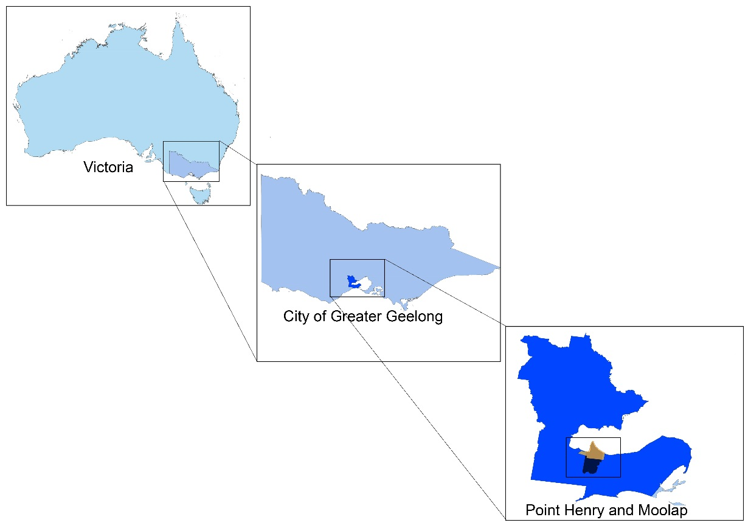
The northern end of Point Henry is the former industrial site of the Alcoa aluminium smelter, rolling mill, and Point Henry pier, used by shipping for supplying raw materials and transportation of manufactured products. The smelter began operation in 1963 while the mill commenced in 1965, with both ceasing operations in 2014 (DELWP, 2016a). Included within land owned by the smelter operators are wetlands, farming land and re-vegetated sites. The surrounding foreshore and coastal waters are crown land. To the south of the smelter along the western edge of the peninsular is the former Cheetham Saltworks site. The Saltworks date back to 1888 when solar evaporation of sea water and salt harvesting first commenced (Heritage Council Victoria, 2013). The site consists of a series of interconnected evaporation and crystalliser pans spread over an extensive area of approximately 500 hectares (1235 acres). The pans are separated by low earthen walls retained by timber beams and an extensive basalt rock seawall that was used to control flows of saltwater in and out of the pans via a sluice system and series of pumps (Heritage Council Victoria, 2013). Known as the Moolap Saltworks, they operated continuously until the 1990s when they closed for a short period, were reopened, then finally ceased operation in 2009 (Heritage Council Victoria, 2013). Ideas to redevelop the land commenced in 2009 when the former Saltworks were decommissioned. The State Government has proposed to revitalise the area with a master plan to be released by the end of 2017, which includes rezoning parts of the area into residential space, a marina and tourism and retail precinct (ABC News. Crothers, 2017).

The Moolap Plan
A draft version of the Moolap Coastal Strategic Framework Plan was released in April 2017. The plan proposes a vision and a number of principles to direct the future land use of the area over the next 20-30 years. It was developed by the Victorian Government Department of Environment, Land, Water and Planning (DELWP) in conjunction with other government agencies including the City of Greater Geelong and the Geelong Authority (DELWP, 2017). Concept proposals from land owners and other interested stakeholders were also included in a community engagement process. As the draft is a strategic land use plan, it includes only high level directions at this stage; detailed management and development strategies are envisioned to be included in later plans.
The development of the plan was driven by a seven-stage process (see Figure 2), and the draft plan was the outcome of stage five. It was developed from background information including site analysis, case study reviews, and feedback from two community engagement workshops. The final plan is expected to be released by the end of 2017.
Figure 2: Project stages of the draft Moolap Plan (DELWP 2017)
The community engagement included feedback from land owners and the general public who were consulted in three rounds. Round one aimed to inform the possible land use draft vision based on public feedback on existing issues, future ideas and information about the site. This engagement included a letter being sent to every owner/occupier in the study area, public notices, two open house events, two workshops, an online survey, written submissions and small group discussions.

The second round included two community open houses, three briefing workshops, an online survey and opportunities for people to make a written submission (DELWP, 2017). Out of 541 respondents to the second round survey, only 14% were involved in the first community engagement. This indicates a low rate of on-going participation, which might have affected the continuity of the engagement process.

Protection of the environment was among the top priority issues highlighted by the community with an 82% response rate. Interestingly, ‘retaining existing businesses/ land uses’ was considered unimportant by participants, with 69% of respondents selecting slightly or not important. The top five issues identified by all respondents as important for the future planning of the study area included: Protection of the environment (82%); Plan for the long term (81%); Plan in response to a rising sea level (52%); Be realistic/practical/deliverable (42%); and Improve community access and facilities (35%) (DELWP, 2016b).

Round one’s public engagement resulted in the development of seven scenarios and supporting principles. These were presented during round two and led to the release of the discussion paper. The seven scenarios are listed in Table 2.

Table 2: Seven proposed scenarios and the respondents’ preferences in round two, [Source: (DELWP, 2017)]
Conserving Moolap | Tourism in Moolap | Living in Moolap | Marine industry | Port in Moolap | Production in Moolap | Business as usual
71% | 16% | 5% | 3% | 2% | 2% | 1%

The preference for conserving Moolap demonstrates community awareness of the environmental significance of the site. Particularly, restoration and protection of the environmental and heritage values with significant emphasis placed upon wildlife and bird habitat, and corridors. Feedback from round two engagement indicated that proposed land uses should ‘preserve, restore and protect the environmental and heritage values of the site’ (DELWP, 2016b). It also highlighted the need for designated conservation areas to be protected into perpetuity by utilising current formal land protection legislation. The feedback additionally proposed management of public access into areas of environmental significance to strengthen protection of migratory and other bird habitat and wildlife corridors. Low impact tourism options that build on the sites recreational, coastline, and conservation values were proposed rather than development of higher impact tourism based on theme parks, hotels and casino options. Low impact and medium density residential buildings were suggested that consider the existing constraints of the site in a way that preserves and protects the environment, industrial, and residential land. However, within the same document it is indicated that ‘conservation concerns should not affect potential residential and accommodation development opportunities’. This contradicts the high priority of the community for capitalising on conservation.

Analysis Framework
In defining a framework for analysis and assessing the application of NBS in the Moolap project, we adopted the NBS framework defined by the International Union for Conservation of Nature (IUCN) for ecosystem-related approaches. IUCN defines 8 principles for NBS (Table 3):
Table 3: Eight principles of NBS according to IUCN
[Source: Adapted from (Cohen-Shacham, 2016)]
No. | NBS principles
1 | embrace nature conservation norms (and principles);
2 | can be implemented alone or in an integrated manner with other solutions to societal challenges (e.g. technological and engineering solutions);
3 | are determined by site-specific natural and cultural contexts that include traditional, local and scientific knowledge;
4 | produce societal benefits in a fair and equitable way, in a manner that promotes transparency and broad participation;
5 | maintain biological and cultural diversity and the ability of ecosystems to evolve over time;
6 | are applied at a landscape scale;
7 | recognise and address the trade-offs between the production of a few immediate economic benefits for development, and future options for the production of the full range of ecosystems services;
8 | are integral parts of the overall design of policies, and measures or actions, to address a specific challenge.

To understand the application of NBS approaches in practice and to define a framework for assessment of future policies and praxis, five main categories of ecosystem-based approaches were defined as shown in Figure 3.
Figure 3: Nature-based solutions (NBS) is used as an umbrella term for ecosystem-based approaches with 5 overarching categories to address human well-being and biodiversity benefits (Cohen-Shacham, 2016).
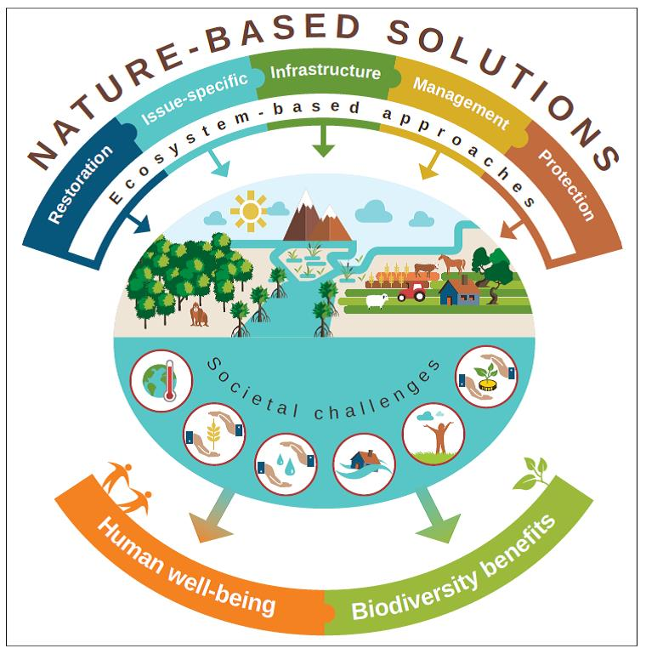

Some examples from each of the five main approaches of restoration, issue-specific, infrastructure-related, management and protection include:

NBS Approach | Examples
Restoration | Ecological engineering, forest landscape restoration
Issue-specific | Climate adaptation services and mitigation and adaptation measures, ecosystem-based risk reductions
Infrastructure-related | Natural and green infrastructure
Management | Coastal zone management
Protection | Protected area management and conservation

These five categories of ecosystem-based approaches were used to assess and review the draft Moolap Coastal Strategic Framework Plan against two outcomes: human well-being; and biodiversity benefits. Using a qualitative approach, thematic analysis of the report was undertaken in order to identify concepts and ideas in the proposed plan that integrate any of the five NBS approaches. The results are presented in the following section.

Results
A thematic analysis of the concepts and ideas proposed in the draft Moolap Plan revealed that the environmental values of the Saltworks and wetlands have been identified and highlighted. However, there seems to be a high priority given to growth and improving the economy of the area, while the potential environmental impacts appear not to have received the same level of rigours research. The proposal for rezoning a large part of the area into residential, recreational and industrial uses, suggests some disparities with the initial community engagement process, where the preferred scenario of 71% of participants was to conserve the environment.
The draft plan divides the area into four precincts, with different directions and strategies proposed for each. The precincts include: Point Henry Precinct; Saltworks and Wetlands Precinct; Industry Precinct; and South-East Precinct (see Figure 4). Except for the Saltworks and Wetlands, the other areas are envisioned to transform into residential, tourism and industrial uses. The Saltworks and Wetlands precinct is often inundated during storm surges and the majority of the precinct is predicted to be permanently inundated by a 0.8m sea level rise in 2100. Coastal retreat was proposed to minimise the risks, which is responsive to the site’s conditions. There is, however, minimal information on whether the mitigation strategies (including an existing seawall in the foreshore with restricted public access), are going to be reconsidered and redesigned for long-term adaptation and enhancing the environmental and ecological conditions of the wetlands. This is particularly important, considering the significance of the Saltworks and wetlands as endangered bird habitats.
Figure 4: The four precincts in Moolap Plan
Conservationists from Birdlife Australia, have explicitly expressed their concerns about how the new plan might affect the bird habitat (ABC News. Crothers, 2017). They have identified the Saltworks at Moolap as one of 19 key biodiversity areas across the country that are under serious threat. The Saltworks pans provide significant ecosystem-services by acting as wetlands and a buffer to filter surface water entering the bay. They capture and store excess carbon and act as a natural stabiliser for the coastline. They also provide food and nutrients for a wide range of marine communities, in addition to habitat for a large number of migratory and local birds (DELWP, 2016a). A public campaign called ‘Save the Moolap Wetlands’ was formed in opposition to the State Government’s plans to revitalise the area with a proposed master plan. The campaign promotes developing the whole area into a world-class ecotourism destination which fosters the conservation of birds and habitat. A main concern of the environmental groups is how the recreational areas proposed in the Saltworks and wetland Precinct will be managed and monitored to minimise the risk to the natural habitats.

The proposed strategies for development in each precinct are also not clear and detailed enough to investigate whether and how constraints of sea-level rise in the low-lying areas of these four precincts will be addressed. According to the datasets provided by the National Climate Change Adaptation Research Facility (NCCARF), the Saltworks and Wetlands prescient, and some areas of the Point Henry precinct are projected to be inundated by a sea-level rise scenario of 0.69 to 1m relevant to 2100. The proposed strategies and implementation plan largely provide high level directions for consideration of inundation and sea-level rise and other climate-driven issues. As such, a risk management plan has not been overseen.
Thematic analysis of the draft plan revealed a number of environmental considerations that deal with climate change in the two precincts with most exposure to impacts. Proposed land use rezoning and development strategies for each of these two precincts were reviewed, in order to identify NBS approaches and the benefits they provide. Table 4, presents the results.

Table 4: Analysis of environemntal directions and links to NBS approaches and beneifts in two selected precincts, (Human Well-Being (HWB); Biodiversity Benefits (BB))

Precinct | Proposed Land Use change | Development Directions (DELWP, 2017) | NBS approaches | Benefits
Point Henry | From Industrial to tourism and residential | ‘Passive recreation on wetlands along the eastern foreshore’ | Protection | HWB
Point Henry | From Industrial to tourism and residential | ‘Coastal retreat: Avoid development in areas impacted by the 2100 one per cent Annual Exceedance Probability (AEP) storm surge extent.’ | Management – Protection | HWB
Point Henry | From Industrial to tourism and residential | ‘Conservation and improvement of the environmental qualities of the wetlands’ | Restoration - Protection | BB
Point Henry | From Industrial to tourism and residential | ‘Facilitate the clean-up of former industrial and contaminated land’ | Protection – Issue-specific | HWB
Point Henry | From Industrial to tourism and residential | ‘Consider the impacts of coastal erosion when designing waterfront, boardwalks or other coastal facilities’ | Issue-specific | BB
Point Henry | From Industrial to tourism and residential | ‘Consider the role of wetlands to manage the impacts and risks’ | Issue-specific (Ecosystem-based risk reduction) | HWB
Saltworks and Wetlands | Environmental with complementary tourism and Environmental/tourism  investigation | ‘Coastal retreat in the management of environmental areas and wetlands, Avoid development in areas impacted by the 2100 one per cent Annual Exceedance Probability (AEP) storm surge extent.’ | Management – Protection | HWB
Saltworks and Wetlands |  | ‘Allow for some water, heritage or nature-based tourism and complementary commercial facilities that are low impact and, are linked to managing and improving the environmental and heritage assets.’ | Management | HWB
Saltworks and Wetlands |  | ‘Ensure there are appropriate buffers, design and levels of access to protect threatened flora and fauna and sensitive wetlands from human activity.’ | Protection | BB-HWB
Saltworks and Wetlands |  | ‘Consider the role of wetlands and retarding basins to manage the impacts and risks from both stormwater and sea level rise.’ | Issue-specific - Management | HWB
Saltworks and Wetlands |  | ‘Ensure any wetlands or retarding basins are integrated where appropriate into the future design and landscape of the precinct and promotes biodiversity values.’ | Infrastructure | BB
Saltworks and Wetlands |  | ‘Assist in the re-establishment of links between isolated habitat remnants that contain high value biodiversity.’ | Restoration - Infrastructure | BB
Saltworks and Wetlands |  | ‘Protect the coastal and marine resources and the ecosystem they provide.’ | Protection | BB-HWB
Saltworks and Wetlands |  | ‘Facilitate the improvement of the environmental qualities of the integrated coastal zone.’ | Management | BB
Saltworks and Wetlands |  | ‘Protect and enhance the foreshore as a primary open space area, a tourist and leisure destination.’ | Protection | HWB
Saltworks and Wetlands |  | ‘Avoid any destruction of seagrass meadows located within the coastal zone- Protect listed flora and fauna within the coastal foreshore.’ | Protection | BB

Discussion
The thematic analysis of the draft plan and results presented in Table 4 reveals the following points. The environmental-focused strategies and directions show a range of NBS approaches for either safeguarding human well-being or the provision of biodiversity benefits, although there is a higher emphasis on human well-being across the strategies. However, there are very few directions that promote benefits to integrate both human well-being and biodiversity improvements simultaneously.
The analysis also reveals a major emphasis on two ecosystem-based approaches; Management and Protection. There is limited consideration for ‘Restoration’, ‘Infrastructure-based’ and ‘Issue-specific’ approaches for risk reduction and adaptation, such as using natural ecosystems or nature-based structures for mitigation and adaptation to climate-induced impacts.
According to the seventh NBS principle presented in Table 3, NBS approaches should recognise and address the trade-offs between the production of a few immediate economic benefits for development, and future options for the production of the full range of ecosystems services. In the current draft plan, future potentials for the provision of ecosystem services remain under investigated. There is a need for a comprehensive assessment of long term environmental impacts of the proposed development plan before the amendments to land use rezoning are approved, and this is often restricted by time constraints. In order to ensure that short-term performance does not come at the price of environmental damage in the future, the ambiguity in the plan around development controls needs to be resolved by improved regulatory directions and the use of a clearer language.
The draft plan is obviously not the final stage of the project and details of development controls, management and design approaches are yet to be determined at the local level. Nevertheless, according to the eighth principle of NBS (see Table 3), ecosystem-based approaches should be ‘an integral part of the overall design of policies, and measures or actions’, to address a specific challenge. We suggest that high level policies should provide a better level of detail in the directions and strategies they provide for management and protection of coastal areas at state and local government levels.
Despite a range of environmental considerations and integration of nature-based solutions within the draft plan, there is still a lot of work to be done to ensure the management and design of the future master plan will integrate NBS principles and consider a balance between human well-being and the protection and enhancement of natural ecosystems. In the final stage of developing the Moolap Coastal Strategic Framework Plan, the feedback received on the draft plan will be used to inform the outcome, which will then be submitted to the Minister for Planning and the Minister for Energy, Environment and Climate Change for approval and implementation. Future research will include the review and analysis of the final Moolap Plan, after it is realised.

Conclusion
Over the next century and beyond, the effects of coastal climate change are set to greatly affect existing and proposed coastal’ developments, ecosystems, and the human well-being of coastal communities. In response to these challenges, on a global scale, ecosystem-based approaches and nature-based solutions (NBS) have been developed as alternatives to coastal defence such as hard engineering structures. In Victoria, there have been overarching policies developed for sustainable adaptation to climate change in coastal areas. It is at the state government level where specific policy development occurs. However, the policies often lack detailed directions for local government, and on-the-ground implementation and design strategies for developers.
The proposed redevelopment of the former industrial site on Point Henry, Moolap, Geelong, in Southern Victoria, provided a case study for investigating the consideration of NBS into planning proposals. Significant sections of the site have been projected to be affected by sea-level rise and inundation by 2100. The analysis of the current draft vision and directions report revealed that a number of NBS approaches are generally considered in the plan. However, the report contains limited detailed information on how NBS and ecosystem-based approaches may be used and measured to adapt to climate change.
This research highlights the fact that although impacts of coastal climate change is increasingly acknowledged and alternative adaptation strategies including NBS are being recognised in the management of coastal areas, there is still a need for evidence-based research to be done to understand the effectiveness of NBS approaches in adaptation policies and practices and a systematic framework to facilitate the application of NBS in future coastal development plans. Integration of an NBS framework into planning processes at different scales can foster coastal developments that are adaptive, resilient and contributive.

References
ABC News. Crothers, J. 2017. Fears 'once in a century' chance to preserve bird habitat could be lost to residential development [online]. Available from http://www.abc.net.au/news/2017-06-17/development-plans-for-south-west-coast-could-harm-birds/8625660 [Accessed 30 June 2017].
Cohen-Shacham, E., Walters, G., Janzen, C. and Maginnis, S., 2016. Nature-based Solutions to address global societal challenges Gland, Switzerland: IUCN.
Convention on Biological Diversity CBD, 2009. Connecting biodiversity and climate change mitigation and adaptation: report of the Second Ad Hoc Technical Expert Group on Biodiversity and Climate Change. Montreal, Canada.
DELWP, 2016a. Moolap Coastal Strategy Framwork Plan: Background Report. Melbourne
DELWP, 2016b. Moolap Coastal Stretegic Framework Plan: Summary of Feedback Community engagement Round two.
DELWP, 2017. The draft Moolap coastal strategic framework plan. Melbourne L. Department of Environment, Water and Planning.
Department of Sustainability and Environment, 2007. EVC/Bioregion Benchmark for Vegetation Quality Assessment, Otway Plain bioregion. Melbourne
Elmqvist, T., Fragkias, M., Goodness, J., Güneralp, B., Marcotullio, P.J., McDonald, R.I., Parnell, S., Schewenius, M., Sendstad, M., Seto, K.C., Wilkinson, C., Alberti, M., Folke, C., Frantzeskaki, N., Haase, D., Katti, M., Nagendra, H., Niemelä, J., Pickett, S.T.A., Redman, C.L. & Tidball, K., 2013. Stewardship of the Biosphere in the Urban Era. In T. Elmqvist, M. Fragkias, J. Goodness, B. Güneralp, P.J. Marcotullio, R.I. Mcdonald, S. Parnell, M. Schewenius, M. Sendstad, K.C. Seto & C. Wilkinson (eds.) Urbanization, Biodiversity and Ecosystem Services: Challenges and Opportunities: A Global Assessment. Dordrecht: Springer Netherlands, 719-746.
European Commission, 2015. Horizon 2020 Towards an EU Research and Innovation policy agenda for Nature-Based Solutions & Re-Naturing Cities. Final Report of the Horizon 2020.
Graham, S., Barnett, J., Fincher, R., Hurlimann, A. & Mortreux, C., 2014. Local values for fairer adaptation to sea-level rise: A typology of residents and their lived values in Lakes Entrance, Australia. Global Environmental Change, 29, 41-52.
Heritage Council Victoria, 2013. Cheetham Salt Works Melbourne H. Victoria.
Hill, K., 2015. Coastal infrastructure: a typology for the next century of adaptation to sea‐level rise. Frontiers in Ecology and the Environment, 13, 468-476.
Inman, M., 2010. Working with water. 39-41.
IPCC, 2014. Climate change 2014: impacts, adaptation, and vulnerability. Cambridge, UK.
Latta, M. & Boyer, K., 2015. San Francisco Bay Living Shorelines: Nearshore Linkages Project, Summary of Key Findings Two Years Post-installation.
McDonald, R.I., Marcotullio, P.J. & Güneralp, B., 2013. Urbanization and Global Trends in Biodiversity and Ecosystem Services. In T. Elmqvist, M. Fragkias, J. Goodness, B. Güneralp, P.J. Marcotullio, R.I. Mcdonald, S. Parnell, M. Schewenius, M. Sendstad, K.C. Seto & C. Wilkinson (eds.) Urbanization, Biodiversity and Ecosystem Services: Challenges and Opportunities: A Global Assessment. Dordrecht: Springer Netherlands, 31-52.
Moosavi, S., 2017. Ecological Coastal Protection: Pathways to Living Shorelines. Procedia Engineering, 196, 930-938.
Morris, R.L., Deavin, G., Hemelryk Donald, S. & Coleman, R.A., 2016. Eco-engineering in urbanised coastal systems: consideration of social values. Ecological Management & Restoration, 17, 33-39.
Nikolaidis, N.P., Kolokotsa, D. & Banwart, S.A., 2017. Nature-based solutions: business. Nature, 315.
Sutton-Grier, A.E., Wowk, K. & Bamford, H., 2015. Future of our coasts: The potential for natural and hybrid infrastructure to enhance the resilience of our coastal communities, economies and ecosystems. Environmental Science & Policy, 51, 137-148.
Vasey-Ellis, N., 2009. Planning for Climate Change in Coastal Victoria. Urban Policy and Research, 27, 157-169.
Victorian Coastal Council, 2002. Victorian Coastal Strategy 2002. Melbourne
Wamsler, C., 2016. Operationalizing ecosystem-based adaptation : harnessing ecosystem services to buffer communities against climate change. Ecology and society, 31.

