Distributions of End-Use Water Consumption among Households

Mishka Talent
Australian National University, Canberra, ACT, Australia

Abstract: Estimating the distribution of domestic water consumption among households is important for establishing baselines against which policy success can be measured. Estimates of this kind are typically produced using household surveys. This study aimed to investigate how simple heuristic estimates of water consumption and surveys compare with measures of water consumption obtained from meter readings. It also aimed to characterise (parameterise) the distribution of metered water consumption in Canberra. The ‘gold standard’ measure of consumption was 7 years of quarterly metered readings of 27,174 dwellings in Canberra. Heuristic estimates and survey-derived estimates were compared with these actual meter readings. Survey estimates were obtained by population weighting an online panel survey that asked respondents about their consumption behaviours. Heuristic estimates were obtained on the assumption that total water consumption can be approximated by combining a priori estimates of consumption for toilet use, shower use, washing of dishes, washing machine use, teeth brushing, cooking and drinking. Heuristic estimates of consumption underestimated extreme values. Survey derived estimates provided unreliable indicators of actual consumption. End-use analysis typically involves expensive and detailed house visit surveys or participant reporting surveys. This study suggests that both self-report surveys and heuristic models should be treated with caution. The extreme variation in distribution of consumption among households requires population sampling much larger than normally undertaken. Nine common mathematical distributions were parameterised using the metered household consumption. This work has application in evaluating policies aiming to modify water consumption.

Key words: Residential Water Consumption; Smart Cities; Water end-use; Water demand forecasting; Water demand management.

Introduction
Potable water is a scarce natural resource but is under pressure in Australia from increasing demand. Water is an important factor in the arrangement of cities (Marshall, 1879) but also vital for their continual growth. The location of Australia Capital Territory (ACT), for example was influenced by a requirement of a suitable water source. Twenty percent of the Territory’s land area is used for water catchment. But there is continual pressure to supply increasing demand for water as the city grows from a planned population of 20,000 to almost 400,000 inhabitants. In the ACT, the additional water required to meet a growing population was met by increasing storage capacity (Icon Water Limited, 2017). In other cities in Australia, desalination plants have been built at great expense (El Saliby et al., 2009). Increasing storage, catchment size or desalination plants are referred to as supply-side solutions. Since the “Millennium Drought” (2001–2009) in Australia (Dijk et al., 2013) governments and local utilities have implemented a range of policies aimed at influencing the demand for water, commonly referred to as demand-side solutions. These include, for example, water restrictions, toilet replacement schemes, and the installation of rainwater tanks. For such policies to be effective it is vital for policy makers to understand how water is ‘consumed’ (Troy, 2008).
The present paper is concerned only with consumption of water by households. Households consume approximately 50% of the water in Australia (Australian Bureau of Statistics, 2016). ‘Consumption’ is includes all metered water ‘used’ by households. Most policies have approached water consumption by devising systems to supply water for a ‘once only use’ whether the water is ingested, used for pleasure or as the medium to transport waste (including human body wastes). Very little delivered water is directly consumed by ingestion. Most is transformed from highly cleaned water into a waste stream (Archer, 1991).
How water is consumed by households, that is, the distribution among various end-uses, is poorly understood. Estimating the distribution among households is important for establishing baselines against which policy success can be measured. Beyond the essential life-preserving requirements, the factors affecting consumption remain largely unexplained despite 40 years of investigation (Tanverakul and Lee, 2016). During the droughts in Australia between 2001 and 2009, many governments enacted water restriction programs (Australian National Water Commission et al., 2006). These policies typically penalised particular activities such as outdoor garden watering and therefor only penalised some types of living arrangements such as those living in detached dwellings. A notable exception was the Target 140 campaign which did not restrict particular activities but instead limited total per capita consumption. Residents were free to use water within their 140 L per person per day allocation. This policy was arguably equally effective (Walton and Hume, 2011) but far less oppressive than policies that penalised certain uses of water.
The current work focusses on average (mean) consumption by households and on those households that use high, or ‘extreme’ quantities of water. The average (mean) consumption of water is valuable in evaluating the effectiveness of directed policies like rainwater tank installation or toilet replacement programs. The social equity (fairness) of different policies can only be evaluated with knowledge of the factors leading to high consumption.
Estimates of the distribution of water consumption among households are typically produced using expensive and invasive household surveys. Such surveys typically attempt to estimate water use of each appliance in a dwelling; so called end-use surveys. The Australian Bureau of Statistics undertook self-reported end-use water surveys by randomly sampling households. The survey was relatively small indicating a belief in low variability in consumption distribution among households. For example, in New South Wales, 7000 households were sampled from a population of approximately 2.3 million (Australian Bureau of Statistics, 2006). Reinhardt (2015) as part of his doctoral thesis undertook a panel survey to investigate the prospects for household-led change in energy and water consumptions. The survey was undertaken by a third-party survey company. A total of 1254 responses were received at, typical of outsourced surveys, approximately $10 per response.
Detailed end-use surveys typically involve continued monitoring of water consumption, for example, every 5 minutes and for each household appliance. Mayer et al. (1999) conducted an early example of end-use monitoring. They logged consumption in 1188 households in the United States but sensibly did not make statistical inferences from their results, instead noting the diversity of consumption patterns. More recent studies have often monitored fewer households but made larger claims of the significance of their findings. Heinrich (2007) analysed consumption patterns in 12 households in New Zealand and suggested that installing low flow shower heads and water efficient washing machines would have the highest effect in reducing water consumption. Three major end-use studies have been performed in Australia. Beal et al. (2011) analysed end-use consumption in 252 homes South East Queensland as part of a $50 million project which focused on water security and water recycling. The results of this work were widely reported, (for example, Willis et al., 2009, Willis et al., 2010, Willis et al., 2011). Loh and Coghlan (2003) undertook a detailed end-use survey of 244 households in Perth and Roberts (2005) undertook a similar survey of 100 detached dwellings in Melbourne. The current paper does not deal with the distribution of water consumption over a day, for example, at what time of day does toilet use occur, although such work is important for informing infrastructure requirements of water systems (Makki et al., 2013). The current paper is concerned with the distribution of water consumption for various end-uses, estimated on a per day and per capita basis.
Talent et al. (2013) found a highly skewed distribution in water consumption among households in Canberra. The sample comprised approximately 25,000 dwellings. The mean consumption was 411 litres per dwelling per day, the median was 485 litres per dwelling per day and the kurtosis was 32.4. The highly skewed distribution suggests that a very large sample is required to achieve a statically significant result in analysis of, for example, mean consumption due to toilet use. Such a large analysis of end-use surveys has not been performed in Australia, presumably because of the great cost involved with such a collection. This study aims to investigate how simple heuristic estimates of water consumption and surveys compare with measures of water consumption obtained from meter readings. It also aims to characterise (parameterise) the distribution of metered water consumption in Canberra.

Methods
To investigate how simple heuristic estimates of water consumption and surveys compare with measures of water consumption obtained from meter readings, three data sources were used. The ‘gold standard’ measure of consumption was 7 years of quarterly metered readings of 29,555 dwellings in Canberra. Heuristic estimates and survey-derived estimates were compared with these actual meter readings. Finally, the estimated confidence interval as a function of smaller sample sizes was quantified. All modelling and calculations were performed using the R programming language, version 3.1.2 (R Core Team, 2015).

Metered Water Consumption Data – ‘gold standard’
A sample of quarterly meter readings was provided by the local water utility for analysis. To ensure a suitable sample of dwellings for statistical analysis, a random stratified selection method was used; National census 2006 collector districts (CDs) were grouped depending on their dominant dwelling type (those with more than 14% semi-detached, those with more than 15% apartments and those otherwise dominated by detached dwellings) and based on the age of developments (1920-1958, 1959-1974, 1975-1987 and 1988-2005) and based on those built in the North and South of the city. This resulted in 24 strata. An equal number of collector districts were chosen from each strata ensuring a similar number of each type of dwellings (detached, semi-detached and apartments) and a similar number of dwellings from each age category in the sample. The sample included 29,555 dwellings. Non-residential addresses, those that could not be matched to utility energy accounts and those with less than 1 year of energy consumption data were removed leaving a sample of 27,174 with sufficient detail for modelling. This sample represented 20.2% of the dwellings in Canberra.
The local water utility (Icon Water) provided quarterly metered water consumption data for the 27,174 dwellings. Values were based on utility meter consumption readings. Estimated readings (for example, due to lack of meter access) at some sites were verified at least every year by actual readings. All dwellings had between one and seven years of consumption data. Daily energy consumption was estimated as the mean value of all consumption data for each dwelling. Household size was estimated from National Census Data (Talent, in press).
Manual inspection of the highest 200 users was undertaken to ensure that these high readings were likely genuine residential readings and not related to commercial uses and also that these readings were not due to water leaks. Figure 1 is replicated from Talent et al. (2013) and shows a single dwelling with a median water consumption of 1668.6 litres per day (line ‘b’), more than 4 times the median consumption of 411 litres per dwelling per day (line ‘a’). The low consumption periods in winter time that follow high consumption periods, generally in summer time, indicate that such consumption is unlikely due to leaking pipes.
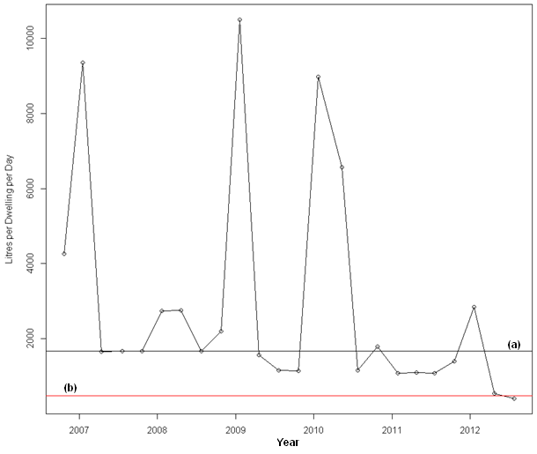
Figure 1: Variation in a ‘high consumption’ dwelling over the study period 2007-2012

Survey Data
Household consumption data was collected using an online panel survey. The survey was conducted between 26th May 2013 and 13th of June 2013 by a third-party survey company. The survey achieved a total of 1254 completed surveys. Respondents were from Sydney (n=522), Melbourne (n=431) and Canberra (n=301). The distribution of survey respondents broadly represented the population (Reinhardt, 2015).

Heuristic model
A mathematical model of total consumption was developed by estimating a distribution of consumption for each major water end-use component. These heuristic distributions were based on publically available literature where available or on the author’s experience as a home energy auditor for the ACT government (HEAT program). The general approach was to estimate an arithmetic mean ($\overline{X}$) and standard deviation (σ) from the literature and generate a normal distribution with these parameters. Modelled values of less than zero litres of consumption were removed. The graphs of each distribution were presented as a probability distribution for ease of comparison for the reader. Such probability distributions could be multiplied by the size of the population where a frequency distribution was required.

The Toilet
The volume of water used in toilets was modelled as the number of toilet flushes (TU) per person multiplied by the daily frequency of flushing (TF).
The volume of water per flush was modelled by a normal distribution ($\overline{X}$=6 L, σ=3). The mean value was consistent with Schlunke et al. (2008). Values below 4 litres per flush were removed.
The frequency of toilet use was modelled as a normal distribution ($\overline{X}$=1.7, σ=0.4). This reflected medical literature on bowel movement frequency. Walter et al. (2002) found 95% of respondents had bowel movements between 3 times per week and 3 times per day. This frequency estimate was multiplied by 2 to account for flushing due to urinating.

The Shower
The volume of water used in the shower was modelled from the expected flow rates of the shower heads (SFL), multiplied by the daily frequency of showers (SF), multiplied by the shower duration measured in minutes (ST).
The shower head flow rate was modelled as a normal distribution ($\overline{X}$=6 litres per minute, σ=3). The mean value reflects the findings of Cordell et al. (2003). Modelled values below zero were removed.
Daily shower frequency was modelled as a normal distribution ($\overline{X}$=1, σ=0.5). Modelled values below zero were removed.
Shower duration was modelled as a normal distribution ($\overline{X}$=6 min, σ=4). Modelled values less than 3 minutes were removed. Dent (2006) reported an average duration of 7 minutes and most respondents to their survey were between 3 and 30 minutes.

Clothes Washing
The volume of water used for clothes washing was modelled as the volume used in each cycle of a washing machine (CW) multiplied by an estimated frequency of use (CWF). 95% of dwellings in Australia wash clothes using a washing machine (Australian Bureau of Statistics, 2006).
The volume of water used by a washing machine was modelled as a normal distribution ($\overline{X}$=105 litres, σ=22) assuming a range of 40-170L per wash cycle (Alliance for Water Efficiency, 2017)
The frequency of washing machine use was based on survey data (Australian Bureau of Statistics, 2006). It was modelled as a normal distribution ($\overline{X}$=0.65 cycles per day, σ=0.3).

Dishes
The volume of water used for washing dishes (DD) was estimated from manufacturer specifications. While only 50% of Australian households have dishwashers (Australian Bureau of Statistics, 2006), hand washing was assumed to use a similar quantity of water to a dishwasher. Water volume for washing dishes was modelled as a normal distribution ($\overline{X}$=24 litres, σ=4). It was assumed dish washers were used every 3 days per person.

Teeth Brushing
The volume of water used for brushing teeth (BT) was modelled as a normal distribution ($\overline{X}$=0.5 litres, σ=2). Modelled values below zero were removed. The model resulted in a maximum consumption of 10 litres per person per day.

Cooking
The volume of water for cooking (CO) was modelled as a normal distribution ($\overline{X}$=5 litres, σ=2).

Drinking
The volume of water drunk (DR) was modelled as a normal distribution ($\overline{X}$=1 litre, σ=0.7).

Indoor Taps Subtotal
Indoor water consumption through taps was estimated as the water consumed in cooking, drinking and brushing teeth. The volume of water consumed through a tap was measured in Beal et al. (2011) and was estimated in the present paper for comparison.
    - Swimming Pools
The volume of water used for swimming pools (SWP) was estimated as the volume of water lost due to evaporation multiplied by a frequency distribution of dwellings with swimming pools. It was estimated that 6% of dwellings had swimming pools (SPF). This value was estimated from satellite imagery (unpublished). The average pool size was estimated at 45,000 litres (9m long, 4m wide and 1.2m deep). Average water loss due to evaporation was estimated as 30,000 litres per year (Dawson, 2013). It was modelled as a normal distribution ($\overline{X}$=82.2 litres per day, σ=27.4).
    - Other Outdoor Use
Other outdoor use (OU) was modelled as a normal distribution assuming average watering for 30 min per week per household through a hose with a flow rate of 17 litres per minute ($\overline{X}$=27 litres, σ=27). 15% of dwellings were assumed to use no water outdoors.

Total Daily per Capita Consumption
Total household water consumption was modelled as the combination of individual uses. The individual uses of water included average volume in litres of each toilet flush (TU), toilet flush frequency (TF), shower flow rate (SFL) measured in litres per minute, shower duration (ST) measured in minutes, daily shower frequency (SF), volume of clothes washing machine cycle (CW), clothes washing machine use frequency (CWF), swimming pool water use due to evaporation (SWP), frequency of dwellings with swimming pools (SPF), volume drunk or ingested (DD), volume used in cooking (CO), volume used for brushing teeth (BT) and other outdoor use (OU). This can be summarised by equation 1:

 | $$Total Daily Consumptino \left(L\right)=\left(TU*TF\right)+\left(SFL*ST*SF\right)+\left(CW*CWF\right)+\left(SWP*SPF\right)+DD+BT+CO+DR+OU$$ | (1)
The possibility of a correlation in the volume of water consumed for different end-uses was explored. For example, those who consumed large volumes of water for their swimming pool may also consume a large volume of water for showering. Individual uses of water were combined (equation 1) assuming either that there was no relationship between end-uses (a random mixing model) or assuming a perfect correlation in consumption between end-uses. Perfect correlation was achieved by ordering, from lowest to highest values, the components of end-use consumption before combining (equation 1). Total per capita consumption was modelled under both scenarios. These are the two most extreme methods of combining the water end-uses.

Comparison between models
We aimed to characterise the error in the estimated mean from taking small samples and assuming a normal distribution of water consumption among households. Random samples were taken from the metered data ranging in size from 10 to 1000 samples. Sampling of each size was repeated 10,000 times. The mean of each sample was calculated and a student’s t-test was used to estimate the 95% confidence interval in that mean value. One would expect that 95% of the time the 95% confidence interval of the estimated mean value would include the true mean (the mean measured from the whole population). The proportion of 95% confidence intervals that include the ‘true’ mean, which we call ‘coverage’ are reported.
To improve characterisation of the distribution in water consumption among households, commonly defined curves of best fit were applied to the data and compared (parameterisation). The ‘gold-standard’ metered data was parameterised to test the hypothesis that the distribution was ‘normal’, a common assumption in the literature. A ‘Normal’, ‘Poisson, ‘Logistic’, ‘Weibull’, ‘Gamma’, ‘Negative Binomial’, ‘Cauchy’, ‘LogNormal’ and Pareto distribution were fitted to the data and compared using the natural logarithm of the likelihood function (loglik). Repeated values in the metered data were removed prior to analysis. The components of the Pareto distribution were optimized using a Kolmogorov–Smirnov (KS) test. The Couchy, Negative-Bionmial and Poisson distributions used the same data but rounded to the nearest whole integer.

Results

Panel Survey
Survey derived estimates of water consumption provided unreliable indicators of actual consumption behaviour. “Household consumption information was sought through two means in the survey: expenditure ranges and the actual consumption (in… kilolitres (kL)). There was not enough data for the latter units of actual consumption to be used in the analysis.” (Reinhardt, 2015 p. 85). The results of this survey were therefor not further analysed.

Heuristic Model
The heuristic model attempted to build a model of city wide water consumption from a basic understanding of the distributions in consumption of components (end-use). Most components were modelled as normal distributions (Figure 2). It should be noted that Figure 2 shows a density distribution of each end-use rather than a frequency distribution to allow better graphical comparison between various end-uses. Also, the graph showing the volume of water used for swimming pools does not include households that did not own swimming pools although this was included in the model. 94% of the population consumed no water for swimming pools in the model.
The heuristic model of consumption, which combined the distribution of end-uses of water resulted in a poor approximation of the distribution of metered water consumption among households (Figure 3). Many of the components of water consumption were modelled as normal distributions which resulted in a normal distribution when components were combined, consistent with the literature (Eisenberg and Sullivan, 2008). For example, toilet flushing volume was modelled as a normal distribution with mean of 6.0 and a standard deviation of 3.0 litres and toilet flushing frequency was modelled as a normal distribution with mean 3.4 and a standard deviation of 0.9 times daily. The sum of these two independent distributions (i.e. no correlation) resulted in a normal distribution with mean of 25.0 and a standard deviation of 10.0 litres. The exclusion of modelled water flushing volumes of less than zero litres resulted in an increased mean of 25.0 litres rather than 20.4 litres had these values not been excluded.
The extreme values that occurred in the metered data did not occur in the heuristic model. This result suggests that at least some of the components (end-uses) that contribute to total household consumption must be non-normally distributed. As highlighted in section 2.1, the data set of metered water consumption excluded the possibility that leaking pipes were the cause of such high consumption. The mean end-use water consumption, the 95% confidence intervals of each estimate and the standard deviation are shown in Table 1.

Table 1: Modelled components of heuristic model
End-use (Major Component) | End-use (Minor Component) | Mean | Mean Lower Confidence Interval (.025) | Mean Upper Confidence Interval (.975) | Standard Deviation
Total Toilet Use (L/day) |  | 24.9 | 24.8 | 25.0 | 9.92
 | Toilet Flush Volume (L) | 7.28 | 7.26 | 7.30 | 2.19
 | Toilet Flushing Frequency (per day) | 3.42 | 3.41 | 3.43 | 0.86
Total Shower Use (L/day) |  | 48.77 | 48.44 | 49.09 | 39.66
 | Shower Flor Rate (L) | 6.15 | 6.13 | 6.17 | 2.83
 | Shower Frequency (per day) | 1.045 | 1.04 | 1.05 | 0.46
 | Shower Length (min) | 7.57 | 7.55 | 7.61 | 2.97
Dishwasher (L/day) |  | 7.89 | 7.88 | 7.91 | 1.31
Washing Machine (L/day) |  | 49.2 | 48.9 | 49.4 | 28.9
 | Washing Machine (L per load) | 105.0 | 104.8 | 105.2 | 22.02
 | Washing Machine Frequency (per day) | 0.760 | 0.759 | 0.763 | 0.41
Taps Total (indoor, L/day) |  | 23.19 | 23.14 | 23.23 | 5.30
 | Teeth Brushing (L/day) | 1.79 | 1.78 | 1.81 | 1.29
 | Cooking (L/day) | 5.04 | 5.02 | 5.02 | 1.95
 | Drinking (L/day) | 1.11 | 1.10 | 1.12 | 0.61
 | Tap Other (L/day) | 10.27 | 10.23 | 10.30 | 4.70
Swimming Pool (L/day) |  | 4.88 | 4.71 | 5.04 | 20.4
 | Evaporation (L/day) | 82.6 | 82.4 | 82.8 | 26.6
 | Swimming Pool Occurrence (%) | 0.059 | 0.058 | 0.061 | 0.24
Other Out Door Use (L/day) |  | 34.75 | 34.56 | 34.94 | 21.5
Total (L/day) |  | 208.9 | 208.4 | 209.5 | 68.9
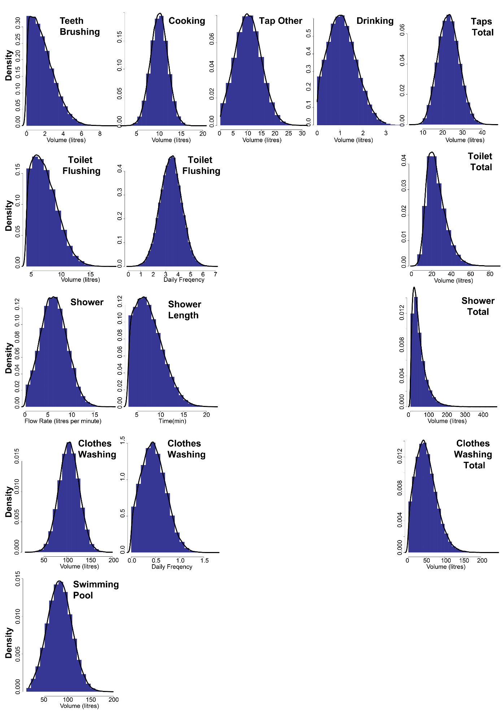
Figure 2: Heuristic estimations of end-use water consumption

In the extreme case of perfect correlation between variables (the Ordered Heuristic Model) the resultant distribution of total consumption showed a non-normal distribution (Figure 3). The Ordered Heuristic Model resulted in much higher extreme values than where no correlation between end-uses was assumed. The Ordered Heuristic Model, however, still lacked the most extreme values found in the metered data. The model also over-estimated the frequency of ‘high’ water consumers, such as those consuming 500 litres per person per day. The higher than expected frequency of dwellings consuming 500-700 litres per person per day results from all swimming pool owners occurring in this range. In the unordered heuristic model, swimming pool owners appeared throughout the distribution.
The mean value of the Ordered Heuristic Model also decreased to 201.3 (σ=103.9) litres per person per day compared with the the uncorrelated heuristic model of 206.0 (σ=61.7) litres per person per day. Allowing perfect correlation between variables resulted in a model that was inconsistent with the distribution of metered data. Neither of the heuristic models enabled the scaling up of the components of water use consumption to a reliable estimate of the whole city (Figure 3).

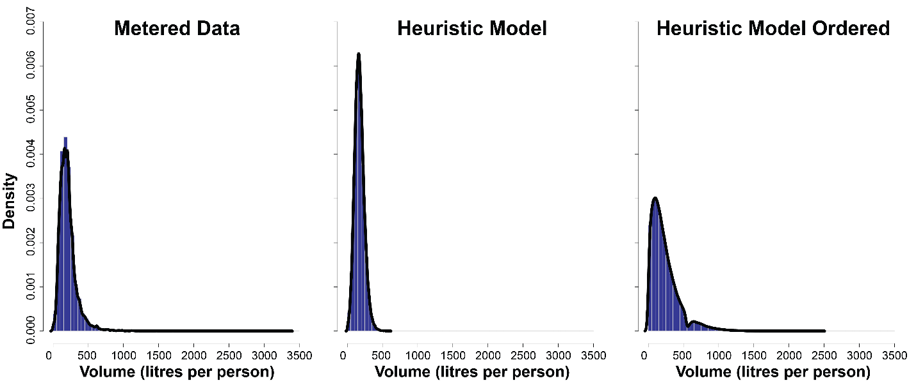
Figure 3: Distribution in water consumption among households. Metered consumption is compared with the heuristic model (uncorrelated end-uses) and the ordered heuristic model (perfect correlation in end-use consumption).

Distribution in Metered Water Consumption

The highly skewed metered data results in poor estimates in the mean when small sample sizes are taken. The distribution in household water consumption was highly positively skewed (Kurtosis = 34), with a mean of 210 (σ=127) litres per person per day and a median of 189 litres. The 95% confidence interval underestimated the true population mean value for sample sizes of less than 500 dwellings (Figure 4).
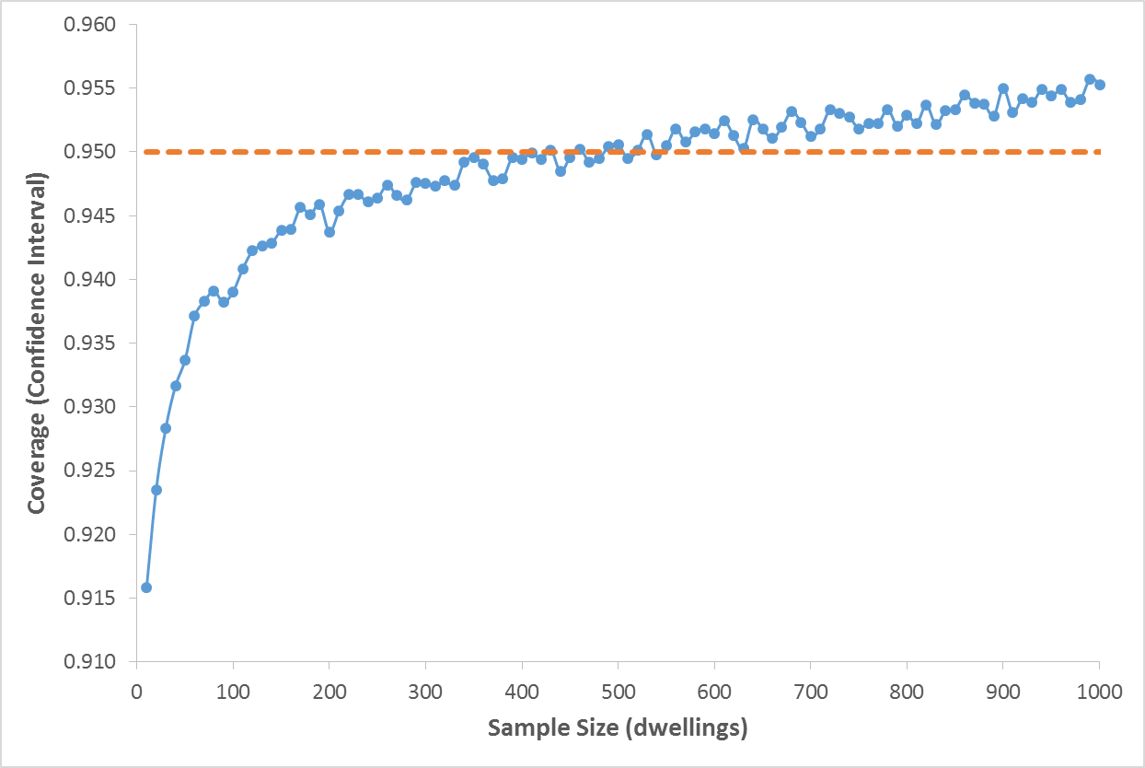
Figure 4 T-test coverage as a function of sample size

The distribution in metered data was best approximated with a Gamma distribution (Table 2). Notable also, was that the Log-Normal distribution performed well compared with other distributions. Surprisingly, the Weibull and Pareto distributions, which are often used in ‘fat-tailed’ distributions (e.g. household income) poorly fitted the metered data.

Table 2: Parameterised curve of best fit to the metered water consumption
Rank | Distribution | Log Likelihood
1 | Gamma | (110,663)
2 | Negative Binomial | (110,730)
3 | Log-Normal | (111,110)
4 | Weibull | (111,672)
5 | Logistic | (112,527)
6 | Cauchy | (113,366)
7 | Normal | (114,694)
8 | Pareto | (115,724)
9 | Poisson | (711,766)

Discussion
The outcomes of policies based on small samples of water consuming households may be poor because of the highly skewed distribution of consumption. This may occur for two reasons:
Firstly, there is a high probability that the estimated mean value, for example, the volume of water used for toilet flushing is erroneous. The estimated mean value may be either higher or lower than the true value. The results of this work support Mayer’s apprehension of statistical generalisation from a study of 1188 households, even within the same country of study (Mayer et al., 1999). The 95% confidence interval estimates of the mean, for samples of less than 500 households, were found to be inaccurate (Figure 4). Where the mean values of multiple end-uses are estimated, samples sizes must be many thousands of households. The exact sample size will depend on the number of end-uses analysed and should be considered along with other sampling criteria (Cordell et al., 2003). The present paper suggests that the standard errors in other studies are underestimated because the extreme variation in water consumption was not accounted for in their statistical analysis (Beal et al., 2011, Loh and Coghlan, 2003). Heinrich (2007) suggested that a sample of 600 would be required for a 95% confidence interval in the mean for shower length, but relaxed this requirement because of the cost of collection was too high and so proceeded with a sample of only 100 dwellings (Heinrich, 2007 p.9). Confidence interval estimates are typically derived by comparison with a normal distribution e.g. using a t-test. However, as shown in this work, the distribution in water consumption not normally distributed. Indeed, the best parameterisation of the data was the ‘Gamma’ distribution. This work questions the ability to accurately evaluate policies based on estimated means of small samples.
Secondly, the frequency of extremely high water consuming households will be under-estimated in small samples. It is important to understand these high users of water to evaluate the social equality of particular policies. It may be that those who use the highest volumes of water do so because they are in a situation of multiple disadvantage. For example, they may use high volumes of water for medical purposes. Most current water policies use financial penalties to limit water use despite little evidence that such policies are effective (Hoffmann et al., 2006). The equity of these policies is poorly tested. Policies that aim to influence water consumption can only ensure equitable outcomes where determinants of water consumption are well understood. Heinrich (2007), Loh and Coghlan (2003) and Beal et al. (2011) all had very small sample sizes and are therefore very unlikely to have sampled the extreme water users in the populations they studied. A stratification sampling technique could be used to improve the chances of capturing these high water users, but only where the determinants of consumption are known prior to sampling.

Conclusions
This study suggests that both self-report surveys and heuristic models should be treated with caution. They both understate the extreme high water users that are observed in the metered data. Average (mean) household water consumption values should be treated with caution where samples are less than 500 dwellings or many thousands of households where many end-uses of water are evaluated. The Gamma and Log-Normal distributions best fitted the metered data. This result contradicts the literature where normal distributions are assumed.

References
ALLIANCE FOR WATER EFFICIENCY. 2017. Clothes Washer [Online]. Home Water Works. Available: http://www.home-water-works.org/indoor-use/clothes-washer [Accessed 2017].
ARCHER, J. 1991. On the water front: making your water safe to drink, Pure Water Press.
AUSTRALIAN BUREAU OF STATISTICS 2006. Cat 4652.5 - Domestic Water and Energy Use, Western Australia, Oct 2006 Canberra: ABS.
AUSTRALIAN BUREAU OF STATISTICS 2016. Cat 4610.0 - Water Account, Australia, 2014-15. Canberra: ABS.
AUSTRALIAN NATIONAL WATER COMMISSION, WATER SERVICES ASSOCIATION OF AUSTRALIA & NATIONAL WATER INITIATIVE (AUSTRALIA) 2006. National performance report ... major urban water utilities.
BEAL, C., STEWART, R., HUANG, T. & REY, E. 2011. South east queensland residential end use study, Urban Water Security Research Alliance Brisbane, Australia.
CORDELL, D., ROBINSON, J. & LOH, M. 2003. Collecting residential end use data from primary sources: Do’s and don’ts. Institute For Sustainable Futures, University of Technology, Sydney.
DAWSON, P. 2013. How much water does a pool use after filling? In: SOLAR, S. (ed.). Suncap Solar.
DENT, J. 2006. Australians urged to save energy with shorter showers [Online]. The Guardian. [Accessed July 20, 2017].
DIJK, A. I., BECK, H. E., CROSBIE, R. S., JEU, R. A., LIU, Y. Y., PODGER, G. M., TIMBAL, B. & VINEY, N. R. 2013. The Millennium Drought in southeast Australia (2001–2009): Natural and human causes and implications for water resources, ecosystems, economy, and society. Water Resources Research, 49, 1040-1057.
EISENBERG, B. & SULLIVAN, R. 2008. Why is the sum of independent normal random variables normal? Mathematics Magazine, 81, 362-366.
EL SALIBY, I., OKOUR, Y., SHON, H., KANDASAMY, J. & KIM, I. S. 2009. Desalination plants in Australia, review and facts. Desalination, 247, 1-14.
HEINRICH, M. 2007. Water end use and efficiency project (WEEP)–final report, BRANZ study report 159. Branz, Judgeford, New Zealand.
HOFFMANN, M., WORTHINGTON, A. & HIGGS, H. 2006. Urban water demand with fixed volumetric charging in a large municipality: the case of Brisbane, Australia. Australian Journal of Agricultural and Resource Economics, 50, 347-359.
ICON WATER LIMITED. 2017. Enlarged Cotter Dam [Online]. Available: https://www.iconwater.com.au/Community-and-Education/Our-projects/Water%20Security%20Projects/Enlarged-Cotter-Dam.aspx [Accessed 1/7/2017].
LOH, M. & COGHLAN, P. 2003. Domestic water use study in Perth, Western Australia, 1998-2001, Water Corporation Perth.
MAKKI, A. A., STEWART, R. A., PANUWATWANICH, K. & BEAL, C. 2013. Revealing the determinants of shower water end use consumption: enabling better targeted urban water conservation strategies. Journal of Cleaner Production, 60, 129-146.
MARSHALL, A. 1879. Water as an element of national wealth
In: PIGOU, A. (ed.) Memorials of Alfred Marshall. New York: Kelley & Millman.
MAYER, P. W., DEOREO, W. B., OPITZ, E. M., KIEFER, J. C., DAVIS, W. Y., DZIEGIELEWSKI, B. & NELSON, J. O. 1999. Residential end uses of water. Denver, CO: American Water Works Association Research Foundation.
R CORE TEAM 2015. R: A Language and Environment for Statistical Computing. Vienna, Austria: R Foundation for Statistical Computing.
REINHARDT, W. 2015. Knowing more, using less: The prospects for household-led change in energy and water systems. Australian National University.
ROBERTS, P. 2005. Yarra Valley Water: 2004 residential end use measurement study, Yarra Valley Water Melbourne.
SCHLUNKE, A., LEWIS, J. & FANE, S. 2008. Analysis of Australian opportunities for more water-efficient toilets, Department of the Environment, Heritage, Water and the Arts.
TALENT, M. in press. Improving Estimates of Occupancy Rate and Population Density in Different Dwelling Types. Environment and Planning B: Planning and Design.
TALENT, M., TROY, P. & DOVERS, S. 2013. Canberra Residential Energy and Water Consumption Baseline Report, Canberra, Australia, Australian National University.
TANVERAKUL, S. A. & LEE, J. 2016. Decadal review of residential water demand analysis from a practical perspective. Water Practice and Technology, 11, 433-447.
TROY, P. 2008. Troubled waters: Confronting the water crisis in Australia's cities, ANU Press.
WALTER, S., HALLBÖÖK, O., GOTTHARD, R., BERGMARK, M. & SJÖDAHL, R. 2002. A population-based study on bowel habits in a Swedish community: prevalence of faecal incontinence and constipation. Scandinavian journal of gastroenterology, 37, 911-916.
WALTON, A. & HUME, M. 2011. Creating positive habits in water conservation: the case of the Queensland Water Commission and the Target 140 campaign. International Journal of Nonprofit and Voluntary Sector Marketing, 16, 215-224.
WILLIS, R., STEWART, R. A., GIURCO, D., PANUWATWANICH, K. & CAPATI, B. 2009. Gold Coast domestic water end use study. Water: Journal of the Australian Water Association, 36, 84.
WILLIS, R. M., STEWART, R. A., PANUWATWANICH, K., JONES, S. & KYRIAKIDES, A. 2010. Alarming visual display monitors affecting shower end use water and energy conservation in Australian residential households. Resources, Conservation and Recycling, 54, 1117-1127.
WILLIS, R. M., STEWART, R. A., PANUWATWANICH, K., WILLIAMS, P. R. & HOLLINGSWORTH, A. L. 2011. Quantifying the influence of environmental and water conservation attitudes on household end use water consumption. Journal of environmental management, 92, 1996-2009.

