From Undetermined to Over-determined Space:
Public / Private Interface in Residential Back-Laneways

Miza Moreau
Melbourne School of Design, University of Melbourne

Abstract: This paper examines interface conditions between public and private spaces in residential back-laneways of Melbourne’s inner-suburbs that were characterized from extensive field observations and documentation. Specifically, it looks at the extent to which different interfaces enable or constrain everyday practices. The objective is first to analyse conditions of the built environment, and second to examine the potential for public reappropriation. In Melbourne, laneways are a common urban feature located predominantly in older inner-suburbs that have high population but low open-space densities. They were implemented in the 19th century for household sewage collection; but with improvements to urban infrastructure in the 20th century, their purpose became ambiguous. On a policy level, all laneways are currently classified as the smallest fragments of the overall road network. In practice, people reappropriate them in numerous other ways. What is at stake here is that these residential laneways could be the last remaining significant amount of underused inner-city land. In order to make visible the existing conditions, this paper surveyed a large area of inner-city Melbourne to capture the diversity and prevalence of different interface types on residential laneways. These interface types are further discussed in relation to observed laneway reappropriations. The paper concludes that more determined interfaces between public and private spaces offer less possibilities for public reappropriation, while undetermined conditions enable more public engagement.

Keywords: public/private interface; laneways; reappropriation; informal public space; infill housing

Introduction
Residential back-laneways are a common urban feature in Melbourne’s older inner-city suburbs that have high population and building densities, but low open space density figures (Figure 1). They are remnants of the 19th-century sewage infrastructure in which night carts collected household waste through back access. With improvements to urban infrastructure in the 20th century that usage of residential laneways was abandoned, and they became places with an ambiguous purpose in the city. The aim of this paper is to make more visible their existing conditions and associated values, which could inform designers and policy makers when considering future prospects for residential back-laneways.
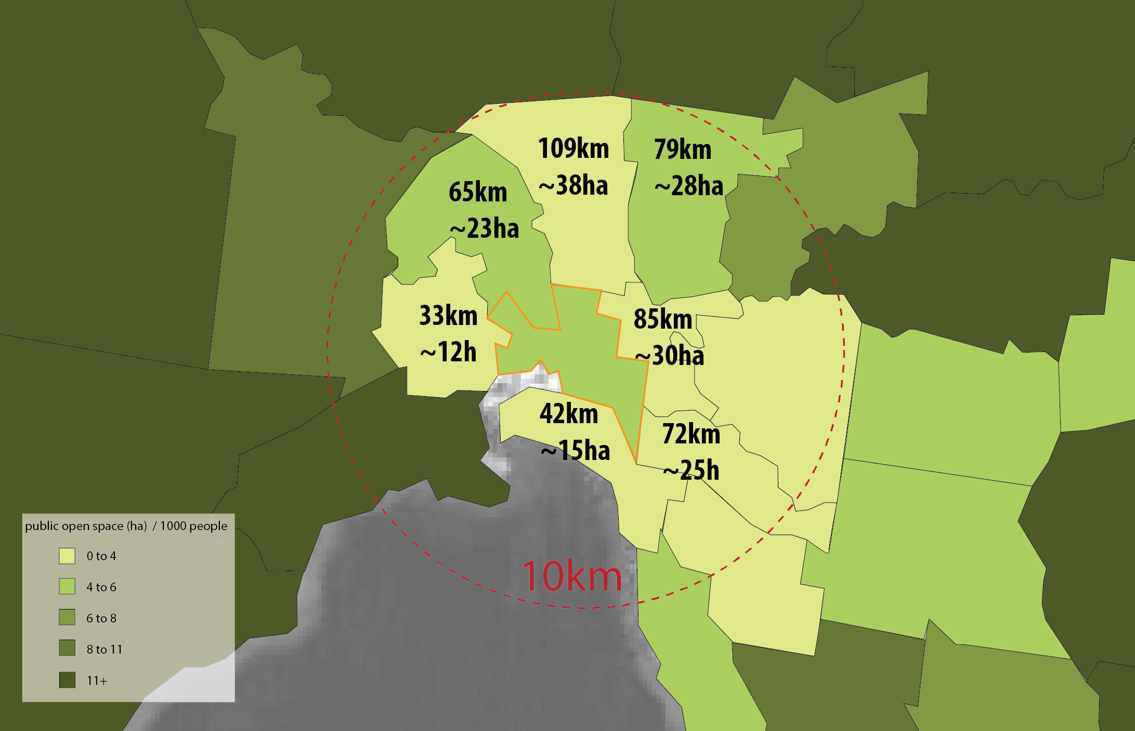
Figure 1. Open space densities in Metropolitan Melbourne and length/area of laneways in inner city councils (Victorian Environmental Assessment Council 2011; City of Yarra 2013; City of Stonnington 2013; City of Port Phillip 2011; Moreland City Council 2014; City of Moonee Valley 2013; Maribyrnong City Council 2007; City of Darebin 2013)
The land that is currently occupied by residential laneways in Melbourne’s inner-city councils could be the last remaining significant amount of underused inner-city land. While a single laneway is a relatively tiny fragment, when considered collectively, laneways add up to a considerable amount of space. As Figure 1 illustrates, there are at least 171 hectares of laneways in seven inner-city councils (assuming an average laneway width of 3.5 metres). These laneways are publically accessible spaces, but they have not been given the same consideration by local governments and planning agencies as other types of open spaces in the city.

Public open spaces are “open, publicly accessible places where people go for group or individual activities” (Carr et al. 1992, p.50), and they encompass many different types – from parks to building steps (Carr et al. 1992). The literature has discussed the value of public open spaces for the social well-being of people in the city (Gehl 2010; Whyte 1980; Jacobs 1961; Thompson 2002; Wolch et al. 2005). It was also suggested that open spaces that incorporate elements of natural landscapes have a restorative effect on people (Chiesura 2004; Ulrich 1981). In addition, open space has been increasingly examined through the lens of green infrastructure as a network of green spaces that provides benefits to urban biodiversity and mitigation of impacts of climate change on cities (Newell et al. 2013; Benedict & McMahon 2002; Gill et al. 2007). Even though residential laneways are considered a type of open space, they are not being examined within any of these contexts.

Currently, all residential laneways in metropolitan Melbourne are classified as Right-of-Ways or the smallest increments of the road network, which is similar to other cities that have large laneway networks. However, in practice, people reappropriate them in numerous other ways. Also, they are experienced differently than streets. Lewis Mumford reflected on this difference eloquently in his paper “Planning for the Phases of Life”:

“…I had for choice, in my walks to the university, either the sight of the trimly tailored front lawns of the prosperous houses, or the rear service lanes that ran parallel, with their outbuildings and occasional clutter, their unexpected glimpses or carpenter sheds and garden tools, of a motor car being repaired or a heap of plant clippings waiting to be carted away; and more often than not, I would prefer the rear alley, precisely for all these little hints of life, activity, transition, which the placid visual arts of suburbia did their best to supress or politely disguise. Animation, though at the price of a little disorder, is more exhilarating, even aesthetically, than frozen respectability” (Mumford 1949, p.8).

Residential back-laneways in Melbourne’s inner suburbs would fit Mumford’s description (Figure 2). As a leftover infrastructure from the 19th century they can be considered a part of what’s called residual urban space (Villagomez 2006). This type of space was created accidentally through abandonment of its original usage, demolition or planning by-laws. Like other types of residual spaces, residential back-laneways are often described as derelict, underused, and obsolete, and are perceived as liminal and as having an unclear purpose and unrealized potential (Berger 2007; Villagomez 2006). Any existing functional uses of residual space are difficult to recognize because they do not fall within conventional “aesthetic expectations, urban habitual patterns and processes” (Foster 2014, p.125). The value of such space is difficult to assess because the extent, range, and meanings of informal uses that take place there are not obvious to policymakers and the general population (Pearsall & Lucas 2014).

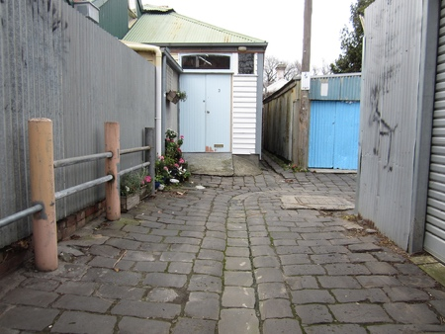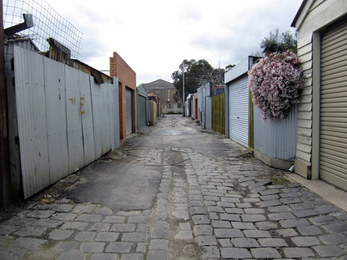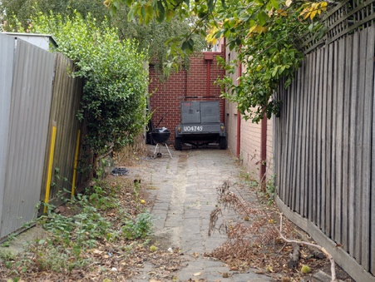

Figure 2. Residential back-laneways in Melbourne’s inner-city suburbs

Examining where and how people appropriate space in the city, and what they do in such space could provide valuable insight into people’s needs and desires. This is particularly insightful when these new activities that arose through appropriation are different from the activities that were initially intended (Rivlin 2007). Appropriation of space is defined as “an interactive process through which individuals purposefully transform the physical environment into a meaningful place while in turn transforming themselves” (Feldman & Stall 1994, p.172). This happens through balancing changes over time within a structure that provides both form and substance for such processes to take place. The process of appropriation of space requires continuous reappropriations in order to maintain its usefulness and value (Proshansky 1976). When interest in this concept is oriented towards the built environment, the material dimension that characterizes space has to be considered (Proshansky 1976), in order to examine to what extent different settings enable or constrain different types of reappropriations.

Looking at the literature on physical characteristics and reappropriations of laneways in Australian context does not yield much insight, as the literature is almost non-existent. However, literature in the international context suggests that residential back-laneways are sites of social and spatial negotiations (Imai 2013; Dovey et al. 2012; Seymour et al. 2010); thus like other public spaces, they are inherently contested with competing interests and conflicting uses. Back-laneways are regarded as both informal community spaces (Martin 1996; Ford 2001; Hess 2008) and problematic spaces (Guttery 2002; Bowers et al. 2005), commonly associated with criminal and anti-social activities such as graffiti, drug injection, illegal dumping, and home burglaries. Historically, they have also accommodated the housing needs of a growing urban population, such as in 19th century North American cities where houses on the back-laneways played an important role in the housing landscape (Groves 1974; Mosher & Holdsworth 1992; Borchert 1973; Beasley 1996). While views on the residential laneways vary, there is also a compelling argument that they are a potentially valuable resource in inner-city areas that have a shortage of public open space (Wolch et al. 2010; Moreau 2015). But to understand their capacity for usage as such requires a better understanding of their existing physical conditions and activity patterns. Even though laneways currently occupy a vast amount of prime urban land, there is very little understanding about how their existing physical features, including interface conditions, enable or constrain their usage as open space.

Background literature
To what extent the built environment is accountable for peoples’ activities has been investigated by various disciplines, such as urban design, landscape architecture, anthropology, human geography, sociology, and environmental psychology. However, as it is acknowledged that the built environment neither determines nor is irrelevant to human actions, making a direct link between the two has presented challenges in studying their relationships. Perhaps for that reason, the literature is not consolidated around a particular approach, as different theories offer different levels of insight.

Study of urban form or morphology is defined as “study of the city as human habitat” in which physical elements of the city (e.g. buildings, gardens, streets) are seen as continuously “shaping and being shaped” by people and spaces around them (Moudon 1997). Morphological analysis utilises built-unbuilt representation, commonly referred to as figure-ground, which renders built space as “figure” while unbuilt space is left as blank thus reading as “ground”. An advantage of this representation is that the pattern relationship between built and unbuilt spaces is easy to grasp. However, as the boundary between these spaces is reduced to a line, this analysis does not make known how these relationships work at the level of this interface (Chow 2002). Typomorphology makes a contribution here, as it is morphological analysis that examines urban form (morphology) through classification (typology) of buildings and open spaces (Moudon 1994). Data are drawn from maps and archives, and the built environment is analyzed at multiple scales. Morphology of the city form is seen as a product of dynamic relationships between the built landscape of the city and its people over a long period of time.

On the other hand, there is space syntax morphological analysis that seeks to explain socio-spatial relationships that hold true at a certain point in time. Space syntax is a set of theories and techniques that examines the relationships between social processes and physical properties of a city (Hillier & Hanson 1984). While space syntax is mostly recognized for its approach to network analysis, its less-cited analysis of settlement layout, or alpha analysis, offers more insight into relationships between built/private and open/public spaces. While it is called “analysis of settlement”, which might imply the entire settlement or city, it can also be used in the analysis of sections of a city such as neighborhoods. Alpha analysis examines the relationships among four parts of settlement: 1) buildings (X); 2) property boundaries (x); 3) open space (y); and 4) surrounding space outside the settlement (Y) (Hillier & Hanson 1984). Settlement layout is examined as a sequence of X-x-y-Y where the X axis (building) is the domain of “insiders” and the Y axis (space outside the system) is the domain of “outsiders.” The interface between buildings (X) and open space (y) is examined through arrangements of ‘boundaries’ and ‘permeabilities’, such as doors, gates, and windows in buildings, and if applicable, the presence of these in secondary boundaries (x) (Hillier & Hanson 1984). This analysis shows relationships at a certain point in time, assuming that settlements are continuously evolving. With the exception of newly built areas, space syntax suggests that these patterns of arrangements are produced largely from ‘bottom-up’ processes and through interventions by various agents over a long period of time (Hillier 2002).

Anderson (1978) also proposes to examine the built environment as a material entity that continuously interacts with a range of activities that are undertaken by individuals and groups. However, the focus is on examining the capacity of the built environment to enable or constrain human activities, rather than analysing the relationships that hold true at one point in time. Anderson proposes to regard the built environment as a “potential environment”, which when it becomes adopted by one or more users becomes that user’s or group’s “influential environment.” The difference between the two represents a “latent environment”, which may not be easily recognized and thus needs to be revealed through “modelling” (Anderson 1978). That is done by incorporating “ecological information”, obtained from field observations, into conventional maps. One of the interests of this approach is examining overlapping conditions where publicly accessible space extends into buildings, and where private space occupies open space.
Jan Gehl’s approach in studying public/private interface in residential streets in Melbourne aligns with this approach in its focus on how the public space of a street overlaps and interacts with the private spaces of dwellings (Gehl 1977). Gehl’s main distinction is between the “soft” interface with a gradual transition and the “hard” interface which is direct in nature (Figure 3). The soft interface entails the transitional space of a front yard, which Gehl believes offers more “opportunities to stay on the public side of the house and to interact passively or actively with people in the street or in other front yards” (Gehl 1977, p.23). While this study of interfaces in Melbourne’s suburbs includes detailed mapping of activities and interface conditions on streets, it entirely omits back-laneways despite their high prevalence in those areas.
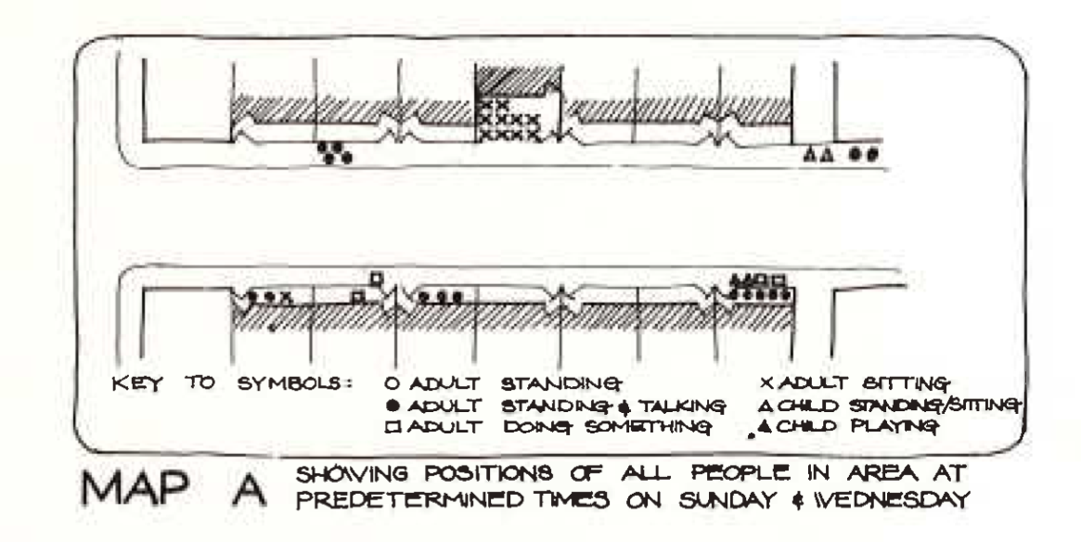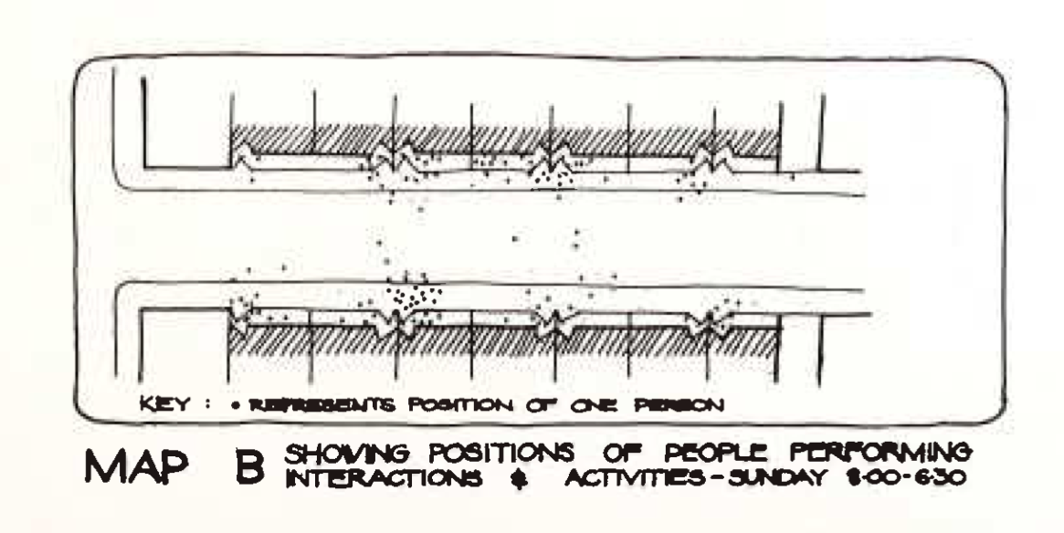

Figure 3. Mapping of activities (Gehl 1977)

Dovey and Wood (2014) took a more inclusive approach to examining public/private interface conditions in Melbourne’s inner suburbs. The aim of the study was to understand “practices of innovation, adaptation and transformation from one interface type to another” (Dovey & Wood 2015, p.1). Focusing on the criteria of physical and visual permeability, setback, and primary mode of access, they propose five interface types: impermeable/blank, direct/opaque, direct/transparent, pedestrian setback, and car setback (Figure 4). Their interface typology encompasses both Anderson’s interest in overlapping claims, Gehl’s approach in transition space from public to private, and analysis of boundaries and permeabiities of space syntax alpha analysis. Unlike Gehl (1977), Dovey and Wood’s interface typology includes some conditions commonly found in laneways, but does not address all the settings that are present in residential back laneways.

Figure 4. Interface typology (Dovey and Wood 2014)

As is evident from this summary of different studies, they are all tailored to the objectives of their inquiry and its context while also sharing an interest in examining built/unbuilt relationships, boundaries/permeabilities, and overlapping territories/claims. In drawing out interface typology for back-laneways, it is important to acknowledge that even though laneways are classified as roadways, they do not function like an average street. Unlike streets which have always interacted with the public face of private domestic territories, laneways were initially placed to be in the back with an interface that was primarily used for sewage collection and other unsightly domestic uses. This interface has evolved over time as the purpose of laneways has changed. In order to make visible the different forms of transformation, this paper surveyed a large area of inner-city Melbourne to capture the diversity and prevalence of different interface types.

Case study area
The focus of this paper is on several inner-city suburbs in Melbourne, Australia, which fall within two local government areas, the City of Yarra and the City of Moreland. The entire study area covers 13.7 km², and it has one of the largest laneway networks in metropolitan Melbourne. This part of Melbourne also has low open space density per capita (Figure 2) (Victorian Environmental Assessment Council 2011). The entire area is diverse in urban morphology, housing stock, and population, due to gentrification that has been ongoing since the 1990s. All the laneways in the study area are classified as vehicular right-of-ways, regardless of their actual use or physical dimensions. This study took place at a time of relative awareness about residential back-laneways in both councils, and during an ongoing public debate about their reappropriation to new uses.

Methodology
All laneways within the study area were visited at least once during 2015-2016. Each laneway was photographed at multiple locations, such as at an intersection with streets or other laneways, and throughout a block. In addition, activities and physical traces of activities were photographed and documented on maps and field notes. Almost 4,000 photographs were taken during the fieldwork campaign, and were location-coded and analysed for both content and location. This information was overlain onto morphology maps and further analyzed for prevailing patterns. The photographs were reviewed multiple times and were the primary data used for developing a typology of prevailing public/private interfaces in laneways. The following criteria for the development of typology were drawn from the literature, but were also tailored to specific conditions of residential laneways in Melbourne.

Accessible / Inaccessible | This criterion defines whether a laneway can be directly accessed from the private plot/residence.
Car / Pedestrian | This criterion considers if the mode of access is by car, foot, or both.
Front Access / Back Access | This criterion distinguishes whether an entrance from a laneway is used as a 1) back access; 2) front access for a secondary dwelling in the back of the plot; or 3) a primary access for a dwelling fronting the laneway.
Direct / Setback | This criterion identifies whether the legal boundary between the laneway and the plot is articulated as a vertical boundary or as a transitional space.

These typologies were than analyzed in relation to public reappropriations that were documented during fieldwork, to examine their occurrences in certain interface configurations.

Findings

Interface
The overall character of residential laneways in Melbourne’s inner-city suburbs is defined by their narrowness and their back-sidedness. They were created in the pre-automobile era for back service access to properties, so the spatial dimensions of many laneways do not reflect contemporary requirements for car access. The legal cadastral boundary between plots and laneways has a strong vertical demarcation in the form of fences and walls. While some houses have windows facing laneways, visual permeability is usually blocked through the use of blinds or frosted glass. Windows are often covered with window security grills, which is even true even on the upper levels.

This study first identified different configurations which could enable or constrain access, modes of access, the primary function of access, and transitional space. Design elements and the age of buildings were considered afterward, to understand the implications that different building and interface types could have on laneways. Although interface typology is related to building typology, there is no direct transfer from one typology to the other; this means that different types of buildings can have the same type of public/private interface.

The aim here was neither to draw out every possible interface type, nor to treat these types as stable categories. The purpose here was to make visible the most distinct types found across the entire study area. As analysis of interface conditions progressed, it became evident that an interface is constantly evolving as new demands create new conditions.

Four criteria outlined above were used to analyze photographs from fieldwork, from which seven different interface types were identified (Figure 5).

- Impermeable. The plot is physically impermeable to the laneway. There is no point of entry / exit into the plot from the laneway for people moving either on foot or in vehicles. An example of this interface type is a fence or a wall.
- Back door. The interface is still vertically demarcated with a fence or a wall, but there is an entry / exit point for direct human movement between the laneway and property. This is a secondary entrance into the plot, as the primary entrance is still on the street.
- Back garage. The interface has a strong vertical demarcation along the cadastral boundary, but there is a garage door which can serve as a point of entry / exit. These garage doors also accommodate movement on foot and bicycle. Sometimes this interface is accompanied by a back door. This kind of interface is found across different building types, from a single family home to a large apartment building with a back-loading underground garage.
- Front door. This is the main point of entry for a dwelling. In some instances, the dwelling might be a secondary dwelling on a plot such as a granny-flat while the main house is still facing the street. In other instances, this interface is found on midblock infills of single family homes.
- Front dual access. In this instance, entrances for both cars and people are present. This is the only way to enter the dwelling. The laneway is no longer in the back, but in the front of dwelling. This is often found in new infill housing such as conversions from light-industrial to residential, backyard infills at the intersection of a laneway and a street, and new mid-block single family homes.
- Front dual access with setback. This interface is similar to the previous one in having the dual front entrance on the laneway, but the building is slightly offset from the cadastral boundary. This interface is often seen in infill developments where the offset provides an additional width for cars to turn in and out of the garages.
- Transition. In this instance, the interface along the property boundary is occupied by a transition space, often in a shape of on-ground parking. The building is offset, and the front, side, or back of the building can be oriented towards the laneway.

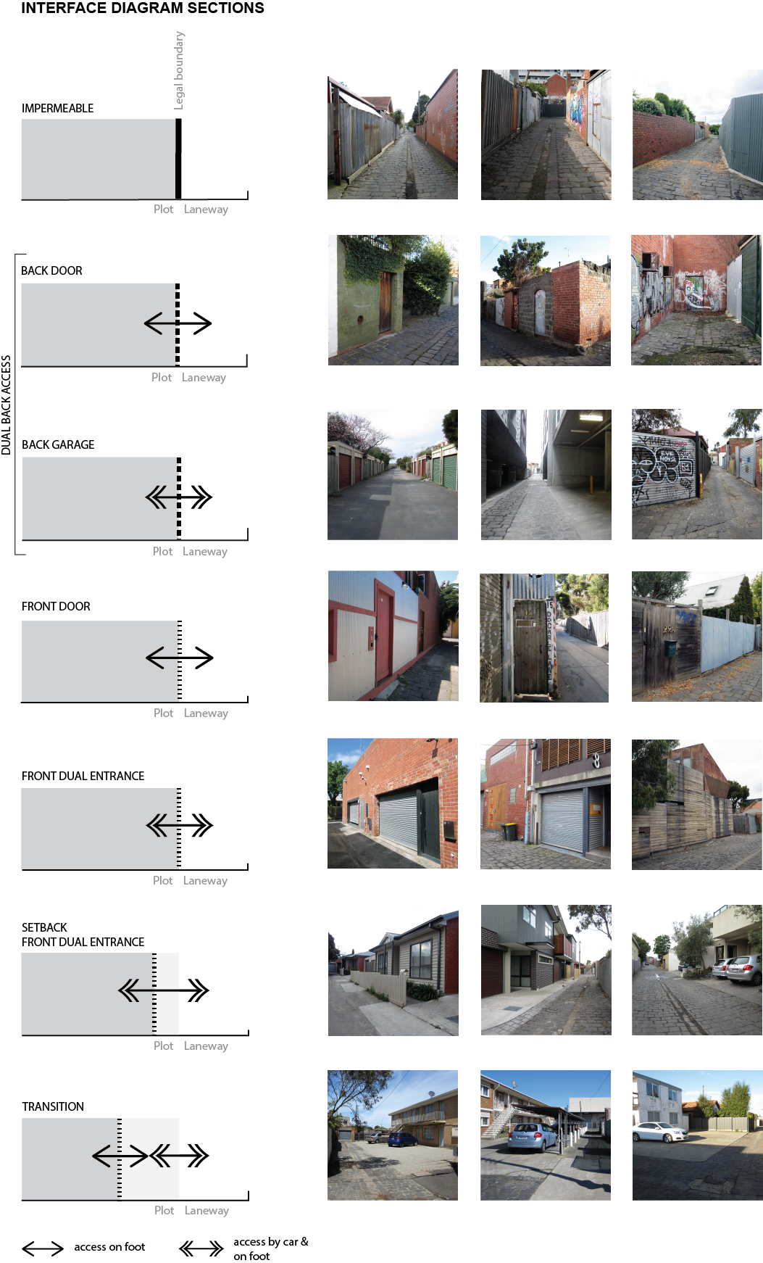

Figure 5. Public/private interface types on residential laneways

Reappropriation
From fieldwork observations, it became evident that laneways are used in a variety of ways (Figure 6). This encompasses different forms of reappropriation and gradients of legality, permanence, and materiality. Detailed analysis of reappropriations of laneways is outside of the scope of this paper. Instead, two very different forms of adaptation will be examined to consider the capacity of public/private interface configurations to enable or constrain adaptation for public uses. These two types of reappropriations are the creation of informal open space and infill housing development.

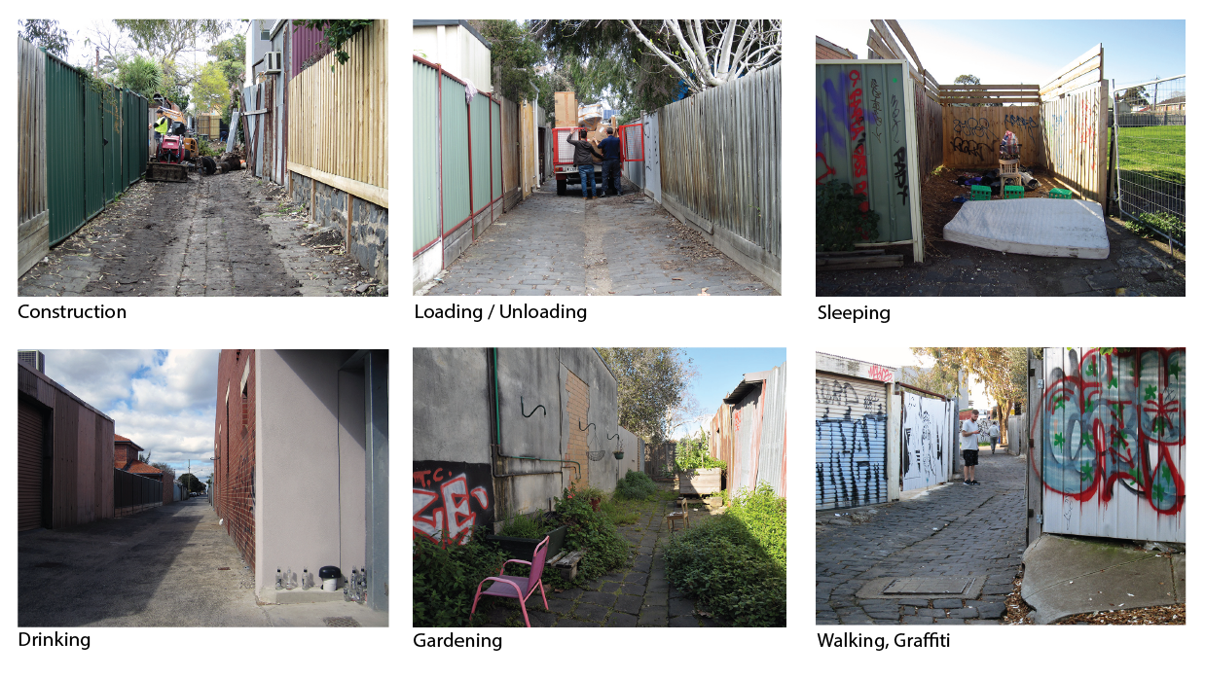

Figure 6. Examples of uses of residential back-laneways

Informal open space
When examining instances in which back-laneways were reappropriated as open space for personal and community use, it became apparent that they preferred more undetermined interface conditions. These were the laneways with an interface that is dominated by the back-sidedness (Figure 9). The interface on these laneways is a mix between impermeable, back door, back garage, and front door (for back unit) types. Fieldwork observations, personal anecdotes of laneway residents, morphological analysis of laneway, and review of aerial photographs show that while most plots have garage-like back access, the back of the property is not necessarily used to park a car. From the interface alone, it is not clear whether a laneway is primarily used by cars or people moving on foot; the conditions are undetermined.

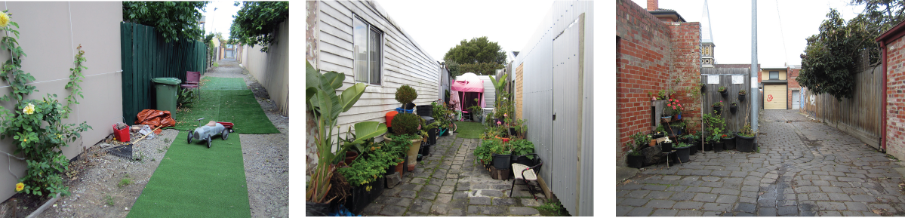

Figure 9. Reappropriation of residential back-laneways as informal open space

When laneways are reappropriated as open space for individual and public use, changes are temporary in nature. They can be modified as needed, as well as completely removed. They do not significantly change the interface condition, but rather adapt to it.

Backyard infill housing development
Backyard infill development is a lot-scale approach to residential infill, in which a traditional suburban lot with one house and back/front yards is converted into multiple attached dwellings without private open space (Figure 7). This change happens through legal means, through planning and design approval from the local government.

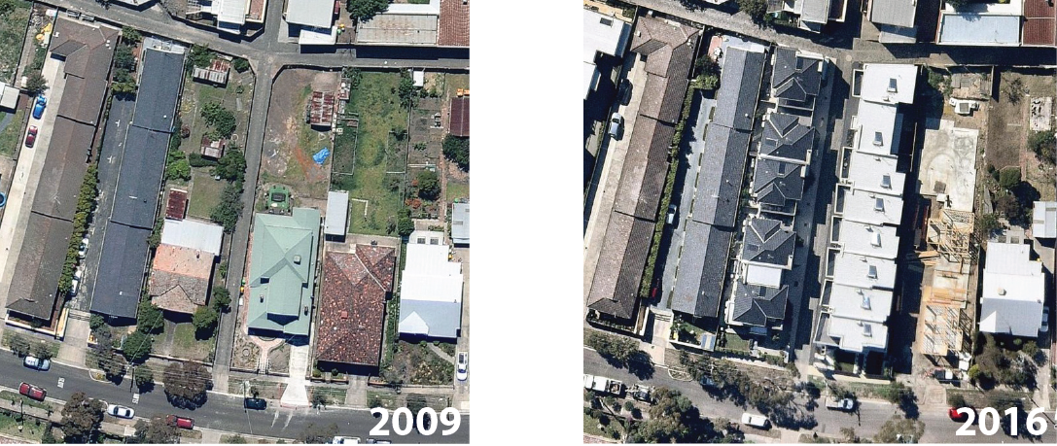

Figure 7. Densification through backyard infill development

This type of adaptation is not influenced by the existing interface conditions, but instead it produces a new long-lasting physical change on laneways. When backyard infill development takes place on a plot that is along the laneway, the front access into residential dwellings shifts from the street into the laneway. The interface condition changes from the back boundary of the plot to a front dual entrance (Figure 8). The laneway is no longer in the back, but clearly in the front of the building, serving as the main entrance and front loading driveway. What was once undetermined space of back-laneway becomes an overly determined space of a residential driveway.

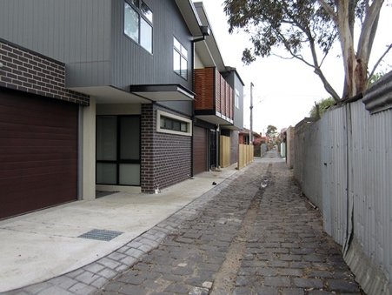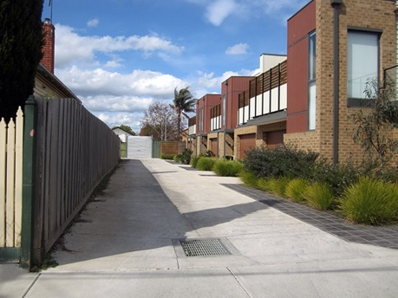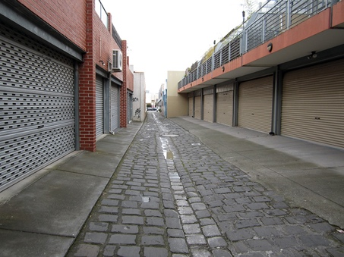

Figure 8. Infill development and creation of new type of interface

Orienting the dwelling towards the laneway does not necessarily create more activities or public engagement on the laneway. The front loading laneways do not have the spatial and functional complexity of streets, which have layers of building interfaces, front gardens, footpaths and their amenities, street trees, and roads. This kind of infill development produced a laneway that has neither the ambiguity of a back-laneway nor the complexity of a street. It becomes an overly determined space, being simply a driveway into garages.

Conclusion
While the literature has identified numerous social, economic, and environmental benefits of urban open space, current planning practices in Melbourne do not acknowledge such possibilities in regards to residential back-laneways. At least 171 hectares of laneways in seven inner-city councils are not regarded as an asset in addressing sustainability objectives. Instead, it seems that residential laneways are left to evolve slowly through infill developments, which permanently alter interface conditions and turn them into the single purpose space of residential driveways. These newly produced overdetermined conditions do not leave much room for other forms of adaptations, such as the creation of informal open spaces. The argument here is not to completely abolish infill housing, but to consider its impact on the loss of both public and private open space in inner-city suburbs. Other prospects and possibilities for residential back-laneways should be considered, especially those which align with larger environmental and social sustainability objectives. The purpose of this paper was to contribute to making visible the existing conditions in residential back-laneways and their associated values, and to establish an empirical framework from which to more rigorously evaluate their prospects.

References
Anderson, S., 1978. Studies toward an ecological models of the urban environment. In S. Anderson, ed. On Streets. Cambridge: The MIT Press.
Beasley, E., 1996. The alleys and back buildings of Galveston: An architectural and social history, Houston: Rice University Press.
Benedict, M.A. & McMahon, E.T., 2002. Green Infrastructure: Smart conservation for the 21st century. Renewable Resources Journal, 20(3), pp.12–17. Available at: http://ec.europa.eu/environment/nature/info/pubs/docs/greeninfrastructure.pdf.
Berger, A., 2007. Drosscape: Wasting land in urban America, New York: Princeton Architectural Press.
Borchert, J., 1973. Alley life in Washington: An analysis of 600 photographs, Washington D.C.: Historical Society of Washington, D.C.
Bowers, K.J., Johnson, S.D. & Hirschfield, A.F.G., 2005. Closing off opportunities for crime: an evaluation of alley-gating. European Journal on Criminal Policy and Research, 10, pp.285–308.
Carr, S. et al., 1992. Public Space, Cambridge: Cambridge University Press.
Chiesura, A., 2004. The role of urban parks for the sustainable city. Landscape and Urban Planning, 68(1), pp.129–138.
Chow, R.Y., 2002. Suburban space: The fabric of dwelling, Berkeley and Los Angeles: University of California Press.
City of Darebin, 2013. Register of public roads,
City of Moonee Valley, 2013. Moonee Valley City Council Right of Way Register ( Appendix C of the Road Management Plan 2013-2017 ),
City of Port Phillip, 2011. Activating Laneways Strategy City of Port Phillip,
City of Stonnington, 2013. City of Stonnington Council Plan 2013-2017,
City of Yarra, 2013. D13 47929 Road Management Plan 2013,
Dovey, K., Wollan, S. & Woodcock, I., 2012. Placing graffiti: Creating and contesting character in inner-city Melbourne. Journal of Urban Design, 17(1), pp.21–41.
Dovey, K. & Wood, S., 2015. Public/private urban interfaces: Type, adaptation, assemblage. Journal of Urbanism: International Research on Placemaking and Urban Sustainability, 8(1), pp.1–16.
Feldman, R.M. & Stall, S., 1994. The politics of space appropriation. In I. Altman & A. Churchman, eds. Women and the environment. New York: Springer Science+Business Media, LLC, pp. 167–199.
Ford, L.R., 2001. Alleys and urban form: Testing the tenets of New Urbanism. Urban Geography, 22(3), pp.268–286.
Foster, J., 2014. Hiding in plain view: Vacancy and prospect in Paris’ Petite Ceinture. Cities, 40, pp.124–132.
Gehl, J., 2010. Life Between Buildings, The Danish Architecture Press.
Gehl, J., 1977. The interface between public and private territories in residential areas, Parkville: Department of Architecture and Building, Melbourne University.
Gill, S.E. et al., 2007. Adapting cities for climate change: The role of the green infrastructure. Built Environment, 33(1), pp.115–133.
Groves, P.A., 1974. The “hidden’’ population: Washington alley dwellers in the late nineteenth century. The Professional Geographer, 26(3), pp.270–276.
Guttery, R.S., 2002. The effects of subdivision design on housing values: The case of alleyways. Journal of Real Estate Research, 23(3), pp.265–273.
Hess, P.M., 2008. Fronts and backs: The use of streets, yards, and alleys in Toronto-area New Urbanist neighborhoods. Journal of Planning Education and Research, 28(2), pp.196–212.
Hillier, B., 2002. A theory of the city as object: or, how spatial laws mediate the social construction of urban space. Urban Design International, 7(3–4), pp.153–179.
Hillier, B. & Hanson, J., 1984. The Social Logic of Space, Cambridge: Cambridge University Press.
Imai, H., 2013. The liminal nature of alleyways: Understanding the alleyway roji as a “Boundary” between past and present. Cities, 34, pp.58–66.
Jacobs, J., 1961. The Death and Life of Great American Cities, New York: The Modern Library.
Maribyrnong City Council, 2007. Maribyrnong city council laneway strategy, Maribyrnong City Council.
Martin, M.D., 1996. Back-alley as Community Landscape. Landscape Journal, 15(2), pp.138–153.
Moreau, M., 2015. A Methodology for exploring relationships among physical features of residential back-laneways and their uses. In State of Australian Cities Conference 2015: Refereed proceedings. Goald Coast: Urban Research program at Griffith University on behalf of the Australian Cities Research Network.
Moreland City Council, 2014. Annual report 2013-2014,
Mosher, A.E. & Holdsworth, D.W., 1992. The meaning of alley housing in industrial towns: Examples from late-nineteenth and early-twentieth century Pennsylvania. Journal of Historical Geography, 18(2), pp.174–189.
Moudon, A.V., 1994. Getting to Know the Built Landscape: Typomorphology. In K. A. Franck & L. H. Schneekloth, eds. Ordering Space: Types in Architecture and Design. New York: Van Nostrand Reinhold, pp. 289–311.
Moudon, A.V., 1997. Urban morphology as an emerging interdisciplinary field. Urban Morphology, 1, pp.3–10.
Mumford, L., 1949. Planning for the Phases of Life. The Town Planning Review, 20(1), pp.5–16.
Newell, J.P. et al., 2013. Green alley programs: Planning for a sustainable urban infrastructure? Cities, 31, pp.144–155.
Pearsall, H. & Lucas, S., 2014. Vacant land: The new urban green? Cities, 40, pp.121–123.
Proshansky, H.M., 1976. The appropriation and missappropriation of space. In P. Korosec-Serfaty, ed. Appropriation of space: Proceedings of the 3rd international architectural psychology conference. Strasbourg: Louis Pasteur University.
Rivlin, L.G., 2007. Found spaces: Freedom of choice in public life. In Loose Space: Possibilities and Diversity in Urban Life. New York: Routledge, pp. 38–53.
Seymour, M. et al., 2010. Resident perceptions of urban alleys and alley greening. Applied Geography, 30(3), pp.380–393.
Thompson, C., 2002. Urban open space in the 21st century. Landscape and Urban Planning, 60(2), pp.59–72.
Ulrich, R.S., 1981. Natural Versus Urban Scenes: Some Psychophysiological Effects. Environment and Behavior, 13(5), pp.523–556.
Victorian Environmental Assessment Council, 2011. Metropolitan Melbourne investigation: final report, Melbourne.
Villagomez, E., 2006. Claiming residual spaces in the heterogeneous city.
Whyte, W.H., 1980. The social life of small urban spaces, Washington D.C.: Conservation Foundation.
Wolch, J. et al., 2010. The forgotten and the future: Reclaiming back alleys for a sustainable city. Environment and Planning A, 42(12), pp.2874–2896.
Wolch, J., Wilson, J. & Fehrenbach, J., 2005. Parks and park funding in Los Angeles: An equity-mapping analysis. Urban Geography, 26(February 2015), pp.4–35.

