Map Mashups revisited: Employing discursive planning tools for Perth’s urban future
Carey Curtis¹, Jan Scheurer¹², Sam McLeod¹
Curtin University, Perth¹, RMIT, Melbourne²

Abstract: Digital mapping tools, and the “map mashups” they enable, may facilitate new and richer discourses about salient planning issues, particularly among stakeholders without specific expertise in geospatial technologies (Batty et al., 2010). In October 2016, the authors hosted a day-long workshop for transport and land use planning decision-makers from public agencies and private practice in Perth, bringing together innovative digital mapping and discourse facilitation tools, in an interactive presentation laboratory. These included the Spatial Network Analysis for Multimodal Urban Transport Systems (SNAMUTS) tool, and several complimentary techniques operating at smaller spatial scales, with a final 35-year backcasting tranche to identify perceived implementation blocks.

This paper describes and summarises the methodological approach, and by drawing on participant observation and feedback, reports key outcomes of the workshop. The extent to which contemporary map mashups and interactive presentation facilities may add value in planning decision-makingis explored. Our interest is whether the approach: deepens stakeholder’s understanding of the complexity and contextual dimensions of futures planning; improves transdisciplinary stakeholder communication about common planning challenges; and, whether it mobilises tacit knowledge relevant for these tasks.

Through experimental testing, many challenges highlighted in the literature became evident. There was also some difficulty among participants in the ability to engage in intertemporal decision making. Employing map mashup techniques in planning contexts to greatest effectiveness must include acknowledging the experimental nature of the processes and providing participants with opportunities to express general insights separately to specifically structured PSS tool input.

Key words: Map Mashups, Planning Support Systems, Backcasting

Introduction
Internet technologies have increasingly enabled users and amateurs to easily present and analyse geographic information on web mapping platforms (Batty et al., 2010). Platforms such as Google Maps have increased accessibility to spatial and local place information for an almost full range of urban stakeholders (Vandeviver, 2014). Concurrently, experts and researchers have sought to develop planning or decision support systems (PSS), typically with the objective of informing and improving critical choices about societies, economies and cities in which people live (May et al., 2008, Brömmelstroet, 2013, Pelzer and Geertman, 2014). As only a long-term planning horizon allows for strategic decisions to be made and implemented effectively, it is critical to acknowledge that planning decisions require a consistent and accurate flow of information (Eweje et al., 2012). Knowledge theorists and popular journalists have hypothesised about the potentially disruptive nature of increasingly large databases and interpretive algorithms, both epistemologically, and in terms of how knowledge-based professions will change in coming decades (Anderson, 2008, Kitchin, 2014). Planning is one such profession, unique in the long future time scale in which planners seek to be effective.

Disciplines such as urban planning have long relied on weak forms of evidence, including personal anecdotes, professional and lived experience, outside precedents, political ideology, and theoretical fashion (Krizek et al., 2009, Davoudi, 2006). Urban planning decisions, particularly those which relate to very large infrastructure investments, may suffer from fallacious thinking, bias, unreasonable discounting, or other forms of unethical practice (Flyvbjerg, 2013, Kahneman and Tversky, 1979, Van Wee, 2011). In many jurisdictions, transport investments have long been subject to political “pork-barrelling” and disingenuous long-term promises made for self-serving short-term ends (Legacy et al., 2017, Hoare, 1992). Urban policy often suffers with limited interrogation of related empirical research (Krizek et al., 2009). Critiques of rational planning have articulated that the full gamut of consequences to complex planning decisions cannot be known, and attempts to comprehensively model them inevitably fail, due to the finite nature of time and the infinite complexity of options (Hostovsky, 2006). These problems – and the potential for cities to become dramatically more efficient and sustainable than at present - amplify the promise of decision support tools. Principally, the aim of planning support systems (PSS) is to provide useful and relevant information, at the moment decisions are considered.

Conversely, the use of PSS tools has been criticised as being technocratic, leading, opaque, confusing, inflexible and insensitive to contextual information (te Brömmelstroet and Bertolini, 2008).This controversy and difficulty in meaningfully using PSS, particularly with highly experienced senior decision-makers, highlights the ongoing challenge of realising the promise of applying technology to improve planning decisions and governance (Pelzer and Geertman, 2014, Pelzer et al., 2014, te Brömmelstroet, 2013, te Brömmelstroet et al., 2016). Clearly, there remains much work to be done to understand the implications of new spatio-temporal analysis and knowledge translation technology to strategic city planning. In view of the deficiencies in “rational” normative urban planning practice, and the possible pitfalls of PSS application, we experimented with planning support systems in a transparent, open, and playful experimental environment.

This paper describes the process, results and insights gained from a one day workshop utilising three different PSS tools for different spatial scales and inter-related planning questions. At the metropolitan scale the Spatial Network Analysis for Multimodal Urban Transport Systems (SNAMUTS) tool was employed to explore urban structure possibilities for Perth in 2050. Then, drawing on the understanding from outcomes at that scale, precinct design charrettes were employed to test the ability to deliver the contingent urban structure at the activity centre scale, prompting revision at the metropolitan level through iterative feedback. Finally an experiment in backcasting was employed to formulate an implementation plan based on an understanding of currently understood impediments.

After a brief review of related technologies – which informed the workshop design – we describe the workshop rationale and research approach. We then report the results of the workshop day, drawing on participant and observer feedback. The diversity in outcomes is discussed, as are the challenges in mapping and analysing the unstructured and spontaneous comments of high-level strategic thinkers. A critical reflection closes the paper.

Decision Support Tools
Increasingly, researchers are developing spatial representation and analysis tools as a means of applying knowledge and improving deliberative practice (Krizek et al., 2009, Medina, 2006). Maps are a fundamental medium for the practice of planning, used universally to consider, design and transact urban space. Maps are particularly useful for consulting and collaborating across stakeholder groups (Craig and Elwood, 1998, Pelzer and Geertman, 2014). In recent decades, many map-based planning support tools aimed at achieving more sustainable outcomes have emerged, reflecting the emerging paradigm (Barandier Jr, 2015). While this paradigm acts as the basis for many of the PSS identified in the literature, the careful adaption of such tools is complimentary to postmodern and communicative planning principles, and citizen-led governance practices, which continue to mature, particularly in the developing world (Sagaris, 2014, Miraftab, 2009). While many PSS are primarily map-based, it is crucial to note that a diverse range of PSS support tools have been developed, and may be applied to a wide range of traditional planning activities (Hanzl, 2007).

Decision support tools aim to increase the translation of knowledge in practice. Urban planning has long dealt with urban problems with the use of technocratic standards or tools based upon prevailing knowledge (Krizek et al., 2009). For instance, building standards arose out of Victorian-era industrial cities, while roadway engineering handbooks and traffic demand prediction models encoded the thinking of 1960s modern rational planning (Southworth and Ben-Joseph, 1995). Many PSS tools are geospatial and map-based, though maps may be absent or secondary to more discursive systems (such as the backcasting tool described in this paper). Almost invariably, though, visualisations are used to represent analysis of the direction of the input or discussion. The development of the current generation of PSS tools must wrangle with the complex multiplicities, uncertainties and disruptive realignments of postmodern and intergenerational sustainability issues of the present age.

Geospatial tools
Planning decision support systems and environments predate the contemporary internet. Similarly, we must acknowledge the definition of PSS as very broad and inclusive of a diverse set of technologies. Often recognised as a pioneering early example of an electronic decision support system, Stanford Beer’s Cybersyn (Pettit et al., 2017), aimed to support the decisions of Chile’s socialist government during the early 1970s, by diagrammatically mapping real-time economic and political data in a control/command room, in which economic decisions were centrally made (Crampton, 2017, Medina, 2006). In the following decades, as personal computers have become ubiquitous, a large diversity of urban simulation tools and experimental city-building platforms have been widely tested, and have proved useful in a broad range of learning contexts. The term Geodesign describes the “on-the-fly” application of analytical capabilities of GIS software to the (traditionally qualitative) planning and design process (Pelzer and Geertman, 2014). Geodesign and PSS development frameworks are becoming packaged or programmed to directly interface with established GIS software platforms. Just as geospatial technology platforms have become commonplace software products (Batty et al., 2010), PSS tools are being packaged within broader GIS tools. CommunityVis, an extension of ArcGIS, is one such commonly utilised software platform, used to generate multiple forms of visual feedback to spatial design concepts (Pelzer and Geertman, 2014, Pelzer et al., 2014, Pontius and Si, 2015). Land use transport interaction and integration models, which have been developed using a wide variety of technologies by a broad range of researchers operating in different contexts (Papa et al., 2016, te Brömmelstroet et al., 2016), now benefit from a wide range of available supporting geospatial platforms capable of maximising both their functional capacities and their computational efficiency. While researchers and formal city-building institutions have devised complex urban analysis and scenario evaluation tools (te Brömmelstroet, 2013, Papa et al., 2016, te Brömmelstroet et al., 2014), media developers have concurrently developed city models for recreational games (Gaber, 2007, Bereitschaft, 2016). While their development purposes differ, there are several fundamental similarities between formal planning support models, and urban planning “games”; for instance, the SimCity computer game franchise has been used in several examples of community participation events (Devisch, 2008). In view of the participatory emphasis of map-mashups posed by Batty et al. (2010), PSS developers must remain mindful of the opportunities their tools may pose for experimentation and “play,” particular across a span of very different contexts.

Backcasting
Reflecting failures in sustainable policy implementation, Backcasting has emerged as a tool for improved change cognition and strategic thinking, particularly when radical departures away from normative practice are proposed. Backcasting is an established deliberation process for plotting sustainable futures, in which a distant desirable future state is used to frame a reverse chronological plan for implementation or realisation (Quist, 2007, Banister and Hickman, 2013). Backcasting stems from efforts to reform energy policy in the decades subsequent to the 1970s (Freestone, 2012, Van Wee and Geurs, 2004). Reflecting the close relationship between energy sustainability and transport, it was then applied in developing strategic sustainable transport policies in Europe in the late 1990s and early 2000s (Van Wee and Geurs, 2004) The Backcasting methodology has been married with geospatial PSS tools (Haslauer et al., 2012, Haslauer, 2015, Quist, 2007), particularly in participatory practice contexts (Wangel, 2011).

An early example of a strategic planning process utilising both backcasting and geospatial PSS is VIBAT (Visioning and Backcasting for Transport Policy), which aimed to assist in transport planning scenarios for the future of London (Hickman et al., 2009, The Bartlett School of Planning and Halcrow Group Ltd, 2005). VIBAT utilised “TC-SIM”, a graphical program which provided feedback on the carbon reduction outcomes of different policy initiatives. Users select a combination of policy packages, which derives a CO₂ production outcome. External factors may also be assigned scenarios, thereby illustrating the complex dynamics which influence transport emission generation outcomes. Järvi et al. (2015) and Tuominen et al. (2014) describe a similar process undertaken in Finland, which pluralistically identified future scenarios, identified corresponding policy packages, devised their implementation process, and evaluated a final impact assessment. Likewise, Haslauer et al. (2012) describe a future land use strategy evaluation model, which computes the reverse-chronological path of land use development patterns based on end future scenarios, to inform present decision making. Interviews with stakeholders are transcribed into land use maps, which are input, evaluated with reference to transport networks, and analysed spatiotemporally (Haslauer, 2015). The model then produces a predictive reverse time series maps of changing land use patterns back to the present day state.

Critically, we note the diversity of practice concepts in which PSS tools can be applied, and the variable quality of discourse they may precipitate. Conceptually, workshops may prompt basic single-loop learning (basic insights, such as what infrastructure options might be appropriate for perceived demand), or, perhaps more rarely, complex double loop learning, which challenges normative frames of practices and leads to greater degrees of understanding (Goodspeed, 2013, Pelzer and Geertman, 2014). Double loop learning, which concerns governing variables and theories of actions, tends to occur where there is interaction or friction between disciplines acting on or around the same issue, yielding new shared knowledge (Pelzer and Geertman 2014). Similar exercises internationally have demonstrated the potential for interdisciplinary deliberation to envisage improved urban policy. Barandier Jr (2015) applied multi-agency deliberation with an “ideal city” public participation visioning exercise in an attempt to break “predict-and-provide” strategic planning psychology in Niteroi, Brazil.

Crucially, these backcasting PSS tools have been developed to support very specific backcasting processes, particularly where status quo practice is viewed as no longer tenable (Soria-Lara and Banister, 2017). However, the diversity of backcasting processes identified in the literature demonstrates the adaptability of the method to various geospatial/mapping tools. As the map mashup matures and interactive maps become an increasingly common information interface (Batty et al., 2010), city planners are likely to find themselves producing or consuming a wide array of unconventional spatial representations more frequently. And, because PSS are designed to embed rich evidence or knowledge, some planners may feel threatened by them.

Perth at 2050 Futures Workshop
This paper describes an experimental workshop held in Perth, Western Australia. The aim was to explore future land use and transport scenarios for 2050, without specific reference to an individual metric or issue, but with a broader view of the urban aspirations of a small group of high-level professional planners. The purpose of the Perth at 2050 Futures Workshop (the Futures Workshop) was to explore Perth’s urban condition at 2050, particularly in terms of metropolitan structure, urban form, and movement infrastructure. The workshop was conceived as a mutual learning and capacity building exercise for both the organising researchers, a set of international academic observers, and local strategic planners. The key objectives were to explore the use of PSS tools, observe and collaborate with high-level strategic thinkers, and provide relevant insight for future research and development of new iterations of both the SNAMUTS tool, and entirely new PSS tools. Critically, the workshop aimed to draw together thinking at different urban spatial and temporal scales in order to refine metropolitan strategic decision making.

The workshop research process employed an iterative mixed-methods approach. A literature review on Backcasting and documented PSS technologies was undertaken to support the workshop and visualisation designs. Concurrently, a study tour of urban locations with high public transport connectivity in European cities was undertaken to gather media (such as traditional, panoramic and 360 degree images) for the precinct-focused component of the workshop. Throughout the workshop, the future year 2050 was employed as a significant milestone date for final outcomes. This date was initially selected as a distant generational timeframe, in which development lead-times for very large projects and strategies could conceivably become spatially manifest. Incidentally, the release of metropolitan-scale draft land use and transport plans for the Perth region at 2050 (Western Australian Planning Commission, 2015, Department of Transport, 2016) occurred during the preparation of the workshop. These released draft plans dovetailed nicely, and formed an obvious “baseline” scenario.

The notion of characters in the city was floated at the outset of the workshop, encouraging participants to consider the experience of the city from a very different set of user perspectives, to think intertemporally, and to consider their own potential life situation and daily activity routines in the decades leading up to 2050. To further insinuate non-normative thinking, maps of Perth were presented at a 90 degree orientation through the day, which incidentally matched Perth’s geography to the format of the presentation media (Figure 1).

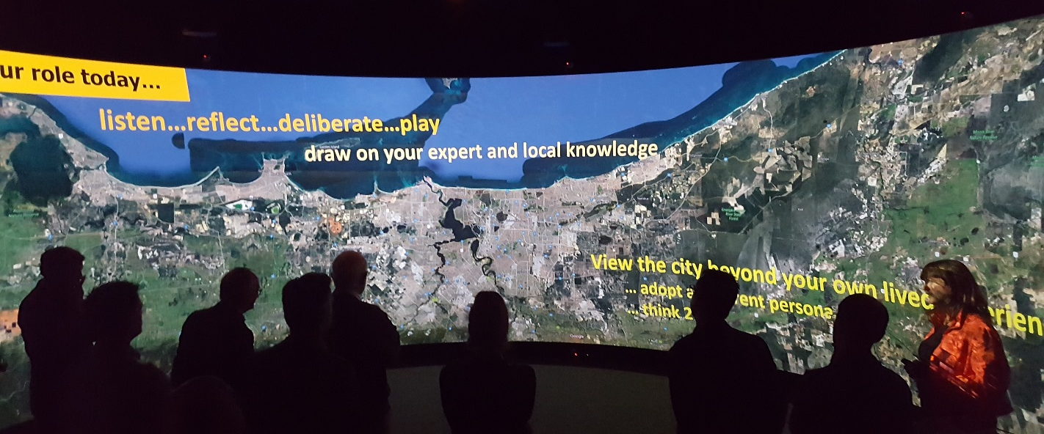
Figure 1: Alternative framing of metropolitan Perth (with the ocean in the west located at the top)

A workshop structure with three steps was devised (Table 1). The first session of the day utilised the SNAMUTS accessibility tool (see www.snamuts.com) developed by the workshop leaders to inform metropolitan-scale thinking. The second session aimed to evaluate whether urban design at proposed high transit accessibility locations could effectively capitalise on such connectivity benefits – or whether local site factors made development elsewhere more feasible, thus informing metropolitan scale thinking. Finally, a backcasting discussion drew together the process, with participants challenged to devise an implementation plan, which might further raise issues to feed back into local place and/or metropolitan scale planning. This conceptual process, aimed at integrating thinking towards the complex multi-scale interdependencies of urban decision-making, is presented graphically in Figure 2, which was presented to participants through the day.
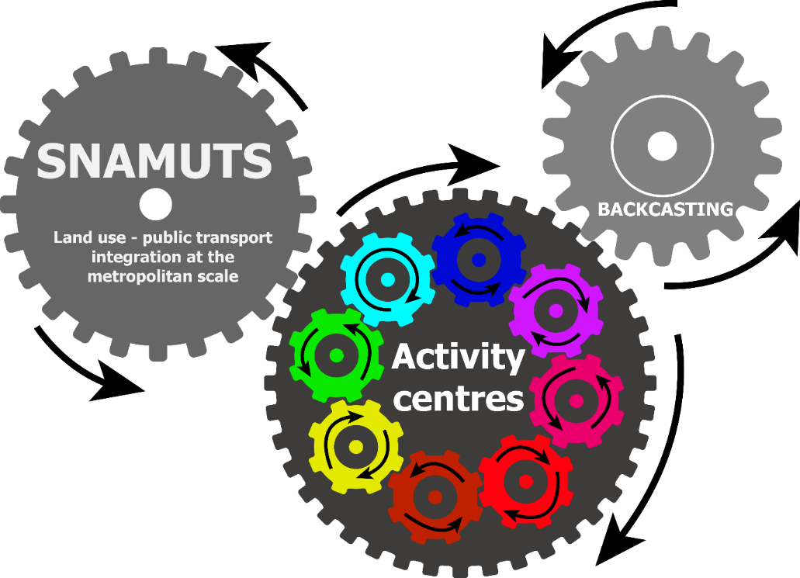
Figure 2: Conceptual model-

SNAMUTS is a spatial analysis tool for understanding the mobility and accessibility offered by public transport systems within current and hypothetical land use patterns (Curtis, 2011, Curtis and Scheurer, 2016). SNAMUTS identifies transport nodes with very high service levels – approximately equivalent to the degree of flexibility of movement provided by private car ownership – through the nodal connectivity indicator, with a colour spectrum of dark grey (low connectivity) to red (high connectivity) (Figure 3). Larger European public transport networks typically exhibit some degree of polycentricity, with multiple red dots within an urbanised area. “Red dots” were utilised as a scale conceptualisation device through the workshop. Stirling and Bayswater, both less than 9 kilometres away from Perth’s urban core, were selected as Red Dot foci precincts (on par with the places selected in the European fieldwork, in Copenhagen these were Flintholm and Nørrebro). Stirling is a Strategic Metropolitan Centre under State Planning Policy 4.2, while Bayswater is not formally classified (WAPC, 2010).

Figure 3: Copenhagen 2012 Nodal Connectivity Analysis, showing multiple "Red dots"

A range of senior state and local government bureaucrats, policy advocates, urban designers and consultants were specifically invited based on their professional experience, degrees of power, demographic and institutional diversity, and varying degrees of previous engagement with the university. Fourteen participants attended. A core group of local academics facilitated the proceedings and operated the visualisation technologies. A number of co-collaborator academics (Hull et al., 2012) from European universities attended as observers and advisors.

The Hub for Immersive Visualisation and eResearch (HIVE) laboratory at Curtin University was utilised as the venue of the futures workshop. Two visualisation facilities were primarily used – the Curved Screen (CS), a 12m by 3m panoramic screen which fills the human field of vision, and Tiled Screen (TS), a large 7680x3240 pixel screen made up of 12 HD displays. In addition to spatial data marked on large maps, the workshop was designed to garner a broad range of qualitative information about how policy makers consider metropolitan issues, and how they perceive the role of planning support tools to assist them in improving the process of making plans. Maps and graphic visualisations of the content of discussion were captured and presented in various forms through each stage of the workshop. Local and guest academic attendees took observational notes and candid photographs throughout the day.

Table 1: Workshop Program
Session | Intent | Technique | Visualisation Media
1a | Metropolitan scale discussion | Interactive presentation | CS - Pre-generated SNAMUTS maps  Contextual information displayed on TS
1b | Metropolitan scale discussion | Participants refine 2050 scenarios | A0 spatially-accurate network maps. Contextual information on CS and TS
2a | Sub-regional, place based | Virtual tour of European and local “Red Dot” places, other TOD and urban design theory | CS - 360 photography  Traditional photography, conventional powerpoint format.
2b | Sub-regional, place based | Participants design futures for local “Red Dot” places | A0 aerial photographs.  Contextual information displayed on TS
3 | Implementation | Backcasting – Open discussion with facilitator and two visualisation interpreters | TS – split in two. Left half – visual mapping of themes and concepts in a “mind-map” diagram (See Figure 7)  Right half – Table of discussion against elements in a structured table format.

Session 1: Perth at the Metropolitan Scale
Session 1 focused on the exploration of potential metropolitan forms and structures of Perth at the year 2050, and their potential accessibility characteristics. This session was to introduce the SNAMUTS tool, illustrating how the “baseline” 2050 plan (Department of Transport 2016) performed across SNAMUTS indicators, and demonstrating the capacity of the tool to generate evaluations in support of metropolitan thinking.

As a PSS, SNAMUTS offers a useful means of deliberating on Perth’s urban structure at 2050, given its ability to consider the relationship between land use development and transport infrastructure. Not only are these two elements core to future strategic development planning, the integration of urban development with public transport is a key planning objective for Perth. SNAMUTS utilises nine indicators to assess different characteristics of the public transport network and its relationship to urban development and accessibility. In addition to rigorously evaluating current service supply standards, SNAMUTS can be used to explore future scenarios for metropolitan urban structure. In this way, SNAMUTS opened the workshop by enabling participants to both gain an evidence-based understanding of how the city presently performs in relation to the planning goal, and for participants to construct a future vision for 2050 in relation to this goal.

SNAMUTS was utilised as a means to stimulate discussion and elucidate consequences of metropolitan transport resource allocation in an open, collaborative (but unfamiliar) environment. It was envisaged that the SNAMUTS tool could be configured to provide near-instantaneous analysis of the participant-designed scenarios, allowing iterative review and discussion. Unfortunately, at the time of the workshop, SNAMUTS could not reliably produce real-time interactivity, so pre-computed 2050 scenarios were devised in order to support strategic discussion. During early workshop development, the usability of digital interfaces for capturing complex urban design concepts and deriving resulting quantitative values (land use density, for instance) for input to SNAMUTS was identified as a key challenge. A0 paper metropolitan maps were therefore utilised, enabling participants to draw their inputs on a media which was familiar and accessible to all participants. This eliminated the risk that participants would have difficulty interacting with the information interface, but inherently eliminated the potential to return “real time” SNAMUTS results.

Session 2: From the metropolitan scale to the activity centre scale
In the second workshop session the aim was to re-consider the potential for highly accessible nodes in a 2050 Perth city, and encourage concurrent thinking between activity centres and broader metropolitan form. Conceptual discussions about Crime Prevention through Urban Design (CPTED) and local Transit Oriented Development (TOD) principles prefaced the session. Difficulties in achieving very high amenity, functional TODs is well-described in the literature (Mees, 2014, Duckworth-Smith and Babb, 2015), so a very diverse range of European station precincts were presented. Utilising the high resolution of the available media, panoramic photography was displayed at a near-realistic scale (providing a degree of perceived/illusory “presence”), alongside maps and contextual information of the metropolitan context (Figure 4). Aerial photography at various scales was utilised to bridge the connection between metropolitan, activity centre and street scales. Pilot experimentation with moving images and the use of interactive map movement (zooming, panning) on the Curved Screen prior to the workshop resulted in disorientation and nausea. The use of dynamic visual media was thus limited to informal discussion times, during which guests could take full control with mapping software available.

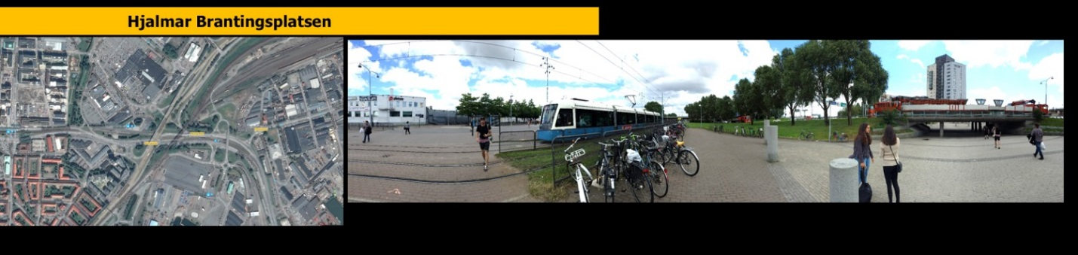
Figure 4: Place-level urban design visualisations (map and 360 photo). This was presented on a screen approximately 12 metres wide and 3 metres high.

In the second half of the session, participants were provided with A0 aerial photographs of the precincts and asked to develop concept plans for the place, capitalising on increased nodal accessibility values, in a group charrette format. Participants self-selected between the two case study areas of Stirling and Bayswater. The visualisation screens were used to display geospatial contextual data, and were available for interrogation while participants formulated plans. At the conclusion of this section, participants were asked whether the properties of the precinct they had considered had prompted re-consideration of metropolitan-scale strategic planning.

Session 3: Backcasting from 2050
The purpose of Session 3 was to perform a backcasting analysis for the scenarios devised during the prior sessions of the day. A “mind-map” and chronological implementation plan table display were developed, operated by research assistants interpreting the discussion. A senior researcher served as a facilitator. InDesign was used to construct a “mind map” visualisation responding to discussion. This consisted of a grouped set of tokens, which were moved, linked and denoted as participants verbalised connections and dependencies. Tokens, which represented actors, institutions, tools, infrastructure options and urban “hardware” components, were presented on screen and distributed on cards, to stimulate thought across urban issues and disciplines. A yearly table was used on another screen to mark milestones suggested by participants.

At the conclusion of the event, participants were asked to provide feedback and open comments on the day, which were received in a combination of in-person discussion, and anonymous submissions to an online comment facility following the event.

Results and Discussion
Despite the prototypical nature of some of the visualisation methods, the Futures Workshop demonstrated several ontological questions and frictions in urban planning policy-making evident in the literature. After a review of outcomes for each session, we conclude against our initial research objectives.

Session 1 –Metropolitan Perth SNAMUTS Analysis
The disparate professional specialties of the attendees became apparent in the first session. Attendees tended to stand adjacent to familiar colleagues. Several participants were engaged with the mechanics of the SNAMUTS tool, questioning the methodological assumptions of travel behaviour and activity preferences. The anecdotal nature of travel activity prediction was discussed, and it seemed that participants were acutely aware of previous practice in transport infrastructure planning, based on unrepresentative personal evidence and normative assumptions, often extrapolated into models. During Session 1, a debate focused around residents’ potential selection of job location and shopping centre choices emerged. One participant remarked that he would choose to attend the nearest Myer department store, while another remarked that he would travel to a further shopping centre for a specific retail experience. The intimacy of the space and the fact that participants all stood permitted for engaging discussion, with participants frequently referencing points against the maps displayed (Figure 5). Interestingly, the use of very high resolution aerial photography of metropolitan Perth seemed novel to many participants, who remarked that they were more familiar with using static zoning maps.

Figure 5: Curved Screen, during Session 1
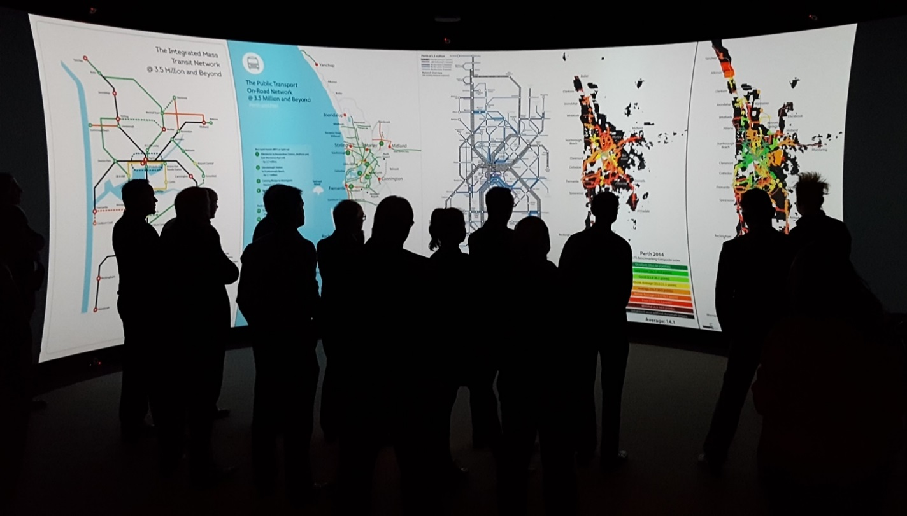

Another participant queried the use of SNAMUTS at a sub-regional scale, questioning whether it would be capable of analysing potential travel opportunity patterns for an inner-urban activity corridor. One European collaborator noted that participants did not seem to grasp the complexity of individual indicators, though the ‘red dot’ served as a very effective and relatable conceptual devise. The use of draft 2050 government plans – prepared by an outgoing state government months prior to an election – potentially engendered a degree of defensiveness observed among representatives from state planning agencies. During the mapping exercise, participants were generally dismissive of outward urban growth and elucidated a wide range of potential intensification development structures, mostly centring around employment redistribution.

Session 2 – Activity Centre Virtual Tour and Charrette
The virtual tour presented in Session 2 was broadly well-received, and the charrette format was familiar to attendees. The supporting visualisation tools were extensively called on by participants to assist in checking attributes of local precincts. Some participants with very detailed or confidential knowledge of the precinct they addressed tended to close-out creative discussion, as the future development scenarios of those places were perceived as fixed. Reference visualisations were frequently used, particularly the high resolution 3D imagery available through Google Earth (Figure 6). Some participants used the opportunity presented by the charrette to articulate radical changes to the urban form aligned with contemporary design principles. The 2050 focus enabled a perceived level of creative freedom, perhaps less bounded by current policy or practices.

Through sessions 1 and 2, the centripetal nature of Perth’s knowledge-based employment sectors was a recurring theme. Participants lamented several difficulties in attempting job decentralisation, including employee preference, existing radial accessibility networks, and the relatively higher desirability of inner-urban residential areas.

Figure 6: Tiled Display during Session 2
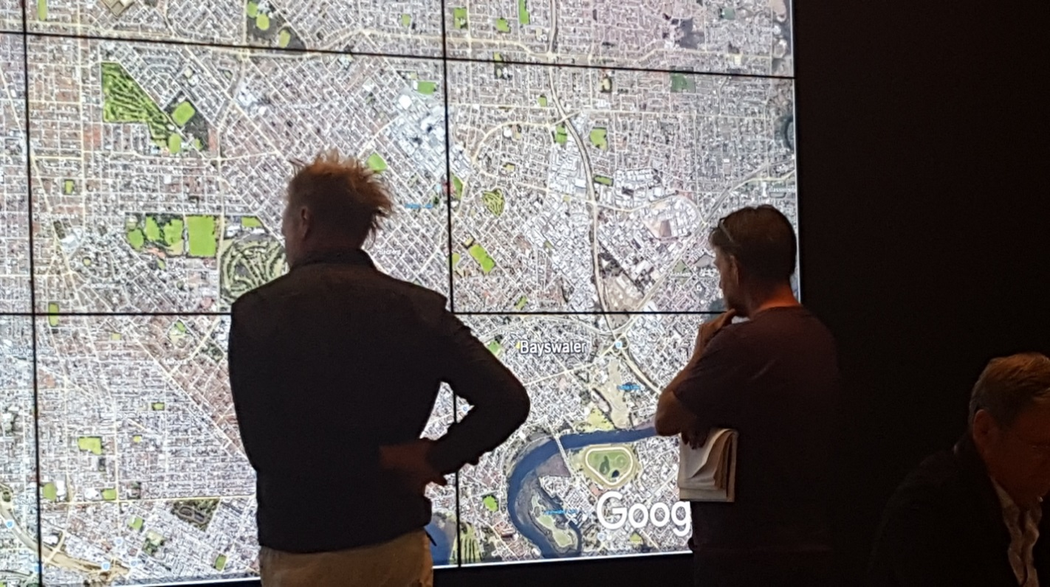

Session 3 – Implementation with Backcasting
The structured backcasting exercise planned for Session 3 quickly deviated into a governance focused discussion of perceived recent and present failures of planning agencies and institutions. Overall, participants struggled to convey a comprehensive long-term vision towards 2050 – rather, they highlighted aspirational accomplishments for their own agency or specific government policy changes.

The need for radical change for Perth was contentious. Some participants treated it as implicit and complained that change was handled badly. Others seemed defensive of status quo, potentially seeing the application of tools at the workshop as a subtle attack on their professional expertise. For instance, one participant questioned whether the planning system in Perth had effectively “sold” higher-density transit-based urbanism to the population. While many participants agreed this was a salient question, discussion was pulled on by other critical questions before a cohesive 2050 vision – much less a detailed implementation chronology – could be devised. A loose set of inter-related points was discussed, graphically represented in Figure 7.
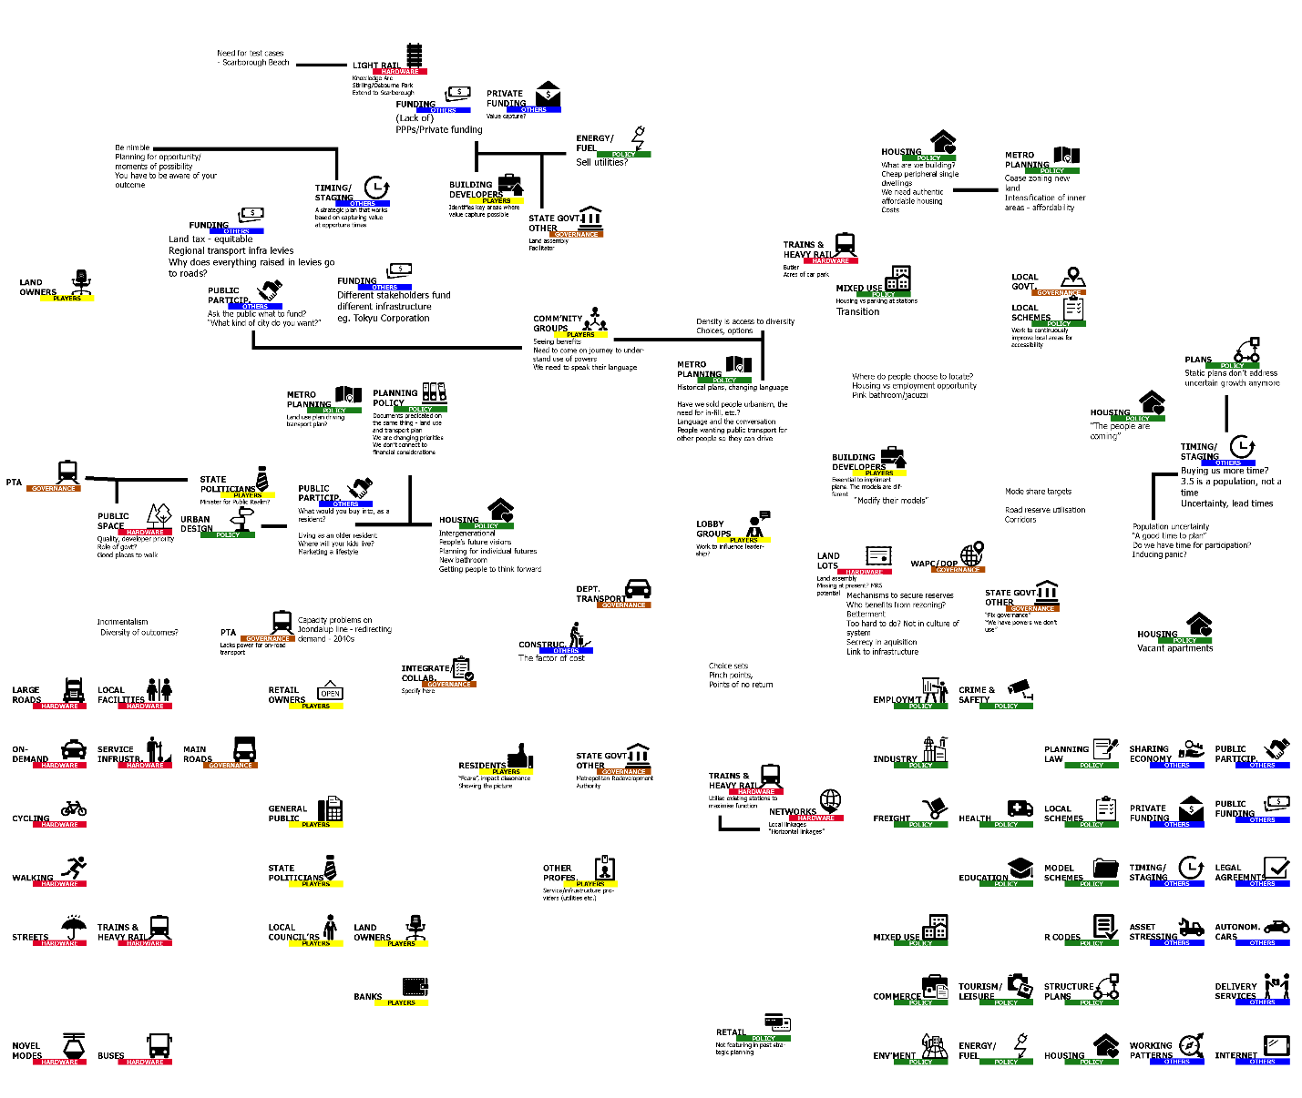
Figure 7: Backcasting visualisation results created “on-the-fly” while interpreting discussion

The heavy emphasis on perceived systematic and inter-agency failures largely prevented the formulation of a comprehensive backcasted future agenda, particularly in terms of a physical infrastructure plan. This is potentially indicative of the value of an early “catharsis” session to enable participants to identify key blocks before moving to backcasting. Up to that point, participants had not had an opportunity to express their particular “pet peeve” experiences. Some observers questioned whether the workshop had actually emerged from sessions 1 and 2 with agreed 2050 outcomes.

Feedback, Critique and Reflection
These findings highlight the complex dynamics between stakeholders, city contexts, power structures, professional orientations, and ideologies during PSS processes. Consistent with other research (Pelzer, 2015), we note the difficulty in structuring discussion to produce easily-interpretable spatial data, and the following difficulty of interpreting discursive, unstructured strategic policy discussion into forms of structured geospatial data or visualisations. This was evident in all sessions, though particularly during the backcasting session. This was reflected in comments from one outside academic observer:

“In the final session with the labels on the screen, it was even hindering: people started to sit with their backs to the screen because it was unclear why they were watching something that appeared to be a back-office task.” (Academic Observer 1)

With reference to our initial research questions, the results garnered from the review process indicate that, despite issues of urban governance complexity and PSS design dilemmas, the workshop formed a valuable opportunity for a set of stakeholders to understand complex contextual dimensions of futures planning. Evaluation of the futures workshop by participants was broadly positive, and supported the exercise as a valuable opportunity for high-level practitioners to explore metropolitan futures in an environment outside their usual practice. Such opportunities in Perth may be regrettably infrequent, perpetuating misaligned practices among divisions of government. The use of a diverse range of maps and map-based PSS was observed to be largely effective in prompting discussion, and potentially more so that other forms of visualisation, supporting the thesis of Batty et al. (2010).

The Futures Workshop day was an ambitious attempt to facilitate different levels of thinking across scales and issues within a single day, exploring different cognitive techniques. The use of various experimentation and “play” motifs was clearly effective in developing an atmosphere conducive to open sharing and participation with the available PSS tools, within this constrained time frame. The comparatively limited success in devising tangible backcasting results logically brings into question the role of the methods and visualisation tools we attempted to use, or, more cynically, whether participants were adequately practiced in such long-term, integrated futures thinking. The influences of the set of participants and the characteristics of PSS technology on the outcomes are difficult to dis-entangle. The use of technology in this instance was critiqued by multiple attendees, particularly with respect to the difficulty in representing the complex interdependencies of all stakeholders, basic methodological assumptions, and the urban form/function interplay. These questions highlight the continued relative absence of collaborative or visual PSS in “traditional” metropolitan planning processes, where more technocratic, specialised quantitative models persist, resulting in a lack of familiarity with more qualitative or deliberative tools. The complimentary role of different PSS tools and backcasting methods in provoking interdisciplinary discussion was clearly demonstrated, through whether the learning that took place was “single loop” or “double loop” was not clearly observed. While ongoing advancement and proliferation of supporting geospatial platforms is likely to further enable the development of more technically complex and rapid PSS, the personal and experimental factors which influence their actual utility are much less certain. In particular, their user interface(s), and processes for garnering input values from deliberative discussion, remain aspects in need of a considerable degree of further study.

Questions remain as to whether Map Mashup tools may threaten, or otherwise subvert, the professional expertise and normative methods used by highly experienced planners. The critiques raised during and after the workshop suggest that PSS with highly experienced stakeholders perhaps ought to be less “designed” and more spontaneously collaborative, experimental and communicative, in a playful approach that departs from the formality of more traditional planning processes. Or, perhaps more radically, stakeholders could be involved in the design of the workshop and PSS themselves. In any case, the integration of broader bases of stakeholder knowledge as an additional input to PSS tools (in addition to scenarios or “what if” inputs) remains as a relatively unchartered area for further research. Drawing on the Futures Workshop outcomes, the technical limitations of the media, including the flexibility of interfaces, the potential for motion sickness, tool usability, data integration potential, and development difficulty remain pivotal challenges, against which these broader challenges of stakeholder learning, knowledge integration, tool richness and practice usefulness must be balanced.

Acknowledgements and Disclosures
The authors would like to thank the participants of the Futures Workshop, the European collaborators, participation of close Department colleagues Shane Grieve, Paul Cozens, Courtney Babb, and the staff of the HIVE for their ongoing technical assistance. The European field work which contributed to this workshop and the research has received funding from the People Programme (Marie Curie Actions) of the European Union's Seventh Framework Programme (FP7/2007-2013) under REA grant agreement n° 608743

References
ANDERSON, C. 2008. The end of theory: The data deluge makes the scientific method obsolete. Wired magazine, 16, 16-07.
BANISTER, D. & HICKMAN, R. 2013. Transport futures: Thinking the unthinkable. Transport Policy, 29, 283-293.
BARANDIER JR, J. R. 2015. Applying the ‘Backcasting’ Method to Achieve Sustainable Mobility: The Case of Niteroi. Transportation Research Procedia, 8, 5-16.
BATTY, M., HUDSON-SMITH, A., MILTON, R. & CROOKS, A. 2010. Map mashups, Web 2.0 and the GIS revolution. Annals of GIS, 16, 1-13.
BEREITSCHAFT, B. 2016. Gods of the City? Reflecting on City Building Games as an Early Introduction to Urban Systems. Journal of Geography, 115, 51-60.
BRÖMMELSTROET, M. T. 2013. Performance of Planning Support Systems: What is it, and how do we report on it? Computers, Environment and Urban Systems, 41, 299-308.
CRAIG, W. J. & ELWOOD, S. A. 1998. How and why community groups use maps and geographic information. Cartography and Geographic Information Systems, 25, 95-104.
CRAMPTON, J. W. 2017. Digital Mapping. In: KITCHIN, R., LAURIAULT, T. P. & WILSON, M. W. (eds.) Understanding Spatial Media. London: SAGE.
CURTIS, C. 2011. Integrating land use with public transport: The use of a discursive accessibility tool to inform metropolitan spatial planning in Perth. Transport Reviews, 31, 179-197.
CURTIS, C. & SCHEURER, J. 2016. Planning for Public Transport Accessibility, Perth, Ashgate.
DAVOUDI, S. 2006. Evidence-Based Planning. disP - The Planning Review, 42, 14-24.
DEPARTMENT OF TRANSPORT 2016. Transport @ 3.5 Million. Perth: Department of Transport.
DEVISCH, O. 2008. Should Planners Start Playing Computer Games? Arguments from SimCity and Second Life. Planning Theory & Practice, 9, 209-226.
DUCKWORTH-SMITH, A. & BABB, C. 2015. Indicating Quality of Place for station precinct development: enhancing ‘place’ in the place/node model. In: BURTON, P. & SHEARER, H. (eds.) State of Australian Cities Conference Gold Coast, Queensland: Urban Research Program at Griffith University on behalf of the Australian Cities Research Network.
EWEJE, J., TURNER, R. & MÜLLER, R. 2012. Maximizing strategic value from megaprojects: The influence of information-feed on decision-making by the project manager. International Journal of Project Management, 30, 639-651.
FLYVBJERG, B. 2013. Quality control and due diligence in project management: Getting decisions right by taking the outside view. International Journal of Project Management, 31, 760-774.
FREESTONE, R. 2012. Futures Thinking in Planning Education and Research. Journal for Education in the Built Environment, 7, 8-38.
GABER, J. 2007. Simulating Planning: SimCity as a pedagogical tool. Journal of Planning Education and Research, 27, 113-121.
GOODSPEED, R. 2013. Planning support systems for spatial planning through social learning. PhD, Massachusetts Institute of Technology.
HANZL, M. 2007. Information technology as a tool for public participation in urban planning: a review of experiments and potentials. Design Studies, 28, 289-307.
HASLAUER, E. 2015. Application of a spatially explicit backcasting model: A case study of sustainable development in Salzburg, Austria. Applied Geography, 58, 128-140.
HASLAUER, E., BIBERACHER, M. & BLASCHKE, T. 2012. GIS-based Backcasting: An innovative method for parameterisation of sustainable spatial planning and resource management. Futures, 44, 292-302.
HICKMAN, R., ASHIRU, O. & BANISTER, D. 2009. Achieving Carbon-Efficient Transportation. Transportation Research Record: Journal of the Transportation Research Board, 2139, 172-182.
HOARE, A. G. 1992. Transport investment and the political pork barrel: a review and the case of Nelson, New Zealand. Transport Reviews, 12, 133-151.
HOSTOVSKY, C. 2006. The Paradox of the Rational Comprehensive Model of Planning. Journal of Planning Education and Research, 25, 382-395.
HULL, A., SILVA, C. & [EDS], L. B. 2012. Accessibility Instruments for Planning Practice (TU1002), Brussels COST.
JÄRVI, T., TUOMINEN, A., TAPIO, P. & VARHO, V. 2015. A Transport Policy Tool for Reduction of Co2 Emissions in Finland – Visions, Scenarios and Pathways using Pluralistic Backcasting Method. Transportation Research Procedia, 11, 185-198.
KAHNEMAN, D. & TVERSKY, A. 1979. Intuitive Prediction: Biases and Corrective Procedures. In: S. MAKRIDAKIS, S. C. W. (ed.) Studies in the Management Sciences: Forecasting. North Holland, Amsterdam: Wheelwright.
KITCHIN, R. 2014. Big Data, new epistemologies and paradigm shifts. Big Data & Society, 1, 2053951714528481.
KRIZEK, K., FORYSTH, A. & SLOTTERBACK, C. S. 2009. Is There a Role for Evidence-Based Practice in Urban Planning and Policy? Planning Theory & Practice, 10, 459-478.
LEGACY, C., CURTIS, C. & SCHEURER, J. 2017. Planning transport infrastructure: examining the politics of transport planning in Melbourne, Sydney and Perth. Urban Policy and Research, 35, 44-60.
MAY, A. D., PAGE, M. & HULL, A. 2008. Developing a set of decision-support tools for sustainable urban transport in the UK. Transport Policy, 15, 328-340.
MEDINA, E. 2006. Designing Freedom, Regulating a Nation: Socialist Cybernetics in Allende's Chile. Journal of Latin American Studies, 38, 571-606.
MEES, P. 2014. TOD and Multi-modal Public Transport. Planning Practice & Research, 29, 461-470.
MIRAFTAB, F. 2009. Insurgent Planning: Situating Radical Planning in the Global South. Planning Theory, 8, 32-50.
PAPA, E., SILVA, C., TE BROMMELSTROET, M. & HULL, A. 2016. Accessibility instruments for planning practice: A review of European experiences. The Journal of Transport and Land Use, 9.
PELZER, P. 2015. Usefulness ofPlanning Support Systems: Conceptual perspectives and practitioners’ experiences. Doctor of Philosophy, Utrecht University.
PELZER, P. & GEERTMAN, S. 2014. Planning support systems and interdisciplinary learning. Planning Theory & Practice, 15, 527-542.
PELZER, P., GEERTMAN, S., HEIJDEN, R. V. D. & ROUWETTE, E. 2014. The added value of Planning Support Systems: A practitioner’s perspective. Computers, Environment and Urban Systems, 48, 16-27.
PETTIT, C., LIESKE, S. N. & JAMAL, M. 2017. CityDash: Visualising a Changing City Using Open Data. Planning Support Science for Smarter Urban Futures. Springer.
PONTIUS, R. G. & SI, K. 2015. Spatial Decision Support Systems A2 - Wright, James D. International Encyclopedia of the Social & Behavioral Sciences (Second Edition). Oxford: Elsevier.
QUIST, J. N. 2007. Backcasting for a Sustainable Future: the impact after 10 years, Delft, Eburon.
SAGARIS, L. 2014. Citizen participation for sustainable transport: the case of “Living City” in Santiago, Chile (1997–2012). Journal of Transport Geography, 41, 74-83.
SORIA-LARA, J. A. & BANISTER, D. 2017. Dynamic participation processes for policy packaging in transport backcasting studies. Transport Policy, 58, 19-30.
SOUTHWORTH, M. & BEN-JOSEPH, E. 1995. Street Standards and the Shaping of Suburbia. Journal of the American Planning Association, 61, 65-81.
TE BRÖMMELSTROET, M. & BERTOLINI, L. 2008. Developing land use and transport PSS: Meaningful information through a dialogue between modelers and planners. Transport Policy, 15, 251-259.
TE BRÖMMELSTROET, M., CURTIS, C., LARSSON, A. & MILAKIS, D. 2016. Strengths and weaknesses of accessibility instruments in planning practice: technological rules based on experiential workshops. European Planning Studies, 1-22.
TE BROMMELSTROET, M., SILVA, C. & BERTOLINI, L. 2014. Assessing Usability of Accessibility Instruments.
THE BARTLETT SCHOOL OF PLANNING AND HALCROW GROUP LTD 2005. Visioning and Backcasting for UK Transport Policy (VIBAT)
TUOMINEN, A., TAPIO, P., VARHO, V., JÄRVI, T. & BANISTER, D. 2014. Pluralistic backcasting: Integrating multiple visions with policy packages for transport climate policy. Futures, 60, 41-58.
VAN WEE, B. 2011. Transport and ethics: ethics and the evaluation of transport policies and projects, Cheltenham, Edward Elgar Publishing.
VAN WEE, B. & GEURS, K. T. 2004. Backcasting as a Tool for Sustainable Transport Policy Making: the Environmentally Sustainable Transport Study in the Netherlands. European Journal of Transport and Infrastructure Research, 4, 47-69.
VANDEVIVER, C. 2014. Applying Google Maps and Google Street View in criminological research. Crime Science, 3, 13.
WANGEL, J. 2011. Change by whom? Four ways of adding actors and governance in backcasting studies. Futures, 43, 880-889.
WAPC 2010. State Planning Policy 4.2: Activity Centres for Perth and Peel. In: PLANNING, D. O. (ed.). Perth: Department of Planning.
WESTERN AUSTRALIAN PLANNING COMMISSION 2015. Perth and Peel@3.5million Perth: Department of Planning.

