Validating Mobile Phone Generated Bicycle Route Data in Support of Active Transportation

Lieske S.N.¹, Leao S.Z.², Conrow, L.³ and C. J. Pettit²
1 School of Earth and Environmental Sciences, University of Queensland, Brisbane, Australia
2 City Futures Research Centre, The University of New South Wales, Sydney, Australia
3 School of Geographical Sciences & Urban Planning, Arizona State University, Tempe, Arizona, USA

Abstract
As our cities continue to growth in an era of urbanization there is a need to harness the power of big data to support data driven planning. Yet we need to ensure this data in credible and reliable, particularly when obtained from smart phone apps through crowdsourced approaches. The goal of this paper is to gain insight in to the geographic representativeness and bias inherent in a crowdsourced dataset of bicycling routes. The empirical investigation uses the RiderLog bicycling data from 2010 – 2014 to contrast smartphone app collected bicycle commuting data with census journey to work data at the Statistical Area Level 2 census geography. The investigation focuses on Perth and the surrounding area of Western Australia. Both app and census data are converted to similar dyadic spatial interaction matrices. Correlations between the spatial interaction matrices are calculated with a modified t-test for assessing correlation in the presence of spatial autocorrelation. Results indicate the app generated data are representative in a number of SA2s located along the Swan River as well as among clusters of SA2s adjacent and close to the Indian Ocean. The app data are also found to exhibit a strong urban bias. Due to increased numbers of users, app generated data are more representative of the broader cycling population in urban areas than in rural areas. Means of extending this research in order to increase usability of crowdsourced data for bicycle transportation planning and management are also considered.

Key words
Bicycling; app; census; spatial interaction; crowdsource

Introduction
The health benefits of active transportation including decreased greenhouse gas emissions, reduced
congestion and improved personal fitness are well known. Nevertheless, the mode share of active
transport is often low. Bicycling stands out among western countries as an area where there is high
mode share in some areas, and very low mode share in others. Bicycling mode share in Australia,
Canada, the United Kingdom and the United States is about one percent which is considerably lower than many European countries including the Netherlands (27%), Denmark (16%), and Germany (10%)
(Pucher and Buehler 2008, Ellison and Greaves 2011). This presents a tremendous opportunity to make improvement in the level of uptake of active transport as these differences are directly traceable to changes in urban planning and transportation policies in countries with higher mode share (Pucher and Buehler 2008).

Data and information are critical elements for the developing active transportation policies and
infrastructure. At the same time, the relatively recent emergence of bicycle share programs and mobile
phone applications are changing the data landscape of active transportation. Evolving from work based on global positioning system (GPS) recording of bicyclist behaviour, several recent studies utilize crowdsourced bicycle route data collected from mobile phone applications. Among the advantages of data generated through these apps are cost savings on GPS hardware, increased sampling of cyclists and capture of bicycling route data at a very detailed scale. High volumes of bicycling route data may be use to indicate areas requiring improvements for rider safety (Blanc et al. 2016) as well as bicycling infrastructure planning and provision more generally. Perkins and Blake (2016) argue the lack of spatially explicit cycling data in urban environments is detrimental to bicycle infrastructure planning.

However, app generated crowdsourced bicycling data have a number of potential inherent problems. Even with the large volumes of data collected from apps, samples tend to be small compared to general cycling populations (Romanillos et al. 2016). Data are collected from a self-selected sample of individual users which may result in geographic bias (e.g. Hecht and Stephens 2014). With geographic bias, bicycling patterns from app data may not be representative of bicycling patterns in a geographic region. There may also be demographic sampling bias (Blanc et al. 2016) where rider characteristics are not representative of the general population of cyclists.

An important step in using these data is validation, or assessing to what degree the crowdsourced data represent the general population of cyclists in an area. In this investigation we seek to validate crowdsourced transportation data generated with the RiderLog mobile phone app. RiderLog is a free Australian smartphone app that collects crowdsourced bicycling journeys. The app records GPS traces of bicyclists as well as some rider information (e.g., age and gender) and route information (e.g., distance, duration, average speed, top speed). The app is used by people monitoring their physical activity and bicycling performance as well as people who support the goals of the app developer, Bicycle Network, to improve bicycling facilities, bicycling safety and overall bicycle usage (Pettit et al. 2016).

From a statistical perspective data validation is a quantitative estimation of the representativeness of a dataset. Key concepts in data validation are the notions of sample and population. A sample is the survey data on hand generated from a subset of the population. Population data are the set of data of all possible measurements or responses if a question is put to an entire group. Ideally, a sample accurately characterizes a population (Harris 2016). If a data set is not valid, it is not a reasonable representation of the real world and this limits its utility to support research, planning and policy development. In an external validation process, a sample may be compared with an external data set known to be representative of a population (Rose and Nagle 2017). Rose and Nagle (2017) recommend validation with external data sets when possible. In this paper we seek to compare the sample, bicycle route data for commuters collected through Riderlog, with the population, census journey to work data where the transport mode is indicated as ‘bicycle’.

While there are no spatially explicit and complete data sets of the routes used by the bicycling population in Australia, the Australian Census’ Journey to Work (JTW) dataset produced by the Australian Bureau of Statistics (ABS) provides commuting flows across regions through a spatial interaction matrix. The Australian census is the official count of population and population characteristics for the nation (ABS 2016a). The 2011 Australian census is described by the ABS as “Australia’s richest statistical resource, which provides a comprehensive snapshot of the nation and all areas within it (ABS 2012). Census data represent the general population and are therefore suitable for use as a benchmark for statistical comparison in a validation of a data sample. The JTW data are limited however in that they only contain origins and destinations for trips rather than the full routes needed to examine features of the infrastructure and neighborhood contexts that influence bicycling activity. If the spatial distribution of the crowdsourced RiderLog bicycling routes are statistically valid as compared to the ABS JTW bicycling data, RiderLog data may be used to address bicycling use and infrastructure at a finer scale that is possible with JTW data. This route-level data may help planners and decision makers improve bicycling facilities and safety, raise modal share and help realise the personal fitness and environmental benefits of active transportation.

Background
Holmes (1978) presents a framework for analyzing the structure of interaction systems. Examples of such systems include travel between an origin and a destination as well as messages, mail, phone calls, business transactions or other information flows. Origin-destination (OD) pairs or, “dyads” (Berry 1968, Holmes 1978) may be recorded as OD matrices where rows represent origins, columns represent destinations (or vice versa) and cells of the matrix indicate flows. In contrast, a row in a dyadic matrix represents an OD pair along with a measure of the interaction (Yan and Thill 2009). Dyadic matrices are the most frequently used format for recording spatial interaction systems including the bicycling transportation data analyzed herein.

Romanillos et al. (2016) provide a literature review that categorizes bicycling data as one of three types: GPS, point and journey. They identify problems of bias inherent in GPS bicycling data collected from self-selected survey participants such as over or under representation of a grouping of age, income or gender. They also note benefits of GPS-based bicycling data including insight into route choice when linked with other geographic data and bicyclist behavior and preferences for specific route characteristics. Their work also highlights the potential of using journey data as validation data sets for other bicycling data. Among the key observations they put forward, “there is no reason to believe that either BSP [bike share program] or big app data provide representative samples of a cities’ population of cyclists or potential cyclists” (p. 127).

Hecht and Stephens (2014) investigate correlations between the urban percentage population within counties (USA) and properties of volunteered geographic information (VGI) sourced from Flickr, Foursquare and Twitter. They compensate for spatial autocorrelation using the method of Clifford et al. (1989) to calculate correlation coefficients for spatial processes. Urban bias was found in all three VGI datasets; the data had more and higher quality information in urban areas than in rural areas. Their findings indicate where data are biased against certain groups and where the perspectives of excluded users will be omitted or overshadowed. The authors conclude that studies using VGI may be more indicative of general human behavior in urban areas than phenomena specific to the activity being studied.

Blanc et al. (2016) assess the representativeness of crowdsourced bicycling datasets using chi-square and z-tests to contrast data collected through mobile apps with travel survey data sets for a number of North American cities. They highlight the potential benefits of the large sample size and high resolution data generated from smartphone apps. Their analysis focused on rider characteristics such as gender, age and income rather than route locations. Again, the self-selection of those who contribute to crowdsourced data is identified as a potential source of bias. Their analysis was done at the city level and their statistical analysis did not incorporate spatial effects. Findings indicated that smartphone app bicycling data under-represent people with low incomes, older riders and women and over-represent certain minority ethnicities. Leao et al. (2017) extend these arguments to recommend evaluation of bias in smartphone generated data and communication of this bias to data users.

Leao and Pettit (2017) use an agent-based modelling approach to Riderlog app data validation. They use an agent-based model (ABM) to generate shortest paths and compare those paths with the actual routes of 16 cyclists. They found 50% of app generated routes are nearly identical to ABM shortest paths. Three cyclists chose similar paths, five cyclists chose routes substantially different than ABM generated shortest paths. Interestingly, two cycling routes were shorter than the ABM generated shortest path which likely shows the limitations of the road network data incorporated in the model Leao and Pettit (2017). They conclude their simulation was able to correctly or partially model over two-thirds of the RiderLog bicycling routes and that more factors could be included to improve the accuracy of the modeling.

Leao et al. (2017) highlight the potential of RiderLog bicycling data as an alternative or supplement to census journey to work (JTW) data. Their aim is to identify the extent to which crowdsourced bicycling data are representative of an entire bicycling population. They use an agent-based model to transform JTW data to bicycling routes that are then comparable with app generated bicycling routes. Findings indicated a very strong correlation in distance ridden between RiderLog and agent-based bicycling tracks generated from ABS JTW data. They identify that if crowdsourced data are representative than they are a low-cost and high spatial and temporal resolution data source for bicycle transportation planning. However, this approach has only been tested on a small sample of data in Eastern Sydney.

Rose and Nagle (2017) note a lack of validation in the micro-simulation space. Similarly, we see a paucity of validation in the crowdsourced bicycle data space. While studies highlighted above compared crowdsourced bicycling data to authoritative data sets, they had notable limitations. None of the studies addressed if a crowdsourced sample of bicycling routes is representative of the geographic distribution of the bicycling routes used by a general population.

Data and Methods
The focus of this investigation are processed and cleaned (see Leao et al. 2017 for cleaning methods and full data description) RiderLog data from June 2010 through May 2014 data for the State of Western Australia. These data contain 12,432 discrete bicycling routes. Bicycle Journey to Work (JTW) data from the 2011 census at the SA2 census geography were downloaded from the ABS (ABS 2016b). The downloaded files are dyadic spatial interaction matrices where each row represents an origin destination pair. The files contain three columns containing SA2 origin number, SA2 destination number and the number of employed persons who travelled by bicycle to work, respectively. Data were formatted with an R script which fills in missing SA2 names, removes observations with zero values and links the correct SA2 names with the SA2 number for both origins and destinations.

In order to compare RiderLog route and ABS JTW data it is necessary to convert the data to comparable matrices. Developing the dyadic spatial interaction matrix for the Riderlog data took place in a series of steps built as a sequence of models in ArcGIS Modelbuilder. The first step was selecting and exporting the commuter trips from the overall Riderlog data set. Commuter trips include the categories 'Transport / Commute' and 'Recreation / Commute' as selected by RiderLog users. The second step in converting RiderLog routes to a dyadic matrix involves determining start and end vertices of the routes and associating them with ABS 2011 SA2 centroids for the SA2 unit within which they fell. These start and end points are then converted to lines. Dissolving by location sums the lines for each SA2-based dyad. RiderLog route lines and the RiderLog dyadic matrix lines are presented in Figure 1. For analysis purposes, in step three the RiderLog dyadic matrix lines are used to create a file of SA2 origin centroid points for each SA2 destination. These files have start points indicated for each destination SA2.

The distribution of RiderLog commuter routes shown in Figure 1 are largely congruent with the observations of Perkins and Blake (2016). Commuting cyclists in the Perth area heavily utilising transport corridors north, east and to a lesser extent (with the RiderLog data) south of the CBD. Also similarly to Perkins and Blake (2016), RiderLog data show heavy use of the roads and bicycling infrastructure surrounding and crossing the Swan River. Further, the RiderLog commuter dyads shown in Figure 1 are congruent with the observations of Perkins and Blake, (2016) that the greatest numbers of commuting cyclists in the Perth area are going to and from the CBD.

The ABS JTW dyadic matrix were next converted from tabular to geographic data with a series of steps built within ArcGIS Modelbuilder. First latitude and longitude information based on SA2 centroids are added to each origin and destination record. Data were then converted to a point layer which served as the basis of creating lines utilizing the JTW start and end points. The resulting ABS 2011 Bicycle JTW dyadic matrix map is presented in Figure 2.

Fig. 1 RiderLog commuter routes within the Perth ‘major urban’ Section of State (ABS 2011) (left) and Riderlog commuter dyads (right).

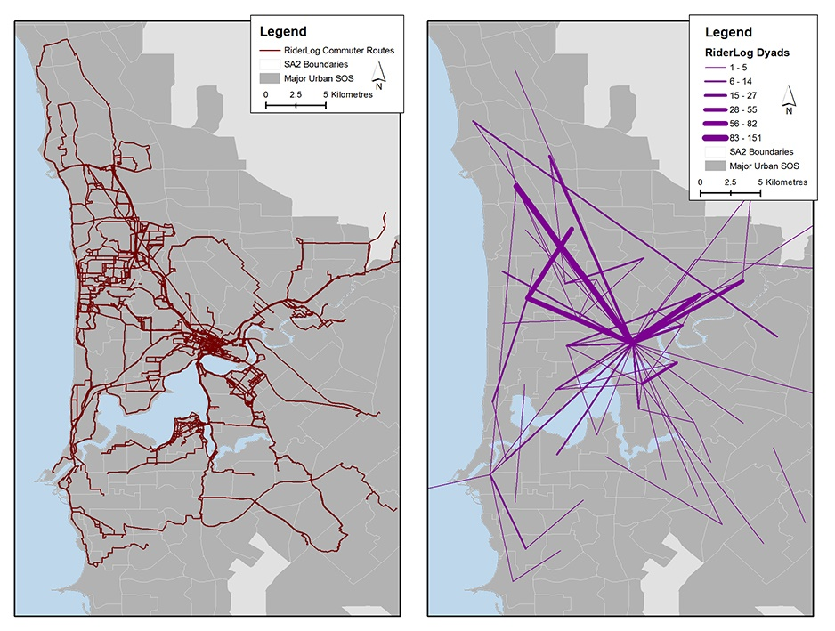

Combining RiderLog and ABS 2011 Bicycle JTW matrices
As with the conversion of both Riderlog and ABS data to dyadic matrices, combining these spatial interaction matrices was accomplished with a series of steps built as a sequence of models with ArcGIS Modelbuilder. The first step in combining the RiderLog and ABS dyadic matrices was to create a set of SA2s that intersect both the Riderlog start points and the ABS origin (start) points. Then, for each SA2 destination, the set of origin SA2s from both the RiderLog start point data set and the ABS JTW origin data set are combined within a single data layer. For each layer, the number of RiderLog dyad start points that intersect each origin SA2 and the number of ABS Bicycle JTW dyad origin points that intersect each origin SA2 were counted and added as separate data attributes.

Fig 2. ABS 2011 bicycle JTW dyads

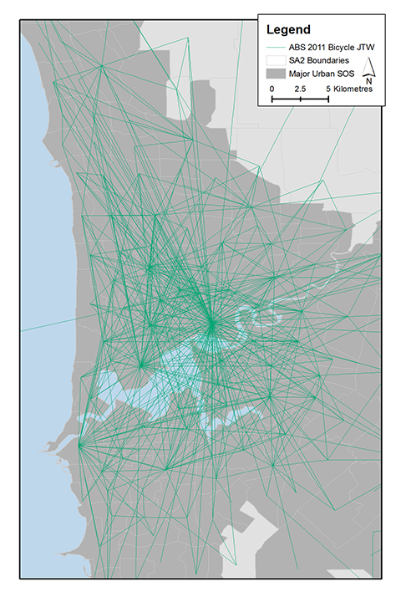
Statistical Analysis
Underpinning this investigation is the idea that correlation between the differing datasets can be used as a quantitative assessment of representativeness. Destination-based correlation between RiderLog and ABS JTW data based on both number of riders and location was calculated for the set of all origins associated with each destination. For example, the basis of the calculation for the Perth City SA2 is shown in figure 3. The correlation calculation includes the RiderLog routes where the destination is Perth City, the number of riders on those routes as well as the ABS journeys where the destination is Perth City and the number of riders on those routes. Statistical calculations employed the method of Dutilleul et al. (1993) for calculation of correlation in the presence of spatial autocorrelation. Calculations were implemented with the software package Spatial Analysis in Macroecology (SAM) v. 4.0 (Rangel et al. 2010).

Fig 3. RiderLog dyads and ABS 2011 bicycle JTW for the Perth City SA2 destination.

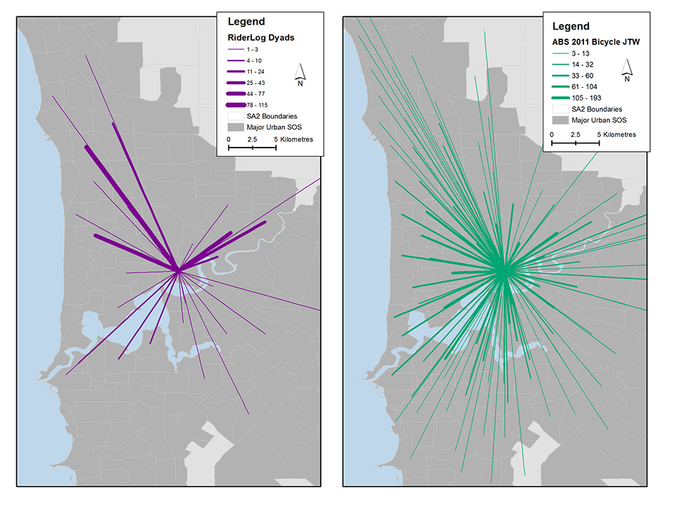

Results
Pearson’s r correlation results with the Dutilleul et al. (1993) correction for spatial autocorrelation are presented in Figure 4. The darkest shading indicates SA2s where RiderLog commuter data are greater than 50 percent correlated with ABS JTW data. The statistical significance of the correlation, again including the Dutilleul et al. (1993) correction, are presented in Figure 4 for those SA2s where p<0.05 (red) and p<0.1 (blue). The results for the Perth City SA2 (routes illustrated in Figure 3) show only a 0.21 Pearson’s r correlation (p = 0.044) and a 0.34 Spearman’s rank correlation. Overall results show SA2s along the Swan River have measurable correlations. There are higher correlations around urban centres such as the Perth CBD and Joondalup. The highest correlations are north of Perth city, along the south bank of the Swan River and in clusters of SA2s near the Indian Ocean.

Results also confirm urban bias in the RiderLog data as very few SA2s outside the Perth major urban area from the ABS 2011 Section of State (SOS) layer contain any recorded routes. This is somewhat to be expected as the Riderlog app was developed with more commuters in mind rather than those bicyclist undertaking longer distance recreational rides. The later was the aim of the Strava Smart Phone app, which was initially developed with more competitive bicyclists in mind. However, comprehensively comparing and testing the data from these two smart phone apps is beyond the scope of this research paper.

Fig 4. RiderLog dyad and ABS 2011bBicycle JTW Pearson’s r correlations and significance.

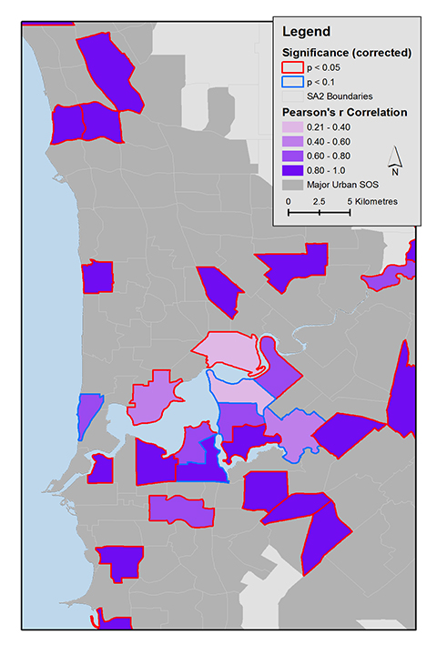
Discussion and Conclusion
This paper seeks to validate RiderLog bicycle commuter data from 2010 – 2014 with ABS bicycle JTW data for the Perth area of Western Australia. Results indicate both statistically significant differences between RiderLog and ABS bicycling journeys as well as similarities in some areas. Similarities are evident in areas of high correlation north of the Perth City SA2, along the south bank of the Swan River and in clusters along the Indian Ocean. RiderLog data are largely absent beyond the Perth major urban area. These observations are congruent with Hecht and Stephens (2014) findings that VGI tend to have greater presence in urban areas.

This research may be expanded and refined in a number of areas. Data validation based on the geography of ride location and rider counts presented here may be extended to include demographic information such as rider gender. Rider gender is an attribute in both the RiderLog data and the ABS JTW data. Another avenue for research is to identify areas over- and under- sampled by RiderLog. Routes in under sampled areas may then be weighted by the population data or, as illustrated in Leao et al. (2017), agent-based modeling may be used to generate routes for under sampled areas. Developing routes for under-sampled areas is an example of statistical inference--determining information about the population from knowledge of the sample (Harris 2016). With the ABS JTW data the numbers of travelling cyclists are as correct as possible but the matter of actual routes are unknown, so generating valid routes based on the data would improve its use in planning and policy decisions. Areas oversampled by RiderLog may be downward weighted or certain observations, for example instances of an individual making the same journey repeatedly, may be removed. There is also the possibility, noted by Blanc et al. (2016), to use these results in conjunction with app developers and promotors to reach out to under-sampled geographic areas that may be identified. A possibility for generating weights is Iterative Proportional Fitting which is used to align survey data with a known population (Rose and Nagle 2017).

Time is also a complicating factor within this analysis. The Australian census represents a data snapshot of the 9th of August, 2011. Although these data are considered to be the definitive record of the population until the release of the next census, a one day snapshot is going to correlate differently with different temporal slices of RiderLog data in what is essentially a modifiable temporal unit problem. Temporal issues and appropriate adjustments are worthy of further investigation. Since the RiderLog data have a more robust temporal range, they may be useful in understanding how JTW data can be imputed to reflect diurnal variations in ridership volumes.

This presentation of methods and results also highlights the utility of app generated data for bicycle transportation research, planning and management. As can be seen comparing the map of RiderLog routes in Figure 1 with the ABS JTW bicycling data Figure 2, the spatial resolution of the JTW data is markedly inferior to the spatially explicit bicycling routes made available by RiderLog. Part of maximizing the utility of these crowdsourced data are continued efforts to assess their representativeness, modelling to see if representativeness may be augmented as well as increasing app users generally. An obvious route for future research is to investigate other geographic areas. The analysis will be expanded to four a total of four Australian capital cities also including Brisbane, Sydney and Melbourne using the recently published riderlog data for these cities on the CityData Store (https://citydata.be.unsw.edu.au/) (Leao et al. 2017). These analyses may also be updated using both more temporally expansive RiderLog datasets and, when available, the 2016 census data. These extensions of this research may also provide insight into who app users are that app distributors / developers could use to expand use of the app through a targeted promotional campaign. For example, areas with high bike commuting as indicated by the census but low app usage could be potential locations for promotional campaigns.

A long-term goal of this research is to develop a comprehensive data set that accurately represents quantities and spatially explicit locations of bicycle commuting routes. This may help planners and decision makers improve bicycling facilities and safety, raise modal share and help in bring about the personal fitness and environmental benefits of active transportation.

References
Australian Bureau of Statistics. (2016a) Quality declaration: 2011 Census of Population and Housing. The http://www.abs.gov.au/websitedbs/censushome.nsf/home/qualitydeclaration (Accessed 15 June 2017).
Australian Bureau of Statistics. (2016b) TableBuilder. Australian Bureau of Statistics. http://www.abs.gov.au/websitedbs/censushome.nsf/home/tablebuilder (Accessed 20 September 2016).
Australian Bureau of Statistics. (2012) New data from the 2011 Census released today: Labour force http://www.abs.gov.au/websitedbs/censushome.nsf/home/CO-65#labour (Accessed 15 June 2017).
Blanc, B., Figliozzi, M., Clifton, K. (2016) How Representative of Bicycling Populations Are Smartphone Application Surveys of Travel Behavior? Transportation Research Record: Journal of the Transportation Research Board 2587, 78–89. doi:10.3141/2587-10.
Berry, B.J.L. (1968) Interdependency of spatial structure and spatial behavior: a genera field theory formulation. Papers in Regional Science 21, 205–227. doi:10.1111/j.1435-5597.1968.tb01449.x.
Clifford, P., Richardson, S., Hemon, D. (1989) Assessing the Significance of the Correlation between Two Spatial Processes. Biometrics 45, 123–134.
Dutilleul, P., Clifford, P., Richardson, S., Hemon, D. (1993) Modifying the t Test for Assessing the Correlation Between Two Spatial Processes. Biometrics 49, 305–314.
Ellison, R., Greaves, S. (2011) Travel Time Competitiveness of Cycling in Sydney, Australia. Transportation Research Record: Journal of the Transportation Research Board 2247, 99–108. doi:10.3141/2247-12.
Harris, R. (2016) Quantitative geography: the basics. (Los Angeles, Sage Publications).
Hecht, B., Stephens, M. (2014) A Tale of Cities: Urban Biases in Volunteered Geographic Information. ICWSM 14, 197–205.
Holmes, J.H. (1978) Dyadic interaction matrices: a review of transformation purposes and procedures. Progress in Geography 2, 467–493.
Leao, S.Z. and Pettit, C. (2017) Mapping bicycle patterns with an agent-based model, Census and crowdsourced data, In: Agent-based modelling of urban systems, Lecture Notes in Artificial Intelligence, Namazi-Rad, Padgham, Perez, Nagel, and Bazzan (Eds), Springer, Switzerland, pgs 112-128.
Leao, S.Z., Lieske, S.N., Conrow, L., Toma,r V., Doig, J. and Pettit, C. (2017) Building a national-longitudinal geospatial bicycling data collection from crowdsourcing, Journal of Urban Science: Crowdsourcing Urban Data (Special Issue), 1, 23, doi 10.3390/urbansci1030023.
Perkins, T., Blake, D., 2016. Understanding Cycling Behaviour in Boomtown Perth, in: Biermann, S., Olaru, D., Paul, V. (Eds.), Planning Boomtown and Beyond. UWA Publishing, Crawley, Western Australia, pp. 331–356.
Pettit, C.J., Lieske, S.N., Leao, S.Z. (2016) Big bicycle data processing: from personal data to urban applications. ISPRS Annals of Photogrammetry, Remote Sensing and Spatial Information Sciences III-2, 173–179. doi:10.5194/isprs-annals-III-2-173-2016.
Pucher, J. and Buehler, R. (2008) Making Cycling Irresistible: Lessons from The Netherlands, Denmark and Germany. Transport Reviews 28, 495–528. doi:10.1080/01441640701806612.
Rangel, T.F., Diniz-Filho, J.A.F., Bini, L.M. (2010) SAM: a comprehensive application for Spatial Analysis in Macroecology. Ecography 33, 46–50. doi:10.1111/j.1600-0587.2009.06299.x .
Romanillos, G., Zaltz Austwick, M., Ettema, D., De Kruijf, J. (2016) Big Data and Cycling. Transport Reviews 36, 114–133. doi:10.1080/01441647.2015.1084067 .
Rose, A.N. and Nagle, N.N. (2010) Validation of spatiodemographic estimates produced through data fusion of small area census records and household microdata. Computers, Environment and Urban Systems 63, 38–49. doi:10.1016/j.compenvurbsys.2016.07.006.
Yan, J., Thill, J.-C. (2009) Visual data mining in spatial interaction analysis with self-organizing maps. Environment and Planning B: Planning and Design 36, 466–486. doi:10.1068/b34019.

