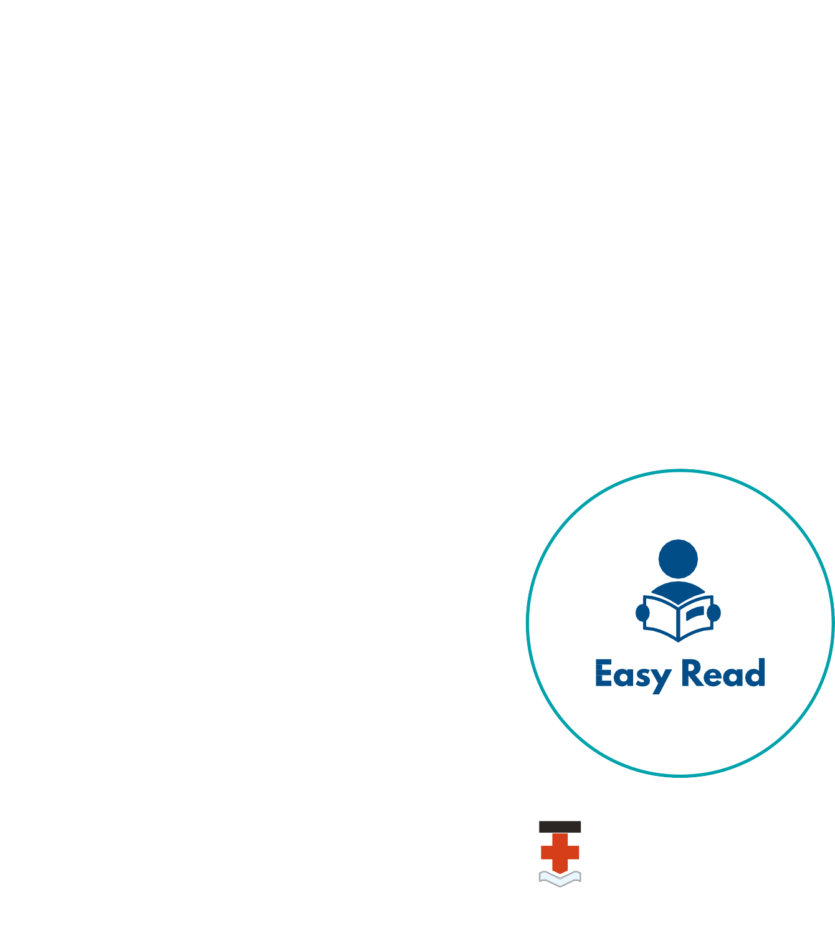INCLUSIVE RESEARCH
A guide to doing research with people with disability

This guide was made by the Disability Innovation Institute at UNSW.
It was made with people with disability and their organisations.
UNSW believes inclusive research is a good way to work.

This guide 2 Words we use 3 Inclusive research 4 Benefits 5 Work together 6 How to do inclusive research 8 Running a research project 10 Project meetings 11 Support 13

Contents
Remember 14

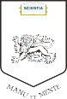

INCLUSIVE RESEARCH: A guide to doing research with people with disability 1

This guide Words we use

This guide is a summary of Doing Research Inclusively; Guidelines for Co-Producing Research with People with Disability.

It is for researchers at UNSW and other universities.

It is for people with disability and their organisations.
These are some words used in inclusive research.

Academic researcher – a person who works for the university and does research on problems or areas of life. Academic researchers are also called professional researchers.

Co-design or co-production – people with disability are included in the research process.

Co-researchers are people involved in the research who are not academic researchers.

Co-researchers are also called Community Researchers, Participatory Researchers or Lived Experience Researchers.

Easy Read – information that is easy to read and easy to understand. Pictures are used with words to explain things.

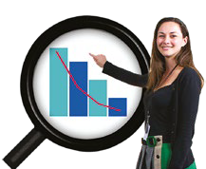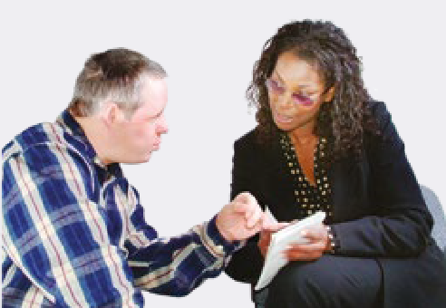

If you read or hear a word you do not understand it is OK to ask someone to explain it.

This guide helps researchers work with people with disability.

2 INCLUSIVE RESEARCH: A guide to doing research with people with disability INCLUSIVE RESEARCH: A guide to doing research with people with disability 3

Inclusive research Benefits

Inclusive research is when people with disability are part of the research team.
It supports people to have a better life.
There are lots of good things about inclusive research.
We get better information about people with disability.

Researchers with and without disability work together.
People with disability are valued.
Working on research helps us speak up.
It gives us skills and jobs.

It helps us meet new people.

Inclusive research:
- Looks at issues that are important to us.
- Uses our life experience.
- Provides information we can read and understand.
It helps organisations change how they work with people with disability.

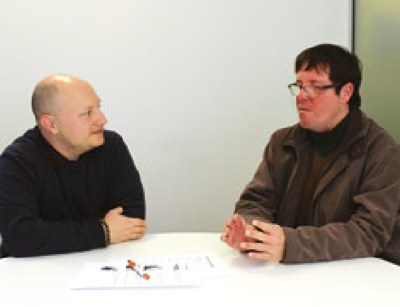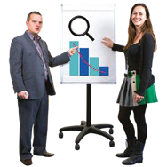

4 INCLUSIVE RESEARCH: A guide to doing research with people with disability INCLUSIVE RESEARCH: A guide to doing research with people with disability 5

Work together Work together

Share the power
Everyone in the team helps make decisions about the research.

Benefit
Everyone must benefit from working on a project.

Diversity
Use people’s different ideas and skills.
Listen to and respect everyone.

Be clear
We must all know what we are doing.

Access
Make sure:
- Buildings have good access.
- Information is easy to read.

Be flexible
We might need to change the way we do things.

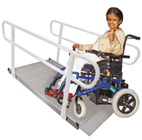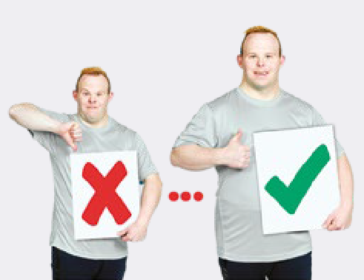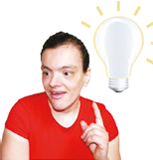

6 INCLUSIVE RESEARCH: A guide to doing research with people with disability INCLUSIVE RESEARCH: A guide to doing research with people with disability 7

How to do inclusive research How to do inclusive research

Starting a research project
Inclusive research must begin at the start of the project.
The team sets out the focus and goals.
There is a leader of the project.

The leader can be one person or a small group.

Costs
Think about what people need so that they can be included:
- Extra time.
- Room.
- Travel needs.
- Payment.

Recruiting
What lived experience do people need?
Recruit through disability organisations.

Payment
People with disability must be paid for their work.
If people with disability need support to do research, this must be paid for.

Evaluate
It is important to check if the research is going well.



8 INCLUSIVE RESEARCH: A guide to doing research with people with disability INCLUSIVE RESEARCH: A guide to doing research with people with disability 9

Running a research project Project meetings

Training
Training is good for all team members.
It can help the team work better.

Ethics
Ethics Boards review research projects to make sure they are done in the right way.
They are separate from the research team.
They may not believe people with disability can work on research.
Any risks are explained to the Ethics Board.

Ownership
Not everyone in the team makes every decision.
The team will help decide what people’s roles are.

Meetings
Team meetings help keep everyone up to date.
People have their say and ask questions.

Think about:
- How many meetings to have.
- How often to have them.
- How long should they go on for.

Meetings need to have:
- Breaks.
- Time to get to know team members.
- Snacks and drinks.

Meetings need to be in places that are easy to get to and have good access.

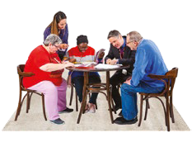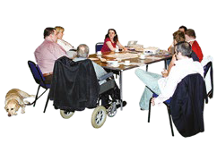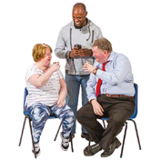

10 INCLUSIVE RESEARCH: A guide to doing research with people with disability INCLUSIVE RESEARCH: A guide to doing research with people with disability 11

Project meetings Support

Information for meetings needs to be easy to read.
This includes emails, agendas, minutes and other information.
Support can be:
- Emotional support to make sure we feel OK.
- Practical support like help with travel.
- Training to build skills.

The Chairperson leads the meeting. They make sure everyone has a say.
They must know how to include everyone.
Researchers with disability may need support to prepare for meetings.

Check in with team members after meetings.
Talk about what is working well and what could be better.
Researchers with disability also support academic researchers.

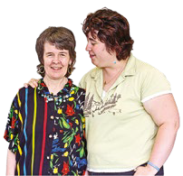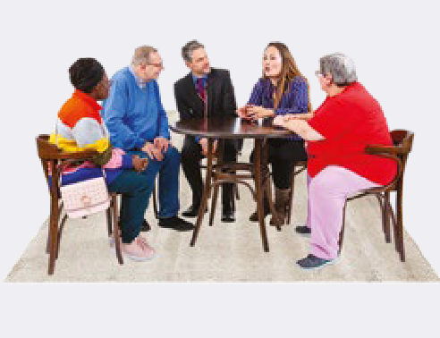

12 INCLUSIVE RESEARCH: A guide to doing research with people with disability INCLUSIVE RESEARCH: A guide to doing research with people with disability 13

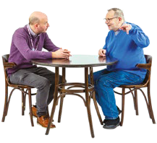Remember

Inclusive research takes extra time and money to do well.

Inclusive research helps:
- People with disability.
- Disability organisations.
- Universities.

Inclusive research
is a good way to work.

14 INCLUSIVE RESEARCH: A guide to doing research with people with disability

For more information contact:
Phone: 02 9385 9114
Email: diiu@unsw.edu.au
Website: www.disabilityinnovation.unsw.edu.au

