
New tech applications for regulatory outcomes
Occasional paper
March 2021

Canberra
Red Building
Benjamin Offices
Chan Street
Belconnen ACT
PO Box 78
Belconnen ACT 2616
T +61 2 6219 5555
F +61 2 6219 5353
Melbourne
Level 32
Melbourne Central Tower
360 Elizabeth Street
Melbourne VIC
PO Box 13112
Law Courts
Melbourne VIC 8010
T +61 3 9963 6800
F +61 3 9963 6899
Sydney
Level 5
The Bay Centre
65 Pirrama Road
Pyrmont NSW
PO Box Q500
Queen Victoria Building
NSW 1230
T +61 2 9334 7700 or 1800 226 667
F +61 2 9334 7799
Copyright notice
https://creativecommons.org/licenses/by/4.0/
With the exception of coats of arms, logos, emblems, images, other third-party material or devices protected by a trademark, this content is made available under the terms of the Creative Commons Attribution 4.0 International (CC BY 4.0) licence.
We request attribution as © Commonwealth of Australia (Australian Communications and Media Authority) 2021.
All other rights are reserved.
The Australian Communications and Media Authority has undertaken reasonable enquiries to identify material owned by third parties and secure permission for its reproduction. Permission may need to be obtained from third parties to re-use their material.
Written enquiries may be sent to:
Manager, Editorial Services
PO Box 13112
Law Courts
Melbourne VIC 8010
Email: info@acma.gov.au

Executive summary 1
About the research 3
researchacma 3
Introduction 4
Purpose 4
Background 4
RegTech explained 4
Technologies being used for RegTech 6
RegTech market 6
How can RegTech support regulatory processes? 8
Compliance 8
Smart contracts for Australian businesses 9
Regulatory reporting 9
UK demonstration of automated regulatory reporting 10
Risk management 10
Automating quality assurance to enhance consumer outcomes 11
Identity management and control 11
Child Information Sharing Scheme 12
Rules as code 12
Markets in Financial Instruments Directive II Regtech pilot 13
RegTech benefits 15
RegTech challenges 16

Executive summary
The paper considers developments in the use of Regulatory Technology (RegTech), including its application in the communications and media sector. This research is intended to ensure the ACMA, as Australia’s communication and media regulator, is aware of current and emerging developments.
The paper explores the use of RegTech, some of the main use cases from compliance, regulatory reporting processes, risk management and identity and control processes. The paper identifies the benefits and risks of RegTech and the conditions where RegTech is likely to offer the greatest benefit, particularly where the regulatory environment is complex and technology can make better use of data to achieve compliance goals. However, RegTech is not a one-size-fits-all solution, and a range of factors from interoperability, data protection, privacy and environmental factors need to be considered.
Regulations are an essential part of the economy and society. They underpin markets, protect the rights and safety of consumers and ensure the delivery of services. Digital technologies are continuing to drive new ways of doing business. Regulatory landscapes are also continuing to adapt and evolve in response to digital transformation and changing market conditions.
In this context, organisations and regulators are turning to new technologies to find ways to improve productivity and increase compliance while reducing regulatory costs. Digital technologies are being deployed by industry and regulators due to their ability to complete mechanical tasks more efficiently and accurately, and, in some cases, more completely than humans. While regulatory technologies applications are designed to help support decision-making, RegTech applications still require human oversight.
This convergence between disruptive technologies, evolving market environments and increasingly complex regulatory landscapes is seeing new RegTech emerge. RegTech has the potential to improve traditional regulatory practices for regulators and regulated entities.
RegTech solutions can be applied across a range of different industries to help support businesses, consumers and regulators to meet current and emerging regulatory challenges. Within the media and communications environment, we are observing that some international regulators are exploring the potential benefits of RegTech.
For example, the Canadian Radio-Television and Communications Commission is examining how data can be better used to monitor broadcaster compliance with local content obligations. The Telecom Regulatory Authority of India (TRAI) is exploring the use of Distributed Ledger Technology (DLT) to help manage problems associated with SMS spam and fraud.
The ACMA will continue to monitor developments relating to RegTech. Feedback on this paper is welcome and can be provided to regfutures@acma.gov.au.

About the research
This research explores how RegTech can assist or address the challenges of meeting regulatory obligations, and how it can assist with regulatory practice.
This paper was informed by desktop research and targeted consultations with a range of stakeholders, including domestic and international government agencies. The ACMA would like to thank those who contributed to the research.

researchacma
Our research program – researchacma – underpins our work and decisions as an evidence-informed regulator. It contributes to our strategic regulatory thinking, and supports a regulatory framework that anticipates change in dynamic communications and media markets. The program also seeks to inform internal and external stakeholders on any developments that may influence our regulatory practice into the future.
This research has been developed as an occasional paper to help inform the ACMA and our stakeholders regarding developments that may influence our thinking on future regulatory practice.

Introduction

Purpose
The ACMA has conducted research on RegTech to ensure that we have a contemporary understanding of developments, including potential applications in the media and communications environment in the medium to long term.
This paper aims to inform internal and external stakeholders, as RegTech applications are anticipated to become more widespread over various sectors in the coming years.

Background
As we continue to experience rapid advances in technology, the ACMA is exploring applications of technology to assist or address the challenges of meeting regulatory obligations. An industry has emerged based on RegTech – that is, the application of technology to meet regulatory obligations.
The global market for RegTech is continuing to grow. According to KPMG, global spending on RegTech is expected to reach $22 billion by 2022, up from $10.6 billion in 2017. According to the Productivity Commission, Australia is well placed internationally for the development of RegTech solutions, with relatively stable and sophisticated regulatory systems. The Productivity Commission also notes that while estimates vary, around 13% of global RegTech providers are based in Australia.
RegTech solutions are currently supporting day-to-day transactions to make business activities simpler and safer. For example, secure portals are enabling consumers to share information with a telco conveniently and safely. Chatbots are creating actionable records and insights relating to consumer complaints. Legal services chatbots are also being developed which use artificial intelligence (AI) to provide services such as contesting parking tickets and cancelling subscriptions. Progress in AI and machine learning will allow stakeholders to proactively identify and predict risk. Real time audits and smart contracts are already available.

RegTech explained
Johan von Solms describes RegTech as follows:
RegTech is a toolkit of technologies which can provide a range of benefits for industry. It is not just a solution to automate manual and time-consuming operational activities, but also a powerful instrument to compute and interpret complicated forecasting results, identify unanticipated risks and crucially drive quicker and more intelligent regulatory assessments, during times of stress.
RegTech has been defined by the Institute of International Finance as ‘the use of new technologies to solve regulatory and compliance requirements more effectively and efficiently’.
RegTech refers to the use of new technology in regulatory monitoring, reporting, and compliance to help businesses comply with regulations efficiently and in a cost-effective way. It is industry and technology-agnostic and is being used across a range of different regulatory environments and industries. RegTech also refers to the use of new technology by regulators to enable a more efficient and effective regulatory environment. RegTech solutions can be applied in any industry with regulatory and compliance requirements.
Technological developments are driving fundamental changes in our regulatory environment. The way regulatory bodies monitor and regulate is increasingly becoming data-driven. RegTech offers regulators and regulated entities the opportunity to better detect, understand and respond to non-compliance. By increasing access to data and sophisticated analytic tools, regulators and regulated entities can become more proactive in understanding and addressing risk. At the same time, the costs associated with compliance and reporting are, in some cases, driving RegTech developments to reduce these costs.
Key technologies such as Al and machine learning are helping to accelerate the RegTech sector. This is enabling companies to streamline or automate processes such as due diligence and reporting, and conduct meaningful analysis of critical compliance risk areas. Companies are using RegTech to deal with the huge amount of data they are generating. As data analytics become more sophisticated, richer and more reliable information is generated which can provide benefits for managing risk and compliance.

Technologies being used for RegTech
Some of the main technologies being used for RegTech are:
 | AI/machine learning
 | Automation/robotic process automation
 | Big data analytics/predictive analysis
 | Application programming interface
 | Biometrics
 | Blockchain
 | Cloud
 | Cryptography
 | Smart contracts

RegTech market
According to the Productivity Commission, Australia is well-placed for the development of RegTech solutions, as around 13% of RegTech providers globally are based in Australia. Analysis from the Boston Consulting Group (BCG) has found that Australia is emerging as a global RegTech hub.
Global RegTech hubs
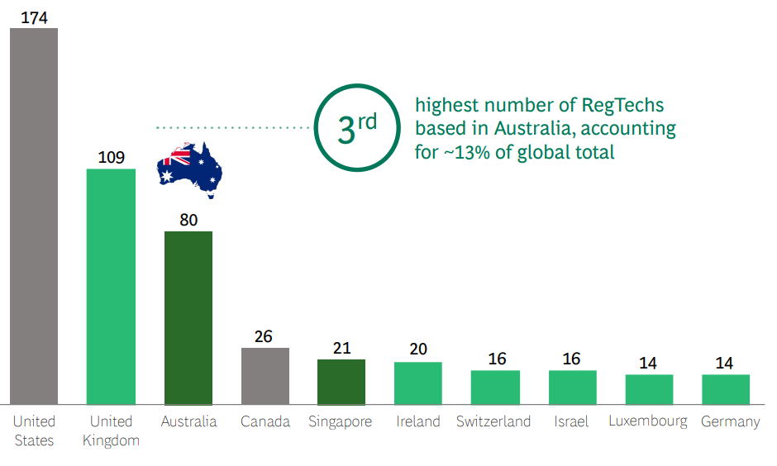
Source: BCG, ‘Australia’s global RegTech hub poised for growth’.
A global survey of RegTech vendors indicates that currently, financial services dominate the sector. However, the focus of RegTech vendors is broadening as shown below.
Non-financial industries targeted by RegTech vendors
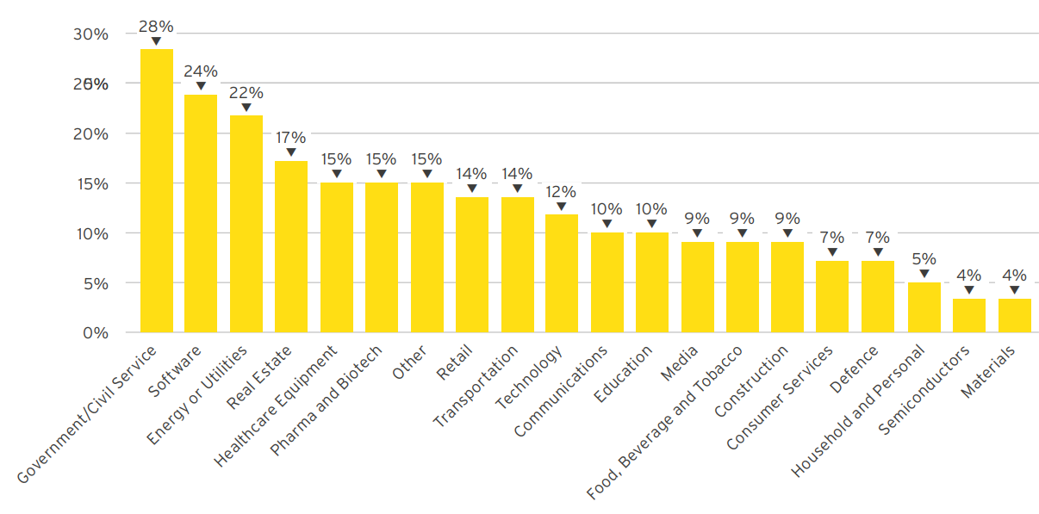
Source: Cambridge Centre for Alternative Finance and EY, Global RegTech industry Benchmark Report.

How can RegTech support regulatory processes?
RegTech is being deployed across a range of industries and regulatory areas to help support compliance processes. There are numerous ways that RegTech could support regulatory processes. This section describes some of the main regulatory use cases.

Compliance
RegTech has the potential to positively change the regulatory landscape by providing technology-based solutions to address demands of compliance within regulated industries. RegTech applications can support compliance in several ways. For example, it can support compliance by reviewing all relevant regulations and reporting on the potential impact of such regulations to the user.
Increased automation of compliance processes is one of the most widely used forms of RegTech and offers many potential benefits for organisations and regulators. For example, the use of robotic process automation can reduce the need to perform repetitive tasks such as collecting data and analysing information across systems. The benefits of this automation include reduced errors and faster processes, freeing up organisational resources to perform higher-level functions such as reviewing alerts and developing responses.
RegTech can also support compliance by design. An example of this is smart contracts, which are self-enforcing through automated execution with the terms and conditions of the contract between the parties written directly into code. Smart contracts have the potential to automate and authenticate processes where it is important for parties to be able to rely on and trust steps or conditions in a supply chain or exchange.
 | Smart contracts for Australian businesses
In 2018, CSIRO’s Data 61 formed a consortium with Herbert Hills Freehills and IBM to build a legal contracting blockchain platform called the Australian National Blockchain (ANB). The aim of ANB is to enable businesses to digitise legal contracts and exchange data relating to those contracts. It will be designed to meet the requirements of Australian law.
The goal is that the ANB will provide smart legal contracts which contain smart clauses with the ability to record external data sources (which could include Internet of Things device data), enabling these clauses to self-execute if specified contract conditions are met. An example of how this could work is a sensor that records the time and date of a delivery, which could automatically trigger a smart contract to inform the other party that the terms have been met to provide payment on the delivery.
Within the media and communications sector, smart contracts could potentially be applied as a billing and charging solution, or as roaming clearance for telcos, and help enable more efficient business processes.

Regulatory reporting
A key benefit of RegTech is that it can support and streamline the generation and distribution of reports and information required by regulators. RegTech can enhance regulatory reporting processes by automating manual reporting processes and utilising data aggregation tools that take information from various source databases and combine data into one complete data set. These tools may also provide feedback on any inconsistencies in the source data. This can benefit management oversight and in reconciliation and variance analysis.
RegTech can also support regulatory reporting by monitoring regulatory changes and producing updated reports that can used to support disclosure obligations. This enables firms to ensure their regulatory reporting continuously meets regulatory reporting requirements.

 | UK demonstration of automated regulatory reporting
In November 2017, the Financial Conduct Authority (FCA) and the Bank of England held a ‘TechSprint’ which explored the potential for an automated solution to help financial institutions report more easily and improve the quality of information. The aim was to find a technological solution which could link regulation, compliance procedures and firms’ policies and standards with companies’ transactional applications and databases.
The TechSprint helped develop a proof of concept that could turn reporting requirements into machine-readable language. Machines could then use this language to automatically execute the rules. Once the rules were translated, machines were able to fulfil the requirements by assessing the information required and then pulling this information directly from a firm’s databases to automate the process of compliance. The TechSprint also demonstrated the potential flexibility of this approach by simulating an FCA rule change in real time and seeing the machine automatically changing the reporting data.
There is a potential for similar RegTech applications within the media and communications sector. Such applications could make it easier for regulated entities to report compliance data, automatically update systems to reflect changing requirements, and support internal compliance monitoring.

Risk management
RegTech has the potential to conduct scenario analysis, stress testing, what-if analysis and risk monitoring on internal business operations using big-data analytics to identify and evaluate these risks. This can enable firms to efficiently adapt and respond to emerging trends and issues.
RegTech has the potential to continually monitor activity, provide real-time insights and identify potential risks, which human beings can then analyse and follow up. Automated analysis combined with human judgment can help organisations develop a clearer picture of risks and to recalibrate, rather than taking remedial action after an issue has occurred.

 | Automating quality assurance to enhance consumer outcomes
In 2019, life insurance provider TAL and Deloitte announced a partnership to deploy a RegTech solution using AI and voice recognition. This solution will be used on phone-based sales calls to help improve consumer outcomes and ensure that regulatory requirements, including those with unsolicited insurance sales, are met. The RegTech solution will feed directly into TAL’s quality assurance program, to help improve the overall responsiveness and mobility of the program.
The RegTech solution will analyse call recordings to look for matches to phrases, statements and key words that TAL has identified as potential indicators of poor consumer outcomes. These calls will then be assessed by TAL’s quality assurance program, improving the overall responsiveness of the program.
RegTech solutions that analyse call recordings could be beneficial within a telecommunications environment, particularly in relation to monitoring issues relating to spam, complaints, quality and staff training.

Identity management and control
RegTech solutions have the capacity to support obligations regarding client identity authentication. For example, RegTech applications are being used in the financial services sector to improve ‘know your customer’ processes. These processes can be time-consuming for financial institutions and their customers, as they require the institutions to collect and analyse documentation covering multiple data sources in various formats and languages. RegTech applications which can draw on data aggregation and analysis tools, along with robotic process automation, can speed up the time needed to manage identity management processes. AI and machine learning can also enhance identity management and control by gathering information across multiple sources.
Identity management and control solutions also have the potential to securely aggregate data about an individual, which can be used to help make informed decisions.
 | Child Information Sharing Scheme
Child Link is a Victorian web-based register (due to go live in December 2021) that will display information about a child and family members to authorised professionals who have responsibility for the child’s wellbeing and safety. Child Link will bring together data from existing systems and services to form a single and aggregated source of information about a child and their engagement in childhood services.
Child Link will provide users with critical information about the children in their care to help make more informed decisions relating to child safety and wellbeing. It will also allow for de-identified and longitudinal data sets to inform better policy development and service design. The data will give insights into how children interact across various universal services and programs as they grow and develop.
Identity management systems could be helpful within the media and communications environment by making it easier to verify customer information.

Rules as code
RegTech has the potential to enable laws to be easier to understand and apply. According to the Organisation for Economic Cooperation and Development (OECD), rules as code ‘proposes to create a machine-consumable version of some types of government rules, to exist alongside the existing natural language counterpart’. This approach generally involves creating rules that are better suited for digital service delivery, creating software tools to write the rules into code and using that code as the basis for service delivery and decisions. This can improve service delivery, make rules easier to understand for consumers and regulated entities, and ensure a more consistent application of the rules by regulators. Rules as code, by highlighting logical structures, could also create improvements in the legal drafting process by ensuring the use of that logic is traceable, explainable and open to correction if required.
Rules as code is being applied in several jurisdictions and bespoke contexts. For example, the New Zealand Government Smart Start website provides information about services that new parents need when they have a baby. The website combines the eligibility rules for 18 financial benefits for new parents. Users can submit anonymised demographic information, and the site returns information about which rebates the subject is eligible to receive. Other recent developments include PaidRight, a payroll application using advanced data analytics developed by Data61 in partnership with Price Waterhouse Coopers (PwC). This application uses a rules as code approach to enable employers to check that employee entitlements have been correctly paid.
In September 2020, the NSW Government created a machine-readable version of the Community Gaming Regulation 2020 (NSW) on its OpenFisca-based rules as code platform. This allows industry and government to embed digital rules directly into their IT systems to streamline compliance and automate any changes in the future. In addition, consumers are able to navigate this digital version of the regulation easily via an interactive questionnaire. The aim of the questionnaire is to make it easier for charities, not-for-profits and businesses to better understand the regulation for conducting different community games. This is shown in Figure 3 below.
Community Gaming Regulation before and after rules as code
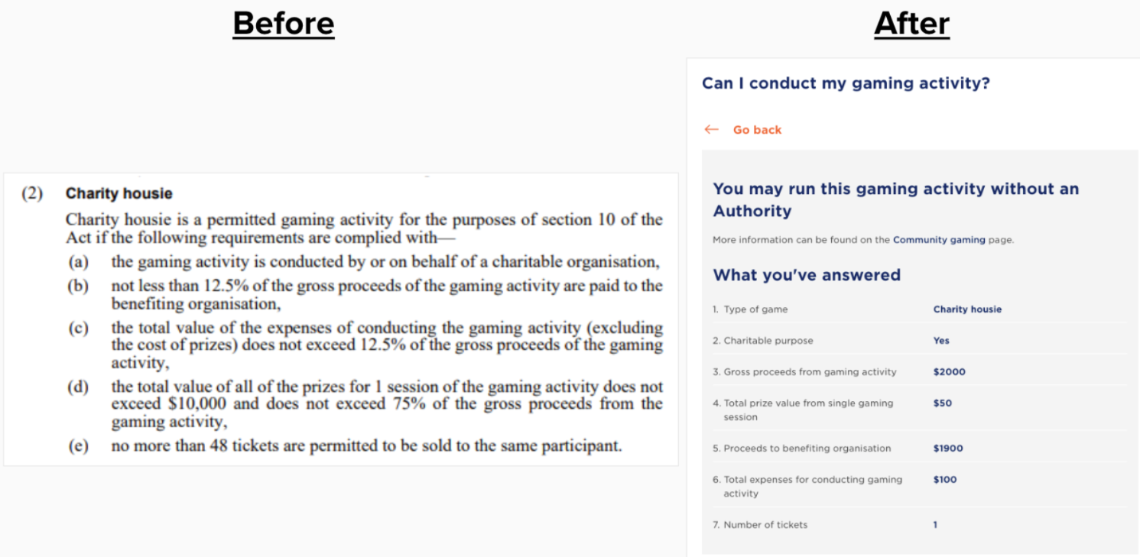
Source: NSW Government, Rules as Code, what it means and why we are doing it, © State of New South Wales. For current information go to www.nsw.gov.au.
 | Markets in Financial Instruments Directive II RegTech pilot
In 2018, ING and the Commonwealth Bank of Australia completed a RegTech pilot to simplify the processing of information and implementation of regulation using the Markets in Financial Instruments Directive II (MiFID II) as a test case. MiFID II is a regulatory framework of European Union legislation and aims to improve the functioning of financial markets. The project was also overseen by the UK’s Financial Conduct Authority.
The project, completed in partnership with fintech, Ascent Technologies and Pinsent Masons, used natural language processing (NLP) and AI to interpret and convert 1.5 million paragraphs of regulation into a series of actionable tasks. Using AI, the banks were able to quickly identify items in the regulation that could be reviewed and actioned, saving hundreds of hours of manual processing.
Rules as code, while a less mature form of RegTech, has potential to generate improvements in the media and communications sector. For example, rules as code applications could make it easier to understand licensing requirements or other regulatory obligations.

The Australasian Legal Information Institute (AustLii) has also developed DataLex, a rules as code platform. In December 2020, AustLii released an app that tests the Treasury Laws Amendment (News Media and Digital Platforms Mandatory Bargaining Code) Bill 2020. It aims to determine if a media organisation has standing to participate in the bargaining process applying sections 52 (G) and (P) of the draft code.
RegTech applications are also currently being deployed in the media and communications sector. Some examples include:
- KT Korp, a South Korean telco, has partnered with China Mobile to commercialise, B.Link, a blockchain-based, real-time roaming charge system which automatically settles roaming charges when a customer on one network roams on the other. This approach allows KT Korp and China Mobile to save time and money.
- Korea Telecom has developed its own AI platform, a network failure root cause analysis solution called Dr Lauren. This system collects alert data occurring during network operation and the AI can identify the cause and location of a network issue within a minute. This capability has the potential to improve network performance, reduce costs and may improve accuracy in reporting.
- Deutsche Telekom Group affiliates T-Mobile Czech Republic (TMCZ) and Slovak Telekom (STSK) have partnered with Elisa Automate to deliver a cloud-based automation solution ASquare, jointly with the Hellenic Telecommunications Organisation. The solution uses machine learning to deliver real-time monitoring, process automation and predictive capabilities to enhance operations. The aim of the solution is to enable the telcos to optimise network-related costs, enhance efficiency and improve customer experience.
The ACMA is also exploring the use of technology to streamline or support regulatory requirements and is building its data analytics capability to support improved regulatory decision-making. Current data projects include enhanced reporting around financial hardship, complaints management and enhanced compliance monitoring of spectrum radiocommunications licensing. Longer term, other applications which the ACMA could explore relate to enhancing regulatory reporting and rules as code applications to help make some regulatory requirements easier to understand.

RegTech benefits
RegTech is likely to offer the greatest benefits when:
- the regulatory environment is complex
- technology can streamline activity monitoring and regulatory reporting
- technology can make better use of data to meet compliance goals
- there is capacity and willingness from the regulator and regulated entity to adopt and use RegTech applications.
RegTech has the potential to offer benefits for regulated entities to operate efficiently and effectively within complex regulatory environments. This is because of RegTech’s ability to automate and streamline activity monitoring, regulatory monitoring, reporting and compliance.
According to the Productivity Commission, one of the main applications of RegTech is in helping businesses assess their regulatory obligations and fulfil regulatory requirements faster and in a manner that is more integrated with their other business processes. The adoption of RegTech can support organisations operating in complex regulatory environments by simplifying processes via automated mapping of regulatory risks to business processes, which reduces the need for manual checks.
In addition, the use of advanced data analytics can allow for regulatory information to be analysed in various ways and streamline activity monitoring, including scenario analysis, automated reporting and searches for new regulations. This can help organisations to efficiently manage and monitor risk, and to meet compliance goals.
An enabling environment between the regulator and regulated entities is also key to ensure the full benefits of RegTech can be realised.

RegTech challenges
While RegTech can provide significant benefits to regulators and regulated entities, it is not without risk. RegTech applications, particularly those deploying AI, need to ensure robust data governance and controls are in place. Organisations should develop an appropriate data quality risk-management program to ensure the accuracy, completeness and consistency of the data used to support the RegTech application is robust. Other issues that should be considered include whether the solution has robust cyber security and privacy protections in place. Legacy infrastructure may pose challenges with the effective adoption of RegTech.
Organisations deploying RegTech may also need to develop systems and processes to identify, address and mitigate errors or malfunctions which could occur through the use of RegTech. Organisations deploying RegTech solutions should ensure appropriate staff training is available. This training should explain how the underlying algorithms are intended to work so staff are better able to assess results.
As noted by the Productivity Commission, when considering a RegTech solution, there needs to be a reasonably high level of confidence in the continuing need for the solution. The Productivity Commission observed that ensuring interoperability of processes, such as aligning the timing of data collection and reporting, is complex and it can take time for the full benefits of RegTech to be realised.
The ethical concerns associated with RegTech should also be considered and appropriately managed. A common ethical concern is ensuring a human is accountable for the outcome of RegTech responses. Accountability requires the individual responsible to have the relevant technical skills and capabilities on how to best use the application, along with ensuring there is a searchable audit trail of the data used to make a decision. These technical skills can be difficult to source in the current operating environment. RegTech can augment and enhance decision-making but it does not replace the need for human oversight. Policy makers and regulators will need to address these challenges to build public trust and guide RegTech towards beneficial outcomes.
Next steps
The ACMA will continue to monitor developments relating to RegTech.
Feedback on this paper is welcome and can be provided to regfutures@acma.gov.au.

Canadian Radio-Television and Communications Commission, personal communication, 23 October 2020.
The press release to the draft telecom commercial communications customer preference regulations 2018 includes the adoption of DLT as the RegTech to enforce regulatory compliance while allowing innovation in the market.
KPMG, ‘There’s a revolution coming: Embracing the challenge of RegTech 3.0’, September 2018, pp. 5.
Productivity Commission, Regulatory technology information paper, October 2020, pp. 7.
An example of this is the DoNotPay chatbot, which describes itself as the ‘world’s first robot lawyer’. This service uses automation to assist clients to protest parking tickets and other small claims.
J Von Solms, ‘Integrating Regulatory Technology (RegTech) into the digital transformation of a bank Treasury’, Journal of Banking Regulation, 2020, pp. 14
Institute of International Finance, ‘Regtech in Financial Services: Solutions for Compliance and Reporting’, 2016.
World Government Summit, ‘RegTech for regulators’, February 2018, p.4
Productivity Commission, Regulatory technology information paper, October 2020, pp. 7.
BCG, ‘Australia’s global RegTech hub poised for growth’, October 2020, pp. 6.
Cambridge Centre for Alternative Finance and EY, ‘The Global RegTech Industry Benchmark Report’, August 2020, pp. 33–34.
Financial Industry Regulatory Authority, ‘Technology based innovations for regulatory compliance in the securities industry’, September 2018, pp. 6.
Department of Industry, Energy, Science and Resources, ‘National blockchain roadmap: Progressing towards a blockchain empowered future’, February 2020, pp. 19.
OECD, ‘Cracking the code: Rulemaking for humans and machines’,12 October 2020, pp. 7.
Ibid; NSW Government, ‘Emerging Technology Guide: Rules as Code’ September 2019.
Matthew Waddington, ‘Research Note: Rules as Code’, Law in Context, Vol 37, No 1 (2020) pp. 182.
Digital Government NZ, ‘SmartStart a new type of service’, accessed 16 November 2020.
Data61, ‘Advanced data analytics ensuring employees receive the correct pay’, 14 December 2020.
Digital NSW, In an Australian first, NSW is translating rules as code to make compliance easy, September 2020
The Korea Herald, ‘KT, China Mobile to boost cooperation on 5G roaming blockchain system’, 5 December 2019.
Broadband World News, ‘BBWF interview: KT’s JP Lee on AI in telecoms’, 9 November 2019.
Elisa Automate, ‘Elisa Automate to deliver Zero-Touch, fully automated network operations to T-Mobile Czech Republic and Slovak Telekom’, 10 November 2020.
Productivity Commission, Regulatory technology information paper, October 2020, pp 14.
Institute of International Finance, ‘Deploying RegTech Against Financial Crime’, 27 March 2017, pp. 29; Amy Wang, ‘The Role of RegTech in Augmenting Regulatory Compliance: Regulating Technology, Accountability and Liability’, UNSWLawJIStuS 10, 2019.
Productivity Commission, Regulatory technology information paper, October 2020, pp 14.

