Making Workplace Adjustments Easy, Effective and Equitable
  - Conversation Guide




jobaccess.gov.au | 1800 464 800

Acknowledgement of Country
We acknowledge the traditional custodians of Australia and the lands upon which we live and work and pay our respects to Elders past and present.
We also acknowledge the stories, traditions, and living cultures of Aboriginal and Torres Strait Islander peoples.
Contents

Acknowledgement of Country 2
Overview 4
Sharing information about disability 6
What should an employer do when an employee shares information about their disability? 6
Good practice considerations for managers 8
General considerations about workplace adjustments 8
Considerations before having the conversation about adjustments 9
Considerations during the conversation 11
Considerations after having the conversation about adjustments 13
Good practice considerations for employees 17
Prepare for the conversation about workplace adjustments: 17
Preferred working styles for employers 19
Preferred working styles for employees 21
Need support with workplace adjustments? JobAccess is here to help. 22
Disability and Adjustment tool 23
Application process for workplace adjustments through JobAccess 24
Reasonable Adjustment Policy 26
About JobAccess 27



Overview
Workplace adjustments (or reasonable adjustments) are administrative, environmental or procedural changes that enable people with disability to have equitable employment opportunities, ensure dignified access and to work safely and effectively.
Not all people with disability require workplace adjustments. However, knowing how to provide adjustments can help employers attract, employ and retain people from a wider talent pool.
If an employer is aware of an employee’s disability, they must legally provide what is regarded as a workplace adjustment, to support them at work.
Workplace adjustments are an important enabler for people with disability to work safely, productively and feel included. Some examples are flexible work arrangements, facilities, equipment, changes to premises, work practices or training that could help a person do their job equitably and with greater autonomy.
Offering workplace adjustments can mean that employees with disability have access to opportunities throughout their employment lifecycle within an organisation – right from starting a new position through to upskilling, training and career progression.
According to a recent national survey by JobAccess, 60 per cent of Australians lack awareness about adjustments. Only 2 in 5 people perceive workplace adjustments as something easy. Additionally, a majority are unsure about the costs and benefits of implementation.
Low awareness about workplace adjustments means employers and employees may be unsure how to ask for or organise adjustments. The purpose of this guide is to help employers and employees approach the conversation from a point of openness, empathy and action.

Sharing information about disability
There is no legal obligation for an employee to share information about their disability, unless it:
- Impacts their ability to perform the inherent requirements of the role, or
- Impacts their safety, or
- Impacts the safety of their co-workers.
If any of these apply, employees only need to share information about how their disability affects their work.
For example, if someone feels dizzy because of medication for a mental health issue, they should talk to their employer about adjustments. These adjustments might include flexible start or finish times. They don’t have to tell their employer about the mental health issue itself.
Some employees choose not to share information, and that’s okay if it doesn’t impact their work. Respect their choice.

What should an employer do when an employee shares information about their disability?
- Talk to the employee about any adjustments they may need at work and make sure to put them in place.
- Ask the employee if they need training to use new assistive tools or software. Also, think about whether you or your team need awareness training to better engage with and support the employee.
- Before sharing their information with any other team members, get permission from the employee. This could be with other teams like IT, Work Health and Safety, or Facilities. Respect the employee’s privacy.

“An awkward conversation is hard but worth it. It's OK, you can jump in and asked the question. If you have good intentions, that will show through.
You won't fix everything in one conversation either. Don't set yourself up for ‘We will have this conversation then everything will be fine’. That's not the case with anybody, in terms of good management or working.
Keep having the conversation, keep connecting, and you will figure it out. Go with the mindset of 'we will figure this out'.”
Sharon Bailey
Disability Champion, Department of Energy and Climate, Queensland Government


Good practice considerations for managers
Managers play a vital role in creating a supportive, inclusive and safe workplace. It is important you are confident and prepared for the initial conversation about workplace adjustments.

General considerations about workplace adjustments
- Start by understanding what workplace adjustments are and what support is available to managers and employees.
- Familiarise yourself with the organisation’s workplace adjustments or reasonable adjustments policy (if you have one).
- Offer workplace adjustments at all stages of employment – from hiring to onboarding, through to learning and development, and promotion.
- Reference your company’s reasonable adjustment policy (if you have one) in job ads and ensure that candidates can easily find it on your website.
- Provide details of a direct contact that a candidate could reach out to, if they require workplace adjustments for any stage of the recruitment process. You can include a statement like:
“Please contact us on (phone number) or (email) for confidential support to ensure an equitable, barrier-free application process.”
- Ask all job candidates and current employees if they require adjustments and about their working preferences. A suggested question to ask is:
“Is there anything we can do to support you to be your best at work?”
- Adjustments should be in place before a new employee commences on their start date. Start the process to organise adjustments when a signed contract or letter of offer is received from the new employee. Have the conversation about adjustments before they start.
- People’s needs can change over time. A person’s likelihood of experiencing temporary, episodic, permanent or situational disability increases with age. Regularly check in with your employees and ensure the adjustments still work well for them.

Considerations before having the conversation about adjustments
- Ensure you’re aware of the inherent requirements or essential duties of the employee’s role.
- If you are unsure what adjustments can be provided, find out who to contact for advice.
- This could include your human resources or work health and safety team.
We’re here to help! You can contact JobAccess on 1800 464 800 or submit an online enquiry to discuss workplace adjustments.
- Select a private location to have the conversation, where potentially sensitive information can be discussed without being overheard. Remember, not all people are comfortable with sharing accessibility requirements.
- Set aside appropriate time for the conversation. Send an invite with the purpose of the meeting and a copy of this guide so that you can both prepare for the conversation.
- Encourage the employee to include a support person in the conversation, such as their Disability Employment Services (DES) provider, if appropriate.



Considerations during the conversation
- Set up a safe space by stating that you are there to help. Let the employee know that any questions are meant to help, not offend.
- Listen to the employee. Understand the barriers they experience and the supports they need at work.
- You don’t have to know the employee’s disability. Focus on what the person needs to do their job safely and effectively.
- No two people experience the same barriers with their disability in the same way. Avoid assumptions about disability and how it can impact someone at work.
- Ask supportive questions, such as:
“What can I do to help you be your best with your application / interview / role?”
“What barriers may you experience at work?”
“What supports have worked for you previously?”
- Ask the employee if they would benefit from a flexible working arrangement, such as working from home, or flexible start and finish times.
- You don’t have to know or have all the answers. If you’re unsure, tell the employee how you will respond (for example, phone or email) and provide a reasonable time frame.
- Clarify and list the adjustments the employee is requesting. If the employee is unsure about the adjustments they need, contact JobAccess on 1800 464 800 to speak to our resourceful Advisers or submit an online enquiry.


Considerations after having the conversation about adjustments
- When an employee requests a workplace adjustment, it’s important to know the process to follow. Use a checklist to ensure you’ve captured the request and set timeframes to action the implementation.
Don’t have a checklist? Download the ‘Reasonable adjustment policy checklist’ (PDF copy and Word copy) from the JobAccess website to get started.
- Plan potential financial or resourcing into your budget to implement the adjustments.
JobAccess provides expert and tailored advice on workplace adjustments. It also provides financial support to purchase adjustments through the Employment Assistance Fund.
- Assess if you need further information or supporting evidence about why the adjustment is required before proceeding to implement the adjustments.
- Check in with the relevant team about how to approve, request, purchase and implement adjustments.
- Set up regular check-ins with the employee to see if the adjustments are working for them, and if they require any different or additional support.
- See how you or your team can better support the employee. Would the team or workplace benefit from disability awareness training?
Do you require further training to help yourself and other team members to support the employee at work? You can organise specific disability awareness, deafness awareness and mental health awareness training through JobAccess. These can be funded by the Employment Assistance Fund.
- If the employee has a Disability Employment Services (DES) provider, they can support you and the employee with the process to organise workplace adjustments.
- If a requested adjustment is potentially unable to be fulfilled, check in with your human resources or work health and safety team to discuss what alternatives are available to your organisation. You can also contact JobAccess on 1800 464 800 for free and confidential discussion about workplace adjustments.

Scenario 1

Inviting a candidate for an interview: Amanda and Thea
Amanda is a hiring manager at a large hospitality group, Star Stays. Amanda is recruiting for the position of Customer Relations Lead and has received an application from Thea. Thea has a strong background in customer service with over 10 years of experience.
Thea is legally blind, and her passion to deliver the best service for her customers makes a world of difference at the workplace. Amanda is impressed with Thea’s resume and calls her to schedule an interview.
Amanda: Hi Thea, this is Amanda from Star Stays. I am calling with regards to your application for the Customer Relations Lead role. Your application stood out to us, and we would like to invite you for an interview.
Thea: Thanks for the opportunity, Amanda! I’d be happy to interview for the role. Can you tell me about your interview process?
Amanda: That’s great, thanks Thea! Our HR team member Susie will join me for the interview. We are looking to conduct the interview next Wednesday at 11.00 am at our office on 1 McMain Street in the CBD. Does that day and time work for you?
Thea: Yes, I will be available to attend the interview next Wednesday.
Amanda: Excellent, thanks Thea! Do you require any support or adjustments to help you be your best in the interview?
Thea: I am legally blind, so I would need someone to meet me at the reception and direct me to the interview room. Also, if there are any written assessments, I will require them in an accessible format.
Amanda: Absolutely, no worries, Thea! I will meet you at the reception and we can walk to the interview room together. If you get stuck for any reason on the day, my contact number is 0444 444 XYZ.
I will follow up this phone call with an email and include all the details we discussed. I will also send through an accessible map with information on how to get here. If you think of anything else, please let us know. See you next week!

Scenario 2

Having the conversation about workplace adjustments: Rosita and Zoe
Rosita owns a small café. She recently hired Zoe as a café worker to take customer orders, manage payments and serve customers.
Zoe is dyslexic and processes information differently. Zoe shared information about her dyslexia with Rosita, who wanted to ensure Zoe has what she needs to be her best in the role. She organised a meeting with Zoe in a quiet space to ensure privacy of information.
Rosita: What are some of the barriers you are currently experiencing at work?
Zoe: I am a visual thinker and understand images better. Usually when there is a lot of information on the menu board, it takes me longer to read and complete the task. Is there any way we can simplify the information on the menu and add images? I do enjoy drawing!
Rosita: Absolutely, we can do that. Is the computer screen set up helpful or can we make any changes to make it easier to read the information?
Zoe: Yes, the white background can make it difficult to read and understand the information. An alternative colour like black would be quite helpful.
Rosita: Sure, that would be an easy change. Are there any other supports we can put in place you might find helpful at work?
Zoe: I can’t think of anything else, as this is my first job after school.
Rosita: No worries, to help access any other supports, we can contact JobAccess. They are a government program that advise on workplace adjustments.
We can lodge an application through their website and speak to an expert to see if there’s anything else that can help you bring your best! I’ll also schedule regular check-ins to see if the adjustments are working for you.


Good practice considerations for employees
Talking to others at work about your disability is a choice that’s up to you. It depends on your own situation.
When you are comfortable to share your access needs, it can build trust and create an open relationship with your manager and colleagues. It gives your employer a chance to support you.
You can also talk about how you’ll do your job well. And it’s a way to discuss teamwork and any workplace changes that can help you succeed.

Prepare for the conversation about workplace adjustments:
- Do you have a list of the essential duties for your job? These are the things you must do in your role.
If not, ask your manager for a copy of the essential duties of the job.
- Consider the barriers you may experience while doing the job or in the workplace. Here are some examples:
  - Physical access (stairs to enter the building, trouble hearing which floor the elevator is on)
  - Environmental barriers (bright lighting that bothers you or excessive noise that affects your concentration)
  - Cognitive and executive functioning (challenges with memory, focus, or decision-making)
  - Sensory environment (how sensory factors like light, sound, or texture impact you)
Remember, everyone’s experience is unique, so think about what applies to you.
- Do you think there are any parts of your job where you might need changes or adjustments? Think about: adjustments to the physical workplace, modifications to work vehicles, special equipment for the workplace, information and communication devices, Auslan interpreting services, flexible work arrangements, or specialist services for people with specific learning disorders and mental health conditions.
- Have you received advice about adjustments that helped you in your previous job or workplace? This advice may have come from a doctor or a workplace assessment. If yes, can you share these suggestions with your manager? Remember, you don’t have to share personal details. Just talk about how these changes can help you best do your job.
- Have you received a workplace adjustment in the past that you think would be useful in your current job or workplace?
- Would additional training help you do your job? For example, learning by watching someone else (job shadowing) or using new tools (assistive technology).
- Do you think your manager or team would benefit from disability awareness training to support you better at work?
- Is there anything else that may support you in the workplace? Such as flexible work arrangements, preferred communication style or other work preferences.
- How often do you think you might need to review the adjustments with your manager?

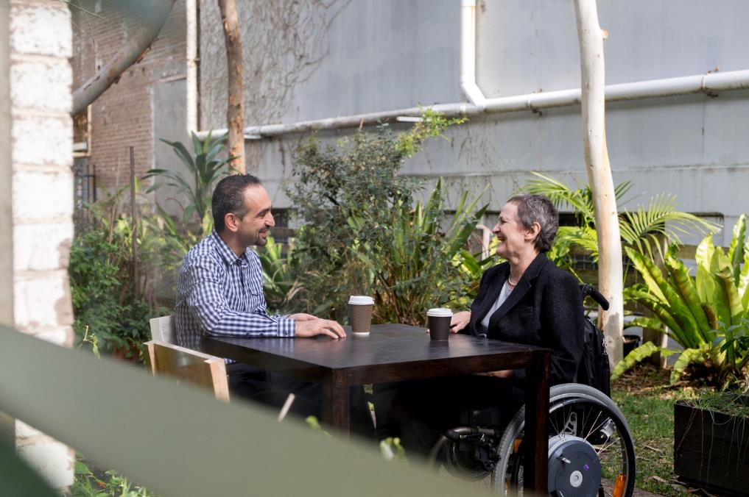

Preferred working styles for employers
Every employee has their own way of working that helps them do their best. This can be affected by things like their personality, how they learn, and where they work.
Whether you lead a small or big team, it’s important to support how your team likes to work. Even if they are all in one place or spread out across different locations. Here are a few key considerations for employers:
- Find out what your team needs. Each person has their own way of working. Adjusting work to fit their style can help build trust and boost productivity. Make time for open and candid conversations to assess and support your team’s preferred working style.
- Ask about preferences and share yours too. When inviting the team to share their preferred working style, sharing your preferences will create space for an open, safe and effective conversation.
- Consider a hybrid approach when collaborating with large teams or small groups. While some team members prefer remote work, others thrive on social interaction.
- Use different ways to communicate. These can include writing, verbal discussion, visuals and audio. This supports different learning styles.
- Use accessible tools to collaborate and connect with your team. Software with good accessibility features means all employees can connect and communicate without any barriers.
- Respect your team’s preferred working style. It’s important to honour your team members’ preferences so they can bring their best. This fosters a culture of inclusion, belonging and engagement.



Preferred working styles for employees
- What are the best ways to communicate with you? Think about: do you prefer face-to-face meetings or prefer talking online? What is the best way to get in touch with you for urgent matters? Think about any accessibility requirements here, such as, using closed captions during online meetings or using assistive technology for note taking.
- How do you learn best? Think about: what helps you understand new information or concepts? For example, visual, verbal explanation or written instructions.
- How do you like to get feedback? Think about: do you prefer hearing it right away or receiving it by email, so you have time to think before discussing it later.
- What type of working conditions suit you best? Think about: do you like a brightly lit office with space for teamwork or quiet, low-lit spaces for better focus?
- When and where do you work best? Think about: do you prefer working from the office or home? Are you more productive in the morning or afternoon?
- What makes you feel excited or interested at work? Think about: what makes you happy and motivated?


Need support with workplace adjustments? JobAccess is here to help.
JobAccess is the go-to service for advice, support and funding for workplace adjustments. It has a team of allied health professionals who offer holistic advice on adjustments. They offer tailored support to employers and people with disability, from the first point of contact.
JobAccess supports all employees, employers and service providers throughout the process – right from an initial assessment through to delivery of adjustments.
In addition to providing advice on adjustments, JobAccess works with the National Panel of Assessors to organise independent workplace assessments at no cost to the employer or employee.
Funding through the Employment Assistance Fund can cover the costs of making workplace changes. This can include buying equipment, modifications or accessing services for people with disability.

Disability and Adjustment tools
If you are unsure about the type of supports that might be beneficial to your employees, workplace accessibility information on the JobAccess website is a good starting point.
The following disability types and diagnosis are consistent with those represented in the majority of applications for workplace modification assessment through JobAccess and the Employment Assistance Fund.
Cognitive
- Managing problem solving thinking attention and memory at work
- Managing learning and applying understanding and comprehension in the workplace
- Managing literacy barriers at work
Physical
- Managing access to work and the office building
- Work health & safety and workplace ergonomics
- Managing restrictions in the upper and lower limbs at work
Sensory
- Managing blindness or low vision at work
- Managing deafness or hearing loss at work
Psychosocial
- Managing mental health conditions at work
Neurological
- Managing multiple sclerosis at work


Application process for workplace adjustments through JobAccess
- Have the conversation about workplace adjustments with your employee. If you require financial assistance to buy work-related modifications or adjustments, you can apply for the Employment Assistance Fund (EAF) online at jobaccess.gov.au.
- JobAccess will contact the applicant within two business days to discuss eligibility criteria and disability-specific barriers in the workplace. If eligibility criteria is not met, the application is closed and the applicant is informed. If eligibility criteria is met, continue to step 3.
- A JobAccess Professional Adviser will determine: is a worksite assessment required? If an assessment is not required, go straight to step 7. If an assessment is required, continue to step 4.
- A worksite assessment will be arranged by JobAccess and conducted by an external assessor. They then submit their report to JobAccess.
- All parties will be contacted to discuss the assessor’s recommendations and next steps.
- The assessor will provide quotes for all recommended equipment / modifications / services.
- The employer and employee will sign an ownership form, outlining equipment/modifications for approval by JobAccess.
- The employer or employee then purchases the items*, and provides a copy of the supplier invoice and proof of payment to JobAccess for reimbursement.
- The purchaser will be reimbursed by JobAccess within 3 business days.
(*) Alternative payment arrangements may be available, on a case by case basis. Your JobAccess Professional Adviser can discuss these with you.

Reasonable Adjustment Policy
A Reasonable Adjustment Policy covers adjustments in all aspects of employment. It increases the likelihood of attracting and employing from a broader candidate pool and retaining current employees who may acquire disability.
A good reasonable adjustment policy would detail:
- What is a reasonable or workplace adjustment
- What is the process for making reasonable adjustments in the workplace
- How to access adjustments
- What evidence may be required to request adjustments
- Who is responsible to ensure the adjustments are put in place within an appropriate timeframe

Free templates to get started
The JobAccess website has a free Reasonable Adjustment Policy template (PDF copy and Word copy) and a Reasonable Adjustment Policy checklist (PDF copy and Word copy) for employers to refer to and adapt to their organisation.

Get expert support at no cost
JobAccess’ employer engagement team – the National Disability Recruitment Coordinator (NDRC) – can support its employer partners with developing a Reasonable Adjustment Policy or reviewing an existing policy to advise on good practice. If you are looking to build a disability-confident culture within your organisation, contact JobAccess on 1800 464 800 to connect with the NDRC and discuss a free, 12-month partnership.


About JobAccess
JobAccess is an Australian Government service that offers expert advice, practical resources and good practice strategies — on matters ranging from workplace adjustments to building employer confidence — to drive disability employment.
This free, easy-to-use, one-stop service provides holistic advice, navigational support and tailored solutions for all people with disability, employers and service providers.
JobAccess services are designed to remove barriers to sustainable employment for people with disability. These services are delivered by a team of allied health professionals and disability employment experts that include people with lived experience and carers who listen, advise and support by keeping the individual and employer in focus.
JobAccess is recognised internationally for its innovative approach to disability employment. The United Nations Public Service Award and Essl Foundation’s Zero Project initiative have recognised JobAccess for improving the delivery of services and innovative policies.

